Operating Systems Assignment
SAM MIFSUD (2305369)
2024
Table of Contents
Introduction 3
Key functions of general Operating Systems 4
Resource Management 4
File Management 6
Device Management 7
Error Handling 8
System Security 9
Use of CLI Commands 9
Windows Batch Commands 9
Change directory (cd) 9
Create new directory (mkdir) 10
Create a new file (type) 10
Add content to a file (echo) 10
Read from a file (type) 10
Copy a file (copy) 10
Rename a file (rename) 11
Show directory contents (dir) 11
Delete a file (del) 11
Delete a directory (rmdir) 12
Clear screen (cls) 12
Linux Bash Commands 13
Change directory (cd) 13
Create a new directory (mkdir) 14
Create a new file (touch) 14
Add content to a file (echo) 14
Read from a file (cat) 15
Copy a file (cp) 15
Rename a file (mv) 15
Show directory contents (ls) 15
Delete a file (rm) 15
Delete a directory (rm) 16
Clear screen 16
Use of OS scripts 18
Windows Batch scripts 18
Creating the Batch script 18
Writing the Batch script 19
Running the Batch script 21
Linux Bash scripts 23
Creating the Bash script 23
Writing the Bash script 23
Running the Bash script 23
Appendices 24
Tutorial Activity – Different types of operating systems 24
General Purpose 24
Mobile 24
Network 24
Embedded OSes 24
Engagement with online course 25
Windows Batch script code 26
Linux Bash script code 30
References 30

Introduction
An operating system is a piece of software used on a computer system primarily to control the low-level operations of the system’s hardware to enable other software and the user to interface with it. It does so by acting as a middleman between the software and hardware, managing resources, tasks and operations and performing a multitude of tasks to make software run effectively on all types of hardware [1].
In this report I will demonstrate my knowledge of computer operating systems by explaining the functions of an operating system and demonstrate my ability in using them by using commands and scripts for Windows and Linux operating systems.
To explain the functions of an operating system I will use credible sources to research said functions, then use that research to create my own descriptions and explanations, with screenshot evidence where possible to demonstrate the functions in practise. I will then use Windows’ Batch commands and scripting functionality, and Linux’s Bash commands and scripting language to demonstrate my ability with using operating systems.
I will also append evidence to demonstrate further ability with a tutorial activity I completed in class and a certified course I completed outside of class.

Key functions of general Operating Systems

Resource Management
One major function of Operating Systems is to allocate hardware resources such as CPU Processor Cores, Memory, Disk and Network bandwidth, and access to peripheral devices between processes running on the system, including itself [2]. It has to make sure that no process uses up too much of the limited resources, and none get too little.
You can see Resource Management in practise in the resource manager or task manager applications in Windows:
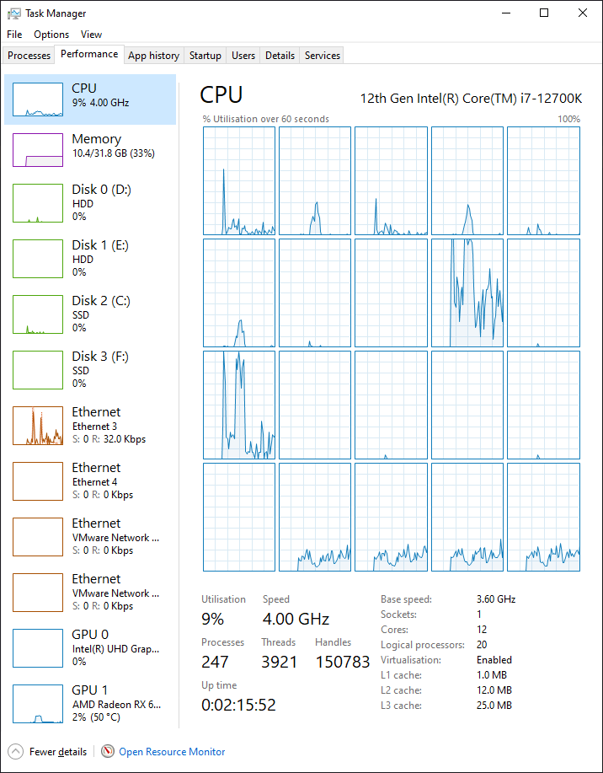
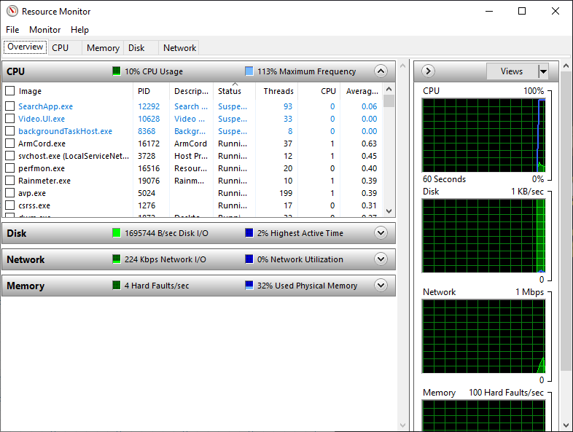

File Management
The Operating System also manages the organization of files on the system’s storage drives. The Operating System needs to ensure that files are organized in directories for the user and applications to access more easily and efficiently, as well as ensuring that files are written and erased effectively. It also needs to keep track of which parts of the drive contain data and which are empty, I.E. marking space as empty after a file is deleted [3].
You can see file management in practise using the File Explorer, which shows directories and contents.
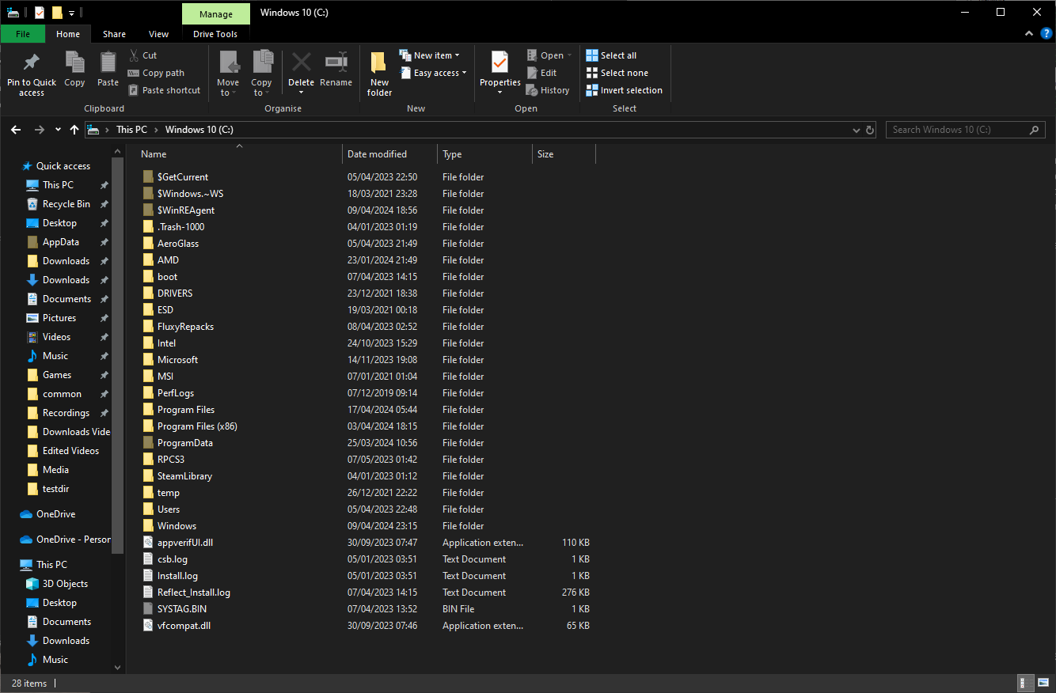

Device Management
The system also has to manage all the hardware devices on the system, both internal hardware and external peripherals. It does this using specialised software called drivers which tell the system how to communicate with specific hardware. The Operating System has to manage the data sent and received to a device, ensuring it is processed in order and does not overwhelm the device’s capabilities. It also manages the allocation of the device’s resources to individual applications [4].
You can see device management in action using the aptly named Device Manager:
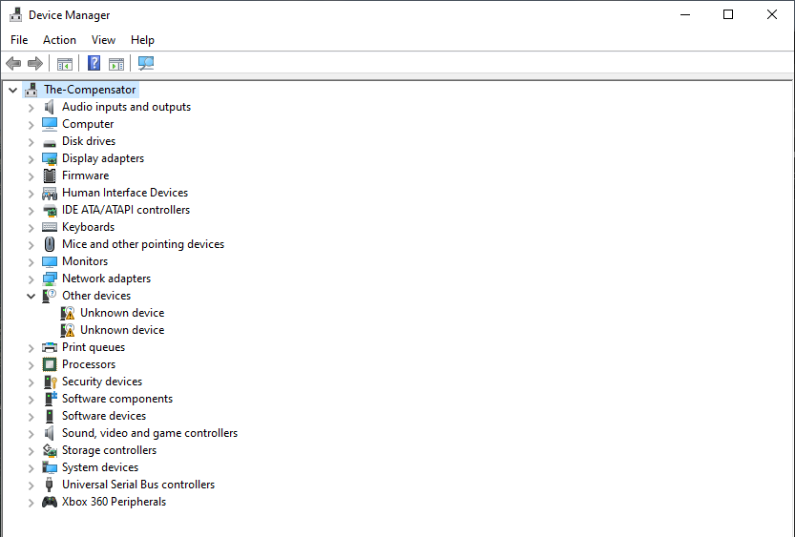

Error Handling
Operating Systems also must handle system and application errors. They should attempt to prevent errors where possible, and where it is not possible to do so they should mitigate them as well as possible, provide useful information to the user to aid them in resolving issues, and log them for the same reason. It should also applications to resume or exit cleanly depending on the circumstances of the error and prevent errors from causing other problems [5].
You can see error handling in practise in the event viewer in Windows:
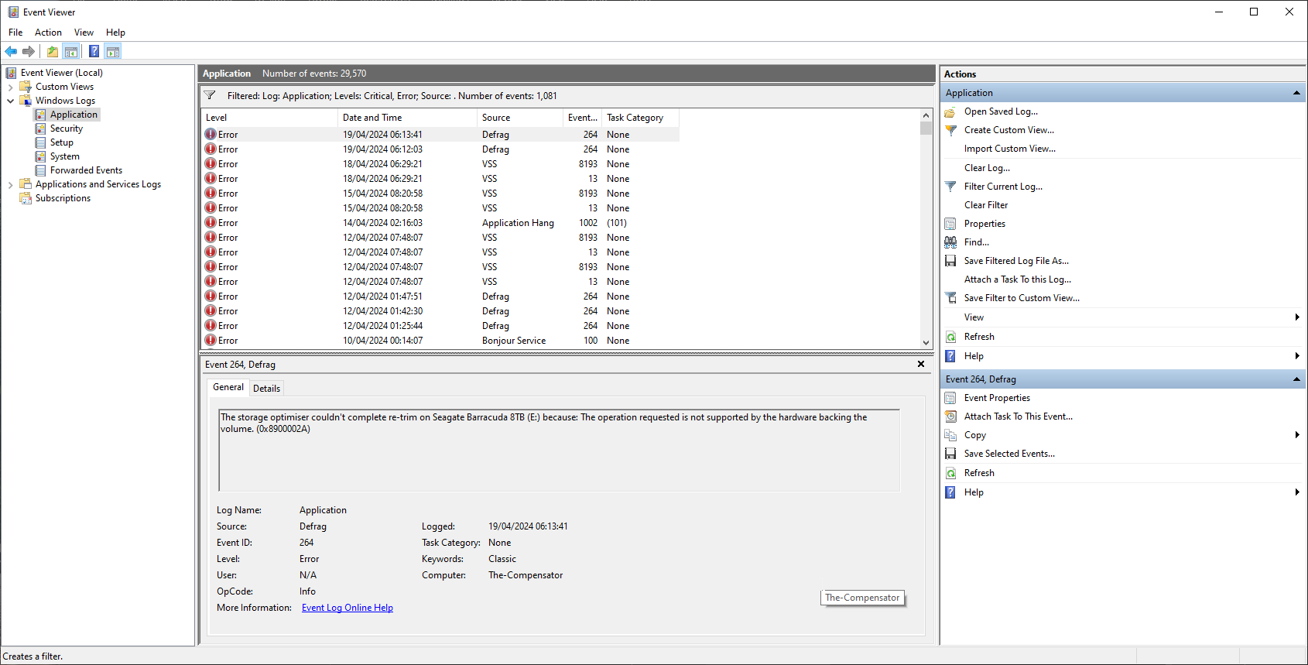

System Security
System Security is an important part of an Operating System’s tasks. It connects tightly with other elements of its jobs, such as ensuring malicious files are not downloaded via the network, deleting any present on drives, as well as managing account and file security and access rights to ensure only the intended users have access to them. Active Antimalware solutions such as Windows Defender are also often present in modern Operating Systems to block malicious network traffic through firewalls and perform many more security measures [6].
You can see System Security in practice in the Windows Security program on Windows:
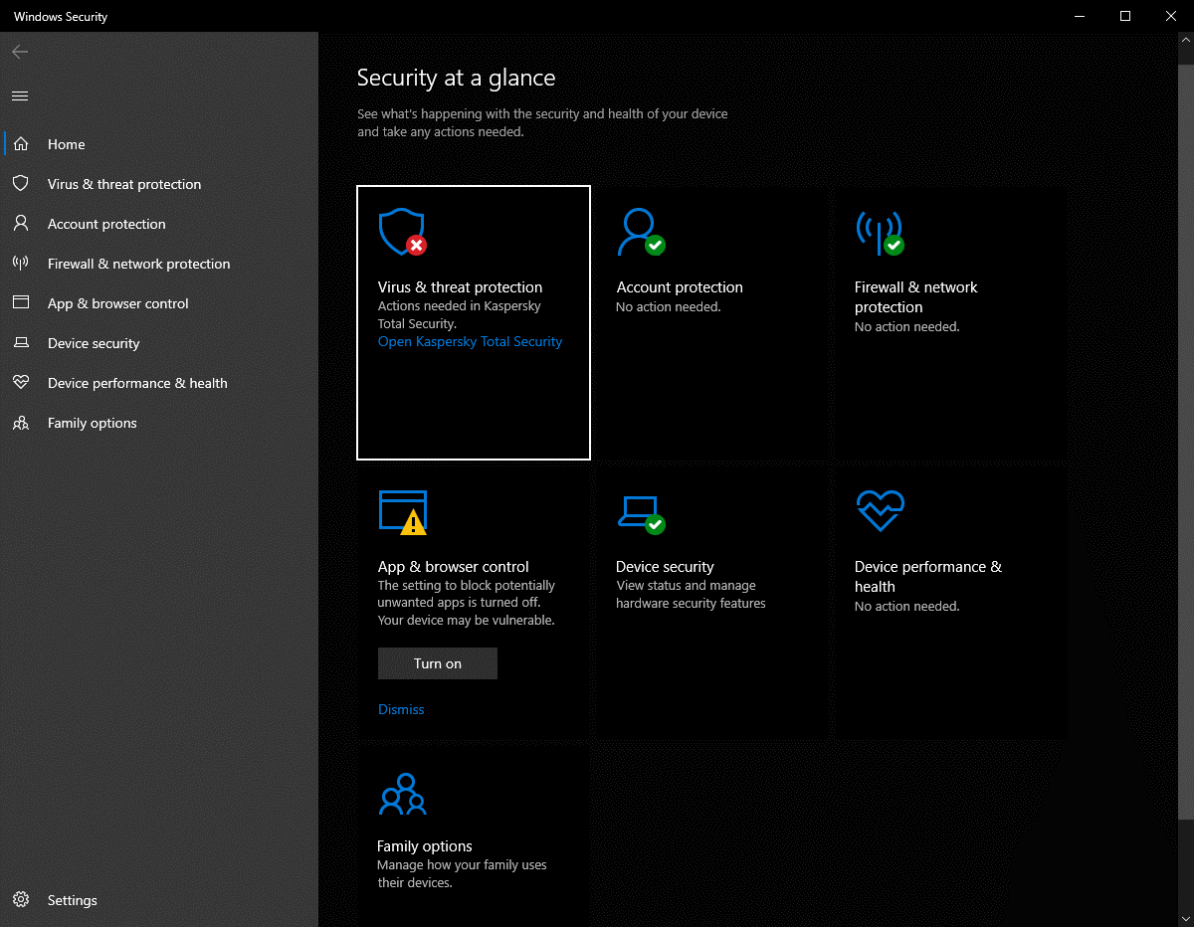

Use of CLI Commands

Windows Batch Commands

Change directory (cd)
To change directories in batch you type cd followed by the directory you want to navigate to. You can do this by typing the full path:
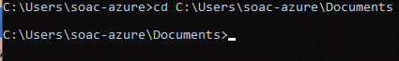
Or by typing the name of the folder you want to navigate to if it is inside the folder you are currently active in:
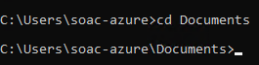

Create new directory (mkdir)
To make a new folder you type mkdir followed by the name you want to give the folder. For example, mkdir testdir will create a folder called testdir in your current active directory:
You can then navigate to the newly created folder using cd:
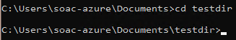

Create a new file (type)
You can use the type command to create a file. Type is usually used to read a file, but using the syntax “type nul > filename.extension” you can create a new file. I created a file called testfile.txt in the test directory:
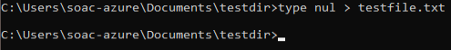

Add content to a file (echo)
The echo command can be used to print something in the console, however it can also be used to add data to a file. I added the text “test” to the testfile I created in the last command:

Read from a file (type)
As I mentioned in a previous command, type is usually used to read from a file, which I can do here to check the file I created in that command and populated in the previous one. To do this I simply write “type” followed by the filename:
This prints “test” showing that the previous 2 commands and this one worked correctly.

Copy a file (copy)
Copying a file can be very useful, allowing backups to be created, files to be shared to other users, and enabling many other tasks to be performed. Copy is a very comprehensive command, with many parameters to extend its functionality, like verifying the integrity of the copied file, or removing decryption from the destination file [7]. For this example, I will simply copy the testfile and verify its integrity. The syntax for this is “copy /v testfile.txt testfilecopy.txt”:
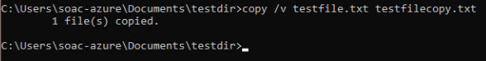

Rename a file (rename)
Renaming a file is as simple as typing rename followed by the current name of the file (with the path in front if it is not in your current active folder, i.e “C:\Users\soac-azure\Documents\testdir\testfile.txt”), then the new name you want to give it. For this example, I will rename testfilecopy.txt to testfilefinal.txt:
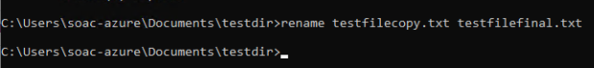

Show directory contents (dir)
The dir command requires no additional parameters to function, and simply shows all the files and subdirectories in the current active directory. There are many additional parameters you can pass to the command if necessary, for functionality such as custom sorting of the output or displaying files with certain attributes (or showing hidden files, which are not shown by default) [8], however for this example I will use the command with no additional parameters:
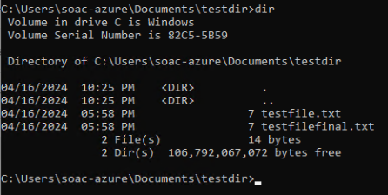

Delete a file (del)
To delete a file you type del followed by the name of the file (with its path if the file is not located in your currently active directory, i.e “C:\Users\soac-azure\Documents\testdir\testfile.txt”). You can pass additional parameters to do things like only deleting files with certain attributes, or specify multiple files or an entire folder to delete multiple files at a time [9]. However, for this example I will just delete the original testfile.txt and then run dir again to verify it has been removed:
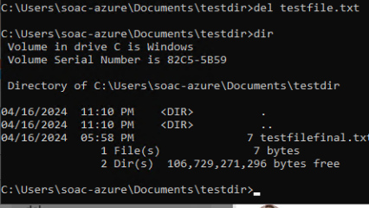

Delete a directory (rmdir)
To delete a directory you use the rmdir command. This command has arguments, with the /s argument being very important for this task as it recursively deletes any files or folders inside the one you are trying to delete. You do not need this argument if you are deleting an empty directory, but if you attempt to delete a directory that is not empty without it it will fail with an error [10]. For this example I will navigate to the folder a level above my testdir (C:\Users\soac-azure\Documents) using cd and then delete it with the /s argument:
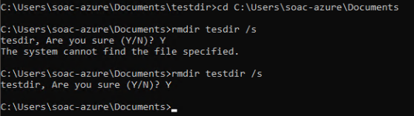
In this example I made a typing mistake and typed “testdir” as “tesdir”, unintentionally showing what happens if you specify a directory that does not exist.

Clear screen (cls)
The command cls can be used to clear the contents of the command prompt window, to de clutter or hide sensitive information if necessary:
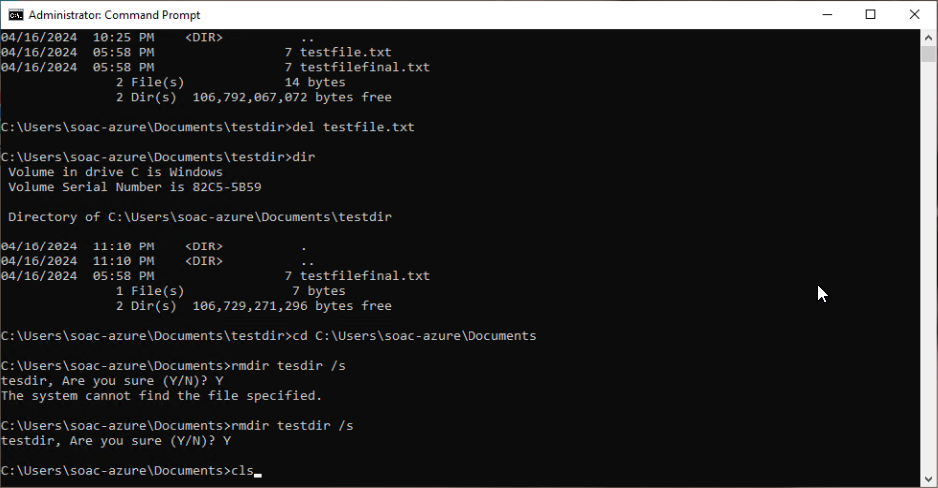
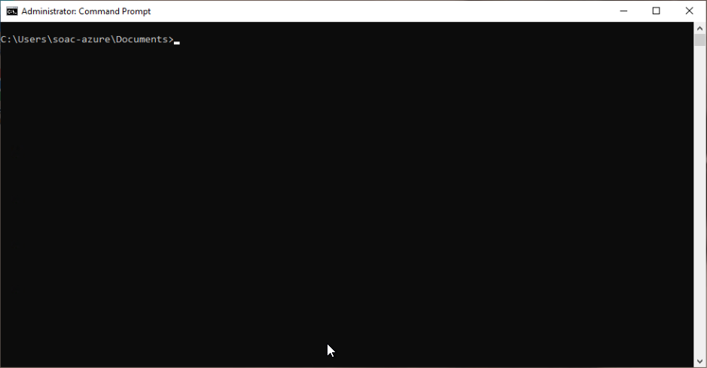

Linux Bash Commands

Change directory (cd)
Changing directories in Bash is the same as in Batch, cd followed by the path you wish to navigate to. You can specify a path relative to the current working directory or relative to the root of the drive [11]. In this example, I will use cd /Documents to navigate to the Documents folder in the default working directory of my Bash terminal (the home folder):
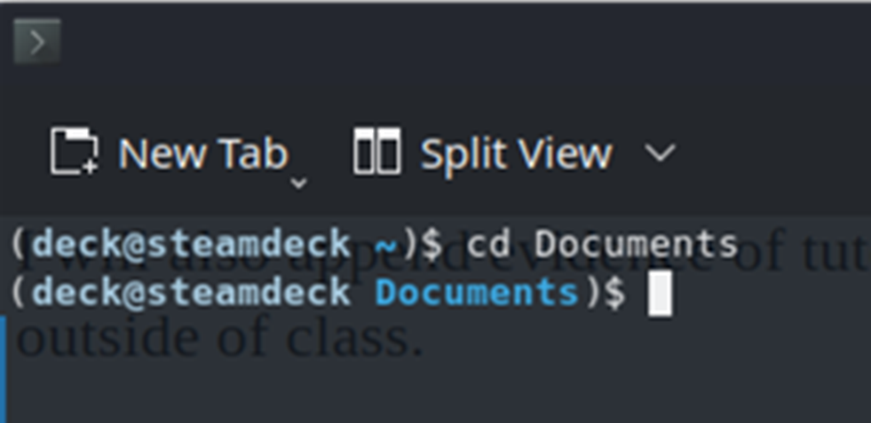

Create a new directory (mkdir)
Creating a new directory in Bash is also the same as creating one in Batch. The syntax for the command is mkdir (directory path). You can also add a -p flag before the directory if you want to create a new directory with a new subdirectory. For example, with mkdir -p /testdir/testdir2 the shell can create a testdir directory then create a testdir2 directory inside of it [12]. However, for the purpose of this example this will not be necessary and I will simply create a single directory called testdir:
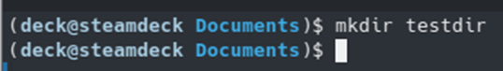

Create a new file (touch)
The touch command is used to create new files in Bash. Typing “touch” followed by the desired name will create a file with that name [13]. For this example I will create a file named testfile.txt:
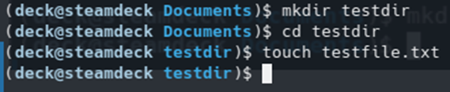

Add content to a file (echo)
The echo command in Linux works similarly to how it does in Windows. By typing “echo” followed by some text that text will be output to the console window, however you can use an argument to send that output to a file instead. In Linux this is done using either a single > or two of them, >>. A single > will delete the contents of a file then add your output to it, whereas two >> will append your output to the end of the file [14]. For this example I will add some text to the file with a single > operator:
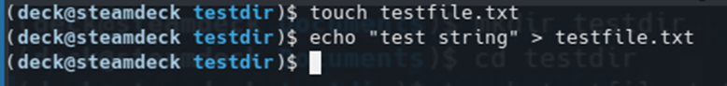

Read from a file (cat)
To copy a file in Linux you type “cp” followed by the path or filename of the file you want to copy and the path or filename you want to copy it to [15]. For this example I will make a copy of testfile.txt with the name testfile2.txt:
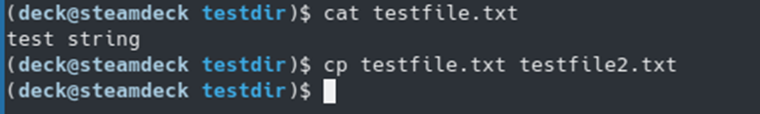

Copy a file (cp)
To copy a file in Linux you type “cp” followed by the path or filename of the file you want to copy and the path or filename you want to copy it to [16]. For this example I will make a copy of testfile.txt with the name testfile2.txt:

Rename a file (mv)
Renaming a file is done using the mv command. The mv command is designed to allow moving files by changing their path, however changing the filename at the end of the path (or simply the filename if it is in the current working directory) will rename the file also [17]. For this example I will rename testfile2.txt to testfilefinal.txt:
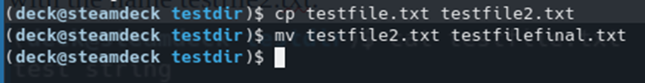

Show directory contents (ls)
The ls command in Bash lists the directory contents in the console window. As with dir in Windows there are many arguments you can use to have it list additional files that are hidden by default, for example [18], but for this example I will use the command alone:
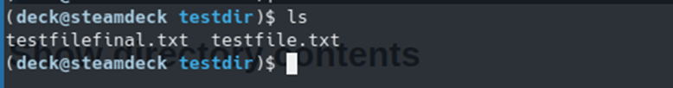

Delete a file (rm)
Bash uses rm for deleting files. Like ls, this command has many optional arguments, such as recursively deleting files and directories within a directory you wish to delete, forcefully deleting files, and many other functions, as well as functions like a star to indicate any file matching certain criteria to be deleted. For example, rm -rf /* will recursively and forcefully delete all files (as the * without any following criteria marks all files) and subdirectories within the root of the drive [19]. For this example, I will simply remove the original testfile.txt:

Delete a directory (rm)
The rm command can, as I mentioned above, also delete directories. You do not need any additional arguments to delete an empty directory, however if the directory contains other files or subdirectories you will need to use the -r command to recursively delete the files and subdirectories within it [19]. For this example, I will cd back to the documents folder and recursively delete the test directory:
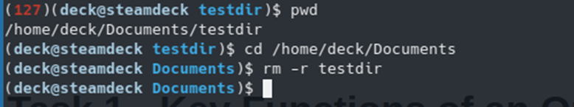
I can then use ls again to verify the test directory has been removed:
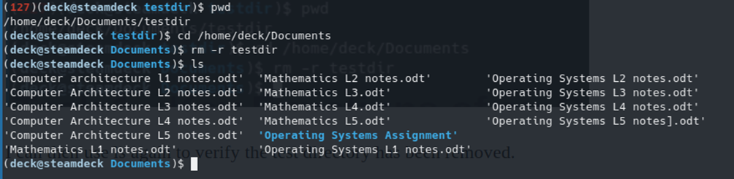

Clear screen
Clearing the screen in bash is as simple as typing “clear” in the console [20]:
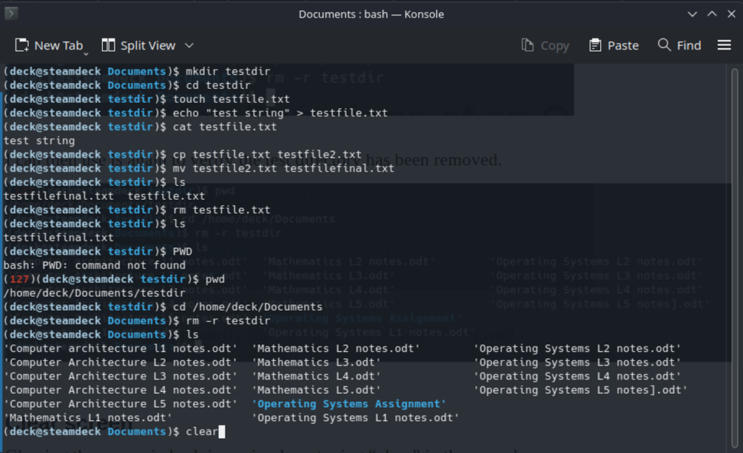
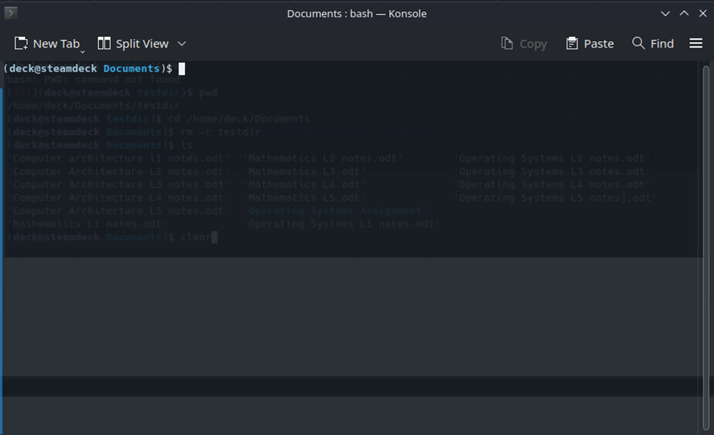

Use of OS scripts

Windows Batch scripts

Creating the Batch script
To create a Batch script on Windows you could use the commands I used in the CLI Commands section, however it is simpler to use the GUI explorer. To do so, you simply create a new test file and change the extension to “.bat”:
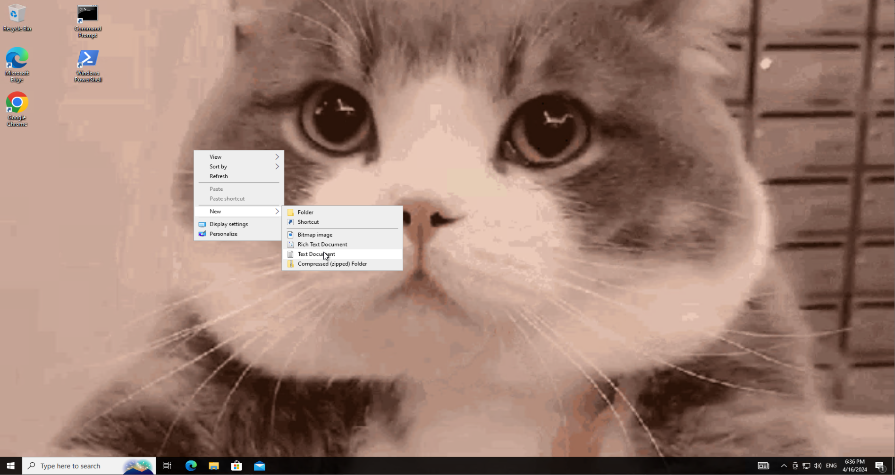
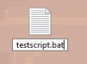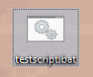
To edit the batch script, right click and press “Edit” in the context menu:
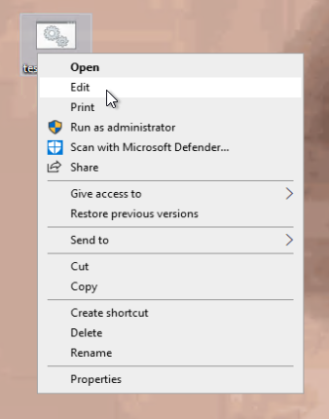
The file will then be opened as a text document in Notepad where a script can be written:
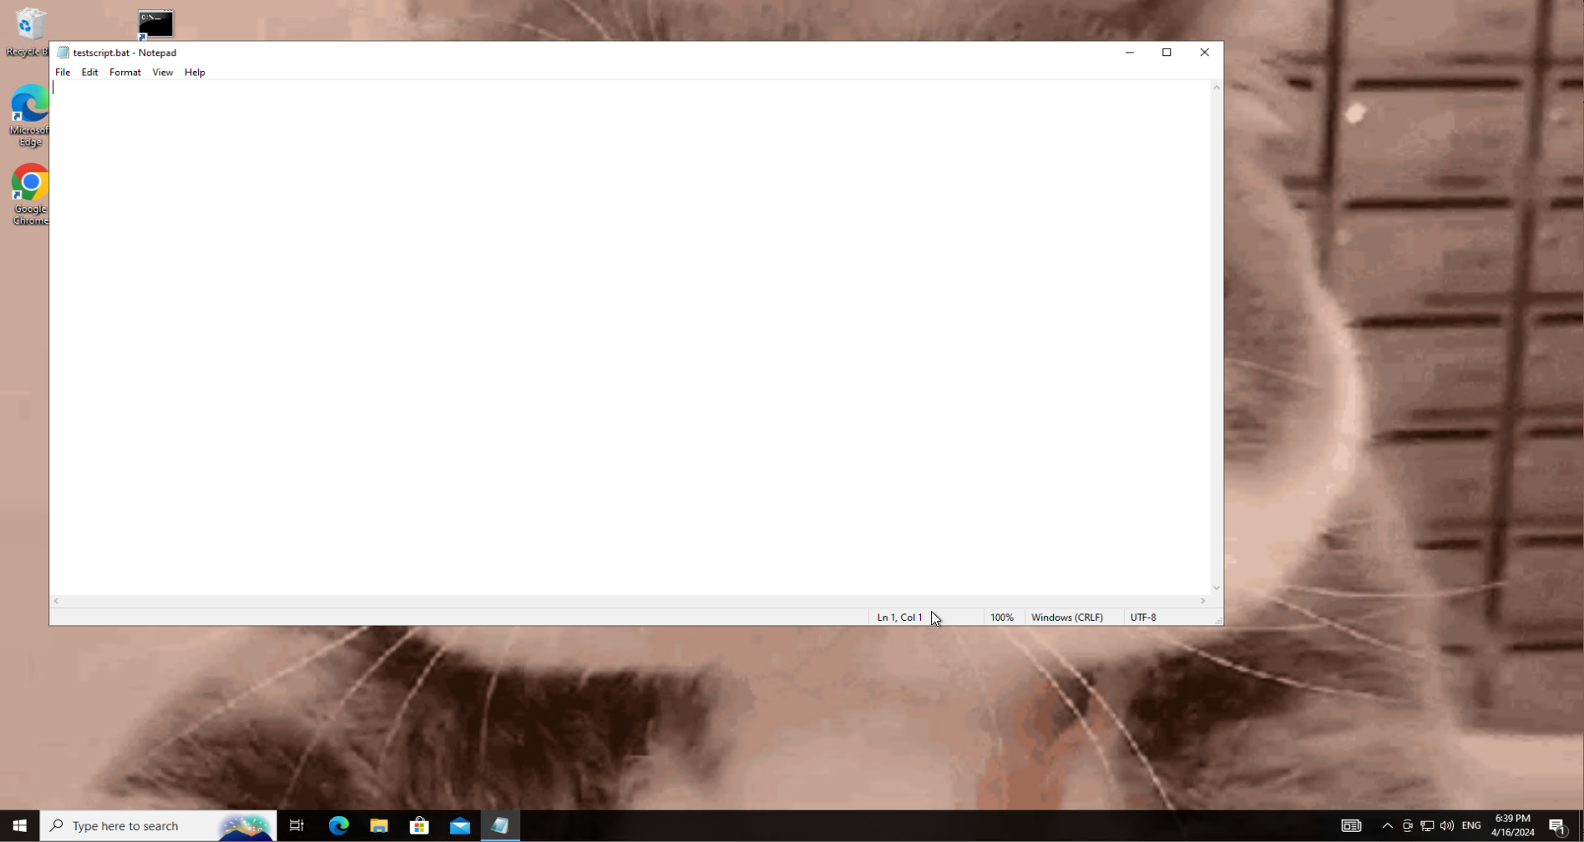

Writing the Batch script
For this assignment I will create a Batch script that allows the user to do all the commands from the previous section under “Windows Batch Commands” with an interface to support them in doing so, as well as adding a few additional functions.
To begin with I added “@Echo off” to the beginning of the script. This stops the command prompt from outputting the commands as they are executed, only outputting strings we tell it to execute. I also added “Pause” to the end of the script to make it so the user has to close the command prompt themselves, rather than it automatically closing when the script stops executing:
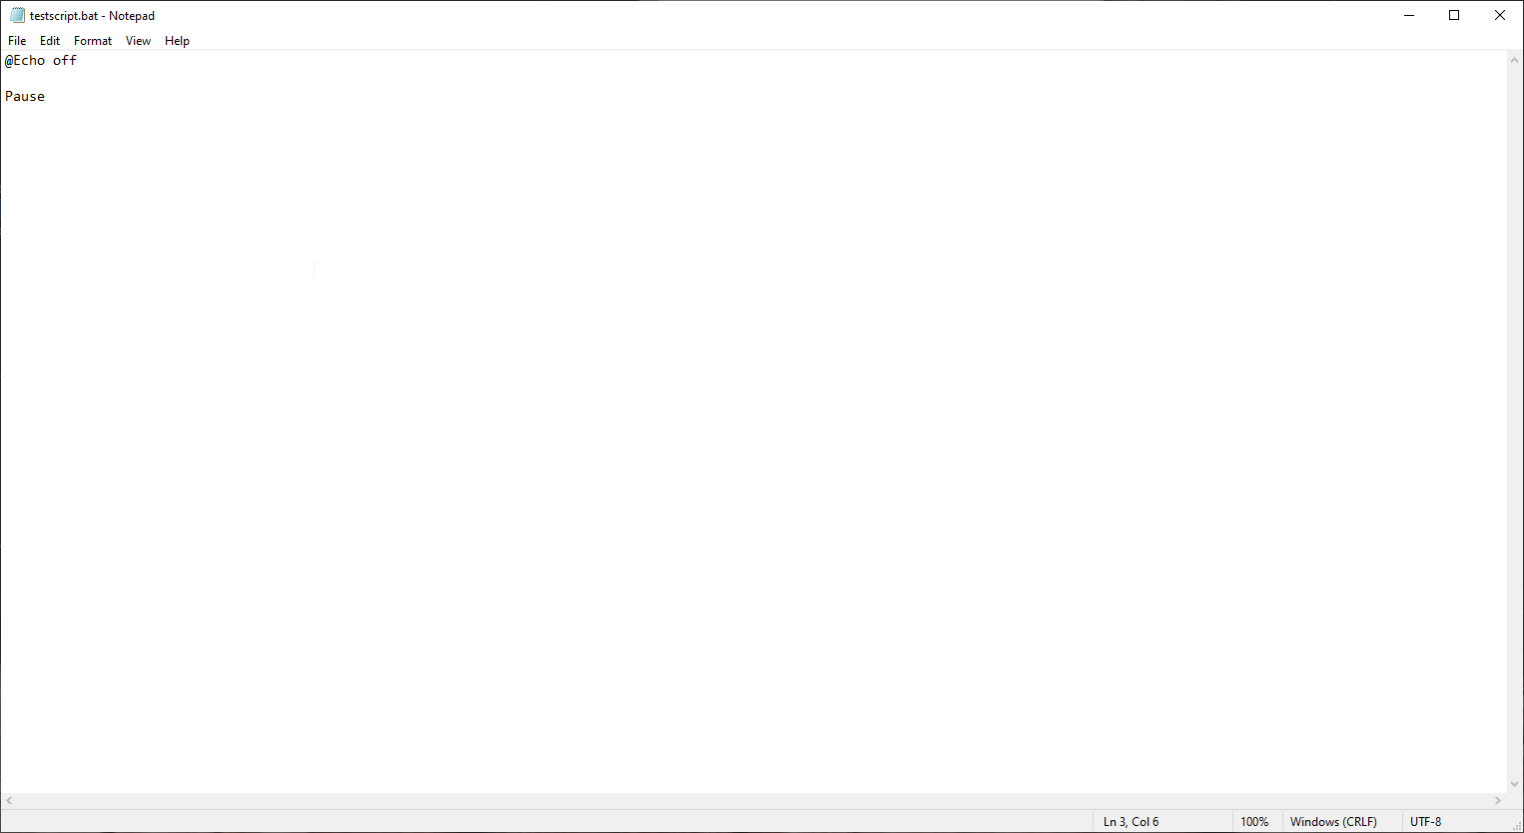
I then designed a Main Menu from which the user can navigate to several functions. The user enters a number, and if it is a valid input it will go to that section of code, otherwise it will print an error and have the user input again:
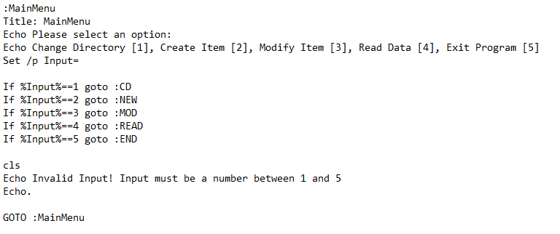
I then created submenus and functions for each option, using GOTO statements to return to the menu upon completion:
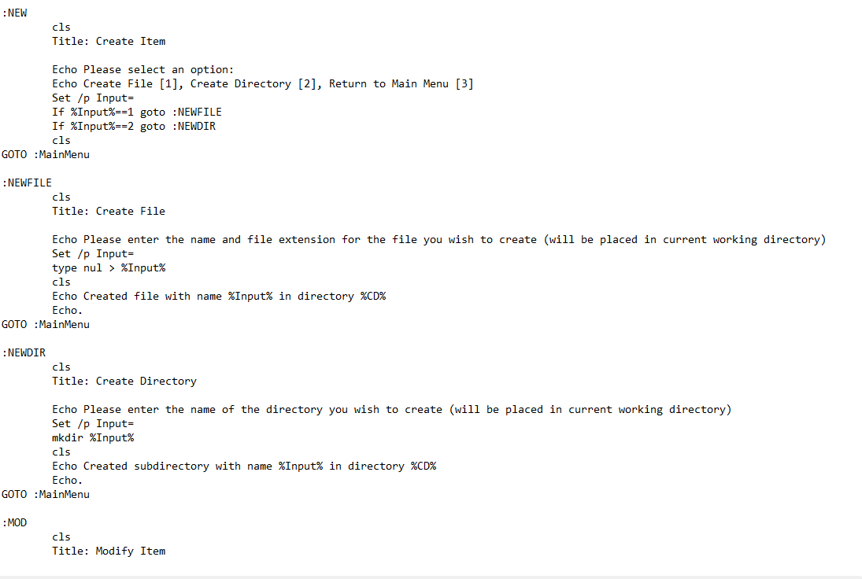

Running the Batch script
To run the Batch script I double clicked it in file explorer which automatically opens it in CMD.
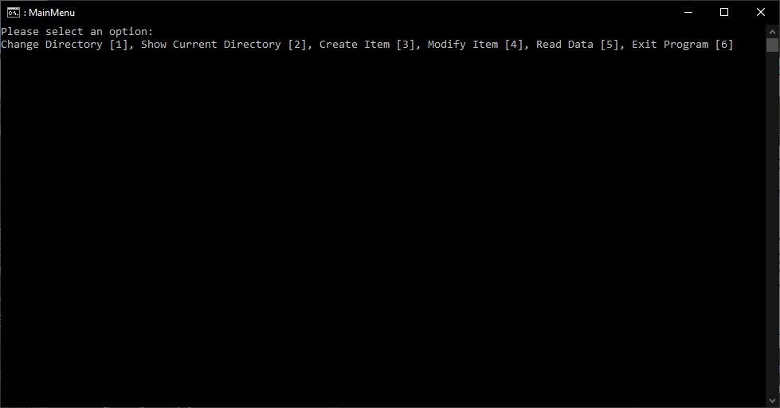
I then tested all the options to ensure they work:
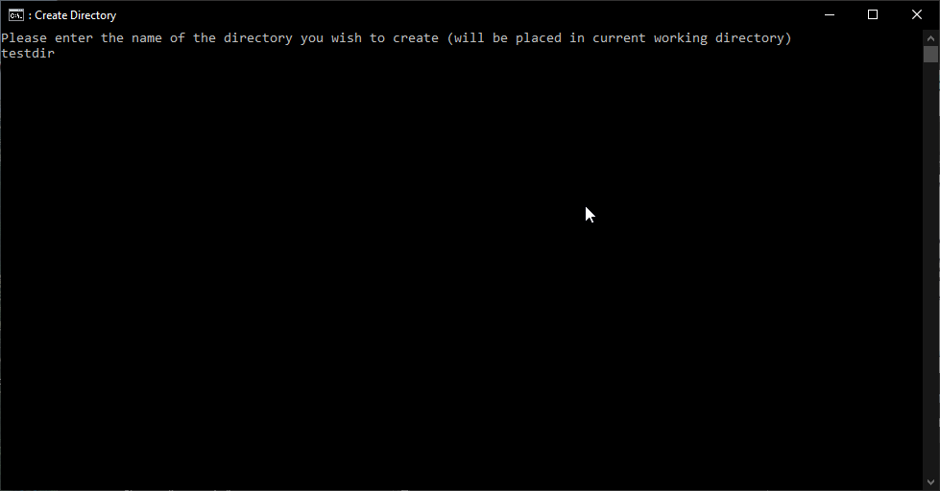
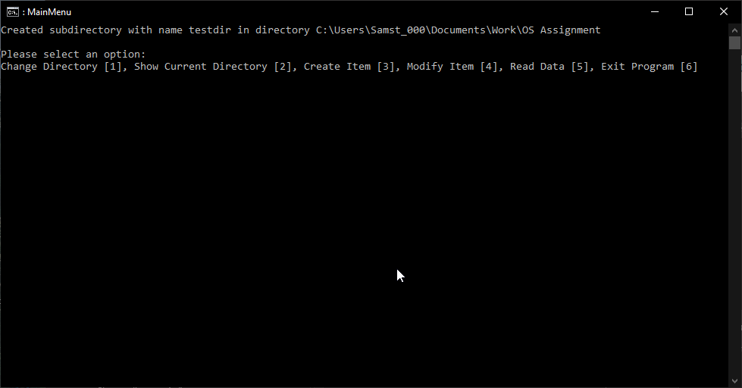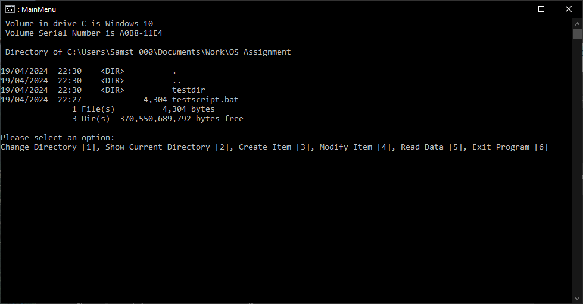

Linux Bash scripts

Creating the Bash script

Writing the Bash script

Running the Bash script

Appendices

Tutorial Activity – Different types of operating systems

General Purpose
General Purpose Operating Systems are designed to run on General Purpose computer systems. These are systems designed for a wide variety of applications, from reading emails to playing games to performing advanced calculations, whereas Specialised Computer Systems are designed and built with a very limited number of applications in mind [21]. Some of the most popular General Purpose Operating Systems are Microsoft’s Windows, Apple’s MacOS and the various Linux distributions available.

Mobile
Mobile Operating Systems are a subset of General Purpose Operating Systems designed for mobile devices such as smartphones, tablets and similar devices. While these devices and systems are very similar to, and often based on, other General Purpose Operating systems such as Linux they are modified for better performance and usability on mobile devices, taking advantage of touch screen interfaces, making better use of hardware to reduce battery drain and utilising other specialised hardware installed in these devices [22]. The most popular mobile operating systems are Apple’s iOS and Google’s Android, a Linux based Operating system with many variations of its own among different phone, tablet and laptop manufacturers.

Network
A Network Operating System or NOS is a specialised operating system designed to run on network hardware to facilitate easier communications between computer systems and other hardware on a network. They perform several basic tasks to make communications on a network smoother and more efficient, such as automating file transferring and hardware resource sharing [23] but on modern server systems they can be used for far more purposes. While file transfer and resource sharing are still important today, other utilities such as providing user accounts across different workstations, providing access to software resources such as applications and storage of files remotely to be accessed over the web, rather than only transferred between machines [24].
One example of a modern Network Operating Systems is Microsoft’s Windows Server line of operating systems, though many other Operating Systems based on Linux and UNIX are used widely and in large numbers in industry.

Embedded OSes
Embedded Operating Systems are found within devices like IoT devices, vehicles, and various pieces of specialised equipment. They are used in a wide variety of applications with a wide variety of tasks. Embedded Operating Systems often need run at optimal performance, such as in a vehicle where achieving real-time processing of data could be crucial for safety equipment such as automatic braking systems [25].

Engagement with online course
For this assignment I signed up to the “Learning PowerShell” LinkedIn course [26] recommended in the assignment brief. In the CLI commands and OS Scripts sections I used CMD Batch commands as I am already familiar and confident with them and felt more comfortable working with them for the relevant tasks. However, the course provides me with an additional opportunity to learn new skills with another shell environment and scripting language which could be useful for me in the future.
Below I will attach screenshot evidence of me working on this course:
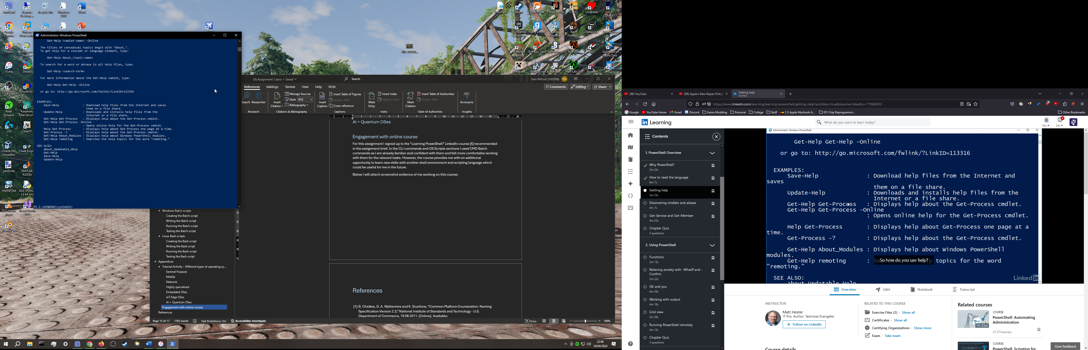
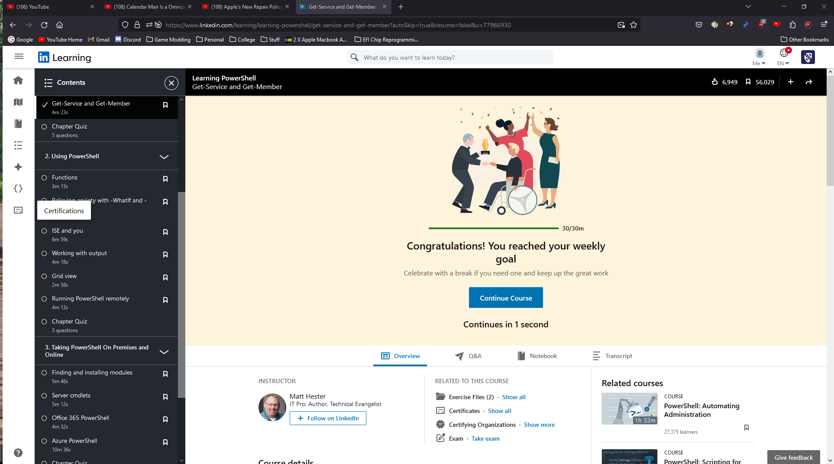
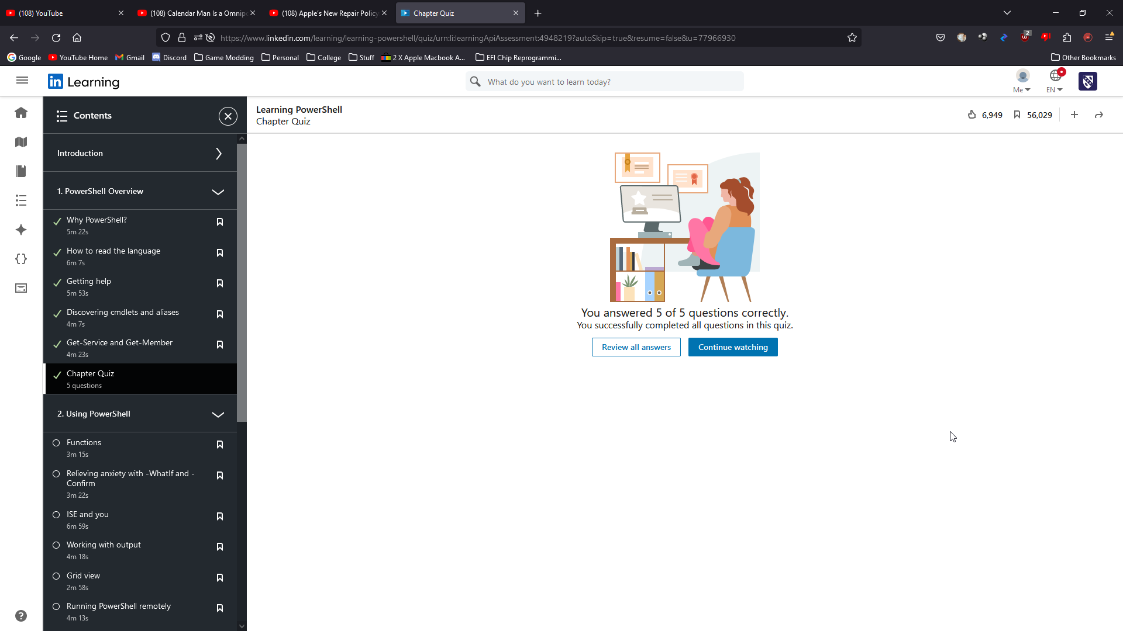

Windows Batch script code
@Echo off

:MainMenu
Title: MainMenu
Echo Please select an option:
Echo Change Directory [1], Show Current Directory [2], Create Item [3], Modify Item [4], Read Data [5], Exit Program [6]
Set /p Input=

If %Input%==1 goto :CD
If %Input%==2 goto :SHOWDIR
If %Input%==3 goto :NEW
If %Input%==4 goto :MOD
If %Input%==5 goto :READ
If %Input%==6 goto :END

cls
Echo Invalid Input! Input must be a number between 1 and 5
Echo.

GOTO :MainMenu

:CD
cls
Title: Change Directory

Echo What directory would you like to navigate to?
Set /p Input=
cls
cd %Input%

Echo Changed working directory to %Input%
Echo.
GOTO :MainMenu

:SHOWDIR
cls
Echo: The current working directory is %CD%
Echo.
GOTO :MainMenu

:NEW
cls
Title: Create Item

Echo Please select an option:
Echo Create File [1], Create Directory [2], Return to Main Menu [3]
Set /p Input=
If %Input%==1 goto :NEWFILE
If %Input%==2 goto :NEWDIR
cls
GOTO :MainMenu

:NEWFILE
cls
Title: Create File

Echo Please enter the name and file extension for the file you wish to create (will be placed in current working directory)
Set /p Input=
type nul > %Input%
cls
Echo Created file with name %Input% in directory %CD%
Echo.
GOTO :MainMenu

:NEWDIR
cls
Title: Create Directory

Echo Please enter the name of the directory you wish to create (will be placed in current working directory)
Set /p Input=
mkdir %Input%
cls
Echo Created subdirectory with name %Input% in directory %CD%
Echo.
GOTO :MainMenu

:MOD
cls
Title: Modify Item

Echo Please select an option:
Echo Modify File [1], Modify Directory [2], Return to Main Menu [3]
Set /p Input=
If %Input%==1 goto :MODFILE
If %Input%==2 goto :MODDIR
cls
GOTO :MainMenu

:MODFILE
cls
Title: Modify File

Echo Please select an option:
Echo Delete File [1], Rename File [2], Add Text to File [3], Return to Main Menu [4]
Set /p Input=
If %Input%==1 goto :DELFILE
If %Input%==2 goto :RENFILE
If %Input%==3 goto :WRITEFILE
cls
GOTO :MainMenu

:DELFILE
cls
Title: Delete File

dir
Echo Please enter the name of the file:
Set /p Input=

Echo Type Y to confirm deletion of %Input%
Set /p Input2=
cls
If %Input2%==Y del %Input%
GOTO :MainMenu

:RENFILE
cls
Title: Rename File

dir
Echo Please enter the name of the file:
Set /p Input=
Echo Please enter the desired (new) name for the file:
Set /p Input2=
cls
rename %Input% %Input2%
GOTO :MainMenu

:WRITEFILE
cls
Title: Write to File

dir
Echo Please enter the name of the file:
Set /p Input=
Echo Please enter the content you would like to add to the file:
Set /p Input2=
cls
Echo %Input2% > %Input%
GOTO :MainMenu

:MODDIR
cls
Title: Modify Directory

Echo Please select an option:
Echo Delete Directory [1], Recursive Delete Directory [2], Rename Directory [3], Return to Main Menu [3]
Set /p Input=
If %Input%==1 goto :DELDIR
If %Input%==2 goto :RDELDIR
If %Input%==3 goto :RENDIR
cls
GOTO :MainMenu

:DELDIR
cls
Title: Delete Directory

dir
Echo Please enter the name of the directory:
Set /p Input=

Echo Type Y to confirm deletion of %Input%
Set /p Input2=
cls
If %Input2%==Y rmdir %Input%
GOTO :MainMenu

:RDELDIR
cls
Title: Delete Directory

dir
Echo Please enter the name of the directory:
Set /p Input=

Echo Type Y to confirm deletion of %Input%
Set /p Input2=
cls
If %Input2%==Y rmdir /s %Input%
GOTO :MainMenu

:RENDIR
cls
Title: Rename Directory

dir
Echo Please enter the name of the directory:
Set /p Input=
Echo Please enter the desired (new) name for the directory:
Set /p Input2=
cls
rename %Input% %Input2%
GOTO :MainMenu

:READ
cls
Title: Read Data

Echo Please select an option:
Echo Read From File [1], Show Directory Contents [2], Return to Main Menu [3]
Set /p Input=
If %Input%==1 goto :READFILE
If %Input%==2 goto :DIR
cls
GOTO :MainMenu

:READFILE
cls
Title: Read File

dir
Echo Please enter the name of the file:
Set /p Input=
cls
type %Input%
GOTO :MainMenu

:DIR
cls
dir
Echo.
GOTO :MainMenu

:END
Title: Program ended, press any key to continue . . .

Pause

Linux Bash script code

References

[1] | B. Cheikes, D. A. Waltermire and K. Scarfone, “Common Platform Enumeration: Naming Specification Version 2.3,” National Institute of Standards and Technology - U.S. Department of Commerce, 19 08 2011. [Online]. Available: https://tsapps.nist.gov/publication/get_pdf.cfm?pub_id=909010. [Accessed 18 04 2024].
[2] | B. Smith, “Operating system resource management,” in 2010 IEEE International Symposium on Parallel & Distributed Processing (IPDPS), 2010, p.1-1, Atlanta, GA, USA, 2010.
[3] | “File Systems in Operating System,” geeksforgeeks, 04 12 2023. [Online]. Available: https://www.geeksforgeeks.org/file-systems-in-operating-system/. [Accessed 19 04 2024].
[4] | P. Singh, “Device Management in Operating System,” Scaler, 14 10 2023. [Online]. Available: https://www.scaler.com/topics/device-management-in-operating-system/. [Accessed 19 04 2024].
[5] | “IM: U: System ErrorHandler,” Apple, [Online]. Available: https://developer.apple.com/library/archive/documentation/mac/pdf/Operating_System_Utilities/System_Error.pdf. [Accessed 19 04 2024].
[6] | V. Pamnani and P. Matarazzo, “Windows operating system security,” Microsoft, 08 02 2023. [Online]. Available: https://learn.microsoft.com/en-us/windows/security/operating-system-security/. [Accessed 19 04 2024].
[7] | J. Gerend, R. Harwood, E. Ross, J. Parente, D. Coulter, C. Plett, B. Mammen and L. Poggemeyer, “Microsoft Learn - copy,” Microsoft, 02 03 2023. [Online]. Available: https://learn.microsoft.com/en-us/windows-server/administration/windows-commands/copy. [Accessed 16 04 2024].
[8] | J. Gerend, R. Harwood, S. Ikebe, E. Ross, J. Parente, D. Coulter, "adzm", "illfated", I. Prittie, M. Jacobs, C. Plett, B. Mammen and L. Poggemeyer, “Microsoft Learn - dir,” Microsoft, 02 03 2023. [Online]. Available: https://learn.microsoft.com/en-us/windows-server/administration/windows-commands/dir. [Accessed 16 04 2024].
[9] | J. Gerand, R. Harwood, "Xelu86", E. Ross, J. Parente, D. Coulter, M. Jacobs, P. Johnson, C. Plett, B. Mammen and L. Poggemeyer, “Microsoft Learn - del,” Microsoft, 02 03 2023. [Online]. Available: https://learn.microsoft.com/en-us/windows-server/administration/windows-commands/del. [Accessed 16 04 2024].
[10] | J. Gerend, R. Harwood, E. Ross, J. Parente, D. Coulter, C. Plett, B. Mammen and L. Poggemeyer, “Microsoft Learn - rmdir,” Microsoft, 02 03 2023. [Online]. Available: https://learn.microsoft.com/en-us/windows-server/administration/windows-commands/rmdir. [Accessed 17 04 2024].
[11] | S. Kumar, “How to Use cd Command in Bash Scripts,” tutorialspoint, 24 03 2023. [Online]. Available: https://www.tutorialspoint.com/how-to-use-cd-command-in-bash-scripts. [Accessed 19 04 2024].
[12] | A. Khoo, “mkdir if not exists,” warp, [Online]. Available: https://www.warp.dev/terminus/mkdir-if-not-exists. [Accessed 19 04 2024].
[13] | K. K. Panigrahi, “How to Create a New File in Linux from Bash?,” tutorialspoint, 16 04 2024. [Online]. Available: https://www.tutorialspoint.com/how-to-create-a-new-file-in-linux-from-bash. [Accessed 19 04 2024].
[14] | “Bash: Write to File,” Linuxize, 04 01 2021. [Online]. Available: https://linuxize.com/post/bash-write-to-file/. [Accessed 19 04 2024].
[15] | “Bash Read File,” Javatpoint, [Online]. Available: https://www.javatpoint.com/bash-read-file. [Accessed 19 04 2024].
[16] | D. Megida, “The Linux cp Command – How to Copy Files in Linux,” freeCodeCamp, 06 06 2022. [Online]. Available: https://www.freecodecamp.org/news/the-linux-cp-command-how-to-copy-files-in-linux/. [Accessed 19 04 2024].
[17] | M. Dancuk, “How to Rename Files in Linux,” phoenixNAP, 20 11 2023. [Online]. Available: https://phoenixnap.com/kb/rename-file-linux. [Accessed 19 04 2024].
[18] | “Lesson 2: Simple Bash Commands,” CHARMM-GUI, [Online]. Available: https://charmm-gui.org/?doc=lecture&module=unix&lesson=2. [Accessed 19 04 2024].
[19] | G. Ramuglia, “How to Delete Files in Bash: Your Guide to the Bash Shell,” I/O Flood, 28 11 2023. [Online]. Available: https://ioflood.com/blog/bash-delete-file/. [Accessed 19 04 2024].
[20] | “Linux clear command,” Computer Hope, 13 03 2021. [Online]. Available: https://www.computerhope.com/unix/uclear.htm. [Accessed 19 04 2024].
[21] | “What is a general-purpose computer?,” Lenovo, [Online]. Available: https://www.lenovo.com/us/en/glossary/general-purpose-computer/. [Accessed 19 04 2024].
[22] | M. Goad, “mobile operating system,” TechTarget, 03 2023. [Online]. Available: https://www.techtarget.com/searchmobilecomputing/definition/mobile-operating-system. [Accessed 19 04 2024].
[23] | R. H. Thomas, R. E. Schantz and H. C. Forsdick, “Network Operating Systems,” Defense Technical Information Center, 01 05 1978. [Online]. Available: https://apps.dtic.mil/sti/pdfs/ADA056078.pdf. [Accessed 19 04 2024].
[24] | A. Kochar, “Network Operating System,” PrepBytes, 11 12 2023. [Online]. Available: https://www.prepbytes.com/blog/operating-system/network-operating-system/. [Accessed 19 04 2024].
[25] | J. H. Zhang, “Study of Embedded Operating System Process Scheduling,” Applied Mechanics and Materials, Vols. 347-350, no. 08, pp. 1598-1601, 2013.
[26] | M. Hester, “Learning PowerShell,” LinkedIn Learning, 14 02 2020. [Online]. Available: https://www.linkedin.com/learning/learning-powershell/. [Accessed 18 04 2024].

