

A Web-Based Application for Remote-Controlled Lunar Exploration Robotics
By
Cerys Bethan Nickels

Supervisor: Dr Nicola Whitehead
Second Marker: Beverley Holland

Project submitted as part of the requirements for the award of BSc (Hons) Software Engineering

April 2018

Declaration
I, Cerys Bethan Nickels, declare that I am the sole author of this project; that all references cited have been consulted; that I have conducted all work of which this is a record, and that the finished work lies within the prescribed word limits.

This work has not previously been accepted as part of any other degree submission.

Signed: C. Nickels
Date: 20th April 2018

Form of Consent
I, Cerys Bethan Nickels, hereby consent that my project, submitted in candidature for the B.Sc. Software Engineering degree, if successful, may be made available for inter-library loan or photocopying (subject to the law of copyright), and that the title and abstract may be made available to outside organisations.

Signed: C. Nickels
Date: 20th April 2018

Abstract
The aim of this project is to create a web-based simulator to train operators to control a Lego Mindstorms robot using a wireless communication network, whilst applying a realistic delay to the communications. This will be achieved with the completion of the project’s objectives.
The design and implementation of the project follows an agile methodology, known as feature driven development (FDD), which uses timeboxes to organise the design and development of the rover and two applications. The rover works as expected, but the application does not successfully connect to the application. The application design has a system usability score of over 60%, which is higher than expected with the current application issues.
This project could be expanded, by adding dual connectivity options, allowing the operator to select between Wi-Fi and Bluetooth, rather than the current Bluetooth option. Additionally, there are many recommendations for improvements, including fixing the connection problems, researching an alternative method to the script for displaying the application and reinforcing the rover structure.
Table of Contents
Declaration 1
Form of Consent 1
Abstract 2
Table of Figures 6
Table of Tables 7
1.0 Introduction 8
1.1 Aims & Objectives 8
1.2 Report Structure 8
2.0 Literature Review 9
2.1 Introduction to Robotics 9
2.1.1 Lunar Exploration Robots 10
2.1.1.1 Russian Lunokhod 10
2.1.1.2 NASA Discovery – Mars Pathfinder 11
2.1.1.3 NASA Mars Exploration – Spirit & Opportunity 12
2.1.1.4 NASA Curiosity 13
2.1.1.5 China’s Jade Rabbit 14
2.1.1.6 NASA Discovery – InSight 15
2.1.1.7 ESA’s ExoMars Mission 15
2.2 Introduction to Artificial Intelligence 16
2.2.1 Programming AI 16
2.2.2 AI in Web Applications 18
2.2.3 AI in Robotics 18
2.2.4 AI in Space Exploration 19
2.2.5 AI in Rovers 20
2.3 Web 2.0 Control of Robots & Communications 22
2.4 Web Services 22
2.5 Integrated Development Environments 23
2.6 Lego Mindstorms EV3 24
2.6.1 Programming Lego Mindstorms EV3 24
2.7 Simulators 24
2.8 Conclusion 25
3.0 Research & Development Methodologies & Data Collection 26
3.1 Research Methodology 26
3.2 Development Methodology 27
4.0 The Build Process 29
4.1 Timebox 1 29
4.1.1 Timebox Aims 29
4.1.2 Lego Mindstorms Robot Initial Design 29
4.1.3 System Architecture 31
4.1.4 System Requirements Analysis 31
4.1.4.1 Functional Requirements 32
4.1.4.2 Non-functional Requirements 32
4.1.4.3 Hardware Requirements 33
4.1.5 Evaluation 33
4.1.6 Aims Completed 33
4.2 Timebox 2 34
4.2.1 Timebox Aims 34
4.2.2 Lego Mindstorms Robot Design 2 – Rocker-Boogie Design 34
4.2.3 Web Application 35
4.2.4 Web Services 35
4.2.5 Evaluation 36
4.2.6 Aims Completed 37
4.3 Timebox 3 38
4.3.1 Timebox Aims 38
4.3.2 Web Application Design 38
4.3.3 Communications 39
4.3.4 Application Development 40
3.4.5 System Sequence Diagram 40
3.4.6 Application UML Class Diagram 41
4.3.7 Evaluation 41
4.3.8 Aims Completed 41
4.4 Timebox 4 42
4.4.1 Timebox Aims 42
4.4.2 Application Development 42
4.4.3 Rover Movement 43
4.4.4 Evaluation 43
4.4.5 Aims Completed 43
4.5 Timebox 5 44
4.5.1 Timebox Aims 44
4.5.2 Web Application Development 44
4.5.3 Rover Code 45
4.5.4 Rover Superstructure Design 46
4.5.5 Improved System Sequence Diagram 47
4.5.6 Improved Application Class Diagram 48
4.5.7 Evaluation 48
4.5.8 Aims Completed 49
4.6 Timebox 6 50
4.6.1 Timebox Aims 50
4.6.2 Web Application & Rover Development 50
4.6.3 Sensors Code 51
4.6.4 Rover AI 52
4.6.5 Two Way Socket Connections & Final Changes 52
4.6.6 Improved UML Class Diagram 53
4.6.7 Testing & Deployment 54
4.6.8 Final Design 56
4.6.8.1 Rover Design 56
4.6.8.2 Web Application 57
4.6.8.2 Final UML Class Diagram 57
4.6.9 Evaluation 58
4.6.10 Aims Completed 59
5.0 Analysis 60
5.1 Data Analysis Introduction 60
5.2 Questionnaire Design & Piloting 60
5.3 Questionnaire Results & Analysis 61
5.3.1 Questions 1-5 (SUS Questions) 61
5.3.2 Questions 6-11 (Software & Hardware Issues) 62
5.3.3 Operational Data 63
6.0 Evaluation 64
7.0 Conclusion & Recommendations 65
7.1 Conclusion 65
7.2 Recommendations for Future Work 66
8.0 Reflection 67
9.0 References 68
Appendix 1: Questionnaire 78
Appendix 2: Rover Build Instructions 80
2.1 Initial Rover 80
2.2 Rocker-Boogie Design 84

Table of Figures
Figure 1: Lunokhod Mission Rover [18] 11
Figure 2: Mars Pathfinder Rover [22] 12
Figure 3: NASA Spirit & Opportunity Rover [27] 13
Figure 4: NASA Curiosity Rover [28] 14
Figure 5: Jade Rabbit Rover Design [39] 15
Figure 6: ESA’s ExoMars Rover [44] 16
Figure 7: MAPGEN's System Architecture [64] 19
Figure 8: A Simple Web Service Operation [82] 23
Figure 9: Web Services Architecture For Secure, Reliable Transactions [82] 23
Figure 10: Lego Mindstorms Robot Examples [93] 24
Figure 11: Initial TRACK3R Rover Design [110] 30
Figure 12: Adapted Initial Rover Design 30
Figure 13: The System Architecture Diagram 31
Figure 14: Rocker-boogie Lego Mindstorms EV3 Rover Design 34
Figure 15: JAX-WS Communication Diagram [118] 36
Figure 16: Setting up the Web Service in NetBeans 8.2 36
Figure 17: Web Application User Interface Design 38
Figure 18: HTML & CSS to Implement User Interface 39
Figure 19: Web Application User Interface Implementation in Browser 39
Figure 20: System Sequence Diagram 40
Figure 21: UML Class Diagram for Timebox 3 41
Figure 22: Timer Function in Java Code 42
Figure 23: Forwards & Backwards Movement Java Code 43
Figure 24: JEditorPane & Code Enhancements Implementation 45
Figure 25: Implemented Application 45
Figure 26: Bluetooth Connection First Attempt 45
Figure 27: Basic Movement Rover Implementation Code 46
Figure 28: Rover Superstructure Design 46
Figure 29: Timebox 5 System Sequence Diagram Using MARTE Features 47
Figure 30: UML Class Diagram for Timebox 5 48
Figure 31: Socket Connection Attempt 51
Figure 32: Sensor Method Code 51
Figure 33: Rover AI Code 52
Figure 34: Socket Connections for AI Socket Transmissions 52
Figure 35: Timebox 6 Final UML Class Diagram Using MARTE Features 53
Figure 36: Creating the JAR Executable & Uploading to EV3 via USB 54
Figure 37: Deployment Script for Website [143] 56
Figure 38: Final Robot with Sensors 57
Figure 39: Final Web Application 57
Figure 40: Final UML Class Diagram 58
Figure 41: SUS Question Analysis 62

Table of Tables
Table 1: The Research Wall Adapted From the Research Onion [105] 26
Table 2: Initial Rover Design Testing Schedule 31
Table 3: Rocker-boogie Rover Design Testing Schedule 35
Table 4: Application Testing Schedule 55
Table 5: SUS Questionnaire Data Results 61
Table 6: Software & Hardware Issues Data Results 62
Table 7: Time and Hazards Results Table 63

1.0 Introduction

1.1 Aims & Objectives
The aim of this project is to create a web-based simulator to train operators to control a Lego Mindstorms robot using a wireless communication network, whilst applying a realistic delay to the communications. This project is important as it could be used for rover designers to identify issues with rover design, and to train operators of lunar/ Martian rovers, as to become familiar with the rover movement capabilities and the communications delays that occur. This is an issue which this project aims to help solve through the simulator and looking at basic rover designs. To achieve this, the project must achieve the following objectives:
- A literature review to determine any existing Lego or rover simulators, and how they work
- Research compatible programming languages and integrated development environments (IDE’s) to program the Lego Mindstorms EV3 robots
- To design and create at least one Lego robot for testing purposes
- To create a simulator based upon the research conducted, incorporating artificial intelligence (AI) aspects to simulate communications delay and hazard awareness, based upon the data received from sensors and human input
- To test the simulator on the Lego robot, and analyse and evaluate the simulator

1.2 Report Structure
This report is organised into three sections. The first section focuses on the theoretical concepts and work which underpins the project. The second section details the practical element of the project, including the design, implementation, testing and analysis of the application and the Lego Mindstorms robot. Finally, the third section focuses on the evaluation, conclusion and recommendations for future projects, and an overall reflection of the project.

2.0 Literature Review
This section of the report details the research undertaken during this section. This includes robotics, artificial intelligence, integrated development environments, Web 2.0, Lego Mindstorms EV3 robots and simulators.

2.1 Introduction to Robotics
According to the Robotic Industries Association, a robot is defined as: "a reprogrammable, multifunctional manipulator designed to move material, parts, tools or specialised devices through variable programmed motions for the performance of a variety of tasks" [1], [2]. The term ‘robot’ derives from the Czech word ‘robota’, which loosely translates to menial labourers, or ‘robot workers’, which acted as inferior servants, freeing ‘real’ people from labour. The term robot started becoming popular on the 25th January 1921, by the first performance of Karel Capek’s play, Rossum’s Universal Robots, in Prague, Czechoslovakia. The play focuses upon an inventor called Rossum, who creates a vat of biological parts to assemble a race of intelligent workers, which could replace human jobs [3, pp. 2–3]. The two enabling technologies that robotics is based on are:
“1. Telemanipulators are remotely controlled machines, usually consisting of an arm and gripper, which receives human provided instructions from a controller.
2. Numeric control is the ability to precisely control machines. In 1952, this led to the implementation of the first machine programming language called APT (Automatic Programmed Tools).” [4]
These two technologies led to the first programmable telemanipulator, and in 1961, the installation of the first industrial robot which used these technologies [4]. Asimov’s three laws of robotics were originally created in 1942, in his short story Runaround. These are:
“1. A robot may not injure a human being, or, through inaction, allow a human being to come to harm.
2. A robot must obey the orders given it by human beings except where such orders would conflict with the First Law.
3. A robot must protect its own existence if such protection does not conflict with the First or Second Law” [5]–[7].
A fourth, or ‘zeroed’ law was later added: “A robot may not harm humanity, or, by inaction, allow humanity to come to harm.” [8], [9]. The significance of Asimov’s laws of robotics is to counteract the work of science fiction writers, whom believe that one day, ‘intelligent’ robots could be physically and mentally superior to humans, and could determine that humans are unnecessary [10].

2.1.1 Lunar Exploration Robots
Lunar exploration rovers are designed for the exploration of nearby moons, asteroids and planets. There are many examples, and include the following:

2.1.1.1 Russian Lunokhod
The Lunokhod Mission was comprised of two lunar rovers, which were tasked with performing a series of scientific operations on the Moon in the early 1970’s [11]. The Soviet Russian rovers were launched from Tyuratam (Baikonur Cosmodrome), Kazakhstan in a Soyuz rocket. Lunokhod 1 launched on 10th November 1970, in the rocket designated Luna 17 [12], and landed in the Sea of Rains, on the Moon. The rover operated for 11 lunar days, and officially ended on 4th October 1971, after the transfer of more than 20,000 television pictures and over 200 television panoramas, as well as conducting over 500 lunar soil tests [13].
Lunokhod 2 launched on 8th January 1973, from the rocket designated Luna 21, and landed in LeMonnier crater, on the Moon. The rover operated for approximately four months, and its operations were announced as completed on 4th June, although there is speculation that the vehicle probably failed in mid-May, or it could not be revived after the lunar night of May-June. It sent back 86 panoramic images and over 80,000 TV pictures [14].
The rover had eight gear motors to control the eight wheels, a custom-made rocker-bogie suspension system and a tub-shaped body, with a domed top, and were equipped with two antennae, two (or three on Lunokhod 2) television cameras, and a wide range of sensors for experimentation [15, p. 3], [16]. Lunokhod 2 had eight rigid rim wire mesh wheels with bicycle-type spokes and metal cleats for traction [17]. These were connected to an independent suspension, motor and brake, which were controlled by a series of commands sent by a team of five people in real-time from Earth [15, p. 3], [16].
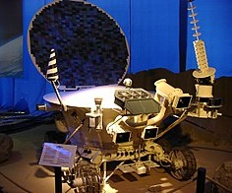
Figure 1: Lunokhod Mission Rover [18]

2.1.1.2 NASA Discovery – Mars Pathfinder
NASA’s Discovery Program began operations in 1996, comprising of 12 missions [19], consisting of telescopes, probes and spacecraft. The Mars Pathfinder mission was launched on 4th December 1996, to investigate the Martian atmosphere, surface metrology, atmospheric conditions and geology. The rover was the first to explore Mars, which is also known as the Red Planet, landing on 4th July 1997, with its final transmission on 27th September 1997 [20]. The rover managed to capture over 16,500 images and take 8.5 million measurements of atmospheric pressure, temperature, and wind speed. The rover performed chemical analyses at sixteen different locations. This mission allowed for the Spirit, Opportunity and Curiosity rovers to occur [21].
The micro-rover, named Sojourner, had six wheels and a rocker-bogie suspension system, which did not have springs. Instead, the series of joints rotated and conformed to the contours of the ground, increasing its stability over uneven surfaces. The rover could withstand a tilt of 45° using three motion sensors to detect excessive tilt [15, p. 3]. The rover was controlled via an onboard supercomputer, performing commands sent by an Earth based team via an uplink [22].
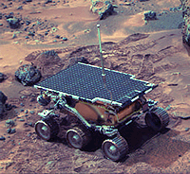
Figure 2: Mars Pathfinder Rover [23]

2.1.1.3 NASA Mars Exploration – Spirit & Opportunity
NASA’s Mars Exploration Rover project is composed of Spirit and Opportunity to perform a series of experiments to explore the following main science goals:
- Determine whether life ever existed on Mars
- Determine the climate and geology of Mars
- Prepare for human exploration [24]
Spirit was launched on 10th June 2003, and landed on the 4th January 2004. Opportunity followed on 7th July 2003 after some minor repair issues, and landed on the 25th January 2004 [25]. The rovers had six independent wheels, with their own individual motor, and had a similar rocker-bogie suspension system as was seen on the Pathfinder rover [15, pp. 3–4]. The rovers had rock abrasion tools for removing the surfaces of rocks to allow for the analysis of the inner layers. Additionally, they had five scientific instruments, which included a panoramic camera, a miniature thermal emission spectrometer, a Moessbauer spectrometer, an alpha particle X-ray spectrometer, and a microscopic imager. They also included magnetic targets to capture dust samples for examination. The spectrometers, microscopic imager and abrasion tool were located on a turret at the end of a robotic arm [25]. The rovers were remote-control operated from Earth, and have sent back over 300,000 images [26]. Initially the commands were sent in advance, allowing for the onboard systems to navigate around dangers, however, due to recent issues with flash memory on Opportunity, operations are becoming more real-time, as less data can be stored [27].
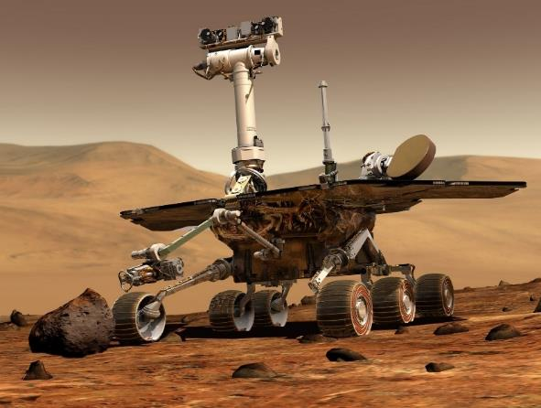
Figure 3: NASA Spirit & Opportunity Rover [28]

2.1.1.4 NASA Curiosity
The Curiosity mission was launched on 26th November 2011, and landed on Mars on the 5th August 2012, with the aim to identify if Mars has ever had the right environmental conditions for life. The data comes from rock, soil and air samples and analyses this data, such as the sample composition, onboard [29]. The mission lasted for approximately two years, although the rover is still in operation [30].
The rover design allows for a speed of 30m/hr, and includes a seven foot arm to move tools used in experiments [29], a geology lab, a laser, spectrometers and several cameras. Each of the six wheels [31] used the airless spring tire design that consisted of several hundred coiled steel wires woven into a flexible mesh. This gives the tires the ability to support heavy loads whilst conforming to the terrain [17]. These had their own individual steering motors, allowing for a full 360° turn, and incorporate a balancing mechanism to prevent overturning [31]. The ‘hand’ is located at the end of the arm, and it is used to grind stones to insert the sample inside its body to determine the composition, whilst the ‘head’ consists of seventeen cameras and a laser as to destroy any large rocks it may come across. The ‘tail’ has hazard avoidance cameras, which displays the ground view to help when reversing.
The rover sends and receives signals from Earth based teams, which contains instructions that have been tested on a simulator the day before, although on-board AI is used to automate certain processes [32]. The Curiosity rover is operated on the real-time operating system VxWorks, which was developed by Wind River. This system is responsible for the entry, descent and landing (EDL), in addition to mission-critical tasks, such as ground operations control, data collection and Mars-to-Earth communication relay that must be performed on a daily basis [33]. Every day, the rover receives its commands based on the previous day's images and data. If the instructions include a change of location, the planned route to this location has been designed using a simulator [34].
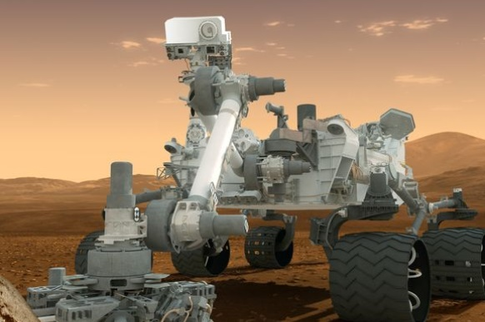
Figure 4: NASA Curiosity Rover [29]

2.1.1.5 China’s Jade Rabbit
China’s Chang’e-3 lunar mission included the Jade Rabbit (or Yutu, as it is known in China), which launched on 1st/2nd December 2013, from Xichang, South China. It landed on the volcanic plain known as Sinus Iridium (Bay of Rainbows), on 14th December 2013 to observe the Moon’s topography and geology construction, explore the components of its surface materials and resources, measure the physical characteristics of the lunar soil and crust, and scout potential valuable mineral resources. It ended in August 2016, after 972 days in operation on the moon, and sent high-resolution photos and scientific data back to Earth [35]–[38]. The rover consisted of six individually motored wheels, with a sub-rocker-bogie suspension, almost identical to NASA’s Mars Exploration rovers and Curiosity, and could withstand a 20 to 30° tilt. The rover had a mast, which contained the stereo and navigation cameras, whilst the robotic arm held part of the instrument payload [39]. The rover has an autonomous navigation system [40], using an onboard Delaunay algorithm, although commands were sent from Earth-based teams [41].
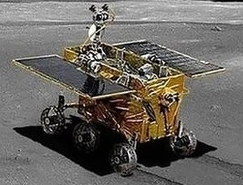
Figure 5: Jade Rabbit Rover Design [42]

2.1.1.6 NASA Discovery – InSight
The InSight (Interior exploration using Seismic Investigations, Geodesy and Heat Transport) mission is part of the Discovery program and is scheduled to launch in May 2018, with the aim of exploring Mars’ deep interior, tectonic activity and meteorite activity to understand the processes that formed the rocky planet more than four billion years ago and the natural phenomena on Earth. The terrestrial planet explorer will land on Mars six months after launch, with science operations lasting over two years [43].

2.1.1.7 ESA’s ExoMars Mission
The ExoMars mission is a collaboration between the European Space Agency and the Russian Roscosmos to explore Mars, searching for signs of life. In 2016, the ExoMars Trace Gas Orbiter was launched, which searches for evidence of methane, and other trace atmospheric gases. It will also aid with the landing location by collecting data on potential locations, and aid communications between the rover and the operations control centre whilst the rover is operational [44], [45]. The 2020 mission to land a rover and surface platform to explore the surface of Mars to search for signs of life, whether they are historical or current, by taking sub-surface and underground samples to analyse its physical and chemical properties for biomarkers, organic substances and signs of water. The rover is expected to land in 2021, and current tests show the rover is capable of managing 25cm tall obstacles (approximately 20% of its height), and a 26° slope with its autonomous onboard AI [45]–[47].
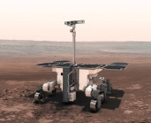
Figure 6: ESA’s ExoMars Rover [47]

2.2 Introduction to Artificial Intelligence
AI, or artificial intelligence, is defined as: “The ability to accurately define what is human intelligence, ‘inference, reasoning, learning from experience, planning, pattern recognition and epistemology’ [1], in such a way that it can be copied by a robot, ‘the science and engineering of making intelligent machines’”, by John McCarthy in 1956 [48]–[50].
In 1950, Alan Turing devised the Turing Test, or ‘Imitation Game’ as it is known, to determine a method of understanding whether a machine (or robot) can model artificial, or human-like intelligence, by posing the simple question, ‘Can machines think?’ [51], [52, pp. 2–3]. This method of determining this question has been scrutinised for its validity of consecutive tests by many academics such as Searle, with his ‘Chinese room argument’ in 1980, which concluded that: “the implemented programs are not by themselves constitutive of, nor sufficient for, minds. In short, strong artificial intelligence is false” [53]–[55].

2.2.1 Programming AI
To programme AI, the programmer must replicate the ability to perform operations on arbitrary objects (strings of bits) and symbols to represent rules for creating, relating or manipulating symbols. The ability to simulate human intelligence is constructed upon the symbolic computation to describe algorithms which have the capacity to process any type of information. This requires higher abstraction levels that is only possible with number processing programming languages, such as Fortran, MATLAB and R [56], [57].
Issues are predominantly domain specific, so heuristic strategies have been experimentally grown through rapid prototyping, as an explicit specification is only possible through interactive and incremental refinement. As ‘fuzzy programming’ (variables can have any value between 0 and 1) is naturally abundant, there are substantial benefits that are made in programming, providing the language reduces the number of technical constructions (such as low-level construction of new data types and manual allocation of memory), and changes towards a more declarative style, which is more advantageous through the use of high-level data structures (such as lists, trees and arrays), and operations (such as pattern matching). This improves symbolic computation on a more advanced abstract level than is possible with standard imperative languages, such as Fortran, Pascal or C [56], [57].
According to Glasgow and Browse [56], AI programming languages have four main properties:
“1. They are interpreted rather than compiler-based.
2. They do not rely on an underlying Von Neumann style of computation.
3. They are based in solid mathematical frameworks so that formal reasoning about the adequacy and correctness of programs may be accomplished.
4. They have friendly programming environments and good user interfaces.”
The requirements of symbolic computation and AI programming allowed for the creation of two new programming paradigms as alternatives to the imperative style. These are based on the mathematical protocols of recursive function theory and formal logic, and include functional programming styles, such as Lisp, and logical programming styles, such as Prolog [57].
According to an article by Wolf [58], some of the most common and greatest AI programming languages are: Python, Java, Lisp, Prolog, and C++, although many more are available, depending on the application and platform of the intended device or system.

2.2.2 AI in Web Applications
AI developments in web are aimed towards making processes easier, such as smart algorithms for online shopping recommendations based upon your search or purchase history. It is designed to run in the background and be fully integrated into the code, wherever possible, to increase functionality and reduce processing power. An example of this is Google Rackbrain, which updates Google’s search algorithm based upon learning new correlations between semantic phrases and successful results [59]. This is also true in speech recognition, where the application has to interpret the request into a query for processing, then output the results to the user, such as with Siri, Cortana and Assistant [60], and in adaptive sites, which can automatically improve their UI (user interface) by learning access patterns [61].

2.2.3 AI in Robotics
For robots to be accepted within everyday life, robots need to understand human behaviour at various levels of abstractions, time scales and in the context of human-robot interactions. The ability for robots to act in a useful, relevant, and socially acceptable manner, requires the ability to learn dynamically and incrementally learn to interpret and understand human behaviour, such as emotions, linguistics and body language. This ability to learn will be implemented using AI machine learning techniques, such as algorithms, to learn the social and physical techniques needed to perform social interactions with humans, and for humans to learn skills from the robots, such as understanding a wider range of behaviours, such as language formation, developmental cognitive and social disorders [62], [63].
AI has a wide range of uses when used within robotics. An example of this is robots can be fitted with vision assistance and grippers to assist in daily tasks, such as opening the door, switches, and using objects for those with limited mobility. The user has a joystick which can be used to control the robot, as well as a screen for visual aid. AI is used in these types of robots for hazard perception, optimising operational/ response times and pathfinding measures for navigating around [64]. They can also be used for smart weapon systems, where automated object recognition algorithms are used to fire at short distance targets [65], or even in the production of fabrics and clothing, where algorithms and computer aided design (CAD) are used to move robotic arms [66].

2.2.4 AI in Space Exploration
AI is used in space exploration in several ways. MAPGEN (Mixed Initiative Activity Plan Generator) is used to automatically generate plans to schedule experiments based upon the resources available. A closed-loop AI-based system, known as a remote agent, is incorporated to accomplish this. This reduces the required number of mission control staff, and achieve a higher scientific accuracy [67]. This software was tested on the Deep Space 1 mission, improving its maturity with every use. The remote agent experiment is a software experiment in the New Millennium Project that allows for increased autonomy, especially when there is increased uncertainty, by allowing the system to plan and execute more activities on the spacecraft, with guidance from the ground controllers on Earth, including maintenance, navigation, and fault diagnosis and correction. This allows for faster processing as no communications delay would occur compared to sending the required data needed back to earth for processing, waiting for it to be processed, and sending the response back to the spacecraft. This is especially critical when the spacecraft is in a hazardous environment, such as near a comet. This also allows for reduced mission development and operations costs, so the savings can be used for other missions, such as the exploration of the oceans of Europa, and analysing the terrain and atmosphere of Venus [68], [69].
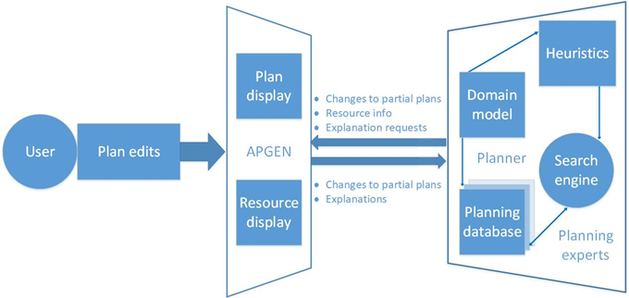
Figure 7: MAPGEN's System Architecture [67]
Steve Chien and Kiri Wagstaff of NASA’s Jet Propulsion Laboratory predicts that in the future, AI will govern the exploration possibilities due to three main reasons [70], [71]:
- The rovers/ craft may fall out of communications range, so will need to determine when and how they come back based on the data received, and if the data is to be documented.
- The rovers/ craft will explore unknown (or little known) areas of space, so will have to be able to adapt to environmental factors, such as unforeseen asteroids, temperatures, or changes to gravity.
- The time it takes to travel to distant regions are huge, therefore AI will be required to intervene as there may be several staff changes before data returns.
In the future, AI will be used to collect, interpret and retrieve data from the probe, spacecraft or rover, to Earth, allowing the possibility to explore space further by collecting better and more useful data. This is important as without AI, humans will not be able to explore these areas, and therefore these missions may never occur [70], [71]. AI will also be used on the Europa Clipper mission, which is expected to perform multiple flybys of an icy moon of Jupiter. This extremely high radiation environment is expected to reset or crash its computer several times in a single flyby, so the AI computer system is expected to diagnose and fix computer issues before the engineers on Earth are aware it happened [72].
The challenges in the proposed system are hazard awareness and rover navigation. The AI will need to identify any hazards, such as an obstacle or changes in altitude, and safely navigate around them to avoid damage to the rover.

2.2.5 AI in Rovers
The aim for AI in rovers is to allow the rovers and space station astronauts to work alongside each other as much as possible. The rovers could be used to conduct surveys, which could then allow for astronauts to go as directly as possible to the most interesting sites to gather more information [72]. AI has been used since the Spirit and Opportunity missions, where it was used as a navigation system to explore Mars, called Autonav [70], [71]. It was uploaded in 2009 on Opportunity, with the aim of providing a good test of some autonomy that could be used on future missions [73]. Autonomous Exploration for Gathering Increased Science (AEGIS) was uploaded on Opportunity in 2010 to increase autonomy when it encounters minor communication issues [74]–[76].
Curiosity was uploaded with the improved version of the AEGIS software in late 2015, to increase autonomy during the long periods of time that communication is impossible with Earth, or when there are delays in sharing data with scientists. Although it does not dictate general operations, the software is used to pick its own targets from up to 7m away, using Navcam, which can be captured as images to be analysed, and if necessary, fired by the laser to determine the chemical composition by ChemCam [74]–[76]. It allows for greater accuracy for identifying and firing at the rocks with the laser, which would be extremely difficult for humans [77]. Since May 2017, the software has been used to select and photograph interesting aspects of Mars [70], [71]. The software has increased the pace of ChemCam activities by 10%, saving time, power, and resources which can be used elsewhere [78, p. 1]. In March 2017, a new algorithm was uploaded to the rover, which adjusts the speed of the wheels based upon the rocks it is climbing. This software, known as traction control, uses real-time data to improve the longevity of Curiosity’s wheels, by preventing wheels from slipping when climbing [79], [80].
The Jade Rabbit rover uses an onboard Delaunay algorithm which analyses images obtained from the navigation and hazard avoidance cameras in real-time, using a stereo imagery tool. The Delaunay algorithm allows the system software to construct a 3D mesh using triangular points that are identified within an image [81, pp. 1–3]. The rover uses this algorithm to identify obstacles to decide the best course of action to get to the destination, using its onboard sensors and determining its relative position using real-time imagery. It received most of its instructions from the ground (as there was a 2.5 second delay), which allowed for near real-time operations with the rover [39].
The InSight mission will include cameras and software almost identical to the Navcam and Hazcam cameras that were included with the Mars rovers Spirit and Opportunity. Navcam is located on the arm to capture images of the instruments on the landers deck, in addition to providing a 3D view of the ground to help determine the position of where the seismometer and heat low probe will be located. The Hazcam camera is located under the edge of the lander’s deck and provides a view of the instrument deployment area [65].
NASA’s Mars 2020 rover is expected to launch for Mars in 2020, with an improved version of AEGIS, due to changes with its onboard instruments that allow for smarter targeting and obtaining relevant research on objects. It is expected that it will be able to change its schedule if it finishes tasks ahead of time, allowing for more data to be collected. The next version of ChemCam, called SuperCam, with a remote RAMAN spectrometer will be used on this rover to identify sample composition [34], [72].
The system in this project will collect and return data to the operator. This can include images of hazards in its path, or of anything interesting it encounters. The system could include features of the Delaunay algorithm, which was used on the Jade Rabbit to analyse the data to be sent back to the user for further analysis.

2.3 Web 2.0 Control of Robots & Communications
Web 2.0 is an interactive and responsive web, which is achieved by allowing websites to communicate with the browser unknowingly and without human interaction. One of the ways this is achieved is AJAX, which stands for Asynchronous JavaScript and XML, which allows for easy to use websites, such as social media, news sites and wikis, that require increased human interaction [82].
Web 2.0 can also be used for robotics. The robot would have a micro-server or chip that allows for communications (via the internet) to the main server to execute commands. For example, in a warehouse, a robot would have a chip that is connected to the main server, and the database. When an order arrives, it is stored on the database. This information is processed into a series of commands (such as location and product information), which is sent to the robot via the web. The robot could collect the items for shipping, then sends a response to the main server that the order is complete. The server could then update the order status and update stock records [83].

2.4 Web Services
There are many different definitions for web services. According to Java [84, p. 363], web services are: “client and server applications that communicate over the World Wide Web’s (WWW) HyperText Transfer Protocol (HTTP)” by providing a standard method of interoperating between software which run on different platforms and frameworks [84, p. 363], [85]. They are interfaces which describes a series of operations that are accessible over a network to perform tasks [86].
Web Services Description Language (WSDL) is an XML based language used for describing web services, including message formats, which details its operations, transport protocols, and its location. Simple Object Access Protocol (SOAP) is an XML based protocol used for accessing web services by transferring the data [86]–[88]. Web services have a machine-processable formatted interface (usually WSDL), with other systems interacting with the service using SOAP messages (usually HTTP with XML serialisation) [89, Ch. 1.4]. A simple example is as follows:
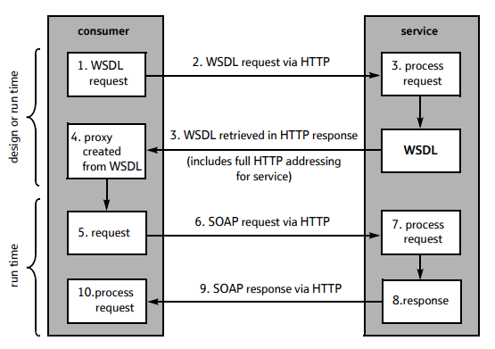
Figure 8: A Simple Web Service Operation [85]
The architecture for a secure and reliable web service operation is as follows:
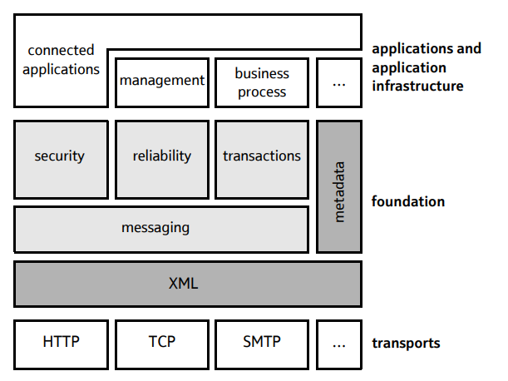
Figure 9: Web Services Architecture For Secure, Reliable Transactions [85]

2.5 Integrated Development Environments
An integrated development environment (or IDE) is an application that expedites the development of applications by supporting the use of single or multiple languages. Typically, these are graphical user interface (GUI), which have all the tools in an integrated environment for application development. Commonly, these tools include debugging, version control and data structure browsing to maximise productivity, by reducing the need for switching between applications [90]. These can be desktop or cloud based, and include Eclipse [91], NetBeans [92] and Visual Studio [93], [94]. These often have add-ons or plug-ins for added functionality and use.

2.6 Lego Mindstorms EV3
Lego Mindstorms EV3 is a robotics kit that allows for the building and programming of a Lego robot. There are seventeen example EV3 robots which can be made from the core set, with an expansion box for larger projects. The programmable brick allows for the required connections to the motors, or one of the sensors, including colour, touch, infrared, gyroscopic and accelerometer [95]. The TRACK3R robot is the closest to the current rover designs; this will be considered for the design phase of this project.
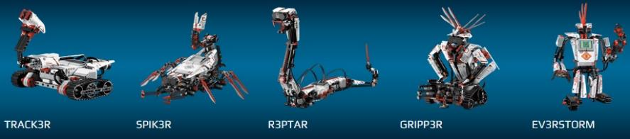
Figure 10: Lego Mindstorms Robot Examples [96]

2.6.1 Programming Lego Mindstorms EV3
Programming Lego Mindstorms can be completed through a wide range of options, including the use of the GUI, where the user interface allows for the drag-and-drop of the programming constructs, such as loops, and to perform tasks. This software can be downloaded through the Lego Mindstorms official website [96]. There is also the option to self-programme the hardware, using one of the compatible languages, such as Not Quite C (a variation of C), C/C++, Ada, Scheme and Java, all requiring the appropriate software, firmware and compilers. For example, the LeJOS software is an implementation of the Java Virtual Machine and includes firmware which replaces the original RIS firmware, and replaces them with many of the core Java classes, allowing for increased functionality, and ease of use [97].

2.7 Simulators
A simulator is a device (or software) that enables the operator (or user) to reproduce or represent something under test conditions, which may happen in real-life scenarios [98]. They are often used as training tools for high-risk scenarios, where it is impossible to replicate it, or if the actual equipment is expensive. These include flight, driving, modelling systems, training, manufacturing, medical purposes for surgery, and for entertainment purposes, such as gaming, TV, theme park rides and movies.
NASA has a range of simulators for different scenarios, such as FutureFlight Central to simulate air traffic control, the Vertical Motion Simulator for aircraft and spacecraft design [99] and the Mars rover simulator. The landing location for the Curiosity mission was decided as a result of simulations on four different sites, which determined that they were all safe to land, with the final decision on the landing site made by the scientists [100]. The landing was performed over 8,000 times on the simulator, with each stage of the landing process simulated, to ensure that the rover landed safely on Mars [101]. More recently, NASA are trying to understand ocean current behaviour with the use of high-resolution global ocean simulators on their Pleiades supercomputer [102].
Simulators can also be physical. For example, sandbox testing is used for rovers to simulate the physical terrain. There is a 90 square metre area in Noordwijk in the Netherlands, known as the Planetary Utilisation Testbed, which is used to test the European Space Agency’s ExoMars mission to Mars in 2018 [103]. Simulators and sandbox texting are used to test manoeuvres, and this strategy was used to devise a strategy to get Spirit out of a crater it was stuck in [104].

2.8 Conclusion
A robot is defined as: "a reprogrammable, multifunctional manipulator designed to move material, parts, tools or specialised devices through variable programmed motions for the performance of a variety of tasks". They are based on two enabling technologies: telemanipulators and numeric control. Lunar exploration rovers are designed for the exploration of nearby moons, asteroids and planets. There are many examples of these, and include the following: Russian Lunokhod, China's Jade Rabbit (or Yutu), and NASA's Mars Pathfinder, Spirit, Opportunity, Curiosity, and InSight.
AI is increasingly used within many sectors to automate processes, by allowing robots to act in a useful way, by having the ability to identify and solve issues, or to report it to those that can. Some of these sectors include: everyday use software, web applications (Web 2.0 onwards), in robotics, space explorations, weather and climate systems, and in rovers.

3.0 Research & Development Methodologies & Data Collection
This section of the report describes the research and development methodologies used during this project, and how the data for analysis will be collected.

3.1 Research Methodology
This project’s research methodology is adapted from Saunders research onion [105]. The research wall (Table 1), is adapted for applied computing projects:
Philosophy: | Positivism |  |  | Phenomenology
Approach: | Deductive |  |  | Inductive
Strategies: | Experiment | Software Development | Document Review |  | Case Study | Survey
Table 1: The Research Wall Adapted From the Research Onion [105]
Initially, a document review strategy is used, as it allows research to be conducted in to the existing knowledge and technologies currently in use. Also, it can be used to understand and achieve projects objectives. Additionally, it can help identify any pre-existing issues, and identifying strategies as to resolve them, should they occur. This strategy is both a positivist and a phenomenological philosophical approach.
However, predominantly, this project centres upon a positivism philosophy, and a deductive approach, since the main aim of this project is to develop a web application to simulate control of a Lego Mindstorms robot, therefore the project is categorised as a software development strategy. Many of the issues that can and will arise within the development of the application can be solved with additional research to determine if it is a common issue and how easy it is to solve.
A positivist deductive approach will allow the author to take the current theory, derive the hypothesis, and develop the application based upon observations made through the research conducted. The testing of the application, the survey results, and the analysis performed on the data will either confirm or reject the hypothesis. This project will have a null hypothesis, which describes the common view, and the alternative hypothesis, which describes the cause of a phenomenon according to the researcher. A null hypothesis should represent no statistical significance between the two variables, but is what the researcher/ experimenter tries to disprove/ discredit [106], [107]. This project has the following hypotheses:
H0: The use of AI has no effect on the number of collisions.
H1: The use of AI increases the number of collisions that occur.
H2: The use of AI decreases the number of collisions that occur.
The usability testing and analysis of the web application will follow a phenomenological philosophy, with an inductive approach, a survey will be conducted, using willing participants. The questionnaires will involve qualitative questions, examining the users views and opinions, allowing for comments and suggestions for improvements, such as glitches and bugs that can be easily fixed, or to provide extra information about the application. Quantitative data can be collected using categories, such as age ranges, number of issues with the software and numeric scales.

3.2 Development Methodology
A wide range of development methodologies are used within the software or application development industries. This project will utilise an agile method, which is a new approach with the aim of minimising risks through timeboxing elements, such as the planning, requirements analysis, design, coding, testing, and documentation to develop new functions by using the feature driven development (FDD) methodology. This allows the developer to design and build one feature at a time in an iterative approach [108], [109]. This approach permits easier application design, development and testing to ensure the application works, before additional features, such as increased levels of AI, are added in later timeboxes. Timeboxing supports the achievement of the success criteria because each timebox is designed around the project aims, objectives and success criteria, prioritising according to time constraints.
As this is a relatively small project, which must be delivered within a short time frame, each timebox will aim to last a week or two, allowing for time to design, build and test each feature, and time to test it within the larger application. This supports the handling of issues that arise, by using the available time to conduct further research and conduct additional testing, minimising the risk of failure, or future issues with integration of the next timebox [110].
Data will be collected for analysis by:
- Log files (if there are any) created by the system during testing for faults/ errors (debugging)
- Data from secondary sources to develop the system, with a possibility of benchmarking at a later stage
- Test data – questionnaires from testers about its usability and functionality. The questionnaire asks the participant to identify the number of hazards hit with and without the time lag, with the time lag and incorporated AI for operational data, the usability of the simulation, and the ease of navigating the robot.
The purpose of the questionnaire is to identify how easy it is to navigate the rover using the system around obstacles. The questionnaire is not generalisable as it was designed for testing this, or very similar, applications. Each question is carefully designed to achieve the desired aims and objectives of the project, whilst maximising the responses through both open and closed questions. This allows for analytical data to measure the success, as well as their thoughts and experiences on using the application, as participants encountered issues.
The questionnaire will be tested using colleagues and fellow students, although the end user of the project would be simulator operators who would use it to simulate a rovers’ day-to-day operations, or to simulate a scenario, such as trying to get a rover out of a crater. This method was used to get willing participants to test the application within the given time constraint. Additionally, as the required hardware is expensive, and the need for honest responses, there needs to be a level of trust, which is more acceptable with this test group.
The questionnaire was prototyped with several colleagues that are not able to test the application, however, were willing to scrutinise the questionnaire before implementation with the testers. This is a valid and reliable method for both prototyping and testing purposes, as it allows for the identification of issues, such as changes to be made to questions, as the testers have no information on the capabilities of the rover or application [111]. If this project was to become live, testing sample would also include rover operators for more valid results.

4.0 The Build Process

4.1 Timebox 1
Start date: 23/11/2017
Duration: 2 weeks
Completion date: 6/12/2017

4.1.1 Timebox Aims
- Design and test Lego Mindstorms EV3 robots
- Outline the system architecture
- Complete the system requirements

4.1.2 Lego Mindstorms Robot Initial Design
The design for the robot is an amalgamation of design features (as much as possible) of existing rovers, additional research undertaken, and the capabilities of the available Lego Mindstorms EV3 kits. Based upon the research undertaken, the common design for current rovers are:
- Wheels – six medium sized independently controlled wheels – rocker-boogie design
- Arm – moveable, contractible and compactable
- Solar powered design – charges onboard power supply
- Maximised surface area for solar panels
- Functional – less concern on appearance
- Tilt capabilities of at least 20°
The design process of the rover used for the project is an iterative process to develop the final design. The initial design was a basic rover design, which was built and tested, with notes made on its performance, and changes made. The rover and the code underwent sandbox testing, which allowed for the code to be independently evaluated, monitored, and tested by isolating sections. This allows the operational environment created to not affect the execution, operation or processes within the application [112].
The initial design is a basic EV3 rover design, which has been adapted from the TRACK3R robot, one of the basic Lego EV3 designs [113]. The robot was built using the online instructions, changes made when they were required, utilising ports B + C for the motor connections. It was tested using basic code written in Java to test its functionality. Testing involved using common household items, such as clothing and objects to represent obstacles, on a carpet to simulate the sand/ rough terrain. The design is shown below:
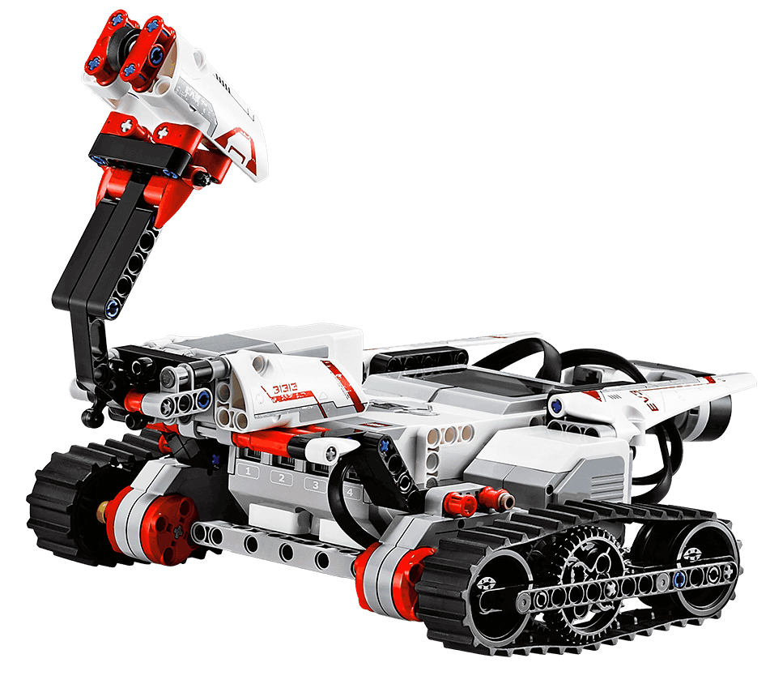
Figure 11: Initial TRACK3R Rover Design [113]
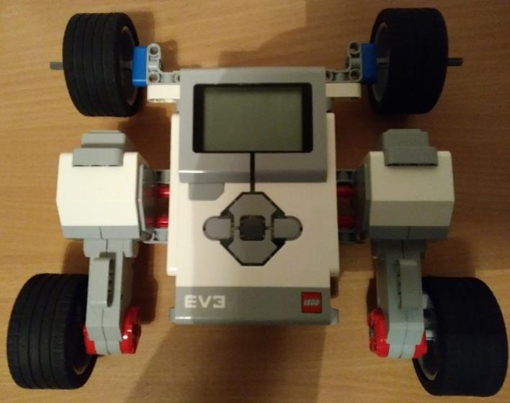
Figure 12: Adapted Initial Rover Design
This sandbox testing revealed that it would benefit more from a rocker-boogie design, so the design will be updated to provide this in a later timebox. The test code was written using LeJOS, an additional library for the Java programming language, and is below:
Test Description | Results | Recommendations
Move around without issues on a flat surface | Passed with ease | None
Navigate successfully over an obstacle 2cm high | Passed, though front wheels fell off after several runs | More security is required within the design
Navigate successfully over an obstacle 5cm high | Failed | Power is needed to all four wheels
Table 2: Initial Rover Design Testing Schedule

4.1.3 System Architecture
The system architecture diagram graphically models the system applications, and the externals they interface with [114]. The system architecture for this project is as follows:
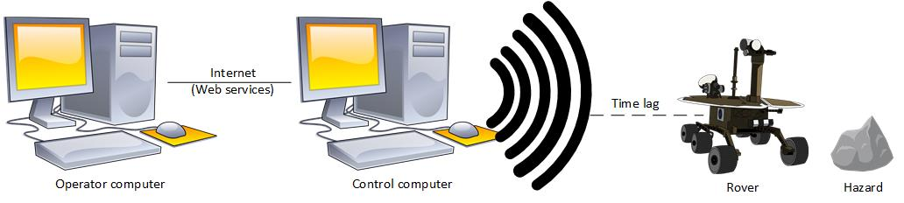
Figure 13: The System Architecture Diagram
This diagram displays the internet connection between the operator and control computers, the wireless connection between the control computer and the rover, and the time lag that it results in. This shows that the safety critical operations, such as what the rover should do when it identifies a hazard, should be completed by the rover to maximise efficiency within the mission by reducing the time lag when possible. This architecture is required as this models a remote-controlled device, which could be accessed from anywhere in the world, and not just next to the rover.

4.1.4 System Requirements Analysis
Software requirements are split into functional and non-functional requirements, and they are prioritised according to the MoSCoW criteria. According to Sommerville [115, p. 105], functional requirements are: “statements of services the system should provide, how the system should react to particular inputs, and how the system should behave in particular situations”, and non-functional requirements are: “constraints on the services or functions offered by the system”.

4.1.4.1 Functional Requirements
Must:
- The rover must accept controls from web interface and perform any commands received
- The control computer must connect to the rover
- The operator computer must connect to the control computer
- Must move forwards and backwards under pilot/ driver/ operational control
- Turn left and right under pilot/ driver/ operational control
- Move forward automatically
- Turn left and right automatically
- Detect obstacles using ultrasound sensors
Should:
- Include artificial intelligence aspects to simulate a communications delay
- Integrate AI pathfinding techniques to prevent collision or damage to the robot
- Have an easy to use user interface (UI) that does not require training
Could:
- Have a realistic viewpoint of its surroundings
- Integrate advanced AI pathfinding techniques to avoid potential instability
Will not:
- Will not allow control of multiple rovers at once

4.1.4.2 Non-functional Requirements
For this system, the non-functional requirements are:
Must:
- Commands/ system must not exceed the memory of the EV3 block (16 MB Flash Memory, 64 MB RAM)
- Be a web-based simulator for Lego Mindstorms EV3
- Be thoroughly tested and have a 70% pass rate.
Should:
- The system should be user friendly
- Have an 80% pass rate during testing
- Be a realistic simulation of real-life scenarios

4.1.4.3 Hardware Requirements
The hardware requirements for this system are:
- The rover must move effectively in sand
- The rover must be able to move around or over hazards, depending on instructions from the software
- The rover must not fall apart whilst in operation
- Must be connected to a Lego Mindstorms EV3 block and sensors (including ultrasound)

4.1.5 Evaluation
Within the desired timeframe, the system architecture diagram and system requirements are completed, and the initial Lego rover design was built and tested. The system architecture diagram had to be redrawn several times to achieve the desired result, and the system requirements took longer than expected, thus only the initial rover design was built and tested. This feature will be included in the next timebox, with the aim of completing it.

4.1.6 Aims Completed
- Outlined the system architecture
- Completed the system requirements
- Initial rover design and testing is completed

4.2 Timebox 2
Start date: 7/12/2017
Duration: 5 weeks
Completion date: 10/01/2018

4.2.1 Timebox Aims
- Finalise Lego Mindstorms rover design
- Start web services and communication design between the operation and control PC’s and the control PC to the rover

4.2.2 Lego Mindstorms Robot Design 2 – Rocker-Boogie Design
This rover was an adaptation of the existing rover design. The main section of the rover was extended to accommodate the additional two motors to allow the four wheels to be independently connected to the motors, as it is based upon a rocker-boogie EV3 design. This allows for individual adjustments to be made by the rover’s code, which can reduce the chance of the rover overturning. The design can be seen below, with its inspiration from the following references [116]–[119]:
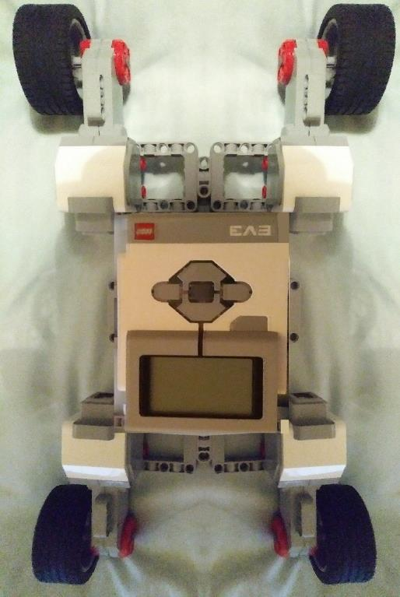
Figure 14: Rocker-boogie Lego Mindstorms EV3 Rover Design
It was built and tested using the rover sandbox testing method, using code adapted from testing the initial design, with the addition of the two additional motors and the code required to operate them. This followed the same testing conditions as the initial design, and was conducted indoors due to inclement weather, using items of clothing to represent rocks, and carpet to simulate the sandy terrain of a planet/ moon’s surface. Ideally, this would be conducted on a beach, using rocks for a more authentic testing environment, but inclement weather prevented this from occurring. The testing schedule can be seen below:
Test Description | Results | Recommendations
Move around without issues on a flat surface | Passed with ease | None
Navigate successfully over an obstacle 2cm high | Passed with ease | None
Navigate successfully over an obstacle 5cm high | Passed but struggled slightly at 75% power | Just increase the power when going over larger objects, or larger wheels
Table 3: Rocker-boogie Rover Design Testing Schedule
This is the final design of the Lego Mindstorms EV3 rover for use on this project. The sensors will be added at a later stage once the code has commenced, and the sensors have been decided upon.

4.2.3 Web Application
The web application will be created using the Java programming language, using leJOS EV3 as the firmware [120] and Eclipse Java IDE [92] as the IDE. The hardware used is the Lego Mindstorms EV3 robots, whilst its accompanying software (downloaded from the website [96]) will provide the necessary drivers to operate the robots. The aim is to replicate the Lunokhod project as a simulation, incorporating AI into the rover code. The code will be version controlled using Bitbucket (Git) to demonstrate the progression throughout the timeboxes.

4.2.4 Web Services
The web services will be built using the Java API for XML Web Services (JAX-WS), a combination of Java and XML. It is a categorised as a ‘big’ web service, which allows for the flexibility needed to build the application quickly within the short time frame. JAX-WS hides the complexity of SOAP messages, with the server-side methods and classes written in Java, with the client running a proxy, with a series of methods to interpret it. This will be coded using the latest version of the NetBeans IDE as it aids the build, compilation (package) and running of the web service [121]. The image below shows how the JAX-WS communication works:
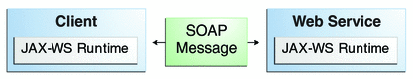
Figure 15: JAX-WS Communication Diagram [121]
Below is the setting up of the Web service in NetBeans 8.2, using the web services option:
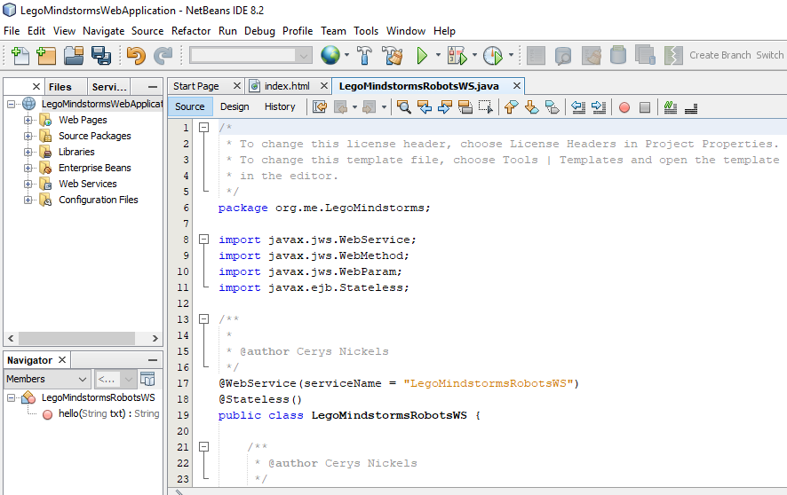
Figure 16: Setting up the Web Service in NetBeans 8.2

4.2.5 Evaluation
Within the desired timeframe, the Lego Mindstorms rover design was finalised and tested. Additional research was conducted upon web services to gain a better understanding of how they operate, and to determine which type of web service was needed. This was more difficult than expected, with the development of the web services underway. Web services was difficult to set-up due to unfamiliarity with the IDE, especially the wide range of options and menus to navigate through. This caused the estimated time for set up to exceed expectations. Additional research was performed, which resulted in help guides to reduce the time required. The rover code should be completed first, to help with the web services side, such as variables and information sent between the rover and web services. This will be started in the next timebox, with the aim of completion within 2-3 weeks.

4.2.6 Aims Completed
- Finalised Lego Mindstorms rover design
- Finished the web services and communication design between the operation and control PC’s and the control PC to the rover
- Started the implementation of the web services

4.3 Timebox 3
Start date: 11/01/2018
Duration: 2 weeks
Completion date: 25/01/2018

4.3.1 Timebox Aims
- Complete the web services and communication implementation
- Complete the web application design
- Start the software design e.g. system sequence diagrams, class diagrams

4.3.2 Web Application Design
The web application user interface (UI) is what the user will see and interface with. The chosen design is simple and easy to use, with easy to identify information, such as the controls. Colour will be added at the end of the implementation stage, in addition to any new controls. This is shown below:
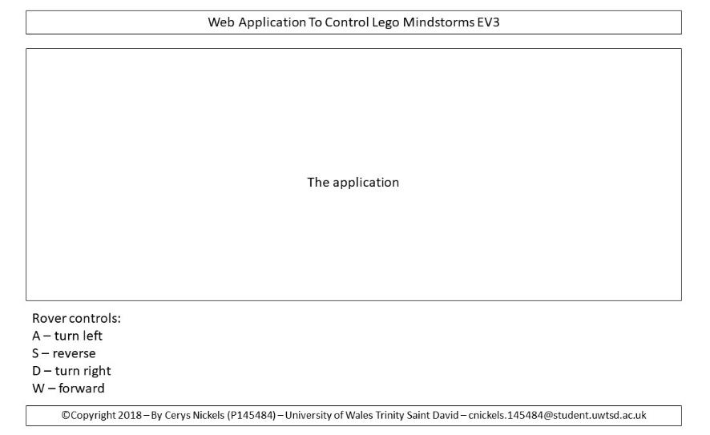
Figure 17: Web Application User Interface Design
This will be written in HTML5, using the template created as part of the web services application (in NetBeans 8.2). The styling is done on a separate CSS style sheet for improved code design. The boxes around each section will change height dimensions based upon the size of the contents. The HTML code can be seen below, with support from the following references [122], [123]:
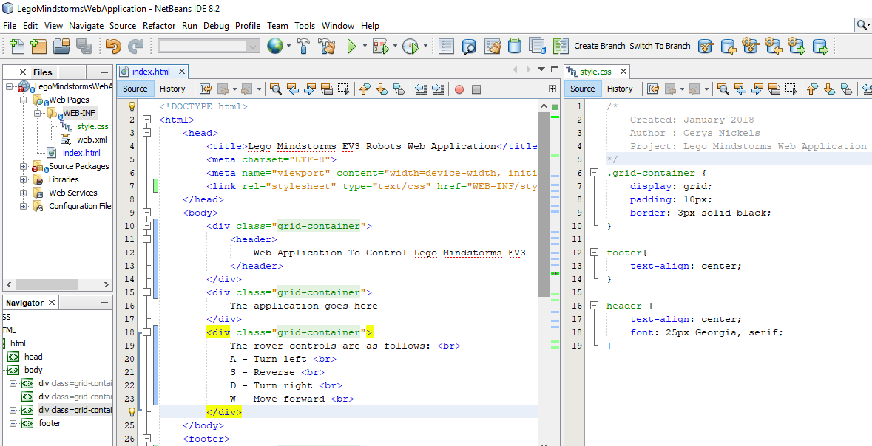
Figure 18: HTML & CSS to Implement User Interface
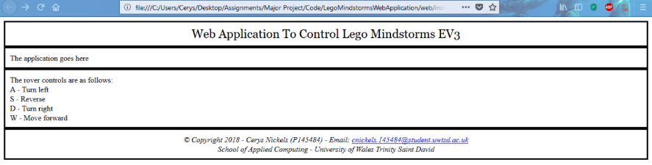
Figure 19: Web Application User Interface Implementation in Browser

4.3.3 Communications
The application communicates with the rover using Bluetooth connectivity, because of the short-range connectivity that is required. If a longer communication range is required, or there is guaranteed Wi-Fi connectivity, then Wi-Fi could be used, with the aid of a Wi-Fi adapter. Commands from the application are sent to the rover, whilst data gathered from the sensors attached to the rover are sent back to the operator for decision making and monitoring purposes. Research was conducted into the use of a camera on the rover to allow the operator to visually see the rovers’ surroundings. However, the materials to achieve this are not currently available, therefore video is not possible. Instead, there will be a visual representation, with a visual trail of its progress (distance travelled) and the feedback from the sensors will be displayed on the application. The delay will be handled within the web services and will be implemented within the communications between the operator and the rover in the code.

4.3.4 Application Development
No further progress can be made on the web services, due to the need to develop the application first, as to determine the information to be sent to the server. Therefore, this will be postponed to a later timebox, to be completed after the application, when the changes can be made to the web service.

3.4.5 System Sequence Diagram
A system sequence diagram shows the processes involved within a system or application. For this project, the diagram is shown below:
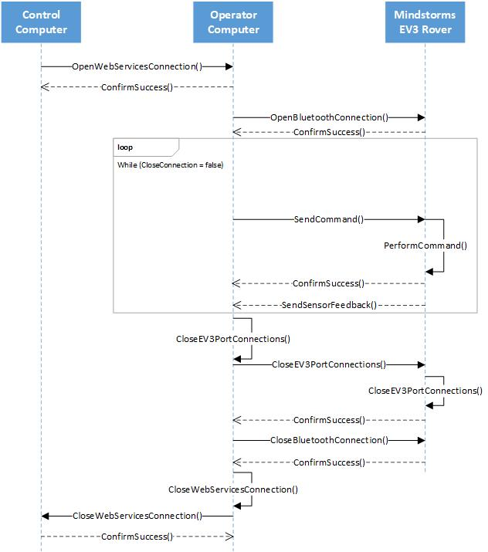
Figure 20: System Sequence Diagram

3.4.6 Application UML Class Diagram
The UML class diagram is a structural diagram which displays the classes within a system, the relationships between them, and the methods and attributes within them [115, Ch. 5.3], [124], [125]. Below is the initial UML class diagram, which will be improved with further research and implementation of this diagram over the next few timeboxes:
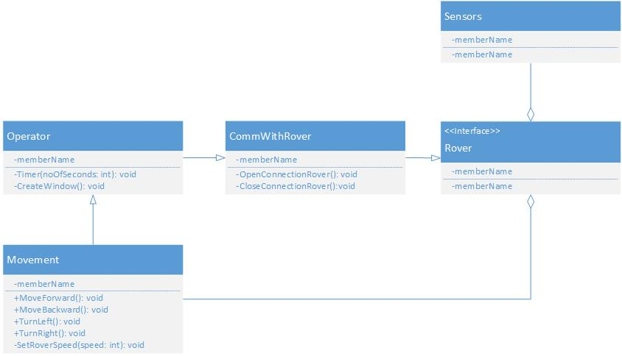
Figure 21: UML Class Diagram for Timebox 3

4.3.7 Evaluation
The web application design was completed within the desired timeframe. Colour schemes will be investigated in a later timebox, due to the need to focus upon the layout/ design within this timebox. Any additions, or changes, to this design will be documented. In addition, the design was implemented using HTML5, and the application will be added after its completion. In addition, communication methods have been decided after research was conducted as to how Bluetooth technology can be implemented between the operator PC and the rover. The system sequence diagram was completed, and the UML class diagram began.

4.3.8 Aims Completed
- Web application design finalised and coded in HTML5 (with the application added upon completion)
- Communication methods have been decided
- System sequence diagram and the initial UML class diagram is completed

4.4 Timebox 4
Start date: 26/01/2018
Duration: 2 weeks
Completion date: 09/02/2018

4.4.1 Timebox Aims
- Set up the rover implementation
- Complete the movement for the rover
- Implement the UML class diagrams

4.4.2 Application Development
Creating the project for the rover application required additional research, especially on how to use the IDE to create the correct project type and the commands to program the rover. A series of videos were found on YouTube by Fischer [126]–[129], which explains how to create the application project, and a collection of commands which can be used to program the robot. Sensor and feedback methods are achieved using methods within classes. These are individual to the sensor, with feedback sent to the operator via the application. The code for this will be implemented within the next few timeboxes.
The communications delay was implemented within the Java code as a timer function using threading. This is because the function must be implemented throughout the application to implement rover movement and the communications delay. The parameter was added for increased flexibility within the application. Threading was chosen as all tasks are executed using threads, and the simplicity, elegance and ease of implementing threads over other concurrent utility libraries. The Thread.sleep() method is conducted in milliseconds, hence the reason for the multiplication by 1000 to allow for seconds in the delay function.
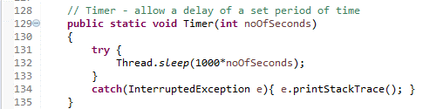
Figure 22: Timer Function in Java Code

4.4.3 Rover Movement
The rover has forwards, and backwards movement capabilities, in addition to turning capabilities. The movement functions incorporate the timer function, which can be seen below:
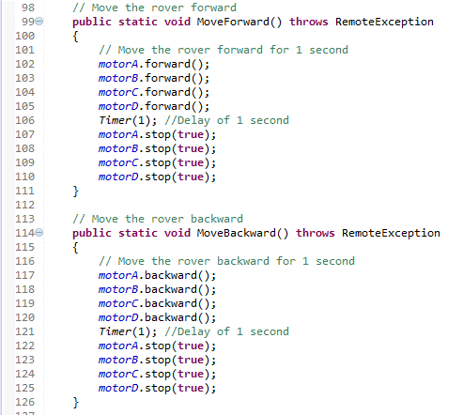
Figure 23: Forwards & Backwards Movement Java Code

4.4.4 Evaluation
The rover setup on Eclipse was initially difficult. The IDE caused issues in creating the workspace, and its associated files. The implementation became easier over time, as the commands became familiar with additional research into their implementation. The code was originally implemented serially, in the main, and was then moved into methods and classes for object-oriented programming later in the development stage.

4.4.5 Aims Completed
- The rover is successfully set-up
- The rover can move forwards and backwards, and turn left and right
- The application window is created, with a working button to disconnect the rover from the ports

4.5 Timebox 5
Start date: 10/02/2018
Duration: 2 weeks
Completion date: 24/02/2018

4.5.1 Timebox Aims
- Rover code implementation – movement and research the implementation of sensors
- Add in controls to operator-controlled movement
- Start implementing the Bluetooth connection
- New rover superstructure design to hold sensors

4.5.2 Web Application Development
The code was cleaned up, with a few changes and enhancements, especially to inform the operator of successful commands/ actions such as movement, through the addition of a JEditorPane, which allows for colour coded messages and text-based information. Enhancements included restructuring the code, so more of the error messages were handled by the buttons, and not within the methods themselves, where possible, thus minimising the code and enhancing readability. The web application now reads user input using the scanner utility [130], and the key pressed corresponds to a case on the switch statement [131]. The code is now fully object-orientated in design, with minor changes to the code structure to fix issues associated with this. There is very little support for Bluetooth connections with the EV3 regarding tutorials and guides. The LeJOS website has been down for the past several weeks and the offline documentation is insufficient. The first attempt used the LocalBTDevice and Bluetooth classes, which did not work. This could be looked at again if the next attempt fails.
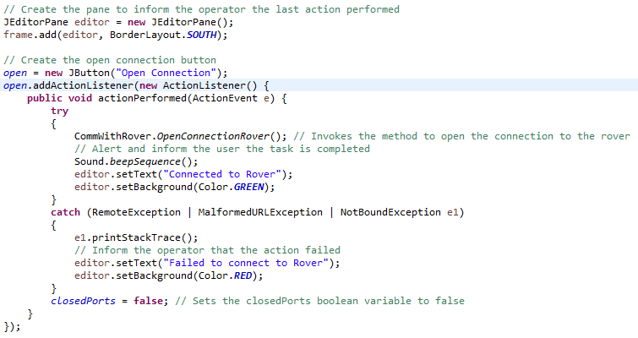
Figure 24: JEditorPane & Code Enhancements Implementation
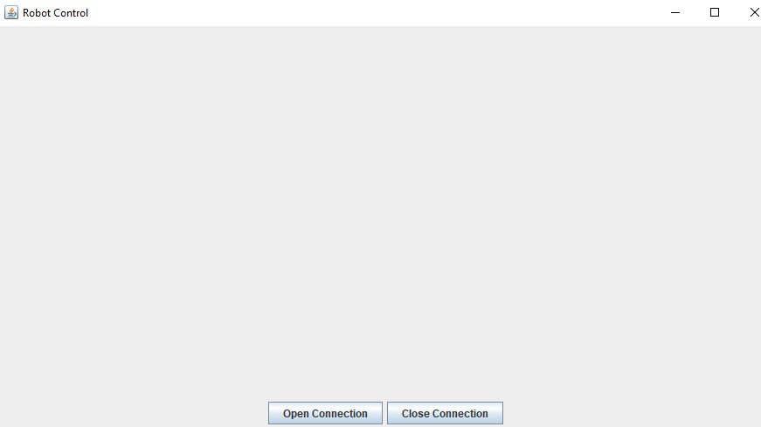
Figure 25: Implemented Application
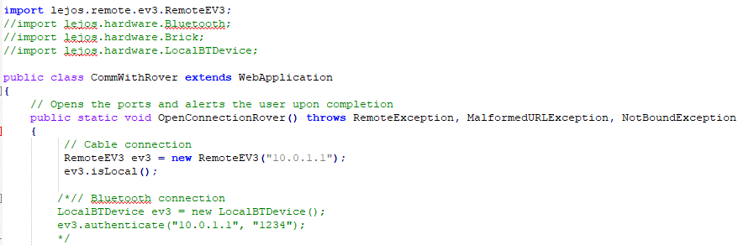
Figure 26: Bluetooth Connection First Attempt

4.5.3 Rover Code
A new file was created to separate the rover code from the application code. This is mainly due to slight changes in code design that are required for the rover implementation. Currently, there is a basic movement program, where the rover will turn to the right. This is due to the positioning of the sensors. This will be used as part of the AI implementation to turn the rover away from any hazards.
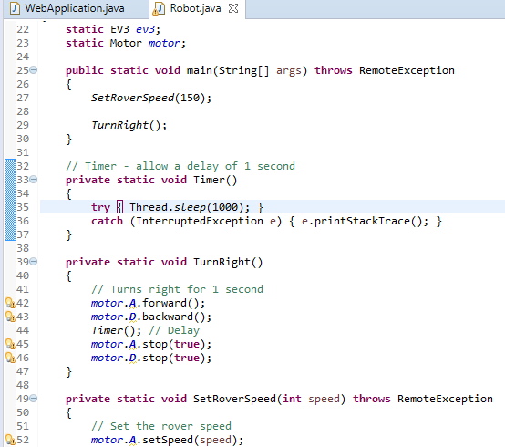
Figure 27: Basic Movement Rover Implementation Code

4.5.4 Rover Superstructure Design
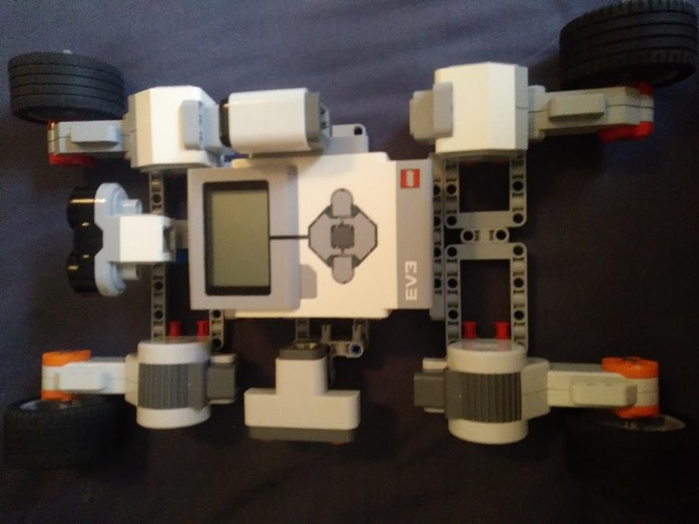
Figure 28: Rover Superstructure Design
This design is using the existing design and reinforcing it to accommodate the additional weight and positions for the sensors. The gyro sensor is directly attached to the brick, and the two ultrasound sensors are connected to the main structural frame.

4.5.5 Improved System Sequence Diagram
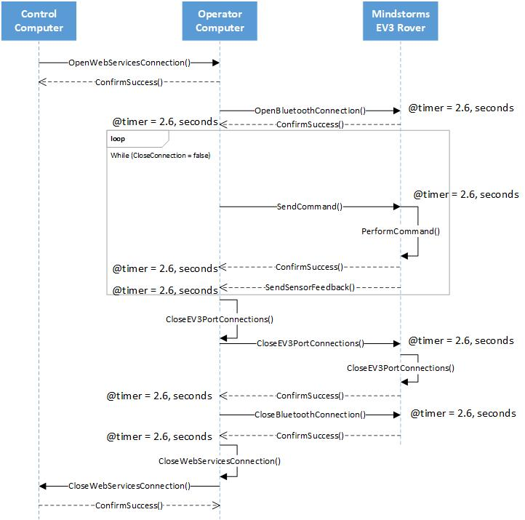
Figure 29: Timebox 5 System Sequence Diagram Using MARTE Features
This system sequence diagram has been improved using MARTE (Modeling and Analysis of Real-Time and Embedded systems), a real-time UML profile tool, which annotates existing UML models with the required information for analysis, especially for performance and schedulability [132, Ch. 1]. This diagram now includes the communication delays, although it could also be used to apply the timer method to other methods.

4.5.6 Improved Application Class Diagram
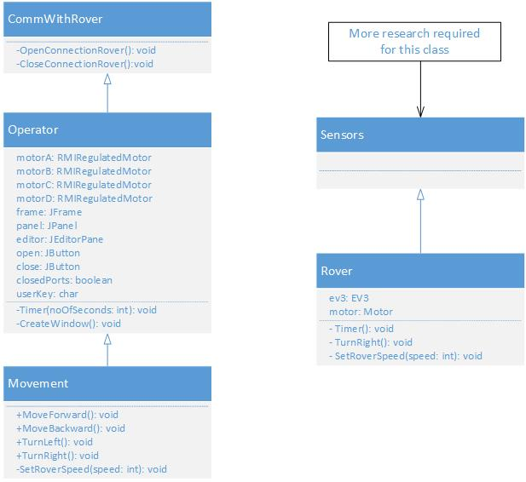
Figure 30: UML Class Diagram for Timebox 5
This is the improved UML class diagram from Timebox 3 based upon additional research and implementation. This was reworked prior to the sensor research, which will continue alongside the implementation in the next timebox. This has been significantly changed, with the implementation of two separate applications, one for the rover itself, which will feed data back to the application, and the second sending commands to the rover, although this is not clearly shown in this diagram.

4.5.7 Evaluation
There were minor issues with staging and committing with Git (Bitbucket), causing a minor inconvenience. This was resolved by creating a new repository in a different location and moving across the existing files. The Bluetooth connection has been extensively researched, with very little success. A new approach will be attempted using sockets in the next timebox, although this will require significant code changes regarding commands.
The class diagram was updated, although it was not scheduled into this timebox. This was necessary towards the end of this timebox to demonstrate the progression of the development through the last two timeboxes, and the code changes made.

4.5.8 Aims Completed
- Rover code implementation – movement is completed
- Added in controls to operator-controlled movement
- Improved the existing class and system sequence diagrams
- Updated the rover design to include the sensors

4.6 Timebox 6
Start date: 25/02/2018
Duration: 10 days
Completion date: 07/03/2018

4.6.1 Timebox Aims
- Rover code implementation – AI and sensors
- Bluetooth connection
- Improve the existing UML class diagram
- Export the application for deployment onto the website and the EV3 brick

4.6.2 Web Application & Rover Development
The second attempt to create the connection is through the use of sockets, which was aided by looking at the source code by Andrew Dillon [133]. This code was inefficient with multiple if statements, but the code worked. This is due to finding a tutorial which aims to solve the issue of connection issues, and because of their versatility. According to Oracle, sockets are: “endpoints of a two-way communication link between two programs running on the network” [134]. They are bound to a port layer and given an address, to allow the TCP layer to identify the location the data is sent to using signals [134], [135, Ch. 10.5.2]. To achieve the socket connections, the code had to be rewritten on both the rover and application to accommodate the sockets, with the movement of the rover being delegated to the rover. This was achieved through sending a number, which is the basis of the switch statement, an enhanced and more elegant solution to the series of if statements seen in Dillon’s code, which then calls a method, or a series of function calls accordingly. This reduces the number of instructions sent through sockets, which increases flexibility, as sections of the code can be used within the AI.
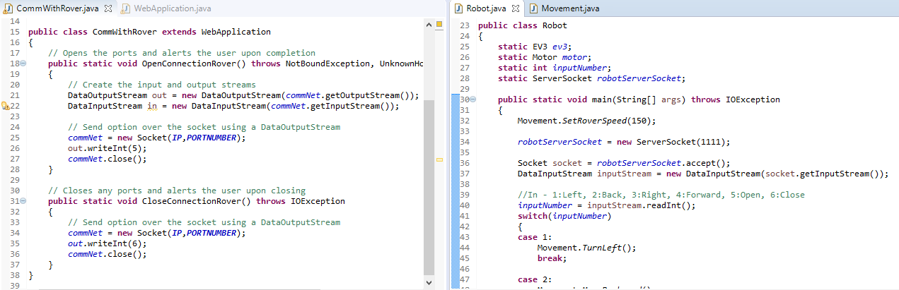
Figure 31: Socket Connection Attempt

4.6.3 Sensors Code
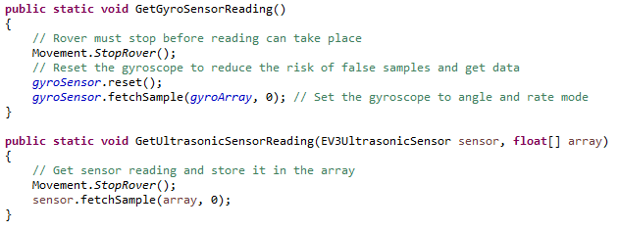
Figure 32: Sensor Method Code
The rover sensor code was adapted from [120], [136, Ch. 10] and required a significant amount of thinking and reworking to get the final result. Originally, the methods required the Sample Provider to be passed in for the ultrasonic, but later it was found that it was not needed if the code was redesigned. Additionally, an array was used to provide greater access to the data, and to allow it to be sent using the socket to the web application, to be displayed on the GUI using an additional JPanel [137]. The sensors are connected to the following ports:
- Left side ultrasonic sensor – port 1
- Front ultrasonic sensor – port 2
- Gyroscopic sensor – port 3

4.6.4 Rover AI
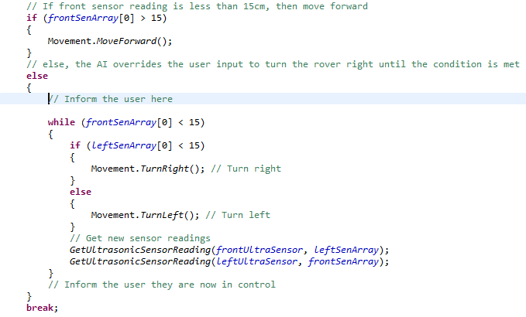
Figure 33: Rover AI Code
The AI element was simple to code, once the logic and planning was completed. This was conducted using comments, which were then coded into the program. The AI was only conducted on the option to move forward, as this is the most likely cause of collision. This could easily be modified for the addition of other options, if required.

4.6.5 Two Way Socket Connections & Final Changes
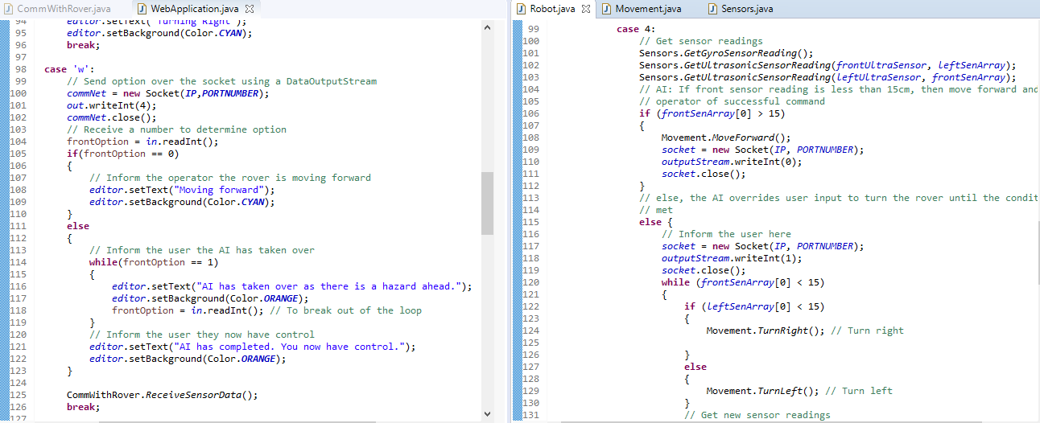
Figure 34: Socket Connections for AI Socket Transmissions
The final changes and socket connections were easy to implement because it utilised existing lines of code. This included an if…else… and while loops to achieve the required result. The final changes involved a loop within the robot class to allow for multiple commands to be received by the robot, more object orientation with the creation of the Sensors class and some minor code changes. There were also adjustments to the UI to allow for the sensor readings to be displayed correctly

4.6.6 Improved UML Class Diagram
Below is the improved UML class diagram, which has been enhanced by the use of MARTE and UML features, such as stereotypes [138]–[140]. The relationships, methods, classes and variables have been updated according to changes during implementation.
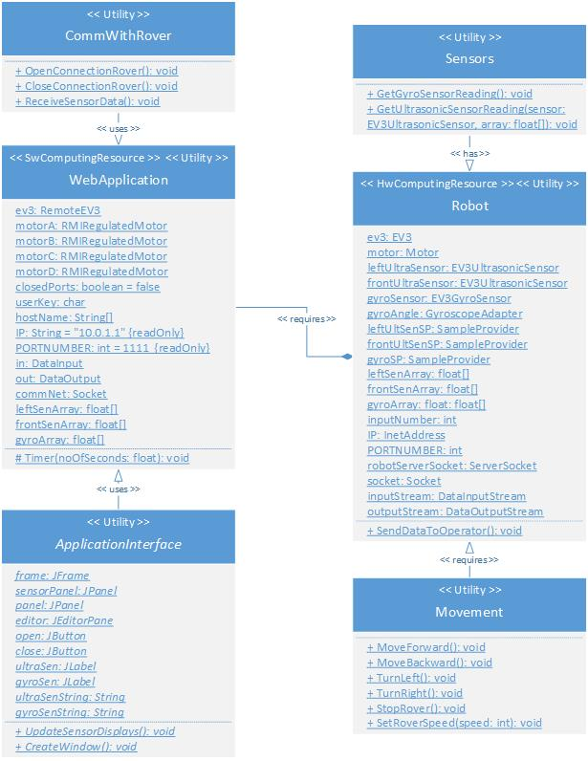
Figure 35: Timebox 6 Final UML Class Diagram Using MARTE Features

4.6.7 Testing & Deployment
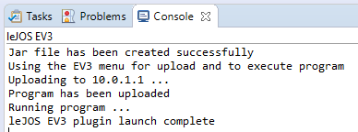
Figure 36: Creating the JAR Executable & Uploading to EV3 via USB
The major issue that occurred during this timebox was the USB connection between the robot and the laptop used for the implementation. This took several days to solve, requiring additional research and experimentation until it was solved. The method used to solve this involved following this tutorial [141], which was followed after reinstalling LeJOS on both devices, and provided instructions to manually install/ update the driver software. Each of the two units (user application and rover code) has been the subject of user testing following the test schedule below:
Test Description | Results | Recommendations
Successful connection to rover from application using Bluetooth | Fail | See below for connection issues
Rover can move forwards under user control | Fail | The Movement class works; however, it does not work under user control. This was further tested using a main method within the class (called unit testing), which was sent directly to the rover. This called each of these functions several times and were successful.
Rover can reverse under user control | Fail
Rover can turn left under user control | Fail
Rover can turn right under user control | Fail
Rover detects objects within specified distance | Fail – Incorrect sensor mode error message during runtime | Research an alternative method to get sensor readings.
User application receives sensor data | Fail – Incorrect sensor mode error message during runtime | Research an alternative method to get sensor readings.
User application receives feedback about success/ failure of commands | Failed | See below for connection issues
AI automatically takes control when sensor reading is within the designated zone | Passed | See above comment regarding movement for explanation.
Connect the motor and sensor ports from brick | Passed | These worked as far as the tester could tell. This was further tested within the main method as part of the additional testing of the movement code.
Disconnect motor and sensor ports from brick | Passed
Disconnected the brick from the application successfully | Failed | See below for connection issues
Table 4: Application Testing Schedule
After testing, some additional research was conducted from these sites: [142]–[145] to fix the errors found with the sensors. This resulted in the creation of separate classes for each of the sensors, each with their own method and structure. After these were re-tested, they have passed. During further testing regarding the connection, issues arose with ‘Request timed out’, ‘No route to host’, ‘Connection denied’ and ‘Failed to connect’, which can be traced back to the use of sockets. This was not resolved after several hours of individual research and attempts, which involved closing the firewall from the laptop, and disconnecting from all other networks, using a Windows 7 PC in case there are issues with either Windows 10, or other settings on the laptop. The developer spoke to several lecturers, the IT administrator and a network PhD student, and have concluded that the issue may lie with the server configuration settings. This is a networking issue that is not within the developer’s area of expertise and could not be solved within the time frame. This was exported onto the web application for deployment.
Deployment required some minor changes to the web application design. For example, providing the operator a set of instructions to correctly set up the application and connect it to the rover. This was an easy addition to make to the application, which will benefit the operators, and reduce the chance of connection issues if this application worked. This reduces the need to create a user guide, which may put off some users from using the site, and reduce the purpose of a simple site, which does not require training to use. Additionally, the application interface required changes as a JFrame is not suitable for the web. Therefore, a JApplet was used, and as this required inheritance, a subclass, called WebAppInt, was created inside of the newly created WebAppInterface class, which replaced the WebInterface class. The executable .jar file had to be digitally signed to upload to the site. The following script to access the application is below:
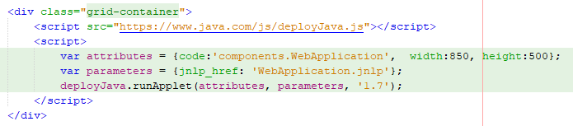
Figure 37: Deployment Script for Website [146]

4.6.8 Final Design
The final designs for the rover and web application are as follows:

4.6.8.1 Rover Design
Due to issues with stability during testing, the rover undertook a redesign, which reduced the length of the rover, thus reducing the need for additional structural support. It was kept to a similar design as the previous for simplicity.
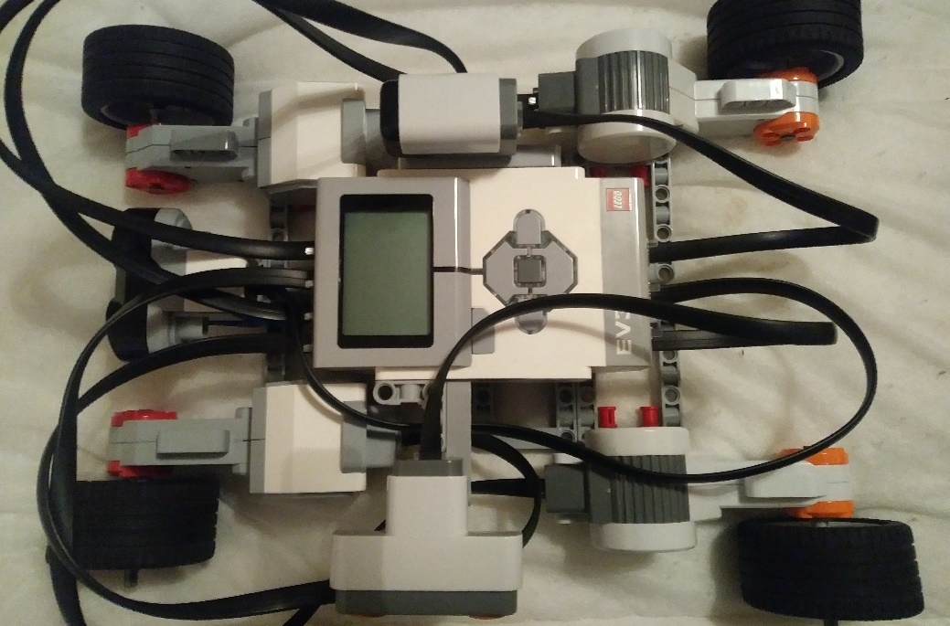
Figure 38: Final Robot with Sensors

4.6.8.2 Web Application
The completed web application is now located on the server and is included on the website that was created alongside the web services. This can be seen below, although the Java plugin is unsupported in Google Chrome, the application resembles Figure 25:
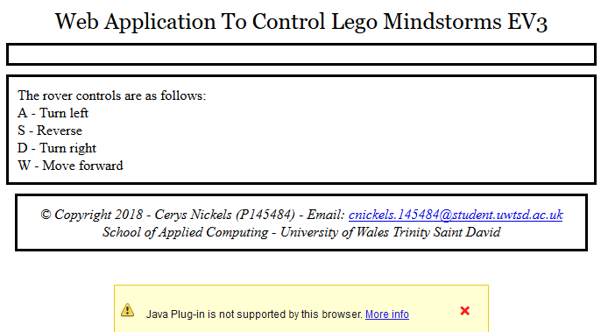
Figure 39: Final Web Application

4.6.8.2 Final UML Class Diagram
Below is the final UML class diagram for the application, which has been improved to fix resolvable issues and to reduce coupling, by ensuring that the data is within each class as much as possible:
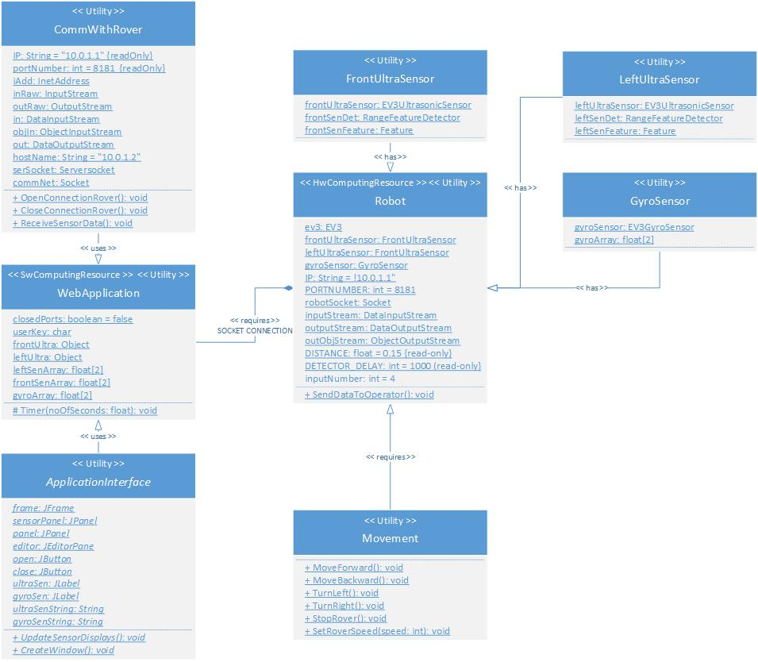
Figure 40: Final UML Class Diagram

4.6.9 Evaluation
The sockets are extremely tricky to implement because of the need to ensure the networking protocols are observed and the connections are not open for too long to avoid issues with receiving data at the other end. This allows for the transmission of data both ways. Sockets are good to use when working, however, it was decided that due to the almost constant stream of data, the ports would not open and close for each transmission of data, however, it would close once the close communication button is pressed. Although this utilises additional resources, the sockets are not constantly opening and closing, thus reducing problems. The network issue is still not resolved.
The sensor code was difficult to implement as there are several methods of implementation. The data collected will be sent to the operator, and utilised for the AI, which had to be taken into consideration, subsequently requiring the code to be rewritten several times. The data received was simple to display, using strings that will update when any new data is received from the rover. This required the additional panel to separate this from the movement feedback (the colour-coded display) and the buttons.
The major issue that occurred during this timebox was the connection between the robot and the laptop used for the implementation. This extended the timebox from its initial 2 weeks to 3 days before the deadline. This additional time was taken from the contingency time, from further testing and analysis, and the subsequent time for documentation and write-up.

4.6.10 Aims Completed
- All code has been completed, with no working connection – See testing for further explanation
- Final UML class diagrams
- Testing and deployment has been completed

5.0 Analysis

5.1 Data Analysis Introduction
The data collected will be analysed using statistics to prove or disprove the hypothesis. Quantitative data is categorised and analysed, using descriptive statistics, such as the mean average, allowing for the lower results to be identified and prioritised first for improvements. Qualitative data is also collected, and although this cannot be analysed in the same way, will be utilised for enhancing the user experience and to improve the application, such as unknown bugs/ issues that were missed during the software testing.
The null and alternative hypothesis for the testing are stated below:
H₀: The use of AI has no effect on the number of collisions.
H₁: The use of AI increases the number of collisions that occur.
H₂: The use of AI decreases the number of collisions that occur.
The independent variable is the use of AI and the dependent variable is the number of collisions.
Due to communication issues between the rover and the application, this cannot be analysed within this project. However, section 5.3.3 below will explain how this data would be analysed.

5.2 Questionnaire Design & Piloting
The finalised questionnaire consisted of 5 questions from the system usability scale (SUS), and 5 which are pertinent to the application. The SUS was created by John Brooke in 1986 as a valid method to evaluate the usability of a product or service using 10 questions, with the results on a scale of strongly agree to strongly disagree. The results are analysed using a Likert scale [147]. The questions involve both quantitative and qualitative questions, allowing the participants to write comments that can easily be interpreted for feedback, such as software/ hardware problems that could easily be fixed, or to provide additional information on their experiences. The questionnaire, which can be seen in Appendix 1, will be handed out to 10 people, who will test and answer these questions. The questions that were excluded from this questionnaire from the SUS are as follows:
- I found the various functions in this system were well integrated.
- I would imagine that most people would learn to use this system very quickly.
- I found the system very cumbersome to use.
- I felt very confident using the system.
- I needed to learn a lot of things before I could get going with this system [147].
These questions were not used in the questionnaire due to irrelevancy, such as question 1, where the two applications are connected, and question 2, where there are two buttons on the screen and four keyboard keys for navigation. Additionally, there was repetitiveness, by asking the same questions in a different manner, with the existing questions, such as questions 3 and 5. The questionnaire was designed to be as short as possible, also allowing for more qualitative data about their experiences, as this can often be more beneficial than quantitative data. The questions used from the SUS are the first five on the questionnaire, which are similar to the questions in the original proposal, which aims to assist with the objectives. Question 5 was reworded slightly to reduce its ambiguity, which was raised during the piloting of the questionnaire. The other five questions were designed to answer the functionality of the application, as well as their results and time taken to complete the course. This data is more valuable when solving issues with the application, as they identify the flaws that have been missed by the application testing, or when conducting data analysis.

5.3 Questionnaire Results & Analysis
The results of the questionnaire are split into the following three distinct sections:

5.3.1 Questions 1-5 (SUS Questions)
Participant | Strongly Agree | Agree | Neither | Disagree | Strongly Disagree
1 | 4 | 5 | 1
2 |  |  |  | 3 | 7
3 | 5 | 4 | 1
4 |  |  |  | 8 | 2
5 |  | 1 | 4 | 3 | 2
Table 5: SUS Questionnaire Data Results
Despite issues regarding the socket connection, ten people tested based upon the design and functionality of the application. These results are inputted into the above spreadsheet, and analysis performed on the collected data to calculate the mean for the first five questions. This can be used to calculate the SUS score and compare it to the success criteria for the application. These results are shown in the graph below:

Figure 41: SUS Question Analysis
The SUS score is 32.4 out of 50 (64.8%), which is not bad, considering the question that let this score down was the unreliability of the system, which can be traced to the current issues with the application.

5.3.2 Questions 6-11 (Software & Hardware Issues)
Question No. | Correctly/ Yes | Incorrectly/ No
6 | 20 | 5
7 | 1 | 9
8 | 10 | 0
9 | 8 | 2
Table 6: Software & Hardware Issues Data Results
Due to time constraints, the feedback received will be recommendations for future improvement, and can be seen in section 7.2. The following feedback was received from questions 8, 9, 10 and 11:
- Likes: Simplicity of the design with easy to use interface (buttons/ messages), instructions to set up are on the same page (no need to look for them further)
- Dislikes: More colour could enhance the overall design
- Hardware issues: More structural support needed, especially when navigating over obstacles
- Software issues: Connection issues (see sections 4.6.7 and 4.6.9 for more details)

5.3.3 Operational Data
If the application worked as expected, operational data would also be collected, including the number of hazards the rover identifies to calculate the mean avoidance rates. The time taken to complete the testing would also be recorded and analysed using a two sampled t-test as there are two samples of data (with and without the AI), and the expected result, known as the t-value, to be as low as possible for a statistically significant difference to exist, which would disprove the null hypothesis and accept the alternative hypothesis [148]–[151]. This value can easily be calculated using the data analysis tool in Microsoft Excel. The table below would be used to analyse the time taken to complete the course against the number of avoided hazards, using an alpha value of 0.05:
Participant | Time taken without AI | Time taken with AI | Hazards avoided without AI | Hazards avoided with AI
1
2
3
4
5
Table 7: Time and Hazards Results Table

6.0 Evaluation
This system partially meets the aim and the objectives set out at the start of the project. This is due to the rover not successfully connecting to the application, and the application not being successfully implemented on the web page due to browser incompatibility. However, the desktop version can be used as an alternative to the web browser version until the compatibility issues have been solved.
Limited data can be obtained from the questionnaire results, due to the connection issues between the application and the rover. The SUS score of 64.8% is a moderate but reasonably expected score, but would be considerably higher with a working application, and perhaps with the full ten questions from the scale, although the questions that were not on the questionnaire were unsuitable for this application. It can be deduced from this score that this application has a reasonable level of usability. The system has a simple design, but the use of carefully selected colour could improve the overall application design.
The rover design structure is almost indistinguishable to the rovers used by the space agencies as much as possible with the Lego Mindstorms kits. Its structural integrity partially backs up the research conducted by the space agencies into the integrity of rover designs. Space agencies use a single sheet (or several welded sheets) of metal to ensure the integrity of the rover, whilst the rover for the project uses several small plastic pieces, joined together using connector pieces. This is due to differences in available resources. The testing exhibited the structure of the design will need reinforcing with another layer beneath the brick.
If this project was redone, perhaps a Wi-Fi connection, rather than a Bluetooth connection would be easier to implement, and would not cause as many issues, due to having a larger knowledge base of how Wi-Fi operates over ports, compared to Bluetooth. This would require a USB Wi-Fi adapter for the rover. Additionally, more research would be conducted into Java web applications and the known compatibility issues associated with exporting them for the web. If this was not possible, research will be needed into an alternative language that is compatible with modern web browsers.

7.0 Conclusion & Recommendations

7.1 Conclusion
The aim of this project was to create a web-based simulator to train operators to control a Lego Mindstorms robot using a wireless communication network, whilst applying a realistic delay to the communications. These were used to create the success criteria, one of the first tasks during the build process.
The literature review focused upon robotics and artificial intelligence, and how they can interlink for use in a wide range of scenarios, from healthcare and domestic use, to space exploration, marketing and web applications. Additionally, research was conducted into web services, simulators, IDE’s and programming languages that are compatible for the web and Lego Mindstorms robots, resulting in the use of LeJOS and Java, and programming using the Eclipse IDE. This completes two of the objectives of the project.
The build process (design and implementation) was conducted using an agile methodology called feature driven development, using timeboxes to design and develop the application. The application does not connect to the rover, and the web application is not compatible with modern browsers. These must be fixed for a usable application, although the desktop application can be used as an alternative to the web application until this issue is fixed. This partially meets the aim, as it is not working as expected, and one of the objectives of the project, although another objective has been completed. The robot has been designed, built and tested to ensure it is stable to use alongside the application, thus fulfilling the last objective.
To expand this project, there could be dual connectivity, such as Wi-Fi and Bluetooth, which could be useful for connection within a different scenario, or if the operator does not have Bluetooth connectivity on their device, they are operating outside the maximum range (100m), or if the connection failed to work. This application could also be configured for a smartphone or tablet, resembling the desktop application that was initially created. These additional tasks would require additional research. Additionally, the recommendations in the next section can be done to improve the current project. This would benefit the operators (the end users) for this application as they can use it to test designs before they are finalised for manufacture. This would reduce costs and time taken to redesign the rover. This may allow for faster exploration of Europa, analysing the terrain and atmosphere of Venus, and other moons and planets.

7.2 Recommendations for Future Work
Due to time and knowledge constraints, the recommendations below have been prioritised using the MoSCoW criteria if the application was deployed for use by rover operators.
Must solve the connection issues (see sections 4.6.7 and 4.6.9 for more details) in the software need to be resolved. This would require additional research into network/ server configurations or get additional support from knowledgeable people which understand the necessary server configurations to ensure it is set-up correctly.
More structural support for the rover should be added for when it navigates slopes – This would require the robot to be redesigned to add additional structural elements or add an additional layer for reinforcing the frame which supports the brick. Additionally, research should be undertaken for an alternative to the script tag to reduce browser incompatibility within the web application. Although, a working desktop application can be used as an alternative.
More colour could be added on the website background to enhance the overall design. This should be a light colour, as part of the CSS style sheet, as to not impact the visibility of the text. A colour palette could be used to ensure text visibility is not impacted. Additionally, a visual representation of the results could be added to the application. This could be a map with the sensor readings being displayed as points. This would require GPS positions, or additional calculations and the use of geographical information system (GIS) software to map this data.

8.0 Reflection
A great amount of knowledge was accumulated whilst completing this project, enhancing the existing time management, research, report writing, planning and programming skills. The learning of Java was required to program the robot and web application, mainly to sockets, Bluetooth connectivity and data transmission. The three main issues encountered were the sensors, connectivity and the browser incompatibility with the application. The sensor issues were solved with a few hours of additional research, but connectivity and browser incompatibility issues will need further research. This is where the time management and planning skills were utilised more, and the initial planned contingency time came into use. This was an excellent idea and is a crucial part of time management and project planning, especially when unexpected issues may occur, such as with programming and hardware, especially when a new programming language must be learnt, or when the hardware is unfamiliar.
On reflection, if this project was done again, the author build process would be planned ahead of time, with each timebox focusing on a new aspect, whether it is a new rover design, rover movement, AI, or user input. The research could be more focused on the range of communication options, rather than setting up Bluetooth without conducting research on how it works. The developer would start with the connections between the rover and the application, and build the two applications from the working connection, by adding in the user input and movement. This is because the key aspect is the communication between the two devices, and neither would operate successfully without the other.

9.0 References
[1] R. Bogue, ‘The role of artificial intelligence in robotics’, Ind. Robot. Int. J., vol. 41, no. 2, pp. 119–123, 2014.
[2] Robotic Industries Association, ‘RIA - Robotics Online’, Robotic Industries Association. [Online]. Available: http://www.robotics.org/Beginners-Guide. [Accessed: 09-Mar-2017].
[3] R. R. Murphy, ‘Introduction to AI robotics’, BJU Int., vol. 108, no. May, pp. 257–291, 2000.
[4] T. Niemueller and S. Widyadharma, ‘Artificial Intelligence – An Introduction to Robotics’, Artif. Intell., pp. 1–14, 2003.
[5] D. G. Feitelson, ‘Asimov’s Laws of Robotics applied to software’, IEEE Softw., vol. 24, no. 4, p. 112, 2007.
[6] R. R. Murphy and D. D. Woods, ‘Beyond Asimov : The Three Laws of Responsible Robotics’, IEEE Intell. Syst., vol. 24, no. 4, pp. 14–20, 2009.
[7] S. L. Anderson, ‘Asimov’s “Three Laws of Robotics” and machine metaethics’, AI Soc., vol. 22, no. 4, pp. 477–493, 2008.
[8] U. Barthelmess and U. Furbach, ‘Do We Need Asimov’s Laws?’, Cornell University Library2, Ithaca, NY, Apr-2014.
[9] P. W. Singer, ‘Isaac Asimov’s Laws of Robotics Are Wrong’, Brookings, May-2009.
[10] M. Wells, ‘The Importance of Issac Asimov’s Three Laws of Robotics’, Michigan Tech, 1998. [Online]. Available: http://www.csl.mtu.edu/winter98/cs320/AI/pmwellsasimov.html. [Accessed: 24-Apr-2018].
[11] NASA, ‘NASA - Soviet Union Lunar Rovers’, NASA, 2015. [Online]. Available: https://www.nasa.gov/mission_pages/LRO/multimedia/lroimages/lroc-20100318.html. [Accessed: 03-Jun-2017].
[12] NASA, ‘Lunokhod 1’, NASA, 2017. [Online]. Available: https://nssdc.gsfc.nasa.gov/nmc/spacecraftDisplay.do?id=1970-095D. [Accessed: 03-Jun-2017].
[13] NASA, ‘Luna 17/Lunokhod 1’, NASA, 2017. [Online]. Available: https://nssdc.gsfc.nasa.gov/nmc/spacecraftDisplay.do?id=1970-095A. [Accessed: 03-Jun-2017].
[14] NASA, ‘Luna 21/Lunokhod 2’, NASA, 2017. [Online]. Available: https://nssdc.gsfc.nasa.gov/nmc/spacecraftDisplay.do?id=1973-001A. [Accessed: 03-Jun-2017].
[15] J. Zakrajsek et al., ‘Exploration Rover Concepts and Development Challenges’, in 1st Space Exploration Conference: Continuing the Voyage of Discovery, 2005, vol. 2525, no. March, pp. 1–23.
[16] C. Beatty, ‘Lunokhod’, Beatty Robotics, 2013. [Online]. Available: http://beatty-robotics.com/lunokhod/. [Accessed: 08-Nov-2017].
[17] N. Smith Kilkenny, ‘Reinventing the Wheel: NASA’, NASA, 2017. [Online]. Available: https://www.nasa.gov/specials/wheels/. [Accessed: 21-Nov-2017].
[18] Wikimedia, ‘Lunokhod 2 Model’, Wikimedia, 2016. [Online]. Available: https://upload.wikimedia.org/wikipedia/commons/0/0d/Lunokhod-2_model.jpg. [Accessed: 25-Oct-2017].
[19] NASA, ‘DISCOVERY ::: Missions’, NASA Discovery Program, 2017. [Online]. Available: https://discovery.msfc.nasa.gov/missions.cfml. [Accessed: 01-Jun-2017].
[20] NASA, ‘Mars Pathfinder’, NASA, 2017. [Online]. Available: https://discovery.msfc.nasa.gov/pathfinder.cfml. [Accessed: 01-Jun-2017].
[21] NASA, ‘Mars Pathfinder Overview | Planetary Missions Program Office’, NASA, 2017. [Online]. Available: https://planetarymissions.nasa.gov/missions/Mars Pathfinder/overview. [Accessed: 01-Nov-2017].
[22] B. K. Cooper, ‘MFEX: Microrover Flight Experiment’, NASA, 1997. [Online]. Available: https://mars.jpl.nasa.gov/MPF/roverctrlnav/rcw.html. [Accessed: 01-May-2018].
[23] NASA, ‘Mars Pathfinder Rover’, NASA, 2017. [Online]. Available: https://nssdc.gsfc.nasa.gov/nmc/spacecraftDisplay.do?id=MESURPR. [Accessed: 25-Oct-2017].
[24] N. J. P. Laboratory, ‘Mars Science Laboratory’, NASA. 2012.
[25] NASA JPL, ‘Mars Exploration Rover’, NASA Facts, 2004.
[26] K. Tate, ‘How NASA’s Mars Rovers Spirit and Opportunity Work (Infographic)’, Space.com, 2014. [Online]. Available: https://www.space.com/24394-mars-rovers-spirit-opportunity-explained-infographic.html. [Accessed: 09-Nov-2017].
[27] E. Howell, ‘Opportunity: Longest-Running Mars Rover’, Space, 2017. [Online]. Available: https://www.space.com/18289-opportunity-rover.html. [Accessed: 09-Nov-2017].
[28] J. Kinane, ‘NASA Mars Rover Spirit’, John Kinane, 2012. [Online]. Available: http://johnkinane-com.secure37.ezhostingserver.com/wp-content/uploads/2011/05/NASA_Mars_Rover_Spirit.jpg. [Accessed: 25-Oct-2017].
[29] NASA, ‘Curiosity Overview - Mars Science Laboratory’, NASA, 2017. [Online]. Available: https://mars.nasa.gov/msl/mission/overview/. [Accessed: 25-Oct-2017].
[30] NASA, ‘Curiosity Mission Updates - Mars Science Laboratory’, NASA, 2017. [Online]. Available: https://mars.nasa.gov/msl/mission/mars-rover-curiosity-mission-updates/. [Accessed: 02-Nov-2017].
[31] NASA, ‘Curiosity Rover - Mars Science Laboratory’, NASA, 2017. [Online]. Available: https://mars.nasa.gov/msl/mission/rover/. [Accessed: 02-Nov-2017].
[32] NASA, ‘Learn About Me: Curiosity’, NASA, 2017. [Online]. Available: https://mars.jpl.nasa.gov/msl/multimedia/interactives/learncuriosity/index-2.html. [Accessed: 08-Nov-2017].
[33] D. K. Taft, ‘NASA’s Curiosity Mars Rover Features Java-Based Simulator, Commercial Software Support - IT Infrastructure - News and Reviews - eWeek.com’, eWeek, 2012. [Online]. Available: http://www.eweek.com/networking/nasa-s-curiosity-mars-rover-features-java-based-simulator-commercial-software-support. [Accessed: 09-Nov-2017].
[34] A. Good, ‘Laser-targeting A.I. Yields More Mars Science’, Mars Exploration Program, 2017. [Online]. Available: https://mars.nasa.gov/news/laser-targeting-ai-yields-more-mars-science/. [Accessed: 12-Nov-2017].
[35] M. Park, ‘China’s moon rover Jade Rabbit is done - CNN.com’, CNN, 04-Aug-2016.
[36] BBC, ‘China’s Jade Rabbit Moon rover sends back first photos - BBC News’, BBC, 15-Dec-2013.
[37] P. Rincon, ‘China space: “Jade Rabbit” lunar mission blasts off - BBC News’, BBC, 01-Dec-2013.
[38] H. Liu, ‘An Overview of the Space Robotics Progress in China’, Proc. 12th Int. Symp. Artif. Intell. Robot. Autom. Sp. (i-SAIRAS 2014), 2014.
[39] Spaceflight, ‘Chang’e 3 – Mission Overview’, Spaceflight, 2017. [Online]. Available: http://spaceflight101.com/change/change-3/. [Accessed: 09-Nov-2017].
[40] A. France-Presse, ‘China showcases moon rover model before space launch’, South China Morning Post, Shanghai, China, 05-Nov-2013.
[41] Spaceflight101, ‘Chang’e 3 – Mission Overview’, Spaceflight101, 2018. [Online]. Available: http://spaceflight101.com/change/change-3/. [Accessed: 01-May-2018].
[42] Slade, ‘Jade Rabbit dead: Will China’s moon rover recover from technical problems?’, Slade, 2017. [Online]. Available: http://www.slate.com/content/dam/slate/articles/video/video/2014/01/jade_rabbit_dead_will_china_s_moon_rover_recover_from_technical_problems/78144477_3117965678001_TNC140128-yutu-1280.jpg.CROP.cq5dam_web_1280_1280_jpeg.jpg. [Accessed: 25-Oct-2017].
[43] NASA, ‘DISCOVERY ::: InSight’, NASA Discovery Program, 2017. [Online]. Available: https://discovery.msfc.nasa.gov/insight.cfml. [Accessed: 03-Jun-2017].
[44] European Space Agency, ‘ExoMars Trace Gas Orbiter and Schiaparelli Mission (2016)’, Robotic Exploration of Mars, 2017. [Online]. Available: http://exploration.esa.int/mars/46124-mission-overview/. [Accessed: 21-Apr-2018].
[45] BBC, ‘The Sky at Night - Mars: Red and Dead?’, BBC, 2018.
[46] European Space Agency, ‘ExoMars Rover’, Robotic Exploration of Mars, 2015. [Online]. Available: http://exploration.esa.int/mars/45084-exomars-rover/. [Accessed: 21-Apr-2018].
[47] European Space Agency, ‘ExoMars Mission (2020)’, Robotic Exploration of Mars, 2016. [Online]. Available: http://exploration.esa.int/mars/48088-mission-overview/. [Accessed: 21-Apr-2018].
[48] J. McCarthy, ‘PROGRAMS WITH COMMON SENSE’, in Teddington Conference on the Mechanization of Thought Processes, 1958.
[49] J. McCarthy, ‘Programs with common sense’, Proc. Symp. Mech. Thought Process., pp. 1–15, 1963.
[50] J. McCarthy, ‘The Inversion of Functions Defined by Turing Machines’, in Automata Studies, Annals of Mathematical Studies, Princeton, New Jersey: Princeton University Press, 1956, pp. 177–181.
[51] M. Alan, ‘Turing. Computing machinery and intelligence’, Mind, vol. 59, no. 236, pp. 433–460, 1950.
[52] S. J. Russell and P. Norvig, Artificial Intelligence: A Modern Approach. 2010.
[53] J. V. Grabiner, ‘Artificial intelligence: Debates about its use and abuse’, Hist. Math., vol. 11, no. 4, pp. 471–480, 1984.
[54] M. Bishop, ‘Fear artificial stupidity, not artificial intelligence’, New Scientist, Dec-2014.
[55] J. R. Searle, ‘Chinese Room Argument’, MIT Encycl. Cogn. Sci., vol. 4, no. 8, pp. 115–116, 1999.
[56] I. Glasgow and R. Browse, ‘PROGRAMMING LANGUAGES FOR ARTIFICIAL INTELLIGENCE’, Comp. Maths. with Appls., vol. 11, no. 5, pp. 431–448, 1985.
[57] G. Neumann, ‘Programming Languages in Artificial Intelligence’, DFKI, vol. 13, p. 34, 2014.
[58] D. Wolf, ‘The 5 best programming languages for AI development | InfoWorld’, InfoWorld, Mar-2017.
[59] L. Alton, ‘App-Improvement AI And The Future Of Web Development | TechCrunch’, Crunch Network, Jan-2017.
[60] I. Gelfenbeyn, ‘AI and the API: Developing the next generation of smart mobile apps’, Tech Beacon, 2017. [Online]. Available: https://techbeacon.com/ai-api-developing-next-generation-smart-mobile-apps. [Accessed: 03-Nov-2017].
[61] M. Perkowitz and O. Etzioni, ‘Towards adaptive Web sites: conceptual framework and case study’, Artif. Intell., vol. 118, no. 1–2, pp. 245–275, 2000.
[62] A. Ali, P.-Y. Oudeyer, C. Mercili, and J. Ruiz-Del-Solar, ‘Guest Editorial Behavior Understanding and Developmental Robotics’, IEEE Trans. Auton. Ment. Dev., vol. 6, no. 2, pp. 77–9, 2014.
[63] P. Y. Oudeyer, ‘On the impact of robotics in behavioral and cognitive sciences: From insect navigation to human cognitive development’, IEEE Trans. Auton. Ment. Dev., vol. 2, no. 1, pp. 2–16, 2010.
[64] C. Bousquet-Jette, S. Achiche, D. Beaini, Y. S. Law-Kam Cio, C. Leblond-Ménard, and M. Raison, ‘Fast scene analysis using vision and artificial intelligence for object prehension by an assistive robot’, Eng. Appl. Artif. Intell., vol. 63, pp. 33–44, 2017.
[65] NASA, ‘Insight: Technology’, NASA InSight Mission, 2017. [Online]. Available: https://insight.jpl.nasa.gov/technology.cfm. [Accessed: 15-Nov-2017].
[66] C. Gale, ‘The Robot Seamstress’, Editor. Adv Res Text Eng, vol. 1, no. 1, 2016.
[67] M. Ai-Chang et al., ‘MAPGEN: mixed-initiative planning and scheduling for the Mars Exploration Rover mission’, IEEE Intell. Syst., vol. 19, no. 1, pp. 8–12, Jan. 2004.
[68] NASA, ‘Remote Agent - FAQ’, NASA, 2017. [Online]. Available: https://ti.arc.nasa.gov/tech/asr/planning-and-scheduling/remote-agent/faq/. [Accessed: 03-Nov-2017].
[69] S. R. Hedberg, ‘AI coming of age: NASA uses AI for autonomous space exploration’, IEEE Expert, vol. 12, no. 3, pp. 13–15, May 1997.
[70] T. Ward, ‘NASA: AI Will Lead the Future of Space Exploration’, Futurism, 27-Jun-2017. [Online]. Available: https://futurism.com/nasa-ai-will-lead-the-future-of-space-exploration/. [Accessed: 08-Nov-2017].
[71] Technology, ‘NASA Says AI Will Lead the Future of Space Exploration | Technology Org’, Technology, 2017. [Online]. Available: https://www.technology.org/2017/07/12/nasa-says-ai-will-lead-the-future-of-space-exploration/. [Accessed: 08-Nov-2017].
[72] E. Howell, ‘NASA Has Big Plans For AI on Mars and Beyond - Seeker’, Seeker, 2017. [Online]. Available: https://www.seeker.com/space/exploration/nasa-has-big-plans-for-ai-on-mars-and-beyond. [Accessed: 08-Nov-2017].
[73] S. Gaudin, ‘NASA’s Mars rover starts to think for itself | Computerworld’, Computerworld, 2010. [Online]. Available: https://www.computerworld.com/article/2516761/government-it/nasa-s-mars-rover-starts-to-think-for-itself.html. [Accessed: 08-Nov-2017].
[74] S. Sharwood, ‘Humanity uploaded an AI to Mars and lets it shoot rocks with lasers’, The Register, 2017. [Online]. Available: https://www.theregister.co.uk/2017/06/22/curiosity_rover_aegis_ai_software_doing_brilliantly/. [Accessed: 08-Nov-2017].
[75] A. Nowogrodzki, ‘How does Mars rover Curiosity’s new AI system work?’, Astronomy, 2016. [Online]. Available: http://www.astronomy.com/news/2016/08/how-does-mars-rover-curiositys-new-ai-system-work. [Accessed: 08-Nov-2017].
[76] NASA Jet Propulsion Laboratory, ‘News | NASA Mars Rover Can Choose Laser Targets on Its Own’, NASA JPL, 2016. [Online]. Available: https://www.jpl.nasa.gov/news/news.php?feature=6575. [Accessed: 08-Nov-2017].
[77] A. Khan, ‘AI: NASA’s Curiosity rover can now choose its own laser targets on Mars’, Los Angeles Times, 2016. [Online]. Available: http://www.latimes.com/science/sciencenow/la-sci-mars-curiosity-autonomous-20160722-snap-story.html. [Accessed: 08-Nov-2017].
[78] R. Francis et al., ‘AEGIS AUTONOMOUS TARGETING FOR CHEMCAM ON MSL: RESULTS FROM THE FIRST 220 SOLS OF ROUTINE SCIENCE OPERATIONS’, Lunar Planet. Sci., 2017.
[79] T. Greicius, ‘An Algorithm Helps Protect Mars Curiosity’s Wheels’, NASA, 2017. [Online]. Available: https://www.nasa.gov/feature/jpl/an-algorithm-helps-protect-mars-curiositys-wheels. [Accessed: 08-Nov-2017].
[80] M. Kaufman, ‘NASA Is Using A.I. to Save the Mars Rover’s Battered Wheels | Inverse’, Inverse, 2017. [Online]. Available: https://www.inverse.com/article/33658-curiosity-gets-ai-to-save-wheels. [Accessed: 08-Nov-2017].
[81] D. T. Lee and B. J. Schachter, ‘Two algorithms for constructing a Delaunay triangulation’, Int. J. Comput. Inf. Sci., vol. 9, no. 3, pp. 219–242, 1980.
[82] D. Nations, ‘What Is Web 2.0 and How Has It Changed the Internet?’, Lifewire, 2016. [Online]. Available: https://www.lifewire.com/what-is-web-2-0-p2-3486624. [Accessed: 03-Nov-2017].
[83] J. G. Zubia and I. T. Parra, ‘WEB 2.0 control architecture for industrial robots’, in 2010 IEEE 15th Conference on Emerging Technologies & Factory Automation (ETFA 2010), 2010, pp. 1–8.
[84] Oracle Corporation, The Java EE 6 Tutorial. Oracle Corporation, 2013.
[85] K. Mockford, ‘Web Services Architecture’, BT Technol. J., vol. 22, no. 1, pp. 19–26, 2004.
[86] K. Gottschalk, S. Graham, H. Kreger, and J. Snell, ‘Introduction to Web services architecture’, IBM Syst. J., vol. 41, no. 2, pp. 170–177, 2002.
[87] W3Schools, ‘XML Web Services’, w3Schools, 2017. [Online]. Available: https://www.w3schools.com/xml/xml_services.asp. [Accessed: 18-Dec-2017].
[88] G. Alonso, F. Casati, H. Kuno, V. Machirajuu, and S. Verlag, ‘Web Services’, in Web Services - Concepts, Architectures and Applications, Berlin: Springer, 2004, pp. 124–151.
[89] D. Booth et al., ‘Web Services Architecture’, W3C Note, vol. 22, no. February, pp. 1--98, 2004.
[90] Techopedia, ‘Integrated Development Environment (IDE)’, Techopedia, 2017. [Online]. Available: https://www.techopedia.com/definition/26860/integrated-development-environment-ide. [Accessed: 29-Aug-2017].
[91] Eclipse Foundation, ‘Eclipse desktop &amp; web IDEs’, Eclipse Foundation, 2017. [Online]. Available: http://www.eclipse.org/ide/. [Accessed: 30-Aug-2017].
[92] Oracle, ‘Welcome to NetBeans’, Oracle, 2017. [Online]. Available: https://netbeans.org/. [Accessed: 30-Aug-2017].
[93] Microsoft, ‘Visual Studio IDE overview | Microsoft Docs’, Microsoft, 2017. [Online]. Available: https://www.visualstudio.com/vs/. [Accessed: 30-Aug-2017].
[94] Microsoft, ‘Visual Studio IDE, Code Editor, VSTS, &amp; Mobile Center’, Microsoft, 2017. [Online]. Available: https://www.visualstudio.com/. [Accessed: 30-Aug-2017].
[95] Lego, ‘MINDSTORMS EV3 - Products - Mindstorms LEGO.com’, Lego, 2017. [Online]. Available: https://www.lego.com/en-us/mindstorms/products/mindstorms-ev3-31313. [Accessed: 03-Nov-2017].
[96] Lego, ‘About EV3 - Mindstorms LEGO.com’, Lego, 2017. [Online]. Available: https://www.lego.com/en-us/mindstorms/about-ev3. [Accessed: 02-Nov-2017].
[97] F. Klassner and S. D. Anderson, ‘LEGO MindStorms: Not Just for K-12 Anymore’.
[98] Merriam-Webster, ‘Simulator | Definition of Simulator by Merriam-Webster’, Merriam-Webster, 2017. [Online]. Available: https://www.merriam-webster.com/dictionary/simulator. [Accessed: 03-Nov-2017].
[99] NASA, ‘NASA Ames Aviation Systems Division: Facilities and Capabilities Main’, NASA, 2016. [Online]. Available: https://www.aviationsystemsdivision.arc.nasa.gov/facilities/index.shtml. [Accessed: 09-Nov-2017].
[100] NASA, ‘DLN Mars Rover Simulator’, NASA, 2012. [Online]. Available: https://dlnrover.grc.nasa.gov/. [Accessed: 09-Nov-2017].
[101] Siemens, ‘Simulation and Virtual Reality - Mars Rover Curiosity: Meeting on Mars’, Siemens, 2012.
[102] K. Williams, ‘Scientists Explore Ocean Currents Through Simulations’, NASA, 2017. [Online]. Available: https://www.nasa.gov/feature/ames/scientists-explore-ocean-currents-through-supercomputer-simulations. [Accessed: 21-Nov-2017].
[103] J. Griggs, ‘Surveillance sandpit tests future Mars rover | New Scientist’, New Scientist, Aug-2009. [Online]. Available: https://www.newscientist.com/article/dn17548-surveillance-sandpit-tests-future-mars-rover/. [Accessed: 16-Nov-2017].
[104] S. Watanabe, ‘NASA - Driving Spirit Versus Opportunity’, NASA, 2007. [Online]. Available: https://www.nasa.gov/vision/universe/solarsystem/rover_drivers.html. [Accessed: 21-Nov-2017].
[105] B. M. Saunders and P. Tosey, ‘The Layers of Research Design’, in Rapport: The Magazine for NLP Professionals, 2012, pp. 58–59.
[106] K. Hinkelmann and H. F. Witschel, ‘How To Choose A Research Methodology’. University of Applied Sciences NorthWestern Switzerland School of Business, Switzerland, 2013.
[107] Management Notes, ‘Types of Hypothesis in Research – Hypothesis | Business Research Methods’, Management Notes, 2017. [Online]. Available: http://www.managementnote.com/types-of-hypothesis-in-research/. [Accessed: 27-Oct-2017].
[108] Association of Modern Technologies Professionals, ‘Software Development Methodologies’, Association of Modern Technologies Professionals, 2017. [Online]. Available: http://www.itinfo.am/eng/software-development-methodologies/. [Accessed: 13-Apr-2017].
[109] P. Abrahamsson, O. Salo, J. Ronkainen, and J. Warsta, ‘Agile software development methods review and analysis’, VTT Publ., no. 478, pp. 3–107, 2002.
[110] Wikidot, ‘FDD - Agile - Feature Driven Development’, Wikidot, 2011. [Online]. Available: http://sliitmscfdd.wikidot.com/introduction-to-fdd. [Accessed: 13-Apr-2017].
[111] I. McConell, ‘How to Use Prototypes to Inspire the Right Feedback’, Studio by UXPin, 2015. [Online]. Available: https://www.uxpin.com/studio/blog/use-prototypes-get-feedback/. [Accessed: 24-Apr-2018].
[112] Techopedia, ‘What is a Sandbox (in Software Development)? - Definition from Techopedia’, Techopedia, 2018. [Online]. Available: https://www.techopedia.com/definition/27681/sandbox-software-development. [Accessed: 11-Jan-2018].
[113] Lego, ‘TRACK3R - Build a Robot - Lego Mindstorms EV3’, Lego, 2017. [Online]. Available: https://www.lego.com/en-us/mindstorms/build-a-robot/track3r. [Accessed: 07-Dec-2017].
[114] IBM, ‘System Architecture Diagrams for the Application Model’, IBM Knowledge Center, 2017. [Online]. Available: https://www.ibm.com/support/knowledgecenter/en/SS6RBX_11.4.2/com.ibm.sa.bpr.doc/topics/r_System_Architecture_diag.html. [Accessed: 04-Dec-2017].
[115] I. Sommerville, Software Engineering, 10th ed. Harlow, Essex, UK: Pearson Education Limited, 2016.
[116] LuisPG, ‘LEGO Ideas - Lunar Rover’, Lego, 2015. [Online]. Available: https://ideas.lego.com/projects/60a186b6-8df7-48e0-823a-e169e24cb55b. [Accessed: 14-Feb-2018].
[117] Masanori, ‘LEGO Ideas - Curiosity EV3 Mars Rover’, Lego Ideas, 2014. [Online]. Available: https://ideas.lego.com/projects/103832e3-d0d2-483c-a30f-6dadee1b2f74. [Accessed: 14-Feb-2018].
[118] S. Dennis, ‘Lego Rovers: demonstrating the programming challenges of space exploration’, University of Liverpool, 2013. [Online]. Available: http://cgi.csc.liv.ac.uk/~lad/legorovers/. [Accessed: 14-Feb-2018].
[119] Lego Mindstorms, ‘Curiosity Rover Made of LEGO’, Lego Mindstorms, 2012. [Online]. Available: https://www.lego.com/en-us/mindstorms/news/2012/december/curiosity-rover-made-of-lego. [Accessed: 14-Feb-2018].
[120] leJOS, ‘LeJOS, Java for Lego Mindstorms EV3’, leJOS, 2013. [Online]. Available: http://www.lejos.org/ev3.php. [Accessed: 11-Oct-2017].
[121] Java, ‘Creating a Simple Web Service and Clients with JAX-WS - The Java EE 6 Tutorial’, Oracle, 2013. [Online]. Available: https://docs.oracle.com/javaee/6/tutorial/doc/bnayn.html. [Accessed: 11-Jan-2018].
[122] W3 Schools, ‘CSS Tutorial’, W3 Schools, 2018. [Online]. Available: https://www.w3schools.com/css/default.asp. [Accessed: 14-Feb-2018].
[123] W3 Schools, ‘HTML Tutorial’, W3 Schools, 2018. [Online]. Available: https://www.w3schools.com/html/default.asp. [Accessed: 14-Feb-2018].
[124] D. Bell, ‘UML basics: The class diagram’, IBM Developer Works, 2004. [Online]. Available: https://www.ibm.com/developerworks/rational/library/content/RationalEdge/sep04/bell/. [Accessed: 14-Feb-2018].
[125] C. Larman, Applying UML and Patterns: An Introduction to Object- oriented Analysis and Design and the Unified Process, vol. 17. 2004.
[126] J. Fischer, ‘LeJOS Mindstorm EV3 Programming (Part 4)’, YouTube, 2015. [Online]. Available: https://www.youtube.com/watch?v=Xl-MPbErYbI. [Accessed: 14-Feb-2018].
[127] J. Fischer, ‘LeJOS EV3 Mindstorm Programming (Part 3)’, YouTube, 2015. [Online]. Available: https://www.youtube.com/watch?v=Mr93YLYTbLw. [Accessed: 14-Feb-2018].
[128] J. Fischer, ‘LeJOS Mindstorm EV3 Programming (Part 2)’, YouTube, 2015. [Online]. Available: https://www.youtube.com/watch?v=eQvQRDCKdtk. [Accessed: 14-Feb-2018].
[129] J. Fischer, ‘LeJOS Java Programming - LEGO Mindstorm EV3 (Part One)’, YouTube, 2015. [Online]. Available: https://www.youtube.com/watch?v=hYd_62rD6VE. [Accessed: 14-Feb-2018].
[130] Oracle, ‘Scanner (Java Platform SE 7 )’, Oracle Documentation, 2017. [Online]. Available: https://docs.oracle.com/javase/7/docs/api/java/util/Scanner.html. [Accessed: 18-Feb-2018].
[131] Oracle, ‘The Switch Statement’, Oracle Documentation, 2017. [Online]. Available: https://docs.oracle.com/javase/tutorial/java/nutsandbolts/switch.html. [Accessed: 18-Feb-2018].
[132] B. Selic, ‘UML Profile for MARTE: Modeling and Analysis of Real-Time Embedded Systems (Version 1.1)’. Object Management Group, p. 754, 2011.
[133] A. Dillon, ‘Remote Control EV3 Rover Program’, AndrewJDillon. [Online]. Available: https://andrewjdillon.weebly.com/remote-control-ev3-rover--program.html. [Accessed: 25-Feb-2018].
[134] Oracle, ‘What is a Socket? (The Java Tutorials)’, Oracle, 2017. [Online]. Available: https://docs.oracle.com/javase/tutorial/networking/sockets/definition.html. [Accessed: 27-Feb-2018].
[135] A. S. Tanenbaum and H. Bos, Modern Operating Systems, vol. 2. 2014.
[136] W. Lu, Beginning Robotics Programming in Java with LEGO Mindstorms, 1st ed. Berkeley, CA: Apress, 2016.
[137] Oracle, ‘How to Use Panels’, The Java Tutorials, 2017. [Online]. Available: https://docs.oracle.com/javase/tutorial/uiswing/components/panel.html. [Accessed: 10-Mar-2018].
[138] K. Fakhroutdinov, ‘UML Class and Object Diagrams Overview’, uml-diagrams.org, 2017. [Online]. Available: https://www.uml-diagrams.org/class-diagrams-overview.html. [Accessed: 11-Mar-2018].
[139] K. Fakhroutdinov, ‘UML Class’, uml-diagrams.org, 2017. [Online]. Available: https://www.uml-diagrams.org/class.html. [Accessed: 11-Mar-2018].
[140] K. Fakhroutdinov, ‘UML Interface’, uml-diagrams.org, 2017. [Online]. Available: https://www.uml-diagrams.org/interface.html. [Accessed: 11-Mar-2018].
[141] The Technic Gear, ‘How to Connect to EV3 using leJOS and USB’, YouTube, 2014. [Online]. Available: https://www.youtube.com/watch?v=_SAaQq8omeQ. [Accessed: 19-Mar-2018].
[142] L. Griffiths, ‘leJOS Navigation: Object Detection’, leJOS News, 2015. [Online]. Available: https://lejosnews.wordpress.com/2015/01/17/lejos-navigation-object-detection/. [Accessed: 06-Apr-2018].
[143] Aswin, ‘Getting heading from a gyro’, leJOS News, 2014. [Online]. Available: https://lejosnews.wordpress.com/2014/06/05/getting-heading-from-a-gyro/. [Accessed: 06-Apr-2018].
[144] L. Griffiths, ‘Publishing and subscribing to samples’, leJOS News, 2014. [Online]. Available: https://lejosnews.wordpress.com/2014/05/04/publishing-and-subscribing-to-samples/. [Accessed: 10-Apr-2018].
[145] E. Zielinski, ‘EV3 Gyro Sensor’. Scranton University, Scranton, PA, p. 6, 2014.
[146] Oracle, ‘How to Make Applets (The JavaTM Tutorials - Creating a GUI With JFC/Swing Components)’, Java Documentation, 2017. [Online]. Available: https://docs.oracle.com/javase/tutorial/uiswing/components/applet.html#plugin. [Accessed: 27-Apr-2018].
[147] J. Brooke, ‘System Usability Scale (SUS)’, Usability.gov, 2017. [Online]. Available: https://www.usability.gov/how-to-and-tools/methods/system-usability-scale.html. [Accessed: 28-Mar-2018].
[148] Statistically Significant Testing, ‘T-Test | Statistically Significant Consulting’, 2017. [Online]. Available: http://www.statisticallysignificantconsulting.com/Ttest.htm. [Accessed: 28-Mar-2017].
[149] Statistics How To, ‘T Test’, Statistics How To, 2018. [Online]. Available: http://www.statisticshowto.com/probability-and-statistics/t-test/. [Accessed: 12-Apr-2018].
[150] Explorable, ‘ANOVA - Statistical Test - The Analysis Of Variance’, Explorable, 2009. [Online]. Available: https://explorable.com/anova. [Accessed: 22-Nov-2017].
[151] Statistically Significant Consulting, ‘ANOVA’, Statistically Significant Consulting, 2017. [Online]. Available: http://www.statisticallysignificantconsulting.com/Anova.htm. [Accessed: 28-Mar-2017].

Appendix 1: Questionnaire
1. I think that I would like to use this system frequently.
Strongly agree Agree Neither agree or disagree Disagree Strongly disagree
2. I found the system unnecessarily complex.
Strongly agree Agree Neither agree or disagree
Disagree Strongly disagree
3. I thought the system was easy to use.
Strongly agree Agree Neither agree or disagree
Disagree Strongly disagree
4. I think that I would need the support of a technical person to be able to use this system.
Strongly agree Agree Neither agree or disagree
Disagree Strongly disagree
5. I thought this system was too unreliable.
Strongly agree Agree Neither agree or disagree
Disagree Strongly disagree
6. How many hazards did the system identify correctly and incorrectly?
Correctly: ___________________ Incorrectly: ___________________
7. Did you encounter any issues with the rover? Please comment in the comments section below.
Yes No

8. Did you encounter any problems using the application? Please comment in the comments section below.
Yes No
9. Do you think it's easier with the AI?
Yes No
10. What do you like about the application?
_______________________________________________________________________________________________
_______________________________________________________________________________________________
_______________________________________________________________________________________________
_______________________________________________________________________________________________
11. What do you dislike about the application?
_______________________________________________________________________________________________
_______________________________________________________________________________________________
_______________________________________________________________________________________________
_______________________________________________________________________________________________
12. Any comments?
_______________________________________________________________________________________________
_______________________________________________________________________________________________
_______________________________________________________________________________________________
_______________________________________________________________________________________________
_______________________________________________________________________________________________
_______________________________________________________________________________________________

Appendix 2: Rover Build Instructions
Instructions for the construction of the robots are as follows:

2.1 Initial Rover
Step 1: Build 2 of the following for the end structure:
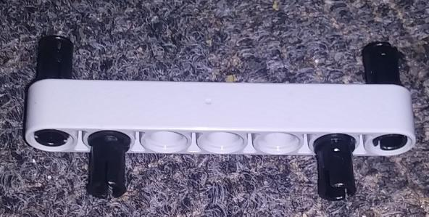
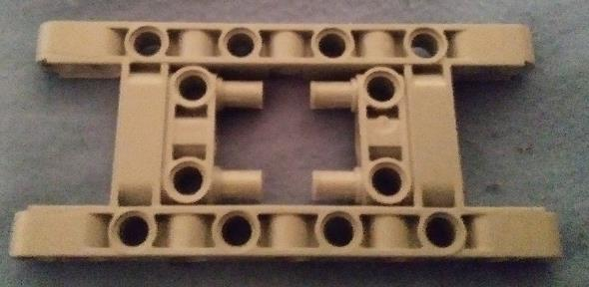
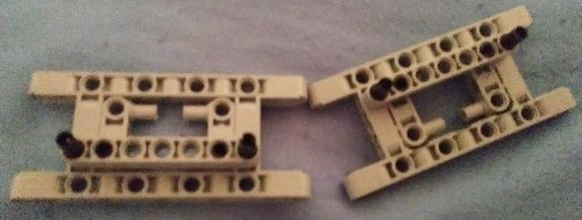

Step 2: Build the following for the middle section:
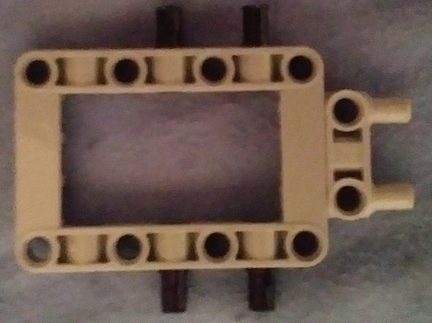
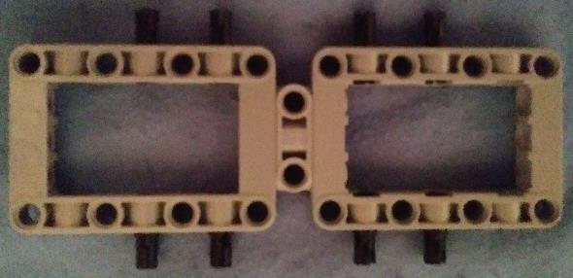
Step 3: Connect the sections as per the image below:
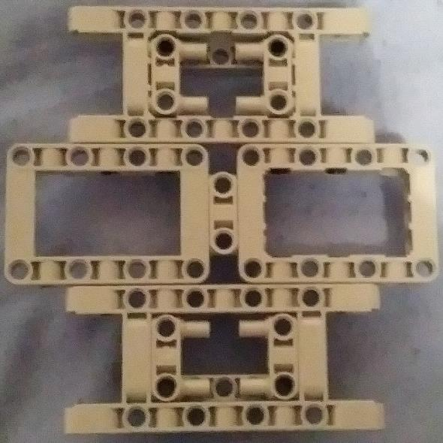

Step 4: Build the 2 front wheels as mirror images and connect them:
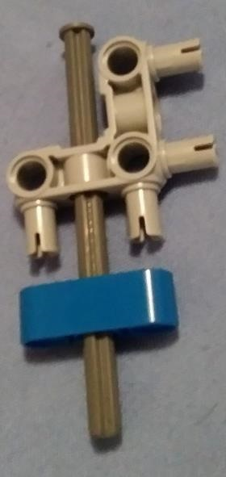
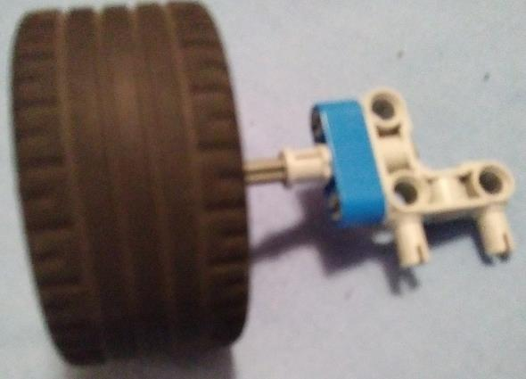
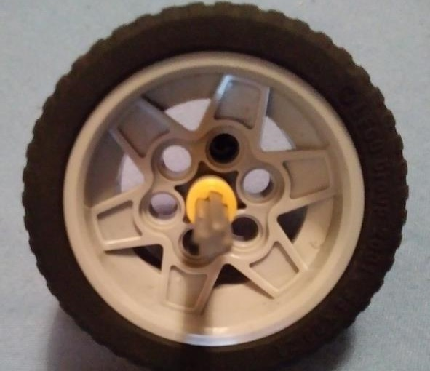
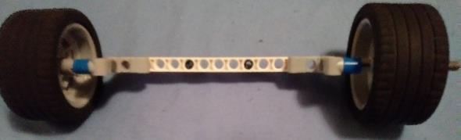
Step 5: Create the 2 motors:
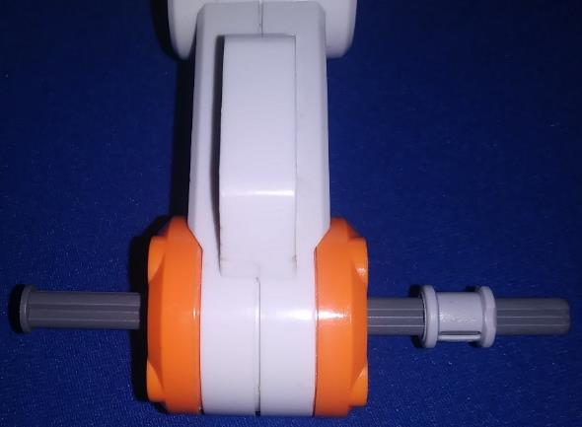
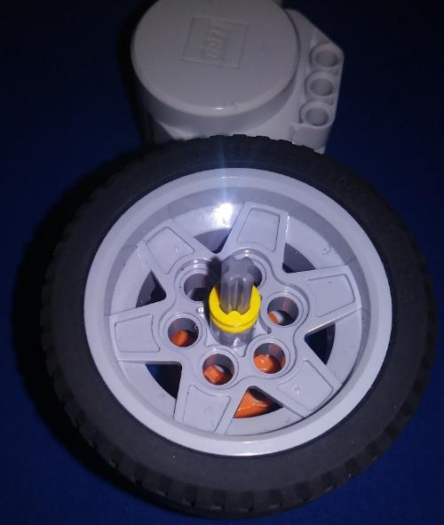
Step 6: Attach the motors, front wheels and brick
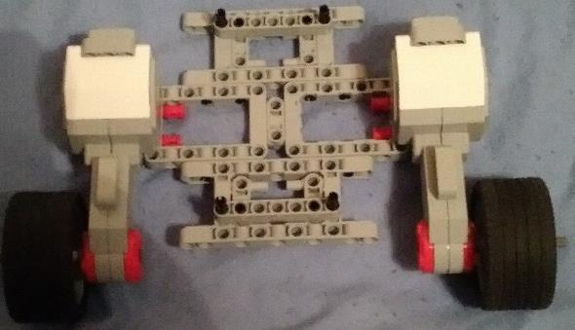
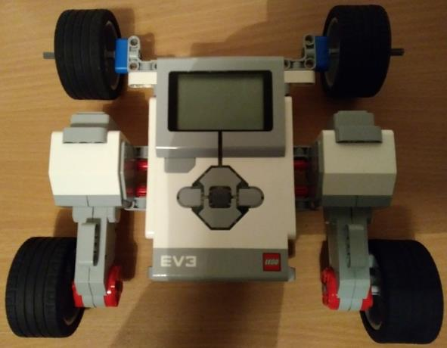
Finally, connect the motors using the cables into ports B + C

2.2 Rocker-Boogie Design
Step 1: Build 2 of the following for the brick supports:
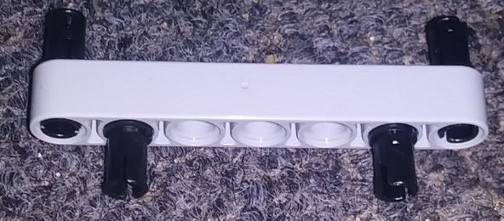
Step 2: Build 3 of the following for the middle section and both ends:
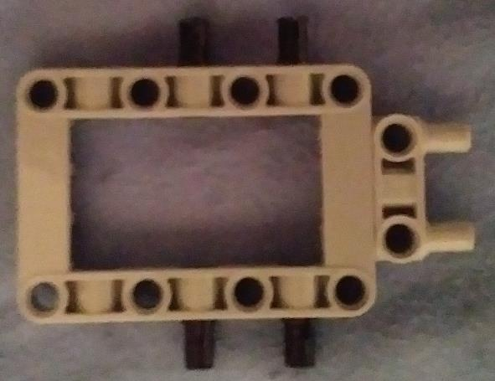
Step 3: Connect the sections as per the image below:
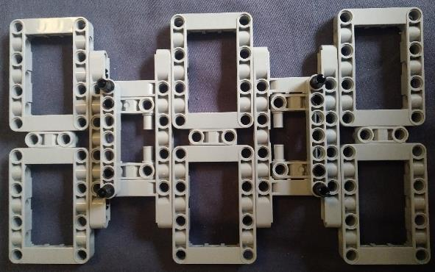

Step 4: Create the 4 motors:
Step 5: Assemble the robot by attaching the 4 motors and brick:
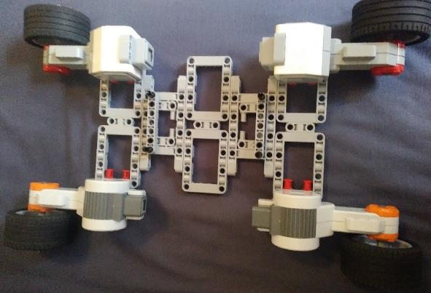
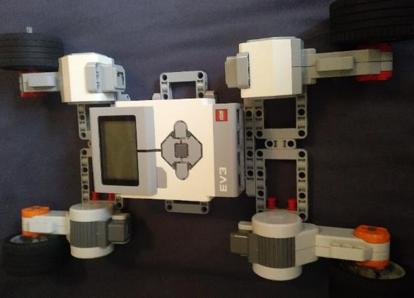
Finally, connect the motors using the cables into ports A + D for the front motors and B + C for the back motors.

