INTRODUCTION TO PHYSIOLOGY

(BMHP 5003 _BIRM)

LECTURES NAME: MUMTAZ GOOLAM

STUDENT NAME: TAHIRA JABEEN

STUDENT NUMBER: 1715952

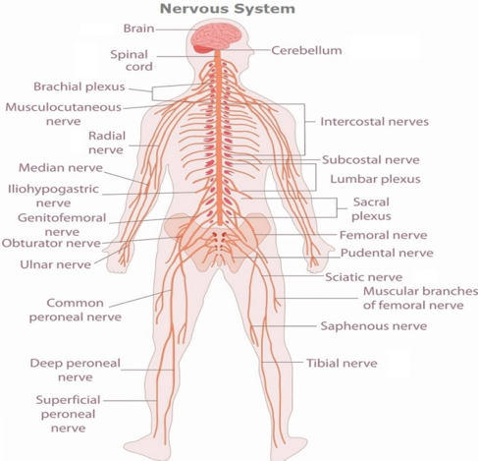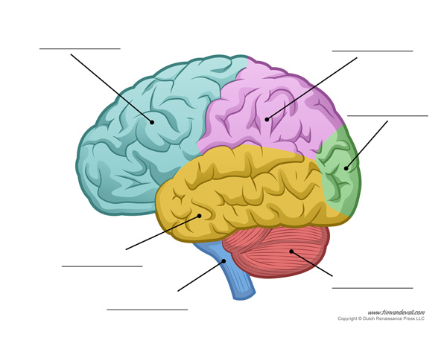
Parietal lobe
Frontal lobe
cerebellum
Temporal lobe
Occipital lobe
cerebellum
brainstem

The Brain
The brain sits in the skull and is round. The brain has four main parts (Lacalli, 1983):

- The brain stem - can also be called the Medulla oblongata. It can be found located by the spinal cord and the pons. it is one inch long.
- The cerebrum - it makes up the majority of the brain. The cerebrum is made up into two hemispheres. Each hemisphere helps to control each of the side of the body that is opposite that hemisphere.
- The cerebellum - is found behind and below the cerebrum is the large part it is a one of the largest part of the brain, it controlled right and left hemisphere, it works higher functioning of interpreting such touches, vision, hearing, speaking, feelings, and emotions, as it also controls learning small controls of movements
- The diencephalon - can also be called the fore brain stem.

The brain weighs approximately 1.3 to 1.4 kg. It has nerve cells called the neurons and supporting cells called the glia.

The obturator nerves
Femoral nerve
The pudendal nerve
The tibial nerve
The genitofemoral nerve

The Spinal Cord
The spinal cord runs down the back of the body and is a long tube, which goes to the brain. The spinal cord has 31 segments, spinal nerves come out of each segment. Sensory nerves are based in the spinal cord, also including the motor nerves. The spinal cord is about 43 cm long in adult women and 45 cm long in adult men and weighs about 35-40 grams (Siebert, Eade and Osterhout, 2015). It lies within the vertebral column, the collection of bones (back bone).

The brachial plexus
It includes a large network of nerves it sends from your spine to your arm, shoulders and hands. Young can injure your brachial plexus, this usually happens when your nerves are stretched, or in the most serious cases, when they have been torn apart from the spinal cord (Thomson and Rorie, 1983).

The musculocutaneous nerve

The common peroneal nerve

This is a leading nerve of the lateral cord of the brachial plexus and can be seen at the inferior border of the pectoralis minor muscle (Eglseder and Goldman, 1997). It leaves the axilla and pierces the coracobrachialis muscle near its point of insertion on the humerus. It gives a branch to this muscle.

The radial nerve
This helps to support the posterior portion of the upper limb. It innervates the medial and lateral heads of the triceps brachii muscle of the arm, as well as all 12 muscles in the posterior osteofascial compartment of the forearm and the associated joints and overlying skin.

The median nerve
Is the main nerve at the top of the forearm. It supports the muscles of the front of the forearm helping to control the basic movements of the hand.

The iliohypogastric nerve
This is a nerve that comes from the lumbar plexus that assists to provide the sensation to skin (Van Schoor, Boon and Bosenberg et al. 2005)

The ulnar nerve
This is a key nerve in the arm and is also a part of the brachial plexus nerve. The ulnar nerve is found in the neck and goes through the shoulder, arm, wrist and ends in the fingers (Apfelberg and Larson, 1973).

This nerve comes from the sciatic nerve and sends the signals to the legs. The front and sides of the legs all the way to the top of the feet. This nerve also helps to control the muscles in the leg that help lift the ankle and toes to the top (Deutsch and Richard et al. 1999).

Superficial peroneal nerve
It is a main nerve of the lateral compartment of the leg. It begins at the lateral side of the neck of the fibula and runs through the peroneal muscles (Adkison and Bosse et al. 1991).

The intercostal nerves
It emerges from the somatic nervous system and aids in the contraction of muscles, as well as providing sensory information from the skin and parietal pleura. The intercostal nerves arise from the anterior rami of the thoracic spinal nerves.

The subcostal nerve
This is a large nerve; it runs along the lower border of the twelfth rib, often gives a communicating branch to the first lumbar nerve, and passes under the lateral lumbodorsal arch

The lumbar plexus
This involves a network of nerve fibres that supplies the skin and musculature of the lower limb. It is located in the lumbar region, within the substance of the psoas major muscle and anterior to the transverse processes of the lumbar vertebrae (Farny, Drolet and Girard, 1994).

The sacral plexus
This is a nerve plexus which provides motor and sensory nerves for the posterior thigh, most of the lower leg and foot, and part of the pelvis. It is part of the lumbosacral plexus and emerges from the lumbar vertebrae and sacral vertebrae (L4-S4).

The sciatic nerve
This is the largest nerve in the human body and is formed by the union of 5 nerve roots from the lower spine. It passes deep in the buttock and down the back of the thigh all the way to the heel and sole of the foot. The sciatic nerve serves a vital role in connecting the spinal cord with the skin and muscles of the thigh, leg, and foot.

The saphenous nerve
This is the largest cutaneous branch of the femoral nerve. It is a strictly sensory nerve and has no motor function (Hunter and Louis et al. 1979).

References
Adkison, D.P., Bosse, M.J., Gaccione, D.R. and Gabriel, K.R., 1991. Anatomical variations in the course of the superficial peroneal nerve. The Journal of bone and joint surgery. American volume, 73(1), pp.112-114.
Alonso, F., Graham, R., Rustagi, T., Drazin, D., Loukas, M., Oskouian, R.J., Chapman, J.R. and Tubbs, R.S., 2017. The subcostal nerve during lateral approaches to the lumbar spine: an anatomical study with relevance for injury avoidance and postoperative complications such as abdominal wall hernia. World Neurosurgery, 104, pp.669-673.
APFELBERG, D.B. and LARSON, S.J., 1973. Dynamic anatomy of the ulnar nerve at the elbow. Plastic and Reconstructive Surgery, 51(1), pp.76-81.
Eglseder, J.W. and Goldman, M., 1997. Anatomic variations of the musculocutaneous nerve in the arm. American journal of orthopedics (Belle Mead, NJ), 26(11), pp.777-780.
Farny, J., Drolet, P. and Girard, M., 1994. Anatomy of the posterior approach to the lumbar plexus block. Canadian journal of anaesthesia, 41(6), pp.480-485.
https://www.mayoclinic.org/diseases-conditions/sciatica/symptoms-causes/syc-20377435#:~:text=Sciatic%20nerve-,Sciatic%20nerve,buttocks%20and%20down%20each%20leg.
https://www.nhs.uk/conditions/pudendal-neuralgia/
https://www.physio-pedia.com/Sacral_Plexus
https://www.sciencedirect.com/topics/medicine-and-dentistry/tibial-nerve
Hunter, L.Y., Louis, D.S., Ricciardi, J.R. and O'Connor, G.A., 1979. The saphenous nerve: its course and importance in medial arthrotomy. The American journal of sports medicine, 7(4), pp.227-230.
Lacalli, T.C., 1983. The brain and central nervous system of Müller's larva. Canadian Journal of Zoology, 61(1), pp.39-51.
Sabanathan, S., Smith, P.J.B., Pradhan, G.N., Hashimi, H., Eng, J.B. and Mearns, A.J., 1988. Continuous intercostal nerve block for pain relief after thoracotomy. The Annals of thoracic surgery, 46(4), pp.425-426.
Siebert, J.R., Eade, A.M. and Osterhout, D.J., 2015. Biomaterial approaches to enhancing neurorestoration after spinal cord injury: strategies for overcoming inherent biological obstacles. BioMed research international, 2015.
Thompson, G.E. and Rorie, D.K., 1983. Functional anatomy of the brachial plexus sheaths. Anesthesiology: The Journal of the American Society of Anesthesiologists, 59(2), pp.117-122.
Van Schoor, A.N., Boon, J.M., Bosenberg, A.T., Abrahams, P.H. and Meiring, J.H., 2005. Anatomical considerations of the pediatric ilioinguinal/iliohypogastric nerve block. Pediatric Anesthesia, 15(5), pp.371-377.
https://www.timvandevall.com/science/human-brain-diagram/

