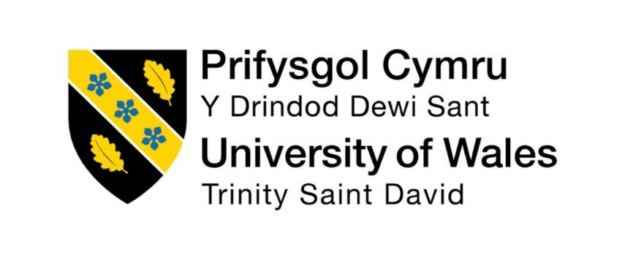

Programme: Master of Business Administration
Module: Human Capital Management
Module code: LCMB7023
Title: Implications for Global Workforce Development of Strategic Human Resource Management in a Time of Sustainability and Cultural Change
Word count: 2537
Lecturer : Ejike Udeogu (Birmingham)
Student Name : Rajash Ghosh
Student ID: 2428528
Submission Date-17/10/2025

Table of content

Introduction………………………………………………………………………………..3
1. The Digital Disruption: Artificial Intelligence, and People Analytics in HRM/IHRM………………………………………………………………………………..4-6
2. The EX as a Strategic Differentiator………………………………………………6-8
3. HRs Agile Transformation………………………………………………………….8-9
4. Personal Skills and Capabilities to the Future of Work Reflection Report…………………………………………………………………………………….9-12
Conclusion…………………………………………………………………………………12
References…………………………………………………………………………..…12-14
Introduction
HRM has turned into being an administrative powerhouse to a Digital Innovation Business Partner by increasing the level of employee engagement and enabling organizational flexibility. The three primary drivers of HRM digital transformation discussed in this article are the use of artificial intelligence (AI) and people analytics, exploded emphasis on employee experience (EX), and the use of agile ways of working. These changes demand the HR directors to maintain humanistic values as well as be accountable in integrating technology. HRM becomes more practical and humanitarian in a more data-oriented, globally interconnected world trying to make disruption an inward rather than an outward affair.

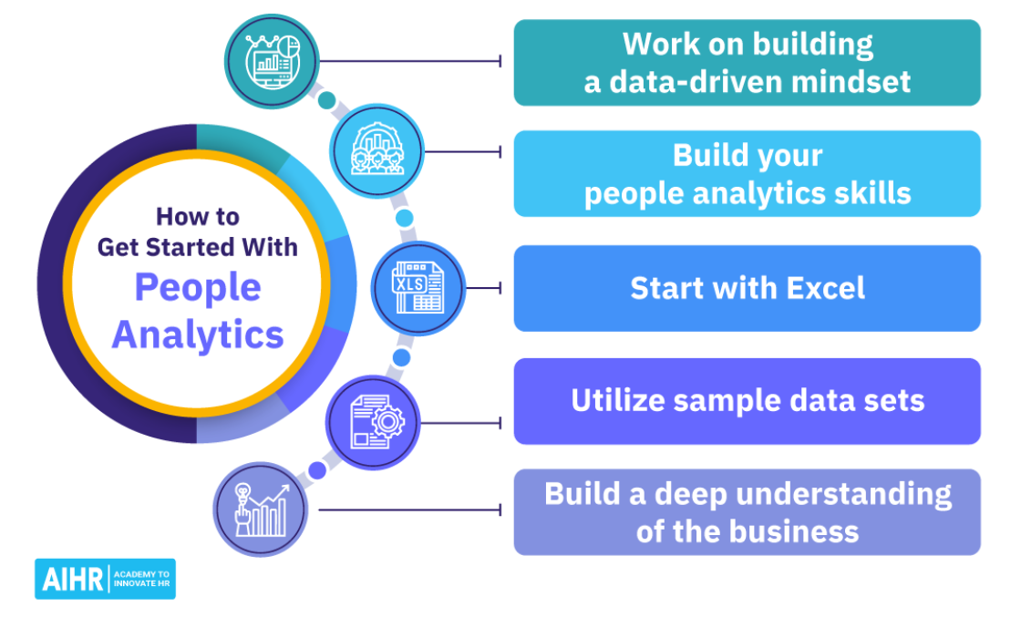

Source: https://www.aihr.com/blog/people-analytics/

1. The Digital Disruption: Artificial Intelligence, and People Analytics in HRM/IHRM
The digitization of HRM practices, especially AI and data analytics, are transforming the HRM activities such as talent acquisition and employee development, both in terms of efficiency and ethical considerations. Decisions made by organizations can be made with the help of People Analytics- a data driven approach to managing people at work (Edwards and Edwards 2019). Indicatively, in the case of Project Oxygen at Google, the analytics were applied in identifying the activities of effective managers and these led to the development of leadership programs at Google (Garvin 2013). Besides, people analytics can now enable organizations to recognize the potential skill gaps in advance before they influence performance, hence, proactive workforce planning (Armstrong and Taylor, 2020).
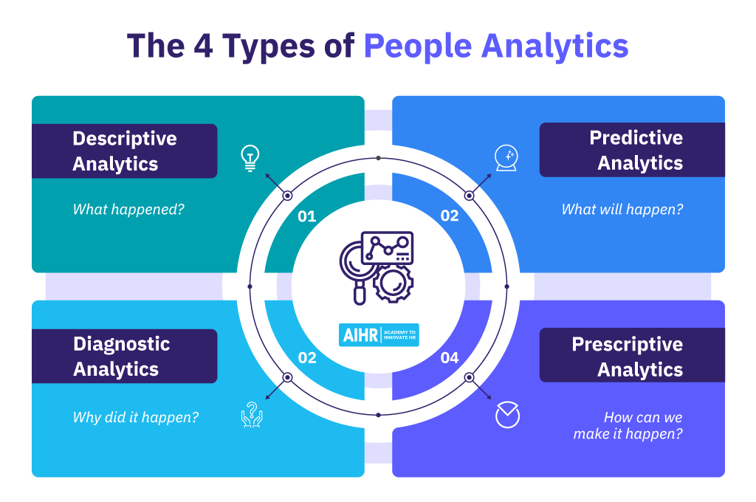

Source: https://www.aihr.com/blog/people-analytics/

The World Economic Forum (2023) claims that data-driven HRM is becoming a necessity to implement sustainable business strategies that can be aligned with the productivity targets, as well as with the well-being of the employee. Tools with AI are now used in talent acquisition, screening thousands of CVs in seconds; first video interviewing with the analysis of the tone of voice and facial expression of the candidate as well as the likelihood of success much more effectively than the traditional human recruiter working alone (Cappelli et al., 2019).
However, this convenience of the do it yourself is not risk-free. O'Neil (2016) warns against weapons of math destruction, as models that are constructed based on historical data may be configured with human bias and the definition of success. This necessitates a high level of ethical questioning and continuous algorithm questioning to facilitate fairness and transparency.
On top of efficiency, the rise of the AI-based HRM implies deeper ethical concerns related to not only data ownership or, at least, data consent but also to algorithmic transparency (Stone and Deadrick, 2015). Remote and hybrid work that is currently gaining momentum has only highlighted the need of digital HRM even further. Performance management is moving away to digital-enabled continuous feedback, with an increasing number of annual reviews. Applications like Lattice and 15Five will allow those check-ins and objectives to be live tracked so that leaders can get a real-time estimate of how their people are performing and feeling engaged (Pulakos et al., 2015).
As the digital platform becomes more popular in the performance management process, it is more than ever that balancing the fine line between feedback and surveillance is the key to keeping employees on side (Armstrong and Taylor, 2020). Openly and frequent discussion is what is most important in keeping technology making, as opposed to controlling.
Digitalisation: Special Issues to IHRM. Digital revolution presents IHRM with several challenges. An MNC that is planning to implement a global HRIS also it introduces international data privacy environment, e. g., the environment of the GDPR of EU that contains restrictions on when and how personal information about the employees may be obtained and processed (Stone and Deadrick, 2015). In addition, monitoring and data collection attitudes are also specific to the culture and thus IHRM policies need to strike the correct balance between global standardisation on the one hand and local legal application and cultural sensibilities on the other. Digital HRM systems used globally also require a high level of training to cover any digital literacy differences between regions and ensure the maintenance of compliance with diverse legal systems (Armstrong and Taylor, 2020).

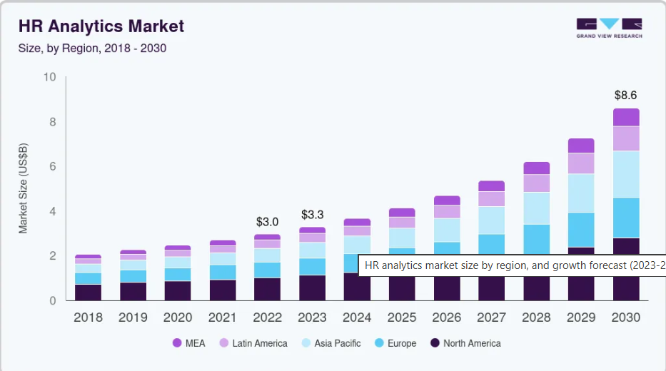
Source: https://www.grandviewresearch.com/industry-analysis/hr-analytics-market

2. The EX as a Strategic Differentiator
No company in the present day competitive talent market, as has been discussed in others, can afford to attract and keep your best people with only a competitive salary. The focus is placed more on the general staff experience, which is also known here as the Employee Experience (EX). Morgan (2017, p. 6) conceptualises EX as organisational cultural environment, technological environment, physical environment of a workplace - all of which determine how people feel and perceive their work at a workplace. Positive EX has proven itself to be a direct driver of business growth in modern organizations, including Google and Salesforce, that are more innovative and have stronger brand loyalty (Deloitte, 2021).
EX significance shows a change in the direction of considering employees as internal customers whose experience defines the success of an organization (Armstrong and Taylor, 2020). Patagonia has a high EX as their culture reflects in their brand mission and allows staff off with pay to do environmental activism producing a highly loyal and engaged workforce with brand ambassadors (Chouinard, 2005). An organisational practice involves culture-led EX, in which culture is central to employee experience (EX), and these organisations are often ranked higher than others with regard to employee engagement rates and retention levels (Morgan, 2017).
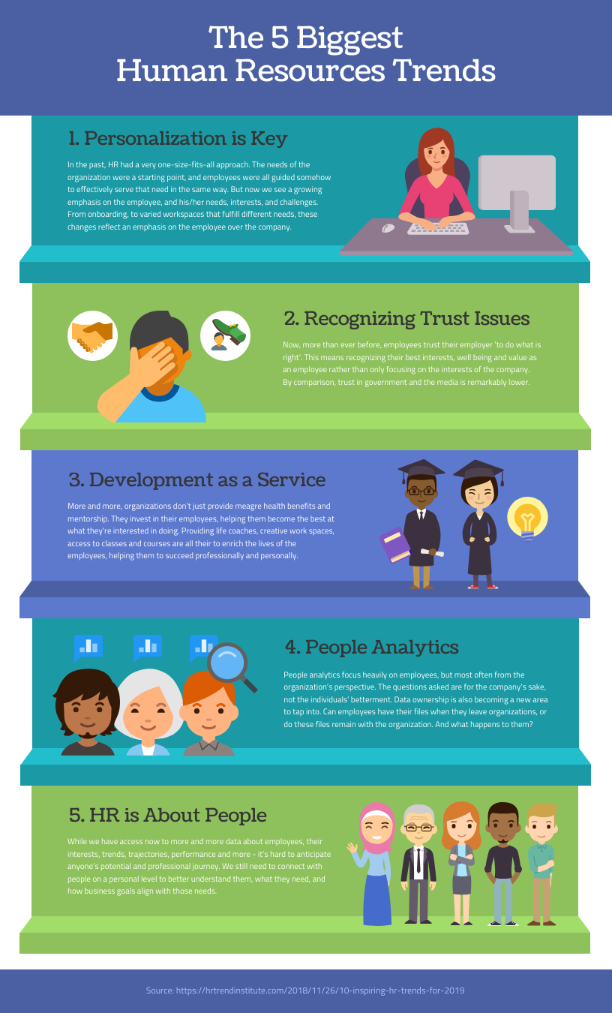
Source : https://venngage.com/templates/infographics/the-5-biggest-human-resources-trends-b20c3bf7-f538-4138-ba3d-915460b46511?

A second important aspect is the technological context. Luxury is not what is anticipated of seamless in the online world as far as a useful do you work toolkit is concerned. Firms such as Adobe have made enormous investments in developing a digitized work environment that is user-friendly among its employees and bring its consumer experience, which it currently provides to its customers, to employees. Their move to abandon annual appraisals in favor of a no frills Digital system known as Check-in has earned them public accolades of success in boosting staff morale and staff competence (Bersin, 2018).
Similarly, companies like Microsoft or IBM have implemented AI-based collaboration tools that facilitate collaboration inclusively and make hybrid patterns of working possible (CIPD, 2022). They have the technology that they require to make people feel like they are part of something regardless their location. This makes it daunting to IHRM to configure an EX that can be used to the needs of both criteria (global consistency) and exceptions (local relevance). Positive experience is a relative notion that is culturally relative.
To illustrate, unlike Western Individualistic culture where adjustable working conditions might be of value, employees of the collectivist countries might tend towards office based team-working, and social grouping of employees (Hofstede et al., 2010). Airbnb is a global company that has attempted to do this by developing a global EX structure based on one corporate value Love and then decentralizing powers to the local offices where they can tailor their cultural programmes, office designs and benefits packages to suit the mores and preferences of their local employees. Further development of multinational companies will make future EX personalized in scale: it will create experiences that are both universal company values and localized (Armstrong and Taylor, 2020).

3. HRs Agile Transformation
HR must become agile, which was initially used only in software development but is now a model that encourages iterative effort, cross-organizational and cross-company input and contribution to be quicker (not to mention, less bureaucratic). Instead of lack of elasticity, yearly cycles of people practice and procedure delivery, agile HRM is based on a more flexible kind of project-based delivery, which adapts to the pace of business happening. The current project management (PM) systems, as stated by Buckingham and Goodall (2019), tend to be cumbersome, bureaucratic and unrelated to work. In contrast, agile performance management is constructed on the basis of prospective coaching discussions and frequent informal check-ins.
Overall, Agile HR practices assist the teams in self-organization providing a creative and flexible treatment of all departments (Denning (2016)). The massive agile change at ING, the Dutch banking conglomerate, resulted in the significant reorganization of the people operations and it was one of the most frequently mentioned war stories in the report. This new form of work required re-defining of job functions, career progression and reward structures as the organisation disintegrated into autonomous, cross-functional groups known as squads. Sprints phones turned out to be the new HR rule that could develop and release things quickly, which greatly shortened time-to-market on new policies and programs (HBR, 2018).
Companies like Amazon and Spotify have also used principles of agility to HR practice, emphasizing on testing and learning in a loop, and undermining command structures (Armstrong and Taylor, 2020).
And talent management is also changing along with this change. Agile organizations are utilizing talent marketplaces as a means of getting workers into project not according to the historical job definition or even according to the career ladder, but in a more adaptable way that fits their skills and personal growth objectives. Time has made employees within the same company more diversified in job experience as the latter provides a lifelong learning culture (Cappelli, 2008). It is a skill allocation dynamism that allows organizations to tap into the internal talent and create individual career progression at the same time (Deloitte, 2021).
Application of agile strategies to a multinational enterprise: The implication to IHRM.
The popularity of flat pyramids of power, open feedback and freedom of action may directly clash with strongs power-distance or uncertainty-avoidance cultures, who need an order of command most of all and resort to their superiors to give clear instructions or clearly-defined procedures (Denning, 2016). It would, therefore, take numerous leadership trainings on agile and localizing rituals like stand-ups or retrospectives without losing the gist of the approach to take the method to the global level successfully.
Finally, Agile HR can only be effectively implemented in different cultures with the help of inclusive leadership and cultural intelligence (Armstrong and Taylor, 2020).

4. Personal Skills and Capabilities to the Future of Work Reflection Report
In the name of Personal Reflection, I would like to make an introduction. The transition between academic theory and professional practice, in modern times of the world of working, needs to be reconsidered more fundamentally, in terms of skills that will thrive in a digital transformation - skills on the threshold of agile work practices, and human-centric experiences.
I have gained a lot through my coursework and an internship at tech start-up; yet I have found out some points where I can develop. In addition to the direction of progression reflection, this reflection assesses my current level of digital literacy, flexibility and experience based on design thinking. Reflective practice is a required aspect of the professional learning process because it links the theoretical ideas and the professional performance (Armstrong and Taylor, 2020).
Digital Literacy and Analysis. My school work has equipped me with an excellent theoretical understanding of the part that data plays in business. In my senior project, I have had the opportunity to practice processing and interpreting data in the wake of utilizing SPSS to examine survey-data to establish how many factors influence each employee engagement. During my internship during this pandemic, I had an insulated layer between me and our HR team whom I learned about how to use Asana, Slack and an extremely basic HRIS of which I am absolutely in love! This revealed that I could acquire vast amount of new technologies and use them within no time.
According to the current situation, HR specialists need to analyze digital information critically and ethically in order to lead strategy (CIPD, 2022). However, I possess my own mouth and it also has its own cutoffs in regard to competence. My understanding of the principles of AI and machine learning algorithms is basic and can restrict my capacity to make an informed decision whether an AI-based HR tool is a fair or effective one. As well, I am not the best in predictive analytics or the pretty version of data (such as Tableau and Power BI) though I can perform some good data analysis.
To address this gap, I have enrolled in an online course, People Analytics 101 and plan to be certified in a data visualisation tool before the end of the year. Developing the given competencies will enable me to convert the complex data insights into workable HR strategies (Armstrong and Taylor, 2020). Flexibility and Agile mind. Personally, I have seen myself as a methodical and organized person; I like to work on a plan and goals. I discovered that this strength assisted me through school life where deadlines were very far between.
Nonetheless, I found out working as an intern in a start-up that this could also be a rigidity. We worked in two weeks sprints and the priorities would change at some stage within the sprint after feedback. Initially, I despised the constant change and could not release the hold of a premeditated agenda. The essence of the modern fluid workplace is adaptability of the employability (Denning, 2016). I was able to learn through observation of other gurus and this was a useful process that up to date serves me well. I was obliged to make myself accustomed to the thought that I didn't have to get answers to everything in the beginning and that I could contribute to it progressively.
A major learning experience I had was when, post the hiring of a new employee after a smooth enough onboarding, I made the suggestion to make one minor and simple change to our onboarding checklist and the change was accepted immediately. This no-holds-barred, take-on-feedback approach won applause, on the part of my boss. To keep advancing my agility, I have read books about Agile and Scrum methodologies and am presently in a club at university that applies Agile method of planning in all their projects. The ability to form the growth mindset will keep improving my performance in the dynamic workplaces (Armstrong and Taylor, 2020).
Empathy and Experience-Based Communication
My job as a part-time customer service representative has served me well in terms of empathy and mindfulness of the user. It also helped me to know how to listen to a customer, hear them and find what they actually need, as well as articulate that response in a simple-to-understand way without sounding condescending. I believe that this can be readily applied to the creation of a good employee experience - whether it is the creation of new hire documentation or your approach to the ER scenario. Empathy is emerging as one of the strategic HR capabilities due to its direct positive effect on communication, engagement, and well-being (Morgan, 2017).
However, I do become more aware of the habit of relying on my task focussed nature as opposed to people focussed when the pressure is on. I will still be in semester so I was working on my group project and everybody said that I was good at ideas but they said that some of how I was communicating them was too direct and in a way choking other people in their contributions. This was a significant revelation. Having known about that, I attempted to be an active listener and repeat the points of other people in the group and then explain my own.
The Planning of Integration and Development.
This self-assessment reflects a tendency to the desire of development. To achieve success with HR in the future, digital savvy needs to be paired with agility and driven by powerful moral responsibility and compassion. Such is my personal development plan: Skills: Complete the course of People Analytics by the end of 2020 and become Tableau certified by mid-2025.
Systematic: Proactively seek project-based work in future jobs and inquire some form of formal Scrum Master certification within 3 years since beginning my career. People skills: find a mentor who is a model of human leadership and continue to request 360 degree feedback to me as to how I communicate and work in teams. The process of evolution is endless. And we can also play a part in this dynamic nature of work, provided we are open to know our entire life, be submissive and doubt ourselves in the long run. This co-ordinated planning is supported by the fact that the HR profession is based on the attention to constant professional growth (CIPD, 2022).

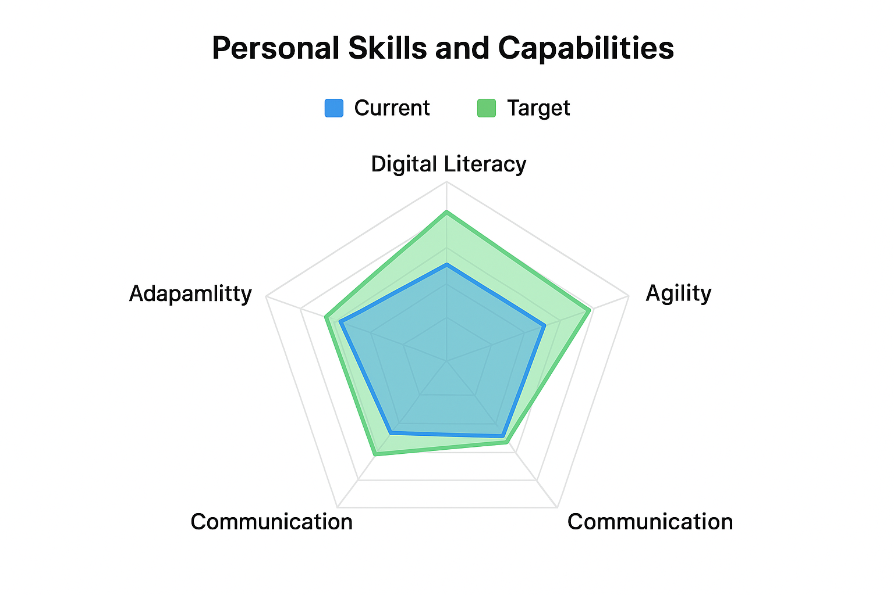

Conclusion
The report identifies three key (mega) trends that define the modern HRM/IHRM: digitalisation under the influence of AI and analytics, emphasis on employee experience as the driver of corporate success and transition to organisational stability to agility. People analytics is an enormous potential but we must be cautious of bias. Agile practices in the HR enable that organization to operate as fast as the business, which inculcates agility and resiliency. Again the solution to HRM is to unite digital resources and human emotions in such a way that we would develop smart ethical and empathetic inclusive workplaces (Armstrong and Taylor, 2020). The profession must continue to self-define itself and expand beyond what is familiar and nourished by empathy.

References
Armstrong, M. and Taylor, S. (2020) Armstrong’s Handbook of Human Resource Management Practice. 15th edn. London: Kogan Page.
Bersin, J. (2018) ‘The rise of people analytics: A new approach to HR’, Forbes, 21 February. Available at: https://www.forbes.com/sites/joshbersin/2018/02/21/the-rise-of-people-analytics-a-new-approach-to-hr/ (Accessed: 10 May 2024).
Buckingham, M. and Goodall, A. (2019) ‘Reinventing performance management’, Harvard Business Review, 97(2), pp. 106–115.
Cappelli, P. (2008) Talent on Demand: Managing Talent in an Age of Uncertainty. Boston: Harvard Business Press.
Cappelli, P., Tambe, P. and Yakubovich, V. (2019) ‘Artificial intelligence in human resources management: Challenges and a path forward’, California Management Review, 61(4), pp. 15–42.
Chartered Institute of Personnel and Development (CIPD) (2022) People Analytics and Digital HR: CIPD Factsheet. Available at: https://www.cipd.org (Accessed: 10 May 2024).
Chouinard, Y. (2005) Let My People Go Surfing: The Education of a Reluctant Businessman. New York: Penguin Books.
Denning, S. (2016) ‘What is Agile?’, Forbes, 2 August. Available at: https://www.forbes.com/sites/stevedenning/2016/08/02/what-is-agile/ (Accessed: 10 May 2024).
Deloitte (2021) Global Human Capital Trends Report. Available at: https://www.deloitte.com (Accessed: 10 May 2024).
Edwards, M. R. and Edwards, K. (2019) Predictive HR Analytics: Mastering the HR Metric. 2nd edn. London: Kogan Page.
Garvin, D. A. (2013) ‘How Google sold its engineers on management’, Harvard Business Review, 91(12), pp. 74–82.
Harvard Business Review (2018) ‘Agile at scale: How ING transformed its organization’, Harvard Business Review, 20 March. Available at: https://hbr.org/2018/03/agile-at-scale (Accessed: 10 May 2024).
Hofstede, G., Hofstede, G. J. and Minkov, M. (2010) Cultures and Organizations: Software of the Mind. 3rd edn. New York: McGraw-Hill.
Morgan, J. (2017) The Employee Experience Advantage. Hoboken, NJ: Wiley.
O’Neil, C. (2016) Weapons of Math Destruction: How Big Data Increases Inequality and Threatens Democracy. New York: Crown.
Pulakos, E. D., Hanson, R. M., Arad, S. and Moye, N. (2015) ‘Performance management can be fixed’, Industrial and Organizational Psychology, 8(3), pp. 347–353.
Stone, D. L. and Deadrick, D. L. (2015) ‘Challenges and opportunities affecting the future of human resource management’, Human Resource Management Review, 25(2), pp. 139–145.
World Economic Forum (2023) The Future of Jobs Report 2023. Available at: https://www.weforum.org (Accessed: 10 May 2024).

