Developing Workplace Critical Thinking in Primark

Mabudta Luwau

Table of Contents
Introduction 1
Part-A 2
1. Differentiate between beliefs, attitudes and values and explain the difference between them by evidence and theoretical model 2
2. Explain the role of Customer Service Assistant in Primark and relevant to management theories 4
3. Critical Assessment of Customer Service Assistant’s beliefs, attitudes and values in a particular management theory to CSA 7
Part-B 9
4. Assessment the impact of values, attitudes and beliefs on the behaviour of Customer Assistant Service in Primark using theoretical model 9
5. Clear identification of a range of management theories to Customer Service Assistant role in Primark 12
Conclusion 15
References 16

Introduction
Critical thinking is more than thinking applying more skills and logical analysis. This can be habitual thinking of ways, and acting which involves in answering and questionnaires (Hughes et al, 2015). Think different is the basic theory of critical thinking. In this assignment, the critical thinking will be applied in the workplace. So workplace is the place where the employees are working for achieving the objectives of an organisation. In a workplace a critical thinking is very important. Because the situations are not always same, in different situations the thinking must be different and in crucial situation the critical thinking must be taken.
In this module, the selected organisation is Primark which is an Irish retail company. The basic products are clothing, cosmetics and household goods in Primark. The parent company is Associated British Foods. Here is a Customer Service Assistant post which is owned by me (Primark, 2018). The locations or branches of this company are more than 368 and number of employees are 70,000. Headquarter of this company is in Dublin in Ireland and founded in 1969 by Arthur Ryan (Primark, 2018). The local name of this company is Penney. In 12 countries this branches are widespread. In Asia, there is one branch which is in Pakistan on branch is in USA but others are in UK. As a retail company, this is a huge because the revenue is over £5.9 billion (Primark, 2018).
This assignment will be worked according to this company (Primark). In this module, the values, beliefs, attitudes and behaviours will be differentiated. The roles of Customer Service Assistant in Primark will be analysed in this assignment. The management theory will be applied in the context of assessment values, beliefs, attitudes and behaviours. Then the impact of beliefs, values and attitudes of the individuals will be assessed based on Primark and its employee roles. At the last section, the range of management theories which are used by Customer Service Assistant in Primark will be analysed and identified effectively.

Part-A

1. Differentiate between beliefs, attitudes and values and explain the difference between them by evidence and theoretical model
Beliefs, attitudes and values are interlinked with each other. Without of each component, behaviour of the individual cannot be built up effectively. To acquire the behaviour an individual must have to overcome three stage of the behaviour. If it is supposed to a tree, belief is a basement of the tree, then values are the log or full body of the three, on the other hand attitudes are branches of three. A three combination creates behaviour of an individual which is picking of the tree.
Beliefs: Belief is an idea which helps to think the person as being true. Own Experience, norms cultures and religions are the sources of beliefs (Kluegel et al, 2017).
Values: Value is the long lasting belief which help to an individual to know about what is important to you. Happiness, wealth, career and family are the components of value and sources for creating value (Donaldson, 2016).
Attitudes: How an individual interact and treat others and approaches the situation is called attitude of an individual. Respect, professional life, convenience and Peer pressure are the sources and components of attitude (Petty, 2018).
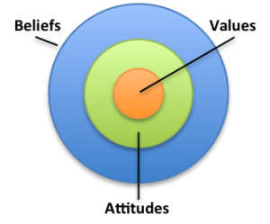
Figure: Differentiation of beliefs, values and attitudes, Source: (Immigration Advisers Authority, 2018)
Beliefs | Values | Attitudes
Belief is an idea which helps to think the person as being true (Kluegel et al, 2017). | Value is the long lasting belief which help to an individual to know about what is important to you. | How an individual interact and treat others and approaches the situation is called attitude of an individual.
Belief is the basement of a person which creates from early life of the person. | Value is the middle man to carry the behaviour. From the basement the value stars (Donaldson, 2016). | Attitude comes from beliefs and values which makes an individual good attitude.
Own Experience, norms cultures and religions are the sources of beliefs | Happiness, wealth, career and family are the components of value and sources for creating value. | Respect, professional life, convenience and Peer pressure are the sources and components of attitude.
Very strong component for an individual to create a good behaviour. In Primark, the customer service assistant believe that without hard work, shine cannot be acquired. | Long term beliefs which is carried out from long time period. Company is my own property so I value of my Company | I hate the manager of the company because he is dishonest person life this is an example of attitude of an individual (Petty, 2018).

In the workplace the belief, value and attitude are potential component to create an organisational behaviour. These three components, when an individual acquires can create an effective individual. A belief can create a value of an individual. Then a value can create an attitude of an individual. In this way the values, beliefs and attitudes are interlinked with each other.

When an individual needs to think critically these three components must be applied in the workplace. Firstly the person has to acquire a belief which will be perfect truth for the person. The situation and people must be observed and then the decision can be made. After that, the person must acquire the value and the importance of the person must have to others this can help to create and make decision critically. When the two components will be acquired by the person, the attitudes will be automatically gained from the workplace (MacLeod, 2014). So the person can express his personal opinion and his decision critically for the workplace. Although there are basic different between the three components, the interlinking must be followed in three components of Behaviour.

2. Explain the role of Customer Service Assistant in Primark and relevant to management theories
Primark which is an Irish retail company the basic products are clothing, cosmetics and household goods in Primark. Here is a Customer Service Assistant post which is owned by me. As a retail company, this is a huge because the revenue is over £5.9 billion. So as a Customer Service Assistant I have some roles and responsibilities which must have to be played by me to the location. The basic customer service assistant roles and duties are given below:
Help to build good relationship with the customers. This is the first job and task for a customer service assistant helps to build a good relationship with the customers to the customer service manager. To build good relationship with the customer, the customer service assistant should have to communicate with them. Their needs, wants and demands must have to be understood by the CSA. When the customers come to location, the CSA should take the number and call them in off time to know about their personal information by convincing them (Miller, 2018). Then the relationship can be built up and will be good.

Deal with difficult or angry customers. The complaints from the customers have to be tackled by the customer service assistant. The problems are noted from the customers and then it is submitted to the customer service manager. Sometime the assistant is to maintain and deal with the angry customers to release the pressure from the manager of customer service. The difficulties should have to handle by the manager but in Primark, the handing responsibilities are in the assistant of customer service.
Know and read the customer. The demand, want and expectation of the customer must have to be known by the company. In Primark, the customer service manager applies this role by the service assistant. The customer service assistant firstly read to the customers when they come in the location. Then know their needs and expectations. The personal information must have to be acquired by the assistant by communicating with them effectively (Primark, 2018).
Promote customer service throughout the organisation. As a customer service assistant, the person should have to promote the service using the name of organisation and brand loyalty. The customer service will be expressed by providing the service to the customers. Primark is a retail company that’s why the customer service should have to be promoted (Miller, 2018). This is can be basic role of customer service assistant.
Work as a part of team. The customer service assistant is a part and individual of a team in the organisation. In retail shops, manager creates a team where the potential members are involved. Actually the customer service assistant must be involved in a team and work together. So the role is to work as a part of team and in Primark I am a part of the team.
Assist to sales: In retail company to sell the products to the customers is the main job of customer service assistant. So when the sales executive deals with the customers, the sales assistant helps to the executive and the CRM to find out the products and fulfilling the customer’s needs (Groovehq, 2018). Sometimes the customers are confused to choice the products in Primark, then the service assistant comes to the customers and helps to choice the products.

Influence to purchase the product to the customers. This is an intelligent and figurehead role for the customer service assistant. When the customers come to the locations and choice the products, the assistant service people come to the customers in Primark. Then know about their choice and demands and according to the choice the product will be suggested (Groovehq, 2018). In this way the customer sale service assistant influence to the customer to purchase the product.
There are most popular six theories of management which are scientific, administrative, bureaucratic, human relation theory, systems theory and X & Y theory. As the role of the customer service assistant is related to administration so the best management theory is administrative theory which is given by Henri Fayal. So this theory is interlinked with the role of customer service assistant below:
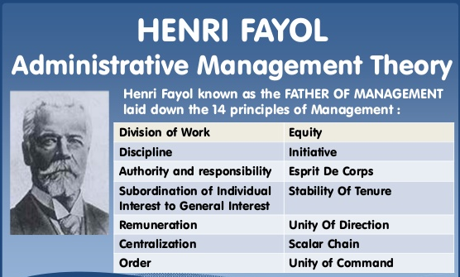
Figure: Administrative Management Theory
Source: (Technofunc, 2018)
In the administrative management theory, there are fourteen principles which are actually related to the role of customer service assistant in Primark. Division of the work is the first principle of this theory, in Primark the assistant is provided the tasks which is divided by the manager of the organisation. In the customer service assistant, discipline is observed because the assistant communicate with the customer with showing the manner and good behave (Technofunc, 2018). They maintain the manager’s works and time management. In this way each and every principles are interlinked with the role of customer service assistant.
This theory is selected because this is the best management theory which can be used universally. By this theory, the service assistants maintain the chain of command as a result the Primark can build a good market by loyal customers. In this theory, an organisation needs more principles; there are all effective principles involved.

3. Critical Assessment of Customer Service Assistant’s beliefs, attitudes and values in a particular management theory to CSA
If it is supposed to a tree, belief is a basement of the tree, then values are the log or full body of the three, on the other hand attitudes are branches of three. A three combination creates behaviour of an individual which is picking of the tree. So the customer service assistant can build his behaviour from these three applications.
Belief is an idea which helps to think the person as being true. In the Primark, the customer service assistant believe that hardworking can give him promotion and benefits (Kluegel et al, 2017). Own Experience of the customer assistant, norms & cultures of customer assistant and religions of the assistant are the sources of beliefs which were acquired from his family and environment. The belief of him can help to influence the customers to purchase.
Value is the long lasting belief which help to an individual to know about what is important to you. This is made from the Primark to the customer service assistant. Happiness, wealth, career and family of the assistant in Primark are the components of value and sources for creating value (Donaldson, 2016). The happiness and wealth are acquired by the assistant from working with the Primark.
How the assistant customer service individual interacts and treats others and approaches the situation is called attitude of customer service assistant. Respect, professional life, convenience and Peer pressure are the sources and components of attitude. Attitude comes from beliefs and values of assistant of customer service which makes an individual good attitude. In the Primark, the customers respect to the assistant and they respect to the customers, this can be indicated attitudes of the customer service assistant (Petty, 2018). In the Primark the belief, value and attitude are potential component to create an organisational behaviour. These three components, when CSA acquires can create an effective individual. A belief can create a value of an individual. Then a value can create an attitude of an individual. In this way the values, beliefs and attitudes are interlinked with each other.
These beliefs, attitudes and values must be applied to the organisation but the outcomes and the results can be positive and negative. So there are some advantages and disadvantages in application of beliefs, attitudes and values. These advantages are; when the beliefs are strong the services of the customers will be strong. Here the service assistant can give the service effectively. The good attitudes of the customer service assistant help to read and know about the customers because the communication, interaction and interpretation are strong (Petty, 2018). The values of the customer service assistant increase the importance which helps to inspire him to do something new. On the other hand, the disadvantages are; good behaviour create good impression to customer but the fare and discount will be increased then Primark will face some problems of profiting. But the three components should be applied by the assistant effective to earn profit.
There is a management theory (Administrative) which is related to the customer service assistant role and its values, attitudes and beliefs. The best management theory is administrative theory relating to the role of Customer Service Assistant. To build good relationship with the customer, the customer service assistant should have to communicate with them (Thompson, 2017). Their needs, wants and demands must have to be understood by the CSA. The complaints from the customers have to be tackled by the customer service assistant. In Primark, the customer service manager applies this role by the service assistant. Actually the customer service assistant must be involved in a team and work together. When the customers come to the locations and choice the products, the assistant service people come to the customers in Primark.

Chain of command is followed by the customer service assistant in Primark. So this indicates that the assistant obeys the orders from the manager of the location. The manager directs to the assistant and he is operated by the manager in right ways. They maintain the manager’s works and time management. In this way each and every principles are interlinked with the role of customer service assistant.
The administrative theory is the best for this role that’s why this is selected for relating to the customer service assistant and the organisation effectively.

Part-B

4. Assessment the impact of values, attitudes and beliefs on the behaviour of Customer Assistant Service in Primark using theoretical model
Values, beliefs and attitudes influence to the behaviour of Customer Assistant Service in Primark in most. In the Primark, the customer service assistant believe that hardworking can give him promotion and benefits. Own experience of the customer assistant, norms & cultures of customer assistant and religions of the assistant are the sources of beliefs. Assistant in Primark are the components of value and sources for creating value. The happiness and wealth are acquired by the assistant from working with the Primark. In the Primark, the customers respect to the assistant and they respect to the customers, this can be indicated attitudes of the customer service assistant (Petty, 2018). In the Primark the belief, value and attitude are potential component to create an organisational behaviour. These three components, when CSA acquires can create an effective individual. The good attitudes of the customer service assistant help to read and know about the customers because the communication, interaction and interpretation are strong. The values of the customer service assistant increase the importance which helps to inspire him to do something new.
How the values of the customer service assistant influence and impact on the workplace Primark these are given below:
Supporting and emerging to the work: The values of the customer service assistant support and emerge to the work like customer dealing, building the relationship with the customers and others.
Conflict with the work: When the value of the customer service assistant is not preference then he must be upset and then he will do the best effort to the workplace in Primark (Makinithappen, 2018).
Create stress: the stress is created by not acceptance of the value to the customer service assistant in the organisation Primark. Then the effort of the employee will be increased to the jobs and then the organisation will be developed.
Actually these impacts are effective for creating the behaviour of the customer service assistant. These impacts come from the values of the people which must be involved in Primark.
Now the beliefs can impact on the behaviour in the workplace. How this will be possible this is given below:
Limiting beliefs limits employee’s potential: The beliefs limits the employee’s potential because maximum people believe negatively and this can influence to do the work. If the Customer Assistant beliefs that he is a looser then he cannot shine in customer service.
Beliefs and information filtering: The information when we acquire from different sources filter with our beliefs and this can influence on the behaviour of the individual in Primark effectively (2knowmyself, 2018).
Beliefs shape reality: The can be shape in reality when an individual thinks that he cannot manage a job then it cannot be possible to get the job. So this impacts on the behaviour of the person in customer service assistant.
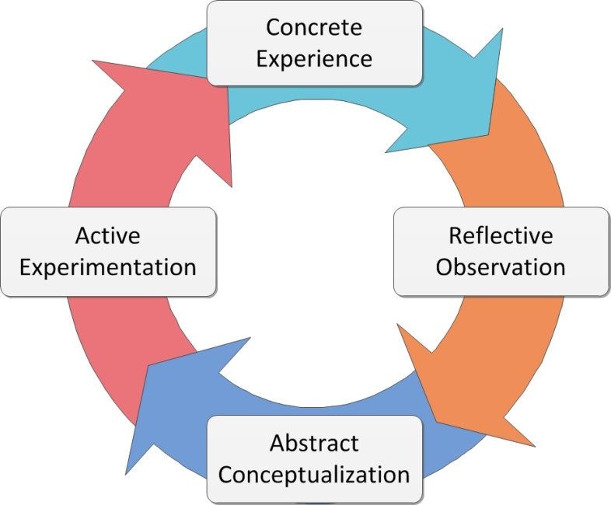
Figure: Kolb’s Model for experiential
Source: (Teaching Sex Ed, 2018)
Kolb gave the model 1984 to meet attitudes, values and beliefs. Here in this model, the four contents are involved which are very effective for the organisation Primark and for Customer Service Assistant. These components are described below:
Concrete experience: The learning must come from the concrete experience from the past situation in the life of individual. In Primark the experience of the customer service assistant come from long term working in the organisation and communicating to the customer effectively. This learning can create the values of the person and change the attitude of the assistant (Teaching Sex Ed, 2018).
Reflective observation: The observation comes from the reflective activities and from the past experience. A work which was done before this learning and further study can help to identify the reflective observation. This observation can indicate the attitudes, beliefs and values.

Abstract conceptualisation: After finishing the work, the key words and terms are actualised effectively and conceptualised the terms and applications. In Primark, the abstract and the past work based concepts must be actualised to meet the customer service effectively. This helps to build the attitudes and values and beliefs of the customer service assistant (Teaching Sex Ed, 2018).
Active experimentation: When the customer service assistant experiment the works actively this can help to know about the work effectively. This experimentation can help to build the attitudes and values to the customer service assistant in Primark.
The workplace attitude has some impacts. The first is; attitudes help to build and increase the jobs and complete the works in the workplace. The objectives are achieved by this time. The negative impression must be removed from the workplace by applying attitudes. So the workplace attitude has more and more impacts to the company.

5. Clear identification of a range of management theories to Customer Service Assistant role in Primark
There are six most popular management theories which are all effective for an organisation and can be applied to understand the organisation and its culture. The theories of the management are described below:
Scientific theory: Scientific theory of management which is given by F W Taylor includes only three elements these are task performance, supervision and motivation. These elements are applied to the organisation to analyse the performance of the employees effectively and then the supervision is applied to operate them in a right way at last the motivation is applied to the employees to inspire them to do the work effectively (Malinowski, 2014). These can help to be efficient economically and this is the objective of this theory of management. In Primark this theory can influence to the economy where the revenues can be increased from application of this theory.

System theory: The system theory of management includes the inputs, outputs and processes besides the feedbacks can be element of this theory. So from the theory this can be said that a management is bounded to informative system. In which the inputs are employees, raw materials and others and the productions are the processes of the organisation and the last products are the outcomes for the organization (Thomson, 2018). In this situation the products some can be defective then it must be back which can be feedback from the result. In this way the management theory is applied in Primark that is supposed.
Administrative theory: In the administrative management theory, there are fourteen principles which are actually related to the role of customer service assistant in Primark. Division of the work is the first principle of this theory, in Primark the assistant is provided the tasks which is divided by the manager of the organisation. In the customer service assistant, discipline is observed because the assistant communicate with the customer with showing the manner and good behave (Thomson, 2017). They maintain the manager’s works and time management. In this way each and every principles are interlinked with the role of customer service assistant.
About these three theories, Primark is conscious and that’s why the applications of these are accumulated by the customer services assistant effectively.
In Primark, the role of me is Customer Service Assistant which main job is to sell the products to the customers and deals with the customers about sales and complaints. There are some activities that I have t do in this organisation. These activities are given below with the examples,
- Build good relationship with the customers. This is the first job and task for a customer service assistant helps to build a good relationship with the customers to the customer service manager (Jaakkola et al, 2014).
- Deal with difficult or angry customers. The complaints from the customers have to be tackled by the customer service assistant. The problems are noted from the customers and then it is submitted to the customer service manager.
- Know and read the customer. The demand, want and expectation of the customer must have to be known by the company. In Primark, the customer service manager applies this role by the service assistant. The customer service assistant firstly read to the customers when they come in the location.
- Promote customer service throughout the organisation. As a customer service assistant, the person should have to promote the service using the name of organisation and brand loyalty. The customer service will be expressed by providing the service to the customers. Primark is a retail company that’s why the customer service should have to be promoted (Jaakkola et al, 2014).
- Work as a part of team. The customer service assistant is a part and individual of a team in the organisation. In retail shops, manager creates a team where the potential members are involved. Actually the customer service assistant must be involved in a team and work together.
- Assist to sales: In retail company to sell the products to the customers is the main job of customer service assistant. So when the sales executive deals with the customers, the sales assistant helps to the executive and the CRM to find out the products and fulfilling the customer’s needs. Sometimes the customers are confused to choice the products in Primark (Groovehq, 2018).
- Influence to purchase the product to the customers. This is an intelligent and figurehead role for the customer service assistant. When the customers come to the locations and choice the products, the assistant service people come to the customers in Primark. Then know about their choice and demands and according to the choice the product will be suggested.
In this section there are three theories are applied which are all very efficient and effective for this module. Here the role is Customer Service Assistant so this is relevant to these theories. These theories have some opportunities that are why the theories are relevant to the role in Primark efficiently. The opportunities are, the employees are managed effectively and controlled by these theories. The productivities are increased by applying these theories. These theories can give the concepts of management and easy management techniques which can help to maintain the communication with the customers and others.
Reflection from this assignment
This assignment is very informative and theoretical that’s why the reflection is high in this module. First of all this assignment includes different types of management theories and models. Which section is the best for an organisation; this can be learned by the assignment. The learning theories can be applied to the organisation which is a learning and reflective issue for me to learn.

Conclusion
After discussing the papers, theories and models in the workplace, it can be said that in the workplace the decision should be developed by thinking critically. To think critically in the organisation, the attitudes, values and beliefs must be analysed, assessed and evaluated which have been done in this assignment. In an organisation, a specific role and how the role can be related and analysed that was described in this assignment. Here the role was Customer Service Assistant and the organisation was Primark is Retail Company so this is relevant to this role. How the role affects to attitudes, beliefs and values in Primark these were analysed and assessed effectively. Then the management theories which can be related to this role were discussed and explained. What activities must have to be done in this organisation carrying the role, are described in this module.

References
- 2knowmyself. (2018). How beliefs affect behavior | 2KnowMySelf. [online] Available at: https://www.2knowmyself.com/how_beliefs_affect_behavior [Accessed 28 Dec. 2018].
- Donaldson, T., (2016). Values in tension. Business in Ethical Focus: An Anthology, p.198.
- Groovehq. (2018). The 10 Customer Service Roles That You Need To Be Good At (And How To Get Better At Each One). [online] Available at: https://www.groovehq.com/support/10-customer-service-roles [Accessed 16 Dec. 2018].
- Hughes, W. and Lavery, J., (2015). Critical Thinking: An Introduction to the Basic Skills-Canadian Seventh Edition. Broadview Press.
- Immigration Advisers Authority. (2018). Personal beliefs, values, attitudes and behaviour - Immigration Advisers Authority Your tagline here. [online] Available at: https://www.iaa.govt.nz/for-advisers/adviser-tools/ethics-toolkit/personal-beliefs-values-attitudes-and-behaviour/ [Accessed 17 Dec. 2018].
- Jaakkola, E. and Alexander, M., (2014). The role of customer engagement behavior in value co-creation: a service system perspective. Journal of service research, 17(3), pp.247-261.
- Kluegel, J.R. and Smith, E.R., (2017). Beliefs about inequality: Americans' views of what is and what ought to be. Routledge.
- Makinithappen. (2018). How do your values impact you at work or in your business? Business Mentoring, Business Coaching, Business Tips, Business Mentor, Business Coach. [online] Available at: http://makinithappen.co.uk/Articles/How-Do-Your-Values-Impact-You-At-Work-Or-In-Your-Business.html [Accessed 17 Dec. 2018].
- Malinowski, B., (2014). A Scientific Theory of Culture and Other Essays:[1944]. Routledge.
- McLeod, S., (2014). Attitudes and behavior. Retrieved on March, 10, p.2015.
- Miller, I. (2018). Top Ten Customer Service Duties. [online] Customerservicemanager.com. Available at: https://www.customerservicemanager.com/top-ten-customer-service-duties/ [Accessed 27 Dec. 2018].
- Petty, R.E., (2018). Attitudes and persuasion: Classic and contemporary approaches. Routledge.
- Primark. (2018). Primark - Homepage. [online] Available at: https://www.primark.com/en/homepage [Accessed 10 Dec. 2018].
- Primark. (2018). Primark - Our Stores. [online] Available at: https://www.primark.com/en/our-stores [Accessed 12 Dec. 2018].
- Primark. (2018). Primark - Products. [online] Available at: https://www.primark.com/en/products [Accessed 17 Dec. 2018].
- Teaching Sex Ed. (2018). Experience + Reflection = Experiential Learning. [online] Available at: https://teachingsexed.com/2014/11/11/experience-reflection-experiential-learning/ [Accessed 15 Dec. 2018].
- Thompson, J.D., (2017). Organizations in action: Social science bases of administrative theory. Routledge.
- Thomson, W., (2018). Theory of vibration with applications. CrC Press.
- Technofunc (2018). Management Theories. [online] Slideshare.net. Available at: https://www.slideshare.net/techno-func/techno-func-managementtheories [Accessed 17 Dec. 2018].

