

University of Wales Trinity Saint David
Motorsports Engineering Level 6
Application of CAE Processes

Preston Thomas
2305918

14/12/2025
3195 Words

Contents
1. Introduction 2
2. Literature Review 2
2.1 Introduction 2
2.2 Finite Element Analysis (FEA in ANSYS) 2
2.3 Computational Fluid Dynamics (CFD) 3
2.4 Thermal Studies and Multiphysics Integration 3
2.5 Comparisons with Other CAE Tools 3
2.6 Limitations of CAE as a Testing Bed 3
3. Assembly Modelling 4
3.1 Assembly Overview 4
3.2 Role and Limitation of Flywheel in Simulation 4
3.3 Justification for Selecting Piston Head 4
3.4 Summary 4
4. Kinematic and Structural Simulation Setup 4
4.1 ANSYS Model 4
4.2 Material Variations and Justification 5
4.3 Simulation Outputs and Metrics 5
4.4 Results and Analysis 5
4.4.1 Total Deformation 5
4.4.2 Equivalent Stress (von-Mises) 6
4.4.3 Equivalent Elastic Strain 6
4.4.4 Directional Deformation (X-Axis) 7
4.4.5 Conclusion 7
5. Weight Optimization 8
5.1 Piston Head Changes Made 8
6. Validation Methods 8
6.1 Cantilever with Uniform Load 8
7. Conclusion 9
9. References 10

1. Introduction
The use of computer aided engineering (CAE) has changed the way designing parts for vehicles works entirely. CAE reduces the number of physical prototypes used and therefore it reduces the amount of money spent on materials. It also means the time spent on machining the part for it to be tested is reduced. These factors greatly improve the efficiency of the design process however, CAE can suffer from oversimplification of data being inputted which can result in less accurate results. The time then needed to make the changes, as well as the program costs, could nullify the efficiency and cost gains made from using CAE in the first place. It also has a slight barrier of entry, however this is less of a problem now as CAE is a more common process. This problem could still be relevant, as if an engineer who is trained to use one system must change to another, it may take some time and extra training, which again will cost more money. This assignment aims to explore both the advantages and limitations of different CAE processes and systems using data collected to come to evidence and research-based conclusions.

2. Literature Review

2.1 Introduction
CAE has become an essential tool for testing part designs and helping development allowing engineers to evaluate the structural, thermal and fluid performance before making commitments to making costly physical prototypes. There are many different CAE programs such as: SolidWorks Simulation, Autodesk CFD and ANSYS this assignments evidence portion will only cover ANSYS however using information gathered in this literature review comparisons will be made. ANSYS has a comprehensive list of capabilities which encompasses finite element analysis (FEA), computational fluid dynamics (CFD) and thermal studies. Academic studies show how ANSYS can be used to help optimise a components geometry and reduce the material consumption while also ensuring that it is structurally sound. This demonstrates its CAEs role in design as a test bed prior to manufacturing. An example of this would be Wang (2016) applied ANSYS Workbench to perform a static analysis and size optimisation on a milling machine bed, this assisted in them being able to make the bed lightweight without compromising its strength. Another example would be, Madenci and Guven (2015) when they emphasise the application of FEA in ANSYS using it to predict stress, strain and deformation. Another area of CAE that ANSYS deals with is CFD which extends the testing ability to fluid flow which helps engineers to replicate some more complex operating conditions such as how a fluid moves through pipes. Altogether these studies help illustrate the use of CAE and specifically ANSYS, as test beds that assist in turning theoretical analysis into a smooth process leading to a more accurate final design.

2.2 Finite Element Analysis (FEA in ANSYS)
ANSYS is recognised for its impressive FEA capabilities which enables engineers to predict the stress, strain and deformations of parts and designs under realistic loading conditions. Madenci and Guven (2015) highlight how ANSYS can be applied across a design to help evaluate the structural integrity before manufacturing, this works as evidence to prove the value of this resource and its capabilities in reducing prototyping costs. FEA inside of ANSYS also supports iterative optimisation which allows engineers to refine a components geometry for weight reduction while maintain the strength of the component, this is an integral part of motorsports. Wang (2016) Provides a more practical example due to ANSYS Workbench and then Modelling being used to optimise a milling machine bed helping to achieve a lightweight design without losing key properties needed for it to function correctly. These studies enforce the value of ANSYS as a virtual test bed for structural performance.

2.3 Computational Fluid Dynamics (CFD)
Beyond the structural analysis performance capabilities, ANSYS can also be utilised through the use of CFD. This enables engineers to replicate complex operating conditions such as airflow around a vehicle, cooling engine bays and fluid movement through pipes. Liu (2024) demonstrated how the use of CFD modelling in ANSYS can help reduce aerodynamic drag and improve efficiency of components on a car. Likewise, Quispe and Velarde (2025) conducted a study on CFD of a car model using ANSYS Fluent which focussed solely on the external aerodynamics of the model. Their works highlighted the importance of drag and lift predictions and how they affect fuel efficiency and the cars stability, this reinforces CFDs role as a virtual wind tunnel which can be used before completing physical validation. The studies referenced above shows how the extensive abilities of CAE processes assist directly with the manufacture of parts in automotive and motorsports spaces.

2.4 Thermal Studies and Multiphysics Integration
ANSYS also incorporates thermal analysis which allows engineers to evaluate how elevated temperatures may affect a materials properties and its fatigue life. This is extremely integral to motorsports engineering alongside with the structural simulations, where components are exposed to incredibly high thermal loads. ANSYS Motor-CAD has been applied to these high-performance situations notedly in the motors used in Formula E and hybrid racing, enabling engineers to model cooling systems such as water jackets and fans. Giglio (2024) used Motor-CAD to predict the thermal response of these electric motors to help ensure they would remain within a safe operating range during a race. This highlights ANSYS’s role in motorsports as thermal management is key to have a safe and sustainable practice in races.

2.5 Comparisons with Other CAE Tools
While ANSYS is the focus of this assignment there are other CAE programs that can provide a useful viewpoint from comparison. Abaqus is often preferred for things such as nonlinear crash simulations and advanced material modelling. Altair OptiStruct is best used in optimisation driven designs for lighter structures. Siemens NX Nastran is used often in aerospace vibration analysis. Laaksonen (2024) compared the thermos-mechanical analyses in ANSYS and Abaqus they noted that Abaqus handled nonlinear fracture mechanics better however, ANSYS was able to use a broader scope to integrate Multiphysics. Thes comparisons show how versatile ANSYS truly is but also shows that more specialised programs may be used and outperform it when applied properly.

2.6 Limitations of CAE as a Testing Bed
Despite all the advantages covered in the above literature review CAE doe not come without some limitations. Werkle (2021) proves that FEA results depend on the mesh quality and boundary conditions assumed. Requiring validation through the use of analytical solutions. The study by Kuttasirisuk et al (2025) shows the importance of simulation when dealing with aerodynamics in motorsport. Validating CFD predictions against scaled models. These studies prove that it is imperative that validation is done to make sure the solver is functioning correctly, this is something that will be further delved into later in this assignment.

3. Assembly Modelling

3.1 Assembly Overview
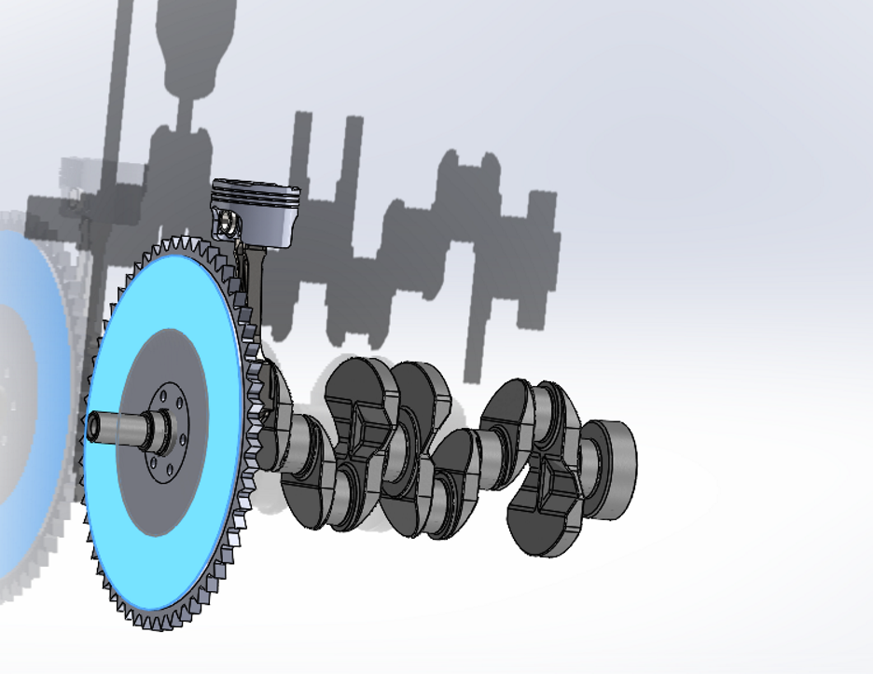
Figure 1 Assembly
The crankshaft assembly modelled above is an example of a typical internal combustion engine (ICE). It incorporates some of the key components such as the crankshaft, Connecting rod, piston head, gudgeon pin and flywheel. This engine set up is used to convert the reciprocating motion of the piston into rotational motion. The addition of the flywheel gives extra rotational stability by storing kinetic energy and smoothing out torque fluctuations in between combustion cycles.

3.2 Role and Limitation of Flywheel in Simulation
While the addition of the flywheel is realistic and important to the assembly it was not selected as the component that the simulation tests would be conducted on. The flywheels main role is inertial which means under normal operating conditions the stress distribution is very uniform. Unless it is subjected to extreme vibrations or an imbalance the flywheel does not usually have high-risk failure zones that could be improved using FEA. These factors as well as its symmetrical geometry and predictable load makes it less suitable for capturing more complex and interesting stress gradients, this also makes it more difficult to identify fatigue-prone areas.
If the simulation was conducted on the flywheel, it would have led to limited information when investigating deformation or thermal effects. For this assignment the piston head will be the focus point.

3.3 Justification for Selecting Piston Head
The piston head was chosen as the focal point for the simulations due to its exposure to intense mechanical and thermal loads. It is exposed to high-pressure combustion gases as well as undergoing high and rapid temperature changes. This makes it the best option for stress and thermal analysis in ANSYS. Sections such as the ring grooves, crown and the gudgeon pin holes experience high stress and have potential to fail under the load.

3.4 Summary
While the flywheel contributes to the dynamic stability of the crankshaft assembly due to the lack of potential information it was the less obvious choice of the two. The piston head offers a more complex testing environment meaning validation is key and performance optimisation is possible.

4. Kinematic and Structural Simulation Setup

4.1 ANSYS Model
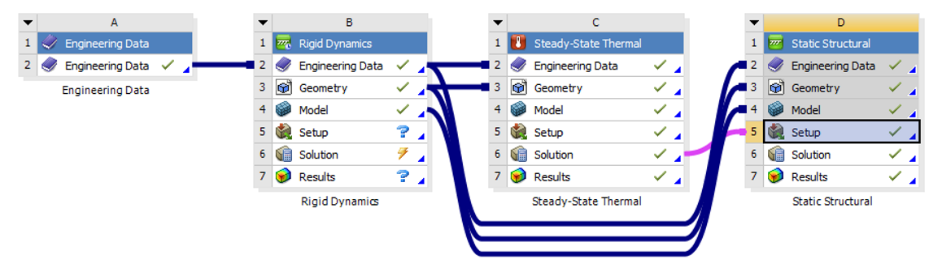
Figure 2 ANSYS Model
To properly evaluate the mechanical and thermal properties of the piston head under load conditions a Multiphysics simulation was created in ANSYS Workbench that could then be applied to the model. Rigid body dynamics were applied to the model so it can simulate the kinematic motion of the assembly. Then the steady-state thermal and static structural analyses were connected to help assess stress and deformation response under thermal and mechanical loads. The simulation was structured to ensure the data could be used in the multiple models, with the geometry and material data being shared throughout them all.

4.2 Material Variations and Justification
With the piston head being selected as the primary test component due to factors previously spoken about an investigation into relevant materials was conducted. To gather a range of information three materials were picked and applied they were: aluminium alloy, titanium alloy and cast iron. These materials were chosen based on automotive and motorsports relevance, each of them offering distinct trade offs in terms of thermal conductivity, strength to weight ratio and elastic modulus.
- Aluminium alloy is lightweight and has high thermal conductivity this makes it a suitable option for heat dissipation however, it can be prone to higher amounts of deformation under load.
- Titanium alloy offers an incredible strength and fatigue resistance with okay thermal conductivity and is often used for high performance racing components.
- Cast iron provides a high stiffness and damping but its weight is high and it doesn’t have as much thermal response.
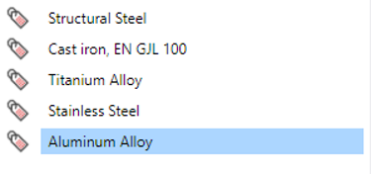
Figure 3 Material List

4.3 Simulation Outputs and Metrics
For each material chosen the same data was extracted from the simulation these data sets were:
- Temperature distribution: this was collected using the steady-state thermal analysis to assess heat accumulation and dissipation across the piston head.
- Equivalent (von-Mises) stress: this data tells the engineers how likely it is for the component to yield under the combination of loads.
- Body temperature: a global measure of the component’s exposure to heat.
- Total deformation: this indicates to what extent the part suffers with displacement under the selected loads.
- Equivalent elastic strain: this reflects the materials elastic response to stress.
- Directional deformation: shows the deformation is a specific axis in this case it was the X-axis.
These results were then turned into heat maps for each material to show a clearer and more direct method of comparison.

4.4 Results and Analysis

4.4.1 Total Deformation

4.4.1.1 Aluminium Alloy
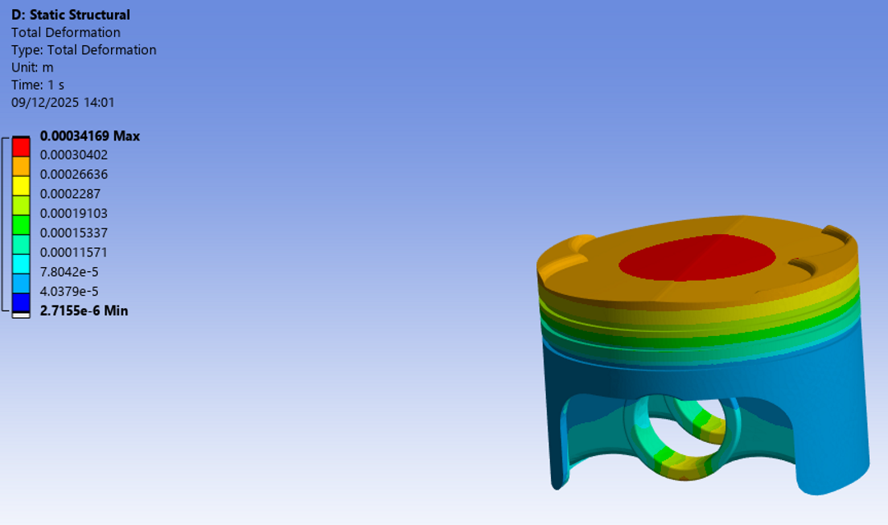
Figure 4 Aluminium Alloy Total Deformation
Deformation ranged from 2.71*10^-6m to 0.00417m with the piston heads crown showing the largest displacement. Aluminium’s lower stiffness explains this high deformation which has the prospect of affecting the sealing performance.

4.4.1.2 Titanium Alloy
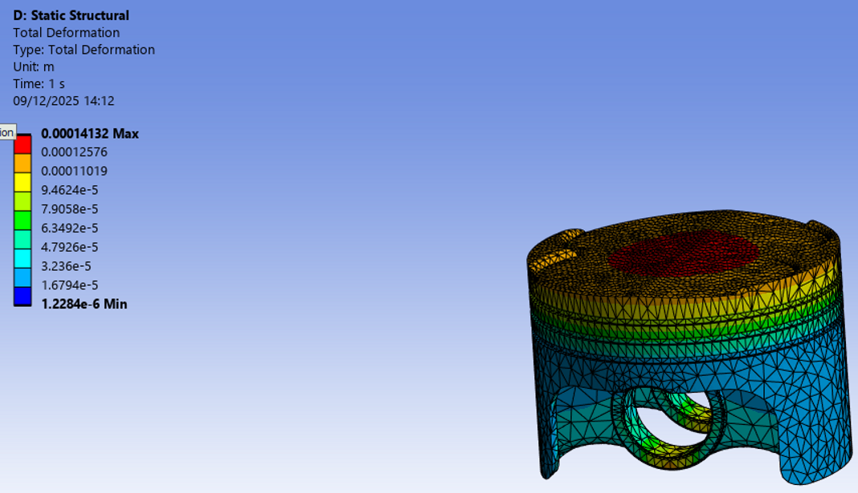
Figure 5 Titanium Alloy Total Deformation
Values for this material ranged from 1.23*10^-6m to 0.000141m in comparison to aluminium this is much lower. Due to titanium’s high stiffness stability under load should be expected.

4.4.1.3 Cast Iron
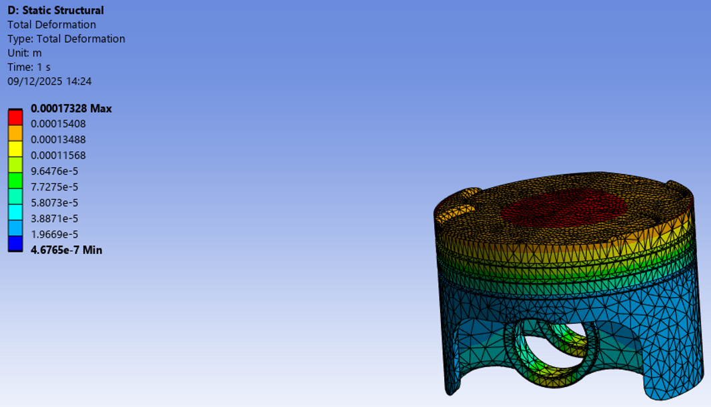
Figure 6 Cast Iron Total Deformation
The deformation ranged from 4.68*10^-7m to 0.000173m this is slightly higher than titanium but much lower than aluminium. The crown deflection remains moderate, but this is consistent with cast irons stiffness.

4.4.2 Equivalent Stress (von-Mises)

4.4.2.1 Aluminium Alloy
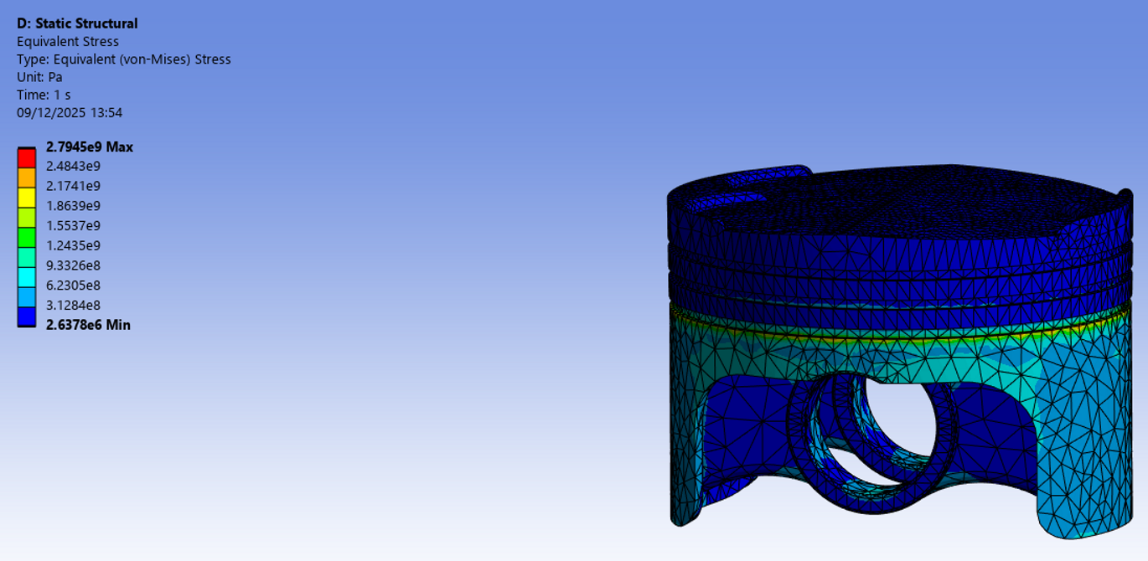
Figure 7 Aluminium Alloy Equivalent (von-Mises) Stress
The stress ranged from 2.64 MPa to 2.79 GPa around the areas that are lighter on material such as the ring grooves or the gudgeon pin holes. Aluminium is closer to its yield threshold than the other materials.

4.4.2.2 Titanium Alloy
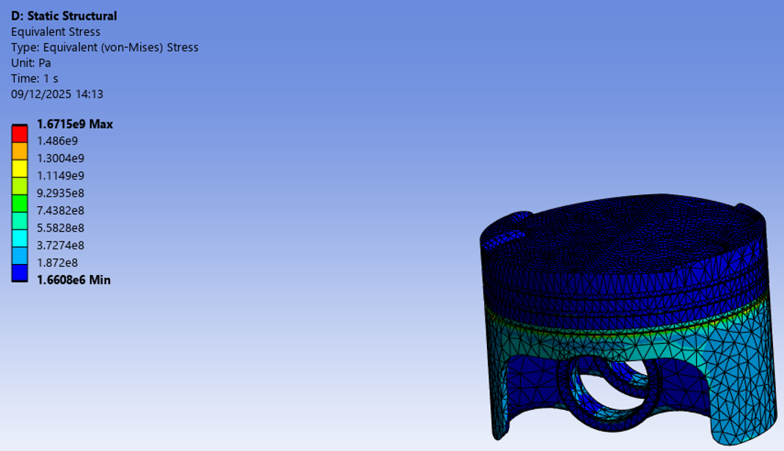
Figure 8 Titanium Alloy Equivalent (von-Mises) Stress
Stress ranges from 1.66 MPa to 1.47 GPa with peaks in similar areas to the aluminium alloy however it is far from its point of yield which confirms its ability to resist stress.

4.4.2.3 Cast Iron
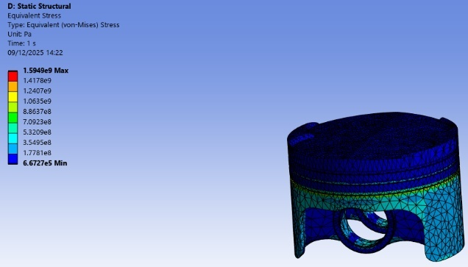
Figure 9 Cast Iron Equivalent (von-Mises) Stress
Cast irons stress ranges from 0.67 MPa to 1.49 GPa with the stress once again appearing in the same areas. This material can withstand stress however it is brittle and this can raise concerns as cracks can form.

4.4.3 Equivalent Elastic Strain

4.4.3.1 Aluminium Alloy
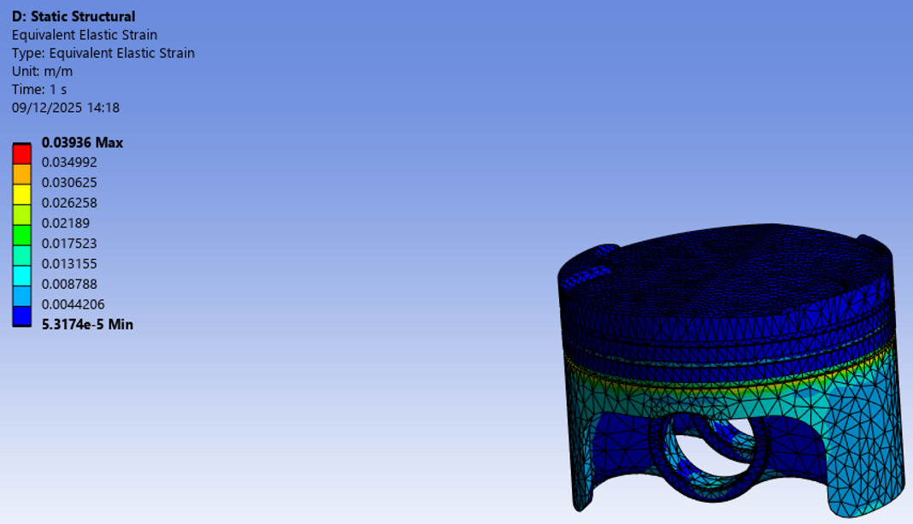
Figure 10 Aluminium Alloy Equivalent Elastic Strain
Strain ranged from 5.32*10^-6 to 0.04396 peaking around the third ring groove. This high strain shows us aluminium’s impressive flexibility however this can become concerning.

4.4.3.2 Titanium Alloy
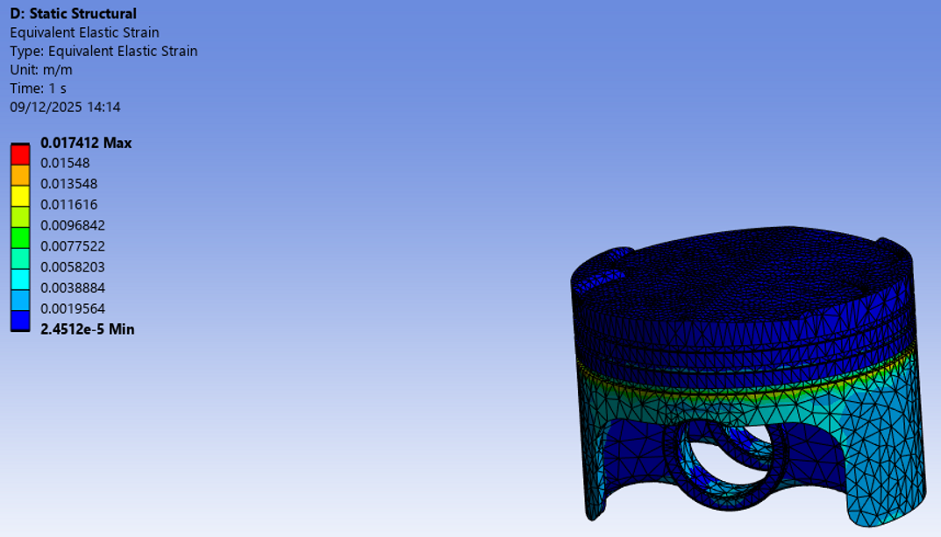
Figure 11 Titanium Alloy Equivalent Elastic Strain
The strain for titanium alloy ranged from 2.42*10^-6 to 0.01741 concentrated in a similar spot. The strain is lower in comparison to aluminium alloy which indicates that titanium has a better fatigue resistance.

4.4.3.3 Cast Iron
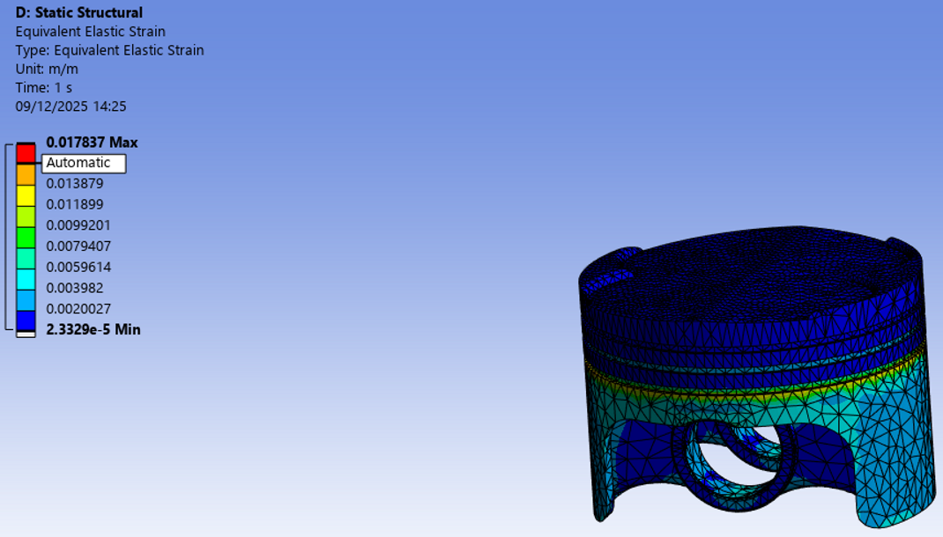
Figure 12 Cast Iron Equivalent Elastic Strain
Cast irons strain was from 2.38*10^-6 to 0.01739 which is a slightly smaller range than titanium’s however it has a higher deformation meaning it has limited toughness.

4.4.4 Directional Deformation (X-Axis)

4.4.4.1 Aluminium Alloy
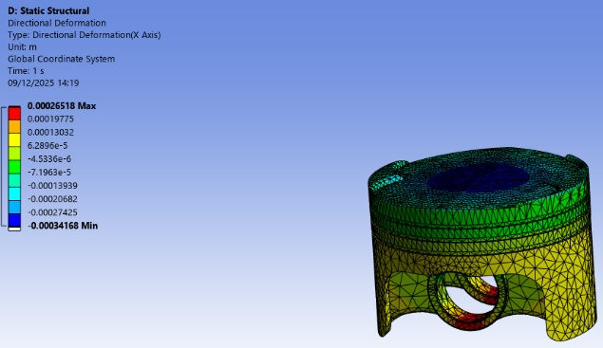
Figure 13 Aluminium Alloy Direction Deformation
These Values range from -0.00342m to 0.00265m which shows the lateral strain areas to be the pin bosses. This high directional deformation is due to aluminium’s flexibility which makes it prone to distortion.

4.4.4.2 Titanium Alloy
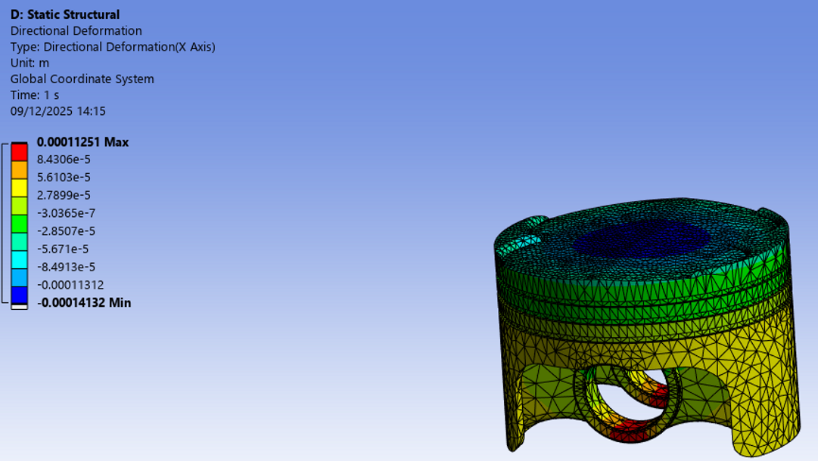
Figure 14 Titanium Alloy Direction Deformation
The directional deformation for titanium alloy ranges from -0.000113m to 0.000113m showing very minimal displacement. Titanium’s stiffness limits how bad the distortion is which helps with maintain the pistons shape and alignment.

4.4.4.3 Cast Iron
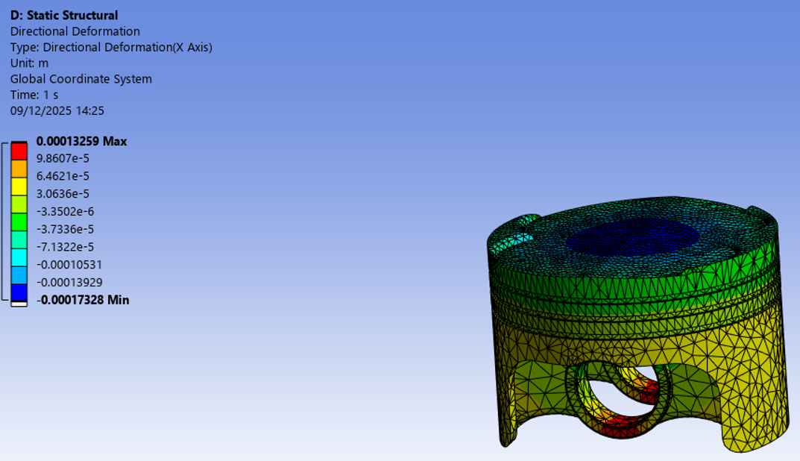
Figure 15 Cast Iron Direction Deformation
The values for cast iron ranged from -0.000713m to 0.000133m showing a moderate level of displacement. Whilst its range is within its limits cast iron can be brittle making it less forgiving than aluminium for example.

4.4.5 Conclusion
Throughout all of the simulations titanium alloy presented itself as the most balance in terms of performance. It had the lowest total and directional deformation, and it maintained a high resistance to stress without approaching its yield point. It also had a lower strain compared to aluminium and cast iron. While aluminium showed incredible thermal conductivity its high deformation and strain raise concerns for the life of the material. Cast iron provided stiffness and moderate deformation control but due to it being brittle it is a less desirable option for motorsports.

5. Weight Optimization

5.1 Piston Head Changes Made
After choosing titanium alloy this allowed for an extreme weight reduction to take place. The simulation results showed titanium had the lowest total and directional deformation, lower elastic strain and high von-mises stress tolerance. The values collected allowed for material to be removed in the low stress areas without compromising areas like the pin bosses.
Reducing the pistons mass improves the engine dynamics. This means there will be lower inertia which decreases the tensile and compressive loads at both TDC (top dead centre) and BDC (bottom dead centre) which decreases the stress values on the con rod and then crankshaft. It also helps with increased RPMs and improves ring sealing whilst helping to reduce wear on the edges. These improvements are key to increasing responsiveness and durability for a car.
Design choices such as altering the pin hole shapes to be more exact, changing the edges to be less prone to damage and crating pockets under the crown to reduce the overall weight. Stress remains concentrated at the crown centre confirming that the lightened geometry was safe and the loads were being delivered in the correct places. Titanium’s fatigue resistance and stiffness made it the best option out of the three for weight reduction.
In conclusion, titanium’s performance made it the valid option and allowed for more weight reduction overall which in turn would help with improving the vehicle even further.

6. Validation Methods

6.1 Cantilever with Uniform Load
The material chosen was titanium alloy with an elasticity modulus (E) of 115 GPa, a poisson’s ratio (V) of 0.32 and shear modulus (G) of 44 GPa. The average pressure for a motorsport’s vehicle is 20 MPa. The radius of the crown is 0.071m.
$$M=\frac{q{\left(L-x\right)}^{2}}{2}$$
Where M is the bending moment for the top of the piston head under continuous loading and q=F/L.
$$A=π{\left(\frac{0.07}{2}\right)}^{2}=0.00385 m^{2}$$
$$F=pA=1.6∙{10}^{6}∙0.00385=6160 N$$
$$q=\frac{F}{L}=\frac{6160}{0.07}=88000 N/m$$
$$p=\frac{q}{b}$$
$$p=\frac{88000}{0.055}=1.6∙{10}^{6}Pa$$
This validation confirms the pressure at the crown in the simulations is correct which confirms that the simulation is operating properly.
6.2 Mesh Comparison
The difference in mesh sizes has an impact on the accuracy and efficiency of the FEA. In this study a 4mm mesh was used for the main bulk of the piston head. This provided a faster analysis time, but it produced rougher stress distribution which under-represented some areas.
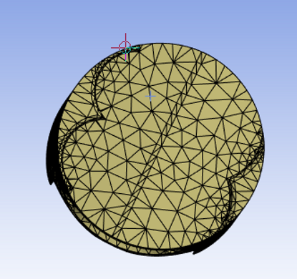
Figure 16 4mm Mesh
A 2mm mesh was applied to the crown of the piston head this makes it easier to capture finer geometric details making it more accurate to the theoretical calculations. This comparison highlights the trade-offs made to increase the precision of the solver, as the 2mm mesh took longer to gather the data.
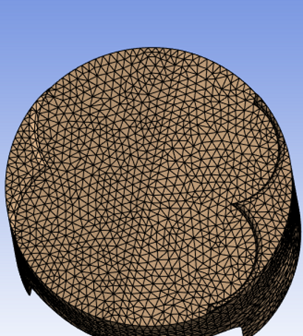
Figure 17 2mm Mesh

7. Conclusion
This study demonstrated the pivotal role CAE plays in the design process in improving efficiency and cost as it removes the necessity for multiple prototypes needing to be made to test. By applying calculations of bending moments to the crown of the piston head the simulations data can be checked and validated to make sure it is running accurately. After completing those because we know that number is being calculated correctly by the simulation, we can then trust that other numbers will be correct if we change anything. Without these simulations it would be impossible to really capture the stress changes throughout the model.
CAE’s role in the motorsport’s world is even more integral as it increases the design iteration stages and allows changes to be made fast if needed. This fact also means engineers are able to explore more adventurous ideas that previously would have cost them a lot of money and time.

9. References
- Academia.edu (n.d.) Finite Elements in Structural Analysis. Available at: https://www.academia.edu/125074409/Finite_Elements_in_Structural_Analysis
- Liu, Y. (2024) Harnessing CFD Modeling Techniques for Optimizing Automotive Streamlines and Reducing Aerodynamic Drag. ResearchGate. Available at: https://www.researchgate.net/profile/Yipeng-Liu-15/publication/377745256_Harnessing_CFD_Modeling_Techniques_for_Optimizing_Automotive_Streamlines_and_Reducing_Aerodynamic_Drag
- Lund University (2020) Master’s Thesis: Structural Analysis using ANSYS Workbench. Available at: https://lup.lub.lu.se/luur/download?func=downloadFile&recordOId=9185227&fileOId=9185666
- MDPI (2025) Article in Vehicles Journal. Available at: https://www.mdpi.com/2673-3951/6/3/105
- Mechanical Journals (2023) Mechanics of Solids. Available at: https://www.mechanicaljournals.com/mechanics-solids/article/32/5-2-8-950.pdf
- Mechanical Journals (2023) International Journal of Automotive Engineering. Available at: https://www.mechanicaljournals.com/ijae/article/48/6-1-6-668.pdf
- Ozen Engineering (2022) ANSYS Motor-CAD Thermal Analysis. Available at: https://blog.ozeninc.com/resources/ansys-motor-cad-thermal-analysis
- ReadFast (2021) ANSYS vs Abaqus. Available at: https://readfast.in/ansys-vs-abaqus/
- SAE Mobilus (2022) Towards a Standardized Assessment of Automotive Aerodynamic CFD Prediction Capability (AutoCFD 2 – Ford DrivAer Test Case Summary). Available at: https://saemobilus.sae.org/papers/towards-a-standardized-assessment-automotive-aerodynamic-cfd-prediction-capability-autocfd-2-ford-drivaer-test-case-summary-2022-01-0886
- Springer (2020) The Finite Element Method and Applications. Available at: https://link.springer.com/book/10.1007/978-3-030-49840-5
- Springer (2024) Chapter: Advances in Automotive Engineering. Available at: https://link.springer.com/chapter/10.1007/978-981-99-6343-0_1
- WebLibrary Mila (2015) The Finite Element Method and Applications. Available at: https://weblibrary.mila.edu.my/upload/ebook/engineering/2015_Book_TheFiniteElementMethodAndAppli.pdf
- Zhang, H. (2017) Static Analysis and Size Optimization for the Bed of Gantry Milling Machine based on ANSYS Workbench. ResearchGate. Available at: https://www.researchgate.net/publication/322157897_Static_Analysis_and_Size_Optimization_for_the_Bed_of_Gantry_Milling_Machine_based_on_ANSYS_Workbench_Selected_Papers_from_CSMA2016

