
Student Name -Aemanben Anwarbhai Dhanani
Student id -2525496

Module Name: International Business Concepts
Module Code: LCMB7034

Lecturer name - Gladius Kulothungan

Table of Contents
Section 1 3
1. Organizational Classification and Global Strategy 3
2. Macro-Environment Appraisal and Market Attractiveness 6
Host Country Analysis (Political, Economic, Legal, and Cultural) 6
Market Entry: Synthesis using Electric Paradigm (OLI Framework) 9
Implications for Entry Success 11
3. Entry Mode Strategy and Strategic Analysis 12
Historical Pattern Recognition 12
Strategic Fit and Justification for India 13
Conclusion and Recommendations 14
Section 2 14
Reflection using Gibbs Reflective Cycle 14
References 18

Section 1

1. Organizational Classification and Global Strategy
Bartlett and Ghoshal’s (1989) introduced an important model to manage a business that operates on global scale. There are two key factors in the process suggested by this framework. One is the potential cost gains from being internationally integrated in areas of production and marketing. Another is the pressure of responding to local market conditions (Macro and Ott, 2024). This model positions multinational companies as per their historical background and derives typology in an international context.
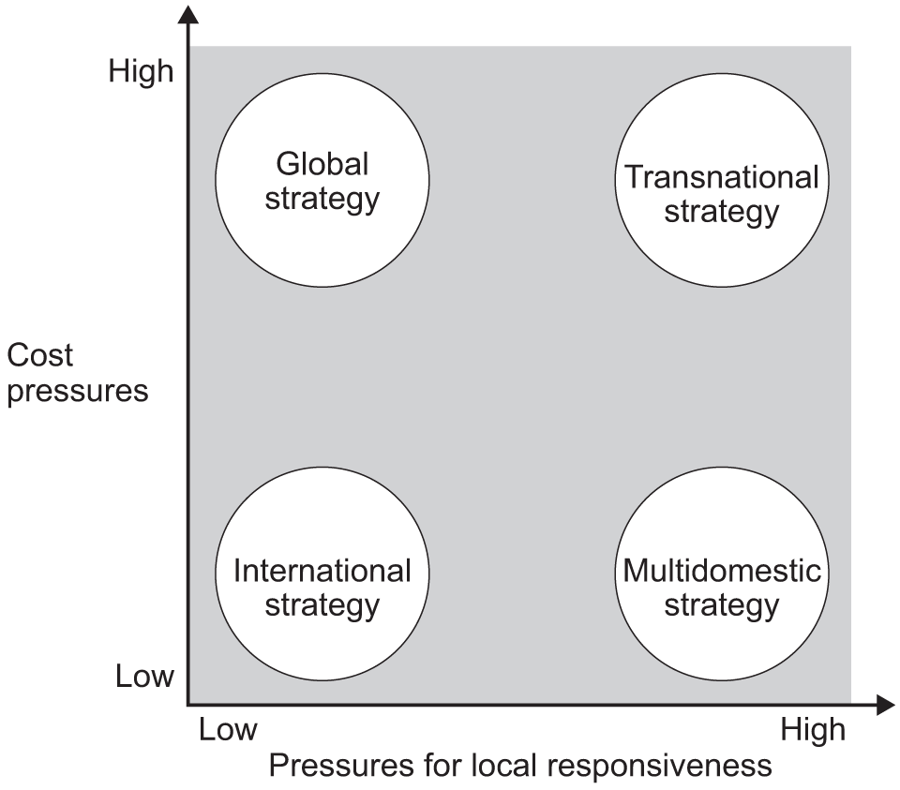
Bartlett and Ghoshal's Framework
Source: [AQA, 2024]
This model classifies Tesla as pursuing a transnational strategy. This approach requires a high level of global integration and local responsiveness. Global integration puts a significant pressure on the company because battery technologies and EV platforms require massive fixed investment. The automaker has its R&D centralized in the US with standardized vehicle architectures. They use their own sales channel to get a high advantage in its product development process and give a better buying experience to the customers (Zucci, et. al., 2026).
Their unified brand proposition provides them cost-efficiency across markets. Tesla also transfers battery chemistry and over-the-air software updates from their headquarters to subsidiaries. Their future plan is to enter the market through a manufacturing plant with an annual capacity of 500,000 vehicles by investing $2 to $3 billion. It will make their products affordable within that ₹20 to ₹25 lakh range which appeals to Indian customers (Kabirdas, 2025). However, the discussions are ongoing between the company and government officials but no official statement is released in public.
The local responsiveness pressures are also significant for the organization. Every country has different safety regulations, tariffs, and charging standards. Even the consumer preferences for pricing and energy infrastructure are different. Tesla has responded by making Giga factories in Shanghai and Berlin instead of relying on exports from the US. The objective is to serve local demands and minimize logistics costs.

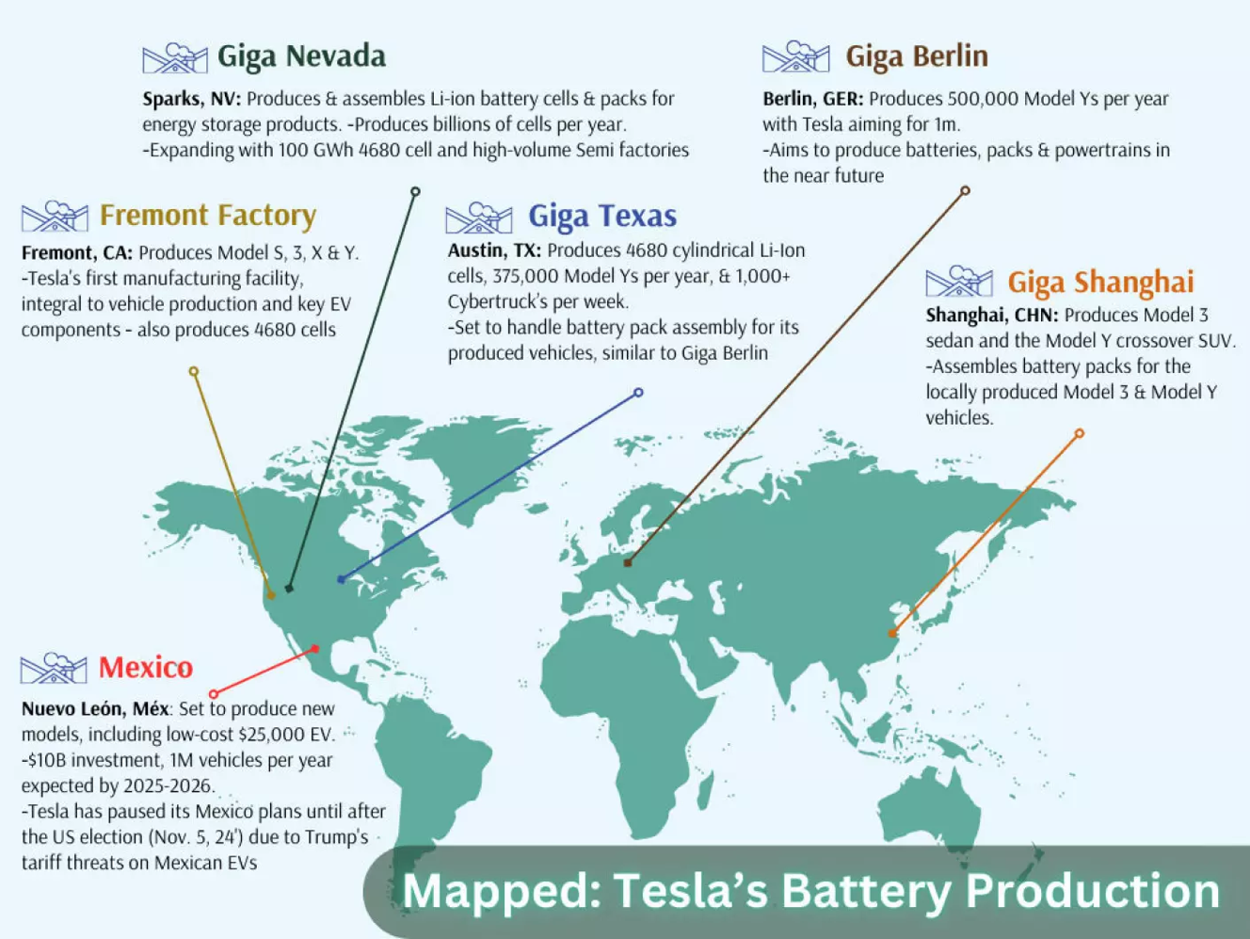
Tesla’s Battery Production Facilities
Source: [Ozsevim, 2025]
The Shanghai gigafactory has become a critical hub for EV production. It is dedicated to making two of their popular models, including the Model 3 sedan and the Model Y crossover SUV. They have achieved an annual production of more than 750,000 vehicles (Ozsevim, 2025).
It is important to understand that this transnational posture is asymmetric and imperfect. This high level of standardization limits them to perform true market-by-market customization. A centralized decision-making also creates tensions in markets like in India, where international automakers face high tariffs. As a result, it limits the competitive positioning of the company against localized rivals. It exposes them to political and trade policy risks in foreign markets.
Global Configuration
Tesla’s geographic footprint is based on three cluster including North America, China and Europe. Most of their cars are manufactured in California, Austin, Shanghai and Berlin. Here, Shanghai is important for both Chinese demand as well as other regions. The regional gigafactory gives them a proximity to large demand centers so the vehicles can be delivered fast (Teguh and Fauzan, 2026). A locally produced vehicle helps them to avoid any tariffs and give customers products at affordable costs. A network also gives economies of scale in battery cells that cannot be matched with pure exporters. Tesla has its proprietary supercharger infrastructure with vehicle data feedback loop for providing their products across geographies. This kind of diversified manufacturing protects them from geopolitical shocks and a single supply chain.
One limitation is the concentration of the footprint in only specific regions. They have a limited presence in India because they only began in 2025 with modest deliveries of model Y (Jha, 2026). This is a significant gap that highlight incomplete geographic coverage. Overall, the current configuration supports Tesla's overall competitive advantage. An incomplete coverage in high-growth markets shows the company is missing a significant market-share.

2. Macro-Environment Appraisal and Market Attractiveness

Host Country Analysis (Political, Economic, Legal, and Cultural)
India represents a crucial market from a strategic standpoint. Here, the industry is witnessing a growing but challenging phase for global EV manufacturers. The potential is not long-term, being the world's largest automotive market by volume. The retail-first model of Tesla must navigate a complex interplay of political, economic, and other forces. This analysis covers crucial factors to the EV industry and Tesla's approach towards the market.
Political: The government shows support towards electrification but oriented towards domestic manufacturing. They have a target of 30% EV penetration of new vehicle sales by 2030 (Amir, 2025). The government also took the PM e-drive initiatives in 2024 to accelerate the adoption of EVs by funding public transit like e-buses and building fast charging networks through a voucher system (Revoltmotors, 2025). This initiative provides production-linked incentives for advanced chemistry cells as well as automotive components. The state level policies provide land and tax benefits for EVs in industrial power houses like Maharashtra, Gujarat, Tamil Nadu etc. (Ojha, 2026).
Tesla must consider that all supportive measures in the market are coupled with ‘Make in India’ policy that privileges local production. The country has introduced a conditional tariff reduction that provides manufacturers a reduced custom duty of 15%. However, the condition is that they have to invest at least $500 million and setup manufacturing facilities within three years to import limited volume of premium EVs (Dhanoa, 2025). It puts a full duty burden on foreign companies willing to enter the market. This policy design provides political support for EVs but the terms of market access require capital-intensive localization.
Economic: The macroeconomic outlook of India is favorable for Tesla. Inflation is moderating and the Reserve Bank of India is also finding ways of monetary ease. The relief from high US tariffs has given boost to investments (Majumdar and Ghatak, 2026). The nation is growing with resilience, and the middle class is also able to spend more than before. There are a rising number of households with discretionary spending in metropolitan cities. Many customers are showing interest in buying Tesla because of the popularity of Elon Musk but the price range is making them hesitate. The Model Y is priced at $70,000 which is higher than any other major market in the world. The Model Y competes with premium electric SUVs like Mercedes-Benz EQB, Kia EV6, etc (Aljazeera, 2025).
The EV market is rapidly expanding with an estimated market size of more than $10 billion which is growing with a 40.7% CAGR from 2050 to 2030 (Grandviewresearch, 2026). The main driver of this growth is the initiatives and subsidies for infrastructure development. Even the customers are getting more aware about environmental sustainability that makes them buy EVs.
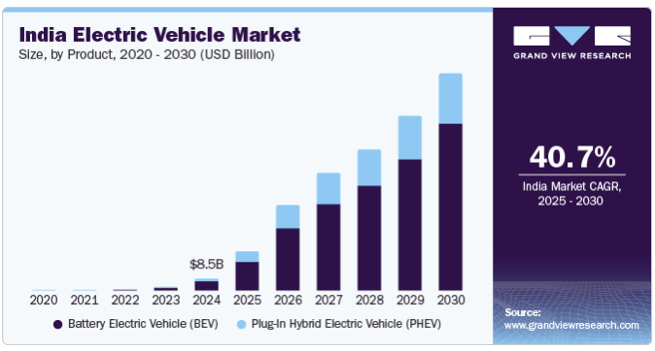
India Electric Vehicle Market
Source: [Grandviewresearch, 2026]
India’s market in EVs is led by Tata Motors (40% market share), Mahindra and MG Motor (Autopanditz, 2026). Majority of the market lies below the range of INR 20 to 25 lakhs. Here, Tesla’s imported Model Y is very costly after duties that position it int a luxury niche. Moreover, there are approximately 30,000 charging stations in the country but the EV-to-public-charger ratio is much less than global benchmarks (Sathaye, 2025). It can cost significantly if Tesla tries to make a charging network due to high tariffs for commercial charging and land acquisition difficulties in dense urban areas. However, the company has a huge opportunity due to rising fuel prices and low operating costs of electric vehicles.
Legal: The regulatory environment in the country provides full support to foreign direct investment in automotive industry. Yet, it creates some barriers for foreign entrants with high duties. They have to follow Bureau of Indian Standards (BIS) norms and battery safety and recycling regulations. It adds compliance cost and time to the company's operations. Even the data protection framework can affect the cloud-based software updates of Tesla and full self-driving data flows. The company is showing less interest in setting up a plant but Elon Musk is keeping his options open in hope for a trade deal for reducing duties. Now the only viable path is local manufacturing to cover the huge size of the market. It would take a lot of time to adapt Tesla's supply chain to the Indian ecosystem because it is heavily centralized (Caalley, 2025).
Tesla’s competitive edge heavily depends on their software which creates concerns regarding intellectual property protection laws. It is easy to manage the labor and environmental regulations in manufacturing. However, a lack of factory means the automaker does not have the full suite of industrial and labor codes. Every state has their own policies regarding EVs which puts an additional layer of legal complexity in the nation-wide network roll-out. All these aspects raise the relative cost of a non-localized strategy. The legal regime is open to FDI (foreign direct investment) in the industry that is 100% under the automatic route (Lexology, 2026). Its main conditions include compliance with environmental regulations and quality standards as per Indian laws. The local sourcing norms are encouraged but not kept mandatory.
Cultural: The customer behavior is a decisive factor for the current strategy of Tesla’s limited presence. The customers are highly value-conscious and status-oriented, even in higher income brackets. They want both practical and symbolic functions and a premium foreign brand signals success (Achrekar, 2021). Still, there are some other factors that influence their decisions such as service network density and long-term reliability. The brand is associated with technological leadership and high network individuals who show willingness to buy the cars from the company. They want Tesla to make cars that are adapted to Indian conditions like high ground clearance and robust suspension for variable road quality.
Range anxiety is a crucial factor among customers due to dense urban congestion with uneven public infrastructure. People are showing trust in the new technology but after-sales service still faces skepticism. The environment is harsh, with heat and dust conditions which can create doubts on the longevity of batteries. The youngsters are aware of worsening urban air quality but it is not a major driver for EV purchase when the price is high. In 2026, the nation has already reached a sale of 2.66 million units which was 2.05 million in 2025 (IBEF, 2026).

All these factors can constrain the accessible market under the high-price import model because people get attracted towards localized product adaptation. A trusted charging network and dense service coverage is not easy for Tesla to deliver at scale without deep operational commitment.
Overall, the host-country environment shows a high potential market with some frictions. The economic and political forces give a large opportunity with a legal design to penalize non-localising strategies. The company’s retail-first entry create brand presence and provides demand data. However, the microenvironment limits volume and margin potential until Tesla addresses the localization pressures.

Market Entry: Synthesis using Electric Paradigm (OLI Framework)
British economist J.H dunning developed eclectic paradigm to analyze the attractiveness of making a foreign direct investment. It is also known as the OLI framework that contains three tiers. This model assumes that organizations are not likely to follow through with FDI if they can get the product internally at a low cost (CFI, 2020).
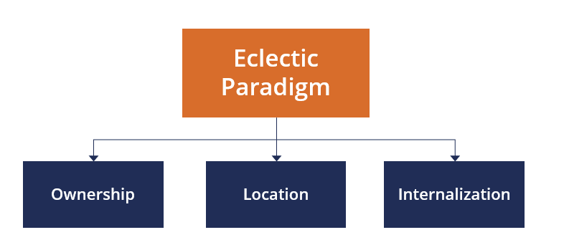
Eclectic Paradigm / OLI Framework
Source: [CFI, 2020]
It is crucial for Tesla to have firm-specific ownership advantages, location benefits, and internalization level advantages.

Ownership Advantages
Tesla is a leader in battery technology and vehicle software with a global brand recognition. Their vertical integration minimizes their reliance on external suppliers. They have a proprietary experience in designing high-power charging networks. No other competitors can replicate the direct sales model and data feedback loops from the global fleet like Tesla does. It helps the company to differentiate against both traditional luxury brands as well as domestic EV players. These benefits are partially affected by price inflation due to high tariffs. The challenges of FDI are related to liabilities and possible language barriers. This factor is stopping the company from achieving economies of scale despite having a well-known brand name. It is crucial to understand the possibility of transferring competitive advantages to the foreign market to counterbalance the challenges (CFI, 2020).
The automaker should use their software superiority and performance to compensate for these cost disadvantages to beat rivals. The current entry mode is practical but constrains the full value realization. As a result, the rivals like BYD are prominently making their name in the Asian markets like India (Shamshuddin, 2026). Here, the rival is winning because it provides high-end cars at a low price due to its manufacturing advantage.
Location Advantages
The scale is large for long-term EV opportunity with government targets and independent forecast of multi-fold growth. The organization has their preferred configuration, which they are not able to achieve due to a lack of manufacturing commitment. The public charging density is still inadequate, which can risk the signature ownership experience of the company. Tata and Mahindra are giving intense rivalry and other foreign players are localizing more aggressively to dilute the benefits for pure importers.
The political inclination for domestic value addition makes things challenging under Tesla’s retail-first approach. Overall, the net location benefits are positive in long-term with current issues for high-volume imports. This imbalance also explains the company's limited sales trajectory since 2025 because they're still not sure about a factory commitment at this stage (Mukharji, 2025).

A 100% tariff on the imported cars makes the customers anxious to buy them. Even Elon Musk has said these tariffs are steepest in the world which is a major deterrent. Recently, the car maker imported an A Model Y car to India from Germany at a shipment value of $46,000. The officials of India and USA are in talks to reduce the 100% levies under a bilateral trade deal (Shah and Kalra, 2025). The giant is struggling with weak sales despite being in Asia's third-largest economy. It has sold just over 100 cars in the country since its debut (Dey, 2025). They are now focusing on improving their EV ecosystem in the country to revive sales momentum.
Home charging is a major element to increase the demand for Tesla because most of the maintenance service is done remotely through software updates. The low sales are not significant because the sales are expected to grow as some policy-level changes take place.
Internationalisation (I) Advantages
A company's management team must analyze this advantage to choose the best investment pathway. They can perform their value chain activity locally or outsource it to the foreign country (CFI, 2020). Outsourcing is good for value chain activities and knowing better about the local markets. The core competitive edge of Tesla relies on its controlled intellectual property and software iteration. They cannot rely only on third-party distribution because it can leak their proprietary knowledge and ability to capture data externalities. A full internationalization can protect their IP and help them adapt their products to Indian conditions. It creates a ground for integrating a large charging network after achieving reduced import duties. The organization is constrained by the high capital outlay of manufacturing facilities and acceptance of low initial scale efficiencies. Hence, the theoretical attractiveness of a complete internationalization is tempered due to opportunity cost of capital.

Implications for Entry Success
The OLI model reveals a current limited presence of tesla in India which is fragile for long-term success. Ownership and location advantage is strong for its premium position but conditional on localization will stop (Zhang, 2026). The company needs equity control of the software and production when it comes to internationalization. There is a strategic issue because the policies that helps the localizing company creates a barrier for non-localizing ones. People are sensitive towards price and the competitive intensity is limiting the company from achieving the desired volume in the ultra-premium import category.
It was anticipated that Tesla could disrupt the EV market in the country and change how the cars are sold and experienced. It is clear from the company's history that it rarely enters a market just for competing but it completely changes what consumers expect. It has created a new definition for the role of software in mobility (Mukharji, 2025). It utilizes business models that are different than the traditional players.
Hence, the success relies more on Tesla’s willingness to reconfigure its location and internationalization choices. A continued high-duty import approach will confine it to a small foothold. They should go for a phased move towards local assembly or full manufacturing to take complete benefits. The paradigm indicates that Tesla’s success in India relies on reconfiguration despite the attractiveness of the Indian EV opportunity.

3. Entry Mode Strategy and Strategic Analysis

Historical Pattern Recognition
Tesla has used an unconventional strategy historically for their entry in other markets. It started its expansion in 2009 after launching their first car by opening a showroom in London. It uses a direct selling strategy where all stores and service centers are owned by the company. It is different than the traditional franchise model used by other automakers. They justify that it gives them an opportunity for providing better service coverage and ensuring customers get the best ownership experience. The franchise dealers are not preferred by them because they often have a conflict of interest between EVs and gasoline-powered cars (Ponders, 2021).
On international level, the firm uses a transnational approach by maintaining presence in different countries. They take advantage of their global structure but adapt their product and sales approach as per local requirements. In 2012, it opened its European distribution center in the Netherlands to provide the vehicles for European markets. The expansion then expanded to power packs in Tesla Giga Nevada in 2016. It was 2019 when the organization first stepped into producing in foreign countries at Tesla Giga Shanghai (Ponders, 2021).
The company entered the early market in Canada, Australia and Europe through exports from its US factories while creating 100% owned local subsidiaries. The same logic was applied to software and over-the-air updates. The strategy of making Shanghai Gigafactory helped them secure exemption from China's historical joint venture requirement for foreign automakers (Jian, 2026). It followed the same path in Gigafactory Berlin to capture European market. They were designed to internalize production and capture location advantages. As a result, they maintain control over quality and vertical integration to take advantage over competitors.
This export and WOS (wholly owned subsidiaries) model has its own strengths and limitations. It gives rapid brand establishment and IP protection. It also helps them to test demand and improve customer experience before going for full-scale factories. However this pattern is capital-intensive and slow to adapt in price-sensitive markets. It leaves the company exposed in places where governments insist on local production or joint ventures.

Strategic Fit and Justification for India
India currently reflect the early stage for the historical pattern followed by the carmaker. It is now exporting Model Y and YL variants from Shanghai Gigafactory with wholly-owned experience centres. It is developing superchargers in major cities like Mumbai, Delhi, Bangalore, Hyderabad, etc (Kelshikar, 2025). It has formally abandoned its manufacturing plants due to tariffs. This model gives them benefits of low resource commitment and high operational control without an exposure of core technology. However, it is not suitable for Indian host environment against political, financial and long-term strategic criteria.
The policy framework in the nation requires an investment of $500 million and commences local manufacturing within three years. The automaker is outside this framework and faces the full duty burden. As a result, the firm is vulnerable to risks of compressed margins despite having the willingness to expand in the country.
The cost of Tesla cars is high after adding the taxes. This low volume is making it risky for the company to build a credible super charger and service footprint. It creates a cash flow issue without a significant revenue scale. Moreover, the road conditions and consumer expectation create operational hurdles for the company. The customers want the cars to have high ground clearance and better suspension than their current cars (Chellani, 2025).
From a control-versus-flexibility perspective, Tesla’s entry mode give them high control but sacrifice flexibility. This is a major factor required for responding to India's price sensitivity. The location advantages can only be materialized if the automaker goes for local production. Otherwise it might remain a niche importer instead of a large-scale player in this growing market.
Alternative Mode - A progressive local assembly can help the company align with the OLI framework. It would unlock low tariffs and support their deployment of superchargers to create a platform for eventual exports from India (Gandhi, 2026). It can also go for contractual manufacturing and start the operations at a small scale before establishing a full-scale manufacturing unit. It will take a lot of money and contains execution risk in a complex regulatory environment. However, these risks are real but manageable through staged commitments with clear milestones.

Conclusion and Recommendations
In conclusion, the mode of entry has delivered strong control to them around the world. This model is good but its application in India has produced only marginal results because it collides with high tariffs and infrastructure gaps. The country is putting pressure on car makers for localization instead of importing. Indian customers are excited for Tesla but the tariff issue is restricting them from buying these cars because the costs are too high. Elon Musk is putting effort with the Prime Minister of India to negotiate a deal but there are no official announcements of Tesla opening their manufacturing facility in the country.
It is recommended that Tesla use a different approach here to expand its wholly-owned retail. The company should reopen structured negotiations for a phased manufacturing commitment, starting with local assembly of selected models. This hybrid approach will help them to take location advantages and reduce tariff risks. They can preserve the option to scale or exit according to the realized demand. Otherwise, the firm might remain a high-profile but marginal player. A recalibration can help to convert its strengths into sustainable competitive advantage.

Section 2

Reflection using Gibbs Reflective Cycle
Professor Graham Gibbs made this model in 1988 for experiential learning using a six-step process (McLeod, 2025). It focuses on revisiting experiences constantly and analyzing them from different angles to decide future actions. It is widely adopted across different professions for self-improvement and mentoring as well. A reflection helps individuals to re-imagine their lived experience for future personal or business benefits. It is one of the best ways to not repeat the same mistakes in the future and perform better than before.
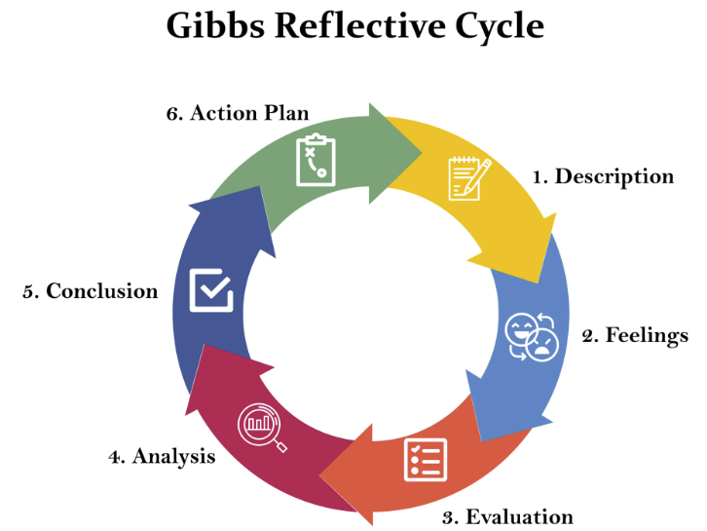
Gibbs Reflective Cycle
Source: [McLeod, 2025]
Description
My task was to perform a strategic synthesis for Tesla regarding its market entry in India. The company has recently entered the market but faced slow progress in their sales despite having a high fan base in the market. It started with understanding the dominant historical entry of the company in its global expansion. It was aimed to understand the suitability of the same strategy for the Indian market. I was tasked to provide clear recommendations to address risks, resource commitment and long-term strategic fit.
I reviewed the macro environment using the OLI framework and external factors. It required collecting secondary data to understand its approaches in China, Europe and other small markets. This process refined the critical evaluation with analytical depth.

Feelings
I felt confident initially due to my solid analytical foundations. However, I faced a significant pressure as I started doing research on the subject. The entry mode decision is pivotal for the report and I was conscious that my recommendations needed to be aligned with India's policy environment and the firm’s observed behavior. I started to feel a sense of clarity as I worked through the historical pattern. It showed me a consistent preference for wholly owned subsidiaries. There were moments of frustration due to the limited public information on the internal decision making of the car maker. The overall process was good because it moved from initial uncertainty to a more measured confidence.
Evaluation
The report was structured sequentially which make the analysis effective to understand the entry mode. The eclectic paradigm and data sources gave credibility to the findings. The secondary sources were relative to the companies' China and European experiences. All these aspects helped me to put evidence in the discussion rather than speculation.
I faced some clear limitations, like the lack of data on Tesla's strategic deliberations. The sales figure and manufacturing announcement of India were limited and some resources were even contradictory. It took me a lot of time to cross-check them before using it for the analysis. There was a significant time pressure which constrained the depth of comparative analysis with alternative entry modes like joint ventures or contract manufacturing (Livesey, 2020). It was initially a difficult project but I feel the situation was resolved afterwards which benefited me as a professional. Overall, the final section achieved a critical and balanced argument despite all challenges.
Analysis
Now I understand that theoretical frameworks have shaped my research strategy. The readings on the eclectic paradigm and entry modes helps to understand the entry patterns of Tesla. The discussion on control vs flexibility and host-country institutional pressures helped me to perform a critical evaluation. I realized that one source should not be used to conclude things because other sources might show contradiction. It is better to make sure the source is authentic and cross-check the facts before using them in the report (MBM, 2022).
Tesla wants high control modes for corporate preference and a logical response to take ownership advantages. It has already shown its strengths in software and brand experience that is difficult to protect through contracts. I understood this when I got to know about the Shanghai Gigafactory and its relevance with the Indian situation. It has become clear to me that a replication of the historical retail first mode is strategically limited in India.
Conclusion
In conclusion, the experience made me better understand how entry mode decisions are taken by multinational companies. The historical patterns might be successful in other markets but should be re-evaluated against local market conditions. The theoretical frameworks are highly valuable analytical tools which should be used by companies instead of rigid templates.
I would like to allocate more time to map out alternative entry mode scenario if I were to approach similar task again. I will explore a wide range of case studies on companies entering emerging markets. Critical synthesis is a major skill that I have developed from this experience. It will help me in both academic work and professional strategic analysis.
Action Plan
In future, I will first make a concise analytical matrix to link theoretical criteria host country constraints. I will also maintain a log of source contradictions to improve transparency and critical awareness. The core frameworks will be revisited regularly in the research to guide the argument. I need to work on my time management skills and I will do this by breaking the project into small but achievable milestones. These improvements will help me to achieve desired project outcomes and make me better in my professional career.

References
Acharekar, S. (2021). 2 major problems Tesla is facing in India. [Online] motoroctane. Available at https://motoroctane.com/news/224489-2-major-problems-tesla-is-facing-in-india
Autopunditz. (2026). India Electric Car Sales Jump 83% in July 2026; Tata Leads With 42.5% Share, Mahindra Surges 126%. [Online] autopunditz. Available at https://www.autopunditz.com/post/india-electric-car-sales-july-2026-tata-mahindra-mg#google_vignette
caalley. (2025). For Elon Musk's Tesla, India is not a straight drive. [Online] caalley. Available at https://www.caalley.com/news-updates/indian-news/for-elon-musks-tesla-india-is-not-a-straight-drive
CFI. (2020). Eclectic Paradigm. [Online] corporatefinanceinstitute. Available at https://corporatefinanceinstitute.com/resources/management/eclectic-paradigm/
Chellani, J. (2025). 2025 Tesla Model Y spotted testing on the streets of India. [Online] allaboutevs. Available at https://allaboutevs.com/blog/2025-tesla-model-y-india-test
Dey, A. (2025). Tesla looks to reset strategy amid sluggish India sales. [Online] bbc. Available at https://www.bbc.com/news/articles/cdrn00pn1m7o
Dhanoa, J. (2025). The Ministry of Heavy Industries notifies a scheme to promote manufacturing of EVs in India. [Online] saikrishnaassociates. Available at https://www.saikrishnaassociates.com/the-ministry-of-heavy-industries-notifies-a-scheme-to-promote-manufacturing-of-evs-in-india/
Gandhi, S. (2026). No relief for Elon Musk's Tesla in India? Here's what the new US-India trade pact suggests. [Online] livemint. Available at https://www.livemint.com/news/us-news/elon-musk-tesla-cars-india-us-trade-deal-donald-trump-narendra-modi-carmakers-11770621290247.html
Grandviewresearch. (2025). India Electric Vehicle Market (2025 - 2030). [Online] grandviewresearch. Available at https://www.grandviewresearch.com/industry-analysis/india-electric-vehicle-market-report
Harzing, A. (2020). Testing key IB typologies: Bartlett & Ghoshal and Gupta & Govindarajan. [Online] harzing. Available at https://harzing.com/blog/2020/02/testing-key-ib-typologies-bartlett-ghoshal-and-gupta-govindarajan
IBEF. (2025). Electric Vehicle Industry in India: Growth, Policy & Market Trends. [Online] ibef. Available at https://www.ibef.org/industry/electric-vehicle
Jha, K. (2026). Tesla Six-Seater Model Y Electric SUV Lined Up For India Launch. [Online] cartoq. Available at https://www.cartoq.com/car-news/tesla-model-y-l-launch-india-six-seat-electric-suv/
Jian, Y. (2026). Tesla becomes China’s No. 6 exporter as its overseas shipments double. [Online] autonews. Available at https://www.autonews.com/tesla/an-tesla-china-exports-boom-as-domestic-sales-fall-electric-vehicle-0716/
Kabirdas, S. (2025). Tesla’s Entry into India: A Game Changer for the Indian Automotive Market? [Online] frost. Available at https://www.frost.com/growth-opportunity-news/mobility-automotive-transportation/powertrain-electric-vehicles/teslas-entry-into-india-a-game-changer-for-the-indian-automotive-market/
Kelshikar, T. (2025). Tesla to install V4 Superchargers in Mumbai & Delhi. [Online] team-bhp. Available at https://www.team-bhp.com/news/tesla-install-v4-superchargers-mumbai-delhi
Lexology. (2026). Foreign Direct Investment (FDI) Policies in the Automobile Sector in India. [Online] lexology. Available at https://www.lexology.com/library/detail.aspx?g=91569627-3ff6-4f23-8b48-c621091b62c9
Livesey, N. (2020). The role of joint ventures in the future of mobility. [Online] pinsentmasons. Available at https://www.pinsentmasons.com/out-law/analysis/joint-ventures-future-of-mobility
Macro, S., and Ott, U. F. (2024). The evolution of the ability to effectively innovate in a transnational organization–A configurational analysis. Journal of International Management, 30(6), 101200.
Majumdar, R. and Ghatak, D. (2026). India’s trade deals will matter more than ever amid uncertainties. [Online] deloitte. Available at https://www.deloitte.com/us/en/insights/topics/economy/asia-pacific/india-economic-outlook.html
MBM. (2022). Gibbs Reflective Cycle: Feel the Benefit of Experiential Learning. [Online] makingbusinessmatter. Available at https://makingbusinessmatter.medium.com/gibbs-reflective-cycle-feel-the-benefit-of-experiential-learning-87e2f0eaae59
McLeod, S. (2025). Gibbs Reflective Cycle. [Online] simplypsychology. Available at https://www.simplypsychology.org/gibbs-reflective-cycle.html
Mukharji, A. (2025). Can Tesla's EVs win over India's price-conscious buyers? [Online] bbc. Available at https://www.bbc.com/news/articles/crkn28dpl4no
Mukharji, B. (2025). Is Tesla stalling on India? Market entry appears in doubt after minister questions intent. [Online] scmp. Available at https://www.scmp.com/week-asia/economics/article/3313433/tesla-stalling-india-market-entry-appears-doubt-after-minister-questions-intent
Ojha, H. (2026). How States are Driving India's Electric Future with Distinct EV Strategies. [Online] outlookbusiness. Available at https://www.outlookbusiness.com/magazine/how-states-are-driving-indias-electric-future-with-distinct-ev-strategies
Ozsevim, I. (2024). Electric Dreams: Tesla’s gigafactory network and EV battery production blueprint. [Online] automotivemanufacturingsolutions. Available at https://www.automotivemanufacturingsolutions.com/electrification/electric-dreams-teslas-gigafactory-network-and-ev-battery-production-blueprint/545858
Ponders, G. (2021). How Did Tesla Go International? [Online] medium. Available at https://medium.com/@gunt_er/how-did-tesla-go-international-2ac33e2c61df
revoltmotors. (2025). What is the PM E-Drive Scheme? Eligibility, Benefits, How to Apply. [Online] revoltmotors. Available at https://www.revoltmotors.com/blog/pm-e-drive-scheme
Sathaye, A. (2025). India currently has a total of 29,277 electric vehicle (EV) charging stations. [Online] sarkaritel. Available at https://www.sarkaritel.com/india-currently-has-a-total-of-29277-electric-vehicle-ev-charging-stations/
Shah, A. and Kalra, A. (2025). Tesla says India's 100% car tariffs make customers anxious. [Online] reuters. Available at https://www.reuters.com/business/autos-transportation/tesla-says-indias-100-car-tariffs-make-customers-anxious-2025-04-23/
Shamshuddin, S. (2026). Tesla vs BYD: Key Comparison Overview (2026). [Online] coverfox. Available at https://www.coverfox.com/car-insurance/articles/tesla-vs-byd-india-comparison/
Sharma, Y. (2025). Tesla finally parks in India. But can it survive? [Online] aljazeera. Available at https://www.aljazeera.com/news/2025/7/18/tesla-finally-parks-in-india-but-can-it-survive
Teguh, M. and Fauzan, A. (2026). Paving the way for a merger with SpaceX, Tesla separates its Shanghai factory? [Online] idnfinancials. Available at https://www.idnfinancials.com/news/66867/paving-the-way-for-a-merger-with-spacex-tesla-separates-its-shanghai-factory
Zhang, L. (2026). Tesla Accelerates Its India Market Entry: Factory, Showrooms, and Local Hiring (image). [Online] tparts. Available at https://www.tparts.com/blogs/tesla-latest-news/tesla-accelerates-its-india-market-entry-factory-showrooms-and-local-hiring?srsltid=AfmBOoomEnOCyA91vujqHgIYTRMN_ZWB218DU-jE14CLm-xrg4_x_QWx
Zucchi, K., Brown, J. and Schmitt, K (2026). How Tesla's Unique Business Model Drives Electric Car Success. [Online] investopedia. Available at https://www.investopedia.com/articles/active-trading/072115/what-makes-teslas-business-model-different.asp

