Architecture of memory: The emotional liminal space in which Louise Bourgeois and Yayoi Kusama recreate associative memory and themes of childhood trauma using three-dimensional art.

Introduction
In this essay I will discuss the emotional liminal space of artists Yayoi Kusama (1929) and Louise Bourgeois (1911), to demonstrate how their work taps into aspects of unconscious and subconscious.
This will involve an analysis of specific works. I aim to explore how psychoanalysis, in relation to childhood trauma, sexual exploitation, and anxiety is present in their work, and as a legacy of these real-life events. This should enable a deeper understanding of the themes within their work to become more apparent. I will also touch on threshold, or in-between space that both separates and opposes factors, helping the viewer and the artwork transcend through memory and time. I will also explore the feelings both artists evoke and as a result how successful both Kusama and Bourgeois do so at creating liminal space. Liminal space does not factor identity, time or community, during the middle stage of a rite of passage it abolishes pre-ritual status and jolts the transition to the status they will hold once the rite is complete. ‘Limen’ a Latin term for ‘a threshold’ results in the quality of ambiguity or disorientation that transpires through the middle stage of a rite of passage.
Both artists use various items, colours and textures to conceptualise and portray their liminal space. This is known as associative memory. In psychological terms this is defined by the relationship between learning and remembering between unrelated items.

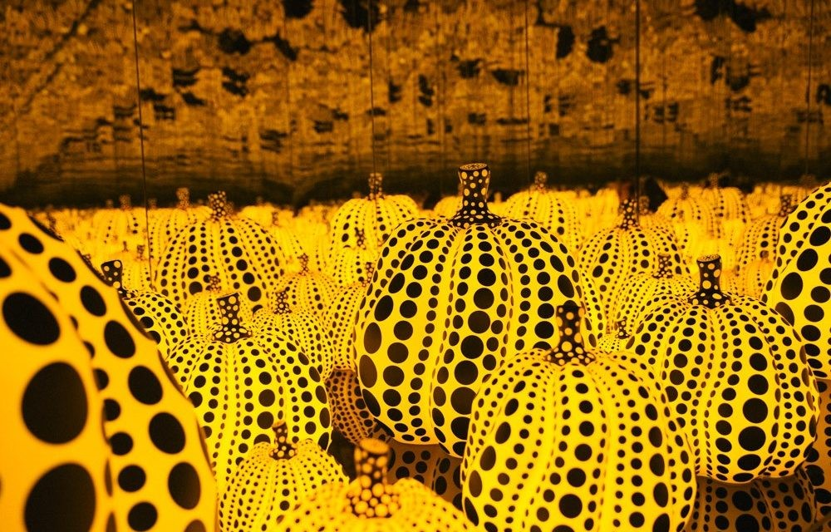
Yayoi Kusama
Yayoi Kusama born in 1929 in a small rural village in Matsumoto, Japan. Kusama has exhibited all over the world including MOMA and the Tate Modern. Kusama uses various methods in her creative practice such as painting, sculpture, textiles and writing, however, Kusama is renowned for her infinity rooms and large scale polka dot sculptures and painting.
Yayoi Kusama began sketching from an early age, she would take her sketchbook everywhere with her. She often would go down to her parents' seed-harvesting grounds and sit amongst the flowers, she at first found this like a way to escape and as though she lived in a fairy tale until one day Kusama experience hallucinations. Kusama described the flowers as crowding her and talking to her which left her paralysed in fear. A lot of her artwork was not only in the form of dots but a perspective of what she experienced, of feeling like she was lost into her physical environment of losing her selfhood in this space that is moving rapidly and expanding rapidly.

“This was the first series of disturbing hallucinations – she calls them depersonalisations – that haunted her childhood. I had thought only humans could speak, so I was surprised the violets were using words.” (Lenz, 2018)

She described being in normal settings just like sitting at a dinner table and the flowers from a tablecloth would trigger another hallucination, she described the tablecloth would envelop her and chase her up the stairs. In response to the fear and shock she felt during these episodes Kusama would immediately go and record what she had seen, this would help calm her and control the hysteria. It was not just flowers Kusama had experience this type of episode with, she had also experienced it with pumpkins and told the story of the first pumpkin she ever saw while out walking with her grandfather, she described it the size of a man’s head, she picked it up and it began speaking to her.

In Kusama’s later work she sculpted flowers and pumpkins, these have become some of her trademark pieces, completely covered in spots, she created a mirrored room of pumpkins. Kusama began painting and sketching, flowers and pumpkins, completely encased with polka dots. Kusama’s work progressed later on in life into sculptures and inflatables with rooms and environments designed to create and illusion, almost creating a large scale dream sequence of her hallucinations. This artwork was featured in the Dallas Museum of Art in 2018 its known as “All the Eternal Love I have for the Pumpkins”. The installation is a mirrored room filled with 64 yellow and black pumpkin, the mirror reflects miles and miles long of pumpkins, like a field. This art piece gives you an insight into the hallucinations that Kusama experienced, viewers described feeling claustrophobic, encased, and almost swallowed by the room. I believe that’s how Kusama felt during her episodes. (Lenz, 2018)
The space in which Kusama has created allows the viewer to become lost amongst this repetitive imagery, controlling the narrative of the feeling of being removed from reality into the mind of the artists. The sequence of the repetitive spots along with the rows of varied sizes, the pop of colour and placement of the mushrooms envelopes the viewer creating a distorted perspective and evokes anxiety. For example, when I look long enough into the spots, I see the spots dancing or increasing in size which questions my perspective to how I am interpretating the size of the actual mushrooms and the size of the space. I find the space very psychedelic, which also creates that notion of transcending through time. Kusama’s art become famous during the 1960s1970s an era of pop art, bold colour, flower power, love and freedom. What Kusama has done has created an installation whereby she controls the narrative of transcending you, the viewer, into an alternate state of universe. Kusama openly discusses her issues with her mental health including her obsessive-compulsive neurosis, and in relation to this piece, what makes it uncanny is the idea you are unable to control your perspective, or control the space that you are in, as though Kusama is in control. In the documentary ‘Kusama: Infinity’ (Lenz, 2018) she says, “My desire was to predict and measure the infinity of the unbounded universe, from my own position in it, with dots”. (Lenz, 2018)
Many of Kusama’s hallucinations stem from her childhood; a time where her mother was enraged by the behaviour of her father and Kusama was the pawn in which she was exposed to sex at an early age.
The hallucinations Kusama experienced were definitely apparent, and it is interesting to see Kusama named the piece “All the Eternal Love I have for the Pumpkins,” because she associated the pumpkins with a negative experience but in a way could the pumpkins be an ode to her grandfather and the time they spent together while she was a young child?
Although now Kusama’s artwork is known globally, when she first moved to New York she had fled from Japan, an extremely strict conservative culture and had no money. In an interview for ‘Kusama: infinity’ she becomes emotional talking about when she first moved to New York and trying to get her work out there and how poor she was, she said she painted every day and drew every hour that she could and although she was poor, she had removed herself from a negative environment where she was able to paint freely, and she felt very fulfilled.
Much like her first few months in New York Kusama said she would paint every day in her childhood. During World War II she would work all day making parachutes and come home to paint in the evening where she would paint intricate flowers over and over. She claimed some days when she was not in the factory, she would produce up to 70 water colours a day. Kusama clearly had an obsessive trait from an early age which progressed into her teens. The structured, repetitive notion of parachute making in the day continued into her repetitive, ritual of painting at night, which manifested as her repetitive motifs.
One of Kusama’s breakthrough works was the ‘Infinity Net Paintings’ 1959. This was her artistic response to watching the waves and the surface of the sea out the window of the plane she flew on from Tokyo to New York. She said,

“When I was on the airplane and looked outside the window, I saw ever-expanding nets on the ocean, and I made them into my art.” (Lenz, 2018)

The nets she painted were made from repetitive singular motion of little loops sort of interlocking.
“I am obsessed with nets. They cover me, strangle me… They fascinate and haunt me.” (Lenz, 2018) In an interview for ‘Kusuma: Infinity’ art dealer and close friend, Beatrice Perry said, “Kusama appeared one day completely unannounced with a young man. They carried one painting in after another, I had never seen anything like it. They had some kind of magic, you could not stop looking at them, and you did not know where they were going, they were hypnotic.” (Lenz, 2018)
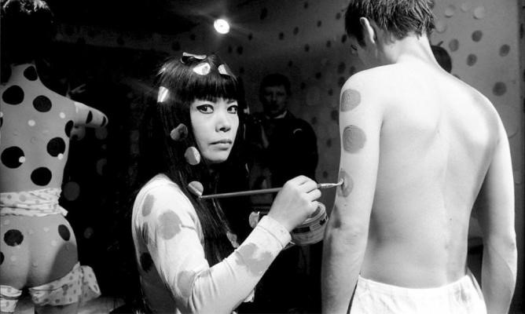

The ‘Infinity Net Paintings’ developed into the polka dot style Kusama is known for. In her development she said, “I come up with new ideas and my canvas cannot keep up with me.” (Lenz, 2018) Kusama had stated that during her childhood her mother would snatch her painting from her, since then it informs her way of working, to work fast and in hysteria even to finish it before it is torn from her. Towards the late 1960s Kusama was known for her support in civil right movements for war and gay rights, and she was the first person to officiate the first gay marriage. Many described Kusama as an attention seeker or fame hungry and during her protests she would paint naked bodies with polka dots. Jeanette Hart a performer in New York, received a call to be painted by Kusama thought it would be a portrait painting and was excited to do it.
She describes the encounter with Kusama
“It never occurred to me that this literally meant paint you, it is hard to define the expression in her eyes. She was not looking at you as thought you were a human being, this was the thing that she was going to manipulate, to colour, to position to what she thought it should be.” (Lenz, 2018)
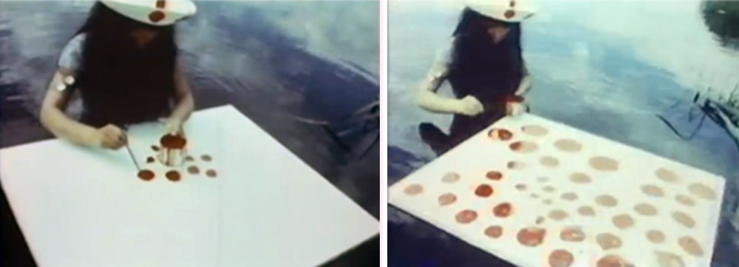

The idea eventually developed into Kusama creating a film about herself she described, “I made a movie called ‘Kusama’s Self-Obliteration’ in which I covered myself in polka dots until I completely disappeared.” (Lenz, 2018) The movie displays Kusama covering everything from horses, to trees, to rocks and water in polka dots, she then covered herself to what she described to allowed her to completely disappear into her environment. She continued to describe it as “The universe is full of nothing, ever-expanding and ever destroying itself. Just like a drop that falls in water, I completely disappear in the universe. I seek the energy of life and I turn it into art” (Lenz, 2018). – her therapy, from perspective of how she feels about life and how her art and these polka dots are her escapism. She went on to conquer Europe in the 1970s and won an award for her film in Berlin which was being shown. After the preview Kusama had people take their clothes off and painted them with polka dots and words of freedom and love – she was self-expressing, it was majestic to watch her do this and allow the paint brush to flow over the bodies like a canvas painting. With reading about how she was perceived by others encountered and referring to clips I had watched from the film of herself, I found it very strange in her facial expressions and her movement in the way she worked. Kusama looks as though she is possessed or in a trance.
“My friends asked me why I kept painting dots and infinity nets. But I never listened to them. I just kept trying to make my own world.” (Lenz, 2018)

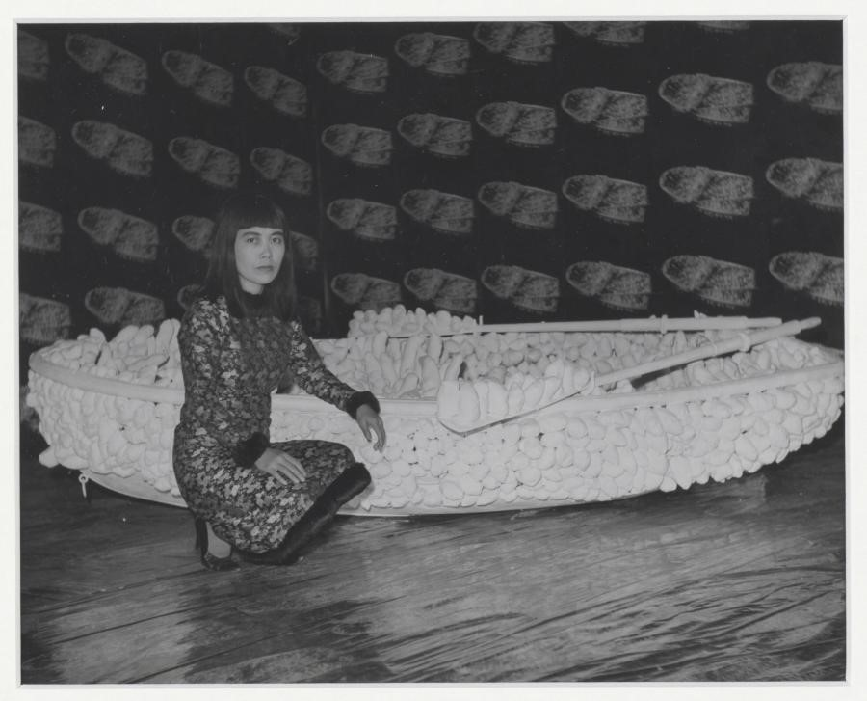

Yayoi was always self-aware when it came to her health and went to see a psychiatrist who conducted a Freudian analysis, she went to help deal with traumatic experiences she had experienced as a child. On many occasions she found her father in some uncompromising situations, her mother used Kusama as a pawn into spying on her husband and would take her rage out on Kusama.
This is believed to of been a massive factor in Kusama’s repetitive, obsessional, focus association with her fear of sex. In some of Kusama’s work during the 1960s she created soft, stuffed sculptures that resembles a phallus. ‘One Thousand Boats Show’ was her first installation in December 1963 in the Gertrude Stein Gallery where she displayed a completely covered the rowboat in soft sculptures protrusions even down to the minute details of the paddles. She then photographed the boat and printed it on paper that covered the room – the boat sat in the middle of the room covered in photographs of itself. This was something no one had ever done before, unlike Claus Oldenburg who worked with harder materials to sculpt, Kusama did the opposite. Kusama had described her work as a release of anxiety, she had used the method of painting to help her deal with her hallucinations and much like her painting she had developed her therapy into methods of sculpting. One of the traits in Kusama’s diagnosis of Obsessive-Compulsive Neurosis was that when something enters her mind, she cannot get rid of it.
The trauma she encountered with her father, seems to be implicitly referenced in her soft sculpture. The soft phallus sculptures are an ode to her father and the anxiety and humiliation she felt during her childhood. What is interesting about her sculptures is that they are soft. In her fear of sex Kusama found a way to create sexual humour and making fun of the penis. However, looking at it from another perspective you could say she referenced the nature of the phallus in a softer tone so that it did not seem so fearful for her because what we associate with soft is more welcoming than what we associate with hard.

Louise Bourgeois
‘The Spiral’ was a recurring theme in Bourgeois work, she described it as ‘an attempt at controlling the chaos.’ (Bernadec, 2007) She began sculpting these in early 1950’s from layers of wood fixed to vertical steel supports, which were later adapted to materials such as bronze and fabric. Bourgeois wrote an autobiography of her childhood experiences which was published in Artforum in December 1982, in which she wrote about Sadie, her English tutor and her father’s lover and the impact it had on her during her childhood,
“She was introduced into the family as a teacher, but she slept with me father and she stayed for ten years. Now you will ask me, how is it that in a middle-class family a lover was a standard piece of furniture? Well, the reason is that my mother tolerated it and that is the mystery. Why did she? So, what role do I play in this game? I am a pawn. Sadie is supposed to be there as my teacher and actually you, mother, are using me to keep track of your husband. This is child abuse.” (Bernadec, 2007)

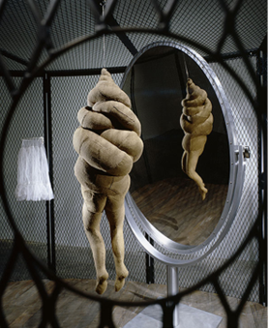

She continued to elaborate on how Sadie was brought in to teach her English and that she was hers. She felt betrayed not only by her father but by her mother too, she was the innocent in the game between her parents. She writes “Concerning Sadie, for too many years I had been frustrated in my terrific desire to twist the neck of this person.” (Bernadec, 2007) Bourgeois sculpted The Spiral Woman as headless and armless figures, they had legs, and the entire torso and neck was twisted into a spiral shape, she described this as the fantasy she had whilst working for her parents with cleaning the tapestries. “The Spiral is important to me. It is a twist. As a child, after washing the tapestries in the river, I would turn and twist and ring them with three others or more to ring the water out. Later I would dream of getting rid of my father’s lover. I would do it in my dreams by ringing her neck. The Spiral – I love the spiral – represents control and freedom.” The Spiral Women is Sadie, associating with fabric, she would twist to rinse the excess water but pictured Sadie’s neck in her hands, to what we can only assume was a form of how she released the pain Sadie’s presence inflicted on her. The shape looks like a weave from rope or thread – which we know Bourgeois spent her childhood in a house with weaves and threads and in reflection of that this piece is made from fabric with patches that almost imitates skin, the shape tightly wrapped, suffocating to what we believe could be the ‘being’ underneath, with no space for air. When I first saw this piece, I also studied the way it was hung, reminding me of the history in which we would hang those in shame in front of an audience if that had committed a crime in their community. However, the mirror alternates the piece and shows the reflection of the being to itself, I am only assuming this was a way for Bourgeois to create that fantasy of self-reflection and shame and creating a scenario in which Sadie is hung in shame, tightly wrapped, and is forced to look at herself and reflect on the things she had done to Bourgeois. But also hung in shame to represent the crime she felt her parents had inflicted on her. I can understand the thought process of Bourgeois in this piece in the way it helped Bourgeois control her feelings towards her father and Sadie’s relationship and understand that release she felt when twisting the tapestry would help release the anger and torment she felt.

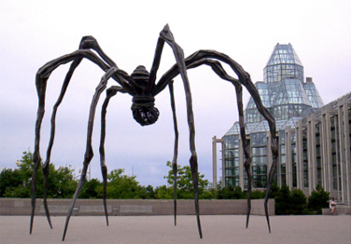

Bourgeois parents owned a tapestry making business and her mother weaved. As the result of the relationship with her father Bourgeois idolised her mother and created a series of spiders in reference to her mother’s work, family, and life ethic.

“It came from a family of repairers. The spider is a repairer. If you bash into a web of a spider, she does not get mad. She weaves and repairs it.” (Bernadec, 2007)

She describes the spider as the protector, a clever insect with a friendly demeanour. Bourgeois watched her mother supress her father’s behaviour and continued life as normal. Much like weaving she referred to her mother as a fixer. In contrast to the positive association Bourgeois had with ‘The Spider,’ as a viewer the piece can be triggering to those who have a fear of spiders. The sculptures thin angled legs are all different heights, giving the impression that the spider is crawling.
As a viewer this can be seen as quite terrifying. My initial thought researching the idea around ‘The Spider’ was that although Bourgeois interpreted her mother as a fixer and someone who supressed her feelings, did she also saw her as a nester.
Someone who protected their young and natural habitat and that in fact she saw her mother as a strong attribute in her childhood. Her mother withstood sickness, and her father behaviour and continued life as normal, that takes a lot of strength.

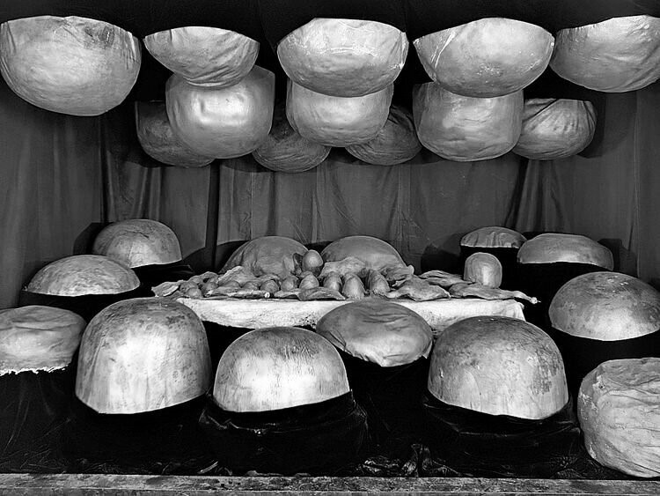
In contrast to the work of ‘The Spider’ in which she paid ode to her mother – ‘The Destruction of the Father’ - the work which was a consequence to psychotherapy she had after the death of her Father in 1951. Bourgeois fell into a deep depression, and this was when she started attending sessions with a psychoanalyst to help with the depression and to deal with the experiences and trauma she had endured. This was coinciding a decade Bourgeois spent in self-imposed seclusion and isolation, she re-emerged in 1964, and began creating the workings of her installations known as ‘Cells’.
Bourgeois work was described to of ‘flourished’ from this point in her artwork, and began exploring more materials that were organic, plastic, latex and metal and created her concept of ‘lairs.’ Bourgeois then experienced another life changing event, her husband passed away around this time in developing her work and this drove her installation of ‘The Destruction of the Father’ which I believe was developed in response to the loss of her children’s father who she believed to of been a great example to her children and in contrast to her own father who she held such pain and resentment, she used this period of mourning and loss to take advantage and create what I believe to be the most eerie piece of work I have seen from Louise Bourgeois. Bourgeois describes

“The Destruction of the Father leaves me with my vulnerable self. I am told of childhood traumas, but that is the only part of the story. I am not sure where from or how these obvious, direct, concentrated, and dense forms come into being. The source of pain, the core of the anxiety remains indecipherable, and yet these sculptures trigger in me memories of individual experiences I would rather forget. The work causes states of fear do brief that speech always comes too late. The meaning evades me: discursive analysis, conceptual terms fail. All tracking leads to dead ends.” (Bernadec, 2007)

The installation displays a scenario of a dinner party that is the insides of a vital organ, set in an ambience of red light, organic shapes plaster a table and cavities of a wall and ceiling made of plaster and latex which Bourgeois described as ‘abscesses,’ creating a space that looks small and not easy to escape from Bourgeois describes the space as “very claustrophobic. There is nowhere to escape.” (Bernadec, 2007) Bourgeois described the round protrusions as abscesses, associating the sculptures like an infection. As though her father was this awful virus to her, who made her feel physically and mentally exhausted and unwell. There is also a reference to phallus in this piece, I think in Bourgeois attempt to really project and really display the deep routed trauma she experienced in her relationship with her father. Amidst the abscesses, the disgusting growing virus, she sculpted phalluses, I believe in reference to the disgust she had experienced with exposure to sex at such an early age. The eerie thing about ‘The Destruction of the Father’ is how Bourgeois would talk about it.

“This piece is a table, the awful, terrifying family dinner table headed by the father who sits and gloats. And the others, the wife, the children, what can they do? They sit there, in silence. The mother, of course, tried to satisfy the tyrant, her husband. The children are full of exasperation… So, in exasperation, we grabbed the man, threw him on the table, dismembered him and proceeded to devour him.” (Bernadec, 2007)

Bourgeois was open about her relationship with her father and shared stories of how he would tell her he wished she were born a boy. How he would play with his food at the dinner table and make bodies with phalluses and tease her about not having one. Bourgeois made this piece in reference to those times of anxiety and resentment. Bourgeois work of the ‘Cells’ is what she describes as a reflection of her personal demons and a form of confronting her past. She would talk about ‘The Destruction of the Father’ as if it happened, although it was just a fantasy it was as though in the process of therapy, she managed to overcome these demons with her father and if she really believes that what she described did happen and in her subconscious it did. And that is how she has dealt with her trauma, as though by eating her father she had swallowed her demons.

Conclusion
Reflecting back on this essay, I believe both artists successfully enveloped the viewer into their artwork in hopes to create a space where they would transcend through memory and time. Both artists sketched, painted and note took during their times of psychological trauma. This was their process of releasing their anxiety, this gave Kusama and Bourgeois the opportunity to create and recollect first-hand from the events of their trauma and enabling both artists to continue to tap into the unconscious mind, allowing them to continue to revive those memories and feelings. Kusama and Bourgeois both used repetition throughout their artwork, The Spiral and The Polka Dot were not only trademarks of theirs but a form of how they could recount their trauma repeatedly.
“Psychoanalytic theory holds that serial repetition is the return of psychic material in symbolic form, and Kusama has traced her obsessive use of the Infinity Net pattern and inverse variations, the phallic accumulation and the polka dot, to ‘childhood trauma.’ (Hoptman, 2001)
As a viewer we are able to understand and intake the environment, atmosphere and emotion through the liminal space they have created. The use associative memory, allows us to transcend through the in-between, leaving behind our ‘limen’ and almost looking into a window of another space and time.

Word count: 3640

Film
- Lenz, Heather. Dogwoof Ltd. 2018. Kusama – Infinity
- Cajori, Masrion & Wallach, Amei. Art Kaleidoscope Foundation. 2008.
Louise Bourgeois – The Spider, the Mistress and the Tangerine

Books
- Morris, Francis. Tate Publishing. 2011 .Yayoi Kusama
- Hoptman, Laura. Phaidon Press. 2001. Yayoi Kusama
- Taft, Catherine. Phaidon Press; Revised & Expanded edition. 2017. Yayoi Kusama Revised and Expanded Edition
- Askew, Lucy & d’Offay, Anthony. National Galleries of Scotland 2013. Louise Bourgeois - A Woman without Secrets
- Bernadec, Marie-Laure & Morris, Francis. Tate Publishing 2007. Louise Bourgeois
- Fisher, Mark. Repeater; 3rd Edition 15 Dec. 2016, The Weird and Eerie
- Celant, Germano. Skira Editore; 1st Edition. 2010. Louise Bourgeois – The Fabric Works
- Bourgeois, Louise & Bernadec, Marie-Laure & Bronfen, Elisabeth. Scalo Publishers. 2001. Louise Bourgeois – Insomnia Drawings
- Rugoff, Ralph. Hatje Cantz Verlag; 1st edition. 2022. Louise Bourgeois – The Woven Child
- Crone, Rainer & Graf-Schaesberg, Petrus. Prestel. 2011. Louise Bourgeois – The Secret of the Cells

Jigsaw/Game
Callaghan, Laura. Laurence King Publishing. 2021. A World of Yayoi Kusama – A Jigsaw puzzle

