

Student name: EMMANUELLA DESTINY SESAY
Student ID: 1916051
Module name: PRINCE OF HEALTH AND SOCIAL CARE
Module code: BMHP5002_LON
Lecture name: RACHEL ADEBAYO

Person-centered Care in Health and Social Interventions
Introduction
Person-centered care is an approach to social and health interventions that requires the health and social care professionals to work collaboratively with people who use their services.It is primarily focused on supporting people as equal partners in developing, planning and monitoring health and social care(Grassi et al., 2016, p. 489). It allows the people to be involved in care-related decisions during social and health interventions.The concept requires social or health workersto adapt their services to meet the expectations and preference of the people in order to ensure their autonomy and dignity is respected during the process of intervention, which is usually a challenging period.It is applicable to various services across different sectors including social care, health, local authorities and housing. It can also be applied to different types of organizations including non-profit, public, or private institutions.The essay seeks to explore the underlying concepts associated with person-centered care and assess the limitations and benefits of the concept in contemporary social and health environments.
Person-centered in health and social care.
In 2016, the member states of the World Health Organization, including the United Kingdom (UK), agreed to implement the World Health Organization’s Framework for Integrated, People-Centered Health Systems(McCormack & McMillan, 2018, p. 33). Currently, there has been significant improvements in activation of patients to ensure they are involved in the decision making regarding their care. However, the adoption of person-centered interventions in social and health services has been slow. According to a study by the Care Quality Commission, an independent government agency that regulates health and social care services in England, only half of the patient population feel they are involved as much as they want in the decision-making process regarding their health care. In 2014, the NHS aimed at supporting 10 percent of people with long term health complications through the King’s Fund.
According to the NHS Constitution, patients have the right to be given information regarding their test and treatment options including their benefits and risks. However, it is imperative to ensure that health and social intervention workers tailor the information to be properly understood by the people, who are often non-professionals. Therefore, it has been a great challenge for social and health workers to make complex information accessible to the population. According to a 2018 study by the Care Quality Commission, known as the NHS Patient Survey Programme,that involved responses from 178,681 patients suggested that only 15% of the respondents were involved in decisions regarding their discharge from the hospital(Boggatz, 2019, p. 463). This is an imperative area that needs to be enhanced the healthcare system in order to improve person-centered care.
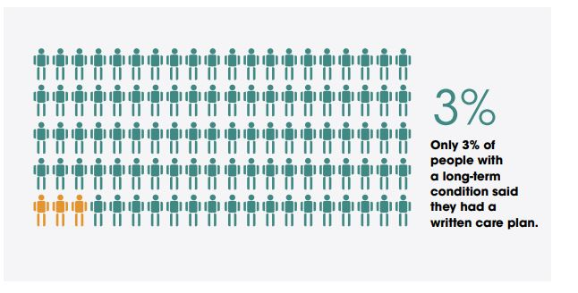
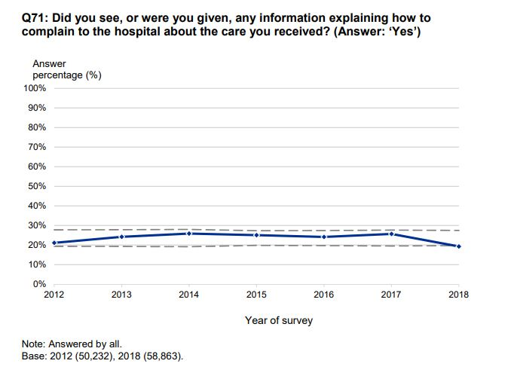
There has been increased awareness on the need for person-centered care in government policies, but there are numerous challenges in the implementation of person-centered care on the ground. Nonetheless, the NHS has embarked on ensuring person-centered care is incorporated as part of community-based approaches in social and health interventions. However, is difficult to asses the progress in the implementation
Provide a clear description of the service that you will be focusing on in the essay eg cancer or dementia.
Patient-centered care is argued to be an indispensable component in the delivery of quality cancer care. Patient-centered in the management and treatment of cancer involves emotional comfort, physical comfort, involvement of family friends and friends, provision of information, education and communication to enable the patient understand and make informed decisions regarding their care, and respect for the patient’s values and preferences(Woodhead, 2014, p. 61). Recent research studies indicate a definite positive impact on treatment outcomes when person-centered care is integrated along with the standard therapeutic regimens.
You can choose an example of service provided such as person -centered care for people with dementia or cancer.
Nearly 367,000 new cancer cases are reported in the UK every year. Cancer treatment is often intense, toxic, protracted, and costly. The long-term complications involved in the treatment make it difficult to identify potential risks and benefits for individual patients(Tajan & Vousden, 2020, p. 772). Therefore, Person-centered care can aid in enhancing patient experiences. This can be attained through treatment planning, communication, and shared decision making.
A nurse can provide a person-centered care to a patient who has recently undergone cancer treatment, by discussing with the patient on how they can provide support during the period of treatment. The nurse may adjust the care plan to meet the needs of the patient by allowing the patient to request close family members to help them handle personal hygiene routine instead of the nurse. The caregiver may also embark on knowing what the patient likes and dislikes through conversations with the patient. For instance, what music can help calm them down, the name of their loved ones, or what activity they enjoy doing. This allows the caregiver to support the patient when they experience anxiety thus improving clinical outcomes. The interaction also allows the patient to feel more confident and comfortable with the services of the caregiver thus making it easier for both of them(Adams & Grieder, 2005, p. 24).
Provide examples of specific organizations or settings that provide these services such as Age UK, Macmillan support UK, Cancer Research UK e.t.c and how they uphold or maintain a person-centered approach in the services they provide.
A wide range of initiatives and approaches are currently implemented in order to enhance person-centered care in health and social interventions. They include initiatives in the promotion of self-management and shared decision making, and specific programmes such as the “Hello, my name is” campaign and quality improvement initiatives such as the experience-based Schwartz rounds. Schwartz Rounds is a group reflective practice forum that support professionals from various disciplines to reflect on the emotional aspect of their services. The forumprovides online and physical training to enhance personalized care in health and social interventions(Cohn, 2018, p. 117).On the other hand, “hello my name is” is a campaign that was founded by the late Dr. Kate Granger MBEin order to promote compassionate care in social and health interventions. According to their website, their key values of the campaign include recognizing affected people as people first before the intervention, and involving people in decision making regarding the intervention and the provision of crucial information to the affected people(campaign for more compassionate care, 2021).
Describe the underlying concept of person-centered care.
There are numerous concepts that are incorporated in the delivery of person-centered care. Firstly, the concept requires respect for the values of the people and prioritizing them instead of the system. Secondly, person-centered care entails taking into account the expressed needs and preferences of the people. Thirdly, it requires the integration and coordination of social and health interventions. Fourthly, the concept requires effective communication, education, and dissemination of information. The concept is also focused on ensuring the people are physically safe and comfortable. This entails the provision of emotional and physical support. Person-centered care also requires the family and friends of the affected people to be involved in the intervention process. In addition, the concept requires the continuity between and within services. Lastly, the concept involves providing access to appropriate care for the people when they need it.
Analyze the underlying concept of person -centered care.
Person-centered approach in social and health interventions is based on various principles that were established by the People and Communities Board, with contributions from the New Models of Care Vanguard Sites for enhancing the care and health of related communities and people(Kunze, 2013, p. 123). The principles include:
- Support and care should be person-cantered; personalised, coordinated, and empowering.
- Services are created in partnership with communities and citizens.
- Health and social interventions should focus on narrowing inequalities and enhancing equality.
- Carers are identified, supported and involved.
- Voluntary, social and community enterprise and housing sectors should be involved as key stakeholders and enablers in health and social interventions.
- Social action and volunteering are identified as primary enablers.
Discuss and analyze the theoretical underpinning of person -centered care.
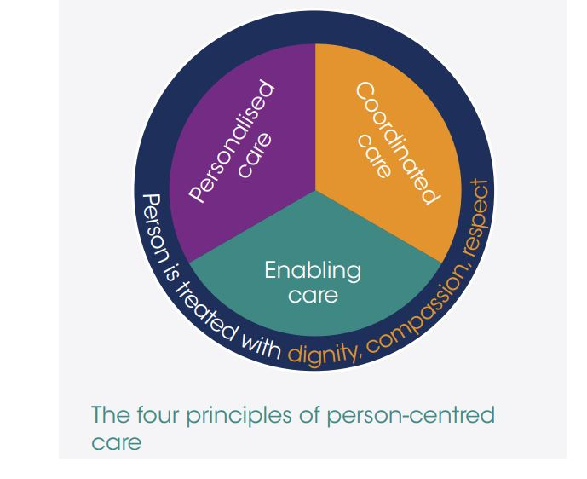
Discuss and analyse the ethical underpinning of person-centred care (i.e., what are the main ethical principles (moral rights/ wrongs) that governs the policies and practices in the health and social care sector?
- Information
Person-centered care requires the dissemination of information that is tailored to be relevant to meet individual needs of the people.
- Communication
Person-centered care requires effective communication with the people in order to allow health and social professionals tounderstand their preferences and values.
- Participation
The people should be involved in decision making process during social and health intervention.
- Care Planning
The people should be involved in care planning in order to allow social and health professionals to develop personalized support and treatment plans that suits the needs of the people.

Discuss and analyse the main benefits and limitation of person-centred care using real life examples/ applications to cancer or dementia services.
Person-centered approach empowers social and health service provides to adjust their services to meet the individual needs of the people. This allows social and healthcare service providers to fulfill the expectations of the people by enhancing social, clinical and health outcomes. Studies suggest that person-centered approaches to healthcare interventions enhance clinical outcomes(Pörtner, 2013, p. 58). Patients who have received person-centered care are less likely to use emergency hospital services and are more likely to follow their treatment plan and take medication correctly as required. Person-centered care also ensures that the people are more satisfied with the care provided since they will be involved in choosing treatments with regard to their preferences and values. It also allows the people to gain more control on their own health since the provision of information ensures the people develop confidence and skills to manage their health more responsibly. Additionally, patient engagement enhances staff morale and performance since it allows the professionals to provide personalized care.
Supporting people with long-terms health conditions to be effective in self-managing their conditions will trigger major financial implications for the Government since 70 per cent of the costs of the National Health Services (NHS) are often spent on people with long-term health conditions. The provision of support to patients to allow them to optimize their medication, and manage their conditions better is known as patient activation. Consequently, the improved social and health outcomes aids in reducing the cost-of-service delivery. Research by the NHS has established that activated patients are healthier, and can manage their conditions better thus reducing the burden on the healthcare system since they use health services less(Kunze, 2013, p. 115).
Recommendations
- The caregivers are the backbone of the care system and should be consulted and involved in the implementation and development of person-centred care. The Government should also provide adequate training on person-centred care for workers conducting social and health interventions.
- The children and young people should be educated in school on physical, mental and sexual health. Statutory agencies can be formulated to enhance comprehensive learning to create awareness and early intervention.
- The Government should provide additional support for patients with long term health complications, complex needs, and disabilities. This may include access to information, educations, health coaching from a professional, and personal budgets to support their health, support and care needs.
- The patients should be supported to maintain social and family connections while receiving treatment. The patients should also be supported to be independent.
- The Government may also enhance the evaluation of the progress in the implementation of person-centred care. Currently, the effort of coordination in care delivery is not closely monitored.
Conclusion
Person-centered care is an imperative component in the delivery of quality social and health care. The concept ensures social and health interventions are conducted collaboratively while considering the people. It allows the people to make contributions in developing, monitoring, and planning for care. This aids in enhancing physical and clinical outcomes. In addition, Person-centered care has been noted to attract numerous benefits for the people and professionals involved in health and social intervention. The Government has made significant contributions in enhancing Person-centered care. However, there is still need for improvement in supporting patients with long-term health complications such as cancer patients. The NHS needs to provide personal budgets, and training to allow them to self-manage their conditions on a daily basis.

References
Adams, N., & Grieder, D. (2005). Person-centered care. Treatment Planning for Person-Centered Care, 17-37. https://doi.org/10.1016/b978-012044155-6/50006-4
Boggatz, T. (2019). Person-centred care and quality of life. Quality of Life and Person-Centered Care for Older People, 449-466. https://doi.org/10.1007/978-3-030-29990-3_7
(2021). A campaign for more compassionate care. https://www.hellomynameis.org.uk/
Cohn, F. (2018). May the Schwartz be with you: Fostering ethical care environments through Schwartz rounds— a live demonstration. The Permanente Journal. https://doi.org/10.7812/tpp/18-071-35
Grassi, L., Riba, M., Bras, M., & Glare, P. (2016). Person-centered palliative care. Person Centered Psychiatry, 487-500. https://doi.org/10.1007/978-3-319-39724-5_35
Kunze, D. (2013). The person-centered approach in adult education. Interdisciplinary Applications of the Person-Centered Approach, 115-123. https://doi.org/10.1007/978-1-4614-7144-8_10
McCormack, B., & McMillan, A. (2018). Integrative nursing and person-centered care. Integrative Nursing, 29-39. https://doi.org/10.1093/med/9780190851040.003.0003
Pörtner, M. (2013). Person-centered work in services for people in need of everyday care. Interdisciplinary Applications of the Person-Centered Approach, 57-62. https://doi.org/10.1007/978-1-4614-7144-8_6
Tajan, M., & Vousden, K. H. (2020). Dietary approaches to cancer therapy. Cancer Cell, 37(6), 767-785. https://doi.org/10.1016/j.ccell.2020.04.005
Woodhead, C. (2014). Eighth Geneva conference on person centered medicine, person centered primary care. International Journal of Person Centered Medicine, 4(1), 61. https://doi.org/10.5750/ijpcm.v4i1.469

