

Module name: Changemakers: Building your Personal Brand for
Sustainable Employment

Module code: BMHP5015

Student name: Agnieszka Szalek
Student ID: 2325666
Lecturer: Caroline Salami

Table of Contents
Introduction 2
Reflection on Unit 1: Brand You 2
Reflection on Unit 2: It’s a Small World 3
Reflection on Unit 3: Opportunity Knocks 4
Reflection on Unit 4: The Pursuit of Happiness 6
Conclusion 7
References 8

Introduction
The portfolio contains a reflection of the four units of the Changemakers: Building Your Personal Brand for Sustainable Employment module. This reflection intends to evaluate the impact of the internet workshop on my knowledge of personal branding, networking, creating opportunities, and resilience in one’s profession. The social and healthcare field embraces reflection as a practice (Bolton and Delderfield, 2018). This gives practitioners the chance to reassess their past practices and self-awareness, in a way that helps them adapt their practices to be more employable. These models helped me practice literary reflection, as a result of each module, in regard to the goal of being a professional in the health and social care sector. This portfolio exercise targeted global interconnectivity, digital health, social professional resilience competence, and serendipity which are social and health interrelated (Naylor et al., 2020; West et al., 2020). The reflection on the exercise and social and healthcare interconnectivity were the main purposes of the portfolio.

Reflection on Unit 1: Brand You
The introduction of the topic Brand You helped me to think on how people develop a professional identity that reflect one’s values, strengths, and ambitions. Establishing a personal brand is becoming more and more acknowledged within the health and social care, as professionalism, trust, and authenticity have a direct impact on the level of confidence service users place on the organization and the overall reputation of the organization (Hancock and Szabo, 2022). One of the most important ideas covered was self-awareness, which is the recognition of one’s own abilities, drives, and deficiencies. Self-awareness, as Goleman (2018) states, is the cornerstone of emotional intelligence and affects how one relates to and engages with other people. During the online taught sessions, including values clarification exercise and quizzes to assess employability skills, I started to grasp the set of qualities that I possess and take to a care setting and these are, empathy, communication and adaptability.

The subsequent concept that influenced my experience was the role that individual values play when making a career choice. In social and health care professions, the practice of value-based work and the melding of individual and social values, yield positive results such as ethical reasoning, resilience, and satisfaction in work (Manley et al, 2021). With my values of integrity, compassion, and respect, I was able to recognize the advocacy work that I do for service users. This served to clarify that personal branding is not merely the image that people project, but the values they hold and practice.

The other transferable skills such as collaboration, communication, and problem-solving, were also a part of the employed skills concept (Jackson and Tomlinson, 2020). As noted, Jackson and Tomlinson (2020) indicated that employability is not solely concerned with technical skills, but also having the ability to adaptive, to self-reflect, and to steer one’s career in a complex, ever-changing environment. The online tasks also encouraged a self-assessment of my skills, a gap analysis, and a reflection of how I can equip myself for the future roles in health and social care.

Reflecting on Unit 1 as a whole, I gained a deeper appreciation of the commitment and planning that goes into the process of personal branding. After considering self-awareness, values and employability skills, I can create a professional profile that serves the health and social care sect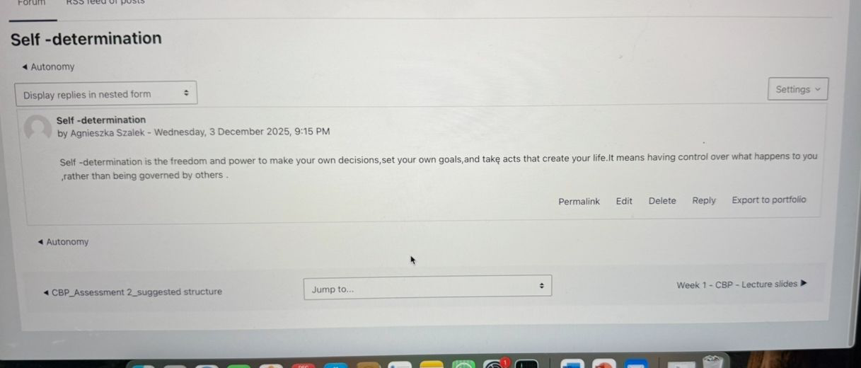 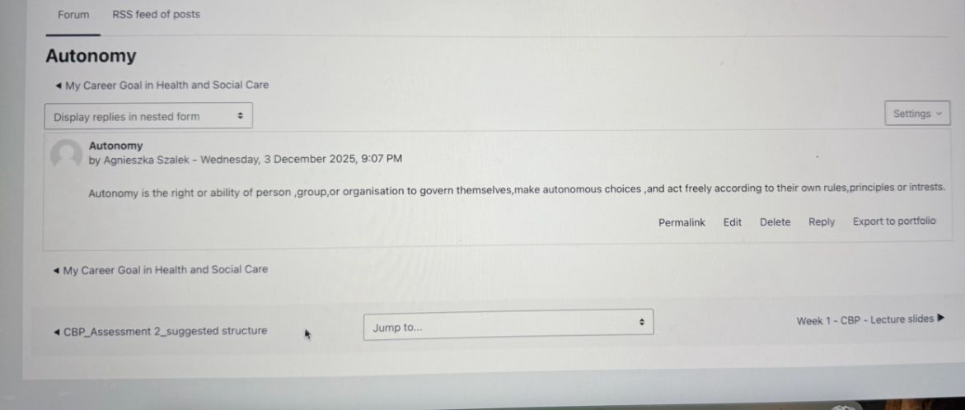

Reflection on Unit 2: It’s a Small World
After this unit, I realized how interconnected the health and social care environment is, and the value of networking, and evaluative and global interconnections in professional practice. One of the core concepts of the unit was networking, which the unit described as the phenomenon of establishing connections to share and collaborate on information and tasks. In health and social care, networking is fundamental to interdisciplinary collaboration, knowledge dissemination and enhancing service user outcomes (Smith et al. 2018). Participation in the forum activities made me appreciate how purposeful interaction can increase personal development and service. For instance, in the Moodle forum, networking scenarios made me aware of the role communication, trust and reciprocity play in professional networks.

The other important element was the advantages of diversity and inclusiveness in relation to networking pursued. Compared to homogenous networks, it has been shown that a diverse workforce provides a variety of different viewpoints which fosters innovative solutions and more nuanced practice in relation to cross-cultural competencies. Several studies support the notion that varied professional networks create and foster a more desirable atmosphere for constructive problem-solving and eliminate the risk of professional “echo chambers” that stifle advancement in one’s career (Page, 2019). This made me think more about how my own networks, both in the real world and in the digital world, could be improved to include more professional diversity, varying cultures, and different experiences.

Another consideration addressed in Unit 2 included evaluation on networks and professional actions. Evaluation facilitates the ability of practitioners to assess the effectiveness of an intervention, recognize the strengths of an intervention, and determine the impact of an intervention. In health and social care, practice is reflection and evaluative practice, which is fundamental to accountability, improvement of health and social care service and to work decision-making (Brookfield, 2017). Activities where I was able to identify the differences between goal-based, process-based and outcome-based evaluations helped me in understanding how each of the evaluations is applicable in multidisciplinary care scenarios, such as in the case of reviewing patient pathways or in the assessment of collaborative programs.

The unit also addressed how the globalization and the digital transformation of the world has made health and social care more integrated than ever. Challenges in health such as global pandemics, workforce gaps, and rapid changing technology demonstrate the need for professionals to think outside of their local context (World Health Organization, 2022). From the activities, I became more conscious of the global trends that also shape local practice and inspire the demand for flexible practitioners. All in all, Unit 2 helped me a lot in understanding how networking and evaluation are fundamental skills in practice in health and social care that are interconnected globally.

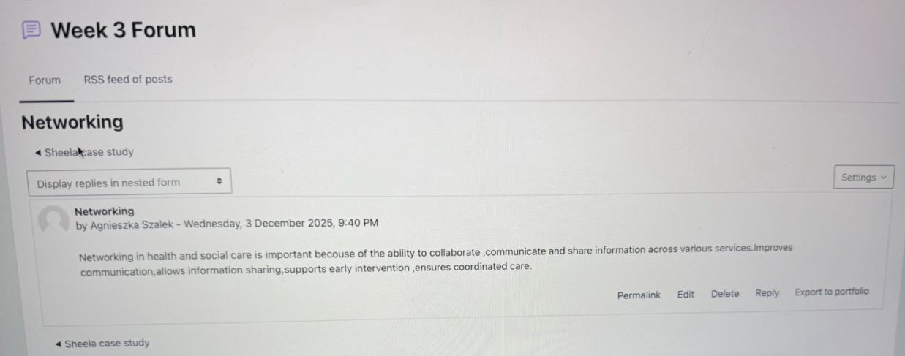

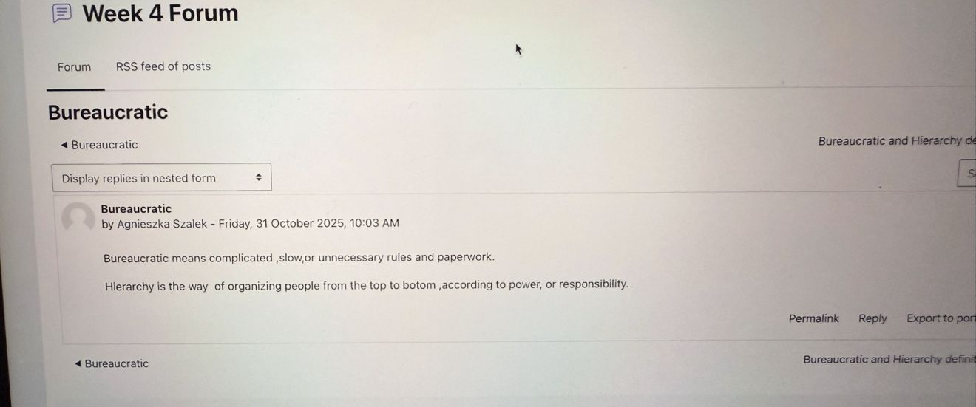

Reflection on Unit 3: Opportunity Knocks
The subject of Unit 3 was the recognition, the creation, and the execution of opportunities regarding one’s self and professional growth. One of the main teachings was the focus on the serendipity mindset, which suggests that one has to be open to the unknown and think of what may seem to be random occurrences in one’s life as important opportunities that can be taken advantage of. As Busch (2021) stated, serendipity is a function of curiosity, preparation, and action as it allows one to engage with the random opportunities and make them productive. I was able to reflect on open-minded and serendipitous attitude to be beneficial in personal growth within health and social care as well as through the field’s online tasks which require a great deal of flexibility and adaptability to varying challenges.

The third unit reviewed the concept of changing one’s perspective, changing the viewpoint of a situation in the hope of identifying new solutions and pathways. Within any domain, perspective understanding is one of the core aspects of cognitive functioning as it allows individuals to become more adept at problem solving, show empathy and gain flexibility within a situation (Grant and Franklin, 2020). I reflect on the exercises that were meant to encourage participants to visualize problems in a different light, and to demonstrate how easily they could be influenced to make decisions based on assumptions. These reflections prompted the understanding that problems need to be approached with the values of openness, creativity and critical thinking, especially when working with a variety of service users and multidisciplinary teams.

This unit also highlighted the importance of identifying career prospects by connecting old and new recruitment techniques with proactive employability pathways. In health and social care, prospects arise more from relationships, digital skills, and continuous skill development rather than from formal recruitment. According to Tomlinson and Anderson (2020), employability in this case should be more of a career self-management strategy, including establishing a digital profile, finding a sponsor, and continuous education. The online activities in the module increased my awareness of effective self-positioning and the identification of opportunities that fit my career aspirations.

Moreover, in Unit 3 reflection on work values prompted me to think about how personal values influence career choices and the kinds of opportunities I pursue. Value alignment with the culture of a workplace is linked to greater motivation, enhanced satisfaction, and a higher likelihood of sustained career success (Holland et al., 2021). In general, Unit 3 increased my capacity to identify, seize opportunities, plus a proactive disposition, and devising measures to propel my career in the health and social care domain.

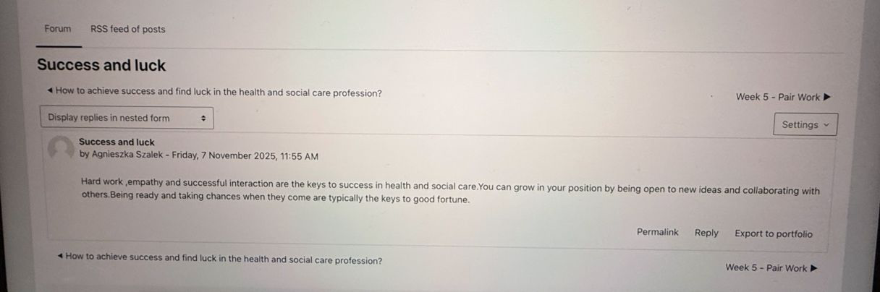

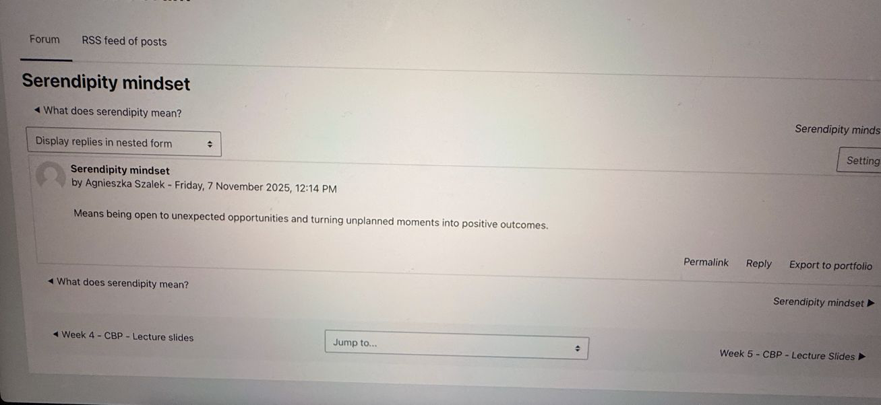

Reflection on Unit 4: The Pursuit of Happiness
Unit 4 focused on theories of personal fulfilment, endurance, and continuous career development. One of the core concepts was the idea of defining limits, which is self-constructed beliefs that restrict an individual’s ability. Meadows (2015) states that these negative defining limits come from an individual’s lack of confidence and motivation and career stagnation due to previous experiences or negative internal messages. The reflective activities and online quiz made me introspectively more aware of how beliefs, like the fear of failure, or self-doubt, may unconsciously control my behaviour in my studies and professional career. The recognition of these beliefs and mental patterns has driven me to adopt an internal framework of more kindness and growth.

Introducing the term grit, Duckworth (2016) defines it as perseverance and passion for long-term goals. Grit is also becoming known as one of the most important predictors of success in high-demand professions. One of these is in healthcare and social care, which involves high volumes of emotional, complex, and unpredictable work. The reflections on this were helpful in valuing the effort needed to sustain long work. The care provided in these professions is also needed to be of high quality, which is why it is important to value effort. The activities and discussions made me appreciate that grit, which is not inborn, needs to be developed in people through practice, reflection, and the right conditions.

Additional significant concepts included the definition of resilience and the capacity to cope with and adapt to multiple challenges. Users of services make new demands of health and social care professionals, which leads to new emotional and organizational changes, and to greater pressure. West et al. (2020) describe some methods of building and sustaining resilience, including the reflective practice of burnout proof wellbeing strategies, and having a significant social support network. My interaction with the materials presented in Unit 4 taught me that some of the methods directly related to staying well throughout a career involve reframing situations perceived as challenges, balancing work with periods of rest, and the seeking of support. Career planning and the use of role models, discussed in the unit, emphasized the importance of identifying role models as those who possess the desired skills, values, and behaviours. The Social Learning Theory suggests that motivation, self-confidence, and professional identity can be positively influenced purely by the observation of good role models (Bandura, 2018). I was able to reflect upon the professionals I admire the most in order to clarify the attributes I wish to develop, which for me are compassion, leadership, and ethical values.

The fourth unit has allowed, to this point in my academic career, the most clear understanding concerning the interplay of psychological fortitude and mindset along with vision and self-actualization, this unit has in turn expanded the understanding of the successful career in health and social care.

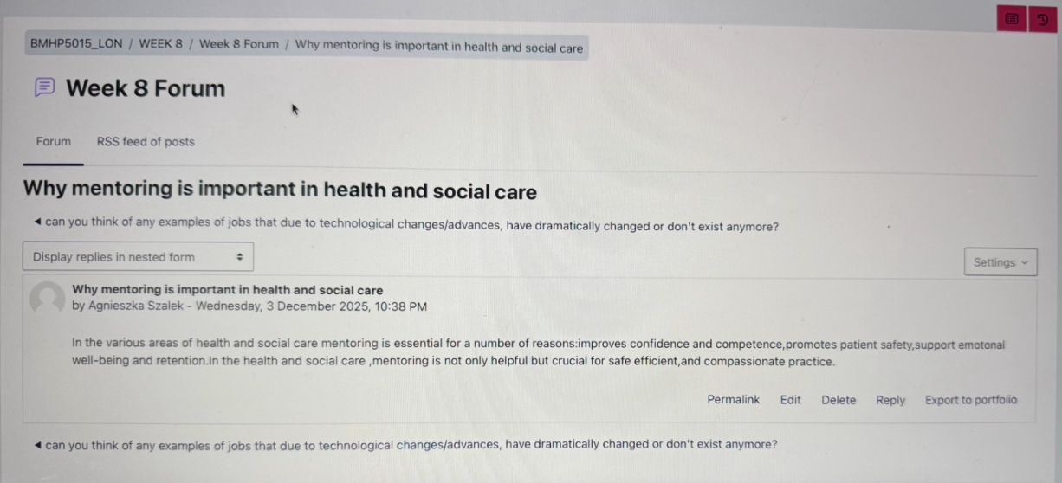
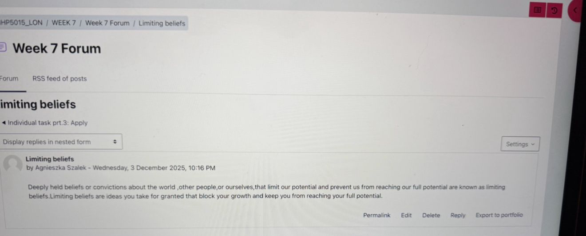

Conclusion
In this case, I can reflect on the work completed thanks to the construction of this portfolio. In Unit 1, I can recognise and appreciate the personal branding, self-awareness and development of these attributes. In Unit 2, I learnt the global interconnections of the health and social care systems and the importance of networking and evaluation. In Unit 3, I was introduced to the importance of opportunity recognition, the value of serendipity and the alignment of one’s career with the self, and this has challenged me to carve out a vision for my career and is, therefore, of enormous value. I can now appreciate the importance of continuity and progressive thinking and the mindset required for growth and, therefore, I thank Unit 4. All these workouts have improved my confidence, self-awareness and employability. I look at my career in the health and social care sector with optimism. I will reflect on my practice and on my professional identity and the digital and non-digital tools for self-care, and I will be of help to the community, the staff and the social care environment in the future.

References
Aicinena, B. (2013) Success and Luck in Professional Practice. Journal of Professional Development, 12(3), pp. 45–57.
Bandura, A. (2018) Social Learning Theory and Human Agency. New York: Routledge.
Bolton, G. and Delderfield, R. (2018) Reflective Practice: Writing and Professional Development. 5th edn. London: SAGE.
Brookfield, S. (2017) Becoming a Critically Reflective Practitioner. 2nd edn. San Francisco: Jossey-Bass.
Bury, M. (2013) ‘Health inequalities and the changing landscape of care’, Social Science and Medicine, 99, pp. 1–8.
Busch, C. (2021) The Serendipity Mindset: The Art and Science of Creating Good Luck. London: Penguin.
Duckworth, A. (2016) Grit: Why Passion and Resilience Are the Secrets to Success. New York: Scribner.
Entwistle, V., Cribb, A. and Owens, J. (2018) ‘Values-based practice in health care’, Health Care Analysis, 26(3), pp. 171–184.
Gibson, C., Hardy, J. and Buckley, M. (2014) ‘Professional networking in the workplace’, Journal of Management, 40(5), pp. 1234–1255.
Goleman, D. (2018) Emotional Intelligence: Why It Can Matter More Than IQ. Updated edn. New York: Bantam.
Grant, A. and Franklin, J. (2020) ‘Perspective-taking and decision-making in complex environments’, Journal of Applied Psychology, 105(9), pp. 973–987.
Hancock, S. and Szabo, C. (2022) ‘Professional identity and personal branding in health care’, Nurse Education Today, 112, pp. 1–7.
Holland, D., Tham, T. and Liu, H. (2021) ‘Work values and career alignment’, Journal of Vocational Behavior, 130, pp. 1–12.
Howard, J. (2019) The Future of Employment in Health and Social Care: The Role of Technology. Health Foundation Report.
Jackson, D. and Tomlinson, M. (2020) ‘Career values and employability in contemporary labour markets’, Journal of Education and Work, 33(3), pp. 213–230.
Larsson, A. and Tacking, P. (2023) ‘Antifragility in health and social care organisations’, International Journal of Health Policy and Management, 12(4), pp. 1–10.
Manley, K., Jackson, C. and McKenzie, C. (2021) Values-Based Practice in Health and Social Care. London: CRC Press.
Meadows, C. (2015) The Power of Limiting Beliefs: Transforming Your Mindset for Success. Bristol: Edgehill Publishing.
Naylor, C. et al. (2020) The Changing Shape of Health and Social Care. London: The King’s Fund.
Page, S. (2019) The Diversity Bonus: How Great Teams Pay Off in the Knowledge Economy. Princeton: Princeton University Press.
Smith, P., Allan, H. and Jones, B. (2018) ‘Interprofessional networking and collaborative working’, Journal of Interprofessional Care, 32(6), pp. 716–723.
Stansky, P. (1996) ‘Opening doors: Strategies for employment readiness’, Career Development Quarterly, 44(4), pp. 301–310.
Tomlinson, M. and Anderson, A. (2020) ‘Employability, work identities and career self-management’, Higher Education Quarterly, 74(3), pp. 290–305.
West, M., Bailey, S. and Williams, E. (2020) The Courage of Compassion: Supporting Nurses and Care Workers. London: The King’s Fund.
World Health Organization (2022) Global Health Workforce Statistics Database, World Health Organization. Available at: https://www.who.int/data/gho/data/themes/topics/health-workforce (Accessed: 22 November 2025).

