Muhammad Taha (ID: 2617284)


LCLM4001 Academic Skills: AS1
Assessment 1 – Reading Assessment
Source Text Provided: BBC News (2026) 'If you post it, they will come: The businesses turning likes into livelihoods'. Available at: https://www.bbc.co.uk/news/articles/cm2701py5npo
PART 1: Upload your photo of your A3 in-class notes here
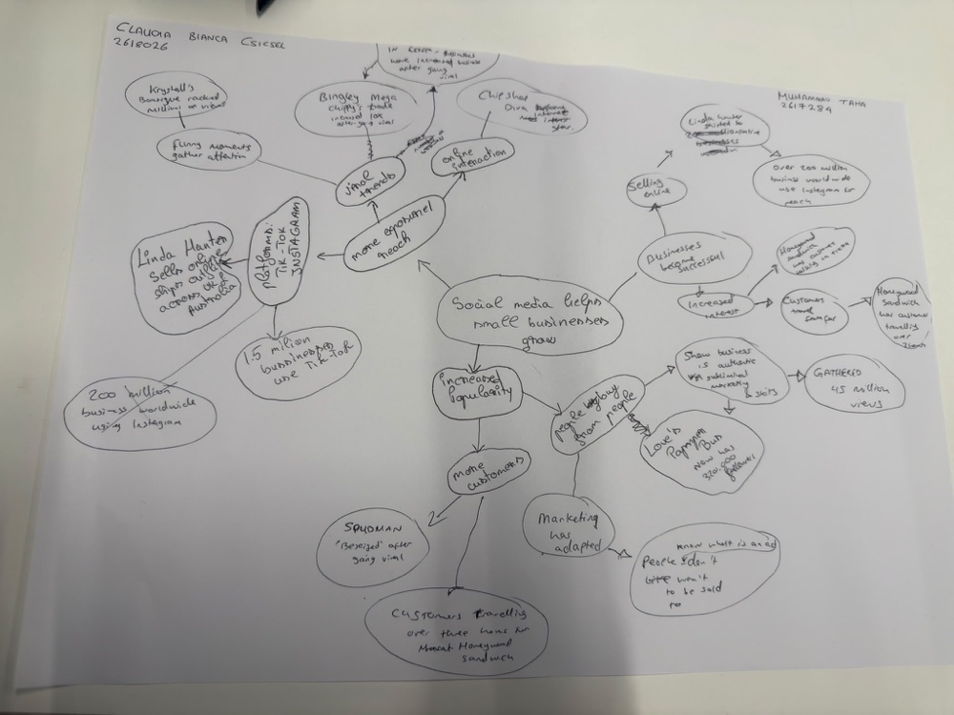
Figure 1: In-Class A3 Mind Map — 'Social media helps small businesses grow' (Claudia Bianca Csicsel, 2618026 & Muhammad Taha, 2617284).

PART 2: Reading & Reflection Questions (A–F)

- What is the main idea of the whole text?
The main idea of the whole text is that social media helps small businesses grow. Social media platforms such as TikTok and Instagram have become powerful tools that help small businesses grow and become successful. By sharing engaging videos online, small traders can reach millions of viewers and turn online popularity into real-world customers and sales.

- What is one key point that supports the main idea, and which specific example from the text shows this?
Social media gives small businesses more exposure and reach helping them attract more customers and sell directly through websites and platforms like TikTok, Instagram and Facebook (1.5 million businesses use TikTok, and over 200 million use Instagram worldwide). Linda Hunter aka ‘Lindy Loo’ is one example: her trade increased tenfold after going viral, and she now sells solely online, shipping outfits across the UK and Australia. This shows us the sheer influence online exposure has had on her business, to the point where Linda has changed her entire business strategy by piggybacking on the exposure received from her online presence, most importantly from when she went viral.

- What is a different key point that supports the main idea, and which specific example from the text shows this?
A different key point from the second circles on the mind map is that social media leads to increased popularity. Increased popularity attracts more customers and is a form of efficient marketing.
Specific example’s increased popularity supporting the main idea of social media helps small businesses grow can be found from the third outer circles of the mind map that shows Spudman, who was "besieged" with customers after going viral, Homewood Sandwich, which has customers travelling over three hours after seeing people talking about it on TikTok, and the Love Is pub, which now has 300,000 followers and gathered 45 million views by posting authentic skits.

- Which part of the text do you think is the most important, and why?

I think the most important point (shown in the second and third circles of the mind map) is that people buy from people, and marketing has moved away from traditional ads, as marketing expert Faye Marting from Laindon notes on page 3 of the article. When a brand is popular and looks authentic, people relate to it, trust it, and are reassured by the number of others who are also interested in it.

The traditional marketing approach such as salesmen would not be as efficient because people do not want to feel sold to. Someone feeling as if they are being sold a product would make one feel as if someone is trying to convince me to part with my money, this would instantly make me lack trust in the one selling the product to me and make me reluctant to part with my money.

People also recognise advertisements for what they are. By contrast, when customers choose a product they found on social media, they feel the decision is their own, and they trust it more because of its online popularity and the interest of fellow customers.

This is the most important point because having a website or social media account is not enough. Small businesses only grow when they show authentic personality and relatable, funny moments, as Krystal’s Boutique, Chip Shop Diva and the Love Is pub do.

Reflection:
- What did you find difficult in this task (including in-class components), and why was it difficult?
During this assessment, I found it difficult to sort all the information from the article into the right circles on our A3 mind map without repeating ideas, this is as social media’s influence on businesses is a vast umbrella and to avoid overlap when portraying my ideas was proving more difficult than expected. It was difficult because there were many different business examples and websites/platforms that connected to both online reach and getting more customers at the same time.

- What helped you with this difficulty, and how did it help you?
Using the mind map structure helped me with this difficulty because we put the main idea ("Social media helps small businesses grow") in the main middle circle, the key points in the second circles, and the specific business examples in the third outer circles. Organising the mind map into clear circles made it easy to see how all the ideas connected and find the exact answers for these questions. The support from my classmate during the group activity of the assessment was also beneficial as having a second opinion with a different perspective really helps in organising your own ideas.

