

Lecturer: Malani Gunaratnam BMSW4004

Problem solving and decision making

Table of Contents

Introduction…………………………………….2
PESTLE Analysis……………………………..2
Fishbone Analysis/ Ishikawa………………...3
Workplace Problem…………………………..4
Conclusion…………………………………….7
Appendix A……………………………………8
Appendix B……………………………………11
Reference……………………………………..13

Introduction

This report that I will be writing about what problems can come up at work and what are the best way to solve them and what are the best tools to use in order to achive this.
The different type of tools that best help one to do so is by using PESTEL Analysis, Fishbone Analysis also known as the Ishikawa.
With these tools I can try to show you one of the best ways to help resolve a work problem that had come up and what they could have tried to use in order to make the best decision for both the employer and the employee, first I will be explaining to you in some details about the two different types of analysis and I will use the best one for me and then I will explain the situation that had happened at work.

PESTEL Analysis

PESTEL Analysis is an examination of six external influences on any organisation which are Political, Economic, Sociological, Technological, Legal and Environmental. (CIPD, PESTLE Analysis, 2018)

- Political looks at tax policy; environmental regulations; trade restrictions and reforms; tariffs; political stability.
- Economic looks at the economic growth/decline; interest, exchange, inflation and wage rates; minimum wage; working hours; unemployment (local and national); credit availability; cost of living.
- Sociological looks at cultural norms and expectations; health consciousness; population growth rates; age distribution; career attitudes; health and safety.
- Technological looks at new technologies that are frequently emerging (for example, in the fields of robotics and artificial intelligence), and the rate of change itself is increasing. How will this affect the company’s products or services?
- Legal looks at the changes to legislation that impacts employment, access to materials, quotas, resources, imports/exports, taxation.
- Environmental looks at global warming and the increased need to switch to sustainable resources; ethical sourcing (both locally and nationally), including supply chain intelligence. Pandemics and other emergencies.

When taking into factor these analyses many businesses can have a better understanding into the external influences that can play a big part in impacting the way the business or organisation makes important decisions. This helps human resources and senior management to highlight any specific risks to the company and make the necessary changes that’s needed.

There has been other acronyms which is similar that have been used for example ETPS, STEP, PEST also STEEPLE (the extra E stands for Ethical) but PESTLE has been used more in the last ten years or so.
(CIPD, PESTLE Analysis, 2018)

If you take a look at Appendix A you will see an example of a PESTLE analysis and can get an idea of how to do it.

Fishbone Analysis/ Ishikawa

The Fishbone Analysis which is also known as the Ishikawa and also known as the cause-and-effect diagram. These diagrams are used to help brainstorm the more effective way to help structure the best possible structure to a problem that may come up at an organisation. (American Society for Quality, 2019)

The fishbone analysis is helpful to use when an organisation is in the product development and troubleshooting stage, it will help to highlight possible future problems and the causes of them according to the level of diagram hierarchy.
Dr Kaoru Ishikawa was a Japanese quality control expert who invented the fishbone to help he’s employees to avoid situations by addressing the root cause. (What is a Fishbone Diagram (Cause and Effect Diagram, 2019)

If you take a look at Appendix B you can see an example of a Fishbone Analysis and can get an idea of how to use it.

Workplace Problem

I have worked for Tower Hamlets Council for over 5 years in the Contract Services department as a kitchen assistant in the school catering service, my job role was to provide cooked food for primary school children, the contract was for part time term only working from 10:45 until 2:30 pm, I had to help prepare the food by cooking and setting up the dinner hall for 500 plus students and also for all the staff members. Our job was to also make sure that we catered for all those who had special food Requirements due to the allergies they had and we had to be very careful to not mix any of the cutlery that we used on a daily basis with those that we use on students that have allergies for example fish, cheese, dairy and nut to name a few.
Working in a school kitchen at times can be very hard to do but as time goes on you learn to finds ways that best works for you, as this job is a very much hands on manual labour work it can take its toll on a person and that was the case here as when I first started work I had already informed them of my health which was I am a type 1 with brittle diabetes and as I had informed my employer they was able to make some small changes at work for example I had more frequent breaks however they was shorter than other members of staff.
As a diabetic over time your health can deteriorate as this was the case with me, my health got to the point where I was having difficulty walking unaided and had developed frozen shoulder, the council Protocol is to have their employee to sign off sick well until they have a proper diagnosis of what is wrong with their health, The next stage would then be to have them come in with their union representative if they have one and to discuss what is the next step in order to bring them back to work.
However, in my case that was not the case, even with my union rep they was not very supportive as the union rep had a much better relationship with the team leaders and management as they all shared the same office building and would see each other on a daily basis as we worked on site of the school we was placed in and would only attend the main building for one day courses or for any meetings with our team leaders.
As time went on I had been signed off sick for a long time and even with a sick certificate from my GP and Consultants I was still asked to call in every week into the office in order to get paid, which I felt for people who maybe unwell would find very difficult if they was on some very strong painkillers as I was. After a long time of being off sick and meeting up with my team leader and HR unfortunately not much was done in order for me to be able to come back to work other than supplying me with a chair to sit on in the kitchen so that I can wash up but at the same time have my other work colleagues pick up the slack for me as I was unable to do the heavy lifting in my job but at the same time they would not receive a pay rise and I would not receive a pay decrease it would have been completely and actually unfair to the other employees and would only in turn cause friction between us.
I was not offered a job elsewhere within the company, placed elsewhere within the company or even given a different job role within the company, I felt that they was many thinks that could have been done in other for me to keep working with in the company without it affecting the company in any way, shape or form.

First off, I have made a fishbone diagram to give you an idea of what is the cause and how to best make it work.

(A diagram of my fish bone analysis)

When you take a look, you will see that for a person who now has difficulty walking and having to use walking aids would no longer be able to work in a teaching due to health and safety measures that are in place not only for the person who is disabled but also for the other employees and employers. These factors all need to be taken into count when trying to highlight a problem but also the next steps and what is the right step for not only the employer but also for their employees.

I feel what they could have done is instead of just putting a chair in the kitchen which for health and safety reasons is not very safe not just for myself but also for the other staff members who come into the kitchen themselves. Instead of making the other staff pick up the work that I could not do in the kitchen for example pick up and move 20 tables and 200 chairs into and out of the dinner hall. Pick up all the dirty dishes and cutlery and carry them into the kitchen, make the staff do all this extra work with a pay rise is professionally unethical.

What I feel that they could have done is they could have moved me to another area within the company for example office work as many of the team leaders and managers started out the same as me as a kitchen assistance and it was through their experiences, but they were able to do the job that they are doing today. I should also start off in the office and do extra training within the office for example Admin, I.T and office work.
There is many training courses available within the council and online that I could have taken to help me transition from one job role to another. I feel that there is always ways available without having to terminate a person’s contracts due to their health, whether it be physical or mental health, especially now with the COVID-19 pandemic that's all organisations be small or large being private or public sector have all suffered due to this and what employers must always think about is the well-being of their staff and promoting well-being can help avert stress levels and build positive working environments where individuals and organisations can flourish. (work, 2019) Employees should ensure they have a united framework in place to support peoples physical health and safety and mental health and offer genesis of help such as counselling.

Conclusion

What I have learnt from doing this assignment is that there is many ways for many organisations and businesses to take a look at all the best possible ways for them to ways for them to deal with problems within the company and what is the best solution by using many different tools that is available and not just the two tools that I spoke about in this report. However, it is not to say that it is still easy to do with these tools unless you understand them and understand the cause-and-effect. This has not been the easiest report to write but it has however been the most interesting and therefore I hope it has been explained to the best of my ability.

I had enjoyed the classes that I had with Malani Gunaratnam she was an absolute pleasure to listen to an learn from and she opened my eyes and mind to the businesses and entrepreneur world.

APPENDIX A

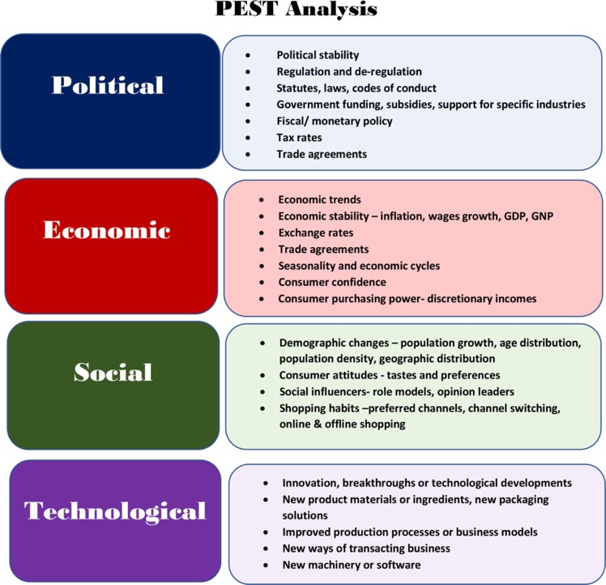
This Photo by Unknown Author is licensed under CC BY-SA

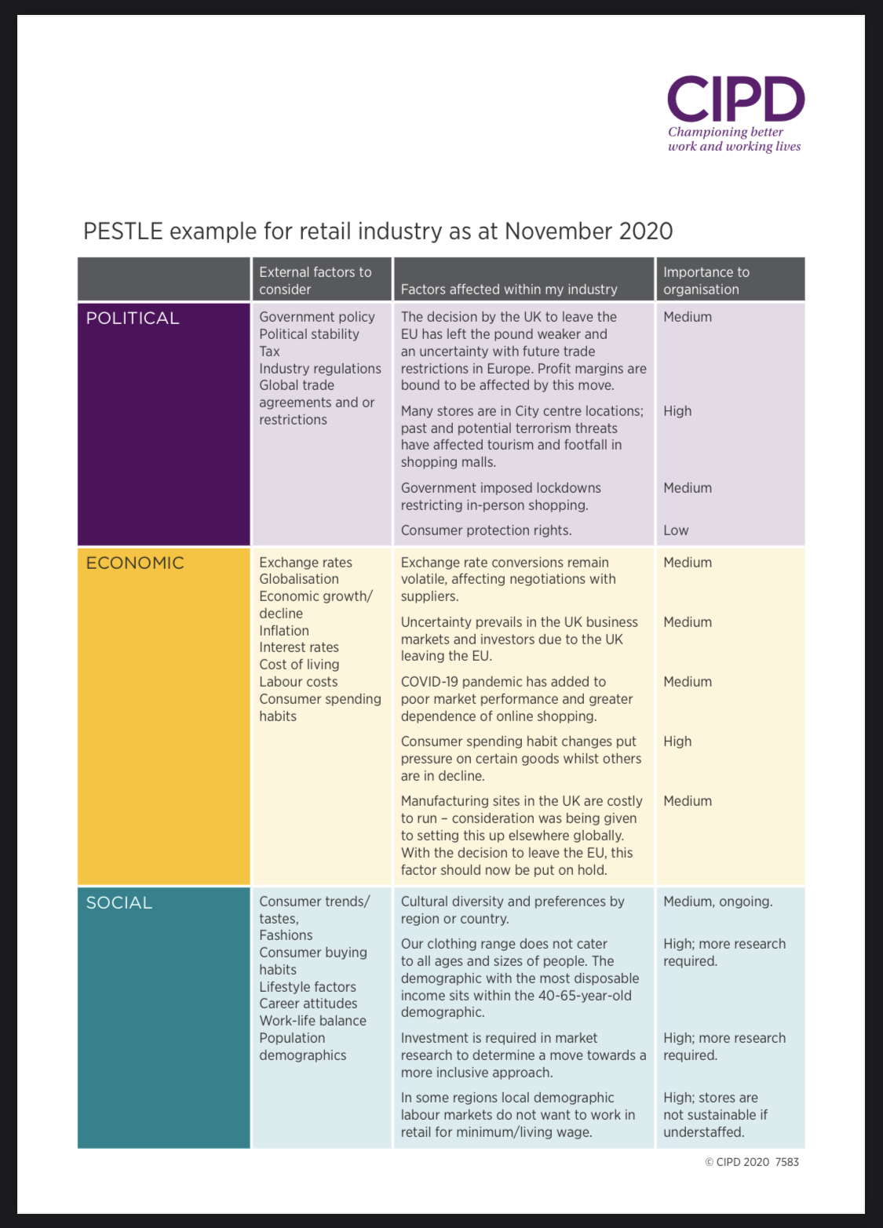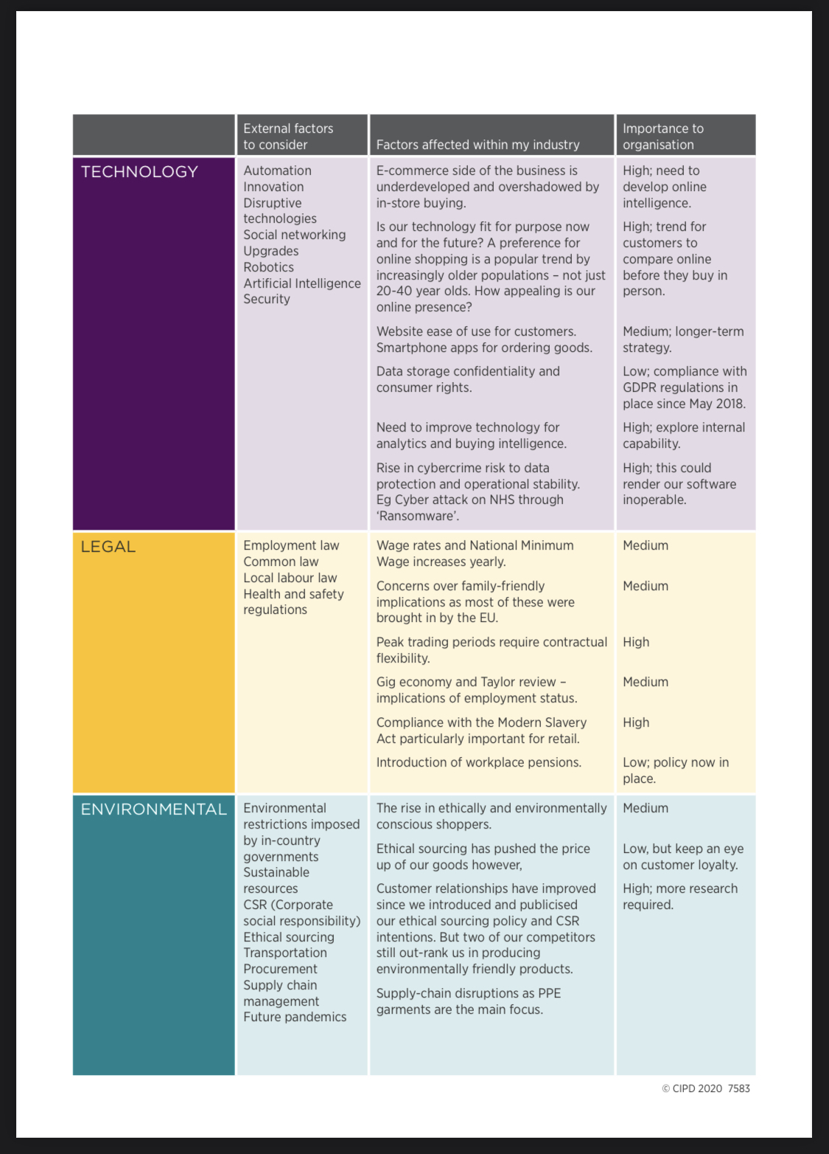
APPENDIX B

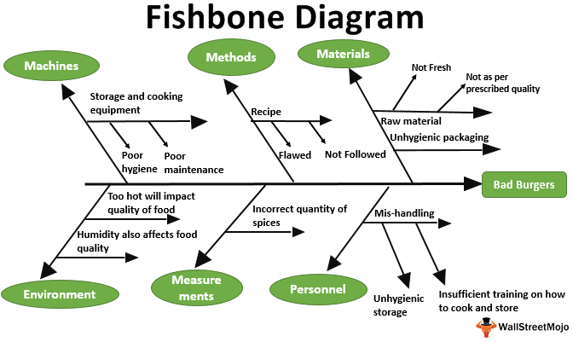

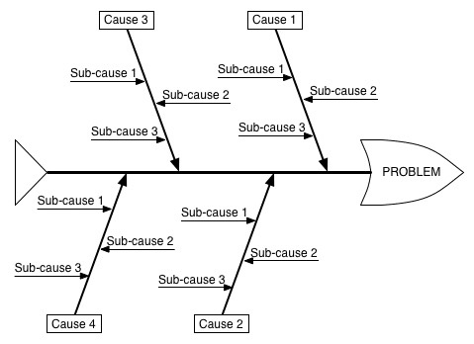

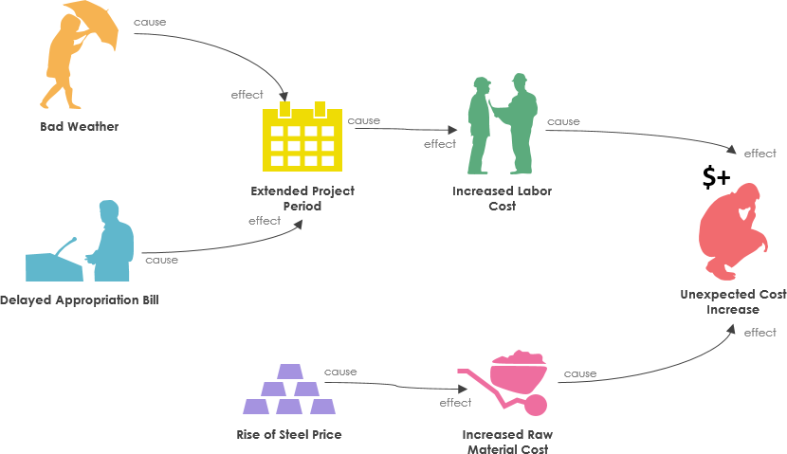
Reference

American Society for Quality (2019). What is a Fishbone Diagram? Ishikawa Cause & Effect Diagram / ASQ. [online] Asq.org. Available at:
https://www.asq.org/qulity-resourses/fishbone. (accessed 8 January 2021)

CIPD, PESTLE Analysis (2018). PESTLE Analysis / Factsheets / CIPD.[online] CIPD. Available at: https://www.cipd.co.uk/knowledge/strategy/organisational-development/pestle-analysis-factsheet#7986. (accessed 8 January 2021)

What is a Fishbone Diagram (Cause and Effect Diagram (2019). What is a Fishbone Diagram (Cause and Effect Diagram)? [online] WhatIs.com. Available at: https://www.whatis.techtarget.com/definition/fishbone-diagram. (accessed 8 January 2021)

Work (2019).Well-being at work / Factsheets / CIPD.[online] CIPD. Available at: https://www.cipd.co.uk/knowledge/culture/well-being/factsheet. (accessed 8 January 2021)

