

Institute of Inner-City Learning Birmingham Campus

BSc (Hons) Health and Social Care

Disclaimer
This document was correct at the time of publication. The Module Coordinator reserves the right to modify any statement if necessary, make variations to the content or methods of delivery of programmes of study, to discontinue programmes, or merge or combine programmes if such actions are reasonably considered to be necessary by UWTSD. Every effort will be made to keep disruption to a minimum, and to give as much notice as possible. An electronic copy of this handbook can be found on the Moodle page for the module.
DECLARATION
This work has not previously been accepted in substance for any degree and is not being concurrently submitted in candidature for any degree
Signed……s.ullah………………………………………
Date……22.7.2026…………………………………………
STATEMENT 1
This dissertation is being submitted in partial fulfilment of the requirements for the degree of BSc.
Signed……s.ullah……………………………………….
Date…22.7.2026……………………………………………
STATEMENT 2
This dissertation is the result of my own independent work/investigation, except where otherwise stated. Other sources are acknowledged by footnotes giving explicit references. A bibliography is appended.
Signed………s.ullah……………………………………
Date……22.7.2026…………………………………………
STATEMENT 3
I hereby give consent for my dissertation, if accepted, to be available for photocopying and for interlibrary loan, and for the title and summary to be made available to outside organisations.
Signed…………s.ullah……………………………………
Date……22.7.2026……………………………………………
STATEMENT 4
I hereby give consent for my dissertation, if accepted, to be available on the university’s IT system to those who have consent to use the system.
Signed………s.ullah………………………………………
Date………22.7.2026…………………………………………

MODULE: Independent project

MODULE CODE: BMHP6020

ASSIGNMENT TITLE: Research Dissertation – Element 2 & 3

LECTURER: Chloe Harries

STUDENT: Sania Ullah

STUDENT ID: 2314490

Abstract
This dissertation investigated the essential elements of the effectiveness of home-based care to the older population as part of health and social care systems. The overall purpose of the study was to examine the experience of home-based care among older adults, family caregivers, and home care workers and to examine the workforce and system-level factors that would influence the provision of these services. The study has value within the framework of the ageing population and the growing political focus on ensuring that people have the opportunity to continue living on their own and stay in their households as long as possible. It is imperative to understand the experience of individuals involved in home care so that it enhances the quality of services, safety and sustainability.
The secondary research design was made, which involved a systematic review and thematic analysis of the available academic literature. Structured database searches were made to find relevant peer-reviewed studies that were then evaluated based on set inclusion and exclusion criteria. A thematic coding method was employed in the selected literature to find the recurrent patterns and critical themes that could be associated with home-based care experiences and service delivery.
Three primary themes were identified in the analysis. These were lived experiences of the older adults who are being given home-based care, role and support requirements of the family or informal caregivers, and workforce, safety and organisational barriers that impact service delivery. The results showed that home-based care is influenced by multifaceted interrelations among patient requirements, caregiver engagements and structural forces in health and social care systems.
Limitations were in the use of secondary data and variation in study situations, which can affect the generalisability of results. To enhance future practise, the study suggests the incorporation of workforce support, better caregiver support services and integration of health and social care systems.

Table of Contents
Abstract 2
Chapter 1: Introduction 6
Introduction 6
Definitions and Terminology 7
Rationale for Research 8
Research Aim 8
Research Objectives 9
Conclusion 9
Chapter 2: Background Information and Analysis 10
Introduction 10
Historical Background 10
Theoretical Background 11
International Context 13
National/Local UK Context 14
Conclusion 16
Chapter 3: Methods and Search Strategy 17
Introduction 17
Search Strategy 17
Searching for Information 17
Research Validation 18
Inclusion and Exclusion Criteria 18
Analysing Research 18
Ethical Considerations 19
Chapter Conclusion 19
Chapter 4: Findings and Discussion 20
Introduction 20
Thematic Analysis 20
Theme 1: Older Adults’ Lived Experiences Of Receiving Home-Based Care 21
Definition 21
Background Information 21
Impact on Research Question 21
Theories, Policies, and Legislation 22
Implications 22
Examples from Your Articles 23
Connections to Other Themes 23
Theme 2: Family / Informal Caregivers And Perceived Support From Home-Based Services 23
Definition 23
Background Information 24
Impact on Research Question 24
Theories, Policies, and Legislation 24
Implications 25
Examples from Your Articles 25
Connections to Other Themes 26
Theme 3: Workforce, Safety, Transitions, and System-Level Barriers To Effective Home-Based Care 26
Definition 26
Background Information 26
Impact on Research Question 27
Theories, Policies, and Legislation 27
Implications 28
Examples from Your Articles 28
Connections to Other Themes 28
Chapter Conclusion 29
Chapter 5: Conclusion 30
Overall Conclusion 30
Recommendations 30
Recommendation 1 30
Recommendation 2 31
Recommendation 3 32
References 33
Appendix 40
Appendix 1: Source Tracking Table 40
Appendix 2: CRAAP Text 41
Appendix 3: Summary Table Of Selected Studies 43

Chapter 1: Introduction

Introduction
The trend of population ageing is one of the features of the twenty-first century. The world population aged 60 years and older will rise to almost 2.1 billion by 2050, almost twice the current level by 2020 (Gu et al., 2021). Greater life expectancy comes with more chronic diseases, frailty, and multimorbidity that continually put the long-term care system and hospital-based services under strain. Health and social care systems have increasingly adopted community-based models of health care, especially home-based care, which provides clinical, personal, and social services at the home of an individual. Skilled nursing, rehabilitation, medication administration, aid of activities of daily living, and palliative care are all covered by home-based care, which is usually managed by multi-disciplinary teams.
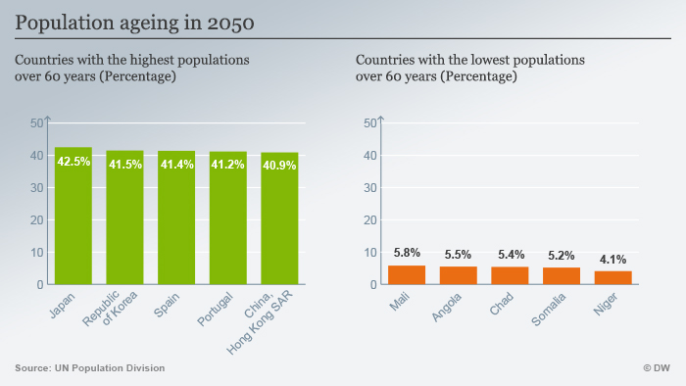
Figure 1: Population Ageing in 2050 (Badr et al., 2019)
There has been evidence that this type of model can minimise unnecessary hospitalisation, enhance patient satisfaction, and facilitate ageing in place, which is the desire of the older population (Inacio et al., 2025). Furthermore, integrated home care interventions have been linked to better functional outcomes and cost-effectiveness compared to the institutional options (Curioni et al., 2023). The ultimate objective of this dissertation is to examine the contribution of home-based care to the well-being and independence of older adults. It aims to critically analyse its efficacy in improving health outcomes, decreasing hospital usage, and improving quality of life in the framework of a thematic analysis of current literature.
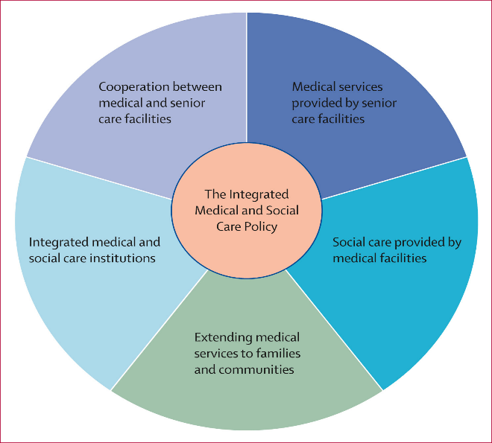
Figure 2: Integrated Care Policy (Rodin et al., 2025)

Definitions and Terminology
Home-based care (HBC) is a wide term used to describe a wide array of health and social services provided in the home of an individual to facilitate medical conditions, functional capacity, and daily living. According to Gavarskhar et al. (2022), home care refers to services that facilitate individuals to stay at home, though they receive preventive, curative, rehabilitative, or palliative care. In this dissertation, HBC encompasses skilled nursing, personal care, therapy services, and psychosocial assistance given by formal caregivers or multidisciplinary teams. Older adults are people aged 65 years or more, although a few studies use an age of 60 years as a global convention in ageing (Ramdowar et al., 2024).
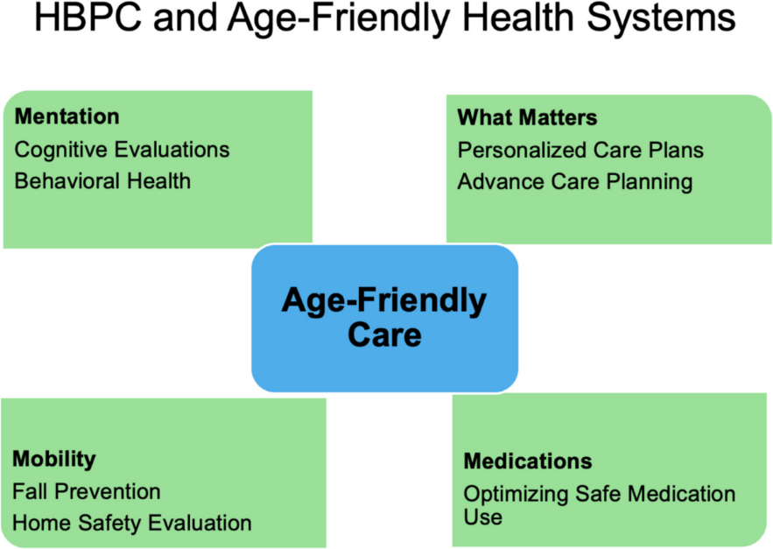
Figure 3: Age Friendly Care (Haferkamp et al., 2025)
Independence is the capability to carry out activities of daily living (ADLs), such as, bathing, dressing, and mobility with minimal or no physical assistance, whereas wellbeing involves non-physiological aspects such as physical health, psychological condition, social status, and quality of life as perceived (Visvardis and Zafeiris, 2024). The term ageing in place refers to the ability of older individuals to reside safely and comfortably within their households as opposed to an institutional setting, a theory that relates much to autonomy and dignity. The dissertation makes use of several acronyms. The abbreviations HBC are home-based care, ADLs mean Activities of Daily Living, and IADLs mean Instrumental Activities of Daily Living, which include activities like financial or medication management. QoL is the abbreviation that means Quality of Life, a multidimensional measurement tool that is commonly applied in gerontological studies. LTC is used to mean long-term care systems (Nova, 2025).

Rationale for Research
Home-based care is becoming an important option, especially with the rapid ageing of the population and the spread of chronic illness that has placed a strain on hospital services and residential long-term care. The patients of older age always report that they want to stay at home where they can feel independent, familiar, and their social identity (Brance et al., 2024). There is therefore a promotion of home-based services by policymakers in ensuring that ageing in place is encouraged at a time when the cost imposed by institutional care is held down. There is an indication that effective programmes of home care have the potential to reduce the number of hospitalisations, postpone nursing home care, and increase functional status and satisfaction (Al-Hamad et al., 2025).
However, the results are quite different in terms of coordination of services, availability of the workforce, and complexity of patient needs, which means that the efficiency does not work at all levels of the situation. There exist significant gaps in research. The current literature frequently emphasises clinical or economic measures, lacking much of a focus on holistic wellbeing, involvement in different activities, and experience of older adults and informal caregivers (Kim et al., 2023). Evidence in care models is scattered, making it difficult to determine best practices. Challenges such as fragmented services and rural disparities need more research. This dissertation will synthesise recent literature on home-based care to analyse findings and implications for policy.

Research Aim
To investigate how home-based care contributes to the well-being and independence of older adults.

Research Objectives
- Define and examine the concept of home-based care, including its models, services, and scope within health and social care.
- Analyse the benefits and challenges of home-based care for older adults, drawing on evidence from current research, literature, and practice.
- Evaluate the effectiveness through thematic analysis of home-based care towards improving health outcomes, reducing hospital admissions, and enhancing quality of life.
- Provide recommendations for policy, practice, and service delivery to strengthen home-based care support for the elderly.

Conclusion
The chapter has provided the context of population ageing and how home-based care is becoming a viable response to the complex health and social needs of older adults. Important concepts and terminology were defined so that everyone could have a homogeneous interpretation of home-based care, independence, and well-being, and what came next was a justification of problems, policy priorities, and gaps in the existing knowledge. The chapter also defined the main objective of the dissertation, which is to assess the effectiveness of home-based care in the context of providing health outcomes, autonomy, and quality of life to older individuals. The next chapter presents background and concerns a critical analysis of the existing literature. It analyses theoretical views, theoretical care models, and empirical benefits, limitations, and efficacy literature of care, thus establishing a basis upon which a methodological approach and analysis will be discussed in later chapters.

Chapter 2: Background Information and Analysis

Introduction
The chapter offers a broad context to the issue of home-based care of older adults, both historically, theoretically, and contextually. It will relate the research to a bigger context of understanding how home care has evolved over the years, the major theories that shape practise, and how services are provided internationally and in the UK. The chapter provides the basis of a discussion of the effectiveness and challenges of home-based care by analysing historic milestones, conceptual frameworks, and policy landscapes. It is a context disclosure that is required to inform the research approach, guide the selection of pertinent literature, and offer the required background to inform thematic analysis to be offered in subsequent chapters.

Historical Background
Reinhard et al. (2023) states in their study that the history of home-based care can be traced to informal family caregiving and community charity, which was the most common way of providing care to older and chronically ill persons even before the modern expansion of hospitals (Reinhard et al., 2023). Organised home nursing developed in the nineteenth century in reaction to poverty, epidemics, and inadequacy of institutional care in the cities. As per Nightingale, sanitation, observation, and community-level nursing, which were components of the public health reform by Florence Nightingale, formed the idea of district nursing services (Nightingale, 2025). As a result of collaboration with Nightingale related researchers Lundy and Master discussed the mobilisation of the first formal district nursing service in Liverpool, and this showed that trained nurses can provide effective nursing care to patients in their homes moreover enhance health results among the disadvantaged people (Lundy and Master, 2024).
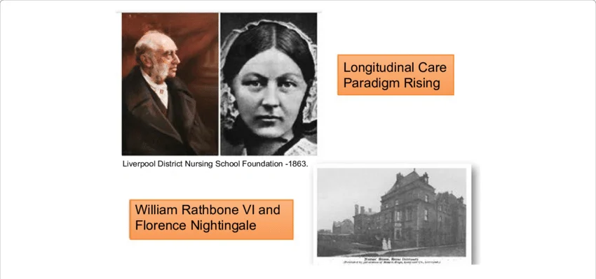
Figure 4: School of District Nursing Liverpool (Ortega-Calvo and Calvo-Calvo, 2018)
Other organisations, such as similar visiting nurse associations, later emerged in the United States and Europe and institutionalised structured care of vulnerable populations at home (Mobasseri et al., 2023). In the twentieth century, modernisation in the biomedical sciences, hospital infrastructure, and medical technology created a transition of healthcare to institutional care, lessening the role of home care. Some of the achievements discussed by Chan and Wong has been the Alma-Ata Declaration of 1978 that established primary health care and community involvement as the core of the equitable health systems across the world (Chan and Wong, 2023). This model indicated the significance of convenient care being provided in the location where people reside, especially in the case of the ageing groups with long-term conditions. According to other reforms in most countries with high income levels, home health services were then incorporated into larger systems of long-term care, with the aim of reducing unwarranted hospitalisation and enabling continuity of care (Schwabe et al., 2025).
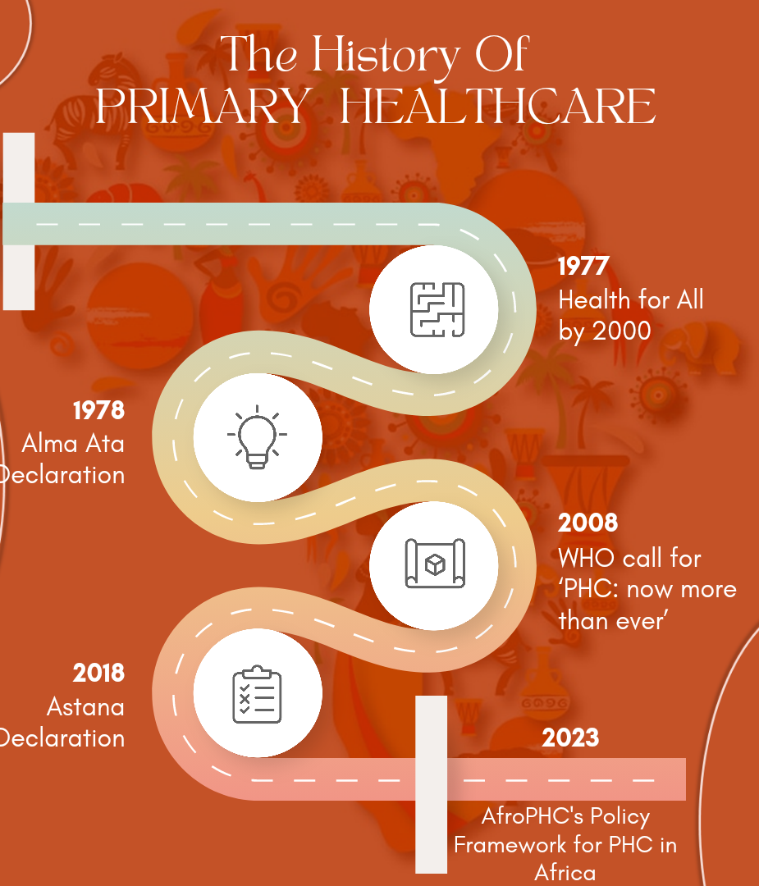
Figure 5: History of Primary Healthcare (Hadasae, 2023)
Since the late twentieth century, the ageing in place concept has become popular in gerontology and social policy. The ecological theory of ageing by Lawton and Nahemow placed a lot of emphasis on the interplay between the functional capacity of individuals and their living environments and the importance of supportive home environments in ensuring that individuals remain functional (Rantanen, 2025). Home-based and integrated care was also advocated by international organisations, such as the World Health Organisation, as the key approach to dealing with multimorbidity and frailty in older adults particularly through implementation of a new Integrated Care for Older People (ICOPE) framework (Sum et al., 2022). Most recently, the use of multidisciplinary home care teams, reablement programmes, and telehealth technologies has increased the extent of services available through basic nursing to the provision of multidisciplinary medical, rehabilitative, and psychosocial services at home (Ma et al., 2025).
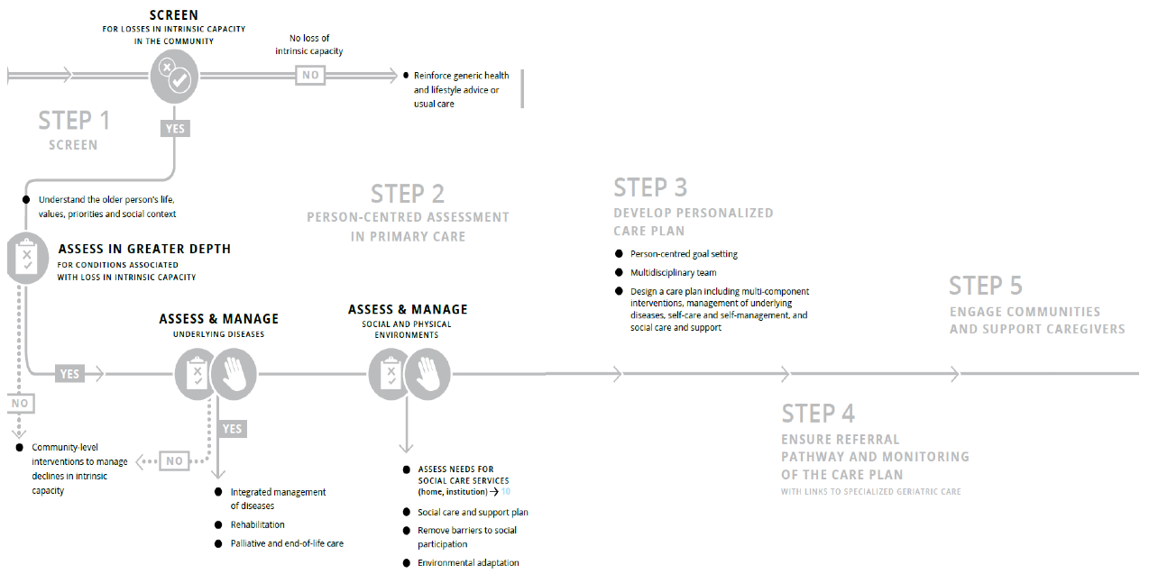
Figure 6: Integrated Care for Older People (ICOPE) framework (Sum et al., 2022)

Theoretical Background
A number of conceptual designs support the perception of home-based care among elderly individuals, especially concerning autonomy, well-being, and service efficiency. Among the most powerful is the ecological theory of ageing developed by Lawton and Nahemow, which is based on the premise that later life outcomes are influenced by the relationship or contact between the individual's functional competence and the environmental challenges (Newcomer and Bexton, 2024). According to this view, adverse home environments may be counteracted by the supportive ones, allowing the elderly to remain independent in old age. This model has been used in empirical studies that prove that environmental adaptations, assistive technologies, and in-home support can lead to decreased functional decline and a lower risk of institutionalisation (Bogler et al., 2023). Nevertheless, critics claim that the model is mostly concentrated on the physical environment and individual capacity and undermines structural inequalities, including socioeconomic status and access to services (Egede et al., 2024).
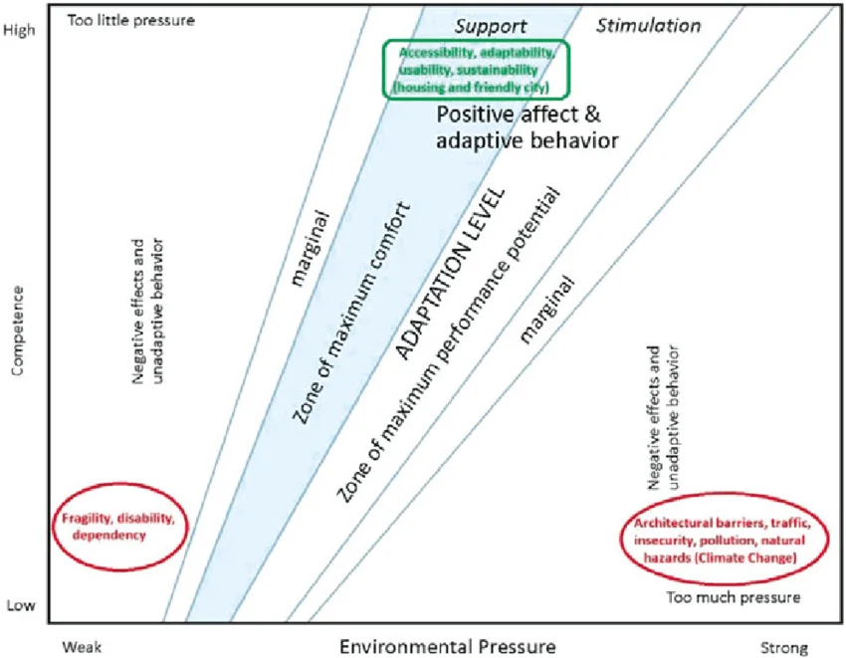
Figure 7: Ecological Theory Of Ageing (Sánchez González and Rodríguez Rodríguez, 2016)
A second conceptual framework is the philosophy of ageing in place, which underlines that older adults prefer remaining in their familiar environment and receiving the support that they need. According to Sampaio and Walsh (2023), ageing in place is not predominantly about where, but who, identity, moreover, social connectedness. It is shown that home-based care has the potential to increase psychological well-being and life satisfaction as it maintains routines and support communities (Ghoshal and Damani, 2025). However, other researchers warn that ageing in place can move care provision towards the families, which can overload families with caregivers and cause hidden unmet needs (Holliday et al., 2022). With this debate, there is an issue of tension between policy ideals and practical realities.
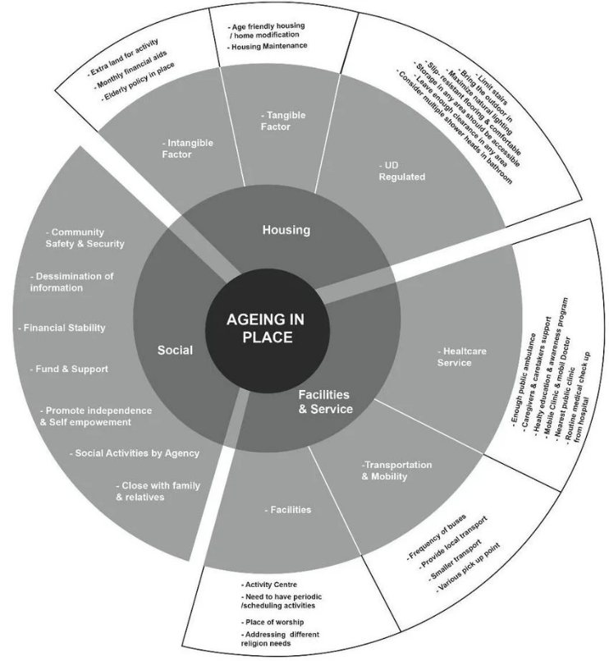
Figure 8: Framework For Ageing In Place (Tobi et al., 2018)
The theory of person-centred care is also central to the theory that the focus is on individual preferences, dignity, and holistic needs as opposed to a disease-focused approach of treatment. In his dementia care studies, Kitwood states that supportive relationships and the acknowledgement of personhood are determinants of well-being (Rojas, 2025). Home-based interventions were also studied and have demonstrated better satisfaction and less behavioural distress under individual rotation and values in care (Gavarskhar et al., 2022). Nonetheless, in home setups, person-centred solutions are sometimes not easily realised because of time scarcity, workforce shortages, and discontinuous services that restrict uniformity of provision (Ma et al., 2025).
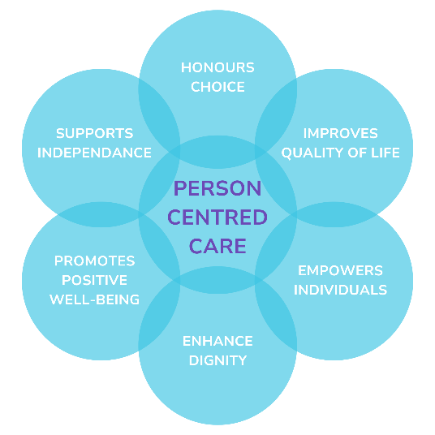
Figure 9: Person Centered Care (Clarke, 2024)
Moreover, the model of chronic care offers a system viewpoint, whereby the best results in long-term conditions depend on coordinated, proactive, and community-based efforts (Chan and Wong, 2023). There is some evidence that integrated programmes of home care align with this model and can decrease hospitalisation and enhance self-management (Bogler et al., 2023). However, opponents argue that the model presupposes a degree of organisational integration and patient involvement that can be absent in under-resourced environments (Rantanen, 2025). Home-based care should focus on environmental support, autonomy, and coordination. However, challenges like social inequalities and caregiver effects complicate its implementation, highlighting the need for tailored solutions in research and practice.

International Context
Home-based care is a key strategy that is adopted globally to support the health and social demands of the ageing population without compromising the sustainability of the health care systems. International organisations promote community-based frameworks that allow older adults to stay in their homes as long as possible. The World Health Organisation advocates the policy of integrated and person-centred care at the community level as a fundamental principle of healthy ageing policies (World Health Organisation, 2025). The increased use of formal home care services to lower hospitalisation and to delay institutionalisation is a wider move to long-term care of chronic conditions, rather than acute, episodic care that once dominated many high-income countries (Ricciardelli and Mercurio, 2026). Meanwhile, limited formal infrastructure results in informal family caregiving being an important factor in low- and middle-income countries, creating access and quality discrepancies (Aboderin, 2017).
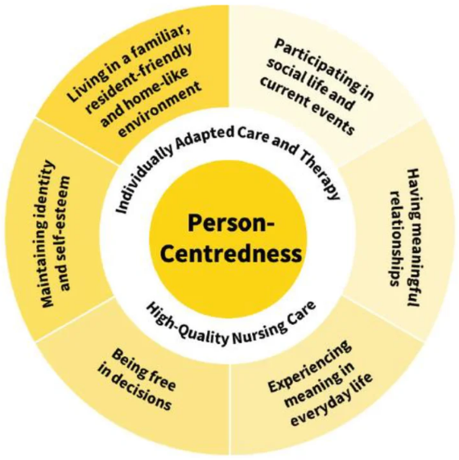
Figure 10: Fundamental Principles Of Person-Centred Care (Halbmayer et al., 2021)
There is a great difference in strategies. Sweden and Denmark are Nordic countries that focus on publicly paid home help and nursing care as components of universal welfare, with high coverage and less dependence on residential care (Szebehely and Meagher, 2018). The United States, in contrast, has a mixed system with private providers and publicly administered programmes like Medicaid, which means that service delivery is uneven and inequitable (Rantanen, 2025). East Asian nations such as Japan have adopted extensive long-term care insurance plans that place emphasis on home and community services.
The world is becoming more open to sharing and standardising knowledge. The framework of Integrated Care of Older People, developed by WHO, fosters integrated health and social services across settings, and the Decade of Healthy Ageing agenda of the United Nations (UN) focuses on community support (WHO, 2025). For example, the community-based integrated care system in Japan has enhanced access to home services but experiences a lack of workforce because of significant population ageing (Nagarajan et al., 2023). Nordic models, on the other hand, show good performance, but demand high levels of public spending, which raises the question of long-term fiscal sustainability. Cultural strength in inter-generational support may result in inequities and strains on the caregiver when the situation is dependent on unpaid family carers.
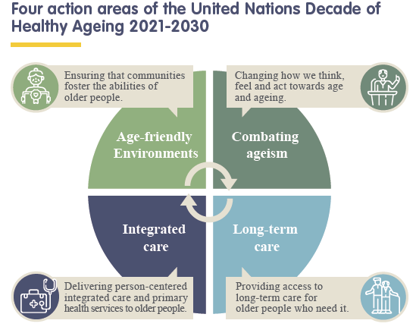
Figure 11: Decade of Healthy (Ageing Institute of Ageing, 2020)

National/Local UK Context
Home-based care has become the heart of the United Kingdom's strategies to assist the ageing population, besides curbing hospital and residential care strain. The intention to support older adults to stay at home is consistent with policies of enhanced independence, quality of life enhancement, or reduced delayed discharges (NHS England, 2019). The UK has also come up with a variety of formal home care services which include domiciliary personal care, community nursing, reablement, and specialist services such as palliative and dementia services. These services are provided by a mixture of government providers, commercial agencies, and voluntary organisations, and integration is being further encouraged by local health and social care alliances (Rantanen, 2025).
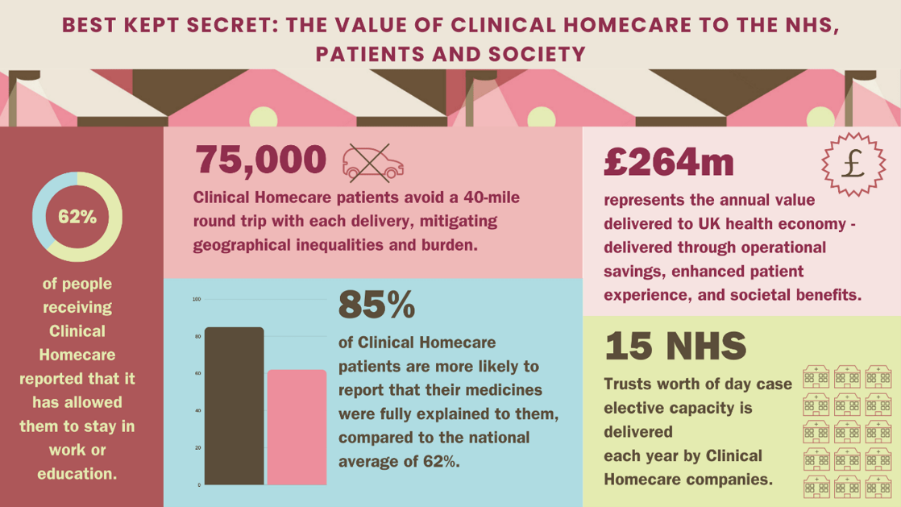
Figure 12: Home Care in UK Under The NHS (Batchelor, 2024)
The arrangements of the provision and extent of home-based care have been influenced by the directives of major policy and legislative frameworks within the country. The Care Act 2014 offers legislation on the provision of adult social care, which defines the duties of assessing, protecting, and personalising care plans (GOV.UK, 2014). It supports the concept of well-being and independence, which ensures that local authorities offer or provide domiciliary services where there is a need. The NHS Long Term Plan (NHS, 2019) also focuses on community-based care, describing the aim to have integrated health and social care teams, enhance community nursing, and digital advances to care of older people in homes. Reablement services under the National Service Frameworks are intensive, short-term support services to bring back independence post-hospitalisation to prevent readmissions and prolonged dependence on care (Tobin et al., 2016).
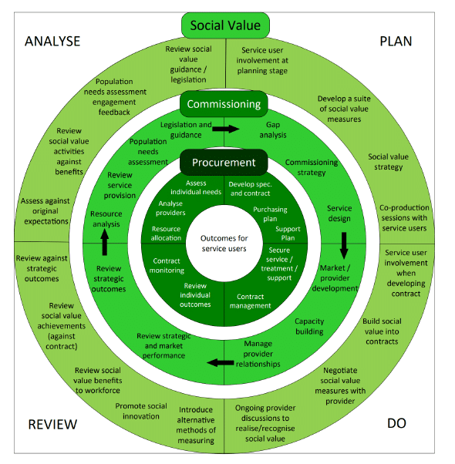
Figure 13: UK National Service Frameworks (Corlett, 2024)
At the local level, implementation depicts regional differences in resource distribution, models of service, and demographics. For example, the Manchester City Council has extended its integrated care teams, bringing together community nurses and social workers, which in one year brought about a 12% decline in delayed hospital discharges (Chang, 2022). To fill these gaps, local authorities are increasingly coming up with activities like community hubs, telecare, and volunteer networks. Other case-studies like the community hub initiative in Newcastle show that the regions where healthcare and social care partnerships are well established perform better in hospital avoidance and patient satisfaction than more divided services (AlOmari, 2022).
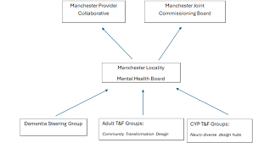
Figure 14: Structure Of Manchester City Mental Health Board (Williamson, 2025)
The sector continues to experience problems such as labour shortage, unpredictable funding, and rising demand due to an ageing population with complex needs, despite the encouragement of the policy. The differences in commissioning, eligibility standards, and quality of services are issues that still persist. However, the UK setting reflects a clear policy focus on home-based care as a crucial element of person-centred, sustainable care of older adults, with continued work on enhancing integration, equity, and effectiveness at both national and local levels.

Conclusion
This chapter has examined the history of home-based care, important individuals and events that have influenced its current position, and theoretical approaches such as ecological ageing, ageing in place, and person-centred care, gaining an understanding of their use and relevance. International and UK perspectives have been considered, demonstrating differences in approaches and delivery. Overall, these approaches have contributed to a comprehensive understanding of the history, issues, and agendas of home-based care. This will help to inform the methodology of the next chapter, ensuring that the literature and data are rigorously examined to gain a comprehensive understanding of the role of home-based care in the independence and well-being of older people.

Chapter 3: Methods and Search Strategy

Introduction
This chapter describes the methodology to be used in this dissertation, and it is built on a desk-based secondary research design. It describes the systematic identification, selection, and analysis of the relevant academic literature, policy documents, and organisational reports to serve the research purpose. The previously created academic methodology poster gave a brief visual summary of a research design, search procedure, and analytical framework, whereas each of the mentioned aspects is described in detail in this chapter. These methods will be essential in maintaining a rigorous and transparent procedure of evidencing the identification of materials that will support the thematic analysis and results as contained in Chapter 4.

Search Strategy
Keywords were also developed based on the title and aim of the research and included home-based care, domiciliary care, community care, older adults, elderly, ageing in place, independence, quality of life, hospital admissions, and long-term care. Sensitivity was expanded with the use of synonyms and other related professional terms, as per systematic search guidance (Mancin et al., 2024). The use of the Boolean operators was used to narrow down the search terms, such as home-based care AND older adults, ageing in place OR community nursing, and NOT paediatric, to narrow down unrelated populations. A search log was kept to record databases, combinations, filters, and results and increase the transparency and replicability.

Searching for Information
The report used standard recognised academic databases and websites to find relevant literature, such as Google Scholar, PubMed, and the UWTSD Library search service. The sources have been selected as they index peer-reviewed journals, government publications, and authoritative reports within health and social care, which ensures credibility and academic rigour (Sizo et al., 2025). To enhance relevance, the filters were used to filter searches based on publication dates, between 2015 and 2026, English language, peer-reviewed status and full-text availability. Recency filtering was used to guarantee that the results were current with policy developments, technology, and current practise.
The iterative process of search was completed. Initial general searches yielded a great number of results, which were further constrained by adding specific keywords, such as the terms community nursing, rehabilitation, or avoidance in hospitals. Synonyms and subject headings were added when searches had no evidence. Key article reference lists were also scanned to find more relevant literature. To facilitate transparency and organisation of the evidence, a source-tracking table was created, wherein the database information, keywords, and inclusion rules were recorded, and summaries of the selected literature were displayed. The table is available as a reference in the appendix (Appendix 1).

Research Validation
In order to have relevance and quality, the articles were first filtered through structured screening instruments known as skimming. To ascertain the correspondence to the aim of the research, titles, abstracts, introduction, and conclusions were examined to adhere to the existing evidence-screening strategies of literature-based research (Mak and Thomas, 2022). Sources that explicitly covered home-based care to the elderly, health outcomes, or independence were retained to be reviewed fully. Currency, Relevance, Authority, Accuracy, and Purpose were tested using CRAAP as shown in Appendix 2. They were particularly specific to recent publications, peer-reviewed articles, and well-known authors/organisations. Though not all sources inverted all five criteria, it was essentially those that showed great currency, direct relevance, and credible authorship. For example, a recent peer-reviewed paper in a known gerontology journal which followed a transparent methodology and had clear findings was deemed worthy of inclusion.

Inclusion and Exclusion Criteria
Selection criteria included peer-reviewed journal articles, government and health-organisation reports, and trusted scholarly materials published 2015 -2026, with the focal point of home-based care of older adults and, specifically, in the UK or similar health environments. The sources dealing with independence, health outcomes, or community care were prioritised. Such exclusion criteria as non-academic sites, opinion articles, outdated studies, non-English journals and research with paediatric or unrelated populations were excluded. The use of these criteria guaranteed the level of consistency in the methods, their relevance to the purpose of the research, and the overall quality of the evidence base (Rogozińska et al., 2020).

Analysing Research
The identified literature was systematically analysed using a thematic coding method. All sources were thoroughly read with the aim of defining common concepts and findings and essential words in the areas of home-based care, independence, health outcomes, and effectiveness of services. These repeated notions were then made into initial codes and thematic analysis requirements as stipulated in the context of qualitative research, which were followed (Christou, 2022). They were then compared and grouped into broad categories using similar codes to come up with general themes based on similar themes to the objectives of the research (e.g., benefits, challenges, and effects on quality of life). Spreadsheets, coding tables and highlighting colour were applied to track sources, codes and new themes, ensuring transparency and organisation. Such an organised exercise facilitated sufficient connection between the evidence and the theme-based findings relating to Chapter 4.

Ethical Considerations
The research employed solely secondary research (the use of existing scholarly sources and official reports), and as such was not associated with any collection of data involving human subjects. Ethical accountability focused on academic integrity by properly referencing all sources in a uniform Harvard referencing format, and also ensuring no plagiarism or misrepresentation. Findings were interpreted in a faithful manner, and evidence was objectively presented. Selection and reporting in literature were done in a transparent manner and in balance, with a view to minimising bias and maximising credibility, aligning with recognised ethical standards of literature-based research (Yoo, 2026).

Chapter Conclusion
This chapter has described the methodological approach to the identification, evaluation, and analysis of the pertinent literature utilised in this study. It described the search strategy, grid, database and filters usage, validation tools usage and the clear use of inclusion and exclusion criteria. The theme coding approach offered a strict process of employing repetitive ideas to formulate significant themes. These were the measures that promoted transparency and academic strength. The findings of this analysis will now be presented in Chapter 4 in the key themes which are directly associated with the research aim and objectives.

Chapter 4: Findings and Discussion

Introduction
This chapter is the result of the thematic analysis of the chosen literature and the critical discussion of the identified main patterns across the studies. This chapter starts with a description of the application of thematic analysis as a method of data analysis to be used to analyse the secondary research data. It goes on to explore three significant themes found in the process of coding: the lived experiences of older adults receiving home-based care, family or informal caregivers and their perceived support of services and workforce, safety, transitions and broader system-level barriers to home-based care provision. All of the themes are discussed critically, synthesising the evidence presented in the reviewed studies to interpret patterns, identify similarities and differences in the results, and consider their implications toward the ultimate answer to the research question.

Thematic Analysis
Thematic analysis is a qualitative divergent analytical approach utilised to detect, categorise, and comprehend designs or themes of a dataset. Thematic analysis is a methodical analysis procedure of qualitative data through coded recurring concepts and then grouping them into larger conceptual themes (Squires, 2023). This is especially effective in secondary research where multiple studies are to be synthesised, and the researcher is able to determine common patterns, relationships, and differences between the literature. The technique gives a systematic but open-minded model of reacting to intricate evidence and connecting results with research aims.
The thematic analysis was integrated into this research by reviewing the chosen articles and coding the initial ideas that appeared as a common theme connected with home-based care of older adults. The recording of these codes and how they were organised into a coding table, followed in the analysis process, was described in Chapter 3, as displayed in the appendix. Like codes were bundled to create broader themes, which were significant issues observed in the literature. In doing so, three general themes were identified: the lived experiences of older adults as recipients of the home-based care services, the role of the family and informal caregivers and their perceived support, and the barriers of the workforce, safety, and system level to the effectiveness of home-based care services.

Theme 1: Older Adults’ Lived Experiences Of Receiving Home-Based Care

Definition
The lived experiences of receiving home-based care are the subjective realities and emotions that older adults experience in each day or everyday life as recipients of health or social care services in their residences. The concept involves physical, psychological, and social aspects of care, such as a sense of independence, dependency, safety, and relationship with caregivers. Norvilaitė et al. (2024) suggest that lived experiences can give a perspective on the interpretation of care given to recipients in a way that could not be measured through clinical indicators, among others. On the same note, Schumacher et al. (2021) opine that patient experience is critical to assessing the performance of community care models since perception of support, autonomy, and relationship with care providers are key determinants of wellbeing and service interaction.

Background Information
The literature discussing experiences in home-based care has grown as ageing in place becomes the focus of policy. Previous healthcare paradigms used to pay more attention to clinical performance or cost-effectiveness, but modern studies show the relevance of patient-centred approaches. According to Olsson et al. (2020), older adults often go through a post-discharge transition period, when physical capacity reduces, as they seek to be independent at home. Equally, Norvilaitė et al. (2024), in their qualitative interview study (17 older adults receiving long-term home nursing services), discovered that the process of home care presence entails a complicated, balanced support and autonomy loss. Participants appreciated professional support and also complained of social isolation and emotional vulnerability. In line with this, Schumacher et al. (2021), who reviewed interviews as part of a pragmatic randomised controlled trial of a cardio-respiratory home care intervention, emphasise client experiences resulting from both medical management and relationship, i.e., trust in nurses and a sense of continuity of care.

Impact on Research Question
The research question is based on the lived experiences of older adults receiving home-based care, which provides a direct answer to how the services can influence wellbeing and independence. According to Norvilaitė et al. (2024), the viewpoints of patients could reflect aspects of care quality that quantitative indicators alone could not rule out, such as a sense of dignity or emotional support. In a similar study, Olsson et al. (2020) discovered the desire of older adults to regain independence despite physical impairment, even at home, after being hospitalised. This observation adds to the larger suggestion that psychological motivation and autonomy can be enabled in home care settings. Nonetheless, Schumacher et al. (2021) introduce a more sophisticated viewpoint, showing that older people themselves can have a heavy burden when it comes to the management of chronic diseases at home. In line with these, whilst home-based care can empower home-based care patients, it can also transfer some of the healthcare management to them.

Theories, Policies, and Legislation
A number of established theoretical frames are useful in explaining home-based care experiences of older adults. The Ecological Theory of Ageing by Lawton and Nahemow suggests that the well-being levels in later life are based on competition between the competence and the environmental press of an individual (Newcomer and Bexton, 2024). This framework is implicitly supported in studies that indicate that older adults at home recovering are trying to restore their independence by adapting to environmental limitations (Olsson et al. 2020). Similarly, person-centred care theory was originally formulated by Kitwood in dementia care with a focus on dignity, autonomy and meaningful relationships in care interactions, which Schumacher et al. (2021) illustrate by the significance of trusting nurse-patient relationships. The legal framework of the UK policy sector includes the Care Act 2014, which includes wellbeing and independence advancement promotion in the social care of adults, even those at home (GOV.UK, 2014). At the same time, the NHS Long Term Plan focuses on increasing community health services to curb the number of hospital admissions and help older adults stay safe at home (England, 2023).

Implications
The observed lived experiences in the literature demonstrate both favourable and unfavourable implications of home-based care. Regarding the positive facet, Norvilaitė et al. (2024) established that older adults often perceived the home care nurse as a close companion who provided physical and emotional support beyond. Respondents identified nurses as being like family members, implying that interpersonal relationships can be built through home-based care. Likewise, Schumacher et al. (2021) believe that structured home intervention can enhance the relationship between patients and human resources by educating patients and continually interacting with healthcare practitioners to self-manage chronic illnesses.
Nevertheless, Norvilaitė et al. (2024) emphasise the topic of social isolation as a common occurrence, stating that patients who receive extensive home care frequently have fewer access points to the world. Similarly, Olsson et al. (2020) provide that a significant part of the elderly population feels frustration and anxiety adjusting to dependency after leaving the hospital. The participants felt vulnerable when they were dependent on caregivers or assistive devices. In agreement with this, Schumacher et al. (2021) explain that home care models can create emotional and cognitive strain by shifting the responsibility of managing the disease into the hands of patients. These results show that home-based care can both encourage independence and ensure dependency.

Examples from Your Articles
The article by Norvilaitaitė et al. (2024) is very interesting in the way older adults understand their experience of the provision of long-term home care services. Conducted qualitatively based on 17 interviews, the researchers established three themes connected with difficulties of care, social well-being, and mixed emotional responses. Respondents were often grateful for professional help, especially with everyday activities and health care. They also reported feelings of loneliness and a wish to have the services expanded to offer greater social interaction, though. The results of Norvilaitė et al. (2024) thus show both positive and limiting factors of home care settings.
Equally, Olsson et al. (2020) studied the older adults on life after hospital discharge. Their qualitative examination indicated the prevalence of one theme that was termed " longing to be independent again. Individuals reported experiencing difficulty in mobility and daily living, but they also stated that they were willing to give it their all to become more autonomous. These results are in line with Norvilaitės et al. (2024), who also detected the tension between support and independence. A randomised trial of a cardio-respiratory home intervention conducted by Schumacher et al. (2021), the analysis of interviews revealed the themes of the responsibility of self-care and the therapeutic connection with the healthcare professionals. Their results offer the hypothesis that education and positive relationships helped the participants to gain confidence in coping with chronic conditions.

Connections to Other Themes
This theme is related to the other themes present in the dissertation. Theme 2 is highly centred on the role of the family and informal caregivers because they determine the experiences of older adults receiving home-based care. As an illustration, as Schumacher et al. (2021) observe, collaborations between professional careers and family members frequently influence patient experiences. On the same note, workforce issues, safety, and coordination of services, as discussed under Theme 3, have a direct impact on the quality of patient experiences.

Theme 2: Family / Informal Caregivers And Perceived Support From Home-Based Services

Definition
Family or informal caregivers are family members, partners, or close persons who offer unpaid services to older adults to help them in their daily tasks, health care, and emotional concerns. In the home-based care systems, such caregivers usually work closely with professional services to guarantee continuity of care. Wool et al. (2019) point out that family caregivers are key partners in addressing the complex health needs of homebound patients, especially in cases where mobility results in restricted access to conventional healthcare environments. Equally, Warkentin et al. (2022) underline that informal caregivers often plan visits, prescriptions, and interactions with healthcare practitioners. Therefore, the theme explores the phenomenon of support to the family caregivers by professional home care services, both facilitating and making it difficult for this relationship.

Background Information
The role of family caregivers has long been a pillar of community-based elder care. With the ageing population being encouraged in health systems, dependency on informal caregiving has been aggravated. By conducting semi-structured interviews with 19 caregivers in a primary care programme based at the home, in the United States, Wool et al. (2019) show that family members often take on great roles in terms of offering daily care coordination. Similarly, Warkentin et al. (2022), in their analysis of telephone conversations with 21 caregivers enrolled in the German RubiN community case management intervention, emphasise how fragmented healthcare systems tend to impose organisational work on families. In line with this, Sunde et al. (2025), based on in-depth interviews with older adult caregivers, demonstrate that family members need to negotiate complex relationships with medical personnel in the process of maintaining trust with the care recipient. All the studies above indicate that the role of informal caregivers as a go-between between old people and formal services is revealed. Nonetheless, they show that this role could be stressful, unpredictable, and require professional help and acknowledgement.

Impact on Research Question
Family caregiver experiences play a major role in determining the effectiveness of home care in promoting the well-being and independence of older adults. According to Wool et al. (2019), caregivers tend to get quite stressed when treating complex health conditions with no professional assistance available to him/her. Their qualitative data indicate that the burden of home-based primary care services is reducible by enabling ready communication and multidisciplinary expertise. On the same note, Warkentin et al. (2022) document that caregivers who joined community-based case management programmes felt relieved when professional coordinators helped them navigate the healthcare systems. In line with this, Sunde et al. (2025) emphasise that caregivers need to maintain a balance between autonomy and safety of older adults, especially where mental health problems are involved. This suggests that the results of home-based care are not solely patient experience, but equally the resources that family caregivers have.

Theories, Policies, and Legislation
There are a number of theoretical factors that can be used to explain the experiences of family caregivers in home-based care. The Caregiver Burden Theory provided by Zarit highlights the psychological interest of role conflicts and emotional burnout as possible personal results of the extended caregiving burden (Yiengprugsawan, 2024). This view is justified by the results of Wool et al. (2019), who proved that caregivers tend to be stressed at the times when they have to address complex health issues but do not have appropriate professional help. Similarly, Pearlin's Stress Process Model (Akbar and Munfadilla, 2022) emphasises the interaction of primary caregiving demands with social and structural factors that affect the well-being of a caregiver, and it aligns with the inability to coordinate care discussed by Warkentin et al. (2022). The legal rights of carers to assessment and support services in England are formally established in the Care Act 2014 (GOV.UK, 2014). Also, according to the Carers (Recognition and Services) Act 1995, the needs of carers are to be factored in during service planning (GOV.UK, 2015). In spite of these structures, Sunde et al. (2025) imply that caregivers are yet to enjoy the appropriate recognition and support in the intricate healthcare frameworks.

Implications
The literature shows that there are some implications for the role of family caregivers in home-based care systems. On the upside, professional home care services would greatly reduce caregiver burden once proper communication and coordination are put in place. In another study by Wool et al. (2019), caregivers who took part in home-based primary care programmes reported a higher level of mental well-being, as professionals could offer them convenient advice and emotional support. Similarly, Warkentin et al. (2022) state that case management interventions have the potential to bolster the confidence of caregivers by assisting them in managing complicated healthcare systems and referring to related services.
Nevertheless, Sunde et al. (2025) emphasise that often, caregivers are torn between respect for the older person and his/her independence and the necessity to guarantee safety and proper treatment. The tension may result in emotional stress and indecisiveness about decision-making. In line with it, Warkentin et al. (2022) state that not all caregivers were satisfied with the level of assistance that the case management programmes had, which may indicate inconsistencies in service delivery and expectations. These contradictory results suggest that informal caregivers can be either supported or strained through home-based care. Professional involvement may be crucial guidance, but a lack of coordination or role delineation can make stress worse.

Examples from Your Articles
The qualitative research published by Wool et al. (2019) offers a comprehensive perspective on caregiver views on home-based primary care services. The researchers based their findings on interviews with 19 caregivers of frail homebound patients and located themes related to emotional support, caregiver burden, and increased service requirements. The caregivers noted that communicating with healthcare teams was easily available, and this assisted them in coping with the stress and in feeling that they were supported in their caregiving roles. A number of participants even claimed that the programme not only saved their own lives but also relieved them of anxiety and offered them some guidance in tricky situations. These results imply that integrated home care teams may play an important role in impacting caregiver wellbeing.
In the same way, Warkentin et al. (2022) examined the experience of caregivers in the RubiN community care and case management intervention. According to their qualitative research, the caregivers found it valuable to have a professional who dedicated their time to organising the services and offering guidance. In line with this, most respondents indicated that they felt relieved since the intervention had lowered the administrative weight of trying to navigate healthcare systems. Nevertheless, not all participants were happy when their expectations did not turn out. A similar perspective, though complementary, is presented by Sunde et al. (2025), who investigate the caregivers of older adults with mental health conditions. Their results demonstrate the narrow line that caregivers have to walk regarding respecting autonomy and guaranteeing proper healthcare interventions to reflect the complexity of informal caregiving roles.

Connections to Other Themes
This theme is inextricably linked with the other themes mentioned in the dissertation. Theme 1 discussed the lived experiences of older adults receiving home-based care, with the role of the family caregiver playing a central role. Indicatively, the provision of support by family members can contribute to a better sense of security and emotional health in recipients of care. In a similar fashion, workforce capacity and system-level barriers, discussed in Theme 3, have a great impact on the support that is provided to caregivers. Informal caregivers tend to be more burdened with more responsibilities when professional services are not properly staffed or not coordinated, which also underscores the interrelationship between these themes in comprehending the effectiveness of the home-based care system.

Theme 3: Workforce, Safety, Transitions, and System-Level Barriers To Effective Home-Based Care

Definition
Workforce, safety, transitions and system-level barriers are structural and organisational variables addressing the effectiveness and sustainability of home-based care services. According to Grasmo et al. (2021), home care workers are often faced with unpredictable conditions in which occupational risks and time constraints may negatively impact worker wellbeing and service quality. Equally, Tong et al. (2016) point out that safety in home care goes beyond clinical risks and includes spatial, physical, and relational issues being encountered by both clients and caregivers. In line with this, Bergqvist et al. (2024) highlight that effective and safe community care service provision requires workforce support and organisational recognition.

Background Information
The growing trends towards ageing in place have postponed the need for home-based care services in most health systems. Nonetheless, this growth has also indicated some systemic issues in the aspect of the capacity to provide health and safety services, as well as harmonising the efforts between the health and social care experts. Grasmo et al. (2021) conducted semi-structured interviews of eight home care workers in Norway, where they used systematic text condensation, showing that workers are often faced with physically demanding jobs and unpredictable conditions in the delivery of care in a home setting. Similarly, an investigation by Bergqvist et al. (2024) based on thematic analysis of twelve interviews with home care workers describes that in spite of pride in their professional role, staff felt that they were undervalued and that organisational structures limited them in their possibilities to offer high-quality care. In line with this, Tong et al. (2016), acting based on a far greater qualitative study based on interviewing 82 home care clients and 55 family caregivers in Canada, point to the fact that safety issues in home settings are multidimensional. All these findings have in common the fact that home care systems need to deal with clinical needs as well as complex environmental and organisational risk.

Impact on Research Question
System-level barriers have a direct impact on whether home-based care services can enhance wellbeing and independence in older adults. According to Grasmo et al. (2021), home care workers can reduce the quality and continuity of care provision due to staffing shortages, time constraints, and excessive physical workload. Likewise, according to Bergqvist et al. (2024), employees often felt proud and powerless, which means that professional commitment is not sufficient to counter organisational constraints. In turn, Tong et al. (2016) show that safety issues in home environments could limit the nature of care that could be provided. They analysed the hazards as perceived by clients and carers to be associated mainly with home layout, equipment accessibility, and interpersonal relationships with care providers. These results indicate that patient outcomes alone cannot measure the success of home-based care. Rather, larger organisational and environmental conditions should also play a role.

Theories, Policies, and Legislation
Safety and workforce issues in home-based care are often analysed in terms of organisation and occupational health theories. The Karasek Job Demand Control Model explains the current relationship between high work demands and low control that eventually results in work stress and burnout (Bakker and Demerouti, 2024). The view is supported by Grasmo et al. (2021), who show that home care workers tend to have heavy physical loads and time constraints, but little control over the environmental conditions in the home of clients.
On the same note, the safety climate theory underscores the role of organisational commitment to safety on worker behaviour and risk management, aligning with the multidimensional safety concerns indicated by Tong et al. (2016). The Health and Safety at Work Act 2012 affects the workforce conditions in health and social care in the UK as it mandates employers to ensure that employees do not face occupational hazards (GOV.UK, 2012). Moreover, the Health and Care Act 2022 focus on workforce development, interconnected care systems and enhanced coordination of health and social care services (GOV.UK, 2022).

Implications
The literature suggests both the positive and negative implications of workforce and system-level dynamics in home-based care. On the optimistic end, Grasmo et al. (2021) have discovered that purposeful connections with clients were usually linked to job fulfilment in the case of home care workers. Likewise, according to Bergqvist et al. (2024), most workers said that they enjoyed working professionally and serving older adults at home. These results indicate that a high level of professional motivation may help to promote the quality of interpersonal care and support continuity. Nevertheless, Grasmo et al. (2021) show that unstable home conditions often subject workers to physical risks and excessive workloads, putting them at risk of musculoskeletal injuries and work-related stress. In line with it, Bergqvist et al. (2024) say that homecare workers may become frustrated due to the lack of organisational support and recognition, even when being devoted to the patient. Finally, Tong et al. (2016) underline that clients and caregivers usually point out spatial risks, including narrow areas or inappropriate equipment, that may make the delivery of care more complicated.

Examples from Your Articles
The qualitative research conducted by Grasmo et al. (2021) provides an in-depth explanation of the occupational experiences of home care workers. In their semi-structured interview with eight workers in three Norwegian home care units, the researchers defined a number of challenges associated with workload, safety risks and organisational pressures. Respondents said that offering care at home was accompanied by unpredictable environmental factors, such as limited space and equipment. Equally, Bergqvist et al. (2024) used thematic analysis of twelve interviews with home care workers to understand their experience.
Participants noted that although they felt proud about their capacity to serve older people in the community, they often did not have authority and organisational support. Employees have proposed that partnered care plans and meaningful leadership might enhance the welfare of staff and patient outcomes. Tong et al. (2016) offer a different opinion by studying the issue of safety through the prism of client and family caregiver concerns. The study detected physical, spatial and interpersonal safety risks in home care settings through interviewing 137 participants. The results align with the workers' views described by Grasmo et al. (2021) and Bergqvist et al. (2024), showing the impact of safety issues on various parties in home-based care systems.

Connections to Other Themes
This theme is closely related to some of the other themes raised in the dissertation. The lived experiences of older people who receive home-based care directly depend on workforce conditions and system-level barriers, as discussed in Theme 1. Taking the example, the number of staffing or time constraints can constrain the quality of interaction between employees and care receivers. Likewise, the same structural issues influence the amount of support family caregivers receive, which should be studied in Theme 2. Informal caregivers frequently take on more roles when healthcare systems are not well coordinated or have the capacity to provide such care. The perception of workforce and organisational barriers is therefore key to understanding patients' experiences and support by the caregiver in a home-based care system.

Chapter Conclusion
The findings of the thematic analysis of the chosen studies were analysed and interpreted in this chapter. Three themes were determined and critically analysed. The first theme addressed the subject of lived experiences of elderly people under home-based care, raising concerns about issues of independence and emotional well-being and supportive relationships with health practitioners. The second theme focused on the aspects of family and informal caregivers, showing how the burden of caregiving can produce not only emotional but also dependency on the system of professional care. The third theme was workforce issues, safety factors and macro organisational obstacles that affect the quality of home-based care services. These findings combined demonstrate that home-based care is influenced by a combination of individual experiences, involvement of family and broader healthcare system structures. These factors are interconnected, and there is a need to understand them to enhance care delivery and patient outcomes. This will be followed by the overall findings and recommendations of the study, given in the next chapter.

Chapter 5: Conclusion

Overall Conclusion
This dissertation discussed the determinants and major factors affecting the quality of home-based care services provided to older adults through a review of the literature and the development of significant patterns in the literature. In Chapter 1, the research topic was presented with a statement of the necessity to learn about the experiences of older adults, family caregivers and care workers in receiving home-based care. The chapter also set out the research purpose and objectives, which were to examine the lived experiences of home care, assess the role of informal caregivers and test workforce and system-level issues that affect care delivery. Chapter 2 surveyed the literature of interest and indicated how home-based care is significant in assisting ageing populations, and how social, organisational and environmental forces contribute to its development in a complex manner.
This review has noted concerns regarding patient independence, caregiver burden and workforce pressures in community care services. Chapter 3 detailed the research methodology employed to identify, assess and interpret pertinent academic literature by a systematic search plan and thematic coding procedure. Chapter 4 summarised and reported the findings of the chosen literature. The analysis showed three themes: the lived experiences of older adults living at home, including care, the lived experiences and support requirements of family caregivers and workforce and structural barriers influencing service delivery. In general, the research goals have been met by showing the joint effect of these interrelated factors on the quality and sustainability of home-based care services.

Recommendations

Recommendation 1
One of the recommendations is the enhanced workforce support and working conditions of home care personnel. This dissertation also concludes that home care workers commonly encounter difficulty with time, physically strenuous work and working environments that are unpredictable when providing care in home settings. The enhancement of the workforce support might involve raising the level of staffing, establishing a more flexible time schedule, and ensuring that workers are subjected to regular supervision and receive professional development opportunities frequently. The implementation of systematic training programmes in fields like safe patient handling, communication proficiency and the care of dementia would also enhance staff confidence and quality of services. The adoption of better workforce conditions can be hampered by both financial and organisational constraints, especially in health and social care systems that are already resource-limited.
Local authorities and service providers might not be able to afford extra finances to expand the workforce or to undertake workforce training programmes. Long-term workforce planning and strategic investment in community care services can, however, counter these barriers. Better working conditions lead to higher staff retention, which could lead to lower costs of recruitment and employee attrition in the long term. Moreover, coordination of health services with social service providers and educational centres might help establish training opportunities among new care workers. Increasing the workforce would eventually enhance continuity of care, improve safety in home settings, and add to more sustainable home-based care services among the elderly.

Recommendation 2
The other significant recommendation is that of establishing better support systems for the family and informal caregivers who are engaged in home-based care. Relatives tend to be primary caregivers of older adults in terms of day-to-day activities, medication administration, and emotional assistance. Nevertheless, the results of this study show that caregivers tend to experience stress, role strain and lack of access to professional help. An increase in caregiver support activities would thus enhance the well-being of caregivers as well as the quality of care provided at home. Implementation of caregiver education programmes, better access to respite services and better communication lines between healthcare workers and families may be considered as practical strategies. It may also help the caregivers to share experiences and be emotionally supported by other individuals who have endured the same difficulties through organised support groups.
The services would assist the caregivers in establishing coping mechanisms and enhancing their capacity to support complex care requirements. Although this could have the mentioned benefits, funding constraints and the varying disparities in service availability to multiple regions could hamper the implementation of caregiver support programmes. Certain caregivers might also be unable to attend support programmes because of time or personal commitments. These challenges can be overcome by providing more flexible methods of assistance, including online education courses, online information resources and telephone support services. Access would also be enhanced through increasing the awareness of the support available in the form of healthcare providers and community organisations. Building caregiver support systems would assist in minimising emotional stress, the integration of coordination among families and professionals and the sustainability of home-based care models.

Recommendation 3
A second suggestion is the enhancement of the coordination and integration of the health and social care services that are concerned with the provision of home-based care. This dissertation's findings propose that fragmentation of service structure may lead to communication gaps between healthcare professionals, social care providers and family caregivers. Such shortcomings can result in care planning delays, disparities in service delivery and inadequacies in managing complicated illnesses at home. Enhancing integrated care pathways would thus contribute to enhancing continuity of care and limiting unnecessary hospital admissions. The design of multidisciplinary community care teams, such as nurses, social workers, occupational therapists, and home care workers, who can work together and support older persons at home, is one such practical approach. Sharing information between professionals and ensuring that all of the care team members have access to current patient information could also be enhanced by shared care plans and digital communication systems.
Frequent meetings on case review would also be helpful to coordinate decision-making and enable professionals to meet the emerging care needs more efficiently. The introduction of integrated care systems can also be faced with organisational challenges, such as variations in management systems, funding models and professions within health and social care systems. The unwillingness to embrace organisational change can also retard the new collaborative models. These barriers are solvable by way of decisive leadership, allocation of roles and investment into common digital infrastructure. Cooperation could also be enhanced by giving combined training to professionals of various services. Enhanced service integration would eventually improve care coordination, patient safety and develop more efficient home-based care systems.

References
Akbar, A. and Munfadilla, A.W. (2022). The Theoretical Review of Stress Processes Model Theory in the explaining stress condition in family structure. The Journal of Behavioral Science, 17(3), pp.140-153.
Al-Hamad, A., Yasin, Y.M., Metersky, K., Kokorelias, K.M., Yasin, L. and Afzal, F. (2025). Home Healthcare Services and Interventions for Older Adults: An Umbrella Review of Systematic Reviews and Meta-Analyses. Journal of Ageing and Longevity, 5(3), p.25.
https://doi.org/10.3390/jal5030025
AlOmari, F., (2022). The mediating role of hospital image: The impact of care cost and service quality on patient satisfaction. Journal of Innovation in Business and Economics, 6(01), pp.1-16.
https://doi.org/10.22219/jibe.v6i01.18475
Badr, H.E., Lakha, S.F. and Pennefather, P., (2019). Differences in physical activity, eating habits and risk of obesity among Kuwaiti adolescent boys and girls: A population-based study. International journal of adolescent medicine and health, 31(1). https://doi.org/10.1515/ijamh-2016-0138
Bakker, A.B. and Demerouti, E., (2024). Job demands–resources theory: Frequently asked questions. Journal of Occupational Health Psychology, 29(3), p.188.
https://doi.org/10.1037/ocp0000376
Batchelor, G. (2024). The Value of Clinical Homecare to the NHS, Patients and Society - Edge Health. [online] Edge Health. Available at: https://www.edgehealth.co.uk/news-insights/value-of-clinical-homecare-to-the-nhs/ [Accessed 2 Jun. 2026].
Bergqvist, M., Bastholm-Rahmner, P., Modig, K., Gustafsson, L.L. and Schmidt-Mende, K., (2024). Proud but powerless: a qualitative study of homecare workers work experiences and their suggestions for how care for homebound older adults can be improved. Journal of Gerontological Social Work, 67(6), pp.841-860.
https://doi.org/10.1080/01634372.2024.2355154
Björkstedt, E., Voutilainen, A., Auvinen, K., Hyttinen, V., Jyrkkä, J., Mäntyselkä, P. and Lönnroos, E., (2023). The role of functioning in predicting nursing home placement or death among older home care patients. Scandinavian Journal of Primary Health Care, 41(4), pp.478-485.
https://doi.org/10.1080/02813432.2023.2274333
Bogler, O., Kirkwood, D., Austin, P.C., Jones, A., Sinn, C.L.J., Okrainec, K., Costa, A. and Lapointe-Shaw, L., (2023). Recent functional decline and outpatient follow-up after hospital discharge: a cohort study. BMC geriatrics, 23(1), p.550.
https://doi.org/10.1186/s12877-023-04192-7
Brance, K., Chatzimpyros, V. and Bentall, R.P., (2024). Social identity, mental health and the experience of migration. British Journal of Social Psychology, 63(4), pp.1681-1700.
https://doi.org/10.1111/bjso.12745
Chan, Y.Y. and Wong, W.C.W., (2023). Global Implementation of Primary Health Care. In Gaps and Actions in Health Improvement from Hong Kong and Beyond: All for Health (pp. 55-69). Singapore: Springer Nature Singapore.
https://doi.org/10.1007/978-981-99-4491-0_5
Chang, M.F., (2022). Challenges and chances for local health and social care integration–Lessons from Greater Manchester, England. Journal of integrated care, 30(2), pp.146-159.
https://doi.org/10.1108/JICA-07-2021-0040
Christou, P.A., (2022). How to use thematic analysis in qualitative research. Journal of Qualitative Research in Tourism, 3(2), pp.79-95.
https://doi.org/10.4337/jqrt.2023.0006
Clarke, N. (2024). Ocean Healthcare. [online] Oceanhealthcare.co.uk. Available at: https://oceanhealthcare.co.uk/blog/is-person-centred-care-the-key-to-better-healthcare [Accessed 2 Jun. 2026].
Corlett, P. (2024). The new National Framework for Commissioning Care & Support in Wales. [online] Blake Morgan. Available at: https://www.blakemorgan.co.uk/the-new-national-framework-for-commissioning-care-support-in-wales/ [Accessed 2 Jun. 2026].
Curioni, C., Silva, A.C., Damião, J., Castro, A., Huang, M., Barroso, T., Araujo, D. and Guerra, R., (2023). The cost-effectiveness of homecare services for adults and older adults: a systematic review. International journal of environmental research and public health, 20(4), p.3373.
https://doi.org/10.3390/ijerph20043373
Egede, L.E., Walker, R.J. and Williams, J.S., (2024). Addressing structural inequalities, structural racism, and social determinants of health: a vision for the future. Journal of General Internal Medicine, 39(3), pp.487-491.
10.1007/s11606-023-08426-7
England, N.H.S., (2023). NHS long term workforce plan [online]
https://www.rcpath.org/static/bf6094b6-2087-45a3-bef230c097d328ae/Letter-to-Medical-Royal-Colleges-and-Faculties-110723-final-WP.pdf
Gavarskhar, F., Gharibi, F. and Dadgar, E., (2022). Care services for older persons: A scoping review. Malaysian family physician: the official journal of the Academy of Family Physicians of Malaysia, 17(2), p.22.
10.51866/rv1221
Ghoshal, A. and Damani, A., (2025). Home-Based Care Services. In The Palgrave Encyclopedia of Disability (pp. 1-11). Cham: Springer Nature Switzerland.
https://doi.org/10.1007/978-3-031-40858-8_535-1
GOV.UK (2012). Health and Social Care Act 2012. [online] Legislation.gov.uk. Available at: https://www.legislation.gov.uk/id/ukpga/2012/7 [Accessed 5 Mar. 2026].
GOV.UK (2014). Care Act 2014. [online] Legislation.gov.uk. Available at: https://www.legislation.gov.uk/id/ukpga/2014/23 [Accessed 5 Mar. 2026].
GOV.UK (2015). Carers (Recognition and Services) Act 1995. [online] Legislation.gov.uk. Available at: https://www.legislation.gov.uk/ukpga/1995/12 [Accessed 5 Mar. 2026].
GOV.UK (2022). Health and Care Act 2022. [online] Legislation.gov.uk. Available at: https://www.legislation.gov.uk/ukpga/2022/31/contents [Accessed 5 Mar. 2026].
GOV.UK. (2014). Care act 2014. Legislation.gov.uk. https://www.legislation.gov.uk/ukpga/2014/23/contents [Accessed 5 Mar. 2026].
Grasmo, S.G., Liaset, I.F. and Redzovic, S.E., (2021). Home care workers’ experiences of work conditions related to their occupational health: a qualitative study. BMC health services research, 21(1), p.962.
https://doi.org/10.1186/s12913-021-06941-z
Gu, D., Andreev, K. and Dupre, M.E., (2021). Major trends in population growth around the world. China CDC weekly, 3(28), p.604.
10.46234/ccdcw2021.160
Hadasae (2023). The History of Primary Health Care. [online] AfroPHC. Available at: https://afro-phc.org/2023/05/26/the-history-of-primary-health-care/ [Accessed 2 Jun. 2026].
Haferkamp, T., Ing, S., Weyer, G. and Gleason, L.J., (2025). Home-based primary care (HBPC): aging in place in 2025. Current Geriatrics Reports, 14(1), p.3. https://doi.org/10.1007/s13670-025-00429-y
Halbmayer, K., Hollands, J., Alasu, S., Korjenic, A., Pichler, B., Reitinger, E., Zojer, E., Knoll, B., Renkin, A. and Dopheide, R., (2021). GREEN: Cool & Care—Research and Development of Greening Measures in Nursing Homes in Austria. Technical and Social Interconnections. Sustainability, 13(20), p.11469. https://doi.org/10.3390/su132011469?urlappend=%3Futm_source%3Dresearchgate.net%26utm_medium%3Darticle
Holliday, A.M., Quinlan, C.M. and Schwartz, A.W., (2022). The hidden patient: The CARE framework to care for caregivers. Journal of Family Medicine and Primary Care, 11(1), pp.5-9.
10.4103/jfmpc.jfmpc_719_21
Inacio, M.C., Harrison, S., Schwabe, J., Crotty, M. and Caughey, G.E., (2025). Models of care across settings supporting ageing in place: a narrative review. Medical Journal of Australia, 223(4), pp.218-225.
https://doi.org/10.5694/mja2.70003
Institute of Ageing (2020). Age-friendly Community and the Decade of Healthy Ageing. [online] Cuhk.edu.hk. Available at: https://www.ioa.cuhk.edu.hk/en-gb/research/research-projects/age-friendly-community-and-the-decade-of-healthy-ageing [Accessed 2 Jun. 2026].
Kim, B., Wister, A., O’dea, E., Mitchell, B.A., Li, L. and Kadowaki, L., (2023). Roles and experiences of informal caregivers of older adults in community and healthcare system navigation: a scoping review. BMJ open, 13(12), p. e077641.
https://doi.org/10.1136/bmjopen-2023-077641
Lundy, K.S. and Masters, K., (2024). A History of Health Care and Nursing¹. Role Development in Professional Nursing Practice.
https://books.google.com.pk/books?hl=en&lr=&id=lKslEQAAQBAJ&oi=fnd&pg=PA1914&dq=Lundy,+K.S.+and+Masters,+K.,+(2024).+A+History+of+Health+Care+and+Nursing%C2%B9.+Role+Development+in+Professional+Nursing+Practice.&ots=h1Qo3M5GgK&sig=_sY6152WfPL3Pr_OqRYVduMuY80&redir_esc=y#v=onepage&q&f=false
Ma, C., Fang, Y., Zhang, H., Zheng, Y., Zhang, Y., Zhao, W., Yan, G., Zeng, Y., Zhang, Y., Ning, X. and Jia, Z., (2025). Nurse-delivered telehealth in home-based palliative care: integrative systematic review. Journal of medical Internet research, 27, p.e 73024.
10.2196/73024
Mak, S. and Thomas, A., (2022). An introduction to scoping reviews. Journal of Graduate Medical Education, 14(5), pp.561-564.
10.4300/JGME-D-22-00620.1
Mancin, S., Sguanci, M., Andreoli, D., Soekeland, F., Anastasi, G., Piredda, M. and De Marinis, M.G., (2024). Systematic review of clinical practice guidelines and systematic reviews: a method for conducting comprehensive analysis. MethodsX, 12, p.102532.
https://doi.org/10.1016/j.mex.2023.102532
Mobasseri, K., Matlabi, H., Allahverdipour, H., Pashazadeh, F. and Kousha, A., (2023). Structure and organising of home-based care for older adults in different countries: scoping review.
https://doi.org/10.5812/healthscope-136546
Nagarajan, N.R. and Sixsmith, A., (2023). Policy initiatives to address the challenges of an older population in the workforce. Ageing International, 48(1), pp.41-77.
https://doi.org/10.1007/s12126-021-09442-w
Newcomer, R.J. and Bexton, E.F., (2024). Ageing and the environment. In The Social Challenge of Ageing (pp. 73-116). Routledge.
https://www.routledge.com/The-Social-Challenge-of-Ageing/Hobman/p/book/9781032720876
NHS. (2019). NHS choices. https://www.longtermplan.nhs.uk/ [Accessed 5 Mar. 2026].
Nightingale, F., (2025). Florence Nightingale: Modern Nursing. Nursing Theorists and Their Work-E-Book: Nursing Theorists and Their Work-E-Book, p.54.
https://books.google.com.pk/books/about/Nursing_Theorists_and_Their_Work_E_Book.html?hl=id&id=usg5EAAAQBAJ&redir_esc=y
Norvilaitė, A., Newland, J.A. and Blaževičienė, A., (2024). Older people’s experience and related factors while receiving home-based long-term care services: a qualitative study. BMC nursing, 23(1), p.580.
https://doi.org/10.1186/s12912-024-02234-y
Nova, A., (2025). An Exploration of Quality-of-Life Surveys and Indicators in Long-Term Care Homes.
https://uwspace.uwaterloo.ca/items/2ee7cad2-1e19-46dc-b18d-fd2cb1e69f62
Olsson, A., Berglöv, A. and Sjölund, B.M., (2020). “Longing to be independent again”–A qualitative study on older adults’ experiences of life after hospitalization. Geriatric Nursing, 41(6), pp.942-948.
https://doi.org/10.1016/j.gerinurse.2020.07.007
Ortega-Calvo, M. and Calvo-Calvo, M.A., (2018). Set Up of “Longitudinal Care” Paradigm in Contemporary Family Medicine and Community Nursing. Int Arch Nurs Health Care, 4, p.102. https://doi.org/10.23937/2469-5823/15100102
Rantanen, T., (2025). Functional Capacity, Activities, and Participation. In Advancing Research on Active Aging and Participation: A Public Health Approach (pp. 51-72). Cham: Springer Nature Switzerland.
https://doi.org/10.1007/978-3-031-94702-5_6
Reinhard, S.C., Caldera, S., Houser, A. and Choula, R.B., (2023). Valuing the invaluable 2023 update: strengthening supports for family caregivers. AARP Public Policy Institute, 10, pp.1-32.
https://www.aarp.org/pri/topics/ltss/family-caregiving/valuing-the-invaluable-2015-update/
Ricciardelli, A. and Mercurio, L., (2026). New Horizons for Health and Care: From Digital Innovation and Ageing to Integrated Systems: Organisational Challenges and Opportunities. Building Innovation in Ageing and Health Policy: Interdisciplinary Management Mechanisms and Strategies, pp.3-33.
https://doi.org/10.1007/978-3-032-09163-5_1
Rodin, G., Feldman, A., Trapani, D., Skelton, M., Unger-Saldaña, K., Essue, B., Pihlak, R., Walshe, C., Rosa, W.E., Banegas, M.P. and Zambrano-Lucio, M., 2025. The human crisis in cancer: a Lancet Oncology Commission. The Lancet Oncology, 26(12), pp.e628-e670. https://doi.org/10.1016/S1470-2045(25)00530-3
Rogozińska, E., Gargon, E., Olmedo-Requena, R., Asour, A., Cooper, N.A., Vale, C.L. and van’t Hooft, J., (2020). Methods used to assess outcome consistency in clinical studies: A literature-based evaluation. PLoS One, 15(7), p.e0235485.
https://doi.org/10.1371/journal.pone.0235485
Rojas, M., (2025). Family relationships are primary for well-being. A person-based relationship approach. Social Indicators Research, pp.1-17.
https://doi.org/10.1007/s11205-025-03726-3
Sampaio, D. and Walsh, K., (2023). Ageing in place. In Handbook on migration and ageing (pp. 98-106). Edward Elgar Publishing.
https://doi.org/10.4337/9781839106774.00016
Sánchez González, D. and Rodríguez Rodríguez, V., (2016). Environmental gerontology in Europe and Latin America. Policies and perspectives on environment and aging. Springer Nature. https://www.researchgate.net/publication/277775613_Environmental_Gerontology_in_Europe_and_Latin_America_Policies_and_perspectives_on_environment_and_aging
Schumacher, C., Dash, D., Mowbray, F., Klea, L. and Costa, A., (2021). A qualitative study of home care client and caregiver experiences with a complex cardio-respiratory management model. BMC geriatrics, 21(1), p.295.
https://doi.org/10.1186/s12877-021-02251-5
Schwabe, J., Pulling, B.W., Caughey, G.E., Crotty, M., Williams, H., Kellie, A., Roder, D., Nixon, K.L., Harvey, G., Sluggett, J.K. and Cations, M., (2025). Variation in healthcare services utilisation and continuity of care in long-term care facilities: a cross-sectional study. BMC health services research, 25(1), p.1216.
https://doi.org/10.1186/s12913-025-13321-4
Sizo, A., Lino, A., Rocha, Á. and Reis, L.P., (2025). Defining quality in peer review reports: a scoping review. Knowledge and Information Systems, 67(8), pp.6413-6460.
https://doi.org/10.1007/s10115-025-02435-0
Squires, V., (2023). Thematic analysis. In Varieties of qualitative research methods: Selected contextual perspectives (pp. 463-468). Cham: Springer International Publishing.
https://doi.org/10.1007/978-3-031-04394-9_72
Sum, G., Lau, L.K., Jabbar, K.A., Lun, P., George, P.P., Munro, Y.L. and Ding, Y.Y., (2022). The World Health Organisation (WHO) Integrated Care for Older People (ICOPE) framework: a narrative review on its adoption worldwide and lessons learnt. International journal of environmental research and public health, 20(1), p.154.
https://doi.org/10.3390/ijerph20010154
Sunde, O.S., Alteren, J., Kleiven, O.T. and Ytrehus, S., (2025). Maintaining trust and seeking support: a qualitative study of family caregivers’ experiences interacting with health care services for home-dwelling older people with mental health problems. BMC geriatrics, 25(1), p.136.
https://doi.org/10.1186/s12877-025-05781-4
Tobi, S.U.M., Fathi, M.S. and Amaratunga, D., (2018). Ageing in place framework as reference guide for housing in Malaysia: Landed property. Planning Malaysia, 16. https://doi.org/10.21837/pmjournal.v16.i5.417
Tong, C.E., Sims-Gould, J. and Martin-Matthews, A., (2016). Types and patterns of safety concerns in home care: client and family caregiver perspectives. International Journal for Quality in Health Care, 28(2), pp.214-220.
https://doi.org/10.1093/intqhc/mzw006
Visvardis, I.P. and Zafeiris, C.P., (2024). Proprioception and Aging. Journal of Research & Practice on the Musculoskeletal System (JRPMS), 8(3).
https://www.jrpms.eu/articles/jrpms_v08i03_084.pdf
Warkentin, N., Wilfling, D., Laag, S. and Goetz, K., (2022). Experiences of family caregivers regarding a community‐based care‐and case‐management intervention. A qualitative study. Health & social care in the community, 30(1), pp.e204-e212.
https://doi.org/10.1111/hsc.13430
Williamson, M. (2025). Manchester City Council Report for Information. [online] Manchester City Council. Available at: https://democracy.manchester.gov.uk/documents/s58200/Dementia.pdf [Accessed 2 Jun. 2026].
Wool, E., Shotwell, J.L., Slaboda, J., Kozikowski, A., Smith, K.L., Abrashkin, K., Rhodes, K.V., Norman, G.J. and Pekmezaris, R., (2019). A qualitative investigation of the impact of home-based primary care on family caregivers. The Journal of Frailty & Aging, 8(4), pp.210-214.
https://doi.org/10.14283/jfa.2019.19
World Health Organisation, (2025). Healthy Ageing through strengthened primary health care. In Healthy Ageing through strengthened primary health care.
https://iris.who.int/server/api/core/bitstreams/db700c6b-3edc-45e1-b74f-6fa2f53ef145/content
Yiengprugsawan, V.S., (2024). Caregiver burden scale: Zarit interview. In Encyclopedia of Quality of Life and Well-Being Research (pp. 638-640). Cham: Springer International Publishing.
https://doi.org/10.1007/978-3-031-17299-1_281
Yoo, S., (2026). An Operational Ethical Framework for GeoAI: A PRISMA-Based Systematic Review of International Policy and Scholarly Literature. ISPRS International Journal of Geo-Information, 15(1).
10.3390/ijgi15010051

Appendix

Appendix 1: Source Tracking Table
Author(s) and Year | Database | Key Search Terms Used | Study Design / Method | Inclusion Reason
Norvilaitė et al. (2024) | CINAHL | older adults AND home-based care AND long-term care experience | Qualitative interviews | Relevant to Theme 1 examining older adults’ lived experiences
Olsson et al. (2020) | PubMed | older adults AND post-hospitalisation AND independence at home | Qualitative study | Supports understanding of recovery and independence in home settings
Schumacher et al. (2021) | CINAHL | home care clients AND caregiver experiences AND chronic care | Qualitative interviews | Provides insight into client and caregiver perspectives
Wool et al. (2019) | PubMed | family caregivers AND home-based primary care AND caregiving impact | Qualitative investigation | Relevant to Theme 2 examining caregiver experiences
Warkentin et al. (2022) | CINAHL | caregiver experience AND community care management AND home care | Qualitative interviews | Contributes evidence regarding caregiver support needs
Sunde et al. (2025) | PubMed | caregiver support AND home-dwelling older adults AND mental health care | Qualitative study | Relevant to caregiver interactions with healthcare services
Grasmo et al. (2021) | CINAHL | home care workers AND occupational health AND working conditions | Qualitative interviews | Supports Theme 3 workforce challenges
Tong et al. (2016) | PubMed | home care safety AND caregiver perspectives AND client safety | Qualitative interviews | Provides evidence on safety risks in home environments
Bergqvist et al. (2024) | CINAHL | homecare workers AND work experiences AND ageing in place | Qualitative thematic analysis | Relevant to workforce barriers and system level challenges

Appendix 2: CRAAP Text
Study | Currency | Relevance | Authority | Accuracy | Purpose
Norvilaitė et al., 2024 | Published within the last 2 years. | Directly addresses older people's experiences with home-based long-term care. | Published in BMC Nursing (a reputable, peer-reviewed journal). Authors are academically affiliated. | Clear qualitative methodology (thematic analysis). Includes direct quotes from participants to support findings. | Aims to investigate patient experiences to inform care. No overt bias detected.
Olsson et al., 2020 | Published in 2020. Slightly older but still within a 5-year relevant window for healthcare research. | Highly relevant to understanding the transition from hospital to home, a key aspect of home-based care. | Published in Geriatric Nursing (a reputable, peer-reviewed journal). Affiliations with Swedish universities. | Uses established qualitative methods (manifest/latent content analysis). Provides clear audit trail with categories and theme. | Explicitly aims to describe experiences to enable person-centered care.
Schumacher et al., 2021 | Published in 2021. | Relevant to a specific, common chronic condition (cardio-respiratory) in home care, and the evaluation of support interventions. | Published in BMC Geriatrics (high-quality, peer-reviewed journal). Multi-site study with academic and research institute affiliations. | Nested within an RCT, providing a robust framework. Uses phenomenological design and thematic analysis. Triangulation of clients and caregivers. | Aims to explore perceptions of an intervention to inform future recommendations.
Wool et al., 2019 | Published in 2019. Still relevant, though the program may have evolved. | Directly relevant to the experiences of family caregivers in a home-based primary care setting. | Published in The Journal of Frailty & Aging (peer-reviewed). Authors from reputable medical and academic institutions. | Clear methodology with semi-structured interviews, multiple coders, and interrater reliability checks. | Seeks to explore the impact on caregivers to identify helpful aspects and areas for improvement.
Warkentin et al., 2022 | Published in 2022. | Directly relevant to the role of family caregivers and their experience with a specific support intervention (care/case management). | Published in Health & Social Care in the Community (a well-regarded, peer-reviewed journal). German academic affiliations. | Uses purposeful sampling and qualitative content analysis. Presents both positive and negative experiences, showing a balanced analysis. | Explicitly aims to explore experiences and attitudes towards the intervention.
Sunde et al., 2025 | Publication date is 2025 (ahead of print), making it the most current. | Highly relevant, focusing on a specific and under-researched area: family caregivers of older people with mental health problems at home. | Published in BMC Geriatrics. Authors from Norwegian academic institutions. | Uses in-depth interviews and Braun & Clark's thematic analysis. Provides rich, detailed themes. | Aims to explore caregivers' experiences to improve interactions with health services.
Grasmo et al., 2021 | Published in 2021. | Provides the essential perspective of home care workers, which is critical for a holistic understanding of the home care system. | Published in BMC Health Services Research. Authors from Norwegian academic and research institutions. | Uses systematic text condensation, a recognized method. Provides detailed descriptions of work conditions. | Aims to explore workers' views on how working conditions affect their health.
Tong et al., 2016 | Published in 2016. While the core concepts of safety remain relevant, policies and practices may have changed. It is at the outer edge of the 10-year window. | Highly relevant as it provides a foundational conceptual model of safety concerns from clients and families. | Published in the International Journal for Quality in Health Care. Authors from a major Canadian university. | Very large sample size (N=137). Robust analytical approach. The resulting conceptual model is a key strength. | Aims to understand how clients and families conceptualize safety.
Bergqvist et al., 2024 | Published in 2024. | Directly relevant, providing the latest insights into homecare workers' experiences and their own suggestions for system improvement. | Published in the Journal of Gerontological Social Work. Affiliations with prestigious Swedish universities and a teaching hospital. | Clear thematic analysis. Presents a balanced view of pride and powerlessness. Direct quotes support findings. | Aims to explore workers' experiences and gather their suggestions for improvements.

Appendix 3: Summary Table Of Selected Studies
Name and Year | Study Design and Sample Population | Key Findings | Strengths and Weaknesses
Norvilaitė et al., 2024 | Design: Qualitative study using face-to-face individual interviews.  Population: 17 older people receiving nursing care in their homes. | Three main themes emerged: 1) Challenges faced (physical needs); 2) Impact on social well-being (social isolation, religious needs); and 3) Contradictory emotions (viewing nurses as family, yet desiring more services). Social well-being and spiritual needs were as important as physical needs. | Strengths: Provides direct insight from older people themselves. Highlights the often-overlooked aspect of religious/spiritual needs in home care.  Weaknesses: Single-country study (Lithuania) which may limit transferability. The sample's diversity in terms of care needs is not deeply detailed.
Olsson et al., 2020 | Design: Qualitative descriptive study using manifest and latent content analysis.  Population: 15 older adults (≥65 years) interviewed in their own homes after hospital discharge in Sweden. | The overarching theme was "Longing to be independent again." This was built on four categories: dependency on others/aids; obstacles in daily life; adapting to the situation; and the importance of psychological and physical values. | Strengths: Focuses on a critical transitional period (post-discharge). Findings are highly relevant for person-centered care planning.  Weaknesses: Single-country study. The time between discharge and interview varied, which may have influenced recall and perspectives.
Schumacher et al., 2021 | Design: Qualitative phenomenological study nested within a pragmatic randomized control trial.  Population: 29 home care clients and their caregivers who participated in a cardio-respiratory intervention (Canada). | Three themes were identified: the burden of self-care responsibility; positive learning and behaviour change from the intervention; and a sense of "feeling connected" to care providers through the therapeutic relationship and timely medical advice. | Strengths: Nested design adds depth to trial findings. Multi-site study (three Canadian provinces) enhances transferability.  Weaknesses: Focuses on clients with specific cardio-respiratory issues, which may not be generalizable to all home care clients.
Wool et al., 2019 | Design: Qualitative study using semi-structured interviews.  Population: 19 family caregivers of frail, homebound patients enrolled in a Home-Based Primary Care (HBPC) program in New York, USA. | Three main themes: the importance of staff's emotional support; the significant burden of caregiving; and the need for a broader range of home-based services. Caregivers reported the program positively impacted their own mental health and stress. | Strengths: Focuses specifically on the experience of family caregivers, a crucial perspective. High interrater reliability among coders strengthens trustworthiness.  Weaknesses: Single HBPC program in one geographic area. Social desirability bias may have influenced positive responses about the program.
Warkentin et al., 2022 | Design: Qualitative study using telephone interviews and qualitative content analysis.  Population: 21 family caregivers of geriatric patients (>70 years) enrolled in a community-based care-and case-management program (RubiN) in Germany. | Main findings were mixed: most participants valued the support and felt a sense of relief, while some were disappointed. Key success factors were a continuous relationship with the care manager, their expertise, and good communication about the program. | Strengths: Multi-site study across several networks. Provides insights into the implementation of a specific care model from the caregiver's perspective.  Weaknesses: Telephone interviews may have limited the depth of data compared to face-to-face. Potential for recall bias.
Sunde et al., 2025 | Design: Qualitative study using in-depth individual interviews and thematic analysis.  Population: 10 family caregivers of home-dwelling older people with mental health problems. | Two main themes: 1) A "balancing act of managing trust" —empowering the older person's autonomy while ensuring they get adequate care. 2) Seeking knowledge, recognition, and support from professionals within a complex care context. | Strengths: Addresses a significant gap by focusing on older people with mental health needs in home care. Highlights the complex negotiation of trust.  Weaknesses: Small sample size. The specific mental health conditions of the care recipients are not detailed, limiting specificity.
Grasmo et al., 2021 | Design: Descriptive and explorative qualitative study using semi-structured interviews and systematic text condensation.  Population: 8 home care workers (HCWs) from three home care units in a Norwegian city. | HCWs reported that meaningful interactions promoted wellbeing, while challenging ones (e.g., verbal violence) were stressful. Unpredictable work conditions (physical environment, time pressure, staffing) were key threats to their safety, health, and wellbeing. | Strengths: Provides a crucial perspective of the home care workforce. Highlights the interaction between environmental, organizational, and individual factors affecting worker health.  Weaknesses: Small sample from a single city. Findings may be context-specific to the Norwegian healthcare system.
Tong et al., 2016 | Design: Qualitative study using in-depth, semi-structured interviews.  Population: 82 home care clients and 55 family caregivers in British Columbia, Canada. | Clients and caregivers identified three intersecting types of safety concerns: physical (injury), spatial (home environment hazards), and interpersonal (worker-client relationships). They preferred home care despite these concerns. | Strengths: Very large sample for a qualitative study. Provides a comprehensive conceptual model of safety from the client/family perspective.  Weaknesses: Data is from a single Canadian province. Does not include the perspectives of home support workers, which were the focus of another paper.
Bergqvist et al., 2024 | Design: Qualitative study using semi-structured interviews and thematic analysis.  Population: 12 homecare workers in Sweden. | Workers felt "proud but powerless"—satisfied with patient care but undervalued and lacking support. They advocated for integrated care, recognition of their competence, flexible approaches, and committed leadership to improve both patient care and their own working conditions. | Strengths: Directly captures worker voices and their practical suggestions for system improvement. Highlights the hierarchical issues in healthcare.  Weaknesses: Single-country study. The sample may not represent the views of workers in private vs. public care settings.

