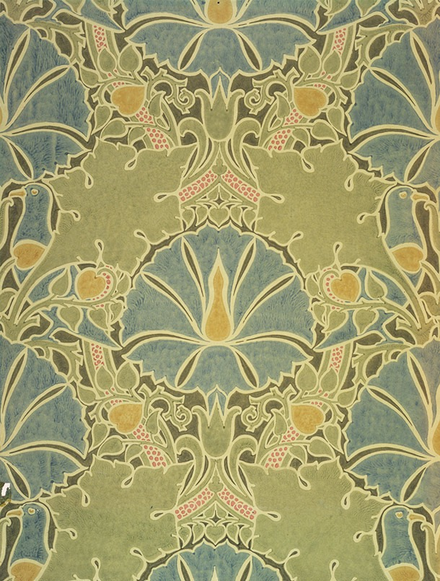
Within a given time period, select examples of what could be considered high and low cultural artefacts. Discuss these, taking in to consideration the surrounding social, political and historical context.

Ibrahim Maadani

P151324

Illustration

WORD COUNT: 2023

Louise Burston
Within a given time period, select examples of what could be considered high and low cultural artefacts. Discuss these, taking in to consideration the surrounding social, political and historical context.

High culture can be considered as something for an elite or sophisticated class of society. This definition of ‘elite’ could potentially be thought of in relation to wealth, intelligence or education. In terms of what would be considered a ‘cultural artefact’ this could apply to the fine arts, literature, music or even architecture.
On the other hand Low culture can be defined as something for a mass audience with a wide appeal or entertainment value but limited in terms of its social and cultural standing. It could also be defined as something which is looked down on by the ‘elite’ class of society. A low ‘cultural artefact’ in relation to high culture could potentially be seen as lesser works of literature (e.g. teen romance novels), pop music and art for commercial fields such as advertising or comic books.
These ideas and definitions of high and low culture could be argued and depending on the individuals personal tastes, philosophy, worldview or ethics what they consider to be ‘high’ or ‘low’ culture would vary.
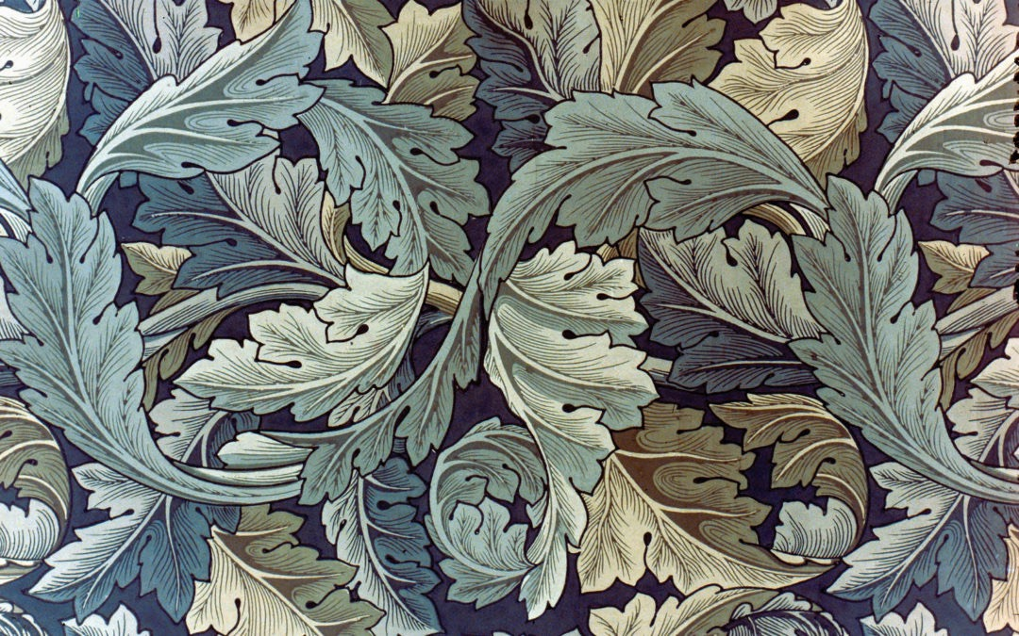
In terms of this essay i’m going to discuss the historical, social and political context of the Arts and Crafts movement and the Mingei (Folk Crafts) movement in relation to high and low culture.
The Arts and Crafts movement began in Britain in 1880 and was initiated by William Morris. It was concerned with the effects industrialisation was having on traditional skills, design and the lives of ordinary people. Through the reform of art and design it sort a new set of principles for working and living that were much simpler and more fulfilling. The idea was that the connection established between the artist and his work through handcraft was paramount in producing items that were both functional and beautiful. The designs showcased an emphasis on plant forms and natural motifs, which took inspiration from medieval gothic art as well as the natural environment.
The critic John Ruskin was one of the notable figures who acted as a proponent against the negative effects of industrialisation. He looked back at the Gothic period (before the renaissance) as an idyllic time with higher moral standards. Ruskin also felt this was reflected in the gothic architecture of the time which was a symbol of the values of that era.
The Arts and Crafts movement was also linked to the Pre-Raphaelites who were also key proponents of medieval art and nature.
William Morris’ firm was one of the first that prioritised the use of handcraft over machine production which would set about creating high quality items. The aim of this was to inspire cottage industries in the working class. As it was believed this method would bring a sense of satisfaction to their labourers. Thus, making a form of democratic art.
In London 1887 ‘The Arts and Crafts Exhibition Society’ was formed with the goal of ignoring the distinctions between the decorative and fine arts. These exhibitions were largely successful.
As the Arts and Crafts movement was linked to social reform and commentary of the time, there was an intertwining of the movement with politics. William Morris as one of the most significant figures of Arts and Crafts was a devoted anti-imperialist and socialist. In 1884, he founded the socialist league and supported the worldwide workers’ revolution.
In the end, a number of outcomes led to the decline of the movement. The handcraft required to produce the items was labour intensive, which made it harder to produce them in larger quantities. Also, there were problems in relation to making the items cheap enough to reach the mass audience it was targeted for. As a result the idea of handcrafted items being a democratic art for the masses was largely unachievable. Thus, many of the Arts and Crafts proponents were forced to adopt machine production. Unfortunately, this resulted in a decrease in quality and a number of the firms went out of business.
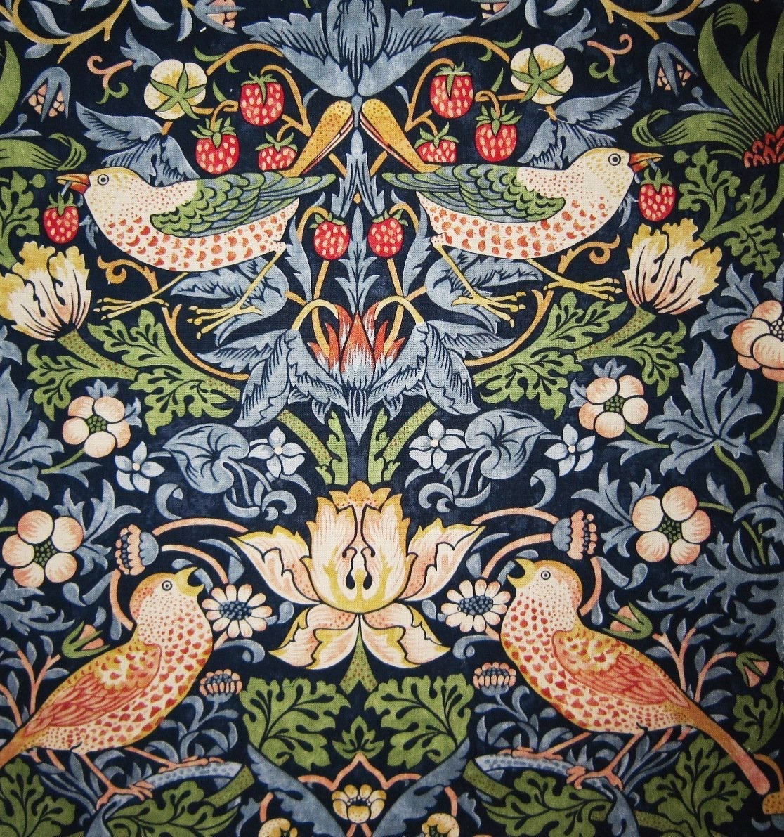
The Arts and Crafts movement as an establishment began to fade at the start of the new century.

This is a design by William Morris entitled ‘Strawberry Thief’ (1883). It consists of interlocking plant forms along with strawberries and birds. It is a clear example of the nature inspired imagery present in The Arts and Crafts movement.
In terms of high and low culture the movement had the goal of elevating the status and quality of design. It could be argued that this goal was largely successful in this image due to the craftsmanship involved and the intricate beauty of the piece.
In terms of the designs production it could be said that its status as a high cultural artefact is tied to the craftsman that made it and if the same design was mass produced by a machine it would lose its cultural value, as its divorced from the individual hands of the artist/craftsman.
On the other hand while the aspect of the craftsman is removed from the item it could still potentially be considered a high cultural artefact due to the original design of the artist, despite the fact of it being produced on a mass scale. However, While it could be argued that mass production might not be considered a depletion of the artistic value of the original work, it is potentially a significant point to consider for a movement with hand craftsmanship as one of its core values.
The natural and aesthetically driven imagery gives the design a universal appeal, making it suitable for use on a mass scale. However, some would consider it to be overly decorative for use in an everyday environment. In 1892, a writer for the journal of decorative arts suggested that the ‘magnitude of the designs exclude them from ordinary work’. The architect ‘Richard Norman Shaw’ who also took a dislike to Morris’ wallpapers said ‘belief that good design consists of pattern - pattern repeated ad nauseam - is an outrage on good taste. A wallpaper should be a background pure and simple that and nothing more. If there is any pattern at all... it ought to be of the simplest kind, quite unobtrusive…’
In reflecting on these viewpoints it is being suggested that highly decorative craftsmanship or intricate pattern based designs don’t have a place in ordinary environments and are perhaps just needless extravagance. In terms of high and low culture it could be argued that the use of outwardly beautiful patterns is a way of spreading a kind of modest culture to various social classes through a mutual contemplation on the beauty of nature.

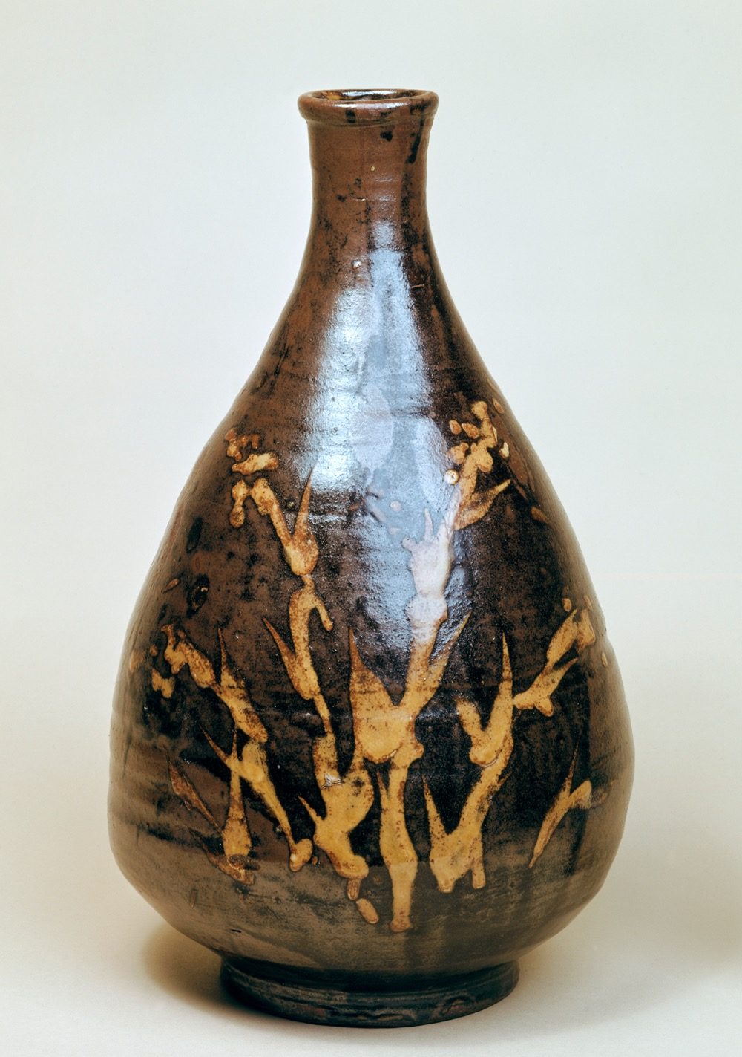
The Arts and Crafts movement in Britain and Europe was also the inspiration for the Mingei (Folk Crafts) movement in Japan, which was established in 1926. Mingei was led by the philosopher Yanagi Sōetsu, he was drawn to the honesty and beauty which he saw in the craftwork of ordinary people.
The term ‘Mingei’ resulted from the combination of ‘min’ meaning ‘the common people’ and ‘gei’ meaning ‘art’. This is a reflection of the work being considered an art form to be appreciated by everyone.
The image to the right is a bottle by Shoji Hamada from around 1935. In relation to the British movement we can see an interesting cultural difference in the approach to the craft. Whereas in Morris’ ‘Strawberry Thief’ there was focus on detailed repeat patterns, Hamada has taken a more minimal and gestural approach to the handcraft. All be it, the central ideas of natural imagery and an aim to beautify the object are still present. Personally, i don’t consider either of these approaches to be superior but actually just reflect the variety in aesthetic handcraft. However, the simplicity of the Mingei designs perhaps reflects the simplicity of the function of the object.
In terms of the Mingei movement one of key ideas was the appreciation of beauty that was ‘born’ rather than ‘made’. Yanagi believed that the work should be created in close harmony with nature in a state of ‘selfless innocence’. In terms of high and low culture perhaps this suggests that the natural world has a certain spiritual quality to it that is more truthful and exists outside these cultural ideas of high and low.
The movement also established a new style of middle-class living. It was a combination of urban and rural, east and west, old and new into a fusion that would align it with the new social and economic conditions of early 20th century Japan.
Thus, in relation to high and low culture it shows how the craft movement could integrate into modern society while still retaining elements of tradition and reflecting the values of the past. In a sense this is one way of looking at the blending of various high and low cultural aspects.
Another important aspect of Mingei art was the actual use of the objects in everyday life, as it was seen as something not only to be admired for it’s aesthetic value. It was believed part of the beauty comes from the functional use of the item as well.
In speaking about high and low culture this could be seen as uniting certain aspects of perceived low or ordinary culture with a higher appreciation for craft and tradition, with a sense of humility and respect for the natural world. Thus, allowing all aspects of the artefact to co exist and be appreciated equally.
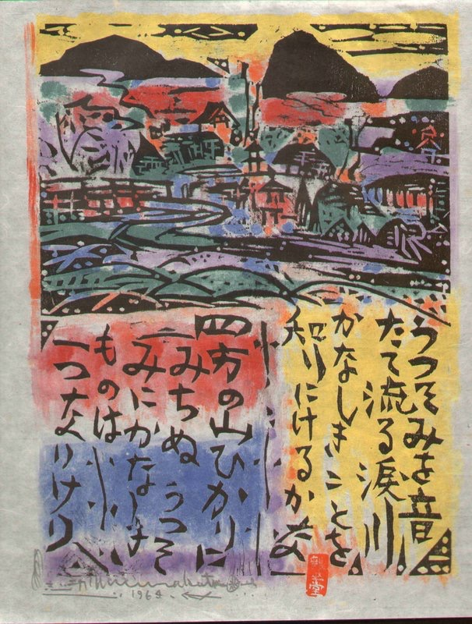

The image to the left is by Shikō Munakata. He was a painter and woodblock artist associated with the Mingei movement.
In considering this piece in relation to high and low culture we can see the effort of this artist to retain certain cultural elements of the past but also to express an individual view and allow for a unique approach to past artistic traditions.
In comparing his work to the master Hiroshige he said ‘’The beauty of a scene is expressed through the heart of an artist”.
The print also has a child like charm to it with the bold primary colours and blocky scenery. This could potentially be seen as reflecting the authenticity of a child’s view of the world, devoid of high and low cultural arguments.

In conclusion, I feel that the relationship between the craftsman and his work is a significant factor to consider when reflecting on an items status as a high or low cultural artefact. I believe that the care and workmanship that an individual puts into their craft, gives it important cultural value. It also represents a kind of integrity which I believe is wholly inclusive of all social classes in forming a unified appreciation of craft and culture.
It could perhaps be argued that decorative/craft based work doesn't hold any high cultural/intellectual value due it’s reliance on aesthetics and absence of any deeper meaning. However, i would argue that through the adornment of items/objects with artistic designs or interpretive painting, it acts as a mirror of the inner beauty of the craftsman and the natural world around him/her.
With regards to the modern world i think craft is something which is increasingly seen as unnecessary. This is perhaps evident in a lot of modern design which largely strips away any adornments or perceived excess design, especially in ordinary environments/objects. Personally, I think while some focus on the function of an object/artefact is entirely necessary for production, to completely eradicate any decorative aspects and view them as irrelevant would be an oversight, as they have an ability to work in harmony with the functional aspects of the item. However, some would argue that there’s a purity to the basic form of an object, without any decorative additions.
In essence, I think that craft and decoration have the ability to project a pure and beautiful view of the world. The argument that this kind of art only represents some sort of past ideal, I feel doesn’t take into account the universal nature of art rooted in traditional handcraft and the effect it has on people the world over. I believe there’s a lot of purity and beauty to be admired in ourselves and the natural world around us, which can be reflected through handcraft.

Bibliography

https://www.enotes.com/homework-help/definition-high-culture-low-culture-hybrid-culture-468640

https://newrepublic.com/article/79269/high-and-popular-culture

http://www.vam.ac.uk/content/articles/w/william-morris-and-wallpaper-design/

http://www.vam.ac.uk/content/articles/b/biography-of-william-morris/

http://www.vam.ac.uk/content/articles/t/the-arts-and-crafts-movement/

http://www.vam.ac.uk/content/articles/d/design-fruit-wreath-wallpapers-william-morris/

http://www.tate.org.uk/art/art-terms/a/arts-and-crafts

http://www.vam.ac.uk/content/articles/a/arts-and-crafts-japan-1926-1945/

http://www.artsandcraftsmuseum.org.uk/Arts_and_Crafts_Movement/The_Arts_and_Crafts_Movement.aspx

http://www.theartstory.org/movement-arts-and-crafts.htm

http://www.mingeikan.or.jp/english/about/

https://www.toki.tokyo/blogt/2016/12/12/mingei-the-revival-of-japanese-folk-art

http://www.nytimes.com/1975/09/15/archives/shiko-munakata-artist-dies-honored-for-woodblock-prints.html

