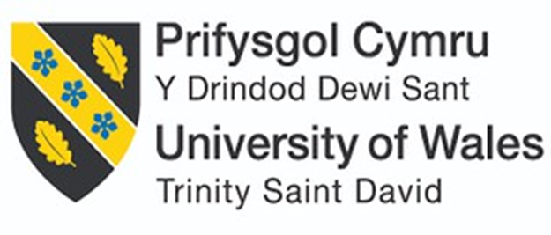

Student Name: Shyam SatishKumar Patel

Student ID: 2520602

Module Name: Strategic Management

Module Code: LCMB7003

Lecturer’s Name: Ghulam Mujtaba

Word Count: 5490

Term 2

Contents
1. Introduction 3
2. Organisational Context and Overview 4
3. External and Internal Analysis of Nike UK 5
3.1 External Analysis: PESTEL 5
3.2 Internal Analysis: VRIO Framework 8
3.3 SWOT Analysis 13
4. Comprehensive and Holistic View of Nike UK 14
4.1 Corporate Social Responsibility (CSR) Strategy and Alignment with Business Objectives 14
4.2 Balanced Scorecard Analysis 16
5. Strategic Choices and Implementation 19
5.1 Strategic Choices Available to Nike UK 19
5.2 Evaluation of Strategic Options Using Ansoff’s Matrix 21
5.3 Validation Through Porter's Five Forces 23
5.4 Recommended Strategy: Sustainable Digital Differentiation 24
5.5 Implementation Challenges and Mitigation Strategies 25
6. Reflection Using Gibbs’ Reflective Cycle 26
References 29

1. Introduction
Organisations must continually adapt to technological change, evolving consumer preferences and sustainability expectations to maintain competitive advantage. For market leaders such as Nike, sustaining this advantage requires continuous strategic adaptation alongside effective use of internal capabilities.
Nike is one of the world's leading sportswear companies, recognised for its innovation, strong brand equity and direct-to-consumer (DTC) digital ecosystem. However, economic uncertainty, changing consumer behaviour, sustainability pressures and intense competition from rivals such as Adidas and Puma present significant strategic challenges.
This report focuses on Nike UK because it operates in a mature and highly competitive market characterised by strong digital retail growth and increasing emphasis on environmental and ethical business practices. Focusing on a single market enables a more context-specific evaluation of Nike's strategic position.
This report focuses on Nike UK because it operates in a mature, highly competitive market with increasing emphasis on digital retail and sustainability, enabling a context-specific strategic evaluation.

2. Organisational Context and Overview
Figure 1: Organisational Context and Overview of Nike Running Footwear in the UK
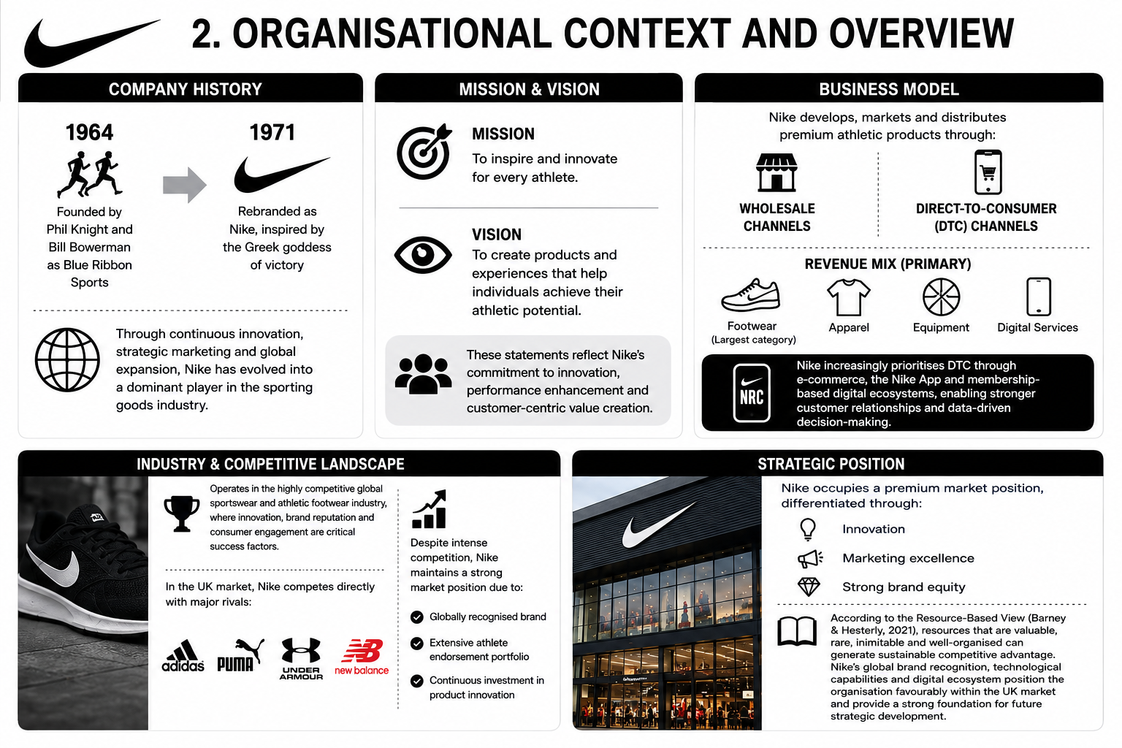
Source: Author's analysis based on Nike (2025), Kotler, Keller and Chernev (2022), Whittington et al. (2023), Barney and Hesterly (2021), and Statista (2025).
Nike's mission, vision as well as business model are centred on innovation, performance and customer value creation, reflecting the organisation's long-term strategic commitment to delivering value through premium athletic products and customer-focused experiences (Nike, 2025; Whittington et al., 2023). The company generates the majority of its revenue from footwear, complemented by apparel, equipment and digital services, while its expanding direct-to-consumer (DTC) ecosystem strengthens customer relationships and supports data-driven decision-making (Nike, 2025; Kotler, Keller and Chernev, 2022). Operating within the highly competitive UK sportswear market, Nike competes with major brands such as Adidas, Puma, Under Armour and New Balance, yet maintains a premium market position through its strong brand equity, extensive athlete endorsement portfolio, continuous innovation and advanced digital capabilities (Statista, 2025). Consistent with the Resource-Based View, these valuable, difficult-to-imitate and well-organised strategic resources provide Nike with a strong foundation for sustaining competitive advantage and supporting long-term growth within the UK market (Barney and Hesterly, 2021).

3. External and Internal Analysis of Nike UK

3.1 External Analysis: PESTEL
A PESTEL analysis provides a structured evaluation of the macro-environmental factors influencing Nike’s operations within the United Kingdom. Understanding these external factors is essential in identifying the most significant opportunities and threats facing the organisation.
Table 1: PESTLE Analysis of the External Business Environment Affecting Nike UK
PESTEL Factor | Analysis
Political | Nike UK operates within a relatively stable political environment; however, international trade policies and post-Brexit regulatory changes continue to influence business operations. As Nike relies heavily on global manufacturing networks across Asia, changes in import regulations, customs procedures and trade agreements can affect supply chain efficiency and costs (Nike, 2025). Furthermore, increasing government expectations regarding ethical sourcing and sustainability reporting place additional pressure on multinational corporations.  Political stability in the UK creates favourable conditions for long-term investment and market growth. However, geopolitical tensions, trade restrictions and protectionist policies represent potential threats because they may increase production and distribution costs.
Economic | Economic conditions significantly influence consumer purchasing behaviour within the sportswear industry. Recent inflationary pressures and higher living costs have reduced discretionary spending among UK consumers, particularly on premium-priced products (Office for National Statistics, 2025). Nike's premium positioning may therefore face challenges as consumers become more price-sensitive.  Exchange-rate fluctuations also affect Nike because products are sourced globally while revenues are generated in local currencies. Currency volatility can reduce profit margins and complicate pricing strategies.  Despite these challenges, growing consumer interest in health, fitness and athleisure continues to support demand for sportswear products. The increasing popularity of online shopping further creates opportunities for Nike's direct-to-consumer (DTC) model.
Social | Social trends strongly favour Nike's market position. Increasing awareness of physical health, fitness participation and active lifestyles has expanded demand for athletic footwear and apparel. The growth of athleisure fashion means consumers increasingly wear sportswear beyond sporting activities, creating additional revenue opportunities.  Younger consumers also place greater emphasis on sustainability, ethical production and brand authenticity. Nike has responded through sustainability initiatives such as Move to Zero and circular product programmes. However, historical criticisms regarding labour practices continue to influence stakeholder perceptions.  Social media and influencer culture further strengthen Nike's ability to engage consumers through athlete endorsements and digital communities.
Technological | Technology represents one of the most important opportunities for Nike UK. Digital transformation has fundamentally altered the sportswear industry through e-commerce, mobile applications, data analytics and artificial intelligence.  Nike has invested heavily in its digital ecosystem, including the Nike App, Nike Run Club and Nike Training Club. These platforms enhance customer engagement, generate valuable consumer data and support personalised marketing strategies. The company's direct digital channels also improve profitability by reducing reliance on intermediaries (Nike, 2025).  Advanced supply-chain technologies improve inventory management, forecasting accuracy and operational efficiency. Furthermore, innovations in product design and material technologies support Nike's differentiation strategy.  However, technological advancement also creates threats. Cybersecurity risks, data protection requirements and rapid technological change require continuous investment. Failure to innovate could enable competitors such as Adidas and Puma to erode Nike's competitive position.
Environmental | Environmental sustainability has become a critical strategic issue within the global apparel and footwear industry. Consumers, investors and regulators increasingly expect organisations to reduce environmental impacts throughout their value chains.  Nike faces pressure to minimise carbon emissions, reduce waste and increase the use of sustainable materials. Climate change may also disrupt global supply chains through extreme weather events and resource scarcity.  Nevertheless, sustainability creates significant opportunities. Environmentally responsible products can strengthen brand reputation and attract environmentally conscious consumers. Nike's sustainability initiatives support differentiation while aligning with broader stakeholder expectations.
Legal | Nike must comply with a wide range of legal requirements including employment legislation, consumer protection regulations, intellectual property laws and data protection requirements such as the General Data Protection Regulation (GDPR).  Strong intellectual property protection benefits Nike by safeguarding product innovations, trademarks and brand assets. However, increasing scrutiny regarding labour standards, supply-chain transparency and consumer rights creates compliance challenges.  Failure to comply with legal requirements could result in financial penalties and reputational damage. Consequently, legal compliance remains essential for maintaining stakeholder trust and operational legitimacy.

Table 2 – PESTEL Opportunities & Threats Summary
Category | Factors
Key Opportunities | - Growth in health and fitness participation  - Expansion of e-commerce and digital channels  - Rising demand for sustainable products  - Increasing popularity of athleisure fashion  - Data-driven customer engagement and personalisation
Key Threats | - Inflation and reduced consumer spending  - Supply-chain disruptions and geopolitical uncertainty  - Intense industry competition  - Reputational risks associated with sustainability and labour practices  - Cybersecurity and regulatory compliance challenges

3.2 Internal Analysis: VRIO Framework
The VRIO framework evaluates whether organisational resources and capabilities provide sustainable competitive advantage.

Table 3 – VRIO Analysis
Resource/Capability | Description | V | R | I | O | Competitive Implication
Brand Equity | Nike possesses one of the world's most recognised brands. The Nike name and Swoosh logo generate strong customer loyalty and premium pricing power (Interbrand, 2024). | Yes | Yes | Yes | Yes | Sustained Competitive Advantage
Innovation and R&D | Innovation has historically been a core strength. Technologies: Air cushioning, Flyknit, advanced performance materials (Nike Inc., 2024). | Yes | Yes | Yes | Yes | Sustained Competitive Advantage
Athlete Endorsements and Marketing | Partnerships with elite athletes and sports organisations contribute to brand visibility and credibility (Nike Inc., 2024). | Yes | Yes | Yes | Yes | Sustained Competitive Advantage
Global Supply Chain | Extensive global sourcing and distribution network enables large-scale operations and market responsiveness (Nike Inc., 2024). | Yes | No | N/A | N/A | Competitive Parity
Digital Ecosystem | Digital platforms and membership ecosystem create direct consumer relationships and generate behavioural data (Nike, Inc., 2025a). | Yes | Yes | Yes | Yes | Emerging Sustained Competitive Advantage

Table 4 – Detailed VRIO Justification
Resource/Capability | Valuable (V) | Rare (R) | Inimitable (I) | Organised (O)
Brand Equity | Strong brand equity supports customer loyalty and premium pricing (Keller and Swaminathan, 2020). | Built over decades and recognised globally (Interbrand, 2024). | Difficult to replicate due to long-term investment in marketing and innovation. | Leveraged through integrated marketing and continuous product innovation (Nike, Inc., 2024).
Innovation & R&D | Supports product differentiation through proprietary technologies. | Protected by accumulated expertise and patents. | Competitors cannot easily replicate Nike's innovation capabilities. | Supported by dedicated R&D investment and innovation teams (Nike, Inc., 2024).
Athlete Endorsements & Marketing | Enhances brand credibility and consumer engagement. | Few competitors possess comparable endorsement portfolios. | Relationships and marketing expertise are difficult to imitate. | Integrated across global marketing campaigns and digital platforms (Nike, Inc., 2024).
Global Supply Chain | Enables operational efficiency and global distribution. | Not rare within the industry. | Not applicable. | Not applicable.
Digital Ecosystem | Strengthens DTC relationships and data-driven decision-making. | Combines digital platforms with customer data. | Requires substantial investment and integration. | Embedded within Nike's digital transformation strategy (Nike, Inc., 2025a)
Source: analysis based on Barney (1991), Nike, Inc. (2024; 2025a), and Interbrand (2024).

Table 5 – Strengths Analysis
Strength | Detailed Analysis | VRIO Assessment
Globally recognised brand | Nike possesses one of the world's most recognised brands. The Nike name and Swoosh logo generate strong customer loyalty and premium pricing power Keller and Swaminathan (2020). The brand is valuable because it drives consumer preference and purchasing decisions. It is relatively rare due to its global reputation and difficult to imitate because it has been developed over several decades through substantial investment. Brand value exceeded US$30 billion, making Nike the world's most valuable apparel brand (Interbrand, 2024). Nike reported FY2024 revenue of US$51.4 billion (Nike, Inc., 2024). Market rankings and industry comparisons also support Nike's leading position (Statista, 2024). | V: Yes | R: Yes | I: Yes | O: Yes → Sustained Competitive Advantage (Barney, 1991)
Strong innovation capability | Innovation has historically been a core strength of Nike. Technologies such as Air cushioning, Flyknit and advanced performance materials demonstrate continuous product development (Nike, Inc., 2024). Innovation creates value by improving performance and supporting differentiation. While competitors invest heavily in R&D, Nike's innovation capability remains difficult to replicate due to accumulated knowledge, patents and organisational expertise embedded in R&D processes (Nike, Inc., 2024). | V: Yes | R: Yes | I: Yes | O: Yes → Sustained Competitive Advantage (Barney, 1991)
Powerful marketing and athlete endorsements | Nike's partnerships with elite athletes and sports organisations contribute significantly to brand visibility and credibility (Nike, Inc., 2024). These relationships are valuable and relatively rare because only a small number of firms possess comparable endorsement portfolios. The combination of athlete partnerships, storytelling and marketing expertise is difficult for competitors to imitate effectively. Demand creation expense: $4.69 billion FY2024 (10.1% of revenue), up 6% YoY; Endorsements include LeBron James, Serena Williams, Caitlin Clark ($28M, 8-year deal) (Nike, Inc., 2024; Statista, 2024; CNN, 2024). | V: Yes | R: Yes | I: Yes | O: Yes → Sustained Competitive Advantage (Barney, 1991)
Advanced digital ecosystem | Nike's digital platforms and membership ecosystem create direct relationships with consumers while generating valuable behavioural data (Nike, Inc., 2025a). The ecosystem is valuable, increasingly rare and difficult to replicate because it combines technology, customer data and brand engagement. Nike has invested heavily in integrating digital experiences (Nike App, Nike Run Club, Nike Training Club) with its broader DTC strategy Nike, Inc., 2025a; Digital Commerce 360, 2024). | V: Yes | R: Yes | I: Yes | O: Yes → Emerging Sustained Competitive Advantage (Barney, 1991)
Significant financial resources | Full year revenues FY2025: $46.3 billion; Market capitalisation: $114.3 billion; Enables substantial investment in marketing ($4.69 billion demand creation), R&D, and digital transformation initiatives (Nike, Inc., 2025a; Macrotrends, 2025). | V: Yes | R: Yes | I: Yes | O: Yes → Sustained Competitive Advantage (Barney, 1991)

Table 6 – Weaknesses Analysis
Weakness | Detailed Analysis | Strategic Implication
Premium pricing vulnerability | Nike's premium pricing strategy can limit accessibility during periods of economic uncertainty. Recent inflationary pressures and higher living costs have reduced discretionary spending among UK consumers, particularly on premium-priced products. FY2025 full year revenues down 10% to $46.3 billion, reflecting consumer price sensitivity in challenging economic conditions (Nike, Inc., 2025a; Office for National Statistics, 2025). | Limits market accessibility during economic uncertainty; Requires value communication strategies and promotional flexibility
Dependence on outsourced manufacturing | The company remains dependent on third-party manufacturers, reducing direct control over production activities. This creates vulnerability to supply chain disruptions, quality control issues, and labour practice criticisms. Nike relies heavily on global manufacturing networks across Asia (Nike, Inc., 2024) | Reduces operational control; Creates supply chain vulnerability; Necessitates supplier relationship management and diversification
Exposure to reputational risks | Reputational risks linked to labour practices and sustainability concerns continue to affect stakeholder perceptions. Historical criticisms regarding labour practices continue to influence stakeholder perceptions. Increasing government expectations regarding ethical sourcing and sustainability reporting place additional pressure on multinational corporations (Nike, Inc., 2024; UK Government, 2024) | Affects brand reputation and stakeholder trust; Requires proactive sustainability and transparency initiatives (e.g., Move to Zero)
High reliance on consumer discretionary spending | High reliance on consumer discretionary spending makes Nike vulnerable to economic downturns. FY2025 Q1 revenue fell 10% year-over-year to $11.59 billion (from $12.94 billion); Q4 revenue down 12% to $11.1 billion. Net income declined 44% FY2025, demonstrating vulnerability to reduced consumer spending power (Nike, Inc., 2025a; Digital Commerce 360, 2024) | Creates revenue volatility; Demands economic resilience strategies and diversified product portfolio across price points

3.3 SWOT Analysis
Table 7: Internal and External SWOT Analysis
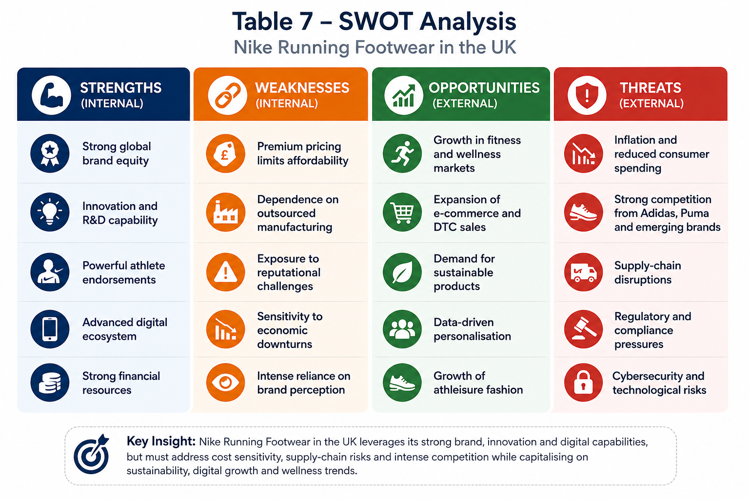

4. Comprehensive and Holistic View of Nike UK

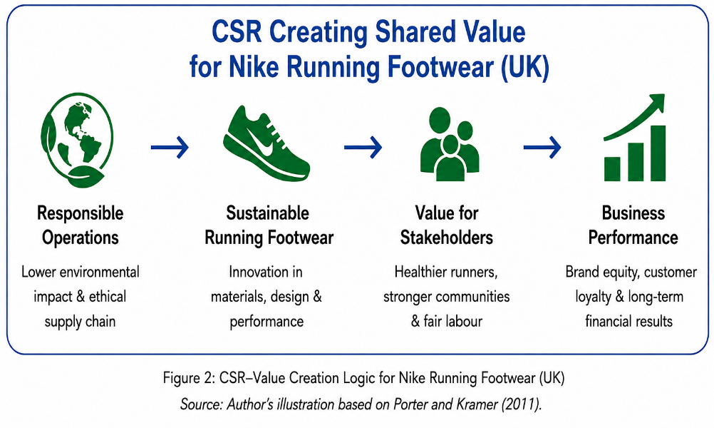
4.1 Corporate Social Responsibility (CSR) Strategy and Alignment with Business Objectives
Corporate Social Responsibility (CSR) has moved from a peripheral activity to a source of sustainable competitive advantage when it is embedded within product strategy (Carroll, 2021; Porter and Kramer, 2011). For Nike Running Footwear in the United Kingdom (UK), CSR is not only about reducing environmental impact but also about creating shared value for runners, communities and the planet. The product line's environmental innovations, ethical supply chain, community engagement and circular initiatives reinforce its premium positioning while supporting long-term growth.
Table 8: CSR Strategy Pillars for Nike Running Footwear in the UK
CSR Pillar | Key Initiatives in Nike Running Footwear (UK) | Alignment with Business Objectives | Strategic Benefits / Competitive Advantage
Environmental Sustainability | • Move to Zero: lower carbon & waste • Use of recycled polyester, Flyknit yarns • Carbon-efficient manufacturing | Reduce environmental impact while offering high-performance footwear | Differentiates the product line; attracts environmentally conscious UK runners; strengthens brand equity
Circular Economy & Product Life Cycle | • Nike Refurbished for used running shoes • Nike Grind in outsoles & midsoles • Product durability & design for longevity | Minimise waste and extend product life while lowering material usage | Reduces resource dependency; builds trust; supports future regulatory compliance
Ethical Supply Chain | • Responsible sourcing of materials • Supplier Code of Conduct & audits • Fair wages & safe working conditions | Ensure ethical manufacturing and reduce reputational & operational risk | Protects brand reputation; ensures supply chain stability; meets stakeholder expectations
Community Engagement | • Nike Run Club (NRC) & local running events • Support for grassroots & youth sport • Partnerships with UK running communities | Strengthen customer loyalty and engagement with running communities | Enhances brand attachment; drives repeat purchase; builds long-term customer relationships
Innovation for Sustainability | • Sustainable cushioning (e.g., React, ZoomX) • Bio-based & recycled materials innovation • Data-led design to reduce waste | Deliver innovative, sustainable products that improve running performance | Creates product differentiation; supports premium pricing; reinforces leadership in sustainable innovation
Source: Author's analysis based on Nike, Inc. (2025a; 2025b), Eccles, Ioannou and Serafeim (2014), and Porter and Kramer (2011).
Sustainability in Product Design and Materials
Nike integrates sustainability into product design through innovations such as Flyknit, React and ZoomX, while increasing the use of recycled materials to reduce environmental impact. Eco-innovation also strengthens brand loyalty and consumers' willingness to pay premium prices (Nike, Inc., 2024; Chen and Chang, 2012; Testa and Iraldo, 2010).
Circular Economy and Product Lifecycle
Nike extends product life through Nike Refurbished and Nike Grind, supporting circular economy principles by reducing waste and conserving resources while responding to growing demand for sustainable products (Nike, Inc., 2025b; Bocken et al., 2014; Geissdoerfer et al., 2017).

Figure 3: Sustainable Product Lifecycle Framework for Nike Running Footwear in the UK
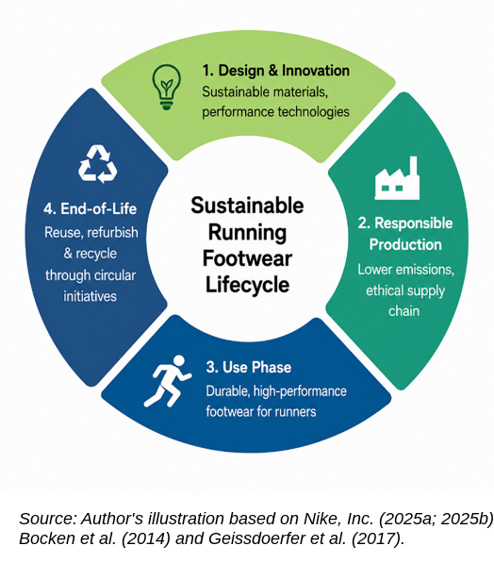
Ethical Supply Chain and Labour Responsibility
Nike manages supply-chain responsibility through supplier audits and monitoring systems that reduce operational risk and strengthen organisational legitimacy (Nike, Inc., 2025a; Seuring and Müller, 2008; Locke, 2013).
Community Engagement and Social Impact
The Nike Run Club (NRC) app, local running events and partnerships with UK running communities promote active lifestyles and social inclusion. These initiatives encourage consumer engagement and strengthen customer–brand relationships, contributing to more positive brand attitudes and greater customer loyalty (Rodrigues et al., 2021; Bhattacharya and Sen, 2004).
Conclusion
Overall, the CSR strategy of Nike Running Footwear in the UK is strongly aligned with its business objectives of innovation, differentiation, premium positioning and long-term growth. By integrating environmental sustainability, circular economy practices, ethical responsibility and community engagement into the product strategy, Nike creates both societal and economic value. This reflects the concept of shared value, where CSR becomes a driver of competitive advantage rather than a cost (Porter and Kramer, 2011; Eccles et al., 2014).

4.2 Balanced Scorecard Analysis
Kaplan and Norton's (1992) Balanced Scorecard (BSC) evaluates organisational strategy through four interconnected perspectives: Financial, Customer, Internal Business Processes, and Learning and Growth. Table 9 applies this framework to Nike Running Footwear in the UK to assess strategic performance using financial and non-financial measures.

Table 9: Balanced Scorecard Analysis
Perspective | Strategic Objective | Key Performance Indicators (KPIs) | Target | Strategic Initiatives
Financial | Increase revenue and profitability of Nike Running Footwear in the UK | Revenue growth, gross profit margin, DTC sales, market share | Increase running footwear sales and expand premium product contribution | Expand Nike Membership, strengthen DTC channels, introduce premium sustainable running footwear
Customer | Strengthen customer loyalty and enhance the running experience | Net Promoter Score (NPS), customer satisfaction, repeat purchase rate, Nike Membership growth, Nike Run Club engagement | Improve customer retention and digital engagement among UK runners | Personalised digital marketing, Nike Run Club integration, product personalisation and omnichannel experiences
Internal Business Processes | Improve operational efficiency and sustainability across the running footwear value chain | Product development cycle, inventory turnover, delivery performance, recycled material content, carbon emissions | Reduce production waste, shorten product development time and improve supply chain efficiency | Move to Zero initiatives, sustainable sourcing, digital supply chain, circular economy programmes (Nike Refurbished and Nike Grind)
Learning & Growth | Enhance innovation capability and organisational learning | Employee training hours, R&D investment, sustainable product innovations, employee engagement, workforce diversity | Increase innovation in sustainable running footwear and strengthen digital capabilities | Investment in footwear R&D, leadership development, sustainable material innovation and digital design technologies
Source: Author's analysis based on Kaplan and Norton (1992; 2004), Nike, Inc. (2025a; 2025b; 2025c).

Strategic Analysis
The Balanced Scorecard demonstrates that the long-term success of Nike Running Footwear in the UK depends upon the integration of financial performance with customer value, operational excellence and continuous innovation. Financial objectives are achieved not only through increased sales but also through premium product differentiation, digital direct-to-consumer (DTC) channels and sustainable product innovation. This reflects Nike's strategy of creating higher-value running footwear that supports premium pricing while strengthening profitability.
From the customer perspective, digital ecosystems such as Nike Run Club and the Nike App extend customer engagement beyond the point of purchase by providing personalised coaching, performance tracking and community interaction. These platforms strengthen customer loyalty while generating behavioural insights that support future product development and targeted marketing strategies (Kotler, Keller and Chernev, 2022).
Operational performance is equally important because the competitiveness of Nike Running Footwear depends upon efficient product development, responsible sourcing and sustainable manufacturing. Initiatives including Move to Zero, Nike Refurbished and Nike Grind demonstrate how environmental sustainability can simultaneously reduce operational waste, improve resource efficiency and reinforce the environmental value proposition of the running footwear product line. Kaplan and Norton (2004) argue that improvements in internal processes often act as leading indicators of future financial performance, making operational excellence a critical driver of competitive advantage.
Finally, the Learning and Growth perspective highlights that sustained innovation remains essential within the highly competitive UK running footwear market. Continuous investment in employee capabilities, sustainable material technologies and footwear research enables Nike to respond to evolving consumer preferences while maintaining technological leadership. As Garvin, Edmondson and Gino (2008) suggest, organisations that foster continuous learning and innovation are better positioned to sustain long-term strategic performance.

Overall, the Balanced Scorecard shows how Nike Running Footwear in the UK aligns strategic priorities with measurable outcomes, integrating financial and non-financial objectives to strengthen competitive advantage and long-term stakeholder value.

5. Strategic Choices and Implementation

5.1 Strategic Choices Available to Nike UK
Strategic choice involves evaluating alternative courses of action that enable organisations to achieve sustainable competitive advantage within their target markets (Whittington et al., 2023). For Nike Running Footwear in the United Kingdom, strategic decision-making is influenced by evolving consumer preferences, increasing environmental awareness, rapid technological innovation and intense competition from premium athletic footwear brands such as Adidas, ASICS, HOKA and New Balance. Consequently, selecting an appropriate competitive strategy requires balancing long-term profitability with innovation, sustainability and customer value creation.
Rather than competing primarily on price, Nike's strategic resources—including its globally recognised brand, continuous footwear innovation, digital ecosystem and sustainability capabilities, provide a stronger foundation for value-based competition. Drawing upon Porter's Generic Strategies (1985) and Ansoff's Growth Matrix (1957), four strategic alternatives can be evaluated for the Nike Running Footwear product line in the UK.

Figure 4: Strategic Evaluation of Competitive Options for Nike Running Footwear in the UK
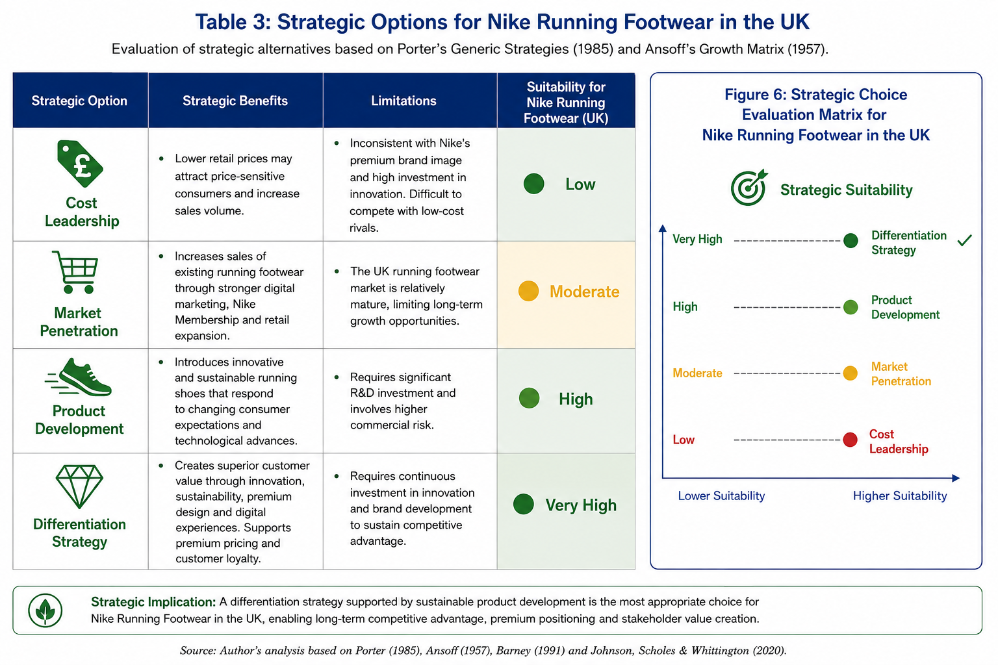
The evaluation demonstrates that a cost leadership strategy is the least appropriate option for Nike Running Footwear. Although lower pricing could improve accessibility during periods of economic uncertainty, competing primarily on cost would undermine Nike's premium positioning and reduce its ability to invest in research, product innovation and sustainable material technologies. Porter (1985) argues that organisations attempting to combine premium differentiation with cost leadership frequently experience strategic inconsistency, resulting in weakened competitive positioning.
Market penetration may generate incremental growth through stronger DTC channels and Nike Membership, but the mature UK market limits its long-term strategic potential. However, the UK running footwear market is highly mature, with strong brand awareness and established customer preferences. Consequently, while market penetration may contribute to incremental sales growth, its long-term strategic impact is likely to be limited.
Conversely, product development represents a stronger strategic alternative because it enables Nike to respond to emerging consumer trends, including sustainability, personalised footwear and advanced performance technologies. Continuous investment in innovations such as lightweight cushioning systems, recycled materials and digital product integration enables Nike Running Footwear to reinforce its technological leadership while addressing growing environmental expectations. From the perspective of the Resource-Based View, innovation capabilities constitute valuable, rare and difficult-to-imitate strategic resources that support sustained competitive advantage (Barney, 1991).
Nevertheless, the most suitable strategic choice is differentiation, supported by continuous product development and sustainability-led innovation. Rather than competing on price, Nike Running Footwear creates superior customer value through advanced performance technologies, environmentally responsible product design and integrated digital experiences. Initiatives including Move to Zero, Nike Refurbished, Nike Run Club and premium footwear innovations strengthen customer loyalty while reinforcing Nike's premium market position. Porter (1985) suggests that differentiation enables firms to reduce direct price competition by creating distinctive customer value, thereby supporting premium pricing and stronger long-term profitability.
Furthermore, increasing consumer demand for sustainable products provides Nike with an opportunity to strengthen differentiation through circular economy initiatives, low-carbon manufacturing and sustainable material innovation. This aligns with contemporary strategic management research, which argues that sustainability has evolved from a compliance obligation into a significant source of competitive advantage and long-term value creation (Porter and Kramer, 2011; Eccles, Ioannou and Serafeim, 2014).
Overall, the evaluation indicates that a differentiation strategy supported by sustainable product development represents the most appropriate strategic direction for Nike Running Footwear in the UK. By combining technological innovation, environmental responsibility and digital customer engagement, Nike is better positioned to maintain premium market leadership while responding to changing consumer expectations and increasing competitive intensity.

5.2 Evaluation of Strategic Options Using Ansoff’s Matrix
Ansoff's Matrix provides a strategic framework for evaluating growth opportunities based on existing and new products within existing and new markets (Ansoff, 1957). For Nike Running Footwear in the UK, market penetration may generate incremental sales through enhanced digital marketing and Nike Membership programmes; however, the mature UK running footwear market limits significant long-term growth.
Market development offers limited strategic value because this report focuses exclusively on the UK market, while diversification would require substantial investment and may divert resources from Nike's core capabilities in performance running footwear.
Conversely, product development represents the most appropriate strategic option. Continuous investment in sustainable materials, performance technologies and digitally integrated running footwear enables Nike to respond to changing consumer preferences while reinforcing its premium market position. This strategy aligns with Nike's innovation capabilities and supports differentiation through product quality, sustainability and customer experience (Barney, 1991; Porter, 1985).
Figure 5: Ansoff’s Matrix Applied to Nike Running Footwear in the UK
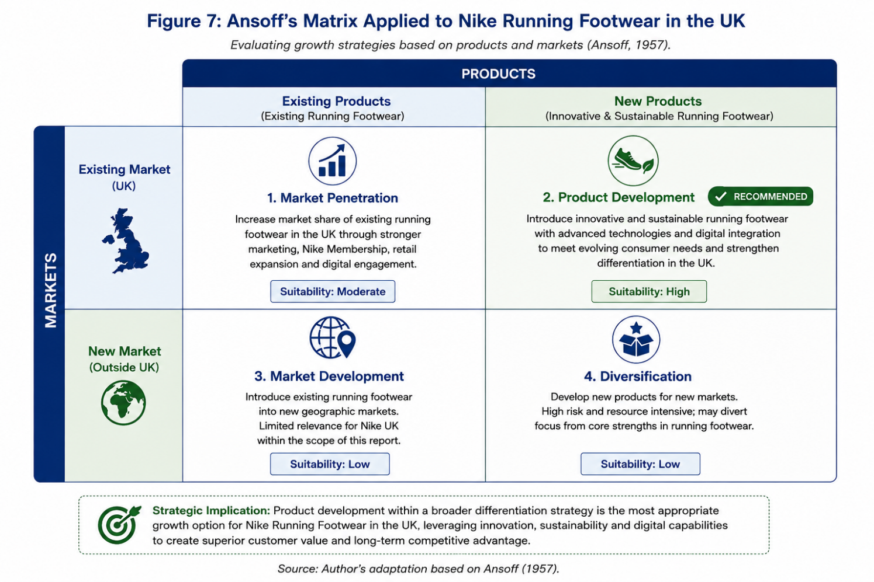
Therefore, Ansoff's Matrix indicates that product development, supported by a differentiation strategy, offers the strongest strategic fit for Nike Running Footwear in the UK by leveraging existing brand equity while delivering sustainable long-term competitive advantage (Ansoff, 1957).

5.3 Validation Through Porter's Five Forces
Figure 6: Porter’s Five Forces Analysis for Nike Running Footwear in the UK
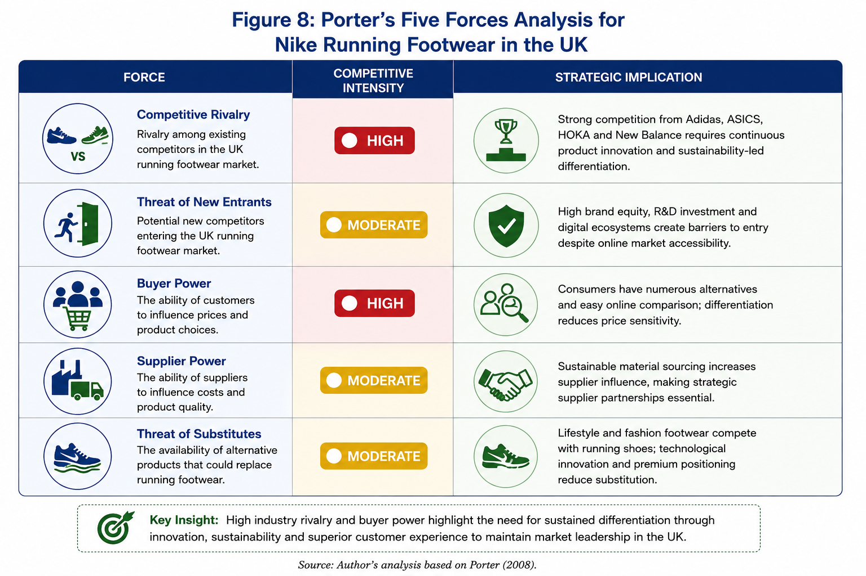
Porter's Five Forces analysis confirms that differentiation represents the most appropriate competitive strategy for Nike Running Footwear in the UK. Highly competitive rivalry and buyer power require continuous innovation, sustainable product development and superior customer experiences to maintain premium positioning. Meanwhile, Nike's strong brand equity, digital ecosystem and technological capabilities reduce competitive threats and reinforce long-term competitive advantage (Porter, 2008).

5.4 Recommended Strategy: Sustainable Digital Differentiation
Figure 7: Strategic Recommendation Framework
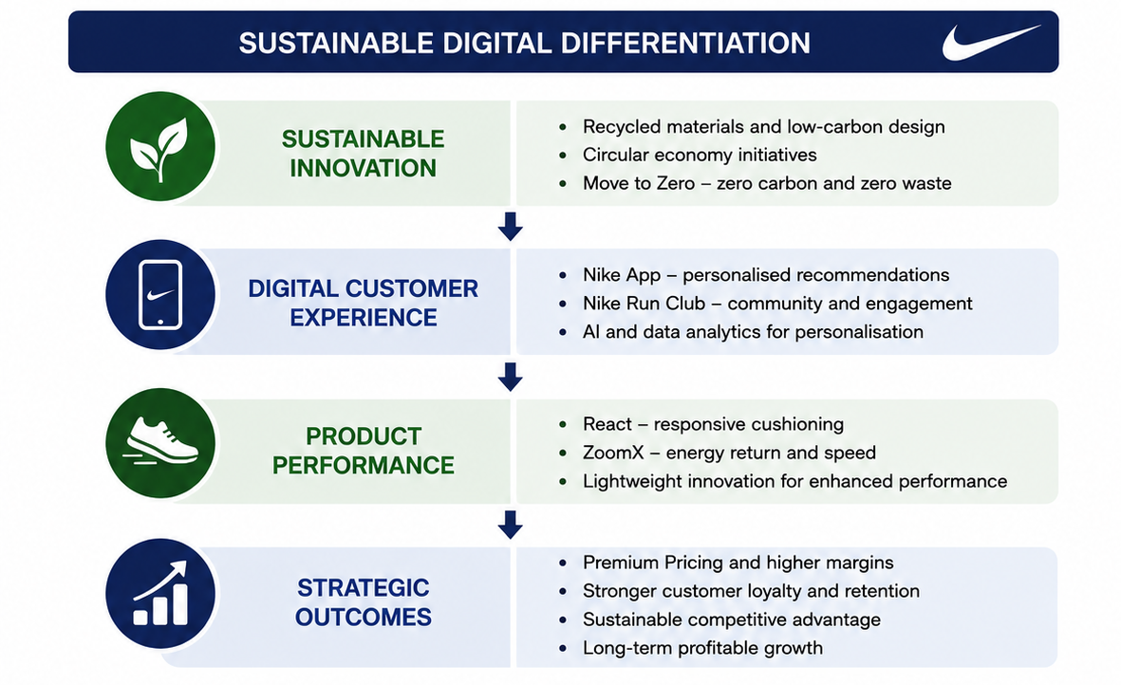
Based on the preceding strategic analyses, Nike Running Footwear in the UK should adopt a strategy of sustainable digital differentiation. This strategy integrates product innovation, environmental sustainability and digital customer engagement to create superior customer value (Day, 1994; Teece, 2007) while reinforcing Nike's premium market position. Rather than competing primarily on price, the strategy leverages Nike's valuable and difficult-to-imitate resources, including its globally recognised brand, innovation capabilities and digital ecosystem, consistent with the Resource-Based View (Barney, 1991).
Sustainable innovation and Nike's digital ecosystem reinforce differentiation by strengthening environmental performance, customer engagement and premium positioningm(Porter and Kramer, 2011; Nike, Inc., 2025b). Simultaneously, digital platforms such as the Nike App and Nike Run Club enhance customer engagement through personalised experiences, community building and data-driven insights, strengthening customer loyalty and lifetime value (Kotler, Keller and Chernev, 2022; Verhoef, Reinartz and Krafft, 2010). Continuous investment in advanced running footwear technologies, including React and ZoomX cushioning systems, further reinforces product differentiation and premium positioning (Damanpour, 1991; Nike, Inc., 2025b).
Collectively, these strategic initiatives develop dynamic capabilities that enable Nike Running Footwear to respond proactively to changing market conditions while sustaining long-term competitive advantage, customer loyalty and profitable growth (Teece, Pisano and Shuen, 1997; Teece, 2007).

5.5 Implementation Challenges and Mitigation Strategies
A successful implementation of the proposed sustainable digital differentiation strategy depends on Nike Running Footwear effectively managing operational, financial and reputational risks. As summarised in table below, the principal implementation challenges can be mitigated through proactive strategic planning, supply chain collaboration and continuous innovation. This ensures that sustainability objectives are integrated into long-term business performance rather than treated as isolated initiatives.
Table 10: Implementation Challenges and Mitigation Strategies for Nike Running Footwear
Implementation Challenge | Potential Strategic Impact | Mitigation Strategy
High Investment Costs | Significant investment in sustainable materials, digital technologies and product innovation may reduce short-term profitability. | Prioritise high-impact investments through phased implementation and monitor ROI using strategic performance indicators.
Supply Chain Complexity | Global supplier networks may differ in sustainability capabilities, increasing operational and reputational risk. | Strengthen supplier partnerships, increase sustainability audits and implement digital supply chain monitoring.
Competitive Response | Competitors may imitate sustainability initiatives and digital innovations, reducing differentiation. | Continue investment in R&D, proprietary footwear technologies and customer data capabilities to sustain competitive advantage.
Consumer Skepticism | Sustainability claims may be challenged if transparency is insufficient, increasing the risk of greenwashing perceptions. | Publish transparent ESG reporting, use third-party assurance and communicate measurable sustainability outcomes consistently.
Source: Author's analysis based on Teece, Pisano and Shuen (1997), Porter (1985), Nike, Inc. (2025a; 2025b).
Although the recommended strategy presents implementation challenges, these risks are manageable through effective strategic governance and continuous capability development. From the perspective of Dynamic Capabilities Theory, organisations that continuously adapt their resources, technologies and partnerships are better positioned to sustain competitive advantage under changing market conditions (Teece, Pisano and Shuen, 1997). Consequently, Nike Running Footwear should view implementation as an ongoing strategic process rather than a one-time initiative, ensuring that sustainability, digital innovation and operational excellence remain integrated throughout the product lifecycle.
Conclusion
This report critically evaluated the strategic position of Nike Running Footwear in the UK using PESTEL, SWOT, VRIO, the Balanced Scorecard, Ansoff's Matrix and Porter's Five Forces. The analysis identified brand equity, innovation, the digital ecosystem and sustainability capabilities as Nike's primary sources of competitive advantage. Sustainable digital differentiation emerged as the most appropriate strategy, aligning with Nike's distinctive resources while addressing growing demand for innovative and sustainable running footwear. Although implementation presents financial, operational and reputational challenges, these can be mitigated through effective governance and phased investment, enabling Nike to sustain market leadership and deliver long-term stakeholder value.

6. Reflection Using Gibbs’ Reflective Cycle
This reflection evaluates my experience of researching, analysing and developing a strategic analysis of Nike Running Footwear in the United Kingdom. Gibbs' (1988) Reflective Cycle provides the structure for this reflection through six stages: description, feelings, evaluation, analysis, conclusion and action plan. The model enabled me to reflect not only on the final report but also on how the process enhanced my strategic thinking, research capability and professional judgement.
Description
The assessment required a strategic evaluation of Nike Running Footwear in the UK using strategic management frameworks, including PESTEL, VRIO, SWOT, CSR, the Balanced Scorecard, Ansoff's Matrix and Porter's Five Forces. The objective was to analyse the product line's competitive position and develop evidence-based strategic recommendations.
To complete the report, I reviewed academic journals, strategic management literature, Nike's sustainability reports and annual reports. Throughout the project, I refined the report by ensuring that every framework focused specifically on the Nike Running Footwear product line, rather than the wider organisation. I also redesigned several sections using professional tables and strategic frameworks to improve the clarity and presentation of the analysis.
Feelings
At the beginning of the project, I selected Nike because extensive academic and corporate information was available. Although this made data collection easier, I initially found it difficult to narrow the analysis to a single product line and apply multiple strategic frameworks without becoming repetitive. As the report developed, I became more confident in integrating the frameworks rather than treating them as independent analytical tools. Redesigning the report into a more consultancy-style format also increased my confidence in presenting strategic information professionally.
Evaluation
One of the greatest strengths of this assignment was the improvement of my strategic analysis and research skills. Critically evaluating academic literature alongside corporate reports strengthened my ability to distinguish between descriptive information and strategic evidence. I also developed a better understanding of how sustainability, innovation and digital capabilities can contribute directly to competitive advantage rather than existing as separate business functions.
However, the assignment also highlighted several challenges. Maintaining product-line specificity throughout the report required continuous revision, while balancing analytical depth with the prescribed word limit proved difficult. I also recognised that strategic frameworks should not be applied mechanically but must be interpreted critically within the context of the organisation and its competitive environment.
Analysis
This assignment significantly improved my understanding of strategic management by demonstrating the importance of integrating internal resources with external environmental analysis (Whittington et al., 2023). Applying the VRIO framework reinforced how valuable, rare and inimitable resources support sustained competitive advantage, consistent with the Resource-Based View (Barney, 1991). Furthermore, evaluating Nike Running Footwear's sustainability initiatives demonstrated that environmental responsibility can function as a strategic capability that strengthens differentiation and long-term value creation, reflecting the concept of shared value proposed by Porter and Kramer (2011).
The process also enhanced my critical thinking by encouraging me to question the suitability of different strategic options rather than simply describing them. Comparing cost leadership, market penetration, product development and differentiation enabled me to appreciate the importance of evidence-based strategic decision-making.
Conclusion
Overall, this assignment strengthened my knowledge of strategic management while improving my research, analytical and critical evaluation skills. It reinforced the importance of integrating multiple strategic frameworks to produce coherent recommendations and demonstrated that successful strategy depends upon both rigorous analysis and professional judgement. The experience also improved my ability to communicate complex strategic information using concise academic writing supported by professional visual frameworks.
Action Plan
In future assignments, I intend to strengthen my critical evaluation further by engaging with a wider range of contemporary peer-reviewed literature and incorporating more recent empirical evidence into my analysis. I also plan to continue developing my ability to present strategic information through professional consultancy-style reports that combine academic rigour with effective visual communication. Finally, I will continue using reflective practice to evaluate my strengths, identify areas for improvement and support my long-term academic and professional development.

References
Ansoff, H.I. (1957) ‘Strategies for diversification’, Harvard Business Review, 35(5), pp. 113–124.
Barney, J.B. (1991) ‘Firm resources and sustained competitive advantage’, Journal of Management, 17(1), pp. 99–120.
Barney, J.B. and Hesterly, W.S. (2021) Strategic management and competitive advantage: Concepts and cases. 7th edn. Harlow: Pearson.
Bhattacharya, C.B. and Sen, S. (2004) ‘Doing better at doing good: When, why, and how consumers respond to corporate social initiatives’, California Management Review, 47(1), pp. 9–24.
Bocken, N.M.P., Short, S.W., Rana, P. and Evans, S. (2014) ‘A literature and practice review to develop sustainable business model archetypes’, Journal of Cleaner Production, 65, pp. 42–56.
Carroll, A.B. (2021) ‘Corporate social responsibility: Perspectives on the CSR construct’s development and future’, Business & Society, 60(6), pp. 1258–1278.
Chen, Y.-S. and Chang, C.-H. (2012) ‘Enhance green purchase intentions: The roles of green perceived value, green perceived risk, and green trust’, Management Decision, 50(3), pp. 502–520.
CNN (2024) ‘Caitlin Clark will reportedly sign a sneaker deal with Nike’, 22 April. Available at: https://edition.cnn.com/2024/04/22/business/caitlin-clark-nike-sneakers/index.html (Accessed: 30 July 2026).
Damanpour, F. (1991) ‘Organizational innovation: A meta-analysis of effects of determinants and moderators’, Academy of Management Journal, 34(3), pp. 555–590.
Day, G.S. (1994) ‘The capabilities of market-driven organizations’, Journal of Marketing, 58(4), pp. 37–52.
Digital Commerce 360 (2024) ‘Nike digital sales decline amid strategic reset’. Available at: Nike Digital sales drop in Q4; annual revenue hits new high (Accessed: 30 July 2026).
Eccles, R.G., Ioannou, I. and Serafeim, G. (2014) ‘The impact of corporate sustainability on organizational processes and performance’, Management Science, 60(11), pp. 2835–2857.
Garvin, D.A., Edmondson, A.C. and Gino, F. (2008) ‘Is yours a learning organization?’, Harvard Business Review, 86(3), pp. 109–116.
Geissdoerfer, M., Savaget, P., Bocken, N.M.P. and Hultink, E.J. (2017) ‘The circular economy – A new sustainability paradigm?’, Journal of Cleaner Production, 143, pp. 757–768.
Gibbs, G. (1988) Learning by doing: A guide to teaching and learning methods. Oxford: Oxford Polytechnic.
Interbrand (2024) Best Global Brands 2024. Available at: https://interbrand.com/best-global-brands/global/2024-report/ (Accessed: 9 July 2026).
Kaplan, R.S. and Norton, D.P. (1992) ‘The balanced scorecard—Measures that drive performance’, Harvard Business Review, 70(1), pp. 71–79.
Kaplan, R.S. and Norton, D.P. (2004) Strategy maps: Converting intangible assets into tangible outcomes. Boston, MA: Harvard Business School Press.
Keller, K.L. and Swaminathan, V. (2020) Strategic brand management: Building, measuring, and managing brand equity. 5th edn. Harlow: Pearson.
Kotler, P., Keller, K.L. and Chernev, A. (2022) Marketing management. 16th edn. Harlow: Pearson.
Locke, R.M. (2013) The promise and limits of private power: Promoting labour standards in a global economy. Cambridge: Cambridge University Press.
Macrotrends (2025) ‘Nike market capitalization 2012–2026’. Available at: https://www.macrotrends.net/stocks/charts/NKE/nike/market-cap (Accessed: 16 July 2026).
Nike (2025) Mission. Available at: https://about.nike.com/en/mission (Accessed: 21 July 2026).
Nike, Inc. (2024) Annual report 2024. Available at: https://investors.nike.com/investors/news-events-and-reports/default.aspx (Accessed: 16 July 2026).
Nike, Inc. (2025a) Annual report 2025. Available at: https://investors.nike.com/investors/news-events-and-reports/sec-filings/sec-filings-details/default.aspx?FilingId=18619433 (Accessed: 21 July 2026).
Nike, Inc. (2025b) Nike, Inc. impact report archive. Available at: https://about.nike.com/en/resources/nike-inc-impact-report-archive (Accessed: 21 July 2026).
Nike, Inc. (2025c) Sustainability. Available at: https://about.nike.com/en/mission/focus-areas/sustainability (Accessed: 21 July 2026).
Office for National Statistics (2025) Consumer price inflation, UK: November 2025. 17 December. Available at: https://www.ons.gov.uk/economy/inflationandpriceindices/bulletins/consumerpriceinflation/november2025 (Accessed: 21 July 2026).
Porter, M.E. (1985) Competitive advantage: Creating and sustaining superior performance. New York: Free Press.
Porter, M.E. (2008) ‘The five competitive forces that shape strategy’, Harvard Business Review, 86(1), pp. 78–93.
Porter, M.E. and Kramer, M.R. (2011) ‘Creating shared value’, Harvard Business Review, 89(1/2), pp. 62–77.
Rodrigues, I., Lopes, J.M., Borges, A., Oliveira, J. and Oliveira, M. (2021) ‘How can gamified applications drive engagement and brand attitude? The case of Nike Run Club application’, Administrative Sciences, 11(3), p. 92.
Seuring, S. and Müller, M. (2008) ‘From a literature review to a conceptual framework for sustainable supply chain management’, Journal of Cleaner Production, 16(15), pp. 1699–1710.
Statista (2024) Brand value of Nike worldwide from 2016 to 2024. Available at: https://www.statista.com/statistics/269599/brand-value-of-nike-worldwide/ (Accessed: 30 July 2026).
Statista (2025) Most well-known sportswear brands in the United Kingdom. Available at: https://www.statista.com/statistics/1343547/most-well-known-sportswear-brands-in-the-uk/ (Accessed: 30 July 2026).
Teece, D.J. (2007) ‘Explicating dynamic capabilities: The nature and microfoundations of (sustainable) enterprise performance’, Strategic Management Journal, 28(13), pp. 1319–1350.
Teece, D.J., Pisano, G. and Shuen, A. (1997) ‘Dynamic capabilities and strategic management’, Strategic Management Journal, 18(7), pp. 509–533.
Testa, F. and Iraldo, F. (2010) ‘Shadows and lights of GSCM (Green Supply Chain Management): Determinants and effects of these practices based on a multi-national study’, Journal of Cleaner Production, 18(10–11), pp. 953–962.
UK Government (2024) Modern slavery statement registry. Available at: https://modern-slavery-statement-registry.service.gov.uk/ (Accessed: 30 July 2026).
Verhoef, P.C., Reinartz, W.J. and Krafft, M. (2010) ‘Customer engagement as a new perspective in customer management’, Journal of Service Research, 13(3), pp. 247–252.
Whittington, R., Regnér, P., Angwin, D., Johnson, G. and Scholes, K. (2023) Exploring strategy. 13th edn. Harlow: Pearson.

