Title- Contemporary Challenges
Name- Hollie Louise Lee
Number- 2204929
Lecturer- Debbie Jenkins
Link to Blog- https://blogsbyhollie.wordpress.com/2023/03/10/contemporary-challenges/
Password- Lou121e@

Visions of the future
Unit 1 is all about ‘visions of the future’, with the first topic covering global warming and the impacts its have on our planet. These impacts include extinction and high levels of C02 that is potentially reaching irreversible damage. Because of this problem, it can encourage event organisations and venues to become more sustainable in pollution, littering and many more. According to eventIMPACTS 2022, an excessive amount of littering at event venues can create a threatening representation towards the sponsors and stakeholders of the event. The site also mentions how poor management of waste can have a detrimental impact on the environment. The Woodford Folk Festival and Peats Ridge Arts and Music Festivals have set in place their own environmental initiatives. The festivals treat their sewage on site as well as reducing waste by recycling and composting. They also enhance “ecology of their sites through using festival resources for habitat restoration” according to GMT 2013.
The second topic of unit 1 talks about the societal issue of inequality and discrimination. Inequality can be judged through class, wealth, gender, race and many other categories. A movement that was introduced to tackle the matter is “Black Lives Matter” with the intentions to address discrimination. Diversity of race, religion, age, gender and other characteristics are important within the event industry as it demonstrates inclusions and equity towards employees as well as. According to Stahl, A (2021), companies with at least a 35% diversity have a higher chance of experiencing a greater financial return than other non-diverse counterparts. A team that includes a diversity can have different perspective in which can all be put together and create a suitable demographic for their customers. Relatively, without diversity a company success rate could potential drop in income and customer satisfaction.
The third topic is all about “health, wealth and happiness”. It focuses on the fact lack of exercise is causing a global health problem and how impacts of physical exercise can prevent strokes, diabetes and heart diseases. In 2018, a WHO report showed that 1.4 billion people of the worlds population isn’t doing enough exercise according to Therrien, A (2018). Participating in physical exercise can also have a positive impact on someone mental health and mindset too. ODPHP (2021) talks about how physical activity reduces anxiety and depression as well as a healthy sleeping pattern. If partaking in exercise can improve someone’s mental health, it will create a positive moral when entering the workplace and any anxieties may become less important as the mental health begins to improve.
The last topic of the unit is the rise of machines and technology. There are worries that there may be a decline in employment due machines doing jobs in companies. An example of this is googles newly released ‘driverless car’ which is explained at Waymo (2022). Lewicki, P et al (P.1, 2019) states that “AUTOMATION HAS BEEN replacing manual activities in workplace for decades”. However, the technology described in the article shows that the ‘RoboPlatform’ is equivalent to 70 employees as well as it working 5.5 times faster than an individual worker.
After discussing the difficulties that are faced across the world and how they would impact the event industry. I have concluded that the biggest global problem that we have is global warming with it having so many effects on different aspects of life. However, with regards to the event industry, I believe that diversity is the biggest problem and something that needs to be tackled. A lot of progress has been made since the 1960’s. on the other hand, it’s still a problem the events industry and other work places need to handle.

The future is Human
The first topic of unit 2 is based on philosophy and different meanings of life. It describes Plato’s cave which was the journey from darkness to clarity or ignorance to enlightenment. It also mentions the intentions of social media, many use the platforms as a way to reinforce peoples beliefs. However, relating back to Platos allegory, media is a distinction between how things appear and how things appear in reality. Disinformation is also mentioned where its described as toxic and deliberately spread and how its not the same as misinformation. It suggests 6 questions to ask yourself when reading information to avoid believing disinformation, these questions involve who wrote the abstract and when it was published. Being cautious of disinformation is an important skill to have in the area of event management and the course. Its vital to use viable sources when writing assignments to prevent the spread of misinformation. The last section of this topic is about implicit bias which is defined as “prejudice that is present but not consciously held or recognized” according to Jost, J.T et al 2023. Everyone is internally bias in some situations, its easy to assume information such as gender.
The second topic is about conflict which is something that naturally occurs which arise with different opinions and perceptions. Because conflict is so common, it is important to deal with it in a calm and considerate way. It’s likely to happen in the working world especially in a role such as management in the event industry. Learning conflict management would be helpful to avoid tension and enable staff to work together. Conflict could also take place with customers with having different views and understandings. I think it’s important to keep calm and collective and find a way to meet each other half way. A theory that can be applied to this is “The Thomas-Kilmann conflict modes”. It shows the different modes people can experience during conflict, these include competition collaborating, compromising, accommodation and uncooperative. Being in the events management sector, it would be important to implement restorative practice to be able to maintain relationships with customers and staff. As a manager, you need a sense empathy, lack of judgement and inclusion to be able to resolve any matters.
A skill that is useful to have is negotiating , so when you come to a disagreement you are able to come to a mutual solution. During the setup, planning and outcome of an event, negotiating is something I would need to participate in when it comes to decision making like prices, venues, guest numbers, amount of accessories etc. There are different ways to deal with negotiation, for example, I could either be a hard or soft negotiator, to be the soft negotiator, I would avoid conflictive situations and come to a decision even if it’s not I would personally want to do. However, if I was a hard negotiator, I will try and have the best idea and the only idea when with people who may think differently. Being an event manager I believe its important to be a mixture of both as it’s a competitive industry but events may fall into the hands of customers in which they get they final say.
The last topic of this unit talks about decision making and how our decisions are made based on past experienced and emotions. It starts off with the definition of ‘delayed gratification’ which means deciding to wait to accept an offer to receive something bigger that initial prize. I learned that our brains have two says of thinking, an instinctive way and a logical way. Instinctive decision making is fast where your initiative is used, this is a very useful way to make decisions as an events manager when under time limited and pressured situations. Logical thinking means you take more time to think analytically and assess different solutions.

Change by design
To begin this unit, the first section is all about a skill called design thinking. This is relatively a successful method which helps find solutions in complex situations. Design thinking is displayed in a diagram to show a non-linear process. The diagram involve the jump between empathising, defining, ideating, prototyping and testing. The advantages of applying this skill as an events manager is that I would be able to find solutions to complex issues if they were to arise. I would be able to go through all the stages of the non-linear process to eventually come to a sufficient idea and deal with the problem.
In the next topic, I had to participate in a task where I had to pick 1 of three problems. The problem I choose was dangerous parking and heavy amounts of traffic near schools. The reason for choosing this problem was due to me experiencing this personally when picking up younger siblings and being a driver myself. To deal with different issues, its important that you have the right mindset to perceive the situation in the correct way, skillset to respond and act in a sensible way and toolset to demonstrate how you approach the situation. The next skill is empathy which is being able to understand someone’s emotions and thoughts, which I belove is an important skill to have. You are able to look after staff and create a non-toxic workplace by showing a bit of empathy. However, if you are a person who is too empathetic people can take advantage of that, being a manager you need to be stern and strict in some aspects.
Topic three demonstrates the fourth method in the design thinking process which is prototyping. Prototyping is a way to gain insight into the rationality of different ideas. The next method of the process is testing which is the final stage of the process, its where you are required to adopt both the correct mindset and skillset. Now that the process has been broken down, you should be able to come to a sensible solution and put your idea forward. Being prepared, highlighting essentials and having a story is an efficient way of pitching your solution and ideas.
The final topic of the unit shows articles which are for, against and middle ground on the theory of design thinking. The article that supports design thinking mentions that the method is “applicable no matter what your role of industry”. It also states that it is helpful in declining any biases that may get in the way (Liedtka, J 2018). Jen, N 2018 believes that it “embodies societies impression with direction” and how it can restrict people on how to work and how they think. On the other hand, there is a mixed opinion form Brunetto, S 2018 in which he states that design thinking targeted at the wrong problems that is the main issue.

Reference list
EventIMPACTS (2022). Why measure waste impacts?. https://www.eventimpacts.com/impact-types/environmental/content/waste. Accessed on 7th March 2023.
GMT (2013). The Conversation. Festivals and the environmental sustainability challenge. https://theconversation.com/festivals-and-the-environmental-sustainability-challenge-11356. Accessed on 7th March 2023.
Stahl, A (2021). Forbes. 3 Benefits Of Diversity In The Workplace. https://www.forbes.com/sites/ashleystahl/2021/12/17/3-benefits-of-diversity-in-the-workplace/?sh=2341f02c22ed. Accessed on 7th March 2023.
Therrien. A (2018). BBC. Lack of exercise puts one in four people at risk, WHO says. https://www.bbc.co.uk/news/health-45408017. Accessed on 7th March 2023.
ODPHP (2021). OASH. Physical Activity Is Good for the Mind and the Body. https://health.gov/news/202112/physical-activity-good-mind-and-body. Accessed on 7th March 2023.
Waymo (2022). The Worlds Most Experienced Driver. https://waymo.com/. Accessed on 7th March 2023.
Lewicki, P et al (P.1&2 2019). Are robots Taking Our Jobs? A RoboPlatform at a Bank. https://ieeexplore.ieee.org/stamp/stamp.jsp?arnumber=8694117. Accessed on 7th March 2023.
Jost, J.T et al (2023). Merriam-Webster. https://www.merriam-webster.com/dictionary/implicit%20bias. Accessed 8th March 2023.
Liedtka, J (2018). Harvard Business Review. Why Design Thinking Works. https://hbr.org/201809/why-design-thinking-works. Accessed on 10th March 2023.
Jen, N (2018). Fastcompany. Design Thinking is B.S. https://www.fastcompany.com/90166804/design-thinking-is-b-s. Accessed on 10th March 2023.
Brunetto, S (2018). When to use Design Thinking and when NOT to? https://sebastiankummetzbrunetto.medium.com/intro-to-design-thinking-when-to-use-it-and-when-not-to-basic-principles-and-the-process-f3970768152c. accessed 10th March 2023.

Proof

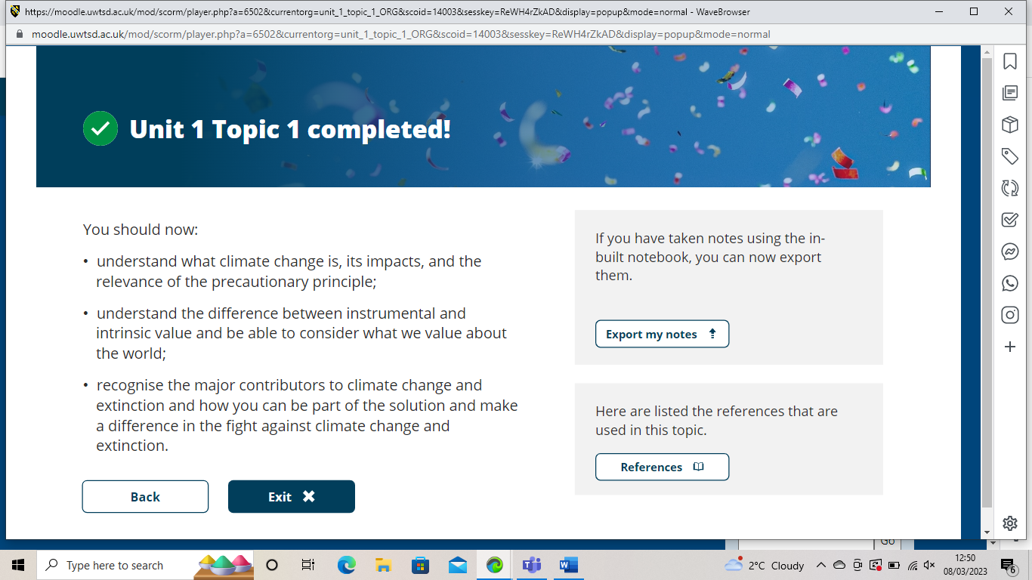

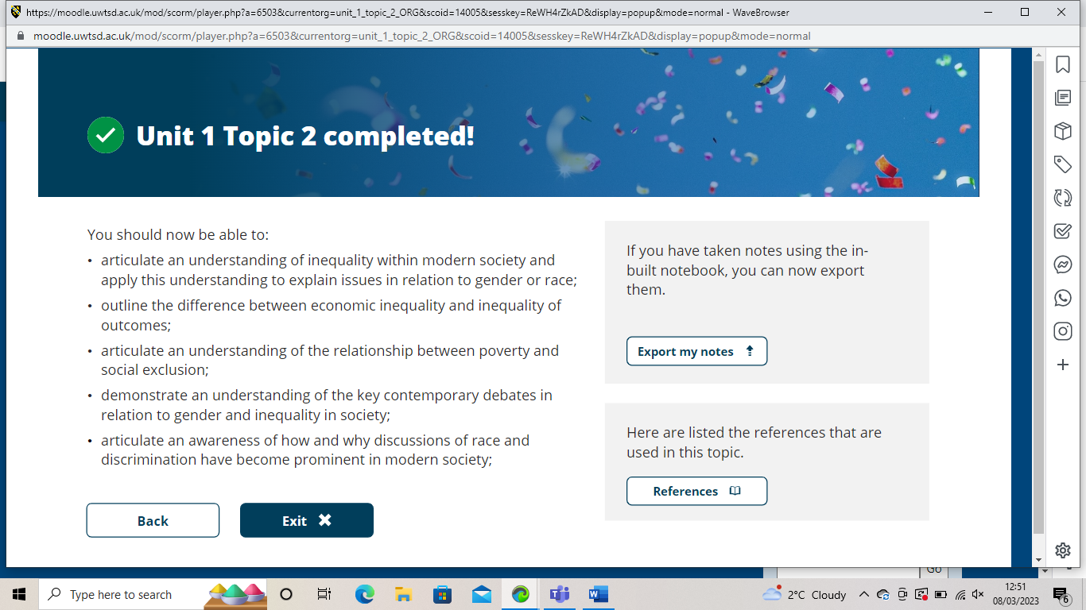

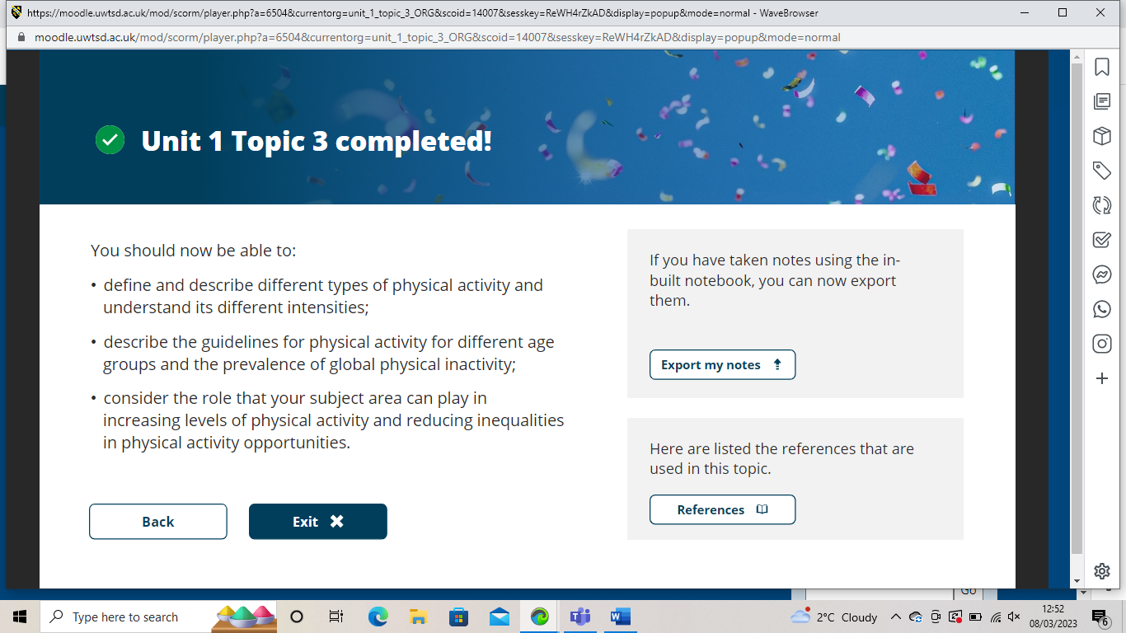

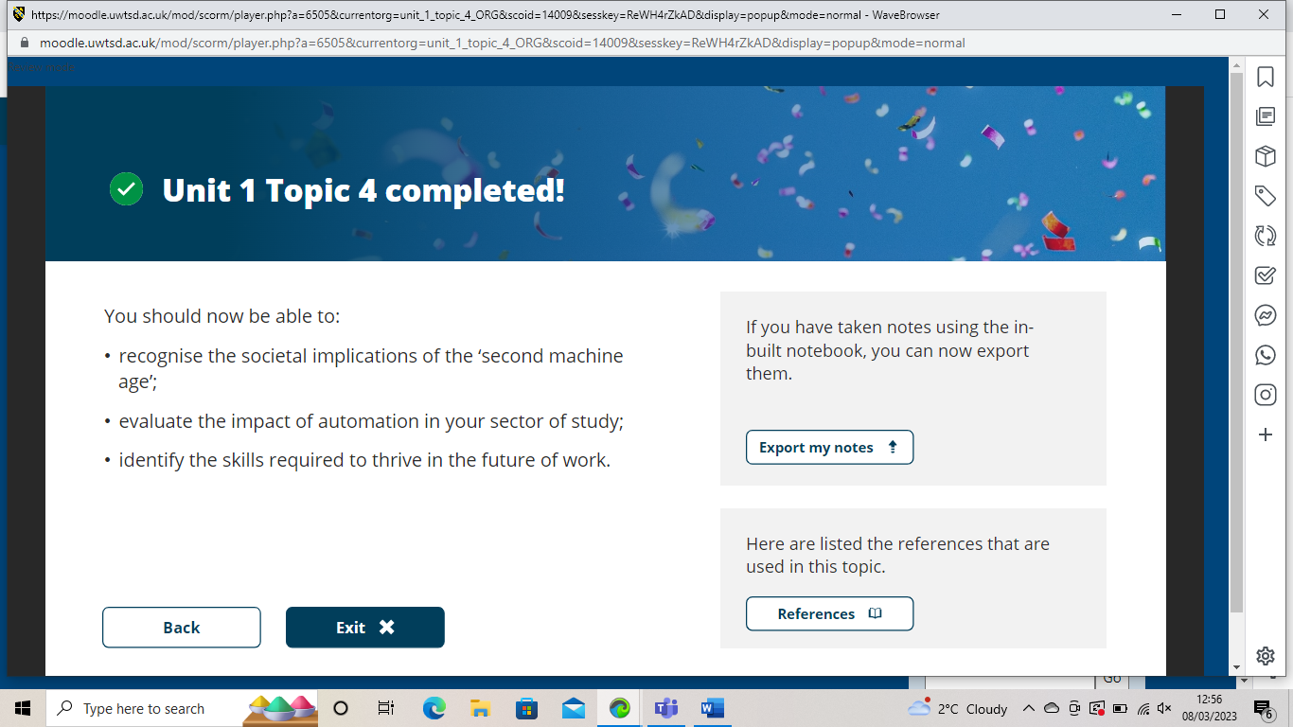

Unit 2


