RICHARD KANJOMA

ASSIGNMENT TITLE: DIGITAL SKILLS AND RESEARCH METHODS
TEACHER: TERRY WALCOTT
STUDENT: RICHARD KANJOMA
STUDENT ID: 1916228

Contents
“IMPACT OF THE MOODLE (VLE) USED BY UNIVERSITY OF WALES TRINITY SAINT DAVID CAMPUS ON ITS STUDENTS’ LEARNING EXPERIENCES.” 1
Introduction 1
Rationale 2
Literature Review 2
Understanding of ‘Virtual Learning Environments’ 2
Relevance of ‘Virtual Learning Environments’ 2
Methodology 3
Primary data collection 3
Secondary data collection 4
Primary data analysis 4
Illustration 1; Bar Chat showing students’ familiarity with Moodle as a ‘Virtual Learning Environment’ 5
Figure 1; Pie chart showing students’ perception about the Moodle 6
Illustration 3, shows students’ attitude towards the use of ‘Virtual Learning Environments’. 7
Illustration 4; showing students’ experiences with the use of ‘virtual learning environments’ 8
Secondary Data Analysis 9
Conclusion 9
Recommendations 10
References 10
Appendix 11

“IMPACT OF THE MOODLE (VLE) USED BY UNIVERSITY OF WALES TRINITY SAINT DAVID CAMPUS ON ITS STUDENTS’ LEARNING EXPERIENCES.”

Introduction
Following the current developments and technological advancements, the education system all over the world is changing to incorporate the use of Information Community Technology in the process of learning and teaching. (Burston, 2013). In the UK, many institutions have embraced the use of ICT to make learning and teaching more meaningful and easy by encouraging learning through the use of ‘Virtual Learning Environments (VLEs).’ Therefore this report indents to find out the “Impact of Virtual Learning Environment (VLE) on students’ learning experience” by looking at prior success of ‘Virtual Learning Environments’, major factors that influence the acceptance of ‘VLEs’ by generally studying students’ reactions and findings presented in literature review.

Rationale
To determine the ‘Impact of the Moodle (VLE) used by University of Wales Trinity Saint David campus on its students’ learning experiences.
Objectives of the research
- To find out whether ‘Virtual Learning Environments’ have any positive impact on students’ learning.
- To find out if the use of ‘Virtual Learning Environments’ by students at University of Wales Saint David Campus will encourage them to learn by themselves on the internet independently
- To find out whether the students at the University have the resources and interest to adopt to ‘Virtual Learning Environments’.

Literature Review

Understanding of ‘Virtual Learning Environments’
According to Arslan (2010), ‘Virtual Learning Environments are those “multimedia” platforms that are interactive in nature through the use of ‘visual’, audios, videos and ‘graphics’ to aid in the process of learning and teaching. ‘Virtual learning environments’ provide the opportunity to teachers to reach their students all over the world through the availability of computers, smart phones, tablets using the internet. (Arslan, 2010). He believes that students are able to attend class, participate by contributing ideas and also do their exams from anywhere in the world without traveling. On the other hand, Rouse (2011) defined ‘VLEs’ as the use of computers and internet in the learning and teaching process as the tools aimed at enhancing and improving students’ learning capabilities by introducing a “teacher and student ID” to access the Learning environment.

Relevance of ‘Virtual Learning Environments’
Jewitt et al. (2011), in their study found out that ‘Virtual learning environments’ are effective in the process of enhancing personal learning at home because of the increased opportunity for students to study with independence, since there is a variety of information provided through web- designed learning and autonomy. (p.8). Kurilovas & Juskeviciene, (2016) believe that virtual learning environments are very important in the learning and teaching process in a university especially where the process requires use of Information Communication Technology (ICT). Byan et al., 2016, explained that ‘virtual learning environments’ enable learning through the use of ‘web-based technologies’ that enable students to learn and teachers to teach at their own homes, time and pace. This creates independence since videos and audios of teachers explaining concepts can be saved and watched later at their own convenience. (Israel, 2015). Further findings by Baker & Gossman (2013) also indicated that ‘virtual learning environments’ have positive impacts on the learning experiences of students at university because they improve on the ‘readiness’ and confidence of students to learn by themselves at home.
Studies by Bernard et al. (2014) also showed that students who used virtual learning environments were doing slightly better than those students who preffered the old methods of face to face learning in a class environment. Similarly, Demian & Morrice (2012) found out that the use of Virtual Learning Environments did not have a big impact on the final grades and general performance of students, however, deeper studies revealed that to a smaller extent, there way positive impact on the performance of students. (p.17). Also, Israel (2015), Northey et al. (2015), Southard, Meddaug and Harris (2015), Gomez et al. (2016) and Ryan et al. (2016) had similar findings.
However much majority studies agree to ‘virtual learning environments’, other studies have revealed the opposite. ‘Virtual learning environments’ are less ‘interactive’ and therefore instill isolation feelings within students especially those that lack sufficient computer knowledge that are always left out since they are unable to login into the module, upload or download study materials hence negatively impacting their learning experience. (Adams, Randall & Traustadottir, 2015). Similarly, Read, Coles, Frey & Littlefield (2013) in their study about VLEs among the UK teachers, found out that teachers were not interested in the use of VLEs since it made it difficult for them to freely deliver to their students. Therefore the researchers concluded that whatever directly affects teachers, in return indirectly affects their students hence a belief that VLEs, will negatively impact on the learning experiences of students. Also, studies by Powers et al (2016) showed that the use of ‘VLEs’, for a psychology course led to a significant fall in the final grades of students compared to the traditional methods applied in learning.

Methodology

Primary data collection
The researcher applied qualitative research method that involved the use of E-questionnaire that was designed following guidelines for questionnaire designs that Babbie and Mouton (2008) recommended. The questionnaire intended to explore the students’ learning experiences with ‘Virtual Learning Environments’ and their opinions and comments were expected to address the following research questions;
- Do you think ‘Virtual Learning Environments’ will make learning and teacher easier and more effective?
- What is the impact of using ‘VLEs’ on the final grades of students at the University…..?
- How has the use of ‘Virtual Learning Environments’ changed the learning experiences and processes of students at the University?
The respondents were given a time period of two weeks to complete the questionnaire and send back responses through email and what Sapp as a document. Responses from questionnaires were then analyzed through micro soft excel and presented by using graphs and tables. In addition, figures were expressed in percentages, averages and descriptions. However, in some cases, respondents declined to answer on a few questions and some respondents chose more than two options, hence the researcher assumed that these were biased and therefore excluded them from sample population and replaced by other students.

Secondary data collection
While collecting secondary data through literature review, the researcher referred to books, journals and magazines, publications like newsletter, annual reports and websites. However, the researcher basically read material that only addressed research questions and the topic.
In general, data was mainly collected on primary basis supported by secondary sources.

Primary data analysis
Within two weeks, 95% of the questionnaires were completed and returned representing 95% response rate from a selected sample of 20 students, majority of them being level four students at the University and other students from other courses and levels. 95% response rate gave the researcher a 0.05 level of significance that was statically significant for the study. Having collected primary data, the researcher followed Creswell (2009) guidelines and definitions of qualitative research to analyze data by thoroughly reading through responses, coding the responses and finally interpreting these responses. (p.185).

Illustration 1; Bar Chat showing students’ familiarity with Moodle as a ‘Virtual Learning Environment’
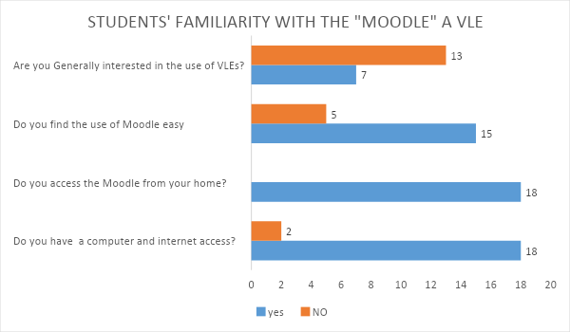
At the University of Wales Trinity Saint David, students use the Moodle to access reading material, attending lectures and uploading documents. The first part of the questionnaire had open-ended questions that intended to find out the familiarity of students with the Moodle. 90% of the students selected have computers and access to internet. Out of these students who have computers and internet at home, 100% of them have accessed the module from before. However, from the students who access the module from home, only 75% of them find ease in using the Moodle while 25% of the respondents find difficulties using the Moodle. Surprisingly, however much most of the students have easy access to the Moodle, only 35% are generally interested in its use, yet the majority 65% of the students prefer going to class for reading material and lecturers instead of the Moodle.

Figure 1; Pie chart showing students’ perception about the Moodle
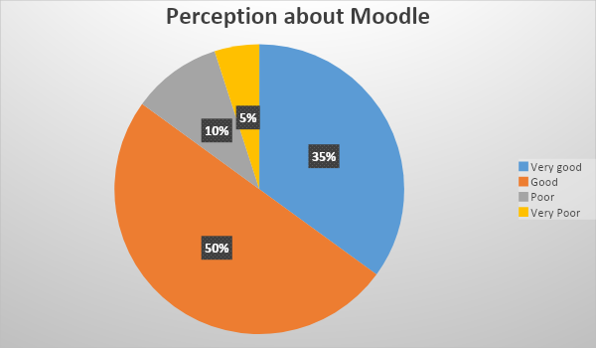
Generally, students think that the material provided on the Moodle is good making it 85% of the students. This could be so because they down the material at their own time and probably saves their time instead of writing notes down. However, 15% of the students who answered the questionnaire find the Moodle poor and the possible reasons could be reading material that is not fully explained and work overload.
Now that students have computers, internet, easy access to the module and good perception about the Moodle, then: Why are the majority not generally interested in the use of Virtual Learning Environments?

Illustration 3, shows students’ attitude towards the use of ‘Virtual Learning Environments’.
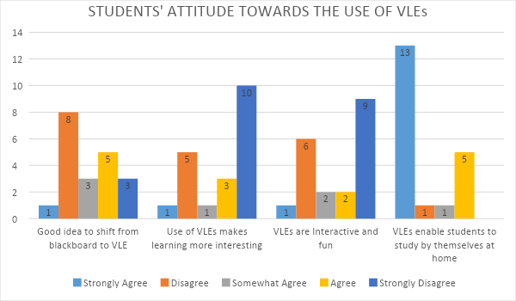
When dealing with students, attitude is very important and it impacts a lot on the learning experiences of students. From the above illustration 3, majority students disagree with the idea of shifting from blackboard to the use of ‘Virtual Learning Environments’ and 75% of the students believe that the use of ‘VLEs’ makes learning less interesting. The study revealed that students find it less interesting because majority of them do not interact freely and no fun while using the ‘virtual learning environments’ according to the primary data collected and analyzed in the above graph. Even though students find the use of VLEs less interesting, less fun and less interactive, majority of them strongly believe that ‘virtual learning environments’ can enable students to study at home on their own.

Illustration 4; showing students’ experiences with the use of ‘virtual learning environments’
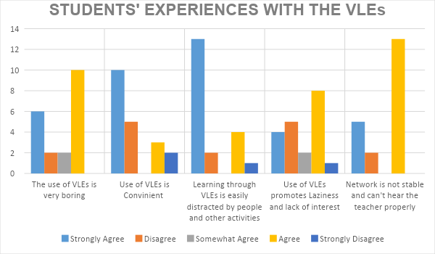
The study focused on students’ learning experiences with the use of ‘virtual learning environments’ by specifically examining variables like interest, convenience, disadvantages of VLEs and the general attitude of students.
From the above illustration 4, 85% of the students who answered the questionnaire find the use of ‘VLEs’ very boring while 10% of them find it fun. From the responses, most of them find it boring because it is not interactive enough compared to physical lessons in a class environment. However, other students do not find it boring, studies show that active students with stable internet network find it interesting because they are able to receive information and communicate back without difficulties. In addition, the study also revealed that 70% of the students agree to the fact that the use of ‘virtual learning environments’ can easy be distracted by noise from cars, dogs barking, children at home and deliveries. Similarly, a bigger percentage of students (80%) also find challenges with unstable internetwork and therefore find difficulties receiving information since they cannot hear the teachers properly due to network issues.
On the contrary, majority students (60%) believe that the use of ‘VLEs’ is very convenient for them because they are able to study from home without paying transport to school. Others find it convenient because they can download and upload material easily according to the study as expressed in illustration 1.

Secondary Data Analysis
Data collected from secondary sources like books, journals and publications is subjective in nature focusing on different variables including; communication, control over learning, participation, motivation, independence, interest and general perception about the Moodle. The study came up with results obtaining mixed reactions about the topic. However, the information obtained is relevant enough to draw conclusions.
Literature review revealed that the use of ‘virtual learning environments’ has positive impacts on the learning experiences of students because it provides an opportunity to students to access variety of information through the full time available Moodle, this is possible because students get information and reading material in various forms including; videos, audios and ‘text form’.
Literature review also found out that with the use of ‘VLEs’, students and their teachers are able to share resources about school among them through the use of technology specially the use of ‘Microsoft Teams’ and other options available. Literature also revealed that ‘virtual learning environments’ increases students’ opportunities to take control of their learning by accessing the Moodle at their own convenience; this is so because the videos, audios and text resources uploaded by the lecturer are easily downloading at students’ pace without fear of missing lectures and missing attendance marks.
In addition, literature has also showed that the use of ‘VLEs’ has led to improved skills especially in computer since students use computers to study hence appreciation of technology. The students are able to learn important applications like PowerPoint, MS Word, MS Excel and many others used to access reading material.
On the other hand, to a lesser extent, some authors disregarded the positive studies and highlighted that the use of ‘VLEs’ is not a good idea for learning because they are less interactive for both teachers and students since students have different learning styles. Studies also showed that using virtual learning environments is boring and hence causing students to feel isolated and less interested especially those who have unstable internet networks and those with limited computer skills and therefore students are affected negatively by the use of ‘VLEs’. Furthermore, literature showed that students’ learning experiences are negatively affected since some students are used to physical classes and learning under supervision and therefore take virtual learning less serious knowing that teachers have no control over their learning.

Conclusion
Data collected from literature review demonstrates that the use of ‘virtual learning environments’ have positive impacts on the learning experiences of students at University basing on factors like convenience, student independence, technological advancements in learning, access to information and sharing information among others. Primary data collected concludes that students are generally not interested in the use of ‘VLEs’ because it is boring, less interactive, unstable network, less fun, some students do not have requirements to study online and above, students are more interested in studying physically at school. Therefore, this report concludes that physical learning in a class room should be maintained. However, virtual learning environments should be used in circumstances where students are unable to go to class physically like the current outbreak of Covid 19 pandemic that has led to use of ‘virtual learning environments’ at the University.

Recommendations
Regardless of students perceptions that ‘VLEs’ are less interesting, less fun and less interactive, it is important for the University to encourage them to embrace virtual learning because it is a ‘necessary evil’ especially during this period pandemics that does not allow students to meet physically for lessons.
In order to attract students and increase their involvements with the use of ‘VLEs’, teachers should teach as if they are in class physically. To begin with, teachers should do a quick role call to ensure students are in attendance and should constantly asks students to contribute, this makes the VLEs very interactive and fun for students.
The teacher should ensure all students know what by discussing with them norms before he/she starts teaching virtually by showing how to contribute, how to raise their hands, how to mute and unmute, how to clap hands. This is important because it makes students comfortable with the method used and increases their interest towards the use of that VLE.

References
Kurilovas E, Juskeviciene A. (2016). Creation of Web 2.0 tools ontology to improve learning; Computer Human Behavior.
Barker, J., Gossman, P. (2013). ‘The Learning impact of a virtual learning environment; Students’ views’. Tean Journal 5(2). Pp. 19-38.
Demian, P. & Morrice, J. (2012). The use of virtual learning environment and their impacts on academic performance.
Jewitt, C., Clarka, W. & Hadjithoma- Garstkaa, C. (2011). The use of learning platforms to organize learning in English primary and secondary schools. Learning, Media, Technology, 36(4), pp. 335-348.
Nortvig, A. M., Petersen, A.K., and Balle, S.H. (2018). A literature Review of the factors influencing E-Learning and blended Learning outcomes, student satisfaction and engagement. The Electronic Journal of e-learning, 16(1), pp. 46-55.
Awan, N. (2013). Students’ opinions on the use of a virtual learning environment at a higher education institution; International Journal of science and Applied Information Technology. Vol. 2, pp 1-5.

Appendix


