MADON IGBINOBA
1815861
LECTURER NAME____DIYA Ganguly
Module: Psychology in Health and Social care
Module code: BMHP 4003
University of wales trinity saint davids
Report
Table of Contents
Introduction 2
Detailed Theory 2
Psychosexual Theory of Development 2
Psychological Theory of Development 3
Cognitive Theory of Development 3
Theory of Moral Development 3
Social and Biological determinants of Behavior Displayed in Health and Social care context 4
Adolescence and Erik Erikson’s theory of psychosocial development 4
Critical evaluation 6
Role of Healthcare Practitioners and Reflection 6
Conclusion 7

Introduction
Lifespan development refers to how an individual grow and change from conception till death. Development is a lifelong process and. and looks at change, constancy and growth patterns in behavior during the course of life. Lifespan development is mainly focused on human development and is regarded as a continuous process and covers three major developmental domains such as cognitive, physical and psychosocial development. Physical development focuses on the how brain, muscles, nervous system, sensory abilities and need of drink, food and sleep affects the behavior of an individual. Cognitive development is focused on intellectual capabilities such as learning, problem solving, memory and intelligence. Social and personality development, however emphases on characteristics that discriminates one individual from others and how connections with each other and social interactions nurture and modifies over the lifespan (Baltes, Staudinger and Lindenberger, 1999).
Development is divided into certain periods according to age. Age periods of the development include: prenatal that begins at conception and continues till birth; infancy and toddlerhood that begins from birth till two years; early childhood that starts from two years to six years; middle and late childhood that begins from six years till the arrival of puberty; adolescence that starts from puberty onset and lasts till 18 years; emerging adulthood begins at 18 and lasts till 25 years of age; early adulthood begins at 25 and lasts till 40-45 years of age; middle adulthood starts at 40-45 and remains till 65 and late adulthood that begins at 65 years till death (Lally and Valentine-French, 2019).

Detailed Theory
There are certain theories of lifespan development. These theories emphasizes on how babies mature and develop into healthy and happy grownup individuals. The four major psychological theories of lifespan development are:

Psychosexual Theory of Development
Psychosexual Theory of Development was proposed by Sigmund Freud (1856-1939). He believed that it is early childhood when the personality develops. Experiences gained in childhood shape the behavior and personalities as adults. According to Freud, development is discontinuous and each individual must pass through a continuous series of periods or stages in childhood and if proper parenting and nurturance is lacking than the individual will stuck in that stage. His stages are known as psychosexual development. Freud stated that pleasure seeking impulses in children are fixated on distinctive area of body known as enormous zone at every stage of development that are oral, phallic, anal, genital and latency (lifespan theories, 2021).

Psychological Theory of Development
Freud’s theory was taken by one other theorist Erik Erikson (1902-1994) and was modified into psychosocial theory. This theory emphasized on social nature of human development instead of sexual nature and that the development occurs over the lifespan rather than in childhood only. According to Erikson, interactions at social level with others influence the sense of self or the ego integrity. Erikson believed that individuals are motivated by the desire of achievement in several aspects of life. Based on psychological theory there are 8 stages of life from infancy till death or late adulthood. Each stage must be completed successfully in order to be a happy and competent adult. Failure of any stage will affect the later stage and new learning(lifespan theories, 2021)..

Cognitive Theory of Development
Jean Piaget (1896-1980) explored childhood development. Piaget emphasized on cognitive development of children rather than psychosocial or psychoanalytical side of development. He believed that thinking is a dominant feature of development and kids are inquisitive by nature, but do not reason or ponder like adults do. According to Piaget, development is discontinuous and cognitive development occurs through stages. As the stages are progressed, there is a distinctive shift in thinking and reasoning. Cognitive theory of development suggests that children establish schemata to help comprehend the world. Schemata are mental models or concepts that are used to understand and categorize information. As the adulthood is reached, schemata are created for almost everything. When the new information is leaned schemata are adjusted via assimilation and accommodation. Assimilation is the taking the new information in regards of what is already known and accommodation is adjusting schemata according to new information. Like other theories, theory of cognitive development is also unfolded in stages. Sensorimotor stage (0-2 years) is when world is experienced through activities and senses. In preoperational stage (2-6 years), use of words and images to represent things take place but logical reasoning is lacking. In concrete operational stage, (7-11 years),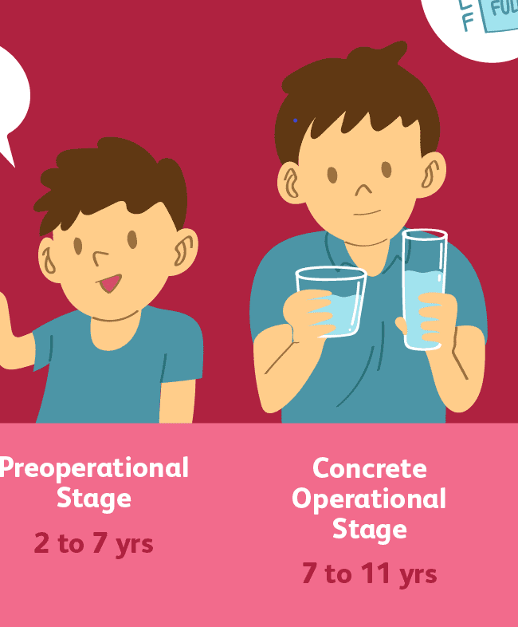
arithmetical operations and logical reasoning are learned and lastly in formal operational stage (12 onwards) abstract reasoning and formal operations are learned.

Theory of Moral Development
Discriminating right from wrong is a task that begins in childhood and continues in adolescence. Lawrence Kohlberg extended upon the Piaget’s theory of cognitive development and stated that like cognitive development, moral development also occurs in stages. According to Kohlberg, person advances from the ability for pre-conventional morality (till 9 years) to the ability of conventional morality (early adolescence) and to achieve post conventional morality (after formal operational thought are gained), which is achieved only by few. These are 3 stages of moral development and have more complex sub stages (Wallston and Strudler Wallston, 1978).

Social and Biological determinants of Behavior Displayed in Health and Social care context
Social and biological determinants are the features that affect the social and health care of an individual human being. These factors are subdivided into other aspects such as socio economic, behavioral and psychological features such as culture, age, ethnicity, gender, education, socioeconomic and environmental factors. The main characteristic of biological behavior is preservation of self. Humans always struggle to achieve healthy and happy life. Preservation of self involves the liveliness of life either psychologically or physically and this is usually achieved by fulfilling mental and financial desires. The need of food and water is essential biological factor that affects the behavior in context of health. While existing in a society, a number of factors influence the personality of a person and affect its mood and behavior. Such factors include culture; in culture the behavior is dominated by eye contacts, greetings and social contacts and respect with others. The social behavior affects the personal and professional life of a person; socioeconomic factor is one of the main factors that affect the behavior of an individual at social level. To achieve a comfortable lifestyle, humans are always in a race of competition. For this the pressure that is faced is a major determinant of the behavior. Environment also plays important role on an individual’s behavior. Broken family, lack of discipline, communal gaps, abusive relationships and poverty brings out the negative behavior. Education is also an important factor that affects the behavior. The data present suggests that areas where literacy rate is high have more happy and healthy individuals.

Adolescence and Erik Erikson’s theory of psychosocial development
Adolescence is termed as the intermediary phase between later childhood and early adulthood. It is marked usually on the onset of puberty and includes sexual maturity based on hormonal and physiological development. In adolescence, social self is identified in terms of social world. At this age, children become more sensitive towards other people’s opinion about them. Psychosocial context of adolescents are different in each child. Various changes in relations with friends and family take place. This stage starts to exert more self-directed control over choices, emotions and actions of the adolescent and start to uncouple from parent’s control (Choudhury, Blakemore and Charman, 2006). The convergence of these external and internal (hormonal) factors affects the behavior and emotions.
Social development of adolescent is usually termed as the procedure of developing a sense of identity and establishment of a purpose and a role. Risk-taking is the one of the important natural part of the adolescent’s life. Social and emotional development is closely related as adolescent look out for a sense of self and personal identification. The manner in which one thinks and feels about others and about themselves is linked to the emotional development. Because of vast changes that are being experienced self-worth, flexibility and coping skill are intensified. Cognition is the process of thinking rationally and perceiving. Brain undergoes remodeling during adolescence to get adaptive to more cognitive skills such as higher level cognitive functioning and better memory and processing. At the same time vulnerability to mental illness also increases. Adolescence is the most sensitive period for brain as well as individuals because at this stage the role and purpose is in adult life is understood (Kilford, Garrett and Blakemore, 2016)
Erikson’s theory of psychosocial development is linked to adolescence because it relates to the older ages including adolescence as compared to childhood theories of Freud, Piaget and Kohlberg. Erikson’s theory is based on 8 stages based on the ages. The first stage is termed as trust vs. mistrust and starts from birth till 18 months of age. At this particular stage, the child is uncertain about the world and is only associated with his caregivers for the constant care and stability. If the care received is consistent and reliable child will establish a sense of trust and will carry the trust to other relations also. If proper care is not given child will feel anxious and will develop mistrust towards every relation and will not be confident towards the world. The second stage is called autonomy vs. shame and doubt. It begins from 18 months and lasts till 3 years. At this stage, children are more attentive on establishing the sense of personal control on physical abilities and on sense of liberation. Successful completion of this stage will lead the child to develop the feature of will and feel increased independence and become more confident towards world. On the contrary, if child is critiqued and controlled overly and is not allowed to proclaim themselves, he might become dependent on others, will have low confidence and will develop shame and doubt on their capabilities. Initiative vs. guilt is the third stage of the Erikson’s theory and starts at 3 years and last till 6 years. Children proclaim themselves through playing and other social interactions. They take initiatives from planning the games which leads to believe in themselves and make decisions. Failure of this stage will make children develop guilt and this delays their learning for next stages. The fourth stage is called industry vs. inferiority and starts at 6 to 12 years. At this age, child starts to learn reading and writing. Teachers play an important role by encouraging or discouraging the child. Encouragement leads to competency and self-esteem however restrictions cause inferiority complexes and a failure of this stage. The 5th stage is called identity vs. role confusion. This stage starts at adolescence i.e. from 12 years till 18 years. Adolescents look out for their identity in the world and if restricted will get confused about their identity and their role as an adult. The two main roles adolescents look out for are in terms of occupation and sex. The 6th stage is known as intimacy vs. isolation and begins at 18 years until 40 years. At this stage people are curious about others are ready to share themselves. If rejections are faced person will become isolated but if they are welcomed joyous relationships form. The 7th stage is generativity vs. stagnation starting at 40 years to 65 years and is achieved by the people who feel they have been productive in their life towards family, work and community. Failure at this stage will develop sense of stagnation. The final stage is called ego integrity vs. despair and start at 65 till death. The sense of integrity is achieved if person has led as successful life and if people have guilt of unsuccessful life, they will develop despair and anxiety issues (McLeod, 2018).
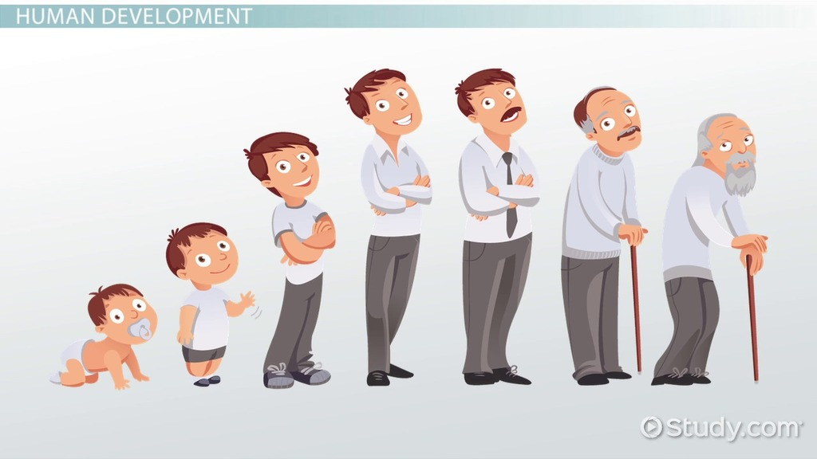

Critical evaluation
Erikson’s theory of psychosocial development is regarded as more realistic approach as it states that personality development takes place over the period of lifespan as compared to other theories which are mainly focused on only childhood development of personality. Psychology re-hypothesized the manner in which later stages of lifer are reviewed because of Erikson’s theory. Because of this theory the middle and adulthood stages of lifer are not considered irrelevant anymore, instead now these stages are regarded as active stages of personality development. Various people find this theory relatable to their own experience also.
Erikson’s theory is unclear in terms of how or why development occurs. Instead it only focuses on explaining emotional and social development of humans. The theory does not present general mechanism for crisis resolution. Erikson did not describe how the failure or success of one stage affected the other stages. Erikson focused his theory on mechanism to think instead of giving factual evaluation. However one of the powerful point of Erikson’s theory is its capability to knot significant psychological development that occur over the period of life.

Role of Healthcare Practitioners and Reflection

The psychological theories provide underpinned concepts of professional practice and helps in enhancing and maintaining societal functioning of individual in healthcare setups. These theories also help the psychologists to apply evidence based psychology to improve the therapeutic work and turn into reflective thinker who does not make naive descriptions for other’s behavior by identifying the features that affect how patients manage situations such as acute or chronic illness (Haslam et al., 2018). These theoretical perspectives informs about issues that affect people’s lifestyle and what endorses certain healthcare behaviors such as exercise, smoking and eating habits. through these theories and research, it can be elucidated how the needs and understanding of people vary so that personalized care can be optimized Also these theories help to work as a more efficient participant of multi-professional groups and enhance and protect the wellness of patients. These theories help the psychologists with their future career as well, by becoming reflective practioners and by gaining an improved understanding of communication processes and work effectually in inter-professional and inter-organization settings (Slogan, 2013; Lianov et al., 2019).
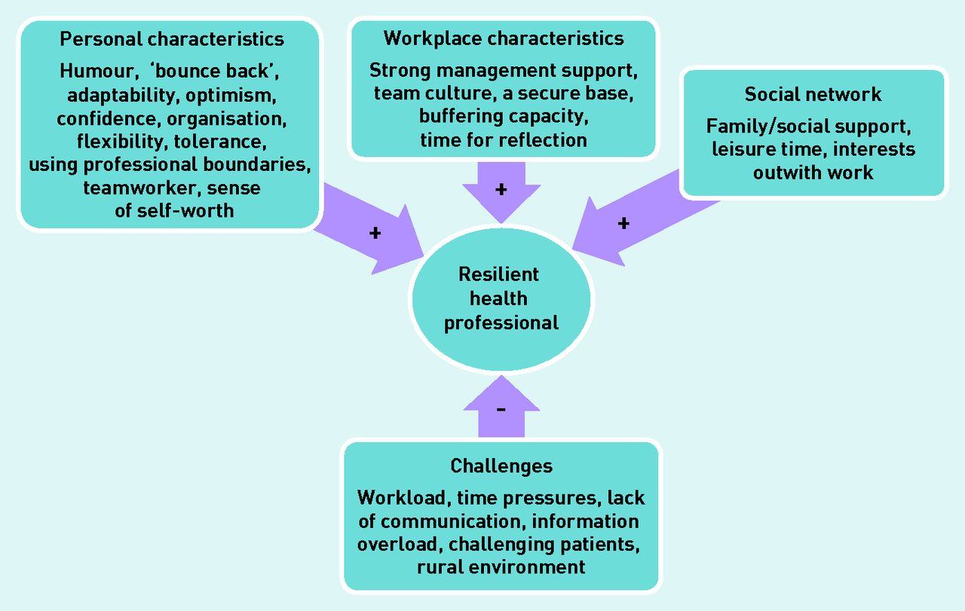

Conclusion
Lifespan development is termed as the changes that occur over the lifespan from conception till death. A person goes through various stages and evolves as an individual adult with distinctive behavior, emotions and cognitions. Many theorists presented theories that support how an individual grows over the course of life and develop learning skills, and behavior. The four main theories are Freud’s theory of psychosexual development, Erikson’s theory of psychosocial development, Piaget’s theory of cognitive development and Kohlberg’s theory of moral development. All these theories are based on stages or period of ages. A person goes through various stages till death such as infancy, early childhood, late childhood, adolescence, early adulthood, late adulthood and older ages till death. Of these adolescence is thought to be one of the most sensitive stages because it is in between childhood and adulthood. A person learns his occupational and sexual role about life in this particular stage. Erikson’s theory supports the adolescence stage as compared to other theories which are only focused on childhood developments. There are certain biological and social factors that affect the behavior of an individual such as need of food and drink which are the biological factors and social factors like culture, education, social status and environment are major determinants of the human behavior in social and health context. The psychological theories of lifespan development are applied in health and social care in number of aspects. They provide a detailed insight of human behavior and can be linked to personalized therapies and thus can improve the quality of care given to the psychological patients. These theories also help improve the communication and let the psychologist reflect better as an individual and as the member of social and healthcare team.
References
- Baltes, P., Staudinger, U. and Lindenberger, U., 1999. LIFESPAN PSYCHOLOGY: Theory and Application to Intellectual Functioning. Annual Review of Psychology, 50(1), pp.471-507.
- Choudhury, S., Blakemore, S.J. and Charman, T., 2006. Social cognitive development during adolescence. Social cognitive and affective neuroscience, 1(3), pp.165-174.
- Haslam, C., Jetten, J., Cruwys, T., Dingle, G.A. and Haslam, S.A., 2018. The new psychology of health: Unlocking the social cure. Routledge
- Kilford, E., Garrett, E. and Blakemore, S., 2016. The development of social cognition in adolescence: An integrated perspective. Neuroscience & Biobehavioral Reviews, 70, pp.106-120.
- Lally, M. and Valentine-French, S., 2019. [online] Dept.clcillinois.edu. Available at: <http://dept.clcillinois.edu/psy/LifespanDevelopment.pdf> [Accessed 26 July 2021].
- Lianov, L.S., Fredrickson, B.L., Barron, C., Krishnaswami, J. and Wallace, A., 2019. Positive psychology in lifestyle medicine and health care: strategies for implementation. American journal of lifestyle medicine, 13(5), pp.480-486.
- McLeod, S. A. (2018). Erik erikson's stages of psychosocial development. Simply Psychology. [online] Available at: <https://www.socialpsychology.org/> [Accessed 24 July 2021].
- Pressbooks-dev.oer.hawaii.edu. 2021. Lifespan Theories. [online] Available at: <http://pressbooks-dev.oer.hawaii.edu/psychology/chapter/lifespan-theories/> [Accessed 24 July 2021]..
- Sloan, G., 2013. Psychology for Nurses and the Caring Professions – Fourth edition Psychology for Nurses and the Caring Professions – Fourth edition. Nursing Standard, 27(28), pp.28-28.
- Wallston, B.S. and Wallston, K.A., 2020. Social psychological models of health behavior: An examination and integration. In Handbook of Psychology and Health (Volume IV) (pp. 23-53). Routledge.

