

BMSW4003

Digital skills and Research Method

Title: Impacts of Virtual Learning Environment (VLE) – Module on the students’ learning experience
Student Name:Ramona Vaman
Student Number:2030332

Table of Contents
Introduction 3
Background 4
Aims and Objectives 4
Research methodology 4
Primary data analysis 5
Secondary data analysis 15
Conclusion 17
References 18

Introduction
Virtual Learning Environment (VLE) is an online platform for educational institutes in London. In recent times, colleges, universities, schools are using this platform to provide education during the confinement of the covid – 19 pandemics. To make sure that the service is top-notch, teachers follow a well-structured module and prepare necessary study materials like presentation slides, documents, videos, assignments, regular assessment and many more. In this report, there is detailed research about the impact of the VLE module on student’s learning experience. The first portion of the report is an online survey conducted on 50 students. And the second portion of the report shows an analysis of the recently published research journals and articles based on the topic.

Background
After the invention of the internet in the 1960s, researchers and technologists are working hard to use the facility of modern technology in the education field. A virtual learning environment is a learning system where teachers and students get to interact with each other via an online platform. But how effective is this technology in student’s learning experience, still needs further research (Simonson, 2020). University of Wales Trinity Saint David London Campus has been adopting the approach of Virtual Learning Environment (VLE) module for quite a long period. As a result, a detailed investigation of their student’s learning experience is conducted here.

Aims and Objectives
This report aims to figure out the roles that the virtual learning environment plays in the student’s mental development and how is it impacting their learning experiences.
Objectives
- To figure out how much positively students are taking the VLE module
- Providing a report which can help the teachers in improving their teaching efficiency
- Having an idea about the student’s comfortability for using new technology (Bamber, 2017).

Research methodology
Research approach
This research follows the combination of both quantitative and qualitative approaches. Here researchers analyse the numeric data obtained from the close-ended questions in the survey. In the second part of the report, there is a qualitative analysis of the data from the secondary source.
Research paradigm
The research paradigm for this purpose is to focus on the impact of the VLE module on the student’s learning experience and to figure out the strengths and weaknesses of this learning system (Allison et al., 2016).
Sampling
50 participants are chosen for the survey. Participant’s responses will be collected systematically applying all the ethical considerations. The whole research process will be conducted via an online platform.

Primary data analysis
The primary data collection is the process of analysis based on the directly collected data. The data collection method can either be interview, observation or survey. Here, the primary data collection is conducted through an online survey. For this purpose, 20 questions were prepared beforehand.
Questionnaire
- Do you find the Virtual Learning Environment (VLE) module useful for your study?
- Yes
- No
- No idea
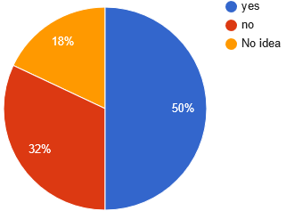
While looking at the student’s response for whether they find VLE as a useful platform for study or not, 50% of them responded to it positively. They think it could be a useful platform for study (Hamilton, 2014). But on the other hand, those who do not think this platform is a useful one are also large, which is 38%. Unfortunately, 18% of the students have no idea about whether this platform can be a useful one or not for study.
- Have you ever participated in VLE before?
- Yes
- No
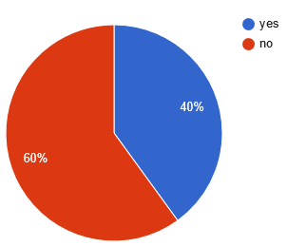
This figure shows that only 40% of the students have participated in the VLE platform before. This means for the other 60% of the students, this platform is new.
- How much do you find the internet as a useful source for learning?
- Effective
- No idea
- Ineffective
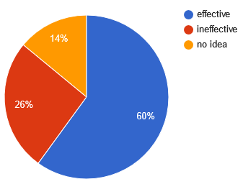
The figure shows that the majority of the students(60%) think of the internet as a useful source for learning. Less than 30% of students do not find the internet as a useful source of learning where less than 15% of students have a vague idea about the internet’s usefulness or uselessness as a source of learning.
- What do you prefer to use the internet for?
- Social media
- Educational purpose
- Research and higher study
- Useless
- No idea
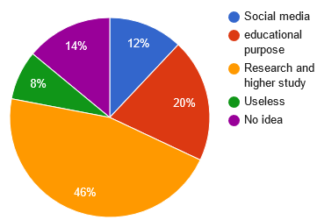
From the figure, it can be seen that 12% of the students think that the purpose of the internet is only for using social media, where 20% of the students believe that, it is for study purposes. But a majority of the students(46%) believes the internet is a useful source for only higher study and research purposes. It seems that students are still unclear about the useful application of the internet (Tsang, Kwan and Fox, 2013). 8% of the students seem to have no idea about the usage of the internet.
- How do you think your skill in using advanced technology?
- Low
- Medium
- High
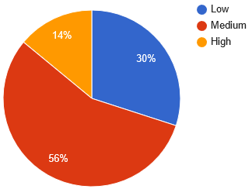
The figure shows that majority of the students, which is 56% believe that their skill in using advanced technology is medium. But the students with lower skill in advanced technology is not very low and that is 30%. Only 14% of the students believe that they have high skills in using advanced technology.
- Do you have enough opportunities to participate in the VLE? (opportunities: laptop, mobile, pc, internet connection)
- Yes
- Not sufficient
- No
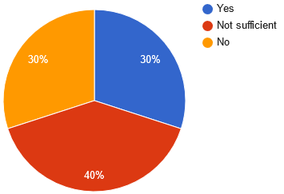
VLE module needs some extra requirements which traditional learning environment did not require that much. Laptop, smartphone, pc, strong internet connection etc. are the main requirements for joining the learning sessions in the VLE platform (Gherabi and Kacprzyk, 2021). The majority of the students (40%) has responded that they do not have sufficient opportunities, and 30% of the students do not have any of the required facilities for participating in the learning session. Only 30% of the students have those required facilities for attending the learning sessions which needs to be considered seriously.
- How much satisfied do you feel after attending the learning session in the VLE platform?
- Satisfied
- Average
- Dissatisfied
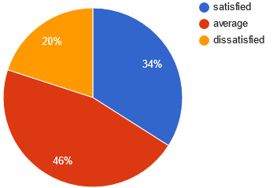
The above figure shows that 34% of the students are satisfied with their learning experience in the VLE platform and 20% of the students do not feel satisfied with their experience. They strive for a better experience. On the other hand, 46% of the students feel it is similar to their previous learning experiences.
- Do you think in VLE teacher’s efficiency gets reduced with time?
- Yes
- No
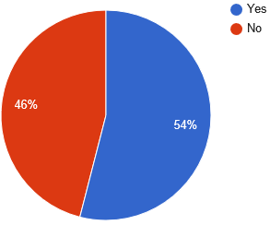
The figure shows that 54% of the students feel like their teacher’s efficiency get reduced with time in the learning sessions on the VLE platform. On the other hand, 46% of the students feel like the teacher’s efficiency remains the same throughout the whole session.
- Could you concentre throughout the whole learning session?
- Yes
- Not sure
- No
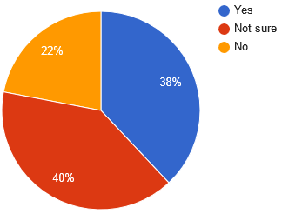
The figure demonstrates that 38% of the students feel like they can concentrate throughout the whole session, where 22% of the students do not feel so. 40% of the students are not sure whether they can fully concentrate on the class or not.
- What kind of impact do you think the VLE module has on student’s grades?
- Positive impact
- Negative impact
- No opinion
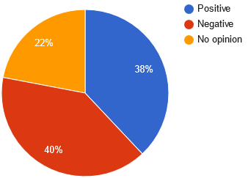
The students who believe their grades get impacted positively and negatively due to the change in the learning environment are around 80%. Where 40% of students think the impact is negative and 38% of students think the impact is positive.
- Do you think the VLE module impacts students’ effort for knowing better the study materials?
- Yes
- No
- No idea
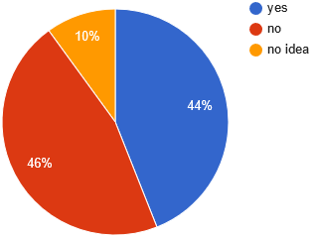
Due to the huge coverage of the internet, everything is available online. It might have impacted the student’s quest for learning new things (Ballentine, 2012). 44% of the students believe that the module has an impact on student’s effort for learning and knowing new things, where 46% of the students feel the opposite. 10% of the students from the survey have no idea about it.
- Do you feel satisfied with the assessment method in VLE?
- Satisfied
- Not satisfied
- Average
- No idea
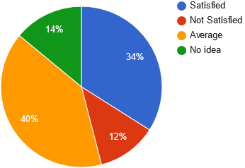
The VLE module introduced a new assessment method for the students which is completely different from the traditional method. 40% of the students think the assessment method is just average. 34% of students are satisfied with the method and 12% are not satisfied. 14% of the students from the survey have no idea about the difference in the assessment method.
- How do you think the VLE Module has impacted students’ socialising and communicating capability?
- Positively
- Negatively
- No impact
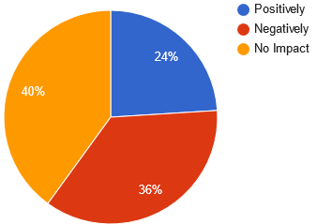
The figure shows that 24% of the students believe that the VLE module has a positive impact on the student’s socialising and communicating capability. And 36% of them believe that this platform harms their socialising and communicating skills, which is a matter of great concern for module designers. The majority of the students (40%) believe that the change in the learning environment has no impact on socialising and communicating.
- Does the VLE module provide enough opportunity for applying skill, knowledge and competence during the learning?
- Yes
- Sometimes
- No
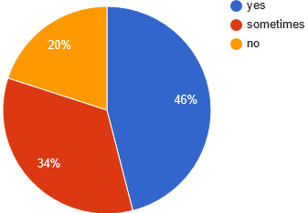
It is a good sign that, majority of the students (46%) feel that they have enough chances for using their knowledge, skill and competence in the VLE platform. But 34% of the students do not think that. On the contrary, 20% of the students think that there is no enough chance for them to apply skills, knowledge and competence.
- Do you think you have improved your technological efficiencies?
- Yes, I have
- No, I have not
- I still have a long way to go
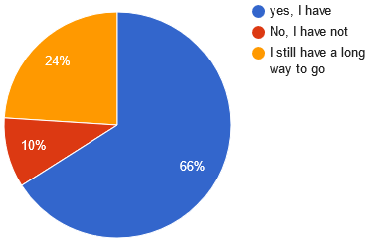
This figure gives hope for advancing further. Most of the students (66%) believe that their technical skills have been improved. 24% of the students think that they need more time. And 10% of the students responded that their skills are still not that good. It could have been due to the impact of lack of required facilities like smartphones, pc, laptops, internet connection and others (Hiscock, 2020).
- Does VLE provide enough opportunity of reviewing the class lessons for lagged behind students?
- yes
- Sometimes does
- No
- No idea
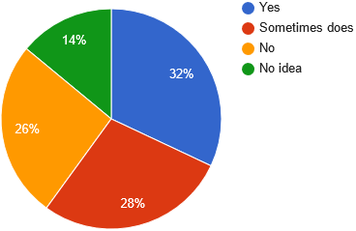
The figure shows that 32% of the students think the learning session does provide opportunities for the lagged behind students and 26% of them does not. While looking at the other slice of the pie chart, 28% of the students believe that the module sometimes provides opportunities for the lagged behind students. 14% of the students have no idea whether the platform provides opportunities for legged behind students or not.
- Do you feel mentally pressured and isolated during the learning sessions on the VLE platform?
- Yes
- Sometimes, I do.
- No
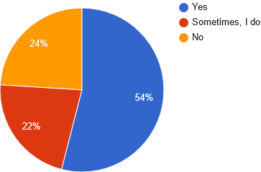
As the VLE – Module improvises creating a virtual platform where students do not attend the class physically, it is possible to feel mentally pressured and isolated (Yuhanis Omar, 2021). The majority of the students (54%) think that so. 22% of the students feel like that sometimes and 24% of them do not think that way.
- Do you feel interested in joining classes in the VLE module?
- Yes
- No
- Not sure
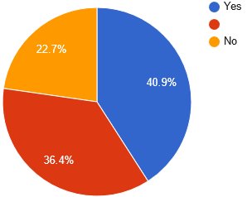
The figure shows that 40.9% of the participants feel interested in joining learning sessions via the VLE platform. 36.4% of the students are not that much enthusiastic about joining classes in the VLE. 22.7% of the students do not feel interested or uninterested in joining the class on the VLE platform which means they are joining classes as they are instructed to do so.
- Would you recommend VLE as a useful tool for learning?
- Yes
- No
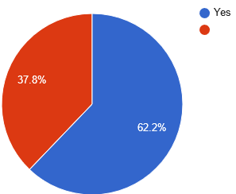
After taking part in the VLE module, the majority of the students (62.2%) seem more interested in it. As they got to know about this platform better. But the rest of the students who are more than 35%, do not think of this as a useful way of learning and do not find it recommendable.
- How do you rate your learning experience in the VLE module, from 1 to 5?
- 1
- 2
- 3
- 4
- 5
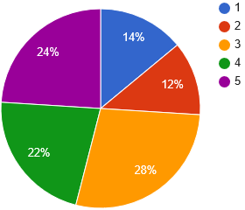
The main motive of the question was to gain numerical data on how satisfied they were with their learning experience (Hall, Pennington and Holmstrom, 2021). Most of the students (28%) went for option 3, which means it was more than just average. 22% of the students rated this as a good learning experience and 24% of the students rated this as one of the best experiences.

Secondary data analysis
Secondary data analysis refers to the method of analysing data obtained from different trusted sources like journals, reports, researches, surveys and others. The main purpose of the research is to analyse the data from previously conducted reports. It will help to find out if there is a reflection of the previously obtained primary data analysis and whether the results from the survey analysis was justified or not.
Case study report
An e-learning platform conducted a case study on a college in Kent. The study shows that the VLE platform has helped their students to develop their way of thinking. Also, the students who stay far away from the college can easily take part in the learning session with the help of VLE. The teachers are now available 24/7 hours for them and they can directly contact their teacher for necessary help (Farrelly, Raftery and Harding, 2018). The case study has also shown that 80% of the student has a strong internet connection at home which is a very important factor that helped the students in receiving better learning experience.
The case study has pointed down some important factors to make the VLE module successful.
- Producing a standard lesson plan and implement useful tactics for making the online teaching environment effective (McAvinia, 2016).
- The online library and different trusted information sources should be involved while developing the VLE module
- Providing necessary training to the teachers and staff to receive a better result.
Recently published Journal
The impact of VLE during the pandemic situation was researched by various researchers recently. Recently research has been conducted by a group of renowned researchers that mainly focuses on the students of the Science faculty and their perception towards the key approaches of the VLE module (Torres Martín, Acal, El Homrani and Mingorance Estrada, 2021).
Educators from this institute claim that, they try to implement the pedagogical approach along with the usage of updated technology in the education system. the researchers had run through a quantitative research approach by providing the participants with a set of questionnaires.
The research outcome shows that students are confident with sending emails, using social media effectively, affluent with using different useful search engines named google, bing, yahoo, and others, have good knowledge about some of the reliable storage systems named google drive, dropbox and got skilled in some of the useful software like Microsoft Word, Microsoft Excel, Zoom, Google Meet, Microsoft PowerPoint, Canva and many more. along with these skills, students have achieved knowledge about different information sources which can be helpful for their self-intrigued learning (Khan, Affouneh, Salha and Khlaif, 2020). Students here highly recommend the VLE platform as a useful module for gaining useful skills.

Conclusion
VLE module is useful for providing education for students from distant locations. But it requires some additional requirements to make this module successful. First of all the demand for necessary electronic devices and strong network connection needs to be fulfilled. Otherwise, a large group of students will be deprived of the service. Secondly, the problem of holding concentration during the whole learning session needs to be considered carefully. Teachers need to go through proper training before starting their tutoring in the VLE platform. in this way, they can come up with the necessary solution for increasing student engagement.

References
Allison, C., Morgado, L., Pirker, J., Beck, D., Richter, J. and Guetl, C., 2016. Immersive Learning Research Network. Cham: Springer International Publishing AG.
Ballentine, B., 2012. Desire2Learn for higher education. Birminghan, UK: Packt Pub.
Bamber, V., 2017. Enhancing learning, teaching, assessment and curriculum in higher education. Maidenhead, England: Open University Press.
Farrelly, T., Raftery, D. and Harding, N., 2018. Exploring lecturer engagement with the VLE: findings from a multi-college staff survey. Irish Journal of Technology Enhanced Learning, 3(2), p.11.
Gherabi, N. and Kacprzyk, J., 2021. Intelligent systems in big data, semantic web and machine learning. Cham: Springer.
Hall, J., Pennington, N. and Holmstrom, A., 2021. Connecting Through Technology During COVID-19. Human Communication & Technology, 3(1).
Hamilton, M., 2014. Autonomy and foreign language learning in a virtual learning environment. [Place of publication not identified]: Bloomsbury.
Hiscock, C., 2020. International Student Voices and the VLE. International Journal of Computer-Assisted Language Learning and Teaching, 10(3), pp.16-27.
Khan, B., Affouneh, S., Salha, S. and Khlaif, Z., 2020. Challenges and opportunities for the global implementation of e-learning frameworks.
McAvinia, C., 2016. Online Learning and its Users. Elsevier Science.
Simonson, M., 2020. Distance Learning. Charlotte, NC: Information Age Publishing, Incorporated.
Torres Martín, C., Acal, C., El Homrani, M. and Mingorance Estrada, Á., 2021. Impact on the Virtual Learning Environment Due to COVID-19. Sustainability, 13(2), p.582.
Tsang, P., Kwan, R. and Fox, R., 2013. Enhancing learning through technology. Hackensack, NJ: World Scientific.
Yuhanis Omar, A., 2021. Enhancing Student Engagement in VLE Platform: Student Perceptions Towards Programming Course Learning Resources. Psychology and Education Journal, 58(1), pp.5607-5612.

