Comparison of Exercising in a Hot Environment and a Cool Environment.
Introduction
Periard et al., (2021) highlight evolutionary adaptations that occurred to allow humans to maintain consistent levels of exertion over long periods of time during abnormal temperatures. Initially developed for prolonged hunting, modern humans still retain these adaptations. Exercise has since become a means of improving and maintaining fitness and health, and for competition (Periard et al., 2021). Smith et al., (2016) discuss how climate change is increasing global temperatures, predicting that by 2050 heavy work in extreme conditions will pose significant health risks, in particular discussing sporting events that may need regulation and restriction of when, where and how sporting events are held to protect the health of competitors.
Soligard et al., (2023) shows nearly 20% of injuries in the Tokyo 2020 Summer Olympics were exertional heat illnesses. Inoue et al., (2023) further explains, with an infographic showing daily temperatures in direct sunlight and the occurrence of heat related illness with a clear trend for higher illness after prolonged warmer periods (Figure 1).
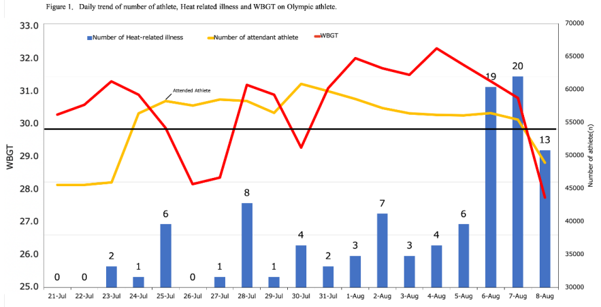
Figure 1: Daily number of attendant athletes, Temperature in direct sunlight (WGBT) and the occurrences of heat related illness (Inoue et al., 2023).
Mantzios et al., (2022) shows performance is directly affected by environmental conditions after analyzing 1258 races showing a clear relationship between performance and environmental temperature. The authors highlight the temperature range for optimum performance of athletes is 7.5-15°C in direct sunlight, with every degree outside these conditions leading to performance declines of 0.3-0.4% (Mantzios et al., 2022).
Thermoregulation helps maintain a steady body temperature; core temperature is regulated by the brain in response to changes in thermal balance in the body (Lim, 2020). Heat can be lost/gained through conduction (transferred through two static surfaces), convection (transferred through heat-trapping mediums such as water or air), radiation (transferred through two non-contacting surfaces) and evaporation (transferred by liquid states changing to gaseous states trapping heat in moisture) (Lim, 2020).
The thermoregulation system includes the hypothalamus, sweat glands, circulatory system, and skin (Saghiv et al., 2020). The hypothalamus produces hormones controlling body temperature and heart rate (HR) (Campbell, 2008). The circulatory system controls body temperature: vasodilation for increased blood flow to skin to lose heat, and vasoconstriction decreasing blood flow to the skin preventing heat loss (Arens and Zhang, 2006). Sweat glands moisten skin to assist cooling through evaporation, however, when air is humid sweat is unlikely to evaporate (Sobolewski et al., 2021).
During exercise, muscles produce heat during the production of energy through ATP which gets stored in the body and needs to be removed from the muscles to maintain intramuscular thermal balance, therefore heat is transferred to the blood to be circulated back to the heart and conserved as heat storage or transported to the skin to lose heat (Lim, 2020). The ability to regulate body temperature is a critical role of being able to function in the heat however it is limited (Lim, 2020), heat acclimation has shown to improve the body’s heat tolerance (Benjamin et al., 2021; Flouris and Schlader (2015).
Mulholland et al., (2023) discuss cardiovascular drift, a normal process where continual steady exercise results in progressive increase in HR and decrease in stroke volume (SV), decreased maximal oxygen uptake is also associated (Wingo et al., 2012). During heat stress, these resulting factors are amplified causing greater physiological strain and decreased performance (Mulholland et al., 2023; Wingo et al., 2012). Cardiovascular drift occurs due to the rising core temperature during exercise and the body attempting to cool down through the thermoregulation system causing an increase in HR as blood flow increases and is being redirected to the skin to cool down as well as the muscles used for exercising. Due to an increase in HR, SV decreases as the ventricular filling time is being decreased before they contract to pump blood round the body (Barreto et al., 2023; Chou and Coyle, 2023).
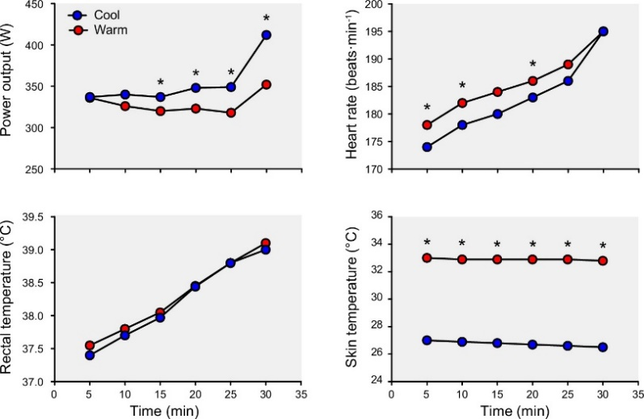
Fig. 2: Hot vs Cold exercise over 30-minutes. HR is higher in hot and less power output (Periard et al., 2021).
The aim of this study is to investigate the differences in physiological and psychological responses to exercising in a hot environment compared to a cool environment. To consider the effects of exercising in different temperatures and how quickly changes may occur participants were required to exercise in a hot environment and in a cool environment.
Method
Participants
13 participants (7 Male, 6 Female, Age 29.7±8.9, Height 172.8±8.8) were recruited from the UWTSD sport and exercise science department. It was required that all participants filled in and signed a PAR-Q to evaluate eligibility.
Study Design
Before beginning the study, VO2 Max tests were completed to find 60% of each individual’s maximum power to sustain a 30-minute bike ride, ensuring consistency of effort. A VO2 Max test is a sequentially increasing intensity exercise test measuring maximum aerobic capacity, an indicator of cardiorespiratory fitness (Buttar et al., 2019). The test was performed on a WattBike® (Wattbike, Nottingham, Uk) a reliable measure for performance over multiple tests (Driller et al., 2014). Protocol for assessing and measuring VO2max can be found in appendix 1.
The participants are required to cycle on a WattBike® in two different environmental conditions for 30-minutes at 60% maximum power. The environmental conditions tested were cycling at a hot temperature (Air temperature=32ºC, Humidity=65%) in an artificially heated room and at a cool temperature (Air temperature=7ºC, Humidity=50%) outside during winter in the UK. The WattBike® was set at 60% power for each individual. The seat height and WattBike® number was recorded and re-used on subsequent tests to ensure consistency between cold and hot experiments. Participants wore a HR chest strap (Polar Electro, Warwick, UK) to measure HR and are required to wear the same clothing to negate insulation effects. Sweat Loss during this exercise was measured by assessing weight (wearing minimal clothing) using the Seca weighing scales (Seca, Hamburg, Germany) pre-exercise and post-exercise. Core Temperature was measured via ear canal using a thermometer (Innovation, Radiant, Taiwan) pre-exercise and at ten-minute intervals during the exercise. Measurements of HR, Rate of Perceived Exertion (RPE) and VO2 were also recorded at 10-minute intervals.
Data Analysis
The data from the tests were put into tables in excel and used to plot line graphs and a bar chart. Paired Sample T-Tests were used to investigate the significance of difference between observations. The effect size was calculated using the Eta Squared equation. The Eta squared equation (Fig. 3) measures the variation explained by a predictor variable in the variation between the outcome variable (Adams and Conway, 2014)
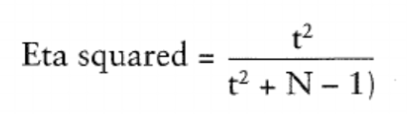
Figure 3: Cohen (1988) Eta Squared equation.

Results
Table 1: A table showing change in values from 10-30-minutes for each variable in cool and hot environments, and the significance and effect size of the results.
 | Cool | Hot | Significance | Effect Size
Temperature | 0.3 | 1.1 | P=0.003 | 0.54
HR | 5.2 | 14.8 | P=0.003 | 0.52
RPE | 2.0 | 4.5 | P=0.003 | 0.53
VO2 | 1.4 | 4.8 | P=0.068 | 0.25
Sweat Loss | 0.3 | 0.6 | P=0.008 | 0.45

The results (Table 1) revealed a significant difference (P<0.05) and a large effect size (>0.14) in temperature, HR, RPE and sweat loss. There was no significant difference for VO2 (P> 0.05). Results were also examined regarding time it took for changes in temperature, HR and RPE to occur in both environments. Sweat loss was considered before and after exercise.

Figure 4: Line graph showing the mean temperature at 10-minutes, 20-minutes and 30-minutes.
At 10-minutes there is already a difference in temperature (1.5°C) between hot and cool environments indicating the body is warming faster during exercise in the hot environment than cool. At 20-minutes the difference is even greater (1.9°C) showing that the body continues to heat at a faster rate than in cooler environments. At 30-minutes the difference is even greater still (2.3°C).

Figure 5: Line graph showing the mean Hearth Rate at 10-minutes, 20-minutes and 30-minutes.
At 10-minutes HR in hotter environments (164.1) is higher than in cooler environments (153.8) a difference of more than 10bpm. At 20-minutes there is even more of a difference in bpm between hot (172.4) and cold (158.6) a difference of 13.8bpm. At 30-minutes the gap is larger, hot (178.9) vs cold (159), a difference of 19.9bpm.

Figure 6: Line graph showing the mean Rate of Perceived Exertion (RPE) at 10-minutes, 20-minutes and 30-minutes.
At 10-minutes tests for hotter environments reported higher ratings of perceived exertion, finding the exercise harder. At 20-minutes a similar reported effect of exercise in the heat and a larger gap of 2.7 between conditions on the borg scale. At 30-minutes there is an even larger distinction between perceived exertion with hotter environments earning a 15.8 on the borg scale. Pushing towards ratings that are described as “very hard” and only achievable for a short period of time (Scherr et al., 2012). The RPE in cooler environments does not continue rising as rapidly and only reaches 11.8 on the Borg scale.

Figure 7: Bar chart showing weight pre-exercise and post-exercise to determine sweat loss in both hot and cool environments.
Figure 7 shows that weight loss in hot environments was far higher over the 30-minute exercise period, indicating increased perspiration in hot environments. 700grams of perspiration was lost in hot environments while only 300grams was lost in cooler environments.

Discussion
The current study relates to previous research that suggest exercising in the heat results in a performance decline due to the physiological effects of heat. The effects of cardiovascular drift can be seen after 10-minutes of prolonged exercise where Wingo et al., suggests that cardiovascular drift occurs.
The current study’s results show a significant difference in temperature between exercising in the hot and cool environment. Figure 4 shows that the core temperature was much higher in the hot environment reaching a mean temperature of 38.5ºC after 30-minutes compared to 36.2 ºC in the cool environment. Period et al., (2021) states a rise in body temperature is a natural response to prolonged exercise, as the heart rate is increasing the blood flow to the muscles during contraction is producing extra heat in the body. while exercising in the heat, air temperature is transferring heat onto the skin through convection resulting in a much higher body temperature. As the air temperature is hot, the body has to rely on evaporation as the only source to lose heat, whereas in the cool exercise test the body was able to lose heat through evaporation and convection as the air temperature can remove heat as it’s a cooler temperature that the body temperature.
The results of the current study show a significant difference in HR in the environments. It is clear from the graph (Figure 5) that the body exercising at cooler temps can adapt and utilise physiological systems to sustain exercise. However, in hotter environments the HR continues to rapidly rise throughout exercise although the workload is staying at the same intensity, this is cardiovascular drift. This is in line with Barreto et al., (2023) and Chou and Coyle (2023) who suggests that the HR rises due to the blood being redirected and flowing closer to the skin, as well as to the muscles required during exercise, to lose heat as the body temperature is rising, and the thermoregulatory system is working to cool the body down, Chou and Coyle (2023) also suggest HR increases to maintain the cardiac output of the exercise during heat strain.
There was a significant difference in the participants’ rate of perceived exertion in the hot and cold environments, Figure 6 shows an increase of 4.5 in the RPE from 10-minutes to 30-minutes while the cool environment only had an increase of 2. This relates to Period et al., (2021) who found a higher RPE results from studies and suggests that the combination of increased thermal, cardiovascular, and perceptual strain can result in a reduction of work rate and increased volitional exhaustion. Choe and Coyle (2023) also suggests that even a slight increase in skin temperature is enough to increase an individuals RPE and cause fatigue to occur earlier.
There was no significant difference in VO2 between exercising in the hot environment compared to the cool, previous research (Wingo et al., 2012; Periard et al., 2021) has suggested that cardiovascular drift is associated with a decrease in oxygen uptake, authors suggests this is because of the reduction in blood flow to the muscles as its being redirected to the skin and reduced oxygen-rich blood delivered to the muscles due to reduced SV.
There was a significant difference in sweat loss between the hot and cold environment, Figure 7 shows that participants lost more weight after the exercising in the heat than in the cold due to the amount of sweat that was during the 30-minute biking exercise. Period et al., (2021) states that a loss of body water through sweating is a natural response to prolonged exercise. In the heat, the body was required to sweat more as it was the only source of heat loss due to the temperature to hot to remove heat from the body.

Conclusion
The current study relates to previous research showing clear physiological differences between exercising in the hot and cool environments. The study shows cardiovascular drift (rising HR, decreased VO2) along with a rise in temperature, RPE and sweat loss occurred during exercise in hot environments which supports that exercising in the heat will result in greater cardiovascular strain than exercising in the cool environment.

Word Count: 2183
References
Adams, M.A., Conway, T.L. (2014). Eta Squared. In: Michalos, A.C. (eds) Encyclopedia of Quality of Life and Well-Being Research. Springer, Dordrecht. https://doi.org/10.1007/978-94-007-0753-5_918
Arens, E. and Zhang, H., (2006). The skin’s role in human thermoregulation and comfort. Thermal and Moisture Transport in Fibrous Materials, pp.560-602.
Barreto, I.V.D.S., Rodrigues, G.D., Oliveira, J.D.S., Neves, E.B. and Soares, P.P.D.S., (2023). Heated environment offsets the cardiovascular responses to prolonged rowing exercise in competitive athletes. Journal of Thermal Biology, 115, p.103603.
Benjamin, C.L., Sekiguchi, Y., Struder, J.F., Szymanski, M.R., Manning, C.N., Grundstein, A.J., Lee, E.C., Huggins, R.A., Armstrong, L.E. and Casa, D.J., (2021). Heat acclimation following heat acclimatization elicits additional physiological improvements in male endurance athletes. International Journal of Environmental Research and Public Health, 18(8), p.4366.
Buttar, K.K., Saboo, N. and Kacker, S., (2019). A review: Maximal oxygen uptake (VO2 max) and its estimation methods. International Journal of Physical Education, Sports and Health, 6(6), pp.24-32.
Campbell, I., (2008). Body temperature and its regulation. Anaesthesia & Intensive Care Medicine, 9(6), pp.259-263.
Chou, T.H. and Coyle, E.F., 2023. Cardiovascular responses to hot skin at rest and during exercise. Temperature, 10(3), pp.326-357.
Driller, M.W., Argus, C.K., Bartram, J.C., Bonaventura, J., Martin, D.T., West, N.P. and Halson, S.L., (2014). Reliability of a 2-bout exercise test on a WattBike® cycle ergometer. International Journal of Sports Physiology and Performance, 9(2), pp.340-345.
Flouris, A.D. and Schlader, Z., (2015). Human behavioral thermoregulation during exercise in the heat. Scandinavian journal of medicine & science in sports, 25, pp.52-64.
Innovation, Radiant, Taiwan https://www.radiantek.com (Accessed 26 March 2024)
Inoue, H., Tanaka, H., Sakanashi, S., Kinoshi, T., Numata, H., Yokota, H., Otomo, Y., Masuno, T., Nakano, K., Sugita, M. and Tokunaga, T., (2023). Incidence and factor analysis for the heat-related illness on the Tokyo 2020 Olympic and Paralympic Games. BMJ Open Sport & Exercise Medicine, 9(2), p.e001467.
Lim, C.L., (2020). Fundamental concepts of human thermoregulation and adaptation to heat: a review in the context of global warming. International Journal of Environmental Research and Public Health, 17(21), p.7795.
Mantzios, K., Ioannou, L.G., Panagiotaki, Z., Ziaka, S., Périard, J.D., Racinais, S., Nybo, L. and Flouris, A.D., (2022). Effects of weather parameters on endurance running performance: Discipline-specific analysis of 1258 races. Medicine and Science in Sports and Exercise, 54(1), p.153.
Mulholland, A.M., Yoder, H.A. and Wingo, J.E., (2023). Effect of Work-to-Rest Cycles on Cardiovascular Strain and Maximal Oxygen Uptake during Heat Stress. International Journal of Environmental Research and Public Health, 20(5), p.4580.
Norouzian, R. and Plonsky, L., (2018). Eta-and partial eta-squared in L2 research: A cautionary review and guide to more appropriate usage. Second Language Research, 34(2), pp.257-271.
Périard, J.D., Eijsvogels, T.M. and Daanen, H.A., (2021). Exercise under heat stress: thermoregulation, hydration, performance implications, and mitigation strategies. Physiological reviews.
Polar Electro, Warwick, UK https://www.polar.com/uk-en (Accessed 26 March 2024)
Saghiv, M.S., Sagiv, M.S., Saghiv, M.S. and Sagiv, M.S., (2020). Thermoregulation. Basic Exercise Physiology: Clinical and Laboratory Perspectives, pp.437-463.
Scherr, J., Wolfarth, B., Christle, J.W., Pressler, A., Wagenpfeil, S. and Halle, M., (2013). Associations between Borg’s rating of perceived exertion and physiological measures of exercise intensity. European journal of applied physiology, 113, pp.147-155.
Seca, Hamburg, Germany https://www.seca.com (Accessed 26 March 2024)
Smith, K.R., Woodward, A., Lemke, B., Otto, M., Chang, C.J., Mance, A.A., Balmes, J. and Kjellstrom, T., (2016). The last Summer Olympics? Climate change, health, and work outdoors. The Lancet, 388(10045), pp.642-644.
Sobolewski, A., Młynarczyk, M., Konarska, M. and Bugajska, J., (2021). The influence of air humidity on human heat stress in a hot environment. International journal of occupational safety and ergonomics, 27(1), pp.226-236.
Soligard, T., Palmer, D., Steffen, K., Lopes, A.D., Grek, N., Onishi, K., Shimakawa, T., Grant, M.E., Mountjoy, M., Budgett, R. and Engebretsen, L., (2023). New sports, COVID-19 and the heat: sports injuries and illnesses in the Tokyo 2020 summer Olympics. British Journal of Sports Medicine, 57(1), pp.46-54.
Wainwright, B., Cooke, C.B. and O’Hara, J.P., (2017). The validity and reliability of a sample of 10 WattBike® cycle ergometers. Journal of sports sciences, 35(14), pp.1451-1458.
Wattbike, Nottingham, Uk https://www.wattbike.com (Accessed 26 March 2024)
Wingo, J.E., Ganio, M.S. and Cureton, K.J., (2012). Cardiovascular drift during heat stress: implications for exercise prescription. Exercise and sport sciences reviews, 40(2), pp.88-94.

Appendices
Appendix 1: VO2 Max Protocol
Ensure you have at least three evacuated Douglas bags for your participant. To evacuate the bags, attach the bag to the vacuum, open the valve on the bag, turn on the vacuum and run until the number on the vacuum remains stable. Close the valve on the bag, turn off the vacuum. Ensure the participant also has a mouthpiece, breathing tube and nose clip for data collection.
The participant will need to wear a HR monitor and have the wattbike seat height set to only have a slight bend in the knee when the pedal is at the lowest point.
The participant will complete an appropriate low intensity warm up on the cycle ergometer for a minimum of 4 minutes. Allowing a short duration warm up on the cycle ergometer prior to the commencement of the test will allow the opportunity for any adjustments to be made to the set up position of the ergometer.
The test begins at a low intensity power output and increases progressively throughout the test until the participant reaches volitional exhaustion. The increments and duration of intensity will be determined by the practitioner on an individual basis and must take into account the participants age, gender, activity history, current activity levels. To set an appropriate workload.
The test will continue until the participant reaches volitional fatigue. On the cycle ergometer, this will be identified by the participant stopping cycling and/or signalling the practitioner. The practitioner may end the test if the participants cycling cadence drops 10 rpm or more below that of their self-selected cycling cadence.
A sample of at least 30s of expired air must be collected at the final workload.
When the test has finished, the mouthpiece is removed from the participant and the external resistive load will be removed from the cycle ergometer. This should be reduced to a resistive load equivalent to or lower than the warm up intensity. The participant will be instructed continue cycling at this intensity at a reduced cadence to cool down on the cycle ergometer for a minimum of 5 minutes. After this point, the participant may get off the cycle ergometer whenever they are recovered.
Douglas bag data collection
It is imperative that data collection is precisely timed using the stopwatch.
Respiratory gases are collected for an exact period of time.
It is important that the mouthpiece and nose clip are worn by the participant PRIOR to the start of the data collection period (e.g. ask the participant to attach the nose clip and mouth piece in the 30 seconds before the planned time for data collection).
The data collection period should have a clear count down from the timekeeper e.g. 3, 2, 1, GO, in which the valve of the designated Douglas bag is opened/closed in line with the count down.
Once this data collection has been completed, remove the mouthpiece and nose clip from the participant.
It may be advisable to provide the participant with some blue roll to remove the mouthpiece.

Conducting the test
Select an appropriate starting workload and increment workload for your participant.
On the wattbike monitor, select a 1 minute repeated interval with 0s recovery.
One tester should be responsible for managing workload intensities throughout the test, and ensuring the participant keeps to the required cadence.
Each minute, ask the participant to rate their perceived exertion using the Borg scale, and record the Average Heart Rate and Average Power at the end of each minute.
Every other minute (minutes 2,4,6,8,10, etc), collect a sample of expired air for the final 30s of the minute.
Instruct the participant to place the nose clip on and insert the mouthpiece at the start of the minute.
Use a timer to ensure you collect exactly 30s sample of air into the Douglas bag. Once collection is complete, participant may remove mouthpiece and nose clip if required.
If you have sufficient testers, evacuate the bags whilst the test is continuing.
Instruct the participant to inform you when they think they are close to being within 1 minute of volitional fatigue (i.e. their maximum effort).
At this point, instruct the participant to put the mouthpiece in and wear the nose-clip.
When they have approximately 30s left, begin collecting expired air in the Douglas bag and start the stopwatch. Instruct the participant to cycle maximally for the final 30s.
When 30s is reached, or the participant stops, close the Douglas bag and record the time.
Record the highest Heart Rate recorded during the final minute, and the average power for the final interval.
If any Heart Rate or Power data has been missed, it can be recalled through the Monitor once the test is complete.
Douglas bag data analysis
Firstly, the gas concentration (%O2, %CO2) of each bag must be sampled.
Analysing the gas concentration is completed for an exact period of time (60 seconds) and is precisely timed using the stopwatch.
A 60 second sampling period equals the removal of 1.8 L of air.
Hold the sample line of the Douglas bag firmly closed and THEN remove the clip/stopper from the end.
Still holding this sample line closed, attach the sample line of the Douglas bag to the sample line of the Servomex gas analyser.
The sampling period should have a clear count down from the timekeeper e.g. 3, 2, 1, GO, in which the sample line is opened/closed in line with the count down.
Record the numbers on the Servomex within the last 15 seconds of the sampling period. If these are not recorded at this point, they will disappear when the sample line of the Servomex is put back into ambient air.
At the end of the sampling period, hold the sample line of the Douglas bag firmly closed until the clip/stopper has been replaced.
Secondly, the volume of gas within the bag must be measured.
Attach the Douglas bag to the vacuum as previously.
Make sure the vacuum monitor is reset to 0 before starting.
Opening the valve and turning on the vacuum must be coincided for accurate measurement of volume. Again, an individual should countdown, e.g. 3, 2, 1, GO, when the vacuum should be turned on, and the valve of 1 bag opened.
When the number is stable, note the value.
Add 1.8 L to the value. This is to accommodate for the 1.8 L removed during the gas concentration sampling.

