Economic Analysis of Ford

1. Introduction
Ford is a multinational automaker. In UK, Ford has been the best-selling automotive brand for years. In this report, it is an economic analysis of Ford on the demand, supply of Ford Fiesta in UK, and market structure of UK automotive industry. There are four parts in the report: demand and market equilibrium analysis, cost structure analysis, market structure of UK automotive industry in which Ford operates, and government regulations and effects on Ford.

2. Demand and Market Equilibrium
Demand of consumers on Ford Fiesta, or maybe not only Ford’s car models, is affected by a variety of factors. Macroeconomic factors include economic conditions, income level relative to car price, the price of fuel, credit availability (Long-Run Trends in Car Use - OECD/ITF, 2013). Microeconomic factors include different income level of consumers, price of different models of car, different consumer tastes or preferences. The automotive market in UK is in equilibrium, but supply exceeds demand. Many automobiles provided by automakers are prepared to be sold. The price of Ford Fiesta model starts at $14,260. Different Fiesta models has different price, but the price is stable after the car launched (Ford, 2018).

Figure 1 presents the number of Ford Fiesta registered cars in UK from 2000 to 2017. The registered number of Ford Fiesta fell down from 2000 to 2005, and increased from 2008 to 2017. Figure 2 presents the gross disposable household income in UK. It can be concluded from the two figures that increase of income is not necessarily connected with increase of Ford Fiesta cars, however, it does not mean that demand of Ford Fiesta is income inelastic, since the number of car can also be affected by lots of factors. But according to Figure 3, when GDP per capital dropped significantly from 2006 to 2010, the registered number of Ford Fiesta decreased at the same time. Therefore, demand on Ford Fiesta is more sensitive to nominal income (GDP per capital) compared to disposable income. When income decreases, the degree of income of elasticity is higher compared to the situation that income increases.

Figure 1. Ford Fiesta registered cars in UK, 2000-2017
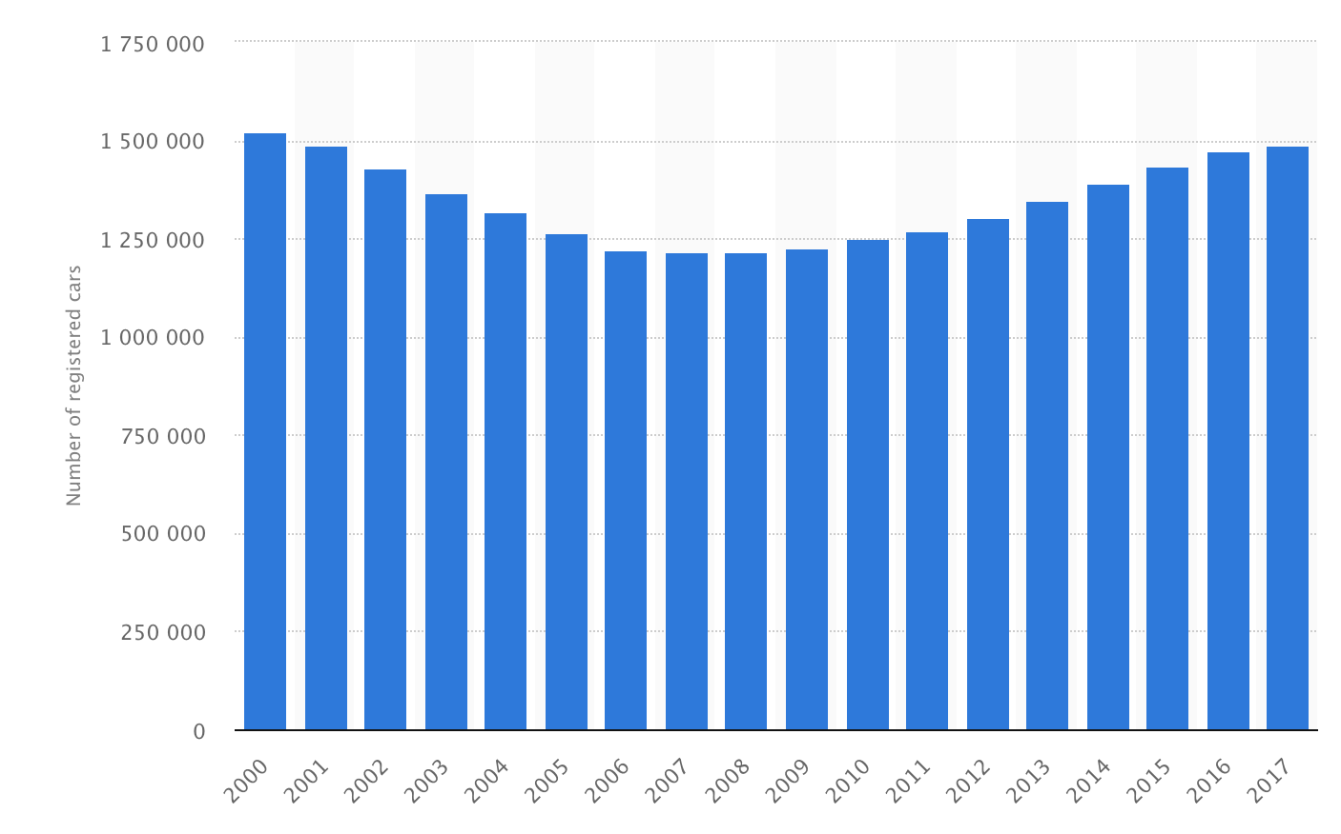
Source: Statista

Figure 2. Gross disposable household income, 2000-2017
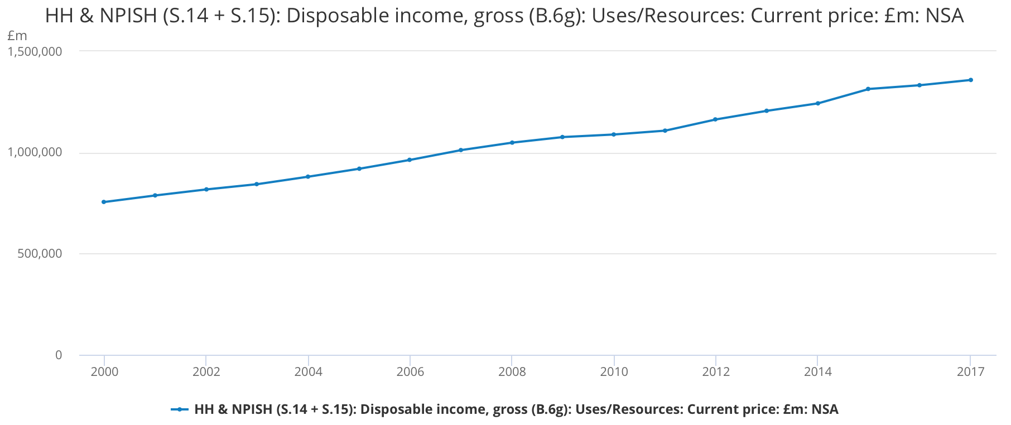
Source: Office for National Statistics

Figure 3. GDP per capita (current US$) of UK
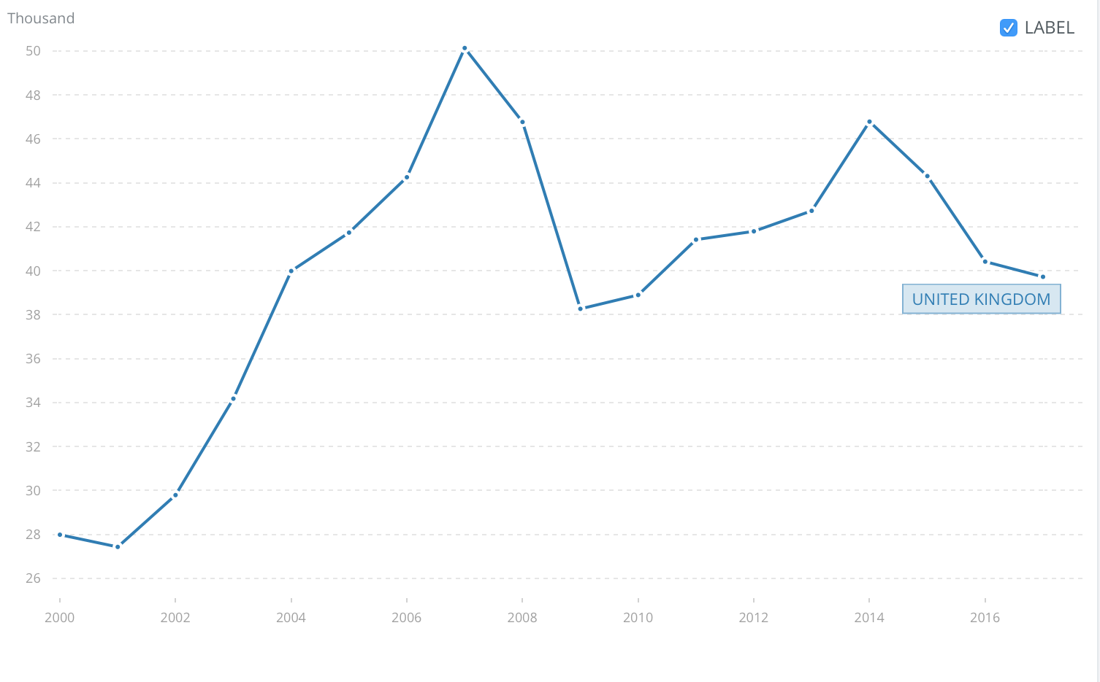
Source: The World Bank

3. Cost Structure of Ford
Ford has improved its techniques and streamlined its production to cut costs in the past. Business of Ford in UK is part of its global business which can take advantage of Ford’s global resources and capabilities (Business Strategy – Ford, 2018). Ford has reached a high level of economies of scale in the early 1990s as a market leader. Figure 4 shows the production and cost of Ford from 1908 to 1924. Ford has keep improving its manufacturing technologies as well as product acceleration to enlarge the production with increased cost efficiency (Grieveson, 2012).

Figure 4. Production and Cost of Ford, 1908-1924
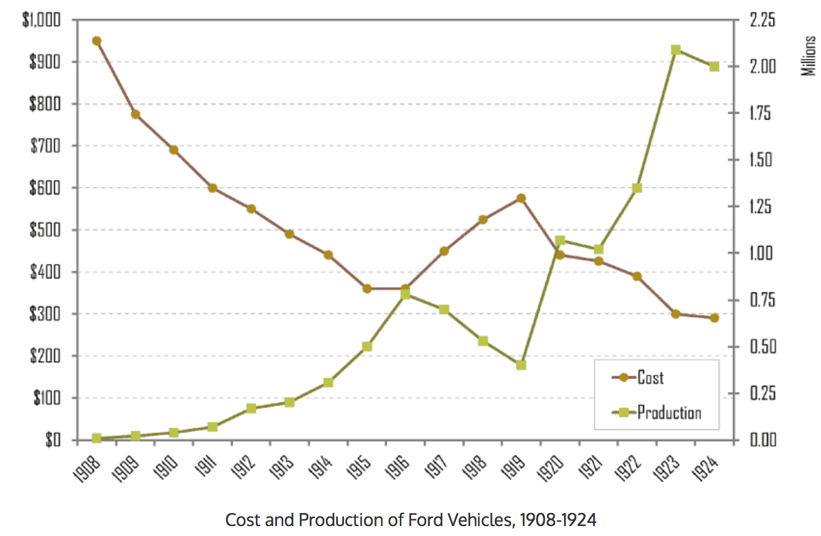
Source: Case File of Henry Ford, Committee on Science and the Arts, 1928 Cresson Medal, Retrieved from The Geography of Transport Systems

Economic value added (EVA), or economic profit, measures financial performance of a company by deducting its cost of capital from its operating profit. Table 5 shows economic profit calculation of Ford from 2013 to 2017. Ford Motor Co.'s economic profit declined from 2015 to 2016 but then slightly increased from 2016 to 2017. However, operating margin of Ford in 2016 is 6.7%, 5.0% in 2017 (Ford Motor Company 2017 Annual Report, 2018). Compared to the key automotive manufacturers, Ford has a high profit margin (see Table 6).

Table 5 Economic profit of Ford
Ford Motor Co., economic profit calculation
USD $ in millions
12 months ended | Dec 31, 2017 | Dec 31, 2016 | Dec 31, 2015 | Dec 31, 2014 | Dec 31, 2013
Net operating profit after taxes (NOPAT) | 6,637 | 6,702 | 10,908 | 6,830 | 7,906
Cost of capital | 4.65% | 5.21% | 5.03% | 6.46% | 6.47%
Invested capital | 176,866 | 160,188 | 148,836 | 142,840 | 133,983
Economic profit | -1,590 | -1,651 | 3,421 | -2,394 | -760

Source: Based on data from Ford Motor Co. Annual Reports
Note: The data of NOPAT, Cost of capital, invested capital are calculated and collected from annual reports of Ford Motor Company. EVA is calculated according to the formulation: Economic profit = NOPAT – Cost of capital × Invested capital.
For example, economic profit of Ford in 2017 is: 6,637 - 4.65% * 176,866 = -1,590.

Table 6. Profit margin of selected worldwide automotive manufacturers, January to June 2016
Automotive Manufacturer | Profit Margin
Ford | 8.7%
GM | 8.6%
Toyota | 8%
Peugeot Citroen | 6.8%
Hyundai Kia | 6%
Fiat Chrysler | 5.9%
Renault Nissan | 4.7%
Volkswagen | 4.5%
Source: Statista

4. Market structure of UK Automotive Market
The automotive market in UK is monopolistic competition. The leading three automakers in the market are Ford, Vauxhall and Volkswagen. As the leading automotive company in UK, Ford has a market share of 10.19% followed by Volkswagen with a market share of 10.06% of UK automotive market (Leading car companies’ market share in UK, 2018). In 2017, Ford Fiesta is the best selling car model. Over 94.5 thousand new models are sold (Best selling car models in UK in 2017, 2018). The market is highly competitive with lots of automakers and various car models.

Ford has applied a moderate price strategy to attract the mass consumers. According to Figure 7, the price of Ford is moderate, not as expensive as luxury brand such as Mercedes-Benz and BMW. Based on the affordable price, Ford has improved its manufacturing and product development in the recent years, while a range of inexpensive vehicles in different categories are provided to consumers. With high level of customization, Ford offer more choices for consumers to expand its market share (Business Strategy – Ford, 2018).

Figure 7. Average prices of some automakers in EU the in 2016, by brand
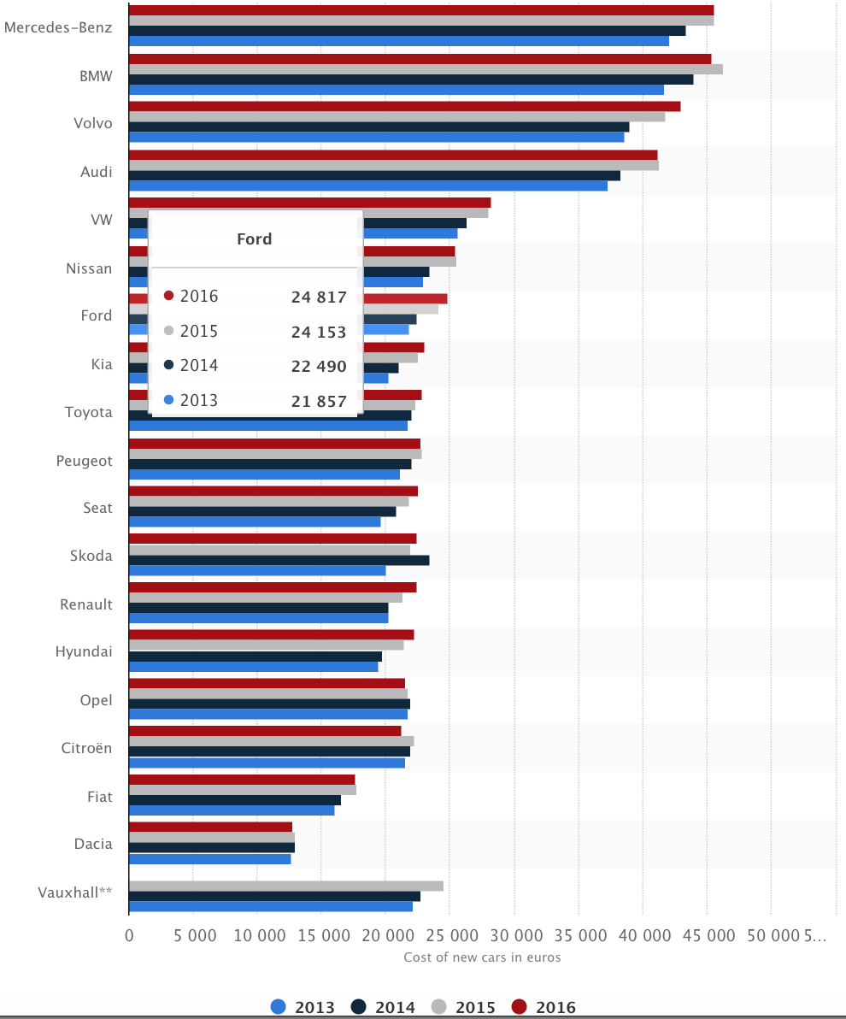
Source: Statista

According to Figure 8, higher market share results in more retail sales since industry volume is constant. Therefore, as a market leader in a monopolistic competition market, Ford can get a better financial performance in UK compared to its competitors. Since the market structure would not be changed in the short term, Ford would benefit from its market position and continue earn above average profit (according to Table 6, Ford has earned above average profit).

Figure 8. Retail sales, Industry volume, and Market share of Ford
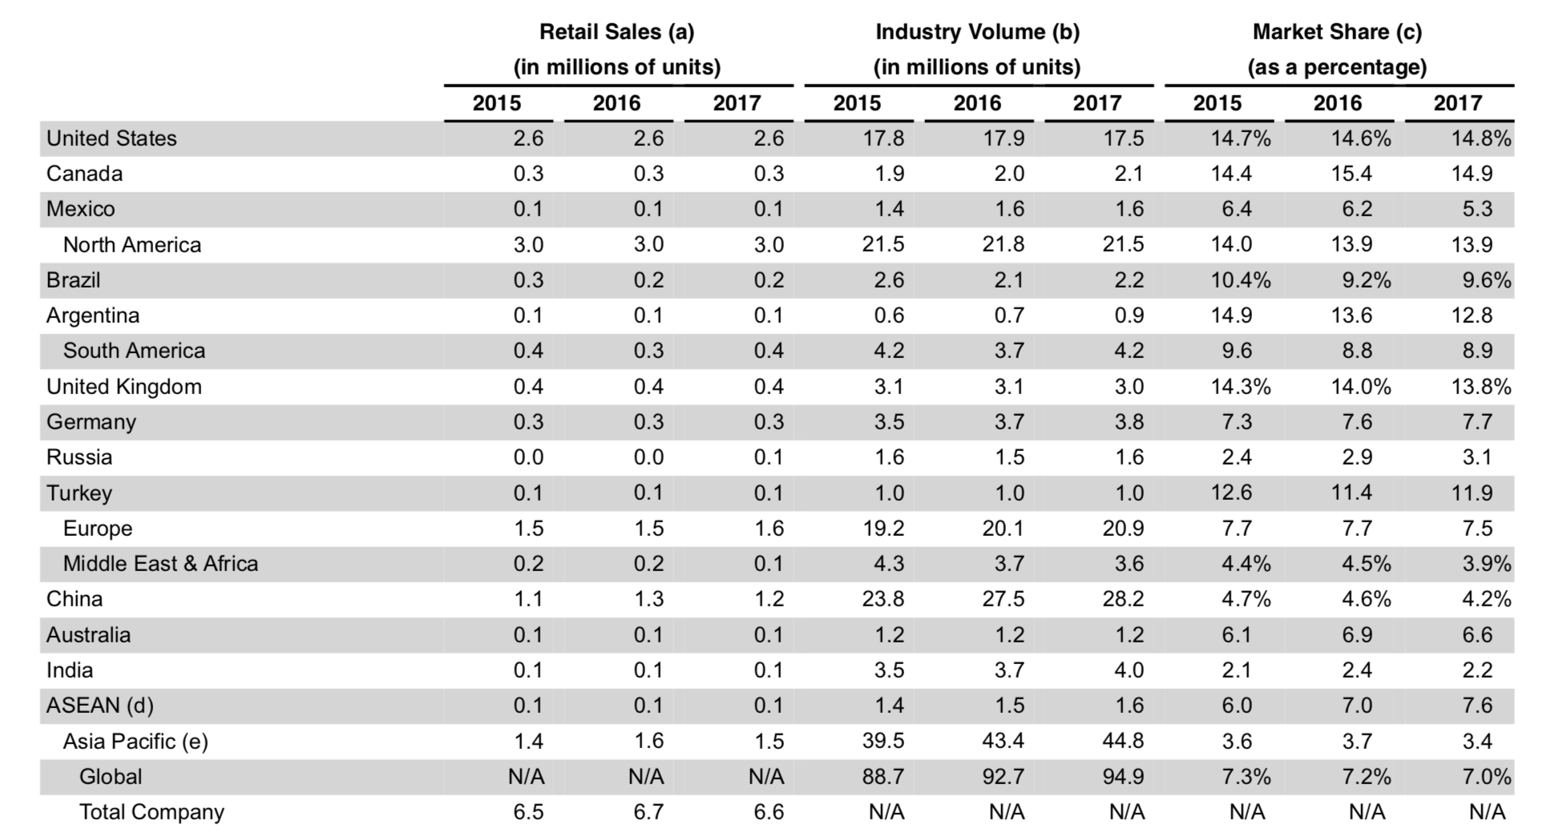
Source: Ford Motor Company 2017 Annual Report

5. Government Regulations
Ford has changed to invest less in manufacturing cars and put more money into electric vehicles to face the regulation. $4.5 billion has been announced by Ford Group to add 12 new electric cars by 2020 in addition to the gas-combustion engine models (Ford Motor Company 2017 Annual Report, 2018). However, improvements on fuel economy need time and investment, although regulations on emissions are increasingly strengthened, consumers would not choose electric vehicles while the fuel prices remain relatively low. Ford must pay its profits to develop the electric vehicles even through there is less market demand.

Reference
Average prices of some automakers in EU the in 2016, by brand (2018) Statista. Retrieved from: https://www.statista.com/statistics/425240/eu-car-sales-average-prices-in-by-make/

Best selling car models in UK in 2017 (2018) Statista. Retrieved from: https://www.statista.com/statistics/299018/car-models-which-sold-the-most-in-the-united-kingdom/

Business Strategy (2018) Ford. Retrieved from:https://www.ford.co.uk/experience-ford/careers/business-functions/business-strategy

EU car sales: average prices in 2016, by brand (2018) Statista. Retrieved from:
https://www.statista.com/statistics/425240/eu-car-sales-average-prices-in-by-make/

Ford (2018) Retrieved from: https://www.ford.com/cars/fiesta/?gnav=header-all-vehicles

Ford Fiesta cars registered in UK 2000-2017 (2018) Statista. Retrieved from: https://www.statista.com/statistics/313272/ford-fiesta-registered-cars-in-great-britain/

GDP per capita (current US$) of UK (2018) The World Bank. Retrieved from: https://data.worldbank.org/indicator/NY.GDP.PCAP.CD?end=2017&locations=GB&start=2000

Gross disposable household income, 2000-2017 (2018) Office for National Statistics. Retrieved from: https://www.ons.gov.uk/economy/grossdomesticproductgdp/timeseries/qwnd/ukea

Leading car companies’ market share in UK (2018) Statista. Retrieved from: https://www.statista.com/statistics/300467/leading-car-companies-market-share-in-the-united-kingdom/

Long-Run Trends in Car Use (2013) OECD Publishing/ITF. Retrieved from: http://www.oecd-ilibrary.org/content/book/9789282105931-en

Manufacturing (2018) Ford. Retrieved from: https://www.ford.co.uk/experience-ford/careers/business-functions/manufacturing

Profit margin of selected worldwide automotive manufacturers, January to June 2016 (2018) Statista. Retrieved from: https://www.statista.com/statistics/697263/automotive-manufacturers-profit-margin-worldwide/

Long-Run Trends in Car Use (2013) OECD Publishing/ITF. Retrieved from: http://www.oecd-ilibrary.org/content/book/9789282105931-en
Ford (2018) Retrieved from: https://www.ford.com/cars/fiesta/?gnav=header-all-vehicles
Ford Fiesta cars registered in UK 2000-2017 (2018) Statista. Retrieved from: https://www.statista.com/statistics/313272/ford-fiesta-registered-cars-in-great-britain/
Ford Fiesta cars registered in UK 2000-2017 (2018) Statista. Retrieved from: https://www.statista.com/statistics/313272/ford-fiesta-registered-cars-in-great-britain/
Business Strategy (2018) Ford. Retrieved from:https://www.ford.co.uk/experience-ford/careers/business-functions/business-strategy
The Geography of Transport Systems (2018) Retrieved from: https://transportgeography.org/?page_id=1257
Ford Motor Company 2017 Annual Report (2018) Retrieved from: https://s22.q4cdn.com/857684434/files/doc_financials/2017/annual/Final-Annual-Report-2017.pdf
Profit margin of selected worldwide automotive manufacturers, January to June 2016 (2018) Statista. Retrieved from: https://www.statista.com/statistics/697263/automotive-manufacturers-profit-margin-worldwide/
Leading car companies’ market share in UK (2018) Statista. Retrieved from: https://www.statista.com/statistics/300467/leading-car-companies-market-share-in-the-united-kingdom/
Best selling car models in UK in 2017 (2018) Statista. Retrieved from: https://www.statista.com/statistics/299018/car-models-which-sold-the-most-in-the-united-kingdom/
Average prices of some automakers in EU the in 2016, by brand (2018) Statista. Retrieved from: https://www.statista.com/statistics/425240/eu-car-sales-average-prices-in-by-make/
Business Strategy (2018) Ford. Retrieved from:https://www.ford.co.uk/experience-ford/careers/business-functions/business-strategy
Ford Motor Company 2017 Annual Report (2018) Retrieved from: https://s22.q4cdn.com/857684434/files/doc_financials/2017/annual/Final-Annual-Report-2017.pdf
Ford Motor Company 2017 Annual Report (2018) Retrieved from: https://s22.q4cdn.com/857684434/files/doc_financials/2017/annual/Final-Annual-Report-2017.pdf

