DS 1 Template

My Screenshots/Photos
- Please add 4–6 screenshots or photos of your digital life.
- You can use your phone or laptop.
- For each screenshot, write one or two sentences explaining what it shows.
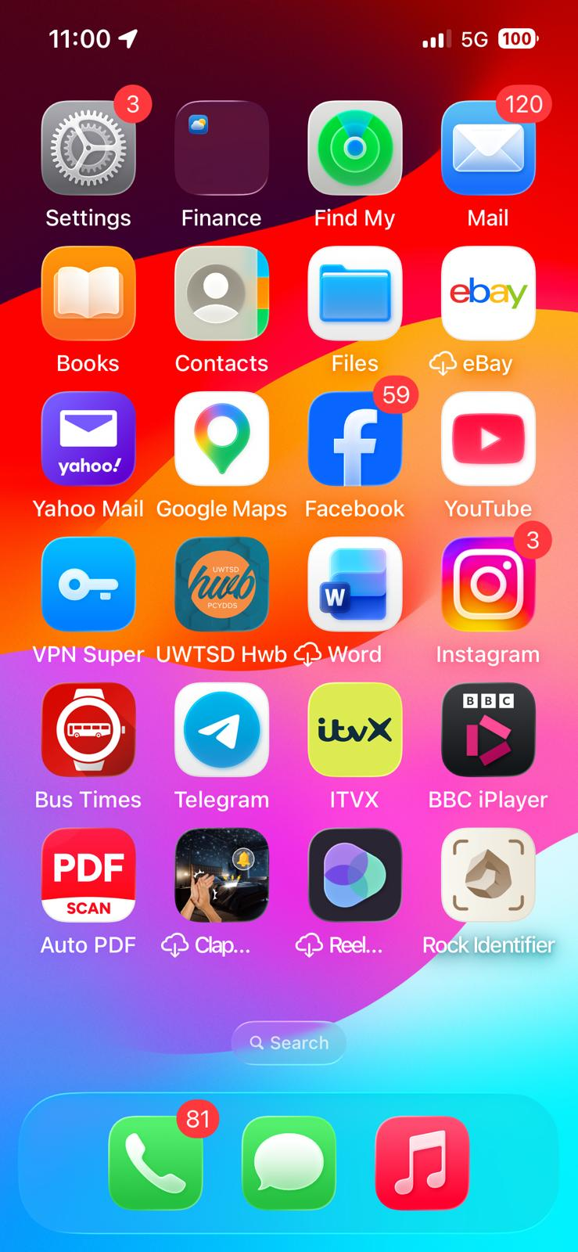
Screenshot 1: Phone home screen
This shows the digital tools I use regularly for communication, education and other aspects. I use my phone home screen for quick access to digital tools and organization.

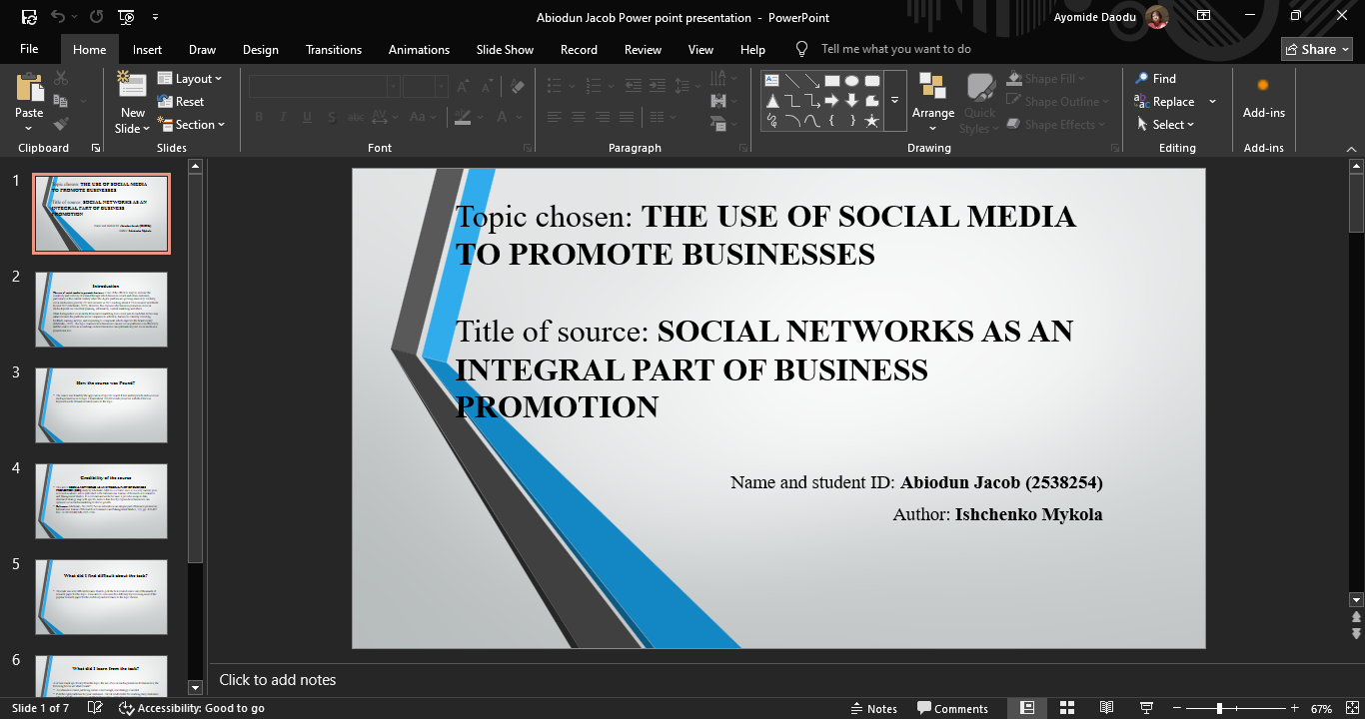
Screenshot 2: Power point Slide
This shows a screenshot of a presentation I created and organized using the PowerPoint tool for my class assignment on my laptop.

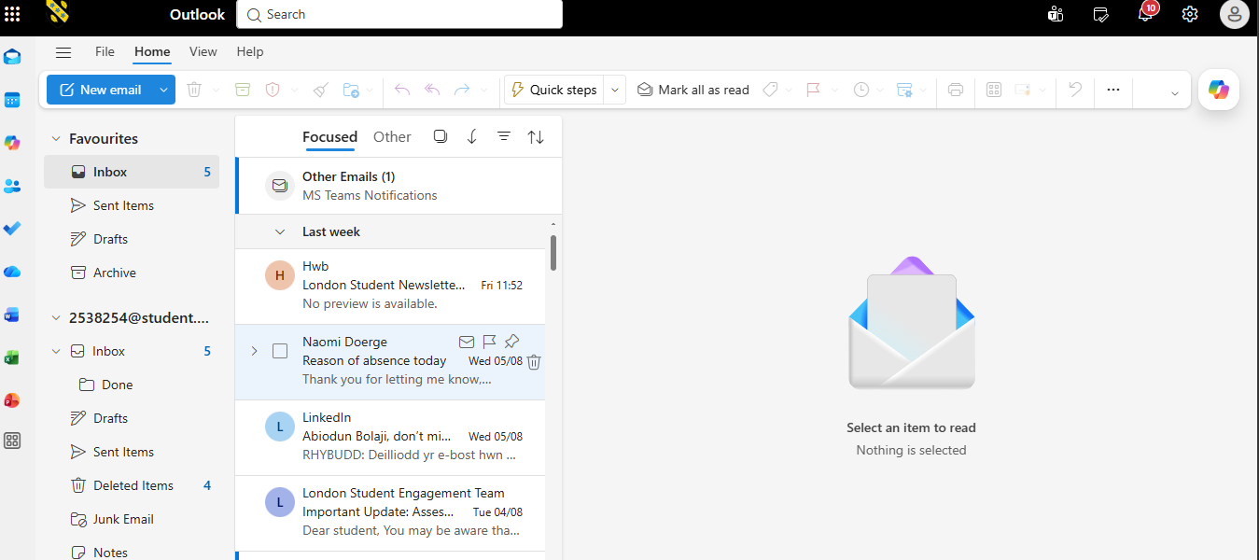
Screenshot 3: Outlook Email app
This shows a screenshot of the outlook app inbox; I use it to read emails and also to send official emails.

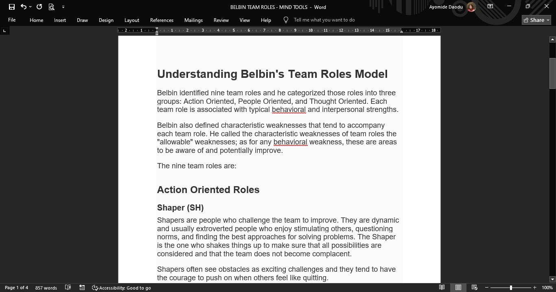
Screenshot 4: Microsoft Word
This screenshot shows that I can use the Microsoft word app to read report and also create to them.

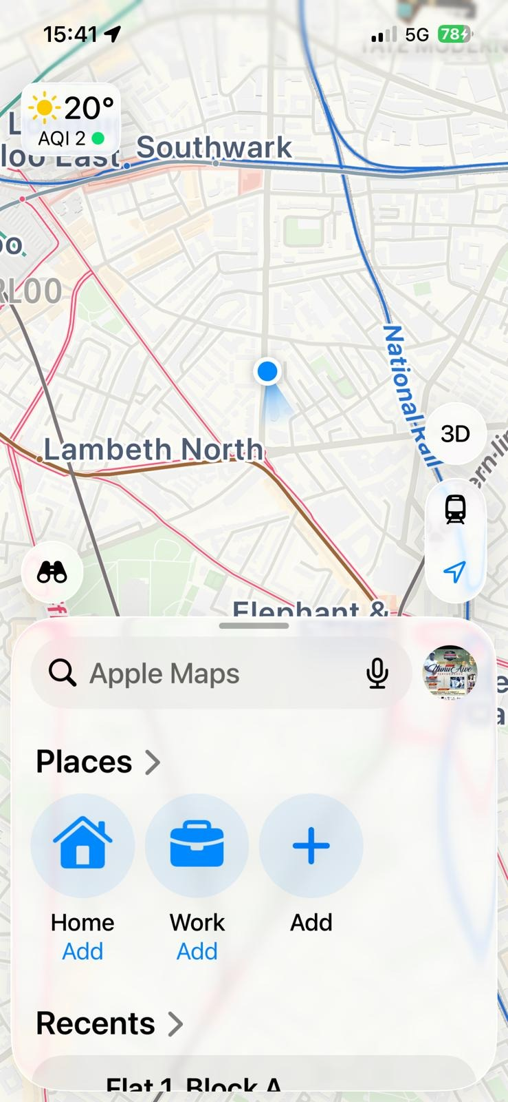
Screenshot 5: Google Maps
This screenshot shows that I can use google maps for navigation and in tracking my location.

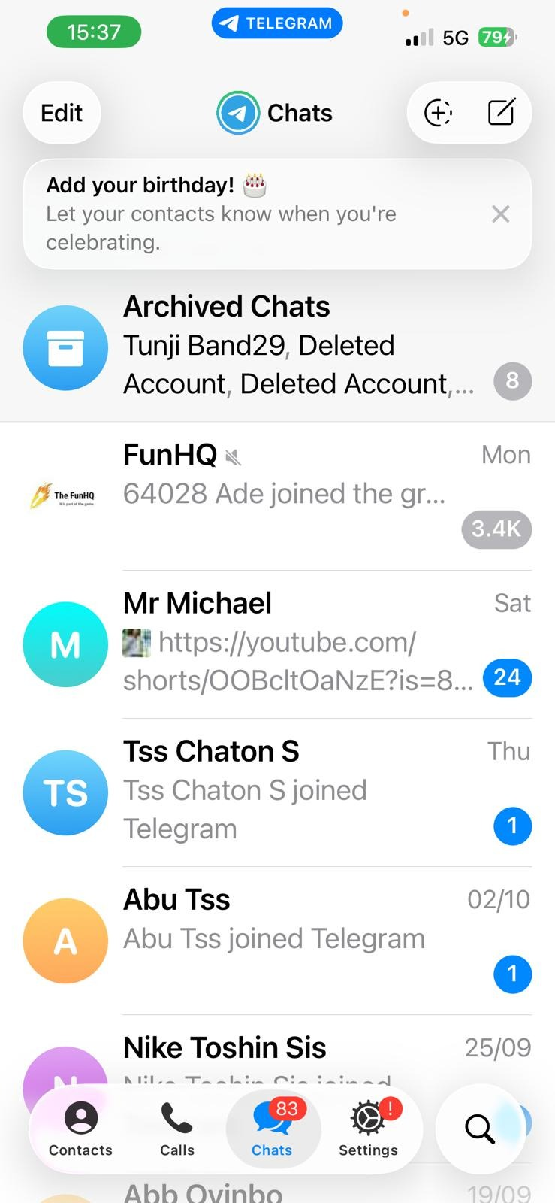
Screenshot 6: Telegram
This shows that I use this platform for messaging and communication to family and friends.

My Short Reflection
- Write 5–8 simple sentences about your digital life.
- You can use the sentence starters below if helpful.
- I use digital tools every day because they help me communicate and complete my daily activities easily.
- I use PowerPoint to create presentations and organize my ideas.
- I often use Word and Outlook to write documents and send official emails.
- I feel confident when I use Telegram to communicate with my friends, family, and colleagues because it is fast and easy.
- I often use these tools; Word, Telegram and Google Maps, which is why they are organized on my phone home screen for quick access.
- I want to improve at creating professional PowerPoint presentations because it will help me convey my ideas clearly.
- I sometimes feel nervous about the use of Google Maps to find locations, but I still use it because it helps me to arrive accurately.
- Digital skills are important to me because knowing them helps me perform better academically and work more efficiently.

Sentence starters
- I use digital tools to …
- I feel confident when I …
- I want to improve …
- I often use these tools: …
- I sometimes feel nervous about …
- I hope this module will help me …
- Digital skills are important for me because …
You can write more if you want.

Submission Checklist
Before you submit, please check:
​​​ ☒ I added 4–6 screenshots
☒ I wrote short sentences for each screenshot
☒ I wrote my short reflection
☒ My work is my own
☒ My file opens correctly
​​☒ My file opens correctly

