A REPORT ON COMMUNICATION WITHIN THE WORKPLACE
BMSK4002

BY GRACE KINDEMBE

EXECUTIVE SUMMARY

The purpose of this report is to demonstrate different methods of communication in the workplace. Then describe two ways of communication-giving examples based on the case study.
Additionally, explain how communication work and describe the different methods suggested for the case study.
Finally give suggestion on how to improve teamwork in the organisation using Tuckman and Belbin teamwork theory.

Table of Contents
EXECUTIVE SUMMARY 2
IMPORTANCE OF EFFECTIVE COMMUNICATION IN AN ORGANISATION 5
Remove barriers: 6
Give motivation: 6
Increase productivity 7
Staffs at work cannot produce a positive outcome without proper communication. It is proven that the team that communicate well achieve better result. 7
Increase Job satisfaction: 7
Share of ideas: 7
Knowing the culture; 7
Reassuring interest: 7
Maintaining relationships: 8
Sign of confidence: 8
Use presentation 11
Listen to Your Team Members 11
Open meeting 12
Emails 12
HOW THE APPLICATION OF THEAM WORK THEORIES CAN IMPROVE TEAMWORK IN THE ORGANISATION (TUCKMAN AND BELBIN) 13
CONCLUSION 14
RECOMMENDATIONS 14
REFERENCE LIST 16

INTRODUCTION

Communication is a process in which people share information verbally or non verbally. There are so many ways of communicating. This can involve facial expression, oral gestures and many others. When at work, managers and employees receive a lot of information. This can be via phones, emails, letter and report. The most important thing is to know how to handle all the information in a correct manner. (Fergusson.2009)

Workplace communication is very important to companies as it allows companies to run smoothly and be more efficient. When employees are able to communicate effectively, it can increase their morale and confidence. For instance, in any organisation, there is always a need for people to interact. Meeting people from different background and culture can also cause communication barrier within the workplace. (Jennifer L.2019)
In this report, we are going to discuss about different ways of communication and how to improve it.

IMPORTANCE OF EFFECTIVE COMMUNICATION IN AN ORGANISATION

Verbal communication can lead to great result when used the wright way but can also be disastrous if the approach is wrong. For example using positive language helps solve problems and encourages employees to excel.
On the other hand, Non-verbal communication plays a huge part when it comes to communicating. This includes the way people look, body language and the facial expression. (Business Queensland. 2019)
Patrick B (2016), states that a workplace that communicates effectively creates a ‘safe environment’ where people can feel free to express their ideas and creativity. Effective communication is not always about mitigating conflict but employers should be able to communicate efficiently when talking to managers, employees and other colleagues. (Pat B. 2016)
Failure to communicate can bring inconvenience at work. It is a big disadvantage to companies and can have the following negative consequences: (1) It prevents positive change; (2) it reduces productivity; (3) it leaves employers at a competitive disadvantage; (4) it reduces morale. (Richard P 2001)

One of the biggest reason many employees want to leave their posts is a lack of communication says a recent survey. Moreover, 47%of employees across the UK said that managers fail to communicate effectively leading to frustration. (Daniel H. 2016)

In fact, Research shows that verbal communication can:

Remove barriers:

Many people find it hard to communicate especially in a new environment. Effective communication will help remove the hurdles between staffs and create good relationship.

Give motivation:

Everyone deserves words of encouragement after achieving great result at work. Word of appreciation from the management team boosts the confidence level of the employees and also helps the productivity.

Increase productivity

Staffs at work cannot produce a positive outcome without proper communication. It is proven that the team that communicate well achieve better result.

Increase Job satisfaction:

When the manager is responding to employees, this mean empowerment. This is a sign of Job satisfaction.

Share of ideas:

Communicating within a company needs two ways exchanging of ideas. When there is a platform to share ideas it brings progress to the company.

On the other hand, non-verbal communication has been known to contribute to 55% of our daily communication. The following criteria are important as this can improve communication at work:

Knowing the culture;

Knowing other people culture is very important. This mean touching, shaking hand, tap on shoulder, all this can have different meaning in different cultures. Knowing this in advance will save staffs from a public embarrassment as culture play a crucial role.

Reassuring interest:

Non-verbal facial expression is also observed at work. Others can also mirror facial expression that one reflects. For instance, smiling at each other’s.

Maintaining relationships:

Keeping a smile in the face can create good ambiance at work or wish make other’s day. This is a sign that here is great relationship, which is very critical in a workplace.

Sign of confidence:

In a workplace, postures can denote attributes. When people stand upright and keep straight postures. Maintain eye contact when conversing with managers or colleagues, implies that the person is confident. Also sitting with knees placed slightly apart and arms away from the body could indicates being relaxed and confident. (Krishna R.2018)

THE IMPORTANCE OF TWO-WAY COMMUNICATION

Two-way communication is essential. It encourages employees to take ownership and understand their ideas and values.
By definition, two-way communication is the exchange of information and ideas from sender to receiver and vice versa. Many companies still fail to establish effective two-way internal communication and don’t realise how this can cause problems at work.
Effective two-way communication is required in order to solve problems better. It helps every staffs to understand the business better and creates better relations within the company by making sure everyone is aware with the latest business updates, objectives, and progress. (mhubtv. 2018)

To possess effective two-way communication skills, employers must have verbal and nonverbal information flowing at the same time. For instance the following methods can be used for this case study:

Face-To-Face.
This is very fundamental for two-way communication. The fact that two people get engaged in a conversation is ideal especially if one has to engage in sensitive discussion. Employees should be able to communicate face to face as this boosts collaboration and creativity over the ability to share ideas more freely. (legacy.2018)

Coaching.

This technique is useful for coaching or counselling. In fact, it helps staffs build new skills. Managers at the toyshop should consider the impact of coaching their staffs as it frequently creates a different approach to their work. For example, increase self-confidence and enables employees to bring more of them into the workplace. This can lead the employees becoming more resilient and positive. (legacy.2018)

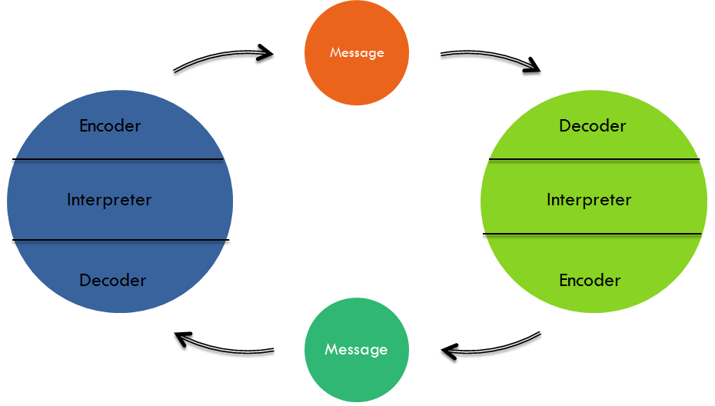

Image available at thinking links (2019)

This theory relies on the fact that communication needs to circular rather than linear. It needs two people taking turn sending and receiving message. (study.com 2019)

EFFECTIVE METHODS OF COMMUNICATION

Effective communication in the workplace is crucial especially in a leadership position. Sometimes what people say can be misunderstood; instead how to say things can make a big difference. Effective communication is what makes the difference between a poor leader and a professional one. Having effective communication skills is the key to good leadership.
When staffs communicate well with the team, it helps reduce misunderstandings and can encourage a healthy and peaceful work environment. Efficient and open communication within the workplace will also enable staffs to get work done fast and professionally. (Valentine B. 2018)

There are many methods to communicate at work. For this case study, the following methods are going to be used:

Communication via training:

Most employers learn better through training. Employees should learn to communicate well during training in this shop.

Use presentation

Some people understand easily when there are images and pictures involved. (This is the case of visual learner). Explaining toys in details will give staffs confidence in the products and in return they should be able to provide clear information to the customers when necessary.

Listen to Your Team Members

The purpose of communication is to be two ways. So, the supervisor should learn to listen to others and give encouragement; this will open up doors so in the future, things will flow more easily. So it is crucial to listen than over talk.

Open meeting

This method remains one of the best to communicate within a team. Employees need to feel confident to ask questions or make complaints in these meeting as it creates balance within the business. (Valentine B.2018)

Emails

Another way the staffs should communicate is via emails. This method is highly recommended for sharing information between employers. It is usually an important component of ways of communication and even though it may not be a replacement for face-to-face or other methods of communication, it is still easily accessible and cost less. (Jim R. 2019)

HOW THE APPLICATION OF THEAM WORK THEORIES CAN IMPROVE TEAMWORK IN THE ORGANISATION (TUCKMAN AND BELBIN)

Teamwork is an activity in which members (staffs) of an organization work together to achieve a common goal. To achieve great success, the company need to have a great team that put ideas together. It has been demonstrated that teamwork at workplace improves communication by facilitating discussion and collaborating between staffs, increase efficiency by taking on more complicated tasks, distribute tasks and makes everyone feels empowerment and a sense of fitting in. (Tim Z 2019)
According Meredith Belbin, there are 9 team roles meaning that Individuals with different qualities and strength can balance well in a team.
When using Belbin’s theory, people learn to understand better their strengths and qualities, which facilitate communication between colleagues and managers. In order to become a higher performing team, each team need to possess those 9 team roles behaviours which include; Resource investigator, team-worker, coordinator, plant, monitor evaluator, specialist, shaper, implementer, completer/finisher. There is no need for the 9 roles to be in one team but individual can still have different approach to a task in order to find balance. (Belbin association.2019)

On the other hand, Bruce Tuckman believes that there are four stages when it comes to team formation. When people understand this, it can help the team become more effective quickly. This includes forming: this is a stage when people are trying to know each other’s. Then Storming: is the stage where many team fails because individuals are trying to push boundaries. Norming consist of people resolving their differences and knowing each other’s strength and weaknesses. Performing is when the team achieve their goal and settle well. Lastly, he added adjourning explaining that most people find it hard to separate especially if there is strong bond. (mindtool. 2019)

CONCLUSION

To conclude, there are different ways of communicating. The most commons are verbal and non-verbal. Effective communication create respect nevertheless of background and culture. Therefore, every workplace should have pattern and rules to follow in order to establish good relationship between managers and employers. When there is good bonding and mutual respect, communication will flow easily and make things run smoothly in the company. The best aspect is that information needs to be passed on a right way because Lack of information can cause disturbances to the company.

RECOMMENDATIONS

Small business owners face many concerns that test their communication skills. Managers should be able to set up utilities such as phone, electric and Internet services. Managers are in charge for ordering supplies and negotiating delivery schedules. They must ensure that the marketing plan is at good standard. The owner must also advertise for interview and hire the people who will work side-by-side with the company as they start on the new business. All these procedures provide good practice for the types of communication small business owners are responsible for.
(Rowblesky. T 2018)

ACTION PLAN

- As the company is expanding, Employers/employees should follow shifts pattern. For instance long hours shifts.
- The company need a night manager who can be on the spot in case there is a problem because as it can lead to misunderstanding if there is a lack of communication.
- For a small business there should have 2 managers. (One on duty and one supervisor)
- For the benefit of the business, staffs need to organise meeting to discuss about different issues, which are leading to communication barrier and could prevent the business success.
- Training is also recommended for the business.
- The company should form teams and divide tasks.

REFERENCE LIST

Belbin association.com 2019; London; Available at: https://www.belbin.com/about/belbin-team-roles/ (accessed on the 05/04/2019)

BusinessQueensland.com/Queenslandgovernmenthttps://www.business.qld.gov.au/running-business/marketing-sales/managing-relationships/communicating-effectively/non-verbal (accessed on the 30/03/2019)

Content wisetesp.com (2018) Available at: https://content.wisestep.com/verbal-nonverbal-communication-important-workplace/ (accessed on the 04/03/2019)

Daniel H. 2016 ;freshbusinessthinking.com (2016) Available at: https://www.freshbusinessthinking.com/poor-communication-is-the-biggest-reason-for-wanting-to-leave-a-job/ (accessed on the 31/03/2019)

Educba,com Available at: https://www.educba.com/different-methods-of-communication/ (accessed on the 03/04/2019)

Fergusson 2009; Communication skills; third edition; Available at:
https://books.google.co.uk/books? Id=wsrmvak9PTMC&printsec=fr (accessed on the 29/03/2019)

Jennifer L (2019)Study.com 2019; available at: https://study.com/academy/lesson/workplace-communication-importance-strategies-examples.html (accessed 30/03/2019)

Krishna R.2019; Content.wisestep.com: Available at: https://content.wisestep.com/verbal-nonverbal-communication-important-workplace/ (accessed on the 04/04/2019)

Legacee.com: Available at: https://www.legacee.com/communication-skills/interpersonal/1-way-and-2-way-communication/ (accessed on the 04/04/2019)

Mhub.tv.com ; London2018 Available at: http://www.mhub.tv/importance-two-way-communication/ (accessed on the 04/03/2019)
Mindtools.com 2019; London available at: https://www.mindtools.com/pages/article/newLDR_86.htm (accessed on the 05/04/2019)

Patrick B. (2016) leadership and choice.com /London 2016 https://leadershipchoice.com/power-good-communication-workplace/ (accessed on the 29/02/2019)

Richard P (2001); Skills for workplace communication; London. Available;https://books.google.co.uk/books?id=ZsY2aaHMyYoC&printsec=frontcover (accessed on the 031/03/2019)

Rowblesky. T (2018) smallbusiness.com. Available at: https://smallbusiness.chron.com/effective-communication-methods-organization-2.html (accessed on the 04/04/2019)

Tim Z 2019 ;smallbusiness.com Available at: https://smallbusiness.chron.com/importance-teamwork-work-11196.html (accessed on the 05/04/2019)

Valentine B (2018)Smallbiztrends.com 2018: Available at: https://smallbiztrends.com/2013/11/20-ways-to-communicate-effectively-in-the-workplace.html(accessed on 03/04/2019)

