Creative Research: writing task 2000 words

Student Name: Leila Roworth

P Number: 1702604

Programme of Study: Surface Pattern Design

Module: 5X01599

Words: 2127

Define skill in the context of your own practice and the work of two artists/makers/designers from the lecture series.

Skill is a complex theme to define "the ability to do something well, expertise" OED (2012:504).

The perception of skill is often embodied in the label ‘handmade'. I believe consumers think this

title adds a sense of value to the design or product. In some ways, I agree with this by believing

that good design can only be produced with a certain level of knowledge and skill. In this essay, I

will outline what skill means as a designer and compare the differences between handcrafted

designs and digital designs.

Designers have a level of knowledge gained from experience within their special field this is often

referred to as "tacit knowledge" Polyanyi (12:2009) I believe this to be embodied in the designer

almost like intuition. A designer knows how to create a product or artwork. Cross says "they know

it in the same way a skilled person ‘knows' how to perform that skill' (1982:25). I am interested in

the way that skill is learned and exercised in order to create different types of artwork and designs

be that digital or hand crafted.

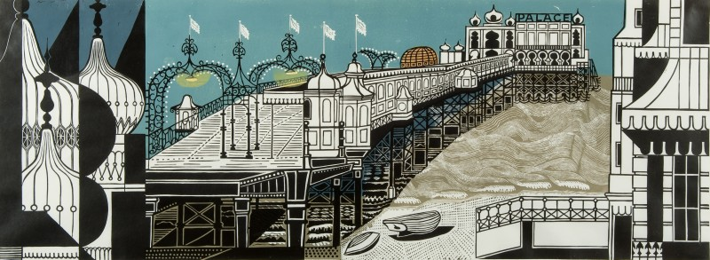
Figure 1 Brigton Pier

Cross says that designer's mode of skill is "constructive". I believe this means that artists such as

Edward Bawden utilising the skill of relief printing can then apply their skill in order to create

beautiful imagery refer to figure 1, Frith (2017). Edward Bawden was an English illustrator and

painter he is best known for his prints and it is this skill of printmaking I will be further outlining. He

created prints that looked painterly and I believe this is why they are loved so much. There is

much knowledge to be learned about relief printing and lots of skills must be taught. Firstly, relief

printing requires the artist to use cutting tools. You need to use the whole of your hand to handle

the tools and your hands ultimately create the print. These handcrafted prints are created by the

artists' personal touch they can only be physically edited by the hand rather than be digitally

manipulated through editing software. Once cutting away the block that will be printed there is no

way to amend every mark that is cut will remain in the print. Tacit knowledge is used in the way

you cut the relief it can only be taught to a certain extent the artist will ‘know' in what way the tools

cut best in their hand.

Relief printing requires the use of the whole hand and beautiful marks can be created with the

tools that could not be produced digitally. Therefore, this means that there are benefits to the none

digital community of artists who still use traditional skills in order to produce work. Often the final

prints show "all the revisions, alterations, erasures and false starts… buried under the surface…

intentions of the artist" (2014:99) if you look closely. Tim Ingold explains further in the Textility of

making about contemporary discussions of art and technology and how they combine. I believe

both can work simultaneously and benefit one another.

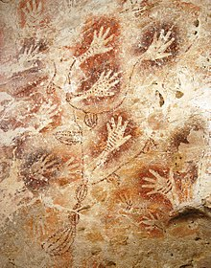

Figure 2 Hands

The hand has been a prominent part of existence for years. The hand is described as "the end

part of a person's arm beyond the wrist, including the palm, fingers, and thumb." OED (2012:257).

I refer to Figure 2 the Lascaux caves discovered in France Ancient History Encyclopaedia (2016).

When caveman lived they recorded their handprints in paintings. The hand to be a personal stamp

on the world. It speaks its own language that we all relate to ‘I was here, I mattered'. The hand

resembles identity and personal belonging. The hand contains the fingerprint completely unique to

yourself “they never change, even as people age” (2008) the hand shows your personal identity.

This is why I believe that artwork created by hands adds that personal value. Sennet says skill is a

"source of legitimacy" (54:1943). Ultimately the hand is a proto-tool it resembles communication

and is a visual symbol relating to making. The hand can create a statement which is why I believe

it is valued within art and design.

‘Craft' and skill are closely connected. Diderot's explains that "craft is a name given to any

profession that requires the use of hands" (1751-80:182). You need to learn skills in order to have

a craft and these can be learned at any stage in life. It is common for artists work to develop and

change due to learning new skills and processes during the period of making. In Edward Bawden's

series of prints you can see in the early years he printed with only one colour and was a painter

before ever considered as a printmaker. As his work and skills developed he created prints with

multiple layers of colour meaning he lined up prints perfectly and overprinted them giving them a

painterly style. I believe he was not only an artist but a craftsman as well.

All designers tackle problems when creating artwork even though technology is at its most

sophisticated level. Designers are constantly innovating and seeing the world in different ways by

creating solutions to problems. When creating artwork multiple errors can arise due to materials,

human error, self-doubt, and these Cross says are called "ill-defined problems" (1982:29).

Designers tackle these daily and problem solving I believe is a highly desirable skill. Overcoming

these problems creates a level of resilience and allows the artist to innovate new ways of working

and perceiving. Therefore, allowing them to produce a higher quality of work. Within my own

practice learning new skills has helped me find my style. I like the freedom of alternating between

creating drawings and designs by hand and utilising digital design in order to give a quality finish.

Digital Pattern design allows designers to create large-scale flawless repeats efficiently with the

click of a button colours can be changed and layouts can be manipulated. There are many

benefits to digital design and time is one of them. Although digital design is progressing pattern

repeats have been around for years and the industrial revolution supported this. In the 19th

century, Britain's patterns were dominated with religious and social connotations until Owen Jones

formally an architect changed this. According to the V&A (2014) Owen Jones "sought a modern

style… he formulated a design language that was suitable for the modern world. He applied this

equally to wallpapers, textiles”. Jones saw an available space in the market to change the way

pattern and wallcoverings should be seen by modernising them and making them relatable to

everyone he created prints that were modern and had likeability. Utilising digital crafting

techniques requires one to be able to adapt quickly and learn new skills consequently. When

designing digitally it allows the artist or designer to create hyper realistic designs that are

seamless. Creating a design such as wallpaper it is vital for the artwork to be of the correct size

and in the correct repeat format. This is the benefit of industrial production and software

improvements it means there is less chance of human error. Jones style would still be relevant in

today’s society as he was designing for the future as the designers of today are.

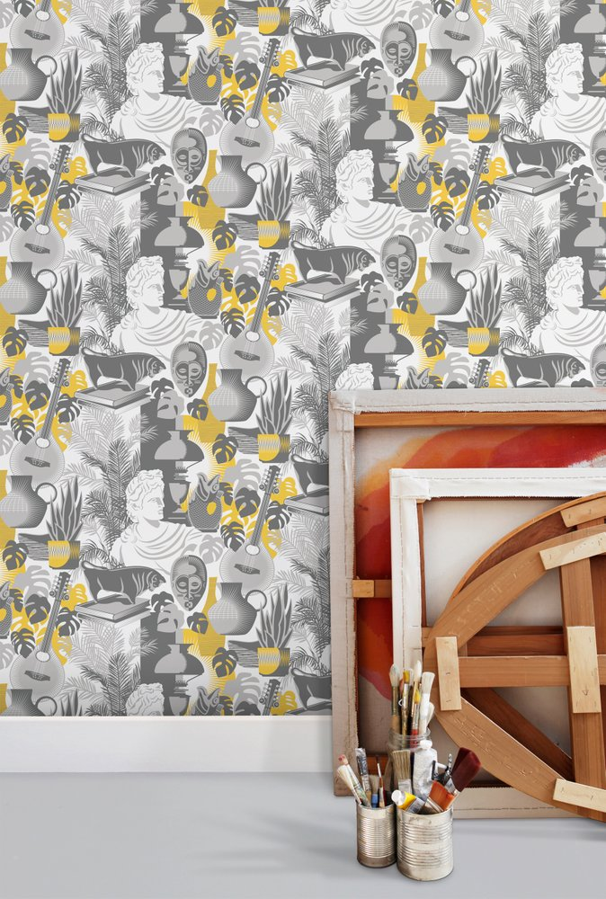

Figure 3 Art Room

Producing digital prints in the way that Mini Moderns wallpaper company does require skill. The

designers have to produce imagery which is drawn either digitally or by hand and then the pattern

can begin to materialise, refer to Figure 3 Copper Mitchell (2018). As a designer working for a

wallpaper paper company requires a number of skills I would argue that the most essential are:

being able to draw in a broad sense, using software to create designs and understanding trends.

Patterns are often opportunities to tell stories I believe Mini Moderns do this really well. Almost

taking the same philosophy from Owen Jones that patterns can be filled with religious and social

connotations but they should be modernised to fit the social climate.

Often people buy into stories that they can relate to. Indeed that within craftsmanship there are

rooted ideas of religion. Sennet says "in Pagan Rome in its belief that the work of one's hands can

reveal much about the soul." (55:1943) Religion is part of society and upbringing. In some cases,

even not being religious, I believe people would appreciate handicraft work as it has the personal

touch that speaks to the soul. People can value artwork that relates to religion as it is their belief.

Artwork and religion are closely connected as there are many painted stories taken from the Bible.

Previously the world was dominated by religion. It was valued due to consumers connecting to the

product and this is also the case in the 21st century designers now are designing for modern times

creating work that is not necessarily religious but has value that can be connected to by an

audience. Mini Moderns do this by painting from archives and using history to reimagine

wallcoverings.

Although wallpaper is seen as a decorative art it is based on an Art and Craft movement and

wallpapers haven't always been produced in a digital way. Soren Peterson provided information

that "exceptional design is good storytelling rooted in strong design philosophy." I agree with this

statement, Mini Moderns printed imagery is taken from the real world and archives they tell stories

that everyone can relate to and that people are happy to have in their domesticated environment,

being their home. Copper Mitchell (2018) says that their design influences are from “mid-century

British textiles...vintage toys, literature and memories”. I believe due to their inspiration being

based on history and archives it creates a story which consumers make a connection to.

Wallpaper collections often tell narratives and have themes of colour, pattern, and place Copper

Mitchell (2018) states “we create pattern with a story” I believe this to be true and it gives their

designs context.

Herbert Read states "the real problem is not to adapt to machine production to the aesthetic of

handicraft" (203:1939). Therefore, I think even with technology being its most sophisticated

consumers still value the aesthetic of hand production and hand-printed artwork. Some wallpaper

companies such as Farrow & Ball and Little Greene still use carved cylinders to create their prints

giving them a painterly textured finish. More recently I find myself drawn to artisan work I believe

this is because so much of our world is seen through a screen it is enjoyable to see imperfections

and misprints. In the industrial world to mass produce prints the benefits of digital design outweigh

working by hand due to factors such as speed and volume of work and quality. This means that

large design companies such as Mini Moderns can produce more wallpapers more frequently and

sell them faster.

I believe to be a designer within the 21st century and have a vast variety of skills you must also

have a conscience about the environment and planet we live on. Within my own practice I do

recycle and reuse most papers and there are many interesting artists who are using their skills in

order to reuse clothing, material and paper and putting life back into these items. McDonough

(40:2009) talks about this in Remaking the way we make things “cradle to cradle is like good

gardening; it’s not about saving the planet but learning to thrive on it”. Mini Moderns produce in the

UK where applicable reducing their carbon footprint small changes within a company can make a

big impact on our environment and I believe more companies should produce in the UK and utilise

the skills and craftsmanship there is.

When comparing the difference in skill between hand crafted designs and digital designs it has

become clear that both design roles require different aspects of skill. I think it would be unfair to

say one is better than the other as I feel both of them have benefits and are desirable. In my

personal practice without hand printing using silk screens and creating relief prints I wouldn’t be

able to explore the possibilities of overlaying and juxtaposing texture and line quality. I revel in the

freedom of combining the two together. I love the aesthetic of creating something digital that looks

hand crafted and has that artisan feel. David Hockney said “methods artists use have a profound,

direct influence on the nature of work they produce” (51:2000). I would be excited to know what

other artists and designers thought about how skill defines their practice. Do they utilise both hand

crafting skills and digital skills simultaneously and can they see the benefits in working in that way.

I think by always learning and gaining knowledge and skills your practice will naturally change with

you as you become exposed to different methods.

Bibliography
Cross, N. (1982 : 25) Design of everyday things. New York. Artists rights society (ARS)
Copper Mitchell, W. (2018) About us (Online) Availbale at: http://www.minimoderns.com/product/artroom-mustard

Figure 3
Copper Mitchell, W. (2018) About us (Online) Availbale at: http://www.minimoderns.com/product/artroom-mustard
(Accessed: 30 November 2018)

Diderot, D. (1751-80 : 182) Encyclopaedia of Diderot. André le Breton

Figure 1
Firth, E (2017) Brighton Pier (Online) Available at:
https://artuk.org/discover/stories/edward-bawdens-tips-for-creating-a-great-linocut (Accessed: 30 November 2018)

Figure 2
Groeneveld, E. (2016). Lascaux CaveAncient History Encyclopedia (Online) Available at: https://www.ancient.eu/Lascaux_Cave
(Accessed: 29 November 2018)

Hockney, D (2000 : 51) Secret Knowledge. London: Thames and Hudson LTD

Ingold, T. (2014) ‘Textility of making’ University of California 99:2014 (Online)
Available at http://oje.oxfordjournals.org (Accessed: 16 November 2018)

Mcdonough, W (2009 : 40) Remaking the way we make things. London. Vintage

Oxford English Dictionary (2012) Franklin Watts 2012

Peterson, S. (2017) The power of storytelling in Design & Innovation (Online)
Available at http://www.huffingtonpost.com/soren-petersonAccessed: (14 November 2018)
Read, H. (1939 : 203) Aestetic Theorising . David Thistlewood.

Polyanyi, M (2009:12) The Tacit Dimension University of Chiago Press

Ruskin, J. (1849 : 127) Seven lamps of architchture (Online) Available at academies.triton.edu/faculty
(Accessed:20 November 2018)

Sennet, R (1943 : 54) The craftsman. New Haven & London Yale University Press

Sennet, R (1943 : 55) The craftsman. New Haven & London Yale University Pres

Watson, S (2008) “How fingerprinting works” (Online) Available at howstuffworks.com
Accessed (6 December 2018)

