Your Name

[Draw your reader in with an engaging abstract. It is typically a short summary of the document. When you’re ready to add your content, just click here and start typing.]
[Document title]
[Document subtitle]

Contents
Task 1 - e-Commerce Website builders/software solutions. 2
Task 2 - Mind-map of contemporary software applications 4
A. Describe mind mapping and explain the benefits of using mind mapping in business operations. 4
B. Create a mind map of contemporary software applications that are used to support day-to-to-to-today business/ Organisation operations. 5
Task 3 - Office Applications for creating, storing, presenting, and analysing information/data. 6
A. Explain four office software solutions for business operations (MS Word, MS PowerPoint, MS Excel, and MS Access), highlighting their major features, benefits, and limitations. 6
B. Test any two features from the following Mail merge, IF Function, VLOOKUP, Pivot Table, Goal Seek in MS Excel. 10
Task 4 - Communication and Collaboration applications. 12
A. Test any two features from the following Mail merge, IF Function, VLOOKUP, Pivot Table, Goal Seek in MS Excel. 12
B. Test one feature of a freely available Communication (1) and one feature of a Collaboration (1) application. 13
References 15

Task 1 - e-Commerce Website builders/software solutions.
Shopify
Shopify is a cloud-based eCommerce website builder that empowers businesses to establish and manage online stores without necessitating advanced coding skills. As one of the most widely utilised eCommerce platforms, it caters to both small enterprises and large corporations. A key feature of Shopify is its array of professional website templates, which can be tailored to align with a business's unique brand identity. [1] Furthermore, it offers secure payment processing via Shopify Payments, alongside support for a multitude of other payment providers. The platform encompasses crucial functionalities, including inventory management, order tracking, customer account features, shipping tools, and marketing capabilities such as discount codes and email marketing [1]. Additionally, Shopify boasts an App Store with thousands of applications, enabling businesses to enhance their online presence with supplementary features. A significant advantage of Shopify lies in its user-friendly interface, which remains accessible while providing robust tools designed to facilitate business growth [1]. Nonetheless, it is important to note that certain advanced features may necessitate the use of paid applications or higher-tier subscription plans.
Wix e-Commerce
Wix is a versatile website builder that incorporates eCommerce functionality, enabling users to establish an online store through an intuitive drag-and-drop interface. It is ideally suited for beginners and small enterprises seeking to develop a website without the necessity for coding expertise [2]. Wix offers an extensive array of customisable templates tailored to a variety of business needs. Users can effectively sell both physical and digital products, process online payments, and manage orders seamlessly through a user-friendly dashboard [2]. Additionally, the platform encompasses a range of marketing tools, including search engine optimisation (SEO) features, email marketing campaigns, and social media integration [2]. These resources empower businesses to attract customers and promote their offerings in the digital landscape. One of the notable strengths of Wix is its user-friendly nature and adaptability in creating visually appealing websites. While businesses with extensive online stores may find that Shopify provides more sophisticated eCommerce features, Wix remains an optimistic choice for those seeking simplicity and creativity in their online presence [2].
Conclusion
Shopify and Wix represent prominent eCommerce website builders that empower businesses to establish online stores without the necessity of coding skills. Shopify is primarily tailored for online retail, providing a robust suite of advanced eCommerce tools. In contrast, Wix caters particularly to novices and enterprises seeking a user-friendly platform to create websites with integrated online selling capabilities.

Task 2 - Mind-map of contemporary software applications

Describe mind mapping and explain the benefits of using mind mapping in business operations.
Mind mapping constitutes an innovative visual technique for organising information, positioning a central idea at the centre of a diagram and connecting associated concepts through branching lines. These branches can encompass keywords, images, colours, and symbols to illustrate the interrelations among various ideas, thereby facilitating greater comprehension and retention of information [3]. This method has gained substantial traction within business environments due to its capacity to assist individuals and teams in organising their thoughts, cultivating new ideas, and addressing problems with greater efficiency. During brainstorming activities, mind maps foster creativity by enabling participants to explore diverse concepts without the constraints of a rigid framework [4]. Furthermore, they serve as effective tools for project planning, as they allow for a clear presentation of tasks, deadlines, and responsibilities, thereby promoting organisational focus and clarity. Mind mapping also enhances communication and collaboration by offering a visual synopsis that can be readily understood by all stakeholders, thereby minimising confusion and bolstering decision-making processes. In addition, businesses can leverage mind maps for risk analysis, marketing strategy development, and future objective planning [5]. The structured and accessible format of mind mapping increases the likelihood that employees will remember essential details and recognise connections among ideas. Overall, mind mapping emerges as a powerful business tool that amplifies creativity, organisation, teamwork, and productivity, thereby facilitating the attainment of organisational goals and enhancing overall operational efficacy.

Create a mind map of contemporary software applications that are used to support day-to-to-to-today business/ Organisation operations.
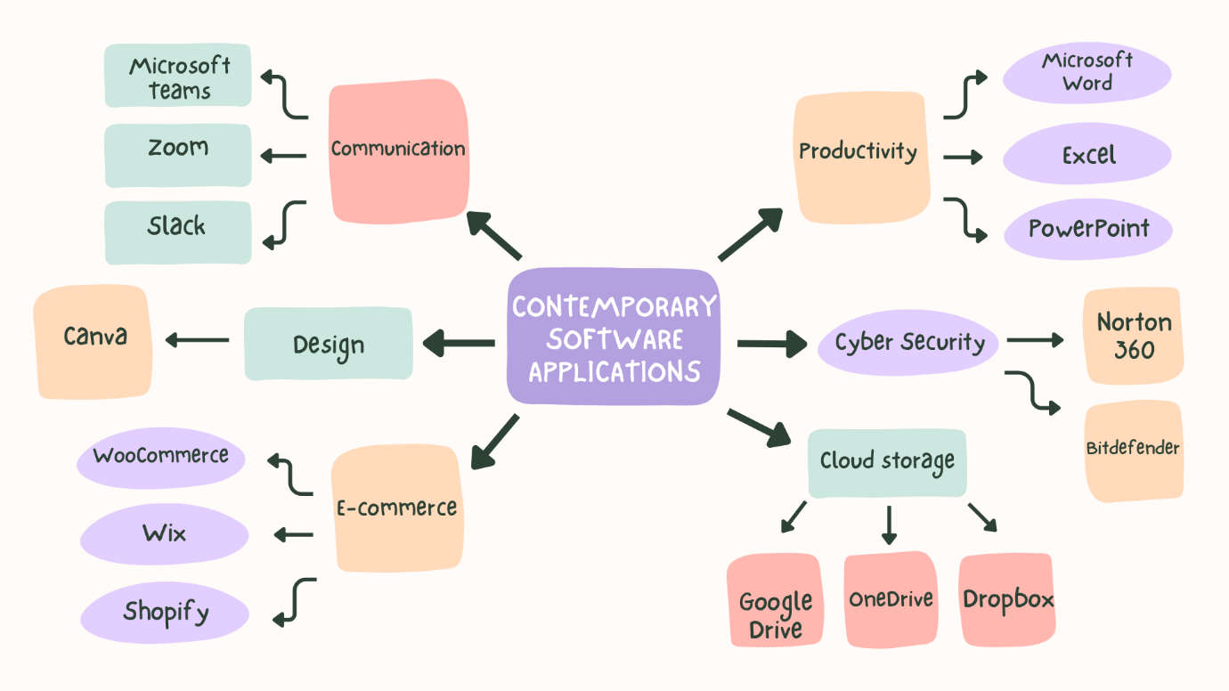
Figure 1: contemporary mind map of software applications.

Task 3 - Office Applications for creating, storing, presenting, and analysing information/data.

Explain four office software solutions for business operations (MS Word, MS PowerPoint, MS Excel, and MS Access), highlighting their major features, benefits, and limitations.
Microsoft Word
Microsoft Word is a robust word processing application developed by Microsoft, renowned for its extensive utilisation in business environments to create, edit, format, and share professional documents. Its widespread adoption as a primary office application can be attributed to its ability to facilitate the production of letters, reports, contracts, meeting agendas, invoices, business proposals, and company policies. Featuring a user-friendly interface complemented by an array of formatting tools, Microsoft Word empowers users to craft professional and uniform documents conducive to both internal and external communications [6]. A significant attribute of Microsoft Word is its advanced document formatting capabilities. Users possess the flexibility to customise fonts, headings, margins, spacing, tables, images, SmartArt, charts, and page layouts, thereby enhancing the overall presentation of documents. Additionally, Word offers built-in templates that enable businesses to swiftly generate reports, newsletters, CVs, invoices, and business letters. The Mail Merge feature significantly accelerates the creation of personalised letters, certificates, labels, or emails by automating the process using data sourced from Excel or Access, thereby effectively reducing the time spent on repetitive administrative tasks [7]. Moreover, Microsoft Word promotes collaboration through Microsoft 365 and OneDrive, allowing multiple users to edit documents concurrently. Functions such as Track Changes, Comments, AutoSave, and Version History facilitate document review and editing, enhancing team productivity. Quality assurance features, including Spell Check, Grammar Check, Accessibility Checker, and Translator, further contribute to the professionalism and clarity of business documents [8]. The advantages of using Microsoft Word are manifold, including heightened productivity, streamlined document creation, seamless collaboration, and effective communication. The use of templates allows businesses to standardise documents, while cloud integration supports remote working capabilities for employees. While it is essential to note that Microsoft Word may not be ideal for analysing large datasets or managing databases, its capabilities remain impressive, facilitating the efficient handling of complex documents even on older computers [7].
Microsoft PowerPoint
Microsoft PowerPoint is a powerful presentation software that empowers businesses to convey information visually through dynamic slides. It is frequently employed in various settings, including meetings, staff training sessions, conferences, sales presentations, project proposals, and marketing initiatives. By facilitating the presentation of complex information in a clear, compelling, and organised manner, PowerPoint enhances the audience's ability to grasp critical messages effectively [6]. The software boasts an array of features, such as professionally designed templates, themes, animations, transitions, charts, SmartArt graphics, icons, videos, audio, and embedded images. Businesses can enrich their presentations by incorporating tables, graphs, hyperlinks, and multimedia elements, fostering interactivity and engagement. The Presenter View functionality equips speakers with notes and timing controls, while Microsoft 365 promotes collaborative efforts by enabling multiple users to work on the same presentation in real time [8]. The benefits of PowerPoint for organisations are significant, as it enhances communication, boosts audience engagement, and supports effective knowledge sharing. Managers can skilfully present business performance reports, financial data, marketing strategies, and project updates in visually appealing formats. Employees often leverage PowerPoint during training sessions, as diagrams, animations, and videos elucidate complex processes more successfully than written documents alone [9]. While PowerPoint offers numerous advantages, it is essential to acknowledge some limitations. Presentations that are poorly designed, featuring excessive text or distracting animations, may inadvertently hinder audience engagement instead of fostering it. Additionally, the effectiveness of the software can be contingent upon reliable presentation equipment, such as projectors or large displays, with potential technical issues posing challenges. Moreover, PowerPoint is not designed for complex calculations or detailed data analysis, areas in which Microsoft Excel excels [6].
Microsoft Excel
Microsoft Excel is a widely utilised spreadsheet software that facilitates the recording, organisation, calculation, analysis, and visualisation of data across various organisations. Its significance as a pivotal business application is underscored by its capacity to support critical functions such as financial management, budgeting, forecasting, inventory control, payroll processing, sales analysis, and performance reporting. The adaptability of Excel allows businesses to efficiently manage both small and large datasets [6]. Excel is endowed with a multitude of powerful features that enhance data analysis. Users can leverage an array of formulas and functions, including IF, SUM, AVERAGE, COUNT, and VLOOKUP, to automate calculations effectively. Additional capabilities such as Pivot Tables, Charts, Conditional Formatting, Goal Seek, Data Validation, and Filters enable organisations to succinctly summarise information, discern trends, and make well-informed decisions. Furthermore, Excel's seamless integration with other Microsoft Office applications simplifies the processes of data import and export for business purposes. Among the numerous advantages of Excel are improved accuracy, automation of repetitive tasks, efficient data management, and enhanced decision-making capabilities. Organisations can utilise built-in analytical tools to examine sales performance, prepare financial statements, monitor budgets, and forecast future outcomes. The incorporation of charts and graphs allows managers to quickly interpret complex data and convey their findings clearly [10]. While Excel offers substantial benefits, it is important to acknowledge certain limitations. The performance can decline with very large datasets, and erroneous formulas may lead to inaccuracies if users are not vigilant. Furthermore, the manual data entry process can introduce human errors, which remain a notable concern. Although Excel serves many purposes effectively, it may be less optimal than dedicated database systems for managing extensive relational data that requires collaboration among multiple users [7].
Microsoft Access
Microsoft Access is a relational database management system (RDBMS) developed by Microsoft, tailored for the storage, organisation, and management of extensive amounts of structured information. Distinct from Microsoft Excel, which emphasises calculations and analysis, Access is specifically designed to manage the relationships between diverse sets of data. Its applications in business contexts commonly include the management of customer records, employee information, inventory data, supplier details, sales records, and booking systems 6]. Microsoft Access encompasses several vital features, such as tables, queries, forms, reports, relationships, and macros [8]. Tables facilitate information storage, while relationships establish connections among different datasets to minimise duplication and enhance accuracy. Queries empower users to efficiently search, filter, and retrieve specific information. Forms offer a streamlined method for data entry, and reports display organised information suitable for printing or management review. The incorporation of automation through macros significantly boosts efficiency by alleviating repetitive tasks. The advantages of Microsoft Access are noteworthy, encompassing secure data storage, enhanced organisation, diminished duplication, and accelerated information retrieval. This enables businesses to adeptly manage thousands of customer or inventory records while ensuring data consistency. Furthermore, Access integrates seamlessly with Microsoft Excel, Word, Outlook, and SQL Server, facilitating the exchange of information across various systems [9]. While Microsoft Access presents numerous benefits, it is essential to recognise its limitations. Primarily designed for small and medium-sized organisations, it may encounter performance challenges when faced with exceptionally large databases or a high number of simultaneous users. As a result, larger enterprises often opt for enterprise database systems such as Microsoft SQL Server or Oracle Database, which offer superior scalability, security, and performance. Additionally, users may need a foundational understanding of database design, which can necessitate supplementary training for staff [6]. In conclusion, Microsoft Access stands out as an effective solution for businesses seeking to manage structured data efficiently, all while avoiding the need for more extensive enterprise database systems

Test any two features from the following Mail merge, IF Function, VLOOKUP, Pivot Table, Goal Seek in MS Excel.
IF Function

Figure 2: Initial Excel dataset used for the IF Function. 
Figure 3: Applying the IF Function in Microsoft Excel.


Figure 4: Results of the IF Function in Microsoft Excel.
VLOOKUP
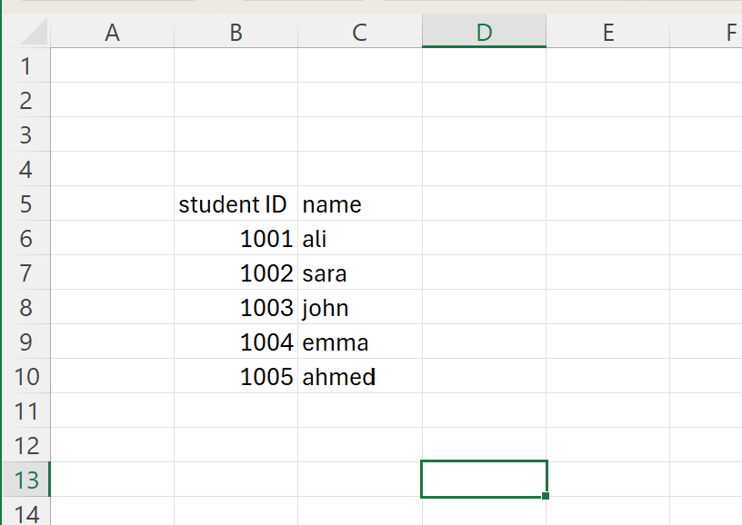
Figure 5: table created for VLOOKUP function.


Figure 6: applying the VLOOKUP function in Microsoft Excel.

Task 4 - Communication and Collaboration applications.

Test any two features from the following Mail merge, IF Function, VLOOKUP, Pivot Table, Goal Seek in MS Excel.
Microsoft Teams (Communication Application)
Microsoft Teams is a communication platform developed by Microsoft that facilitates organisational communication through instant messaging, voice calls, video meetings, and file sharing. Its widespread adoption in contemporary organisations underscores its effectiveness in keeping employees connected, whether they are working in the office or remotely. The seamless integration of Microsoft Teams with other Microsoft 365 applications, such as Word, Excel, PowerPoint, and Outlook, enhances communication and document sharing efficiency [11]. A defining characteristic of Microsoft Teams is its instant messaging capability, which allows for prompt communication via individual or group chats. Users can also schedule virtual meetings featuring screen sharing, meeting recordings, live captions, and chat functionalities. Furthermore, Teams supports file sharing through OneDrive and SharePoint, enabling employees to access and edit documents directly within the application. The platform's ability to create distinct channels for various departments or projects significantly aids in organising conversations and fostering collaborative teamwork [12]. The advantages of Microsoft Teams for businesses are numerous. It enhances employee communication, accommodates remote and hybrid work environments, reduces travel expenses through online meetings, and boosts productivity by consolidating multiple Microsoft applications into a single platform. The ability to engage in real-time messaging and collaboration facilitates quicker decision-making and more effective project management. While a stable internet connection is essential for optimal performance, and new users may require time to acclimate to its features, the overall prospects for utilizing Microsoft Teams are promising [13]
Google Drive (Online Collaboration Application)
Google Drive is a cloud-based storage and collaboration platform developed by Google, which empowers users to store, share, and edit files online. Its widespread adoption among businesses is a testament to its effectiveness in facilitating collaboration among employees, regardless of their location, provided they have internet access. With support for numerous file types—including Google Docs, Sheets, Slides, Microsoft Office files, PDFs, and images—Google Drive is an adaptable solution that caters to organisations of varying sizes [12]. A standout feature of Google Drive is its real-time collaboration capability. This functionality allows multiple users to work on the same document concurrently, with instantaneous visibility of each other's modifications. Additionally, the platform's version history feature enables users to revert to prior document states should errors occur. Files can be shared securely with customisable permission levels, including Viewer, Commenter, or Editor, thus ensuring that businesses can effectively manage sensitive information. The automatic saving of changes further mitigates the potential for data loss, providing users with peace of mind [11]. The advantages of Google Drive for businesses are extensive. It enhances teamwork, fosters remote working capabilities, provides secure cloud storage, and minimises reliance on physical storage devices. Employees can access files from a variety of devices, such as computers, tablets, or smartphones, which promotes flexibility and efficiency in the workplace. While it is important to note that file access is contingent upon internet connectivity and that the free version has some limitations regarding storage capacity, the overall benefits position Google Drive as a valuable asset for organizations. Additionally, those dealing with highly sensitive information can implement further security measures to safeguard their data effectively [13].

Test one feature of a freely available Communication (1) and one feature of a Collaboration (1) application.
Microsoft Teams

Figure 7: using Microsoft Teams chat to send message to other peers.
Google Drive
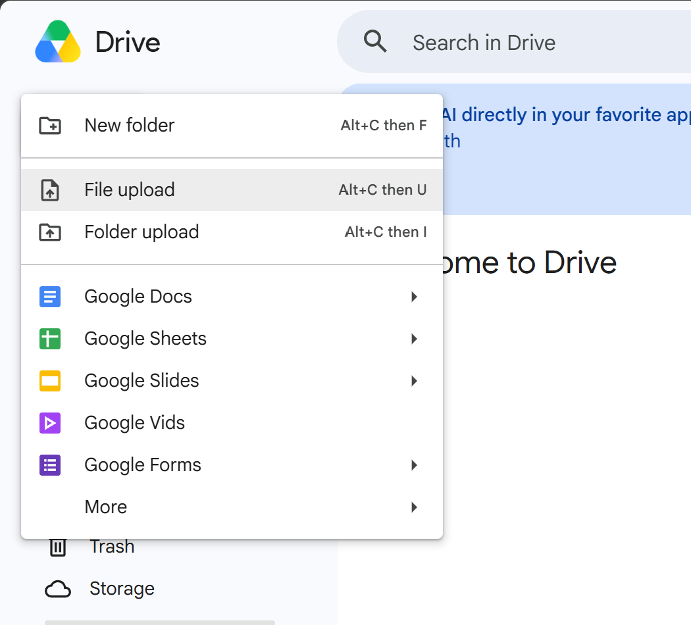
Figure 8: searching Google drive and press file upload.

Figure 9: uploaded file has been completed.

References
[1] J. Jana, “Why Is Shopify so Popular for Ecommerce? (7 Great Reasons),” DoDropshipping, May 5, 2026. [Online]. Available: DoDropshipping – Why Is Shopify so Popular for Ecommerce?. [Accessed: Jul. 22, 2026].
[2] Wix, "What is Wix?," Wix Blog. [Online]. Available: https://www.wix.com/blog/what-is-wix. [Accessed: Jul. 22, 2026].
[3] T. Buzan and B. Buzan, The Mind Map Book. Harlow, UK: Pearson Education, 2010.
[4] M. Davies, "Concept mapping, mind mapping and argument mapping: What are the differences and do they matter?", Higher Education, vol. 62, no. 3, pp. 279–301, 2011.
[5] Mind Tools, "Mind Maps: A Powerful Approach to Note-Taking," 2024. [Online]. Available: https://www.mindtools.com. [Accessed: 22-Jul-2026].
[6] Microsoft, Microsoft 365 Documentation. [Online]. Available: https://learn.microsoft.com/en-us/microsoft-365/. [Accessed: 22-Jul-2026].
[7] J. Lambert, Microsoft Office 365 Step by Step. Redmond, WA: Microsoft Press, 2022.
[8] Microsoft Support, Microsoft Office Support. [Online]. Available: https://support.microsoft.com. [Accessed: 22-Jul-2026].
[9] J. Walkenbach, Microsoft Office Bible. Indianapolis, IN: Wiley, 2021.
[10] C. Frye, Microsoft Excel Step by Step. Redmond, WA: Microsoft Press, 2022.
[11] Microsoft, Microsoft Teams Documentation. [Online]. Available: https://learn.microsoft.com/en-us/microsoftteams/. [Accessed: 22-Jul-2026].
[12] Google, Google Drive Help Centre. [Online]. Available: https://support.google.com/drive. [Accessed: 22-Jul-2026].
[13] J. Lambert, Microsoft 365 Step by Step. Microsoft Press, 2022.

