Globalization strategy and differentiated services

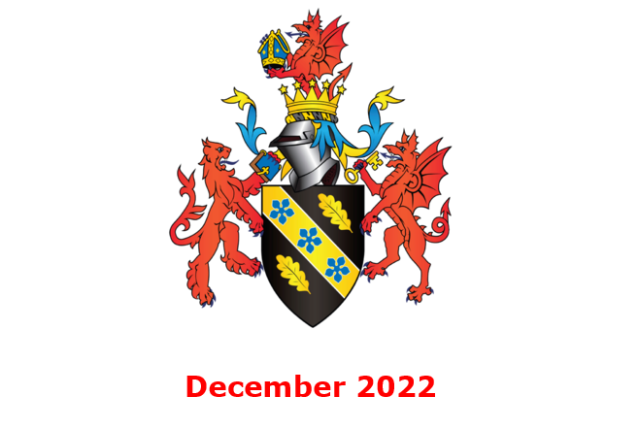

MODULE NAME: Strategic Management(BMMB7013)
NAME: Hongcheng Lv
STUDENT NUMBER: 2218228
Contents

Executive Summary 4
1. Xiaomi Group's business development 6
2 . Xiaomi's strategic analysis 6
2.1 Macro environment analysis (PEST analysis method) 7
2.1.1 Policy and legal environment (P) 7
2.1.2 Economic Environment Analysis (E) 7
2.1.3 Social Environment Analysis(S) 8
2.1.4 Technical Environment Analysis (T) 9
2.2 Internal environment analysis 9
2.2.1 Talent team 10
2.2.2 Interconnected communication methods 10
2.2.3 User strategy for growing together 11
2.2.4 Internet ecosystem construction 12
3. Xiaomi's competitiveness strategy reconstruction 13
3.1 Strengths. 14
3.2 Weaknesses 15
3.3 Opportunities 17
3.4 Threats 18
4. Xiaomi's development strategy design in the context of the pandemic 19
4.1 International business challenges in the context of the pandemic 19
4.2 Xiaomi's competitiveness analysis (Porter 5 forces) 20
4.3 Xiaomi's strategy reshaping the direction 21
5. Conclusion 22
6. Xiaomi Group's strategic adjustment proposal 23
6.1 Optimize global business layout 23
6.2 Strengthen online communication with users 23
6.3 Shaping differentiated services 24
6.4 Strengthen core technology research and development 24
6.5 Increase the layout of Xiaomi's high-end flagship models 24
6.6 Build a more systematic Xiaomi ecological chain 25
References 27

List of Figure:
Figure 1(P8)：Number of smartphones sold to end users worldwide from 2007 to 2021
Figure 2(P12)：Xiaomi Group VRIO model analysis table
Figure 3(P14)： Xiaomi Group SWOT analysis matrix
Figure 4(P18)： Number of cities in which 5G is available in 2022 by country
Figure 5(P19)： Worldwide Top 5 smartphone companies,2022Q2 Unit Market Share

Globalization strategy and differentiated services
Xiaomi Group's strategic reinvention

Executive Summary
This paper aims to creatively shape the strategic development direction of Xiaomi Group based on scientific analysis. As we all know, smartphones are a product of the Internet era and an indispensable and important tool for people in today's world, and the competition among global smartphone manufacturers is very fierce. Xiaomi Group is the world's third-largest international company in smartphone shipments and is committed to allowing more people to use high-quality and inexpensive smartphones and feel the changes brought by technology to their lives. To adapt to the development environment under the background of the new crown pneumonia epidemic, how to provide innovative customer service, reshape the strategic direction, and then enhance the core competitiveness of products is an urgent problem for Xiaomi. In the research process, this paper analyzes the macro environment and internal environment faced by Xiaomi Group by applying the PEST tool and VRIO model, establishes a SWOT matrix to analyze the advantages and disadvantages of Xiaomi Group, and uses the Porter 5 force model to sort out Xiaomi's competitive strategy. The results of the study show that Xiaomi Group is currently facing challenges such as intensified market competition, product positioning to be optimized, and slightly insufficient core capabilities, and the existing strategy can no longer meet the needs of future development. It also put forward Xiaomi's future development strategy, that is, by optimizing the global business layout, strengthening supply chain management, shaping differentiated services, strengthening core technology research and development, increasing the layout of Xiaomi's high-end flagship models, and carrying out relevant organizational changes and optimal allocation of resources, consolidating and enhancing global market share, enhancing brand value, and achieving sustainable development.

1. Xiaomi Group's business development
Founded in April 2010, Xiaomi Group is a consumer electronics and intelligent manufacturing company with smartphones, smart hardware and IoT platforms as the core, and its annual revenue has exceeded 100 billion yuan in just 7 years since its establishment. On July 9, 2018, Xiaomi successfully listed on the main board of Hong Kong, creating the largest technology IPO in Hong Kong's history and the third largest technology IPO in the world. Xiaomi Group's 2022 interim report shows, Xiaomi's business covers more than 100 countries and regions around the world, Xiaomi has become the third largest enterprise in global smartphone shipments in the world, with a market share of 13.8%, entered the top three mobile phone markets in 55 countries and regions, and shot the top five in shipments in 67 countries and regions, and Xiaomi ranked 266th on the Fortune Global 500 list for the fourth consecutive year. Xiaomi Group has also formed a differentiated strategy in terms of user service, their vision is "to make friends with users and be the coolest company in the hearts of users" (reference here), achieving a Xiaomi that continues to create long-term miracles.

2 . Xiaomi's strategic analysis
Enterprise strategic management is a series of operations and management operations that combine the daily business decisions of enterprises with long-term planning decisions(Ansoff 1976). Once the concept of strategic management was proposed, it had an important impact in the field of international economics and management, Professor Michael Porter(1980) proposed five competitive forces that determine the attractiveness of industries, and Steiner(1982) also enriched the connotation of corporate strategic management.

2.1 Macro environment analysis (PEST analysis method)
To analyze the external environment faced by an enterprise, it is necessary to analyze not only the macro environment faced by all enterprises in the region from a large aspect but also the specific industry environment faced by the enterprise. PEST analysis(Michael A.H.,ect,1987) is a key tool to analyze Xiaomi's political, legal, economic, social and technical environment. To this day, the connotation of PEST continues to be enriched, and Richard L. Daft(2003) and Barbett A. Scholars such as E. Bensusan(2003) have optimized the model to give strategic managers more choices.

2.1.1 Policy and legal environment (P)
The political environment is the basic condition to ensure the survival and development of enterprises, according to the current political environment, the international social-political situation is relatively stable, which is conducive to the international development of Internet enterprises and intelligent equipment manufacturers; In China, vigorously support enterprise scientific and technological innovation, and the mobile Internet has developed rapidly; The implementation of a strict regulatory mechanism to ensure healthy competition in the market is conducive to the development of Xiaomi.

2.1.2 Economic Environment Analysis (E)
The 2020 pandemic caused the world economy to contract, and in 2020 the world economy experienced its worst recession since World War II, with negative global economic growth of 3.5%. However, with the scientific understanding of the epidemic and effective epidemic prevention measures in countries around the world, the economies of various countries have begun to recover in an all-around way, and major economies will fully recover in 2023. Chinese GDP has exceeded US$12,000(Aaron O’Neill ,2022), and there is a general willingness to consume technology products such as smartphones.

2.1.3 Social Environment Analysis(S)
In today's increasingly globalized society, most people, regardless of race, religion or values, have made their smartphones a part of their daily lives, and are accustomed to swiping social media, watching videos, video chatting and reading on their phones. In 2016, less than half of the world's total population owned a smart device, reaching 78.05% in 2020. About half of the world's population, including children, currently owns a smartphone. 97.5% of Chinese citizens access the Internet via smartphones, and smartphone suppliers sold about 1.43 billion smartphones worldwide in 2021, with functional technology products represented by mobile phones still being the mainstream of global consumption(Federica Laricchia Oct18,2022).
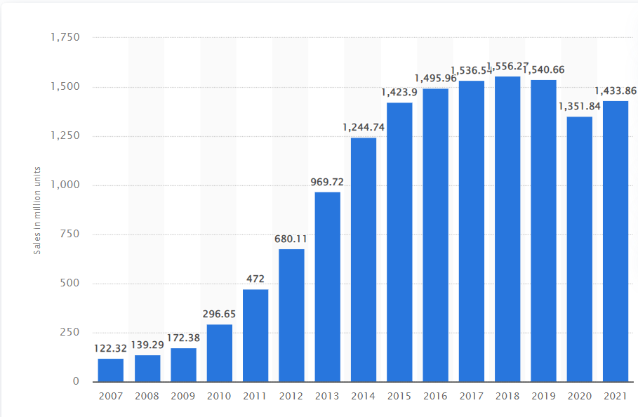
Figure 1：Number of smartphones sold to end users worldwide from 2007 to 2021

2.1.4 Technical Environment Analysis (T)
With the technological breakthroughs in smartphone-related fields in recent years, smartphones have ushered in greater development space, such as the development of smart chips, AI technology, lithium battery technology, 5G communication technology, folding display technology, etc., which has promoted the sustainable development of the industry.
Apple is a major manufacturer of smartphones worldwide, with the company shipping more than 57 million iPhones worldwide in the first quarter of 2022, 44.6 in the second quarter and 52 million in the third quarter. Apple’s sales tend to be very cyclical, peaking in the fourth quarter of each year, much like in the fourth quarter of 2021, when they took the first spot in terms of units shipped globally with around 84 million units. Samsung held the largest slice of the global smartphone market by shipments during the third quarter of 2022, after falling to second in the fourth quarter of 2021, when Apple was the leading smartphone vendor. Xiaomi has taken a tight grip on the third position, accounting for a market share of 13.4 in the third quarter of 2022(Federica Laricchia,Nov15 2022).

2.2 Internal environment analysis
The internal environment of the enterprise includes the internal resources and capabilities of the enterprise, and the VRIO model is a powerful tool for analyzing the internal resource environment of the enterprise. The VRIO model(Jay B.Barnyard,1995) was first proposed by Jay B. Barney, who believes that the resources and capabilities that affect the competitiveness of enterprises mainly include four aspects: value, rarity, inimitability, and organization. Fleishe C and Bensoussan B believe that few resources can be evaluated by the VRIO model, and only those resources that pass each test can be recognized as competitive and valuable resources, thereby giving the company a competitive advantage(Fleisher,c.S. and Bensoussan .B. ,2013). The following will conduct an in-depth analysis of the four aspects of Xiaomi Group's talent team, communication methods, user strategy and ecosystem to find out the unique resources and capabilities of Xiaomi and prepare for the selection, formulation and implementation of Xiaomi's competitive strategy(Zhao.J,2021).

2.2.1 Talent team
Value. Xiaomi has the best human resources, the team is led by Lei Jun, composed of senior employees of the world's top IT companies, and constantly introduces a large number of scientific researchers to form the unique human capital of the enterprise.
Scarcity. Entrepreneurs with star effects and high-end talent teams that fit with enterprises are all in the wind; Like Xiaomi, there are very few innovative companies that provide a free and equal work platform.
Imitability. Xiaomi has formed strategic human resources that are in line with the management and development of enterprises. Based on different enterprise development trajectories, talent development and enterprise growth form a tacit understanding, which is difficult for competitors to imitate.
Organizationability. Elite talents have the space to give full play to their value, and the company's "people-oriented" structure is flat and decentralized, abandoning the concept of class and maximizing the value of talents.

2.2.2 Interconnected communication methods
Value. Establish the Xiaomi community to enhance the interaction between users and employees; Use new media to stimulate user enthusiasm for participation, accurately grasp market changes and production needs, and effectively identify opportunities.
Scarcity. Establishing Internet-based communication channels is a must for modern enterprises, and the core of the Internet is sharing, so it is not scarce(Chunfang.W,2017).
Imitability. Many competitors have established communication platforms with users or disseminated information through new media.
Organizationability. The resource has a wide audience and strong influence, and enterprises can be well organized and utilized.

2.2.3 User strategy for growing together
Value. Xiaomi grasps the psychology of users' desire to participate in the creation, gradually penetrates the strategy of user participation, enables users to participate in various processes of the product production chain, improves products and services, and helps enterprises identify changes in market demand and further create innovation.
Scarcity. The boundary between users and Xiaomi is blurred, users are both consumers and product creators, users and products are seamlessly connected, and enterprises that can deeply participate in users are scarce.
Imitability. Enterprises not only through products but also through corporate culture to form a strong bond with users, but also make users treat Xiaomi's products as if they were their design and production of products, this value-based bond relationship is also an ordinary purchase relationship that can not be replaced.
Organizationability. Xiaomi wants everyone to enjoy technology, the purpose of which is to bring value to users, and the company's policy system is also built to support this goal.

2.2.4 Internet ecosystem construction
Value. The Xiaomi ecosystem includes the mobile Internet ecosystem, the smart hardware ecosystem, and the e-commerce platform ecosystem. And according to user needs, we will continuously improve products, improve the ecological chain, and effectively identify opportunities and threats.
Scarcity. It has advantages in hardware, software and user communication, and its formation process is unique and difficult to imitate for most competitors, so it is scarce.
Imitability. Xiaomi has created a complete closed-loop business ecology through mobile phones, smart home appliances, Internet services, etc., which meets people's expectations for a better life, realizes business logic and self-consistency, and can continuously expand. When enterprise products and services form an ecosystem, enterprises become complex systems that interact with each other, so they are difficult to imitate.
Organizationability. All resources within the ecosystem are interconnected and mutually supportive, and their purpose is to build the Xiaomi brand and realize user value, so they are organized.
Figure 2： Xiaomi Group VRIO model analysis table

Resource or capability | Value | Rare | Inimitable or non-substitutional | Organised to exploit | Impact on competitive advantage
Excellent talent team | yes | yes | yes | yes | Realized sustainable competitive advantage
Connected communication | yes | no | no | yes | Realized Competitive Parity
User strategies for growing together | yes | yes | yes | yes | Realized sustainable competitive advantage
Internet ecosystem | yes | yes | yes | yes | Realized sustainable competitive advantage

3. Xiaomi's competitiveness strategy reconstruction
The coronavirus pandemic is testing every ambitious market player..When discussing the future development strategy of Xiaomi, a systematic strategic analysis is required, and the SWOT analysis method commonly used in the industry is used here to point out the advantages, disadvantages and external opportunities and challenges of Xiaomi mobile phones, hoping to help Xiaomi managers make more appropriate strategic decisions. SWOT analysis is a well-known tool, proposed by Werick, a management professor at the University of San Francisco in the 80s of the 20th century, to analyze the strengths, weaknesses, opportunities, and threats of enterprises to help enterprises gather resources and actions in the places where they have the most opportunities and make the strategy of the enterprise clear.
Through the systematic analysis of the external and internal environment of Xiaomi Group, combined with the development of global smartphones and other industries, the SWOT analysis matrix of Xiaomi Group was formed.
Figure 3： Xiaomi Group SWOT analysis matrix
Opportunities  1. The communication industry is developing rapidly  2. Continuous optimization of the international division of labour  3. The international market has great potential | Strengths  1. Marketing network covering the whole world  2. Unique Internet marketing model  3. Good ecosystem  4. Excellent MIUI system
Threats  1.Fierce competition in the same industry  2.Technical barriers to patents | Weaknesses  1. Lack of core technology  2. Poor independent production capacity  3. Insufficient after-sales service

3.1 Strengths.
Global marketing network. Xiaomi has established a global webpage(Xiaomi,2015) to carry out product promotion, sales and consumer interaction, and has opened more than 2,000 "Xiaomi Homes" around the world to carry out offline product display, sales and maintenance. Especially in India, and Southeast Asia, it has realized the localization of Xiaomi mobile phone production and sales, becoming the largest smartphone brand in India. In the European market, although Xiaomi has a late layout, it has adopted the European telecom operator Changjiang Heji Group, retail giant A.S. Watson, German electrical appliance retailer MediaMarkt and other cooperation, and set up a European headquarters to create Xiaomi's first overseas market.
Unique Internet marketing model. Through the empowerment of the Internet, Xiaomi has created a precedent of "hunger marketing" in China, built Xiaomi Mall, and saved warehousing costs and channel costs; At the same time, it cooperates with Amazon, JD.com, Tmall and other online retail platforms to provide more convenient online sales services.
Good ecosystem. Xiaomi has formed three major product circles, the first circle layer is the peripheral of mobile phones, such as headphones, small speakers, mobile power, etc.; The second circle layer is smart home appliances, such as air conditioners, TVs, tablets, air purifiers, etc.; The third circle layer is daily necessities, such as towels, toothbrushes, etc. It is worth noting that Xiaomi uses mobile Internet technology to realize network management of all products and realize remote control management through mobile phones to create smart home life.
Excellent MIUI system. MIUI is a set of mobile phone operating system independently developed by Xiaomi, supporting most countries and languages in the world, with more than 540 million monthly active users, Xiaomi through online and offline sales network, timely absorption of user feedback, and continue to improve MIUI system, always maintain a high frequency of updates, compared with other Android system users, this is the unique competitive advantage of Xiaomi mobile phones.

3.2 Weaknesses
Lack of core technology. Xiaomi Group adheres to technology-oriented and builds core competitiveness with breakthrough self-developed technical capabilities, investing RMB7.3 billion in R&D costs in the first half of 2022, with a growth rate of 19.4%. According to the data, Xiaomi Group will be equipped with the self-researched surging F1 battery management chip on the new generation of flagship models in 2022, effectively enhancing the battery life of mobile phone products and improving user experience. However, like most Chinese mobile phone manufacturers, the main accessories of Xiaomi mobile phones rely on imports, including core accessories such as processors, cameras, and screens, resulting in Xiaomi mobile phones relying too much on external enterprises and being vulnerable to the external environment.
Mobile phone production relies on OEM. Xiaomi mobile phones have more than 800 devices, involving more than 100 suppliers, Xiaomi companies are selected with Motorola, Apple and other brands of the same suppliers, and by Foxconn, and Inventec OEM assembly. In the global mobile phone industry, entrusting OEM is a more common practice, such as Apple mobile phones entrusted to Foxconn, Huawei mobile phones also partially entrusted to BYD OEM, but Samsung mobile phone set design, chip manufacturing and mobile phone production as one, with stronger anti-risk ability. Although Xiaomi has first-class parts suppliers and foundry factories, it does not have independent production capacity, and Xiaomi should pay more attention to the improvement of the company's independent production capacity.
Insufficient after-sales service. In addition to the services provided by Xiaomi Home in large cities, Xiaomi mobile phones are outsourced to local mobile phone repairers in remote areas, and it is difficult for Xiaomi to effectively manage them, resulting in some consumers not being satisfied with Xiaomi's after-sales service.

3.3 Opportunities
The communications industry is developing rapidly. The intergenerational development of communication networks, from 1G to 4G and 5G, has directly led to the switch between the incremental market and the existing market in the mobile phone industry. China and the United States are significantly ahead of other nations in their 5G rollout, with a combined 652 cities in which 5G is available(STATISTA Research Department, 2022).
The international division of labour continues to be optimized. The global mobile phone industry is moving towards the smart market, and the production capacity centre is shifting to China. From a global point of view, the global mobile phone industry chain is mainly distributed in the United States, South Korea, Japan, China and other places, of which, the United States with brand and technology as the core, South Korea and Japan with core components and technology as the advantage, China is the most complete market in the global mobile phone industry chain, directly the capacity planning in China can maximize profits.
The international market has great potential. The competition in China's domestic mobile phone market is becoming increasingly fierce, but the competition in the international mobile phone market is relatively mild, and markets such as Europe and Latin America have a great room and potential for development. Smartphone penetration in Latin America has remained constant at 69% since 2019, with this percentage expected to reach 73% by 2025.
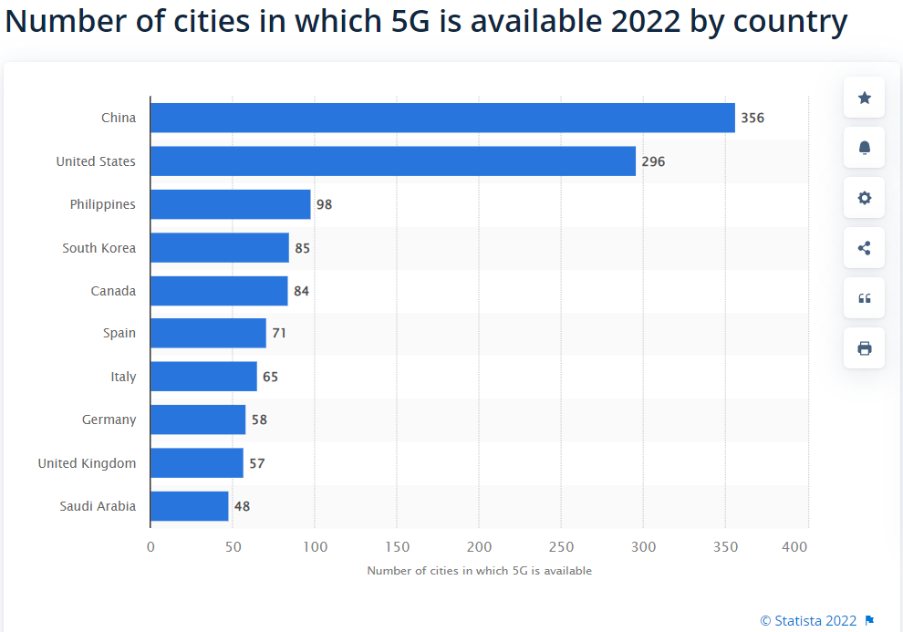
Figure 4： Number of cities in which 5G is available in 2022 by country

3.4 Threats
Fierce competition in the same industry. In China, Huawei, Lenovo, VIVO, OPPO, etc. have fierce competition, and Xiaomi is more similar to their target users; In the international market, mobile phone manufacturers such as Apple and Samsung occupy more market share, and it is difficult to catch up.
Technical barriers to patents. In recent years, global market players have paid more and more attention to the protection of intellectual property rights and patented technologies, and disputes over patented technologies have often arisen between some enterprises, which also poses a threat to the security of the supply chain(Xiaohua Bao and Larry D.Qiu,2012). At present, Qualcomm, Samsung, Ericsson, Apple, Huawei and other companies hold important communication technologies, Xiaomi not only has to pay high patent costs but also faces the risk of technology infringement, strengthening its technical capabilities is particularly important.

4. Xiaomi's development strategy design in the context of the pandemic

4.1 International business challenges in the context of the pandemic
At present, the epidemic caused by the Omicron variant is still a global pandemic, and the global economic recovery is difficult, which subtly changes the global business environment and brings enlightenment to the operation and management of multinational enterprises such as the Xiaomi Group(Post Covid-19 Customer Strategy Imlications ,2020). First, the pandemic has shown the negative impact of globalization, prompting companies to rethink how they manage their supply chains. Second, companies need to place more emphasis on strategic flexibility to protect their development gains in a challenging environment. The third is to strengthen digital capabilities and focus on enhancing core competitiveness. According to IDC, smartphone shipments fell for the fourth consecutive quarter amid global uncertainty and weak demand(IDC,2022), and Xiaomi needed to reshape and redesign its corporate strategy if it wanted to firmly capture its existing market share and achieve its sustainability goals.
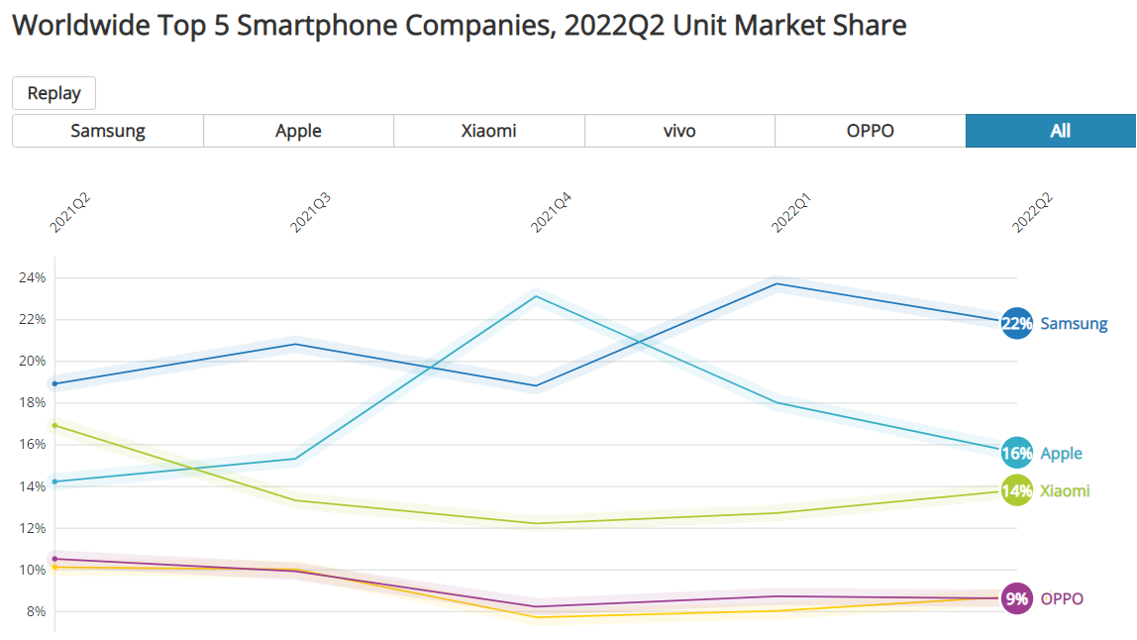
Figure 5： Worldwide Top 5 smartphone companies,2022Q2 Unit Market Share

4.2 Xiaomi's competitiveness analysis (Porter 5 forces)
Reshaping corporate strategy starts with defining core values. Twenty years ago, IBM transformed IBM by engaging 320,000 employees in 170 countries to discuss the values of a new common enterprise(Paul Hemp and Thomas A.Stewart,2004). Today, Xiaomi's core values of "sincerity and love" can still be discussed, after all, the company has passed the entrepreneurial stage and needs new value guidance.
Before proposing Xiaomi's new strategic plan, the "Porter 5 Forces" model is used to further analyze Xiaomi's current strategy. In terms of international competition, Apple, Samsung, and Huawei are the main competitors in the international market, and in China, brands such as VIVO, OPPO, and Honor are accelerating their layout at the middle and low end; In terms of suppliers, Xiaomi chips use Qualcomm, cameras use Leica products, and suppliers have strong bargaining power; In terms of customers, homogenization is serious, and consumers want to buy high-quality and low-cost mobile phones; In terms of alternative threats, including other competitors' products, tablets, wearable devices, etc., higher requirements are put forward for maintaining competitiveness with scientific and technological innovation; In terms of potential entrant threats, this is an open market, and new market players may be available at any time to better compete with products.

4.3 Xiaomi's strategy reshaping the direction
The low-cost strategy has helped Xiaomi reduce its production and operating costs in the past few years, and gain market share at lower prices than competitors' products. However, at present, the cost compression space of Xiaomi mobile phones is limited, and the cost leadership strategy is no longer suitable as Xiaomi's guiding competitive strategy, but it is also part of the future development strategy.
A differentiation strategy requires companies to offer products and services that are different from others so that customers who want to own them will not be able to buy them even if they pay a higher price. At the heart of this strategy is to make the company's products and services differentiated, even irreplaceable, and customers willing to pay for this difference. Companies need to make their products different from others and difficult to be imitated by competitors, and this strategy can give companies a unique competitive advantage. When the homogeneity of industry products is serious, differentiation strategies can help enterprises find new ways, avoid price wars, and discover new markets and potential needs. The differentiation strategy makes other enterprise products or services that can not replace the enterprise, and can enhance customer loyalty to the enterprise, Xiaomi does a good job in product, marketing, service and market differentiation, to form its unique competitive advantage.
The specialization strategy requires Xiaomi to concentrate its resources on a specific segment and become an expert in this segment. At the heart of this strategy is to target a specific buying group, product market or regional market, where low costs or differentiation are used to gain competitive advantage. With the improvement of Xiaomi's brand power, Xiaomi is eager to enter the high-end market to get a piece of the pie.

5. Conclusion
What kind of development strategy to choose is an eternal topic for enterprises, especially in the era of increasingly fierce global competition. By applying the PEST tool to analyze the macro environment faced by Xiaomi Group, the Chinese and international legal environment, economic environment, social environment and technical environment have formed positive support for Xiaomi Group; By using the VRIO model to analyze the internal environment of Xiaomi Group, excellent talent team, effective communication methods, user strategies for common growth, and Internet ecosystem are the core resources and capabilities of Xiaomi Group. With the rapid development of the telecommunications industry, the demand for smartphones in China and the world has great potential, but it also faces hidden worries such as international strategy optimization, intensified industry competition, professional technical barriers, and insufficient after-sales service. Combined with the analysis of Porter's 5-force model, the future differentiated development path of Xiaomi is further clarified, and the future strategic choice should highlight the global business layout, strengthen supply chain management, shape differentiated services, strengthen core technology research and development, and increase the layout of Xiaomi's high-end flagship models to help Xiaomi Group adapt to a more complex international market environment, create a safe industrial chain and supply chain, and continuously enhance brand influence.

6. Xiaomi Group's strategic adjustment proposal
Based on the above analysis, Xiaomi Group should make major adjustments to its strategy to meet the needs of market competition under the influence of the new crown pneumonia epidemic. research suggests that only a few organizations use a dual strategy of market and technology drivers when attempting to innovate(Fank Lattuch,etc.,2013)。 Therefore, this strategic adjustment will be a new arrangement, fully considering the competitive position of Xiaomi Group in the global smartphone market, as well as international political, economic, technological and other changes, and has an important guiding role for Xiaomi Group to achieve sustainable and stable development, as follows:

6.1 Optimize global business layout
Benchmarking the experience of global leading enterprises such as Apple(Qing Liu,etc., 2021), strengthening the international business development strategy, carrying out production centres, R&D centres, design centres and other layouts around the world, focusing on the R&D centre in the United States, the design centre in Europe , and the production centre in China and Southeast Asia, to hedge the strategic risks under the wave of anti-globalization.

6.2 Strengthen online communication with users
Make full use of MIUI background feedback, the global Xiaomi website and other platforms, listen to users' expectations and opinions on Xiaomi products, improve the MIUI system promptly, so that every opinion can be tracked, implemented and feedback, and build a business ecology with consumers.

6.3 Shaping differentiated services
In China and major target market countries, 200 new "Xiaomi Home" have been opened as a core market penetration strategy to provide professional official services(Robert B.Woodruff ,1997), including product trials, trade-ins, free laser engraving, UnionPay support guarantees, acceptance and feedback of consumer complaints and suggestions, etc. Establish a unified service guarantee system and evaluation system at home and abroad.

6.4 Strengthen core technology research and development
At present, Apple, Samsung, Huawei and other major mobile phone manufacturers are using their chips, Xiaomi should also organize R&D teams to develop smartphone chips, more of their core technologies and patents, minimize the restrictions of patent technical barriers on their development, provide users with expected products, and improve product performance and competitiveness (Handan Li ,2015).

6.5 Increase the layout of Xiaomi's high-end flagship models
Optimize product positioning, accelerate the entry into the ranks of high-end smartphones given the current market competition dilemma, develop high-end flagship products(Chris Perot,Fan Chen and Airu, 2014), serve users with better products, and help the company establish good brand power. Only if the company is conceived of as a hierarchy of care competencies, core products, and market-focused business units will it be fit to fight(C.K Prahalad and Gary Hamel ,1990) . the ability to socialize a strategy is the real test for successful implementation(Abraham Stan ,2007).

6.6 Build a more systematic Xiaomi ecological chain
With Xiaomi mobile phones as the center, we continue to invest in and incubate smart hardware-related products and build a product chain from mobile phone peripherals, smart home appliances, smart hardware, daily necessities and other products to form a solid and unbreakable ecosystem. Strengthen the user experience report for product function improvement suggestions, invite some users to communicate with engineers face-to-face, and then convert users into "loyal users". Strengthen the control of the product quality of Xiaomi ecological chain enterprises, strengthen the concepts of "high-cost performance" and "products must conform to simple design" to ensure that the products of ecological chain enterprises meet Xiaomi's requirements and concepts for products. Fight for the right to standard-set Internet devices,Cooperate with major international intelligent hardware suppliers to formulate product communication standards to ensure the beautiful experience of users using Xiaomi products, deliver the wisdom and convenience given by Xiaomi ecology to more users, change people's lives with science and technology, and become a great technology-enabled company.
To ensure the adjustment of the above strategic goals, Xiaomi Group needs to optimize the aspects of organizational structure adjustment, increasing investment in scientific research, carrying out offline marketing network construction, and new product design and research and development to ensure the smooth achievement of strategic goals.
The smartphone industry is a technology-intensive and capital-intensive industry, and its international business competition is also facing more complex conditions, this topic focuses on technology and market aspects of research, and the breadth and depth of research have certain limitations. It is also possible to conduct in-depth research on the aspects of business model and brand strategy to find more effective development strategies, which will not only help Chinese enterprises to go global but also help national multinational enterprises better integrate into China and jointly build a harmonious, prosperous and orderly international market order.

References
Ansoff,H.I., Declerck,R.P. and Hayes,R.L.(1990). From Strategic Planning to Strategic Management.Berlin :Heidelberg.
Aaron O’Neill,(2022).Gross domestic product (GDP) per capita in the main industrialized and emerging countries in current prices in 2021.[online]Available at:<GStatistahttps://www.statista.com/statistics/256427/gdp-per-capita-in-the-main-industrialized-and-emerging-countries/>[Accessed Jun 30,2022].
Brian.L and Stan.A ,(2007). Strategy & Leadership: Chicago Vol. 35, Iss. 4, pp38-42.
Babette E.B. and Craig S.F.,(2007).Business and Competitive Analysis .Place of publication not identified:Ft Pr.k.
Bao, X. H. and Larry D. Q., (2012).How Do Technical Barriers to Trade Inluence Trade.Review of Internationaleconomics,20(4),pp691-706.
Chunfang .W,(2017). Research on "Internet +" marketing model of smart phones in Chinese market.Guangxi University.
Fleisher, C.S., & Bensoussan, B. (2002). Strategic and Competitive Analysis: Methods and Techniques for Analyzing Business Competition.Place of publication not identified:Pearson College Div.
Frank .L and Richard J. Pech and Frank,(2013). Market and technology drivers: shaping an innovation strategy.Journal of Business Strategy,.Vol. 34 Iss 5 .pp. 4 - 11.
Federica .L.(2022).Global smartphone sales to end users 2007-2021.Statista,[online]Available at:<Shttps://www.statista.com/statistics/263437/global-smartphone-sales-to-end-users-since-2007/>[Accessed Nov 12,2022].
Federica .L.(2022).Quarterly smartphone market share worldwide by vender 2009-2022.STATISTA.[online]Available at:<https://www.statista.com/statistics/271496/global-market-share-held-by-smartphone-vendors-since-4th-quarter-2009/>[Accessed Nov 12,2022].
Global 500.Fortune.(2022).[online]Available at:< https://fortune.com/global500/>[Accessed Feb 23,2022].
Handan .L,(2015). The reasons and countermeasures for China's mobile phone exports to encounter technical trade barriers.Hubei:Hubei Today (Second Edition).
Xiaomi Shopping Mall.(2015)[online]Available at:<https://www.mi.com/global/>[Accessed Oct19,2022].
Jing .Z(2021),Research on the Influencing Factors of Users' Contributive Participation Behavior in Xiaomi Community.
Michael E. Porter,(1980). Competitive Strategy.Place of publication not identified:AOM.
Michael A.H. and R.Duane Ireland and Robert E.Hoskisson,(1987).Strategic management.,South-Western College Pub.
Prahalad,C.K.and Hamel,G.(1990)The core competence of the corporation:Harvard Business Review.68, p79-91.
Paul.H and Thomas A.Stewart,(2004).Leading Change when business is good. HBR vol 82,no.12 , pp 60-70.
Pwc,(2020),Post Covid-19 Customer Strategy Implications, [online]Available at:<https://moodle.uwtsd.ac.uk/pluginfile.php/440387/mod_resource/content/1/post-covid-19-customer-strategy-implications.pdf>.[Accessed Oct19,2022].
Qing .L.,etc.,(2021). Analysis of global city network based on global value chain: A case study of Apple mobile phone supplier.Acta Geographica Sinica,Vol. 76,pp870-887.
Richard L.Daft,(2003). Management (6th ed.). Place of publication not identified:Thomson South-Western.
Steiner and George F,(1982). Management Policy and Strategy.Place of publication not identified:Collier Macmillan.
IDC,(2022).Smartphone Market Share,[online]Available at:<https://www.idc.com/promo/smartphone-market-share/market-share>[Accessed Aug4,2022].
Statista Research department,(2022).Countries with the highest number of cities in which 5G is available 2022.Statista.[online]Available at:<https://www.statista.com/statistics/1215456/5g-cities-by-country/>[Accessed Nov10 ,2022].
Woodruff, R.B. (1997). Customer value: The next source for competitive advantage. Journal of the Academy of Marketing Science, 25(2),pp139-153.
Xiaomi Corpration,(2022)Xiaomi Group's 2022 interim report,[online]Available at:<https://ir.mi.com/system/files-encrypted/nasdaq_kms/assets/2022/09/26/4-52-30/2022%20Interim%20Report.pdf>[Accessed Nov10,2022].
Yu Y. et al.(2021).IFP35 as a promising biomarker and therapeutic target for the syndromes induced by SARS-CoV-2 or influenza virus,37(12).

