C
Component 2
Written Assignment (Case study)


Elena Rangelova Lateva
2018848
BMHP4003
Psychology in Health and Social Care
Lecturer: Rebecca Kavanagh
Case study report

Contents
Introduction 2
Social identity theory (SIT) 2
Attribution theory and Fundamental attribution error 3
Frustration aggression hypothesis (FAH) 5
Conclusion and recommendations 6
Reference Page 7

Introduction

This paper will investigate the importance of the mental health well-being, especially among teenagers. One of the greatest challenges for the 15-year-old boy, that has recently received a diagnosis of Emery-Dreifuss Muscular Dystrophy, is to stay in a stable mental health. He is a football player, and he has been forced to give up his place at the Aston Villa academy, which is very big lost for him. The impact of the disease is affecting achieving his life’s dream, which has led to suicide attempt. Previous research has established that “disease and health behaviours in adolescents have patterns that are distinct from those of children or adults. In particular, adolescent mortality and morbidity rates shows worrying trends in national priority such as mental health- for example male suicide.” ( BMJ 2005;330:411). Findings from studies done since 2000 show that suicide is among the top three to five causes of mortality in young men in most high-income and middle-income countries sampled ( Pitman, Krysinska, Osborn, King, Suicide in young men, 2012, P. 2383-2392, https://www.sciencedirect.com/science/article/pii/S0140673612607314).

Social identity theory (SIT)
According to social identity theory (SIT; Tajfel & Turner, 1979) our knowledge and emotional attachment to our group memberships have implications for our well-being and behaviour. Additionally, our group membership provides us with a self-esteem (McKeown, S, Haji, R, & Ferguson, N (eds) 2016, Understanding Peace and Conflict Through Social Identity Theory: Contemporary Global Perspectives, Springer International Publishing AG, Cham. Available from: ProQuest Ebook Central. [26 November 2021]. Humans are inherently social beings. Indeed there is a social psychological perspective that we have a fundamental evolutionary-based need for intrapersonal relationships (Baumeister & Leary,1995). Individuals strive to improve their self- image by trying to enhance their self-esteem, based on personal identity, personal achievement, various social identities, affiliation with a successful group. Social categorizing is a cognitive process. When an individual gets self-esteem from being a member of a group and sees her/his group as superior to others. Actions taken tend to benefit the group. Level of self-esteem is maintained by social comparison. (Tajfel, H. &Turner, J. (1979) Social identity theory, dikutip dari, www. learning-theories. com, diakses, 20). SIT applies to the given case study, because the service-user is being part of group -football training academy. Since the boy lose his place in the group that used to belong, he has been suffering with anxiety and depression.

Attribution theory and Fundamental attribution error

  - Attribution theory
Attribution theory is a theory about how people explain things and seeks to explain how and why people make these casual attributions. Attribution refers to the way people try to understand the behaviour of others and interpret events around them (https://www.slideshare.net/abhishekpanda376/attribution-theory-ppt, accessed 28/11/2021)
Attribution theory represents another expression of the idea that spontaneous thought follows a systematic course that is roughly congruent with a formal statistical model (the analysis of variance; see Kelley, 1967). Attribution theorists are concerned with individual’s attempts to comprehend the cause(s) of behaviour. Following Heider’s (1958) lead, the attributional approach starts with the assumption that casual questions are spontaneously prompted when we observe our own actions or the actions of others, and the “explanations” we consider in this quest can roughly categorized as residing either in the individual (his abilities, motives, personal preferences), or in the environment (social pressures, task difficulty, and so on). As humans, we have a strong desire to understand and explain our experiences. When we encounter certain experiences, such as somebody acting aggressively and rude towards us, we try to work out why it happened and explain the behaviour using a self-generated theory. Being able to understand the behaviour of others is very important as it allows us to predict how that person may act in the future, and this enables us to have influence over that person and decide how we are going to behave towards them next time.
Therefore, the search for causal explanations about the social world around us offers us great comfort as it brings order to our lives and gives us a feeling of being in control of our own destiny. For this reason, a key question within attribution theory is, "Why did he do that? 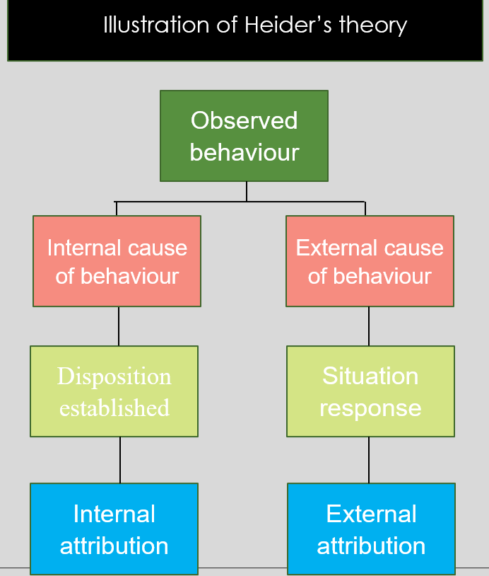
  - Fundamental attribution error
The FAE (or 'correspondent bias' - Fleming & Darley, 1989; Gilbert & Jones, 1986) is the tendency to attribute another person's behaviour to their dispositional qualities, rather than situational factors (Heider, 1958; Ross, 1977).
According to this theory we are asking, what could be the reason for the boy’s verbally abusive behaviour, why was he rude? The receptionist who is a woman in late adulthood, maybe because of lack of experience, took the behaviour too personally and judged his attitude very fast, probably thinking that his behaviour is caused by bad temper or individual characteristics. She responded by raising her voice without knowing what the condition and the situation from the boy’s side could be. However, the staff member is considered to generally polite, which leads us to the suggestion that to be rude is not part of her personality, and she reacted in a situation that she most likely hadn’t experienced before as she has recently taken up the post. The service user has his rights to complain relating the conduct of the receptionist staff member, because he went there to seek help and counselling. The counselling centre should be run by people who are qualified for any diseases that could cause anxiety and aggression. My recommendation is to be provided proper training to the receptionist how to deal with such situation.

Frustration aggression hypothesis (FAH)
Huesmann (1986,1998) proposed that when children observe violence in mass media, they learn aggressive scripts. Scripts define situations and guide behaviour. The person first selects a transcript to represent the situation and then assumes a role in the script. The service user is a teenager and at this age is typical that kids learn easily naughty language and use it.
A frustration is “an interference with the occurrence of an instigated goal-response at its proper time in the behavior sequence” (Dollard et al., 1939, p. 7). Dollard et al. (1939) started their monograph with a sweeping generalization as their core assumption: “Aggression is always a consequence of frustration” (p. 1). This statement means, they were quick to note, that (a) “the occurrence of aggressive behavior always presupposes the existence of frustration” and (b) “the existence of frustration always leads to some form of aggression” (Dollard et al., 1939, p. 1)
Physical pain is the clearest example of negative effect, and a great many experiments have demonstrated that the infliction of pain frequently spurs a wide variety of organisms, humans as well as other species, to attack available targets(Berkowitz, 1983; Ulrich, 1966). The service user can not sit down, as this can cause cramping pain in his legs. Studies have found that physical discomfort heightens the accessibility of hostile ideas. Except the physical discomfort, as he is standing and moving around and often become breathless, the boy is experiencing psychological discomfort. The service user is seeking counselling after suicide attempt, so most likely is that the boy is in depression. Psychological as well as physical discomfort can produce the aggression-activating negative affect. Even depression can arouse aggressive tendencies (Berkowitz, 1983). This last statement
will not be surprising to many mental health specialists because the clinical literature abounds with reports of hostility displayed by adult and child depressives. But whereas psychoanalytic theory states that the hostility produces the depression (depression supposedly is aggression turned inward), an increasing number of experiments have shown that the experimental inculcation of depressive moods frequently gives rise to angry feelings and even attacks on an available target, especially if the subjects give little thought to what they are doing (Berkowitz, 1983; Finman & Berkowitz, 1989; Hynan & Grush, 1986; I. Miller & Norman, 1979).
Impact of counselling for individuals.
Counsellors can enhance their understanding and knowledge of issues relevant to the needs of persons with disabilities and their families by learning about the various forms of personal and societal barriers they often encounter. Of particular importance is for counsellors to collaborate with their clients to (a) identify which barriers are most salient, (b) examine the ways the identified barriers inhibit their functioning or prevent them from coping more positively, (c) explore which ones are within their control to change, and (d) determine strategies they can use to cope with and move past them. This process is not always easy, nor is it particularly linear, and may require some time and effort to resolve. Adjustment to disability is a phrase used to describe the way individuals are coping and functioning while living with a disability. More specifically, it may refer to the thoughts, feelings, and behaviours of individuals who are trying to reach a place of acceptance and personal integration of the disability into their self-concept. Oftentimes, adjustment to disability is conceptualized as the final phase of accepting one’s disability and in moving forward with one’s life (Livneh & Antonak, 1994; 1997; 1999).

Conclusion and recommendations
In this paper was pointed why the boy is so much affected by losing his membership in the football academy according to SIT, the attribution theory which explain the internal and external cause of behaviour, the fundamental attribution error, explaining why the receptionist’s reaction is wrong, and how the frustration leads to aggression.
My recommendation is the receptionist to be upheld, but to be provided proper training how is right to deal with verbal aggression, relating to be accurate to the counselling centre activity.

Reference Page
- Pitman, Krysinska, Osborn, King, Suicide in young men, 2012, P. 2383-2392, https://www.sciencedirect.com/science/article/pii/S0140673612607314

- (McKeown, S, Haji, R, & Ferguson, N (eds) 2016, Understanding Peace and Conflict Through Social Identity Theory: Contemporary Global Perspectives, Springer International Publishing AG, Cham. Available from: ProQuest Ebook Central. [Accessed: 26 November 2021].
- (Tajfel, H. &Turner, J. (1979) Social identity theory, dikutip dari, www. learning-theories. com, diakses, 20)
- https://www.slideshare.net/abhishekpanda376/attribution-theory-ppt, accessed 28/11/2021
- The FAE (or 'correspondent bias' - Fleming & Darley, 1989; Gilbert & Jones, 1986)
- Dollard et al., 1939, p.1, 7
- Berkowitz, 1983; Finman & Berkowitz, 1989; Hynan & Grush, 1986; I. Miller & Norman, 1979
- Livneh & Antonak, 1994; 1997; 1999

