
Counselling
Within the UK, bereavment counselling is currently one of the most used areas within the counselling sector. It aims to provide support to individuals either through telephone support, support groups or individual one on one counselling, in order for them to come to terms with their loss (Vlasto, 2010).
A study carried out by Gallagher, Tracey & Millar (2005) carried out a study on ex-clients who had all taken part in bereavement counselling that had been offered to them by a team from a major voluntary sector bereavament care organisation. 89 returned questionnaires were collected and the data from the questionnaires revealed that clinets reported positive experiences from their counselling sessions and found that their post-counselling outcomes were helpful in helping them with their grieveing process.

What is counselling?
Counselling is a distinct form of helping individuals who are suffering with all kinds of issues such as; bereavement, cancer patients, depression sufferers and many more. There are many different types of counselling all of which have the same aim in mind, to understand the ways in which individuals deal with the situations they happen to find themselves in order to provide an understanding of their situations to enable inidividuals to come to terms with the situations they are faced with in a healthy and safe environment (Fallowfield, 1988).

Counselling
Counsellors working withing the voluntary sector are seen as one of the main providers of ‘talking treatments’ and they are akso key providers of bereavament counselling for individuals in need suring their bereavament process (Vlasto, 2010).
It has previously been reported that individuals would prefer to speak to a counsellor during or after they have been through the bereavement process because counsellors are seen to be;
- Empathetic
- Non-Jusgemental
- Trusting
- Reassuring
- Genuine

Life After Loss:
Bereavement Support Information Leaflet



Challenges In Old Age; Social and Developmental Transitions / December 2019



Support groups
A study carried out by Diamond, Lund & Caserta (1987) examined the social support, coping, health and life staisfaction of 192 participants aged between 50 and 93 who were all bereaved. Following the death of their spouses, participants were given questionnaires over six time periods. The results of the study found that social support played a big part in the bereavment outcomes during the first two years of bereavement.

Another study carried out by Lund & Caserta (1992) examined the participation of 134 bereaved spouses in twenty-six self-help support groups which consisted of eight weekly meetings. Statistical differences were found between number of meetings attended and feelings of percieved values of the support groups.

Support groups
Bereavement support groups were developed with the main aim of helping individuals who are currently going through a bereavement to understand their grief in order to normalise the ways in which their grief manifests by providing support programmes in a safe, loving and warm environment (Picton, Cooper, Close & Tobin, 2001).
There are many different types of support groups all over the UK that all aim to connect indidividuals who are all going through the same types of matters. Support groups have been reported by people who use them, to be exceedingly helpful for the individuals attending them. Research has explored the factors that keep individuals attending support groups and has examined the extent in which bereavement support needs are being met by such groups (Steiner, 2006).
Support groups can be used in order to reducce the psychological difficulties that individuals find themselves facing either after a bereavement or during the time when the individuals themselves find themselves becoming unwell either physically or mentally (Cain, Kohorn, Quinlan, Latimer & Schwartz, 1986).

Counselling
Another study carried out by Simonsen & Cooper (2015) examined the ways in which bereavament counselling helped seven individuals who had to come to terms with the loss of a loved one. Interviews were carried out individually on each participant and results were analysed using interpretive phenomenological analysis. The results of the study found that, like previous research carried out in this area, bereavement counselling is an effective and helpful practice when helping the bereaved come to terms with their loss in an effective and healthy way.



Conclusions:
It is clear to see from the evidence provided that the use of support groups and counselling appear to be beneficial to individuals going through bereavement. It is hoped, that in the future, individuals suffering from bereavement will be able to healthily come to terms with the loss of a loved one enough to be able to carry on living their day to day lives with the help and support of the counsellors and individuals in the support groups. Further research could examine the ways in which individuals who attend support groups or counselling sessions cope with their bereavement when they are away from the support groups and sessions to examine the positive differences that they have on the outcomes of bereavement.

References

A Gallagher, M., Tracey, A., & Millar, R. (2005). Ex‐clients' evaluation of bereavement counselling in a voluntary sector agency. Psychology and Psychotherapy: Theory, Research and Practice, 78(1), 59-76.

Cain, E. N., Kohorn, E. I., Quinlan, D. M., Latimer, K., & Schwartz, P. E. (1986). Psychosocial benefits of a cancer support group. Cancer, 57(1), 183-189.

Dimond, M., Lund, D. A., & Caserta, M. S. (1987). The role of social support in the first two years of bereavement in an elderly sample. The Gerontologist, 27(5), 599-604.

Fallowfield, L. J. (1988). Counselling for patients with cancer. BMJ: British Medical Journal, 297(6650), 727.

Picton, C., Cooper, B. K., Close, D., & Tobin, J. (2001). Bereavement support groups: Timing of participation and reasons for joining. OMEGA-Journal of Death and Dying, 43(3), 247-258.

Simonsen, G., & Cooper, M. (2015). Helpful aspects of bereavement counselling: An interpretative phenomenological analysis. Counselling and Psychotherapy Research, 15(2), 119-127.

Steiner, C. S. (2006). Grief Support Groups Used by Few— Are Bereavement Needs Being Met?. Journal of social work in end-of-life & palliative care, 2(1), 29-53.

Vlasto, C. (2010). Therapists' views of the relative benefits and pitfalls of group work and one-to-one counselling for bereavement. Counselling and Psychotherapy research, 10(1), 60-66.

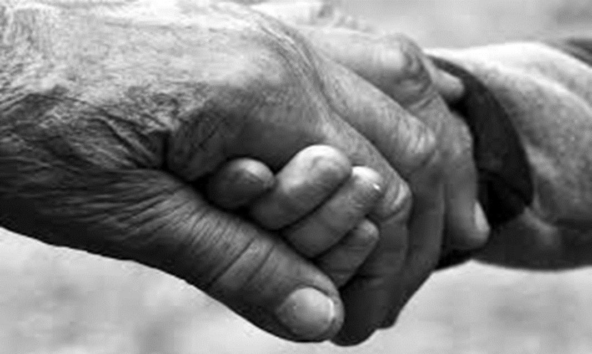

Life After Death
How to deal with the loss of a loved one: A support guide for those coming to terms with a loss

December 2019

Section 1: Executive Summary
Contents

Section 1; Executive Summary Section 3; Life after loss; How to cope with bereavement

Section 2: Introduction Section 4; Conclusions

Executive Summary
Physicians, throughout their working and home lives, are expected to at some point, encounter and have some sort of experience with grief. Grief illustrates a multidimensional response to loss that is thought to be encountered by everyone at some point or another throughout their lifetimes. Despite its prevalence, grief and loss have largely remained outside of the province of medicine (Casarett, Kutner & Abrahm, 2001). Benjamin Rush, a founder of modern medicine, suggested that grief was a philosophical threat to health.
Recent decades have seen a rise in research evidence based on the experience of grief and loss and has led to an expanding in relation to attention from the traditional thoughts surrounding grief and bereavement in its trail through an emotional journey of distress to recovery. There have been vast changes in terms of how individuals experience loss and bereavement through the help of grief therapy (Hall, 2014).

Section 2: Introduction

What Is Bereavement?
- As defined by Strobe et al (1993), bereavement is a state of loss that triggers a grief reaction that ultimately manifests in a set of behaviours otherwise known as mourning.

Bereavement, along with grief, often refer to either the state of having lost someone as a result of death or the response in which an individual has to such a loss (Zisook & Shear, 2009). Death Is suggested to be one of the most painful adaptational challenges that families have to go through, whether that be the death of a spouse, child, parent, grandparent or any other individual within the family. Between January 2019 and October 2019, there were 46,133 reported deaths in England and Wales alone (ONS, 2019).
According to Kleinman (2012) it has been suggested that at present, there is no irrefutable scientific evidence reported that indicates what a ‘normal’ length of bereavement is. Worldwide and across cultures, societies differ vastly in their perceptions on the amount of time in which one should grieve their losses of loved ones, with some using a year as a marker and others believing that the bereavement of a loved one should last a lifetime (Kleinman, 2012).
Over the years researchers have attempted to define the discrete stages of grief beginning with the initial period of numbness that occurs very shortly after the loss of a loved one that eventually leads to the depression stage and then finally ends in the recognition and recovery stages (Zisook & Shear, 2009). Researchers have however found that the lengths and intensity of grief and bereavement differ from person to person and across culture. Grief and bereavement are unfortunately not at present a main topic of conversation within medical schools or general and psychiatry practices. Engel (1961) raised the question ‘Is grief a disease?’. This examined and explained how grief has many of the same symptoms/characteristics of physical diseases such as physical impairment, distress and so on. With these types of physical diseases, it was suggested that although healing takes place, it is not always fully completed. For individuals who already suffer physical diseases such as distress, bereavement could then have a detrimental effect on the individual’s health leading to complicated grief that could potentially manifest into something as serious as psychiatric complications (Zisook & Shear, 2009).


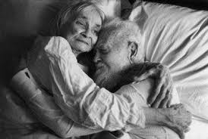

Spousal Bereavement
According to Neimeyer & Holland (2015) by the time individuals reach the age of sixty-five, approximately one half of women and around 10% of men will have experienced the loss of a spouse. By the time an individual reaches the age of 85, these figures are expected to rise to around 80% for women and 40% for men.
Lund, Caserta & Dimond (1993) carried out research lasting eleven years on spousal bereavement amongst older adults in the United States. Their studies began in 1980, funded by the National Institute on Aging and examined the process in which individuals go through in order to adjust to losing a spouse. A sample of 192 recently bereaved spouses and a control group of 104 currently married individuals over the age of 50 all participated in the study. The findings from the original study were then used in a second study in order to examine self-help groups and their effectiveness in relation to the bereavement adjustment process.

Theories related to bereavement
There are many theories related to bereavement such as, the grief wheel, phases (Freud, Lindemann), stage model (Kubler-ross), attachment theory (Bowlby & Parkes), active tasks (Worden) and the Dual process model (Strobe). All of these theories set out to examine and explain the ways in which individuals are thought to deal with bereavement/grief in their day to day lives.

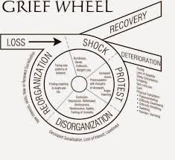
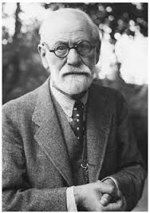
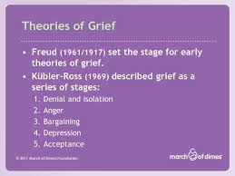

Section 3: Life After Loss: How to deal with bereavement

freud: phase model
In recent years, research has examined the ways in which we as individuals deal with bereavement. Grief work originated around 1917 when Sigmund Freud published a paper regarding his concept of grief work which, following on from this, Lindemann and Bowlby both integrated his workings into their own explanations of grief and the grieving process (Strobe & Schut, 1999). In 1961 Freud suggested that grief was a solitary process that individuals follow once they have lost a loved one. Freud stated that firstly, individuals would become withdrawn from society and the world around them in order to lessen the blow received shortly after the death of a loved one. During this time, it is suggested that detachment from the deceased would then become more of a gradual process. The psychological function of grief was then thought to release the individuals from their bond in which they had with the deceased when they were alive. By reliving memories and looking back at the past, individuals can then find themselves detaching from the deceased whilst working through the loss in order to overcome the grief (Buglass, 2010).
Following on from Freud’s research, Kubler-ross (1969) identified the five stages of grief known as, denial, anger, bargaining, depression and acceptance. Although the research conducted by Kubler-ross (1969) follows on from Freud and suggests as he does that there are stages in relation to bereavement and the ways in which individuals deal with grief, there are many limitations to the research. One limitation that stage/phase models have is that although it is not disputed that the stages are there, the reality of bereavement is that the stages/phases can overlap or occur in different sequences rather than the set stages set out by Freud and Kubler-ross. Corr (1993) suggested that the research carried out by Kubler-ross was mainly based around clinical impressions as opposed to being based around empirical data therefore suggesting that it cannot be properly applied to those who are currently or who have recently been through a bereavement (Buglass, 2010).
Sigmund Freud’s 1917 work ‘Mourning and Melancholia’ suggested that the crossover between melancholia (a feeling of deep sadness) and mourning seemed justified by the general picture of the two conditions. Mourning is suggested to be the general reaction to the loss of a loved one or the loss of a concept that has been taken over such as one’s liberty or an ideal and so on. Freud suggested that the distinctive mental elements of melancholia were; painful depression, termination of one’s interest in the outside world, loss of capability to love and so on (Freud, 1957). Freud’s theory however has been criticised for the fact that it assumes a model of subjectivity that is purely based upon strongly bounded forms of individualisation. Freuds theory suggests that mourning a loved one simply comes to an end once the bond between the deceased and the individual going through bereavement has lost its emotional attachment. Although there has been a vast amount of criticism surrounding Freud’s ‘Mourning and Melancholia’, Sacks (1985) argued that the composition from Spenser and Yeats in some ways reflects a Freudian economy where reassuring substitution becomes the central aim (Clewell, 2004).
In recent years the original multistage theories of grief have moved away from the set stages in which one grieves a loved one and focuses more on the fact that responses to loss are more widely variable than once thought and that there is no clear defined course that individuals must go through in order to grieve their loved ones. An article by Maciejewski et al (2009) suggested that although the stage/phase models posed some good points, they do not take into account the variability in the nature and course of grief therefore suggesting that there is no definitive stages to grief (Silver & Wortman, 2007).

Attachment Theory
The attachment theory, designed by Bowlby (1973), examines the importance of human attachments and the bonds that individuals have with their loved ones that are developed early on in life. As both Freud and Kubler-ross suggested, Bowlby also suggests that grief is overcome through four stages that are somewhat overlapping and flexible. These stages are known as, shock, yearning and protest, despair and finally recovery (Buglass, 2010). The attachment theory sets out to provide an explanation for the common need that humans have to form powerful affectional bonds with other individuals, and the reactions or emotional distress that is ultimately caused when these individuals are no longer around leading to the detachment of these previously formed bonds. Bowlby uses childhood experience in order to better explain bereavement and how our childhood experiences influence the ways in which we deal with bereavement in adulthood. Parkes (1998) carried out similar research to Bowlby and suggested that like Bowlby’s theory of bereavement, there are four phases of bereavement. These are; Shock or numbness, yearning or pining, disorganization and despair and then eventually recovery. This particular theory proposes that grief is the transition in which the bereaved person goes through from the distressed state of confrontation with reality right through to some form of a resolution. The issues with both Bowlby and Parkes’ theories is that the grief work hypothesis suggests that there is some kind of notion in which individuals go through and are forced to confront in order to come to terms with the death of a loved one in order to prevent detrimental health consequences (Buglass, 2010).
The attachment theory could in turn, be linked to the vast amounts of research that have been carried out over the last few decades on mortality rates of the bereaved. Considerable amounts of research based on the health implications of bereavement. Bereavement has over the years been linked to an increase in mortality rates for the close relatives of the deceased, Research in this area has been ongoing since the late 50s where Kraus and Lilienfeld suggested that individuals who were married seemed to have lower death rates throughout different age groups than those who were single, widowed or divorced. Following on from this, Young et al (1963) sought to examine the duration effect in relation to widowhood and mortality and found that mortality rates rose by 40% when becoming widowed (Rees & Lutkins, 1967). Research into traumatic life-events have in recent years progressed from research surrounding cumulative effects of life events with the use of scales such as the social readjustment rating scale to in recent years becoming more focus specific in areas such as bereavement (Strobe, Strobe & Schut, 2007). Research into whether or not the death of a loved one increases the risk of mortality has become more common over the last few decades. Longitudinal studies have been carried out in order to examine the impact that the death of a loved one has on mortality rates and these types of studies appear to be the most effective at finding relevant links between the two. It has been suggested through the vast amounts of research carried out on spousal bereavement that individuals who are recently bereaved (within around six months) are more likely to be prone to either develop physical health problems or in severe cases, it can lead to death of the bereaved (Strobe, Strobe & Schut, 2007).
Throughout history the study of grief and bereavement has been approached in way of studying the depressive illnesses that adults seem to have after the loss of a loved one. Over the years, few attempts have been made by psychoanalysts to hypothesise the processes that are grief and mourning and a vast amount of the literature out there looks predominantly at depressive illness with adults in relation to grief and bereavement (Bowlby, 2008). The attachment theory can be used to explain both mortality rates and declines in health whether that be mental or physical health due to the loss of a loved one.

Section 4: Conclusion

Conclusion
Although grief theories of bereavement have their positives ad can be linked to situations such as the increase in mortality rates after the death of a loved one (attachment theory), there are still many limitations to the research. Grief is seen as a involuntary reaction to bereavement and misapplying grief theories and stages of grieving to individuals could potentially lead to the individuals developing a ‘should or must’ attitude towards grieving where they believe they are either grieving wrong as they are not in the stages they should be or it could lead to them questioning their own bereavement processes which could lead to them becoming stressed/ill. It should also be taken into account when examining stage/phase models when looking at bereavement that all individuals can and will grieve differently due to differences in personality traits and cultural backgrounds along with the issue surrounding the nature of the relationship between the bereaved and the deceased. Person-centred counselling has been suggested to be a key strategy to overcome bereavement along with support groups and talking therapy.

References
Bowlby, E. J. M. (2008). Loss-Sadness and Depression: Attachment and Loss (Vol. 3). Random House.
Buglass, E. (2010). Grief and bereavement theories. Nursing Standard (through 2013), 24(41), 44.
Casarett, D., Kutner, J. S., & Abrahm, J. (2001). Life after death: a practical approach to grief and bereavement. Annals of internal medicine, 134(3), 208-215.
Clewell, T. (2004). Mourning beyond melancholia: Freud's psychoanalysis of loss. Journal of the American Psychoanalytic Association, 52(1), 43- 67.
Engel, G. L. (1960). Is grief a disease? A challenge for medical research. Psychosom. Med., 22, 18-25.
Freud, S. (1957). Mourning and melancholia. In The Standard Edition of the Complete Psychological Works of Sigmund Freud, Volume XIV (1914- 1916): On the History of the Psycho-Analytic Movement, Papers on Metapsychology and Other Works (pp. 237-258).
Hall, C. (2014). Bereavement theory: recent developments in our understanding of grief and bereavement. Bereavement Care, 33(1), 7-12.
Kleinman, A. (2012). Culture, bereavement, and psychiatry. The Lancet, 379(9816), 608-609.
Lund, D. A., Caserta, M. S., & Dimond, M. F. (1993). The course of spousal bereavement in later life. Handbook of bereavement: Theory, research, and intervention, 240-254.
Neimeyer, R. A., & Holland, J. M. (2015). Bereavement in later life: Theory, assessment, and intervention. In APA handbook of clinical geropsychology, Vol. 2: Assessment, treatment, and issues of later life. (pp. 645-666). American Psychological Association.
Office of National Statistics (2019, November 26) Deaths registered monthly in England and Wales. Retrieved from: https://www.ons.gov.uk/peoplepopulationandcommunity/birthsdeathsandmarriag es/deaths/datasets/monthlyfiguresondeathsregisteredbyareaofusualresidence
Prigerson, H. G., Horowitz, M. J., Jacobs, S. C., Parkes, C. M., Aslan, M., Goodkin, K., ... & Bonanno, G. (2009). Prolonged grief disorder: Psychometric validation of criteria proposed for DSM-V and ICD-11. PLoS medicine, 6(8), e1000121.
Rees, W. D., & Lutkins, S. G. (1967). Mortality of bereavement. British Medical Journal, 4(5570), 13.
Schut, M. S. H. (1999). The dual process model of coping with bereavement: Rationale and description. Death studies, 23(3), 197-224.
Silver, R. C., & Wortman, C. B. (2007). The stage theory of grief. JAMA, 297(24), 2692-2694.
Stroebe, M. S., Schut, H. A. W., & Stroebe, W. (2007). Health consequences of bereavement: A review. The Lancet Infectious Diseases, 370(9603), 1960-1973.
Stroebe, M. S., Stroebe, W., & Hansson, R. O. (Eds.). (1993). Handbook of bereavement: Theory, research, and intervention. Cambridge University Press.
Zisook, S., & Shear, K. (2009). Grief and bereavement: what psychiatrists need to know. World Psychiatry, 8(2), 67-74.

