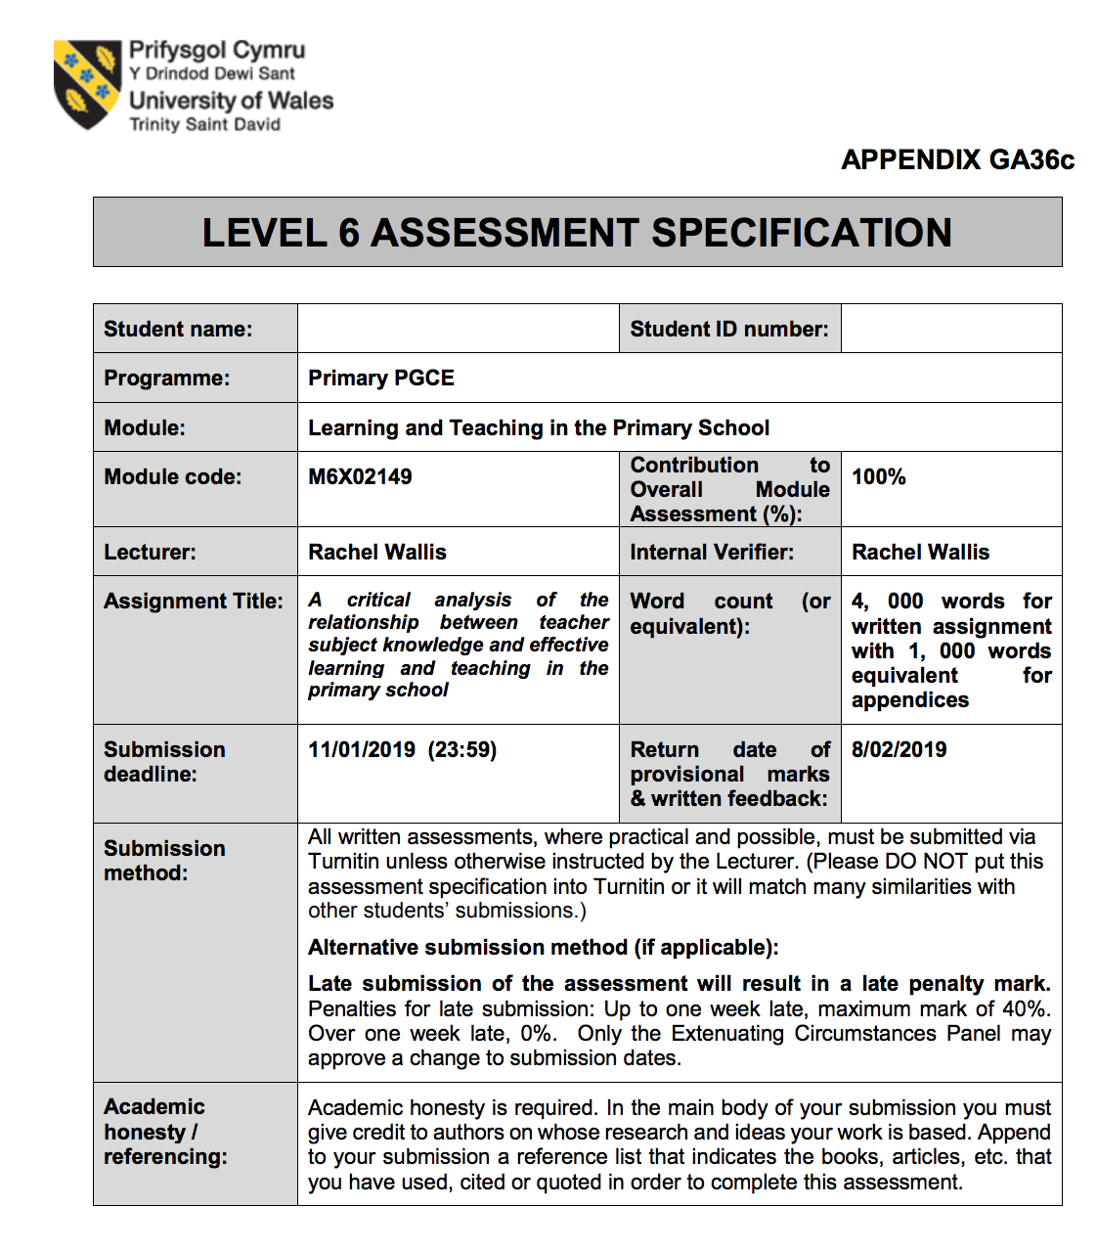
P143981
Kieron James
A critical analysis of the relationship between teacher subject knowledge and effective learning and teaching in the primary school

Kieron James P143981
Deadline: 11/01/19
Learning and Teaching in the Primary School
Rachel Wallis

Introduction
Subject knowledge is seen as a key aspect of a teacher’s job, with research that suggests poor subject knowledge relating directly to poor results for the teachers. This essay will discuss the relevant literature around subject knowledge and its impact on the standard of teaching. It will also look at the incoming curriculum in Wales and what potential impact could that have on teachers relating to their subject knowledge.

I will then analyse my subject knowledge against the current literature by basing it on my experience while on part one of my PTE experience. Throughout the essay the school and all the staff and pupils will be kept anonymous to ensure that the essay complies with the British Education Research Association (BERA) guidelines.
The school are a Welsh Government funded flying start facility while they also offer a gypsy traveller service such is the requirement of the local community. The school has 32% of pupils that are eligible for free school meals and identifies 44% of pupils as having additional learning needs. There are very few pupils from an EAL background. I was placed in a reception class with 27 children in there (15 boys and 12 girls) who were between the ages of 4 and 6. The classroom had a teacher and two full time teaching assistants who were there to provide assistance throughout my time on PTE.

Literature review
Subject knowledge is seen as an important aspect of being an effective teacher. In 1987 Lee Schulman wrote a report called ‘Knowledge and Teaching: Foundations of the New Reform’ this report sparked the debate of the importance of a teacher’s subject knowledge.
Schulman (1987,p.7) cites Fenstermacher (1986) who stated that “A teacher knows something not understood by others, presumably the students. The teacher can transform understanding, performance skills or desired attitudes or values into pedagogical representations and actions”. This suggests that both Schulman and Fernstermacher believe that a teacher should use their knowledge of a subject and use this to further their pupils learning in order to get the desired results from the students.

Schulman (1987, p.8) believes that there are seven categories of a teacher’s knowledge base, these are:
- Content knowledge.
- General pedagogical knowledge.
- Curriculum knowledge.
- Pedagogical content knowledge.
- Knowledge of learners and their characteristics.
- Knowledge of educational contexts.
- Knowledge of educational ends.

Pedagogy has been defined as "the art, science or profession of teaching" (Kincheloe, 2005, p.53). while general pedagogical knowledge has been defined as the knowledge of teaching and learning theories, principles, and processes that cut across disciplines (Auseon, 1995, p.56). (Auseon, 1995, p.56) cites (Gudmundsdottir, 1987, p. 6). Who defines subject matter knowledge as the teacher's understandings of the subject she/he teaches. The combination of both subject matter knowledge and general pedagogical knowledge allowed Schulman to develop the theory of pedagogical knowledge. Schulman (1987, p.8) believes that “pedagogical content knowledge is the blending of content and pedagogy into an understanding of how particular topics, problems, or issues are organised, represented and adapted to the diverse interests and abilities of the learners”. Schulman is suggesting that pedagogical content knowledge is key to becoming an effective teacher as it allows the teacher to develop lessons that will engage the students and help them achieve the desired targets.

The research by Schulman led to the development of the knowledge quartet by Tim Rowland. Rowland (2005) states that “the Knowledge Quartet (KQ) is a theoretical framework for the analysis and development of mathematics teaching”. Rowland studied twenty-four mathematics lessons conducted by trainee teachers with the of determining how mathematical content knowledge is evident within their lessons. Rowland (2005) ‘identified 18 categories which were later grouped into four subordinate units’ these were:
- Foundation
Rowland (2005) states that “This first category consists of trainees’ knowledge, beliefs and understanding acquired in the academy, in preparation (intentionally or otherwise) for their role in the classroom"
- Transformation.
Rowland (2005) states that “The second category concerns knowledge-in-action as demonstrated both in planning to teach and in the act of teaching itself.” This suggests that the teachers will be aware of the pedagogy of teaching and be able to ensure that all lessons are pitched at a level that can be understood by the intended target.

- Connection.
Rowland (2005) states that “This category binds together certain choices and decisions that are made for the more or less discrete parts of the content”. Rowland is suggesting that the teachers understand the content and are aware of the links that could be made between various parts of the content that link together. They understand when it is appropriate to progress the content to further the learning.
- Contingency.
Rowland (2005) states that “Our final category concerns classroom events that are almost impossible to plan for. In commonplace language it is the ability to ‘think on one’s feet”. Here Rowland is stating that the teachers must be able to adapt and overcome any unforeseen circumstances within the lessons. An example could be being able to answer a difficult question posed by a child and using it as a learning experience that deviates from the intended lesson plan.

Coe et al (2014) conducted research into what makes great teaching and defined effective teaching “as that which leads to improved student achievement using outcomes that matter to their future success” (Coe et al, 2014). Coe et al (2014) suggests that there are six components that are considered when assessing the quality of teaching these are:
- Pedagogical content knowledge
- Quality of instruction
- Classroom climate
- Classroom management
- Teacher beliefs
- Professional behaviours
Coe et al (2014) believes that Pedagogical content knowledge is the most vital aspect to being a high-quality teacher and states that there is strong evidence of a positive impact on the children’s learning. This supports Schulman’s view that pedagogical content knowledge is key to a teacher being effective and reaching the desired results from their teaching.

Coe et al (2014) cites Sadler et al (2013) who tested a group of experienced school science teachers on their understanding of the content they were teaching and on the kinds of misconceptions they expected students to show. Coe et al (2014) reports that the understanding of the content was good, however, the teachers’ ability to identify pupils’ misconceptions in the lesson was not as expected. Following the results of Sadler et al (2013) report, Coe et al (2014) suggests that supporting teachers in their understanding and knowledge of students’ misconceptions will be a promising strategy to improve the impact that they can have on their lessons. This claim is supported by reviews of the impact of teacher professional development in these areas (Timperley et al, 2007; Blank and de las Alas, 2009).

(Shulman, 1987, p.14) states “Most teaching is initiated by some form of "text": a textbook, a syllabus, or an actual piece of material the teacher or student wishes to have understood”. Shulman is suggesting that teaching that is conducted by the teacher is usually started with a stimulus that either the teacher or a student has a prior knowledge of. He later states that “Although most teaching begins with some sort of text, and the learning of that text can be a worthy end in itself, we should not lose sight of the fact that the text is often a vehicle for achieving other educational purposes” (Shulman, 1987, p.14). This suggest that educators must have a good base level of content knowledge to be able teach their students. This does not require an exceptional content knowledge to be an exceptional teacher as an expert in a field may not have the pedagogical knowledge required to be a good teacher. This research is supported by The National Association for Research in Science Teaching (NARST) believe that ‘A science teacher’s knowledge is used as a basis for helping students understand scientific concepts. While a scientist’s knowledge is from a research perspective and is used as a basis of developing knowledge in their field’ (NARST, n.d.).

The research by NARST is another strand of research that is in support of Schulman (1987) and Coe et al (2014) in suggesting that while subject content knowledge is important and pedagogical knowledge is important, it is the incorporation of both these that is required to develop pedagogical subject knowledge which is the key aspect to being an effective teacher.
Enser (n.d.) states that “We can see this need for excellent subject knowledge in Rosenshine’s Principles of Instruction (Rosenshine, 2012). Like Coe’s work, this looked at the defining characteristics of effective teaching and found, among other things, that effective teachers were able to provide detailed explanations of the material they were teaching”. This view is shared by Willingham (2009) who believes that “In many subjects, we need to ensure that our knowledge is broad as well as deep. Pupils learn best when they are provided with a wide variety of examples to illustrate an abstract concept.”
Hill et al (2005) investigated the importance of teachers’ pedagogical content knowledge in mathematics. Hill cited a number of different studies that found that a teachers’ level of understanding of mathematics directly correlated to the achievements of their pupils.
Hill et al (2005) suggests that a teacher with good pedagogical content knowledge equated to more than a month’s additional learning for students in a year. This is significant as it is further evidence that teachers should develop their subject knowledge as it means that they will get greater results from their students. Metzler and Woessmann (2012, pg.1) agree with Hill et al (2005) findings and reported that “teacher subject knowledge exerts a statistically and quantitatively significant impact on student achievement therefore teacher subject knowledge is a relevant observable factor that is part of overall teacher quality”.

Following the results of the extensive research carried out by various academics, Professor Daniel Muijs of OFSTED (n.d) believes that “Teachers should have to prove their subject knowledge is up-to-date at regular intervals to maintain their qualified status” this highlights the importance that OFSTED are placing on subject knowledge with indications that it will become a requirement for teachers to stay up to date with their subject knowledge in order to maintain their qualified teacher status. Muijs believes that teachers should be required to attend subject CPD events to ensure that they are up to date and meeting the needs of the curriculum.

Poulson (2001) cites Wragg, Bennett and Carre (1989) reported “a survey of teachers in 400 primary schools in Great Britain, which found that many seemed to have limited knowledge of some subject areas and did not feel confident to teach them the National Curriculum”. Poulson highlights that teachers may not be confident to teach the whole of the curriculum, this is a pressing issue, even more so in Wales. Wales is about to undertake a significant education reform; Professor Graham Donaldson has been tasked with developing a new curriculum for Wales which is to be introduced to the whole of Wales by 2022.
Donaldson (2015, Pg.5) states that “there is a belief that subject knowledge has stood the test of time and remains the best path to a sound and relevant education.” This led to Donaldson moving away from stand-alone subject and he has developed a new curriculum which has four main purposes he wishes to meet.
The Welsh Government (n.d) state that the four purposes are that all children and young people will be:
- Ambitious, capable learners who are ready to learn throughout their lives.
- Enterprising, creative contributors who are ready to play a full part in life and work.
- Ethical, informed citizens who are ready to be citizens of Wales and the world.
- Healthy, confident individuals who are ready to lead fulfilling lives as valued members of society.
In order to meet the purposes of the new curriculum Donaldson developed ‘Seven areas of learning’ that he feels are relevant to have a successful curriculum in Wales. Donaldson (2015, pg.34) has listed the seven areas as:
- Personal and Social Development, Well-Being and Cultural Diversity.
- Language, Literacy and Communication Skills.
- Mathematical Development.
- Welsh Language Development (English-medium schools).
- Knowledge and Understanding of the World.
- Physical Development.
- Creative Development.
These seven areas are a significant change to the current curriculum and now see standalone subjects as cross curricular areas that will see teacher’s subject knowledge having to broaden in order to meet the purposes outlined by the Welsh Government.

Donaldson (2015, pg.63) believes that “Good teaching and learning means employing a blend of approaches including direct teaching”. Donaldson (2015, pg.63) cites Hattie’s (2009) definition of direct teaching as “The teacher decides the learning intentions and success criteria, makes them transparent to the students, demonstrates them by modelling, evaluates if they (the students) understand what they have been told by checking for understanding, and re-telling them what they have been told by tying it all together with closure”. This suggests that Donaldson wants the teachers to scaffold their learning to create unique learning opportunities for the children and allows them the freedom to be think creatively with their learning, this could be linked to Piaget’s theory of constructivism.

This approach to the curriculum by Donaldson suggests that they are focussing on the outcomes of the learning. He believes that learning is shaped by more than individual subjects but meeting the objectives of the curriculum. This means that the curriculum will develop key skills for the children in Wales. (Donaldson, 2015, pg.5).

However, this approach by Donaldson will create problems for current teachers within Wales. The introduction of a new curriculum that is heavily focussed on cross curricular learning with the seven areas. This puts a bigger emphasis on subject knowledge and shows that Donaldson agrees with the work of Shulman (1987) and Coe et al (2014). This will ensure that future trainee teachers will develop a much wider range of knowledge and move away from specialising in a particular subject.

Professional teaching experience analysis

From my professional teaching experience, I have had extensive experience of teaching children between the ages of four and six. This determined that my subject knowledge was not stretched to the extent it would be in a key stage two classroom, however there were a number of occasions that my subject knowledge was tested.

As I am progressing to KS2 in the second part of my PTE there will be many ways in which my subject knowledge will be tested. The theme for the term is ‘Potions’ the lessons that I will be delivering throughout the term will need to relate back to this topic area. I have very little knowledge on this topic so will require significant research in order to build my content knowledge. Coe et al (2014) states that “the most effective teachers have deep knowledge of the subjects they teach, and when teachers’ knowledge falls below a certain level it is a significant impediment to students’ learning” this highlights the importance of teachers developing their subject content knowledge being of a high standard to ensure that their students have a high-quality education. Once I have a high level of base content knowledge I will develop my general pedagogical knowledge for the age group. Progressing this I will try and merge the two together to develop my pedagogical subject knowledge to be a more effective teacher.

Language

Throughout the PTE, my subject knowledge of Welsh was challenged. I am not a fluent Welsh speaker and Welsh isn’t spoken in my day to day communications. Starting the PGCE has allowed me to develop my Welsh linguistic skills. However, while on PTE I found myself struggling to incorporate it into my lessons as it was not my natural first language. I attempted to incorporate it into my daily routine in the classroom but found many aspects of this challenging. PTE allowed me to determine that my standard of both written and oral Welsh needs significant development to meet the standards required. The lesson that I felt my lack of subject knowledge was apparent, was my first observation lesson. I was well prepared for the lesson with all my resources being set up well ahead of time, but while introducing the lesson on shapes I attempted to incorporate Welsh. I pronounced a number of Welsh words incorrectly which meant that the pupils were pronouncing the words incorrectly. This is an example of poor subject content knowledge as I was relaying false information to the children. In order to fix this, I spoke with both my university mentor and class mentor to determine methods in which I could improve my subject knowledge of Welsh. From this I proceeded to check on pronunciation with my school mentor prior to the lessons to ensure that I did not make the same mistake again. I also used this as a learning opportunity for the children, I explained to them that everyone makes mistakes and the important thing is that I have learnt from my mistake.
Moving forward in PTE I will have to increase my subject knowledge in Welsh significantly as the standard expected by the pupils will be far higher. In preparation for this I am familiarising myself with commands that the class will be used to hearing as well as phrases to praise the students throughout the day. I will also plan my Welsh lesson well in advance to ensure that I have time to make sure that all the content is correct and familiarise myself with any pronunciations that I am unsure of. Following this process fits in with Murphy’s (2011) view that a teacher’s understanding of a topic will impact on how the idea is ‘‘shaped’’ or ‘‘tailored’’ when presented in a classroom. As such, ‘‘teaching necessarily begins with a teacher’s understanding of what is to be learned and how it is to be taught’’. By improving my subject content knowledge and my pedagogical knowledge, it allows me to have a precise idea of what content needs to be covered and how it needs to be delivered.

Literacy and communication

On my PTE my communication skills were tested throughout as I had to adapt my delivery style to ensure that the children could understand instructions. The lesson in which I am going to reflect on is a PE session to 27 children (see appendices 3.0). I found this to really test my communication skills as PE is a passion of mine and I like to pride myself on my subject knowledge due to my large amount of experience of delivering sport. The aim of the session was to develop basic ball skills, prior to the session I was confident that I would be able to achieve the objective of the session as my content knowledge is excellent. However, I found myself using phrases and delivering in a far too complex way for the age group of the session, this suggests that while my content knowledge was sufficient, my pedagogical content knowledge was not at the level required to deliver to that age group. The definition posed by Schulman (1987, p.8) states that “pedagogical content knowledge is the blending of content and pedagogy into an understanding of how particular topics, problems, or issues are organised, represented and adapted to the diverse interests and abilities of the learners”. While I have significant content knowledge, the lack of pedagogical knowledge for that age group and therefore impacted the effectiveness of my session. In order to improve my overall subject knowledge, Schulman (1987) believes that it is the teacher’s responsibility to use the content knowledge and ensure that this knowledge becomes pedagogically powerful for the lesson delivery. Therefore, to overcome the lack of pedagogical knowledge that I possessed, I thoroughly researched ways in which I could adapt my delivery and sessions to ensure that the next session would allow the children to meet the desired lesson objectives.

While my subject knowledge in Literacy was not challenged in reception, as I was confined to teaching Read Write inc sessions which are very limited in content. However, it is highly likely that my subject knowledge will be challenged when I progress to year five in part two of my PTE experience. I had a meeting with the class teacher to determine what aspects of literacy I would be teaching. The area of the literacy curriculum that I have been given will require me to thoroughly research both the content and pedagogical knowledge to ensure that I am sufficiently prepared to deliver effective lessons.

Mathematics and Numeracy
On my PTE experience, I was given the topic of shape by the class teacher. It was an introduction to shape and the class had very little experience of identifying shapes at all. My subject content knowledge was far advanced of what was required for a reception class. However, the first lesson of the topic (See appendices 2.0) was also my first lesson on PTE. I had prepared as much as possible to ensure that the lesson went to plan but was feeling nervous as it was my first teaching experience. The content of my lesson was correct for the age group but as I was teaching I found that my pedagogical knowledge was not sufficient for the task. I did not have an effective teaching style for the lesson and used to much complicated language for the age group I struggled with the organisation of my resources and this led to a disjointed session and showed poor pedagogy on my behalf. This led to confusion within the task and also affected my confidence as a teacher and meant that all the children did not achieve the objectives of the session. Shulman (1987) states that “the key to distinguishing the knowledge base of a teacher lies at the intersection of content and pedagogy, in the capacity of a teacher to transform the content knowledge she or he possesses into forms that are pedagogically powerful and yet adaptive to the variations in ability and background presented by students.” This suggests that the amount of subject knowledge while important will not get the required results from the teaching if the teacher’s pedagogical knowledge is not of a standard high enough to engage the children.
Upon my reflection of that lesson (see appendix 1.0 ) I re-evaluated some aspects of my teaching and delivery to ensure that the remaining groups received a better learning experience. The next lesson I had separated my resources in a far more organised manner and had researched what vocabulary I should use while delivering the session. The groups that completed the tasks following this had a far better learning experience.
This was me improving my general pedagogical knowledge and led to a far more engaging and successful lesson for the class when I completed it the very next day.

Digital competency
Digital competency was not a major focal point in the foundation phase classroom. I used only very basic DCF elements as the ICT equipment in the classroom was limited. However, I had the chance to help a year six class with an ICT project on excel as the teacher was not confident with using the software. There was no planning required on my behalf, but it enabled me the opportunity to share my extensive knowledge with regards to digital competency. This allowed me to guide the class through a tutorial of basic excel functions and the teacher gave me the scope to extend the task for those pupils who were excelling. I felt that the teacher gave me a chance to show my pedagogical subject knowledge and I feel that I was able to help all the children in the class meet their target for the sessions I was involved in. Lenon (2015) states that “Good subject knowledge matters not only because at the top of the ability range you need to be able to stretch pupils but also because teachers with good knowledge tend to make lessons for younger children more interesting. They have more substance to be interesting about”. I feel that the opportunity I was presented allowed me to develop my understanding of the importance of good subject knowledge in delivering sessions, I was able to stretch the high performing students while make the other student achieve their targets while ensuring they were engaged throughout. Heggart (2016) believes that “expert teachers can make use of their subject knowledge to organise and use content knowledge more effectively for their students to understand. In addition, expert teachers are more likely to be able to respond to the needs of any particular classroom” I believe that aspects of Heggarts’ belief were on show throughout my ICT session as I was able meet the needs of all the children within the classroom, therefore showing a high level of “pedagogical subject knowledge”

Conclusion
To conclude from the extensive amount of literature on subject knowledge it is evident that there is a direct link between a teacher’s subject knowledge and the performance of the children in that class. Coe et al (2005) highlights a number of key aspects for effective teaching with “Pedagogical content knowledge” being the most important aspect. This aspect of subject knowledge has made me consider the implications that poor subject knowledge has on the learners. Following this I will take steps to ensure that my subject knowledge is of a high standard to ensure that my students have the most positive learning experience possible.
With the new curriculum that is coming to Wales a wide range of subject knowledge is more important than ever. By moving away from stand-alone subjects and towards areas of learning, having a broad spectrum of knowledge is far more important than specialising in one or two subjects. Failure to broaden your knowledge base could have significant detrimental effects on the achievements of the class.
In my future teaching I will take the feedback from my mentors and students to ensure that all my content is relatable for the age group and I will attempt to make sure the way I pitch my sessions is to an appropriate level for the students. With regards to my language, I will continue to develop my understanding and knowledge of Welsh to ensure that I am hitting the targets set out by the Welsh Government.
References

- Auseon, J. (1995). The Role of Pedagogical and Subject Matter Knowledge in Preservice Art Teaching. Marilyn Zurmuehlen Working Papers in Art Education, 13(1), pp.54-68.

- Coe, R., Aloisi, C., Higgins, S. and Major, L. (2019). What makes great teaching?. Review of the underpinning research. [online] Durham: Sutton Trust. Available at: https://www.suttontrust.com/wp-content/uploads/2014/10/What-Makes-Great-Teaching-REPORT.pdf

- Donaldson, G. (2015). Successful Futures. Independent Review of Curriculum and Assessment Arrangements in Wales. Cardiff: Welsh Government, pp.1-65.

- Edwards, Ruth & Hyde, Rosalyn & O'Connor, Mary & Oldham, Jacqueline. (2015). The importance of subject knowledge for mathematics teaching: An analysis of feedback from Subject Knowledge Enhancement Courses.

- Enser, M. (n.d.). Knowing your subject: The role of disciplinary knowledge in effective teaching | impact.chartered.college. [online] impact.chartered.college. Available at: https://impact.chartered.college/article/enser-knowing-subject-disciplinary-knowledge-effective-teaching/ [Accessed 3 Jan. 2019].

- Government, W. (n.d.). Learning Wales. [online] Learning.gov.wales. Available at: http://learning.gov.wales/news/sitenews/successful-futures/?lang=en.

- Heggart, K. (2016). How Important is Subject Matter Knowledge for a Teacher?. [online] Edutopia. Available at: https://www.edutopia.org/discussion/how-important-subject-matter-knowledge-teacher [Accessed 4 Jan. 2019].

- Kincheloe, J. (2005). Classroom teaching. New York: Peter Lang.

- Lenon, B. (2015). What really makes a good teacher?. [online] Telegraph.co.uk. Available at: https://www.telegraph.co.uk/education/educationopinion/11347131/You-dont-need-a-qualification-to-be-a-good-teacher.html [Accessed 2 Jan. 2019].

- Metzler, J. and Woessmann, L. (2012). The impact of teacher subject knowledge on student achievement: Evidence from within-teacher within-student variation. Journal of Development Economics, 99(2), pp.486-496.

- Murphy, C. (2011). The role of subject knowledge in primary prospective teachers’ approaches to teaching the topic of area. Journal of Mathematics Teacher Education, 15(3), pp.187-206.

- NARST (n.d.). NARST: Publications - Research Matters - to the Science Teacher. [online] Narst.org. Available at: https://www.narst.org/publications/research/pck.cfm.

- Ofsted (2008). Improving primary teachers’ subject knowledge across the curriculum. A summary of evidence from subject surveys (excluding English and mathematics) 2007/08. [online] London: Ofsted. Available at: https://dera.ioe.ac.uk/305/1/Improving%20primary%20teachers%20subject%20knowledge%20across%20the%20curriculum.pdf.

- OFSTED (n.d.). Ofsted boss calls for teachers to prove subject knowledge. [online] Schools Week. Available at: https://schoolsweek.co.uk/ofsted-boss-calls-for-teachers-to-prove-subject-knowledge-to-stay-qualified/.

- Poulson, L. (2001). Paradigm Lost? Subject Knowledge, Primary Teachers and Education Policy. British Journal of Educational Studies, 49(1), pp.40-55.

- Rowland, T. (2014) The Knowledge Quartet: the genesis and application of a framework for analysing mathematics teaching and deepening teachers’ mathematics knowledge. SISYPHUS Journal of Education, 1(3), pp. 15-43 [downloadable from http://revistas.rcaap.pt/sisyphus/issue/view/293]

- Shulman, L. (1987). Knowledge and Teaching: Foundations of the New Reform. Harvard Educational Review, 57(1), pp.1-23.
Appendices

Appendices 1.0
Profiad/ Experience

Teimladau/  Feelings  Beth yw eich teimladau ynghylch y profiad?  “What are your feelings regarding the experience?” | I was given the numeracy topic of ‘shape’ to teach to the children within the class. I felt that my introduction went well, and all the children enjoyed my introduction to simple 2D shapes.  I felt that my task was a good indicator for me to gage the ability of the children as I am still getting to know the children. I was surprised by how difficult some children found the task and the lack of previous knowledge with shapes. I feel this had a significant impact on the pace of my session.
Cofio a Deall/  Remember and Understand  Allwch chi restru’r agweddau ar y profiad dysgu a aeth yn dda?  “Can you list the aspects of the learning experience that went well?”  Pa elfennau o’r profiad dysgi oedd yn siomedig?  “What were the elements of the learning experience that were disappointing?” | I was pleased with my session because the it challenged the children but most of the 10 children (2 groups out of 6) completed the task.  The children enjoyed learning about shapes and were able to think of real-life examples of the shapes that they learnt about.  The children developed their fine motor skills by gluing and sticking the pictures into the correct category.  The children were able to label the shapes correctly, they differed in the way they Copied the words, the methods used were copying off a whiteboard or by over/under writing the words.  I was disappointed with my classroom management with regards to low level disruption. I do not feel I dealt with low level disruption as well as I could have. The children were fiddling and not sitting properly during my introduction. I feel this had an impact on the learning of some individuals within the group. So, this will be something I develop in my future teaching.  I also think that my organization needs improvement. While all my resources were set up and books prepped for the lesson ahead of time. When I started taking the lessons I got a little confused with the number of resources I had out at once and this slowed down my teaching and therefore increased the amount of time that I was teaching for.
Gwerthuso a dadansoddi/  Evaluate and analyse  Beth fyddwch chi’n cadw’r un fath i sicrhau dysgu ac addysgu effeithiol yn y dyfodol?  “What will you keep the same to ensure effective teaching and learning in the future?”  Beth oedd achos yr elfen siomedig bwysicaf?  “What was the cause of the most important disappointing element?” | When I repeat this lesson for the remaining groups on Thursday I will keep the task the same as I feel that it challenged the children but was achievable. I think that doing this will continue to work on the positive elements that I experienced in my lesson. I will also repeat the introduction to the smaller groups as opposed to the whole class, this will allow me to reinforce the learning and therefore should allow the children to complete the task correctly.  I think the cause of the most disappointing issue was the nerves that I felt as it was my first lesson that I had planned myself. I feel that If I had been slightly more organised I would have been able to get through another group of children in the session and therefore reducing the workload for later in the week.
Casgliadau a chamau gweithredu/  Conclusions and actions  Beth yw eich atebion posibl i’r materiaon siomedig a nodwyd?  “What are your possible solutions to the disappointing issues identified?”  Beth ydych yn mynd i’w wneud nesaf?  “What will you do next?” | I believe that the solutions to the issues identified are:  To target the low-level disruptions, I will go over the classroom rules with the group to ensure that every child is reminded of what is expected of them in every session. Then if the low-level disruption continues I will ensure that I pick them up and stop them as soon as I notice. This will also reinforce the rules to other children and act as a deterrent.  To improve my session, it is imperative that I improve my organisation. I will ensure that my resources are laid out in a far more effective manner to allow for the session to run more smoothly and therefore improve the learning experience of the children.  I will ensure that I incorporate the solutions that I have outlined into my future teaching and this should ensure that any tasks I do in the future will not encounter the same issues that I faced.
Y profiad newydd / Transformed experience

Profiad/ Experience

Teimladau/  Feelings  “What are your feelings regarding the experience?” | I believe that this session was a significant improvement to the previous session that I taught. The session to the remaining groups was far more fluent as I had organised myself which allowed for a more effective session. However, I do not feel that I was strict enough with the children, while this was an improvement on the first session I feel that it needs to be a factor that I put serious consideration into to improve the standard of my teaching.  The session pace was quicker than the previous session, I believe this was because I was becoming more comfortable with teaching and the topic as a whole. This allowed me to use the language that the children could understand, this meant that with prompts they could identify the 2D shapes. I feel that the groups taught today were of a higher overall ability than the previous session and therefore completed the task in a quicker time which enabled me to get through the remaining groups in the allotted time.
Cofio a Deall/  Remember and Understand  How did the use of resources impact the learning?  Why did learners engage the way they did? | The use of resources had a number of positive impacts on the learning these were:  - Pictures of the items that are recognisable to them gained their interest and therefore made them more enthusiastic in the session.  - The children enjoyed the responsibility of gluing the pictures into the books themselves and this was used as a motivating factor throughout the session.  However, the resources did have a negative impact on the learning, the negative was:  - As I had a wide array of pictures, some children were complaining that they didn’t have the same pictures as someone else and this caused a minor tantrum. While I dealt with the issue immediately, it did interrupt the flow of my session negatively.  The learners engaged the way they did because shape is a topic that they come across every day without realising. After the session I had children bring me items from around the classroom that were different shapes, so this suggests to me that it is a topic that the children enjoy and therefore they are willing to engage with.
Gwerthuso a dadansoddi/  Evaluate and analyse  What was the cause of the most disappointing element?  How does this session compare with the last session taught? | The cause of the most disappointing element of my session was the lack of attention I paid to minor disruptions. I forgot to reinforce the classroom rules to the first group and this led to some silly behavior from certain members of the group. This was disappointing as I had personally identified that being an issue from my first session. While it improved in the further groups I still believe that it was the most disappointing element of the session.  This session was a significant improvement on my previous session as my personal organisation in the task was far better. This ensured that the children’s learning experience was a much more positive experience. This session also had improved quality in the teaching as I had become more comfortable with teaching the topic and was able to teach with more clarity.
Casgliadau a chamau gweithredu/  Conclusions and actions  How will you solve the main issue with today’s session? | I will ensure that every group will discuss the classroom expectations before the session. This will reinforce the rules to the children and therefore this should reduce the amount of minor interruptions that I face during the session. This will allow my future sessions to be of a higher quality and improve my teaching as the children will become accustom to the expectations I set out as a teacher.
Y profiad newydd / Transformed experience

Appendices 2.0

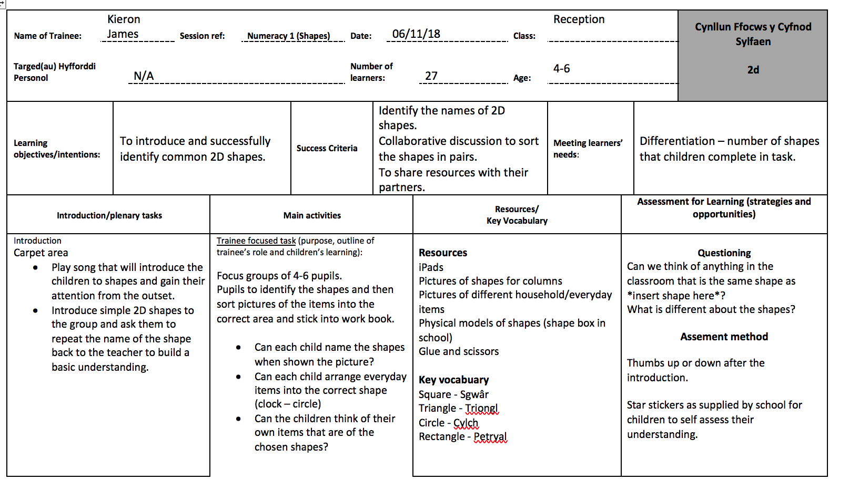

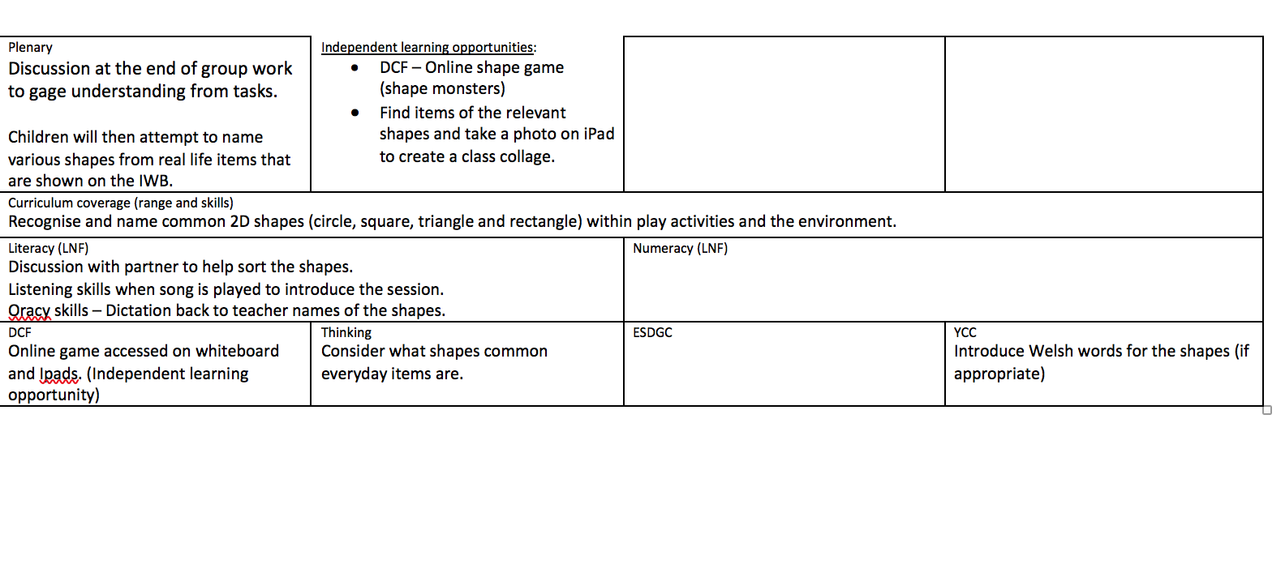
Appendices 3.0


