Student ID: 2018162 Level 4. Certificate of Higher Education Professional Skills for Construction
Student name: Catalina Trasc Module: Construction Technology - Past and Present

Domestic Building Components
and their Functional Requirements

- Introduction
- Primary functions of a building
- Components of the proposed building
  - Substructure
  - Superstructure
  - Functional requirements of components: foundation, walls( exterior and interior), doors, windows, roof, finishes
- Proposed 3 bedroom bungalow
- The windows
  - Definition
  - Functional and Performance Requirements
  - Terminology
  - Classification of windows: by material, method
  - Method of Window Installation
  - Issues associated with Construction of windows
  - Remedies to Performance Issues
- Conclusions

- Introduction:
The main purpose of this essay is to present the components of a 3 bedroom bungalow type construction. In the first part, the author wants to expose in usual and easily accessible terms both the main functions of a building and each basic function of the main components. In the second part, the attention will be subjected to a component within the superstructure, namely the windows, these representing a subject of interest both from a functional point of view and from an architectural point of view.
The building is usually a structure with a roof and walls built for permanent use. The rudimentary buildings were originally built out of the purely functional need for a controlled environment that would moderate the climatic effects. Buildings are complex, dynamic and socio-technical systems that want to provide solutions to a multitude of design problems.

- Primary functions of a building:
The three primary functions of any building are:
- To insure safe and stable enclosure
- To insure comfortable environmental conditions
- Aesthetic and psychological appeal

- Components of the proposed building:
It is very important to understand the main components of a simple ground floor bungalow and the
construction stages on site after the design is decided. Obviously the construction starts by preparing the support layer, by topographic measurements that establish exactly the position of the future house. Then plants, trees and any other impediments are removed from the field, then the axes of the construction are drawn, after which the earth is dug.
The first stage and one of the most important is the realization of the foundation respecting the plans (dwg – Drawing ) provided by the designer. All the installations of the house (water supply, sewerage, electricity, heating and ventilation system) will be incorporated in the foundation so that later they will be divided in each room of the construction, where they are requested. After the completion of the foundation, the slab is made over the ground floor, it is continued with the exterior walls, the interior ones, the slab over the ground floor, the roof, windows and doors and finally the finishes are made, both interior and exterior. The finishes are referring to plastering works, painting, install tiles and parquet, sanitary objects, electric lights, radiators, other types of carpets, wallpaper, glass, decorative bricks whatever the customer requests are.

  - Substructure:
Substructure and superstructure are the two major components of a building project. The substructure it is defined as: “that part of a building or other structure which is below the ground, unlike the superstructure which is above the ground. Typical stages or elements of the substructure, such as foundations, are listed in the margin.” (A.V. Hore, et al., 1997)
The substructure represents the lower part of a building that is built below ground level. The substructure function is the load transfer from the superstructure to the underlying soil, in this way the infrastructure is in direct contact with the supporting soil, involving the foot and plinth of a building. The substructure is that part of a building that at the end of the project you can’t see it, it is located under the DPC – Damp proof course.
  - Superstructure:
The simplest scheme of the two main components of a building is represented in the pictured above. The substructure is the part under the ground and the superstructure is the part above the ground:
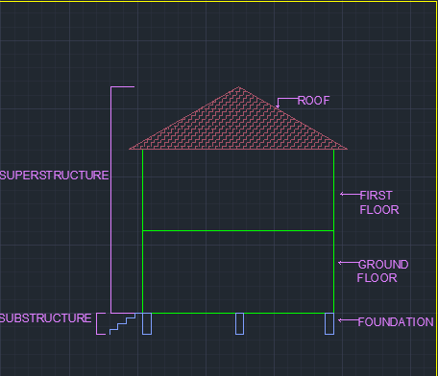
- The internal and external components of a building that is constructed over the substructure.
- The structure starts from the top of the plinth until the top of the construction.
- This structure transfers the loads from the upper part of the building to the substructure.
- Sructures above the bar and the wear surface.
- Includes walls, beams, columns, windows, doors etc.

Fig. 1- Superstructure and Substructure simple version
  - Functional requirements of components: foundation, walls( exterior and interior), doors, windows, roof, finishes.
- Foundation - is that lump of a structure or building which is in direct contact with the ground. The foundation releases to the ground all the forces and weights exerted by the building.
- Exterior walls - An exterior wall usually forms part of a building envelope, separating the settlement inside from that outside.
- Interior walls - divide the internal space, includes separating/party walls
- Roof - is defined as the top structure forming the upper covering of a building.
- Doors - is defined as a solid barricade to an opening or doorway which can be opened for access or closed to deny access.
- Windows - an opening made in a wall or roof to permit daylight coming through some transparent or translucent material fixed in the opening.
- Finishes - finishes are referring to plastering works, painting, install tiles and parquet, sanitary objects, electric lights, radiators, other types of carpets, wallpaper, glass, decorative bricks etc

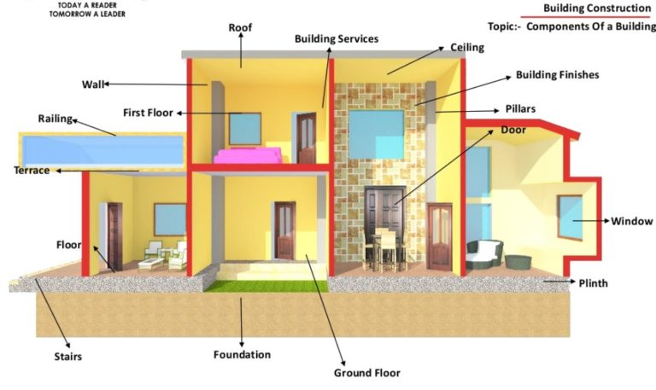
Fig. 2 - Superstructure and Substructure in a Building (Vernon, 2020)
- Proposed 3 bedroom bungalow:
In the second part of the essay, after a brief presentation of the proposed bungalow, the emphasis will be on the component called windows. This component was chosen for technological reasons, because the windows represents the communication path between the exterior and the interior of the house. The building materials and mounting technology are constantly evolving and the windows of a house can be changed easily to improve the functional and aesthetic appearance of the building.
The proposed bungalow has approximative 140 sm, an open space kitchen, a dining area and a living room, a master bedroom with en-suite bathroom and other 2 bedrooms with a common bathroom. It is included a porch area and a small terrace in the back. The roof plan consists of steel beams, horizontal beams and long-lasting galvanized iron roofing, pre-painted with tile effect style roof.

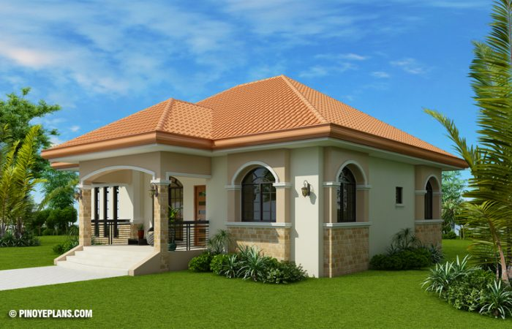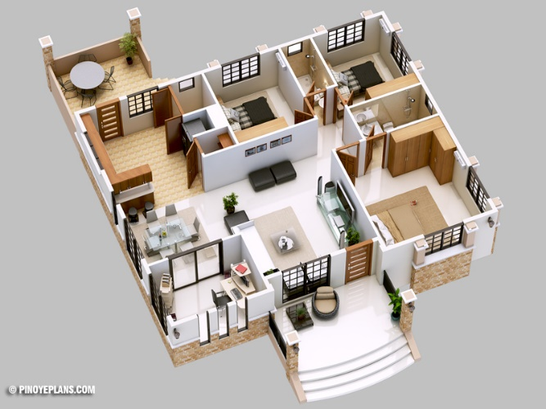
Fig. 3 Bungalow proposed façade (Anon., 2012) Fig. 4 Proposed plan 3D (Anon., 2012)

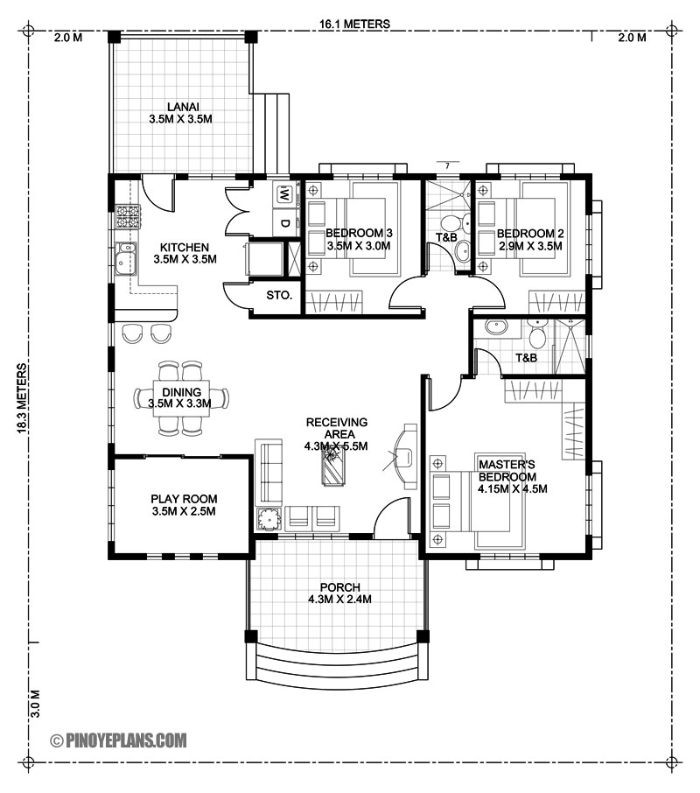
Fig.5 Proposed plan 2D (Anon., 2012)

5. The windows:
5.1 Definition
A window may be defined as an open able barricade or as a framework of wood, aluminum, steel with a glass section or a combination of these materials safe in a wall opening. Window is an opening in the wall or roof of a building, fitted with glass in a frame to admit light or air and allow people to see out, they are arranged in an architectural design. (Britannica, 1998)

  - Functional and Performance Requirements: (Enzo, 2017)
- Provide safety and security: windows offer natural daylight and keep you safe with a quality locking system
- Provide Efficiency: to measure windows can eliminate the appearance of draughts. Homeowners are increasingly looking for ways to make their homes energy efficient, windows do this by keeping the cold air outside and keeping warm air inside. Provide adequate thermal and sound insulation.
- Comfort offer: The windows in your kitchen allow hot air to escape, in bathrooms they facilitate the evacuation of steam, in other areas of the house allow you to send messages with people outside the house.
- Visual appeal: windows can easily enhance the aesthetic appeal of a house.
- Increase the resale value of the house: by installing high quality windows, the selling price goes higher.

  - Terminology:
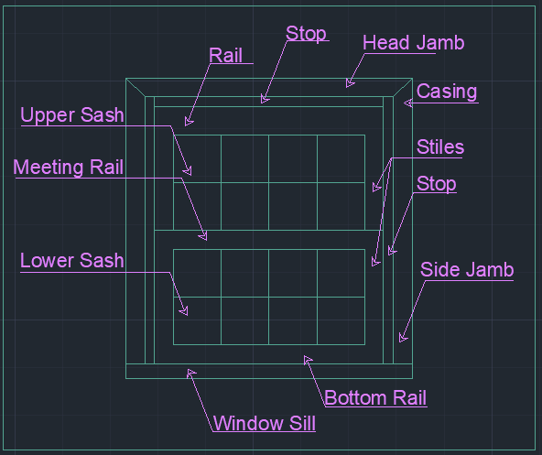
Fig. 6 – Windows Terminology
  - Classification of Windows: by material, method
Classification of the windows according to the material from which they are made is done as follows:
- Timber.
- Steel.
- Aluminium.
- PVC-U.
- Composite.
- Fibreglass.
Classification of the windows by method:
- Fixed windows - In this case, in the opening of the wall, the glass pane is invariably fixed The shutter can’t be opened or closed which makes it the most weather-proof of windows.
- Sliding windows - In this case, window shutters are movable in the frame. Based on our requirements, the movement may be in horizontal or vertical plan.
- Pivoted windows - the pivots are located in the window’s frames. Pivot is a shaft which helps to oscillate the shutter. A pivoting window rotates on a vertical axis, which is normally situated in the exact centre of the window, so in this way the window is properly balanced.
- Double-hung windows - consist of pair of shutters annexed to a single frame. The shutters are supplied one above the other. These two shutters can slide vertically with in the frame. So, the windows can be open even on the top or at the bottom as needed.
- Louvered windows – looks like the louvered doors which are provided for the ventilation without the need for an outside vision. Wood, glass or metal are the main materials that louvers are made of.
- Casement windows - are the most used and common windows at present. The shutters are attached to frame and these can be opened and closed on the same system like door shutters. Rebates are allocated to the frame to receive the shutters.
- Metal windows – can be realized with a small price and their strength is very big, so now days these are widely using especially for public buildings.
- Sash windows – it is a type of bent window, but in this case the panels are completely glazed. It consists of upper, lower and intermediate rails. The space between the rails is splited into small panels.
- Corner windows – this type of windows are provided at the corners of the room having two faces in perpendicular directions, such that the air or light can come in the house in two different directions.
- Bay windows – are windows designed in the form of a wall which are provided to increase the opening area which allows greater ventilation and light outside.
- Dormer windows – are provided for sloping roofs, to offer ventilation and lighting in the room, also increasing the aesthetic sense.
- Clerestory windows - If the rooms in a construction are of different ceiling heights, clerestory windows are provided for the room which has greater ceiling height than the other rooms.
- Lantern windows – this type of windows are used for flat roofs, with the main purpose of providing more circulation of light and air.
- Gable windows – are provided for sloping roof buildings at the gable end of the roof.
- Ventilators – Ventilation is the main purpose of those windows, being install at a higher height that the windows closer to the roof level. They have small size and horizontally pivoted shutters.
- Skylights - are generally laid on top of sloping roofs to provide light. It is provided parallel to the sloping surface. Lead gutters are arranged to frame to make it as waterproof.

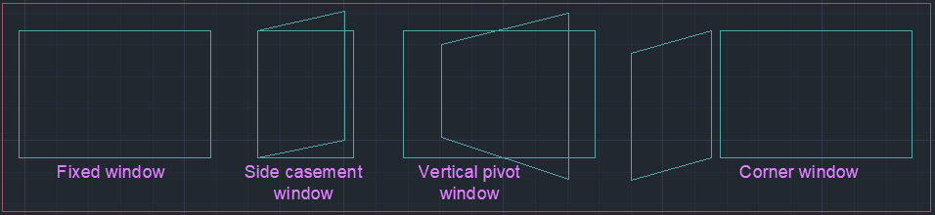
Fig. 6 – Different window types
  - Method of Window Installation:
There are two main ways to fix windows to exterior walls:
- Build in, where the window is fixed and the wall is built around it.
- Fixed in prepared openings, where the window is fixed in position after the wall has been build.

  - Issues associated with Construction of Windows:
A number of aspects must be taken into account when selecting, installing and detailing windows. Those include:
- Position of the window.
- Method of installation.
- Thermal bridging: thermal bridge it is an area of the construction that has a higher thermal transmission than other parts and decreases the overall thermal insulation of the structure, can lead to localized cold surfaces, condensation and mold growth.
- Airtightness: is the measurement criterion used to assess the air leaks of a building. Air leakage occurs through cracks, gaps and other unintentional openings in the building envelope and is uncontrollable.
- Window performance

  - Remedies to Performance Issues:
Thermal bridging and air leakage around windows can be reduced by:
- Installing high performance trickle vents.
- Security frames are adjusted properly and correctly.
- Sealing any gaps between the frame, the nearest cavity and the surrounding masonry.
- Sealing between the frame/window sill and the plasterboard lining.
- Ensuring that there are no gaps in the joints between the frame.
- Ensuring that seals are installed correctly.

6.Conclusions:
When a person wants to invest in the construction of a house, must take into account several factors when choosing the design, materials used and costs allocated to each category of work because its health and safety can be influenced by the decisions made.
Choosing quality windows can prevent the appearance of mold and unwanted cold air, can encourage the entry of natural light and fresh air. As technology is constantly evolving, digital systems allow access (closing and opening) of windows and curtains even when people are away from home.

References
A.V. Hore, J.G. Keloe, R. McMullan & M.R. Penton, 1997. Construction 2. In: Substructures and grundworks . London: Palgrave, pp. 114-127.
Anon., 2012. www.pinoyeplans.com. [Online]
Available at: https://www.pinoyeplans.com/listing/three-bedroom-bungalow-house-design/
[Accessed 01 04 2021].
Britannica, T. E. o. E., 1998. https://www.britannica.com. [Online]
Available at: https://www.britannica.com/technology/window
[Accessed 22 April 2021].
Constructor, T., n.d. theconstructor.org. [Online]
Available at: https://theconstructor.org/building/superstructure-substructure-building-construction/1651/
[Accessed 03 04 2021].
Enzo, 2017. https://byvincenzo.com. [Online]
Available at: https://byvincenzo.com/the-importance-of-windows-in-a-house/
[Accessed 23 04 2021].
Vernon, J., 2020. www.acarslink.com. [Online]
Available at: http://www.acarslink.com/substructure-and-superstructure-in-building-construction/
[Accessed 02 04 2021].

