Course Name: Effective Team work and Communication
Student Name: Rennee Dunbar
ID Number: (1919477)
Term& Group: Term 1 / Group2
Lecturer: Magdalena Wronska
Submission Date: 01/09/20

Contents
Introduction: 3
Section 1: 3
Sub- section a: Types of communication skills 3
Verbal communication 3
Non-verbal communication 4
Sub- section b: Models of communication - 4
Berlo: 4
Shannon and Weaver: 5
Schramm’s Model of Communication: 6
Section 2: Case study 7
Section 3: 7
Sub- section A- Personal examples of poor communication in the workplace: 7
Sub-section B- Suggested improvements: 7
References: 8
Appendix A: 9

Introduction:
The purpose of this academic report is to demonstrate an understanding of various models of communication and communication skills. There are increasing concerns surrounding effective teamwork and communication within a work setting so it is therefore necessary, to be aware of the different variety of communication skill which illustrates the importance of this report. To achieve this, references to case studies will be made along with the application of theory, which will be used when exploring personal examples of communication within the workplace.

Section 1:

Sub- section a: Types of communication skills
Communication takes form in many ways, each individually broken down and categorised under the sub-headings of verbal or non-verbal communication. For communication to take place Maund (2017, p.4), argues the process of encoding and decoding must take places between two individuals or several persons, with the idea or thought originating within the ‘sender’s’ mind, being distributed as a message for the receiver to decode. Condruz-Bacescu (2020) agrees that broadcasting and interpreting messages communicated, is a skill that is needed for communication to work effectively.

Verbal communication
According to Maund (2017), verbal communication is predominantly the most frequently used form of communication. Throughout this form of communication, it is believe that for it to be considered effective, the message being transmitted requires a high level of accuracy so when it is being interpreted by the receiver during dialogue, confusions, which are very common during this form of communication, does not lead to lack of understanding (Robinson and Robinson (1982), cited in Maund, 2017, p. 2). Condruz-Bacescu, (2020) argues that there are different ways in which people can communication verbally (professionally or unprofessionally), which will determine whether the message being transmitted will be decoded by the recipient in the intended way. Failure to communicating in the right professional context to result in ineffective communication which could affect professional development.

Non-verbal communication
Non-verbal communication presents itself through the use of a person’s body language, gestures, or signs during communication. Ivy and Wahl, (2014), cited in Maund, 2017), describes non-verbal communication as ‘communication that takes form in ways other than written or spoken language which creates meaning for someone’. Within a work environment it is important that staff and management are aware of their body languages when communicating with others as it can lead to confusion or misinterpretation of information being distributed if the body language of the person does not match their verbal language. Maund (2017) implies that the use of non-verbal communication such as touch, space or even eye contact with verbal communication allows an individual to ‘decipher messages being transmitted’ (Condruz-Bacescu, 2020).

Sub- section b: Models of communication -

Berlo:
The Berlo model of communication was developed in 1960 by David Berlo as a further developed model of the Shannon and Weaver model of communication. This model of communication focuses on verbal and non-verbal forms of communication which takes place collectively during a conversation, as a way of improving communication between the sender and the receiver. Believed to be affected by various independent elements (Wronska, 2020a), this model consists of 4 fundamental features which are thought to describe all communication processes: ‘sender, message, channel and receiver’. Uniquely, this model stands out from the Shannon Weaver’s model of communication through its focus on the emotional aspects that is incorporated in all forms of communication. The component known as ‘source’ (Wronska, 2020) focuses on the recipient who sends the original message. Interlinked with this component is the sender’s communication skills and whether it is of a high standard as this is believed to impact on how the coded message is decoded and understood by the receiver. The attitude, knowledge, culture, and social system of the sender are also influential components that enables the sender to communicate their message. Message also known as encoding (Wronska, 2020a), is the material in transmit that originates from the sender’s thoughts during points of communication. Sent in various formats, the message can be affected by the following factors: content, elements, treatment, structure and code; therefore it is important to be aware of them as it will determine how the receive interprets the message from the sender. Channel details the process that takes place once the message from the receiver has been sent (Samantha, 2017). Referring to the five human senses, these key factors reflect the importance of non-verbal communication methods and the ways in which they support the understanding that derives from decoding a verbally communicated message. Finally, receiver refers to the individual who will be decoding the message delivered from the sender. It is believed that for communication to be effective the receiver must have the same ‘thinking pattern and supporting factors’ (Wronska, 2020) governing their communication however within a study conducted by Condruz-Bacescu (2020), professional and unprofessional communications were viewed as effective with the dynamics of such communication described as ‘uncontrollable and constantly changing’.

Shannon and Weaver:
In 1948 Claude Elwood and Warren Weaver wrote an article called ‘A Mathematical Theory of Communication’ which over time became known as the Shannon and weaver model of communication (Wronska, 2020c). Initially the model consisted of 5 elements (Sender, Encoder, Channel, Decoder and Receiver) but ‘Noise’ was added as the 6th element that was seen as a physical disturbance that could prevent the coded message send from being understood by the receiver. According to this model for communication to work effectively, the receiver must successfully decode the message sent by the sender through a technological channel e.g. a mobile phone before they can understand or interpret what the sender is attempting to communicate with them. In some cases the channel used by the sender to process the message could be used to decode the message being sent to the receiver but this is not always the case as external factors within the environment could act as a barrier e.g noise. Initially made to improve communication via the use of technologies, this model of communication (Wronska, 2020c), was created with the aim of minimising noise pollution that interfered with telephone communications but was later adapted to ensure all forms of communication was more effective.
Technical, semantic and Effectiveness are all forms of problems which the Shannon and Weaver model of communication (Wronska, 2020c), has identified that can impact whether communication is a success. Some strengths of this model are as followed: the acknowledgement of noise and the benefits removing it could mean for effective communication, the notion that communication is a two-way process and the idea that communication is viewed as quantifiable. However, the model is said to not reflect the true nature of human communication because it was originally created to improve telephonic communication and is therefore not adaptable, the response provided by the receiver is not seen with the same level of value and importance as the message from the sender which Maund (2017), would argue means the communication is therefore not effective and it is not very applicable to large communication formats. Although this model of communication (Wronska, 2020c) has its benefits, it fails to credit how important non-verbal communication methods are when having a verbal conversation with someone. Patricia (2017) argues that a lack of non-verbal communication does not allow the true version of the encoded messages sent to be decoded by the receiver. Therefore, it could be suggested for the Shannon and Wearer Model (Wronska, 2020c) to be more accurate regarding human communication, ‘noise’ should not be the only element viewed as a potential disturbance impeding the receiver from obtain the message sent, rather all forms of non-verbal communication should be viewed as a disturbance.

Schramm’s Model of Communication:
This model of communication was developed by Wilber Schramm (1954) who believed the thought process which takes place in the mind of individuals can only be ‘converted when the information is encoded, therefore initiating communication’ (Wronska, 2020b). Once this coded message has been received by the recipient, it is believed that the primal response is to decode the message but until this happens, the coded message is insignificant and communication can not be coherent or ‘flow between two people’ (Wronska, 2020b) therefore, a response can not be given to the message originally sent resulting in an inadequate attempt at communication. According to this model of communication, the ‘knowledge, experiences and cultural background of an individual’ (Wronska, 2020b), are all factors which need to be considered when reflecting on what could impact on how a coded message is interpreted by the receiver.

Section 2: Case study
The case study about the professor and the village (Appendix A) helped to develop my understanding of the Berlo model of communication and the Schramm model of communication (Wronska, 2020). Within the Berlo model it is believed that the thinking patterns of the receiver must be an exact replica of the sender otherwise communication will not be effective. This case study reflected that the thinking patterns of the professor and the people living in the village were different which resulted in the coded message sent by the professor to seek help from the villager not being effective and receiving no response. In relation to the Schramm model, this case study showcased that without the receiver decoding the message in the way the sender desired it will not provide the necessary response needed (i.e. the villages ignoring the professor’s cry for help) which causes the original message to become useless.

Section 3:

Sub- section A- Personal examples of poor communication in the workplace:
While working in retail as a sale assistant, a customer came in wanted a particular item, I was really busy on the shop floor but at the same time I was trying to help to find what the customer was after. Because I was busy with a lot of work that needed to be done, I asked one of my colleagues to assist the customer instead. I told my colleague exactly what the customer wanted so she decided to help, proceeding on with my work my colleague came and told me everything has been sorted, which I was happy and thankful for. I continue to do my work so I can finish on time before I could go on my break, about half an hour before my break only to see the same customer came back to me upset saying that my colleague gave her the wrong item. I think there was a misunderstanding with communication and language barrier due to the customer being a foreigner and English is not her first language, I went back to my colleague to let her know that she didn’t give the customer the correct item and explain to her that the customer was upset, my colleague went and get the correct item and we both apologize to the customer. At the end of it all the customer went away with what she wanted, and we also gave the customer a £15 voucher to spend in store. In the case of maria and Pedro case study, the confusion and misunderstanding could have been avoided if my colleague took the time to listen and understand what the customer was saying, and ask questions if she didn’t understand what she was saying.

Sub-section B- Suggested improvements:
To improve such poor communication active listening and good communication is key, make sure you are listening and your giving eye contact to let the person know that they’ve got your full attention and you acknowledge and understand what they’re saying. Always ask question if you’re not sure or understand what to do or what the message is saying. Also to the person who is sending /giving the message which is the (encoder) needs to make sure the message that they’re sending is clear so that when the receiver which is the (decoder) receives the message it is clear and concise so you know and understand what to do ,which the Shannon and weaver model explains. So, in this case you must be actively listening and have good communication skills in order to make improvement.

References:
Condruz-Bacescu, M. (2020) ‘Professional Communication in Companies’, Journal of Languages for Specific Purposes, (7), pp. 43-55. Available at: https://web.b.ebscohost.com/ehost/pdfviewer/pdfviewer?vid=1&sid=49187415-5186-48c7-9641-9c2513970164%40pdc-v-sessmgr01 (Accessed: 31/08/2020)
Maund, A. (2017) ‘Certificate in higher education: skills for the workplace students yearbook’, London: SAGE Publications
Patricia (2017) ‘Importance of Nonverbal Communication-Old’. Available at: https://www.youtube.com/watch?v=rSYbrd2vOHc (accessed: 31/08/2020)
Samantha (2017) ‘Berlo’s model of Communication’. Available at: https://www.youtube.com/watch?v=KHGMNV95NkQ (accessed: 1/09/2020)
Wronska, M. (2020a) ‘Models of Communication: ‘Berlo’. BMSW4002_LON: Effective Team Work and Communication. Available at: https://moodle.uwtsd.ac.uk/course/view.php?id=7030 ( accessed: 27/08/2020)
Wronska, M. (2020b) ‘Models of Communication: ‘Schramm’. BMSW4002_LON: Effective Team Work and Communication. Available at: https://moodle.uwtsd.ac.uk/course/view.php?id=7030 ( accessed: 27/08/2020)
Wronska, M. (2020c) ‘Models of Communication: Shannon and Weaver’. BMSW4002_LON: Effective Team Work and Communication. Available at: https://moodle.uwtsd.ac.uk/course/view.php?id=7030 ( accessed: 27/08/2020)

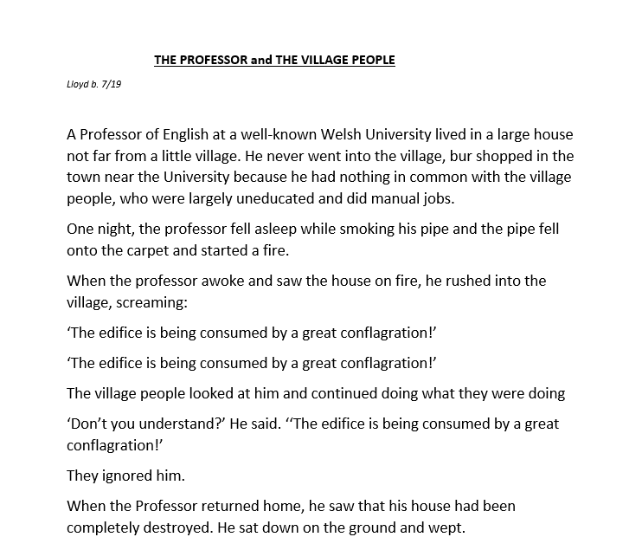
Appendix A:



