Individual Academic Report
Bachelor of Arts in Business Management
Academic Year: 2023/2024
Student Name: Ileana Lupu
Student Number: 2231908
Lecturer Name: Khai Le
LCBB5008_BIRM
Management Economics

REPORT

To: Khai Le
From: Ileana Lupu
Date:20/10/2024
Subject: Strategic Analysis of Challenges, Opportunities, and Stakeholder Dynamics in the UK Mobile Network Industry
Table of Contents
Introduction 4
Section 1: Challenges and Opportunities in the UK Mobile Network Industry 5
Section 2: Profit Maximisation Theory and Application in the UK Mobile Network Industry 5
Section 3: Government Policies and Their Influence on the UK Mobile Network Industry 7
Section 4: Application of Economic Theories to Managerial Decision-Making in the UK Mobile Network Industry 8
Supply and Demand in the UK Mobile Network Industry 8
Price Elasticity and Consumer Response 8
Market Structure and Competitive Strategy 8
Section 5: Stakeholder Issues in the UK Mobile Network Industry 9
Customers 9
Shareholders 10
Regulators 10
Society and Environmental Concerns 10
Section 6: Recommendations towards Sustainable Growth in the UK Mobile Network Industry 10
1. Continuous Investment in 5G and Beyond Technologies 10
2. Emphasis on Service Innovation and Differentiation 11
3. Enhance customer retention and loyalty programs 11
4. Emphasize CSR and Sustainability 12
5. Meet Regulatory Challenges and Engage with Policymakers 12
6. Leverage Data Analytics and AI for Operational Efficiency 12
Conclusion 13
References 14

Introduction
The mobile network industry in the UK is regarded as the base on which the country builds its digital infrastructure (UK Government, 2018). According to statistics, in 2016, UK mobile data mostly used 1.5GB on a 4G average. Thus, it holds a leading role in economic development and technological innovation. Over the last couple of years, this industry has undergone various phases of opportunity and challenge for adaptation towards the changing consumer, new technologies, and shifted regulatory requirements. The proposed merger between Vodafone and Three simply indicates the shifting dynamics of market competition and consolidation in this industry. Operators like Vodafone, EE, Three, and O2 have to work within an extremely competitive environment, with increasing infrastructure costs and high expectations from the consumer side for seamless connectivity (Vodafone, 2023).
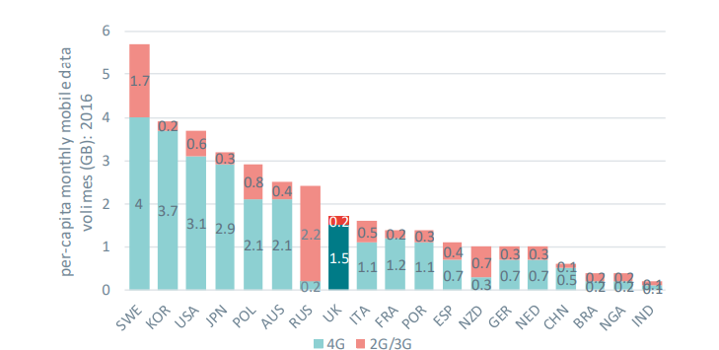
Fig 1. Monthly data per capita (GB) 2016
Another challenge is that 5G brings a competitive advantage and significant financial investment. While this technology promises to revolutionize communication capabilities and improve efficiency, companies have the challenge of balancing these opportunities with the goals of profitability and sustainability of business (Ahmad et al., 2024). The report critically analyzes the major economic challenges and opportunities the industry has encountered or might face within the UK mobile network industry, focusing on applying the theory of profit maximization, market structure, and stakeholder interests. It will also discuss government policy influences and conclude with recommendations on profitability and sustainability in this fast-moving industry.

Section 1: Challenges and Opportunities in the UK Mobile Network Industry
The UK mobile network industry has to undergo various challenges and opportunities to decide its shape and course of evolution. Strong competition between leading players such as Vodafone, EE, O2, and Three is one of the major challenges the sector faces. For example, as explained above, the proposed merger between Vodafone and Three indicates how smaller operators find it difficult to maintain their competitive edge in a consolidated marketplace (SiliconRepublic, 2023). Mergers generally improve efficiencies but also have associated concerns about reduced competition and higher prices for consumers; therefore, it has to be scrutinized by the CMA.
The other challenge is the heavy investment burden for 5G infrastructure. Heavy investments in building and upgrading networks were necessary. In addition, high spectrum auction costs have further squeezed profit margins and forced operators to reassess pricing and operational strategies (UK Government, 2020).
On the opportunity side, increasing mobile data demand, driven by smartphone usage and digital services, creates growth potential. Introducing 5G allows for higher speeds and new revenue opportunities, such as services for vertical industries - for example, autonomous vehicles and smart cities - that rely on high-speed, low-latency networks (Schneir et al., 2018).

Section 2: Profit Maximisation Theory and Application in the UK Mobile Network Industry
It is a significant attribute of economics and is usually considered the objective of a firm that competes in market competition. The profit maximisation theory states that every firm seeks to attain an output level at which its marginal revenue equals the marginal cost (Bond et al., 2020). This aims to maximise profit. It can be related to the UK mobile network industry, such as how companies like Vodafone, EE, O2, and Three will set prices, levels of output, and investments to seek to maximise their profitability.
In a competitive market with close substitutes, the UK mobile network industry operators can only have a very limited price-setting ability. They have, therefore, tried to exploit the privileges of economies of scale and unique value-added services. For instance, as illustrated in the figure below, in 2017, the weighted average monthly price for mobile usage baskets (excluding handsets) was £18.36. Companies can combine complementary services like mobile data, home broadband, and entertainment packages to avoid churning and maximize revenue streams (Zakaria et al., 2024). This bundling strategy capitalizes on price discrimination, whereby firms charge different prices depending on what combination of services they provide, enabling them to capture consumer surplus and increase overall profitability.
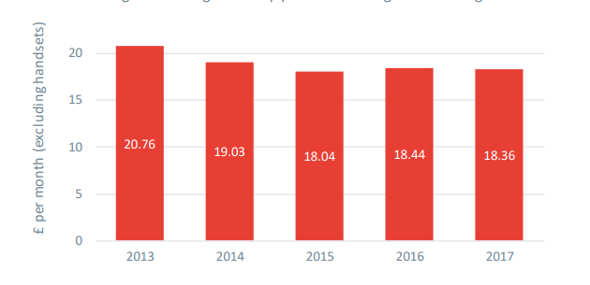
Fig.2 Weighted average monthly prices for average mobile usage baskets assets (publishing.service.gov.uk)
However, this industry's profit maximisation cannot be straightforwardly conceptualized with substantial fixed costs involved in investment into infrastructure, especially in the latest 5G rollout. Mobile network operators face the daily balancing act of their profitability in the short term against long-term investment strategies, knowing full well that very often, immediate profits may have to be sacrificed for the possibility of much larger revenues generated by new technology and services (Chivandire, Botha and Mouton, 2019). Such has been the case with the deployment of 5G, which, although infrastructure upgrades will cost significant money upfront, potential long-term benefits such as increased data consumption, new services, and superior connectivity may yield higher profitability over time.

Section 3: Government Policies and Their Influence on the UK Mobile Network Industry
Government policies determine the pattern of operation for the UK mobile network industry. Issues such as regulative frameworks, taxation policies, and particular industrial regulations involving spectrum auctioning may have an important impact on the strategy of a mobile network provider (UK Government, 2023). The UK government enforces several regulations that ensure fair competition, consumer safety, and pricing, while Ofcom and the Competition and Markets Authority ensure innovation and infrastructure building.
The most critical influence of government policy on the UK mobile network industry can be seen in spectrum auctions. Spectrum auctions are one way for the government to allocate portions of the electromagnetic spectrum to different mobile operators, and high associated costs make such auctions one of the serious factors that influence the profitability of providers of mobile networks (UK Government, 2023). The UK auctions of 5G spectrum were very competitive, with behemoths like Vodafone, EE, and Three spending considerable amounts to secure rights to that essential commodity. Buying the 5G spectrum allows operators to upgrade their service offerings; on the flip side, large out-of-pocket expenses are likely to strain finances and reduce other business investment opportunities (Vodafone, 2021).
Certain policies by the government encourage investment in infrastructure and innovations by mobile operators through subsidiaries and grants, targeting countryside areas to improve connectivity. The UK government Shared Rural Network-SRN initiative is an agreement between the government and mobile operators to try and improve mobile coverage in those areas that are hard to reach (Shared Rural Network, 2020). Under this initiative, the government grants funds to incentivize operators to extend their networks to previously considered commercially unviable rural areas. While such a policy will reduce the digital divide, it further raises financial and operational difficulties for network providers, who must decide how to extend their operations into less profitable areas.

Section 4: Application of Economic Theories to Managerial Decision-Making in the UK Mobile Network Industry
Various economic theories, such as the theory of demand and supply, elasticity of price, and market structure, are vital factors in managerial decision-making in the UK mobile network industry. These theories help firms optimize resource allocation decisions, pricing strategy, and market positioning (Phillips, 2021).

Supply and Demand in the UK Mobile Network Industry
Supply and demand play an important role in managerial decision-making. The increased use of smartphones has driven it, the application of digital services, and the adaptation of 5G technology. Growing demand due to greater use of smartphones, more applications of digital services, and adaptation of 5G technology has called for massive investments in 5G infrastructure to meet consumers' demand for quick and reliable services (Mendonça et al., 2022). As a manager, the onus of constant re-evaluation falls on consumer demand and widening network capacity according to that. In the process, high spectrum acquisition costs and disruptions in the global supply chain- supply side challenges were seen as major examples in COVID-19 strategic planning about network expansion as far as cost control is concerned.

Price Elasticity and Consumer Response
Demand price elasticity also plays a role in the context. While mobile services are normally inelastic, people take them for granted- some among them, for example, premium data-intensive services, show their elasticity. For example, there could be a decline in consumption or substitutions towards lower-priced alternatives should the price for premium services increase (Sawadogo, 2021). Vodafone has agreed upon various pricing levels for 5G services to show appreciation of price elasticity since price-sensitive consumers and high-value volume consumers who pay more when the speed is faster with big data allowance are targeted. This will also help in the segmentation of the market and, hence, maximization of revenue (Vodafone, 2023.).

Market Structure and Competitive Strategy
The UK mobile network industry is oligopolistic; it contains a few firms, which are normally very large. Currently, the major players in the industry are Vodafone, EE, O2, and Three (Statista, 2023). Firms operating within an oligopolistic market should always consider their competitors' moves when making strategic decisions. For example, when one company introduces a new pricing model, competitors rush for adjustments to avoid losing market shares. In this regard, the merger between Vodafone and Three may raise some concerns, if approved, concerning a potential reduction of competition, hence increasing prices and concentrating the market. This would, in turn, compel remaining firms to reconsider their pricing and service strategies in light of this new competition configuration.
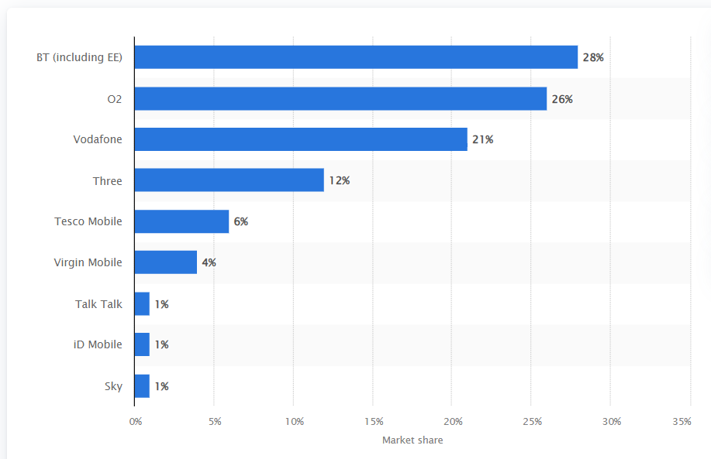
Figure 3: Market share held by mobile operators in the United Kingdom (Statista, 2023).

Section 5: Stakeholder Issues in the UK Mobile Network Industry
The UK mobile network industry involves stakeholders such as customers, shareholders, regulators, and society. Each of these stakeholders continues to play a significant role in influencing the companies' business strategies (UK Parliament, 2017). To achieve long-term success, managers need to balance each of these competitive interests.

Customers
Customers are the primary stakeholders; they demand faster and more reliable services (Marand and Thorstenson, 2020). This has, in turn, been driven by growing demand for streaming, social media, and online gaming, which has driven operators to raise their investments in upgrading networks by way of 5G technology. Customer loyalty remains extremely volatile; as low switching costs have made it easy for consumers to switch quickly to different providers for better deals or superior services. Companies retain customers through bundled service offerings, loyalty programs, and personalized pricing. Examples are Vodafone's loyalty program "VeryMe", which is aimed at customer-centric activities to mitigate churn. Meanwhile, data privacy and security are of topmost priority (Vodafone, 2019). Data breaches could be severely devastating to reputation, and therefore, EE and O2 have invested heavily in cyber security, compliance, and obedience to laid regulations such as GDPR.

Shareholders
Shareholders are relevant to provide the necessary capital for innovation and extension. They have to provide handsome returns on the invested money, which often leads to the conflicting requirements of short-term profitability and long-term investment needs -5 G among the costliest projects (Harford, Kecskés and Mansi, 2017). Managers must weigh these with their dividend-paying requirements and responsibilities to improve share performance. Vodafone, for example, came under pressure from shareholders to ensure that its investments in 5G would not jeopardize its near-term financial stability.

Regulators
These head the list of regulators that ensure that the industry standards and competition are upheld, including Ofcom and the Competition and Markets Authority. Ofcom conducts auctions of spectrum vital in network expansion, while the CMA vets mergers, such as the proposal between Vodafone and Three, to check against monopolies (Ofcom, 2023). Therefore, consumer protection is ensured through regulatory oversight in pricing and competition.

Society and Environmental Concerns
Society, in this regard, through the perspective of CSR, would want mobile operators to work sustainably. Secondly, environmental sustainability is also an increasing concern for companies like EE committed to renewable energy. In general, business firms that place sustainability within their business model reap the benefits of a better reputation and appeal to all socially conscious consumers, while the ones failing to do so suffer reputational harm and regular penalties from regulatory bodies.

Section 6: Recommendations towards Sustainable Growth in the UK Mobile Network Industry

1. Continuous Investment in 5G and Beyond Technologies
Mobile operators must keep up with investments in 5G infrastructure and, later, when the time comes, also in 6G if they want to remain competitive. Applications will grow even further with demand increases, from IoT to autonomous self-driving cars to smart cities (Parcu et al., 2023). While high costs of infrastructure development remain an issue, the companies could seek avenues of partnership with the government for financial alleviation, such as that proposed by the UK's Shared Rural Network initiative, while at the same time enhancing connectivity across under-served areas.

2. Emphasis on Service Innovation and Differentiation
The operator could survive above water only if it competes on service differentiation in the oligopolistic market. Tailor-made data plans, exclusive content deals, and value-added services such as mobile banking will be some of the differentiators (Opazo-Basáez, Vendrell-Herrero and Bustinza, 2022). A case in point is how Vodafone has tied up with various entertainment providers to sell exclusive streaming deals and its bundled packages to gain and retain customers. Continuous innovation and weathering of services provided by the operators would help cut down churn and gain market share.

3. Enhance customer retention and loyalty programs
Customer retention is vital to long-term profitability due to low switching costs. Mobile operators must go one step further in improving their loyalty programs and developing personalized services with flexible pricing models to retain customers (Larsson and Broström, 2020). Therefore, AI-driven analytics should be enabled for personalized recommendations and services due to the customer's behaviour and personal preferences. For example, Vodafone's "VeryMe" loyalty scheme has been well-received in increasing customer engagement through bespoke rewards and incentives.
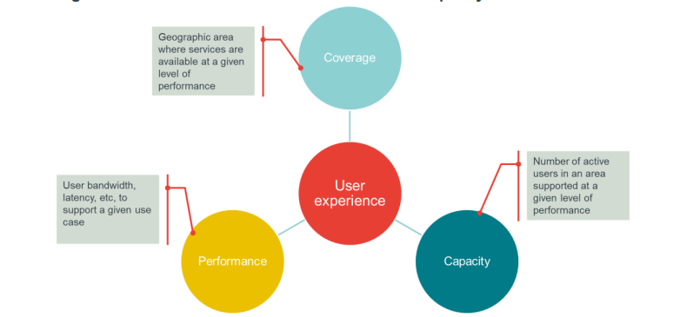
Fig 4. Users opt for coverage, capacity and performance in networks (publishing.service.gov.uk)

4. Emphasize CSR and Sustainability
Sustainability should form the core of every mobile operator's business model. This involves reducing energy consumption and e-waste, among other things, by shifting to renewable energy sources. For instance, EE has promised to power all its operations with 100% renewable energy, setting a good example for the rest of the industry. Besides this, operators will have to work on device recycling to reduce the impact of e-waste. Sustainability will improve the brand image of companies beyond compliance with regulations and help them gain eco-sensitive customers (Chidolue et al., 2024).

5. Meet Regulatory Challenges and Engage with Policymakers
Mobile operators must proactively engage with regulators at Ofcom and the CMA to navigate this challenging regulatory environment. Companies can collaborate with policymakers to identify and shape industry standards and regulations supporting innovation and competition. They should also advocate for policy outcomes that enable investment in infrastructure while minimizing regulatory obstacles to growth (UK Government, 2021). Close collaboration with regulators is key for businesses to continue developing their networks and services compliantly.

6. Leverage Data Analytics and AI for Operational Efficiency
Mobile operators should fully use advanced analytics and AI to gain operational efficiencies and enhance the delivery of services. The technology could help improve network performance by predicting customer needs and smoothing out operations to achieve goals in cost savings and service quality improvements for the best user experience as demonstrated in the figure below. For instance, AI-driven predictive maintenance allows network providers to identify potential issues before they cause service disruptions. Data analytics will also enable better customer segmentation whereby operators can provide more tailored services and price models, improving customer satisfaction and profitability (Ganesh and Kalpana, 2022).
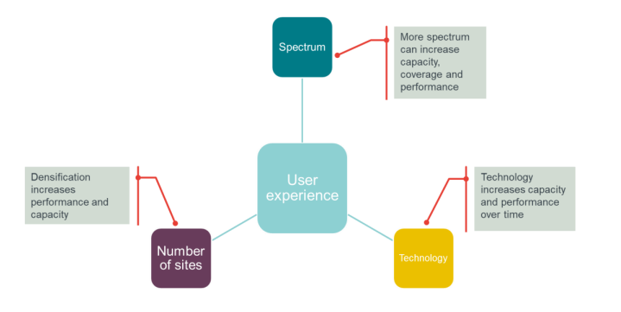
Fig 5. Leveraging Technology improves network(publishing.service.gov.uk)

Conclusion
The UK mobile network industry is a complex interplay of challenges and opportunities driven by the rate of technological change, competitive pressures, and regulatory imperatives. The continued impetus for 5G infrastructure while offering significant benefits in the longer term lays heavy near-term financial and operational demands on the network providers. Equally, market consolidation, such as the recently proposed merger between Vodafone and Three, has underlined the growing imperative for operators to balance competition with the desire to achieve market dominance. Pervasively relevant, government policies on spectrum auctions and rural network initiatives considerably influence the strategic choices of mobile operators. High costs, especially related to the procurement of spectrum rights, stress profitability, even as they open future growth opportunities through enhanced service capabilities. From the managerial perspective, these economic theories allow for insight into the firm's optimal price strategies, investment decisions, and competitive positioning through the theories of profit maximization, supply and demand elasticity, and market structure. The industry's sustainability would depend on how the operators can pursue stakeholder interest harmony and technological innovation to sustain customer loyalty in a highly saturating market.

References
Ahmad, I.A.I., Osasona, F., Dawodu, S.O., Obi, O.C., Anyanwu, A.C. and Onwusinkwue, S., 2024. Emerging 5G technology: A review of its far-reaching implications for communication and security.
Bond, S., Hashemi, A., Kaplan, G., & Żoch, P., 2020. Some Unpleasant Markup Arithmetic: Production Function Elasticities and Their Estimation from Production Data. SPGMI: Compustat Fundamentals (Topic). https://doi.org/10.3386/w27002.
Chidolue, O., Ohenhen, P.E., Umoh, A.A., Ngozichukwu, B., Fafure, A.V. and Ibekwe, K.I., 2024. Green data centres: sustainable practices for energy-efficient infrastructure. Engineering Science & Technology Journal, 5(1), pp.99-114.
Chivandire, G., Botha, I., & Mouton, M., 2019. Impact of capital structure on financial performance: Evidence from telecommunication operators in Africa. The Journal of Private Equity, 22. https://doi.org/10.3905/JPE.V22I4.5571.
Ganesh, A.D. and Kalpana, P., 2022. Future of artificial intelligence and its influence on supply chain risk management–A systematic review. Computers & Industrial Engineering, 169, p.108206.
Harford, J., Kecskés, A., & Mansi, S., 2017. Do Long-Term Investors Improve Corporate Decision Making? Finance Down Under 2015 Building on the Best from the Cellars of Finance (Archive). https://doi.org/10.2139/ssrn.2505261.
Larsson, A. and Broström, E., 2020. Ensuring customer retention: insurers’ perception of customer loyalty. Marketing Intelligence & Planning, 38(2), pp.151-166.
Marand, A., Li, H., & Thorstenson, A., 2020. Competing on price, speed, and reliability: How does bounded rationality matter Journal of the Operational Research Society, 72, pp. 2059 - 2072. https://doi.org/10.1080/01605682.2020.1759384.
Mendonça, S., Damásio, B., de Freitas, L.C., Oliveira, L., Cichy, M. and Nicita, A., 2022. The rise of 5G technologies and systems: A quantitative analysis of knowledge production. Telecommunications Policy, 46(4), p.102327.
Opazo-Basáez, M., Vendrell-Herrero, F. and Bustinza, O.F., 2022. Digital service innovation: a paradigm shift in technological innovation. Journal of Service Management, 33(1), pp.97-120.
Parcu, P.L., Pisarkiewicz, A.R., Carrozza, C. and Innocenti, N., 2023. The future of 5G and beyond Leadership, deployment and European policies. Telecommunications Policy, 47(9), p.102622.
Phillips, R.L., 2021. Pricing and revenue optimization. Stanford university press.
Sawadogo, F., 2021. Demand price elasticity of mobile voice communication: A comparative firm-level data analysis. Information Economics and Policy, 57, p.100939.
Schneir, J., Whalley, J., Amaral, T., & Pogorel, G., 2018. The implications of 5G networks: Paving the way for mobile innovation. Telecommunications Policy. https://doi.org/10.1016/J.TELPOL.2018.06.001.
Shared Rural Network (SRN). (2020) Shared Rural Network: Connecting the countryside. [online] Available at: https://srn.org.uk/ [Accessed 28 Sept. 2024].
SiliconRepublic. (2023) Vodafone-Three UK merger referred for deeper competition probe by CMA. [online] Available at: https://www.siliconrepublic.com/comms/vodafone-three-uk-competition-probe-cma [Accessed 28 Sept. 2024].
UK Government. (2018) Telecommunications networks: A forward look at capability and risks. [online] Available at: https://assets.publishing.service.gov.uk/media/5a79ee87e5274a1767550c95/telecommunications-networks-v1.pdf
UK Government. (2020) 5G supply chain diversification strategy. [online] Available at: https://www.gov.uk/government/publications/5g-supply-chain-diversification-strategy/5g-supply-chain-diversification-strategy [Accessed 28 Sept. 2024].
UK Government. (2021) Digital competition consultation. [online] Available at: https://assets.publishing.service.gov.uk/media/60f59c938fa8f50c76838784/Digital_Competition_Consultation_v2.pdf
UK Government. (2023) Spectrum statement. [online] Available at: https://www.gov.uk/government/publications/spectrum-statement/spectrum-statement [Accessed 28 Sept. 2024].
UK Government. (2023) UK wireless infrastructure strategy. [online] Available at: https://www.gov.uk/government/publications/uk-wireless-infrastructure-strategy/uk-wireless-infrastructure-strategy
Vodafone. (2019) Vodafone full annual report 2019. [online] Available at: https://investors.vodafone.com/~/media/files/v/vodafone-ir/documents/performance/financial-results/2019/vodafone-full-annual-report-2019.pdf
Vodafone. (2021) Vodafone UK acquires spectrum for 5G services. [online] Available at: https://www.vodafone.com/news/services/vodafone-uk-acquires-spectrum-for-5g-services [Accessed 28 Sept. 2024].
Vodafone. (2023) 5G: Changing the face of technology. [online] Available at: https://www.vodafone.com/news/technology/stories/5g [Accessed 28 Sept. 2024].
Vodafone. (2023) Merger of Vodafone UK and Three UK to create one of Europe’s leading 5G networks. [online] Available at: https://www.vodafone.com/news/corporate-and-financial/merger-vodafone-uk-three-uk-europe-leading-5g-networks [Accessed 28 Sept. 2024].
Zakaria, A.F., Lim, S.C.J. and Aamir, M., 2024. A pricing optimization modelling for assisted decision making in telecommunication product-service bundling. International Journal of Information Management Data Insights, 4(1), p.100212.

