

Postgraduate/Distance Learning
Assignment coversheet & feedback form

THIS SHEET MUST BE THE FIRST PAGE OF THE ASSIGNMENT YOU ARE SUBMITTING (DO NOT SEND AS A SEPARATE FILE)

For completion by the student:
Student Name: Paul Kiernan

Student University Email: 1704194@student.uwtsd.ac.uk
Module code: HPCA7002  Module title: Researching Contemporary Cosmologies | Student ID number:  1704194 |  |  | Educational support needs:  No
Assignment title: What do astrologers believe? House systems and relativism.
(word count 4188)

Assignment due date: 10st Aug 2020
This assignment is for the 6th module of the degree
I confirm that this is my original work and that I have adhered to the University policy on plagiarism.
Signed ……………………………………………………………
Email submission:if you are submitting this form via email, please tick this box
(as a substitute for your signature) to confirm that you agree to the above declaration.
Assignment Mark
1st Marker’s Provisional mark
2nd Marker’s/Moderator’s provisional mark
External Examiner’s mark (if relevant)
Final Mark

NB. All marks are provisional until confirmed by the Final Examination Board.

For completion by Marker 1 :
Comments:

Marker’s signature: |  |  | Date:
For completion by Marker 2/Moderator:

Comments:

Marker’s Signature: |  | Date:
External Examiner’s comments (if relevant)

External Examiner’s Signature: |  | Date:

Introduction
This research examines what astrologers believe. In particular, it will explore astrologers’ attitudes to house systems and will re-examine Nick Campion’s suggestion that adopt a relativistic view of house systems. The research will recognise that, as per Campion’s suggestion, there are a variety of ‘astrologies’ rather than one monolithic ‘astrology’.

Aims
The aim of this research is to re-examine Campion’s suggestion that astrologers adopt a relativistic paradigm with regards astrological house systems. Campion noted that circa 70% of respondents agreed that ‘the right house system is “the one which works for you”’, a relativism that Campion linked to the influence of the popular astrologer Dane Rudhyar. Sue Tompkins noted that ‘there are about a dozen house systems’ in common use, with Michael Munkasey describing over twenty, suggesting, therefore a wide array of systems in which relativism can be applied. Recognising that astrology isn’t a monolith, Campion noted that ‘some scholars prefer to talk of “astrologies” rather than “astrology”’, but did not differentiate these distinctions in his own survey. This research however will group participants to help account for broad ‘astrologies’ and see if certain groups hold different opinions about the research topic.

Objectives
The objectives of this research are to conduct quantitative and qualitative research into the research question via questionnaires, complemented with semi-structured interviews, which Judith Bell advocated to gain first an overview, and subsequently more in-depth opinion. A mixed-methods approach is chosen, as described by Hennink, Hutter and Bailey, to interpret the results of quantitative data and to understand and explain the processes, perceptions and motivations underlying the research question. The research will examine to what extent Campion’s conclusion remains true, and if different ‘astrologies’ affect the results.

Terminology & Literature Review
House systems are one of the four major components of the astrological toolkit. House systems are a ‘12-fold division of the celestial sphere’ which represents an area of life, or, describes a quantitative measure for astrological analysis. Key to house system interpretation are the four ‘angles’, composed of the Ascendant (the eastern intersection between the ecliptic and horizon) and the Descendant opposite it, as well as the MC, (Medium Coeli, aka the Midheaven) and the IC (Imum Coeli) opposite it. Placidus is a house system formed from a temporal division between these angles. Others, such as Equal, begin from the degree of the Ascendant, with each house starting from successive 30º of arc from that point, whilst Whole Signs takes 0º of the Ascendant sign, and does likewise. For convenience, I will be adopting the terms ‘modern’ and ‘traditional’ to loosely define astrological traditions, with ‘modern’ astrology most influenced by the authors of the 20th Century, and ‘traditional’ astrology most influenced by more ancient authors. I do so recognising that one cannot anachronistically imagine that any astrologer today is not influenced by the modern period, and also that within these broad categorisations are further sub-categorisations. Nevertheless, this broad distinction is a rough demarcator of astrological traditions, often employed by astrologers. Of particular note is ‘Hellenistic’ astrology, a form of ‘traditional’ astrology inspired particularly by authors from the first several centuries CE.
With so many house systems available, controversy exists about what house system one ought to use. Robert Hand suggested that ‘debate has long raged as to what is the proper method for computing’ house systems, and Tompkins agreed, entitling her opening section on houses with ‘The Thorny Issue of House Systems’, suggesting that the research topic is known to be controversial within the astrological community; indeed, one urban-legend describes a fist-fight breaking out at an astrological conference over which house system is best. Rudhyar argued for individualistic relativism, where ‘if we believe in the validity of a house system and a particular zodiac, it is these we should use’ provided one honestly connects to the system, an argument which builds on his post-modern sentiment in which ‘no system of interpretation is absolutely “true” – no more than any theory of science, or any system of social morality is absolutely “true”’. Campion noted that ‘an overwhelming relativism in relation to astrological technique’ exists, which he links to Rudhyar’s influence. Whilst Rudhyar argues for a relativistic attitude to house systems, he also argues for the supremacy of Campanus (a division of the prime-vertical projected through its poles), which focuses on the individual’s local-space, core to Rudhyar’s idea of ‘person-centered’ astrology. But he also denigrates other house systems, referring to Equal as ‘totally indefensible’.
Houlding notes that ‘in theory there are valid philosophical arguments that allow every house system to be perceived as the most appropriate according to one’s inclinations’, in other words, with so many house systems available, it’s easy to find one to attach philosophical arguments. Arguments derived from historical importance may also form part of an astrologer’s decision-making. Whole Signs was argued by James Holden to be the most ancient form of house division. Awareness of the ancient use of Whole Signs is only recently understood by astrologers, J.D North, when documenting the history of house systems completely fails to mention or describe Whole Signs at all. Project Hindsight was a translation project to recover ancient astrological practice, and included Robert Hand and Robert Schmidt. Whilst Project Hindsight and James Holden argued for Whole Sign Houses as the most ancient form of house division, Tompkins described Equal Houses as the most ancient form of house division instead, without mention of Whole Signs. Additionally, Hand argued that ‘Whole Signs interpretation works better most of the time’ compared to other house systems, clearly arguing against a relativist position, whilst Schmidt, via a Project Hindsight translation, also argued for the primacy of Whole Sign. However, Schmidt, in the last years of his life refuted the sole advocacy of Whole Signs, concluding that is ‘irresponsible to advocate the sole use of whole-sign places to learners of Greek astrology’, noting that Whole Signs ought to be used in conjunction with other house systems, contradicting previously published information from Project Hindsight.
In summary, there are many house systems available for an astrologer to choose from, and they are recognised as a controversial component of the astrological toolkit. Campion attributes house system relativism to Rudhyar, but Rudhyar, although recommending a relativist position, denigrated Equal houses in practice, whilst promoting the primacy of Campanus. Arguments for historical authority may want to contend with the changing landscape of research into astrological history. Additionally, I will group astrologers into different recognised ‘astrologies’, particularly the broad strokes of ‘modern’ and ‘tradiitonal’, often employed by astrologers.

Methods
A mixed-methods approach was chosen to explore the research question, combining questionnaires, with qualitative data derived both from questionnaires and semi-structured interviews, as suggested by Hennink, Hutter and Baily. A self-administered digital questionnaire (see Appendix A) was distributed amongst several online astrological websites, and Facebook groups with 183 respondents. Following Judith Bell’s suggestion that anonymity means that no one else will see the completed questionnaire, and Hennink, Hutter and Bailey’s suggestion of removing any information that may identify a participant, I will refer to participants by their number and an invented moniker. The questionnaire consisted of multiple choice, open questions and Likert scales with a three to five interval as suggested by Judith Bell. The questionnaire was complemented with a small set of semi-structured interviews, conducted principally online, in order to interpret, and contextualise the findings, and to gain insight on underlying trends and motivations. The research question involves subjective experience which is required to be interpreted by the researcher. Hennink, Hutter and Bailey argued that ‘reality is socially constructed’ and that the researcher’s ‘background, position, or emotion are an integral part of the process’, therefore I will employ reflexivity to examine how my own biases, experiences and social background may influence the research process and conclusions.

Reflexivity
Hennink, Hutter and Bailey recognised the need for self-reflection, so that the researcher’s influence on the research is made explicit. With this in mind, I am a semi-professional astrologer, born in Ireland but living in the UK, and have been studying or practicing astrology for almost 15 years. I employ a mix of modern and ancient methods of astrology in my own practice. Hennink, Hutter and Bailey recognised the distinction between the ‘insider’s point of view’ and an ‘outsider’s point of view’, referred to as ‘emic’ and ‘etic’ respectively. I adopt an emic perspective in regards astrological language and feel confident in understanding ‘thick descriptions’ of astrological nuance that Clifford Geertz described. My own preference for house systems is Placidus and Equal, and I hold some philosophical arguments against Whole Signs, making me a not unbiased researcher. Recognising this, I have endeavoured to remain dispassionate in my research and not introduce my own ideas or preferences so that my participants can speak freely and the research be unbiased, holding back from counter discussion where necessary.

Research
Campion noted that, on average, 70% of respondents agreed to the statement that ‘the right house system is the one which works for you’. My research re-examined this statement, but, in recognising Campion’s view of ‘astrologies’, I split my data across astrological tradition. Figure 1 shows the results of this survey across all traditions, demonstrating that unlike in Campion’s survey, only 53% of respondents agreed with the relativist statement.
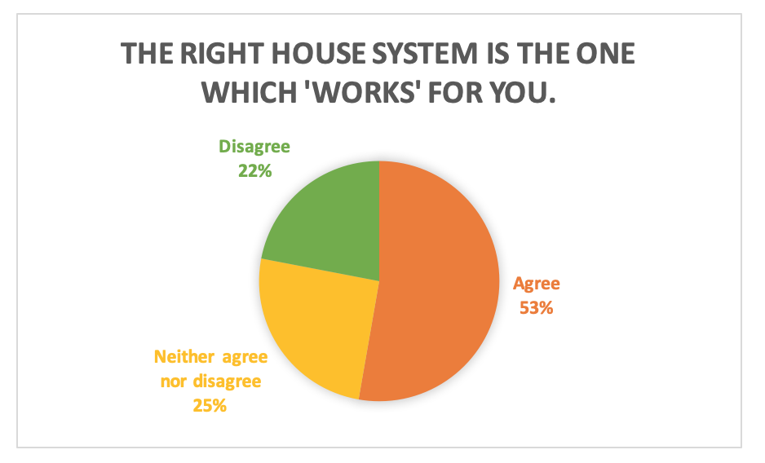
Figure 1. The right house system is the one which 'works' for you

Campion’s information was derived from participants attending the Astrological Association (AA) conference in Great Britain in 1999, and the United Astrology Conference (UAC) in the USA, in 2002. However, examination of the lectures covered at these conferences arguably shows a preference for ‘modern’ forms of astrology, with far fewer ‘traditional’ lectures. When I filter out ‘traditional’ astrologers from my survey data, 62% of respondents agree with the question (see Figure 2), which comes closer to Campion’s data, albeit not exact.

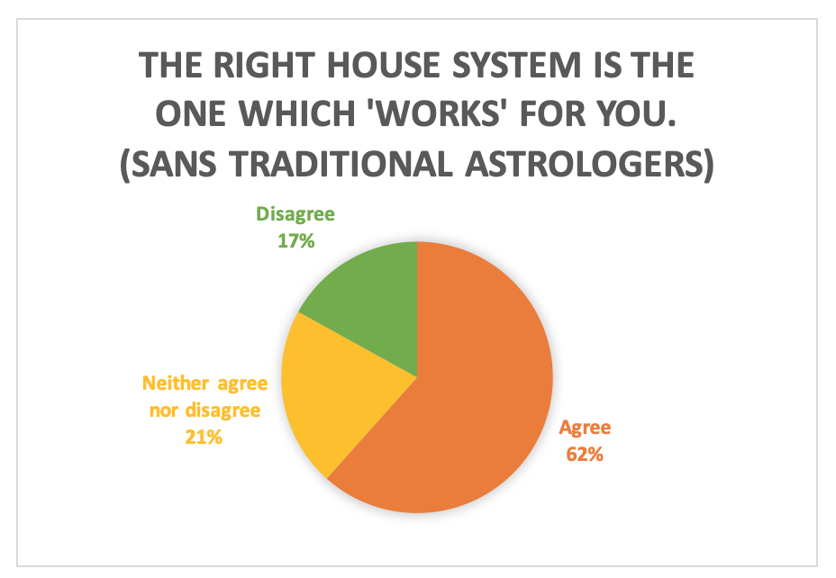
Figure 2. The right house system is the one which 'works' for you (sans traditional astrologers)

It’s possible, therefore, that due to the venue chosen, ‘traditional’ astrologers were precluded from Campion’s data. It is equally arguable that ‘traditional’ astrology was not popular enough at the time the surveys were conducted to warrant adding such lectures.
When ‘traditional’ astrologers are examined alone, the number of respondents who agreed with the statement falls to a statistically insignificant average (see Figure 3), suggesting that ‘traditional’ astrologers arefar less likely to hold relativistic views of houses than their ‘modern’ neighbours.

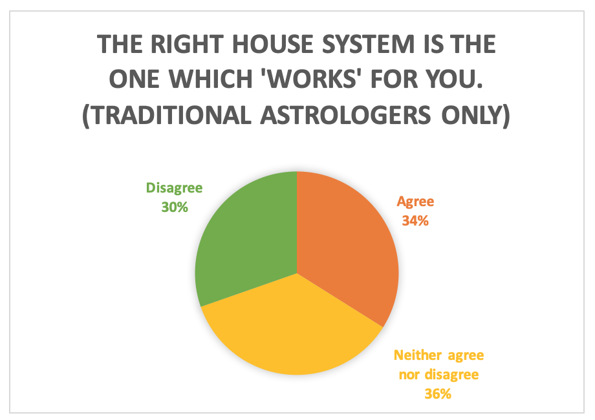
Figure 3. The right house system is the one which 'works' for you (traditional astrologers only)

To set a control for this question, I also asked a similar, but inverse, Likert statement: ‘Some houses are more accurate than others’. If Campion’s assertion that astrologers hold a relativistic view of houses is correct, then the response to this question should inversely mirror Campion’s question. Figure 4 demonstrates, however, that 49% agreed that some houses are more accurate than others compared to an expected 30%.

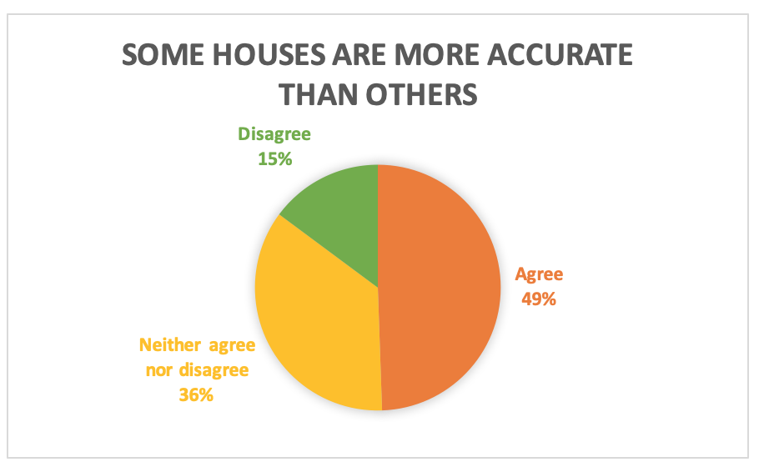
Figure 4. Some houses are more accurate than others
If the survey is again divided by tradition, a similar theme emerges (see Figure 5), but with 43% of ‘modern’ astrologers agreeing, contrasted with 55% of ‘traditional’ astrologers, suggesting again that ‘traditional’ astrologers are less likely to hold a relativistic view of houses.

Participants | Agree | Disagree
‘Modern’ astrologers | 43% | 15%
‘Traditional’ astrologers | 55% | 18%
Figure 5. Some houses are more accurate than others - split by tradition

I honed in on this theme across my interviews to discover what the discrepancy between these Likert statements might be. In noted that introduction to, or familiarity with, ancient astrological practices, particularly Hellenistic astrology, coincided with a notable drop in relativistic sentiments, and an increase in more absolutist ones, particularly with Whole Signs.
A good example of this is William who identified as a professional psychological astrologer who in recent years has begun to learn Hellenistic astrology. He agreed that some houses are more accurate than others. When asked about it he said:
If I had known about Whole Signs at the very beginning, ye, this would be different. But, some houses are more accurate than others? I would have to absolutely agree with that, but we just haven’t worked out why or worked out how. That’s been the journey of my life in astrology, not just working out what are the significators for ADHD, but where do I draw the bloody cusp!?

In other words, for William, Whole Sign Houses are the most accurate, and solves the problem of house systems which had frustrated him when he had tried to marry his psychological insight with astrological technique, and a desire for accuracy.
Gabriel agreed with both Likert statements and identified as a ‘Hellenistic’ astrologer. When questioned about the apparent discrepancy between the statements, he replied:
Gabriel:
Well, I’ve been trying to convert many people to Whole Signs lately, so when I read the right house system is the one which works for you I understand that for me, it’s true.
Me:
Do you think there are some people for whom it’s not accurate, so they use another house system which works for them?
Gabriel:
Yes. Because they do not understand the model!
…you cannot use modern techniques with Whole Sign Houses perfectly, and you cannot use Greek techniques with Placidus. It will not work very well.

When questioned further, Gabriel believes that for Hellenistic astrology, Whole Signs really do work better than others. Gabriel believes that each astrologer ought to use only the house system pertaining to the era of astrology being practiced, but that Whole Signs are best for Hellensitic astrology. In that way, his answer is indeed relativist between astrological traditions, but absolutist within his own tradition. Several times throughout the interview Gabriel referred to Schmidt’s work and essentially echoed Project Hindsight’s view of Whole Sign primacy, espoused prior to Schmidt’s death. Several times when I asked Gabriel a question, he answered with what Robert Schmidt has said on the topic, or evoked his thinking. For example, when asked about quantitative measurement vs qualitative measurement via the houses, every other interviewee provided their own opinion, but Gabriel would regularly say “Robert Schmidt says…” or “If you read the Greek texts…” by way of answer, alluding to the fact that his own views closely echo those of Project Hindsight. It’s possible therefore that just as Rudhyar has influenced ‘modern’ astrologers, who, perhaps unknowingly, reference Rudhyar’s views, that ‘Hellenistic’ astrologers are influenced by Schmidt’s views as they understand them. Some open questions in the questionnaire seem to support this, as many mentioned Schmidt as a reason they adopted Whole Signs as their preferred system. It is unclear what effect, if any, Schmidt’s latest retraction about the primacy of Whole Signs would have on astrologers like Gabriel. So as to not create a defensive tone, and with my own reflexivity in mind, I chose not to delve further, although it may be worth further study.
In contrast, Oliver, who identified as a ‘modern’ astrologer who uses some ancient techniques, agreed that the right house system is the one which works for you, and disagreed that some are more accurate than others. However, he elaborated by saying:
I’m impressed by Placidean’s measurement of time…Equal house works adequately for most people. I prefer that to Whole Sign. Whole Sign to me, I mean it’s going back to the traditional roots, where instead of counting degrees and having them nice and tight…well, they’re just broad and more fuzzy, and doing away with all the crispness you can get out of modern astrology.

Oliver appeared to hold the relativism of the kind that Campion links to Rudhyar, but underlying this is a hierarchy of preference. He liked Equal, is impressed by Placidus, and preferred them both to Whole Signs, suggestive of hierarchy. But his reasoning also included that you lose the ‘crispness’ you can get from modern astrology. In other words, he is implying that ‘traditional’ astrology which uses Whole Signs rather than degrees is less crisp, and, a connotation Oliver builds, is that perhaps less accurate as a result.
In contrast is Mateo, a semi-professional psychological astrologer who believes that the right house system is the one which works for you, and disagrees that some houses are more accurate than others. When asked if all houses are therefore equally accurate, he said:
Mateo:
I would think so, yes. I think it has to do with the fact that you cannot take one element from the chart alone, there is not one element alone that tells you the truth of the chart.
…
But, for instance, in the Argentinian national chart. If you use Equal Houses, Jupiter is in the 1st House, which has nothing to do with Argentina in my opinion, but if you use Whole Sign Houses it goes into the 2nd, so for Argentina I would use Whole Sign Houses.
Me:
Would you switch to a different house system then, if you thought the chart wasn’t making sense in the house system you were using?
Mateo:
I don’t know if I would really do it, but I think it could happen - like for instance in my experience with the Argentinian chart, but that could be that it makes more sense because we don’t have the right time or something.

So, although Mateo argues against the notion that some houses are more accurate than others, there is nevertheless a sense that at the very least some houses are more inaccurate than others, even if it’s contextual to a given chart. Nevertheless, Mateo does not necessarily switch between houses to find the one which works best.
There is clearly a divide, then, between ‘modern’ and ‘psychological’ astrologers in regards preferred house system. The survey data also reinforces this theme which emerged from the interviews. Figure 6 demonstrates the preference for these three house systems split between ‘modern’ and ‘traditional’ astrology against the number of respondents who listed that house system as a preference. The distinction is starker if the Hellenistic astrologers are taken alone, with 76% of Hellenistic astrologers preferring Whole Signs, and only 6% preferring Placidus.

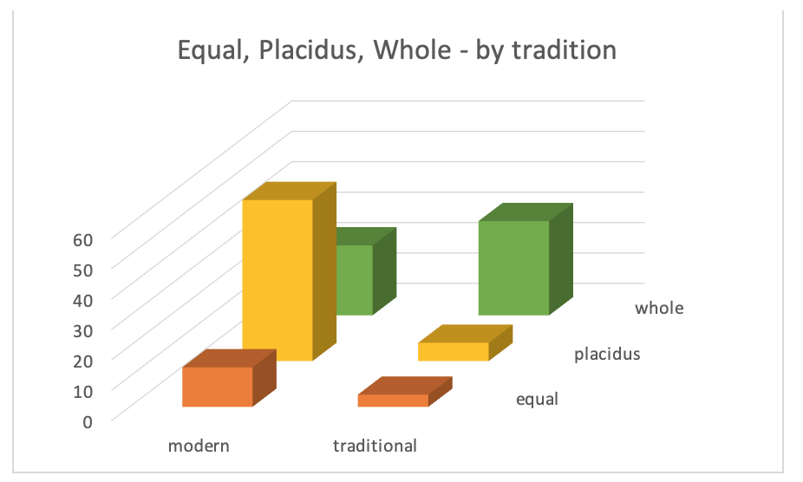
Figure 6. Equal, Placidus, Whole - by tradition

It’s possible, therefore, that there’s a tribal politics underlying astrologers’ house system preference. It’s arguable that announcing preference for Placidus, for example, is like a badge to convey belonging to the ‘modern’ group, whilst announcing a preference for Whole Signs is a badge to convey belonging to the ‘traditional’ astrologer group.
In conclusion, then, it seems that there’s a divide within the astrological community in regards the relativism of house systems, which can be broadly grouped into ‘traditional’ and ‘modern’ camps. Traditional astrologers were more likely to believe in the primacy of one house system in particular, and were more likely to imagine that failure of others to adopt that house system was due to misunderstanding, or, possibly, because perhaps other house systems work better for other traditions. ‘Traditional’ astrologers, ‘Hellenistic’ in particular tended to hold a relativistic position outside of ‘traditional’ astrology, and an absolutist one for ‘traditional’ techniques, with Whole Signs being advocated. Modern astrologers were more likely to adopt a relativist viewpoint, with some nevertheless suggesting a hierarchy of preference. The ‘traditional’ astrologers I spoke to preferred Whole Signs and tended to make arguments against Placidus, whilst modern astrologers tended to speak favourably of Placidus, with some arguing against Whole Signs, and others contextualising its use. Campion’s survey may not have accounted for this distinction within ‘astrologies’ due to the forum chosen for his survey data which may have precluded answers from ‘traditional’ astrologers. House systems may also form part of a tribal politics within the astrological community.

Conclusion
House systems are a controversial topic in astrology. Rudhyar advised a relativistic understanding of house systems, however, he contradicted that advice in practice, by arguing that Campanus works best for person-centred astrology and that Equal can’t be justified at all. With Rudhyar’s advice in mind, Campion noted that 70% of astrologers hold a relativist position for house-systems. Campion also noted that some scholars prefer to talk about ‘astrologies’, and with multi-variant ‘astrologies’ in mind, my research has re-examined the Campion’s conclusions, by differentiating the research question between broadly ‘modern’ and ‘traditional’ groups. 62% of ‘modern’ astrologers asserted the relativist position, whilst a statistically insignificant number of ‘traditional’ astrologers did. When this question was controlled against, both ‘traditional’ and ‘modern’ astrologers, however, also suggested that some houses are more accurate than others, with almost 49% of all respondents agreeing, suggesting some nuance in regards relativist vs absolutist belief. When examined again within their grouped ‘astrologies’, ‘traditional’ tended to agree with the statement more than ‘modern’ astrologers. Interviews within the various groups demonstrated that in practice both groups tended to favour one house system and sometimes tended to denigrate another, but both groups nevertheless broadly adopted a relativist position external to their grouping, with ‘traditional’ astrologers, and ‘Hellenistic’ in particular, adopting an absolutist position within the group. In other words, Hellenistic astrologers tended to suggest that Whole Signs was absolutely the best for, at least, Hellenistic astrology, and possibly all astrologies. The breakdown of preferred house system between the two groups, and the noticeable, albeit sometimes subtle, denigration of another house system may suggest that house systems are a way of announcing a kind of astrological politics, and all the inferred tribal ‘belonging’ and shared philosophy that this may entail. In a way, this demonstrates a relativism reminiscent of what Rudhyar was doing in practice, if not what he advised. Just as Rudhyar argued against one house system and argued in favour of another, so too did both ‘modern’ and ‘traditional’ astrologers. If it really is the case that house systems are contentious, they are arguably contentious in the same manner that politics is contentious.
As Campion concluded, astrologers tend to hold a relativist position about house systems, but a clear differentiation exists between ‘modern’ and ‘traditional’ astrologies, with ‘traditional’ astrologers tending toward an ‘absolutist’ view in practice. More research, focused on differentiating ‘astrologies’ may be helpful when examining similar topics in greater depth.

Table of Figures

Figure 1. The right house system is the one which 'works' for you 7
Figure 2. The right house system is the one which 'works' for you (sans traditional astrologers) 8
Figure 3. The right house system is the one which 'works' for you (traditional astrologers only) 9
Figure 4. Some houses are more accurate than others 9
Figure 5. Some houses are more accurate than others - split by tradition 10
Figure 6. Equal, Placidus, Whole - by tradition 14

Bibliography

Primary Sources
The Astrological Association, Conference 1999 Recordings, https://www.astrologicalassociation.com/shop/recordings/conference1999_recordings.php, [accessed 2/8/20].

Participant #41, survey submitted 26/6/20, interview online via Zoom, 29/7/20.

Participant #66 (Gabriel), survey submitted 27/6/20, interviewed online via Zoom 10/7/20.

Participant #129, survey submitted 28/6/20, interview online via Skype, 1/8/20.

Participant #164 (William), survey submitted 30/6/20, interviewed online via Zoom 17/7/20.

United Astrology Conference, UAC2020, https://www.uacastrology.com/recordings/UAC-2002-c22997088, [accessed 2/8/20].

Secondary Sources
About Project Hindsight, http://www.projecthindsight.com/geninfo/about.html, [accessed 15th July 2020].

Bell Judith, and Waters S., Doing Your Research Project: A Guide for First-Time Researchers, Open University Press (McGraw-Hill Education, 2014).

Campion, Nicholas, Astrology and Cosmology in the World’s Religions, (NYU Press, 2012).

Campion, Nicholas, Prophecy, Cosmology and the New Age Movement: The Extent and Nature of Contemporary Belief in Astrology, Doctoral Thesis, University of the West of England, Bristol., 2003.

Friedman, Hank, Ending the War between the Astrologers, http://www.soulhealing.com/ending.htm [accessed 19/07/20].

Geertz, Clifford, “Thick Descriptions”, in “The Interpretation of Cultures”, Basic Books, 1973.

Hand, Robert, Whole Sign Houses, The Oldest House System: An Ancient Method in Modern Application, Reston, VA: ARHAT, 2000.

Hennik, Monique, Hutter, Inge and Bailey Ajay, Qualitative Research Methods, Ashford, Sage Publications, 2013

Holden, James Herschel , Ancient House Division, American Federation of Astrologers Journal of Research, vol. 1, no. 1 (August 1982), Tempe, AZ.

Houlding, Deborah, The Houses: Temples of the Sky, Wessex Astrologer Limited, 2006.
Munkasey, Michael, An Astrological House Formulary, https://www.scribd.com/doc/6495552/An-Astrological-House-Formulary#scribd, [accessed 20/6/20].

Rudhyar, Dane, The Astrological Houses: The Spectrum of Individual Experience, Doubleday, 1972.

Schmidt, Robert, Paulus Alexandrinus Introductory Matters, Berkeley Springs, WV: Golden Hind Press, 1993.

Schmidt, Robert, The So-Called 'Problem of House Division': Definitions of Greek Terms and New Translations of Key Passages, Project Hindsight, Cumberland, MD, 2016.

Tompkins, Sue, The Contemporary Astrologer's Handbook: An in-Depth Guide to Interpreting Your Horoscope, Astrology Now (Flare Publications, 2006).

Appendix A
The questionnaire was distributed online via Google Forms. 183 respondents answered and submitted the questionnaire.
In certain cases, where people chose “other” and typed a response, I sometimes accounted for their answer in one of the other groupings. For example, I included ‘Evolutionary astrology’ with Modern/psychological. Likewise, when providing their preferred house system where people answered “I sometimes use Placidus but I also like Whole”, I treated their question as having answered both Placidus and Whole.
Questions are given below, with answers in red where appropriate.

What tradition of astrology best describes your preferred approach?
- Hellenistic astrology (9.3%)
- Medieval/renassiance astrology (3.8%)
- Broadly ‘traditional’/ancient astrology (17%)
- Modern/psychological astrology (25.3%)
- A mix of ancient and modern astrology (33%)
- Other

Do you principally use the tropical or a sidereal zodiac?
- Tropical (82.4%)
- Sidereal (15.4%)
- Not sure (2.2%)

What branches of astrology do you frequently or typically practice? Check all which apply.
- Natal (95.1%)
- Horary (40.1%)
- Electional (33%)
- Mundane (36.8%)

How would you describe your astrological experience?
- I am a student/beginner (2.7%)
- I practice astrology infrequently for myself or close family or friends only (4.9%)
- I practice astrology frequently, mostly for myself or close family or friends (24.2%)
- I practice astrology for others frequently, but I do so free of charge (18.1%)
- I am a semi-professional astrologer (26.4%)
- Astrology is my main or sole profession (23.6%)

Have you ever taken an astrology course?
- Yes, and I completed it (67%)
- Yes, but I didn’t complete it (6.6%)
- No, but I plan/want to (6.6%)
- No, and I have no immediate plans to (19.8%)

What is a house system?
[open question]

What is the main house system that you currently use?
- Alcabitius (3.8%)
- Campanus (1.63%)
- Equal (9.78%)
- Koch (2.17%)
- Placidus (34.24%)
- Porphyry (7.61%)
- Regiomontanus (7.61%)
- Sripati (0%)
- Topocentric (Polich-Page) (1.09%)
- Vehlow (1.09%)
- Whole (30.98%)

Apart from accuracy, what first drew you to this house system?
[open question]

What was the first house system that you were introduced to, or taught to use?
- Alcabitius (0.05%)
- Campanus (1.1%)
- Equal (16.5%)
- Koch (3.8%)
- Placidus (69.2%)
- Porphyry (1.6%)
- Regiomontanus (1.6%)
- Sripati (0%)
- Topocentric (Polich-Page) (1.1%)
- Vehlow (0%)
- Whole (3.8%)

What house systems have you experimented with or have used frequently? Check all which apply.
- Alcabitius (19.2%)
- Campanus (14.8%)
- Equal (50.5%)
- Koch (34.1%)
- Placidus (77.5%)
- Porphyry (33%)
- Regiomontanus (47.3%)
- Sripati (3.3%)
- Topocentric (Polich-Page) (6%)
- Vehlow (3.3%)
- Whole (68.7%)

Do you prefer to use different house systems for different branches of astrology (e.g. Placidus for natal, Regiomontanus for horary etc.)?
- Yes (44%)
- No (56%)

Do you prefer to use a different house system for specific techniques within a given branch of astrology (e.g. Porphyry just for 'length of life' techniques, or Topocentric when rectifying charts)
- Yes (35.7%)
- No (64.3%)

House system should ‘work’ at all latitudes and locations.
- Strongly Disagree (7.7%)
- Disagree (8.8%)
- Neither agree nor disagree (28%)
- Agree (24.2%)
- Strongly Agree (31.3%)

Some house systems are more accurate than others.
- Strongly Disagree (7.1%)
- Disagree (7.7%)
- Neither agree nor disagree (35.7%)
- Agree (17%)
- Strongly Agree (32.4%)

The right house system is the one which works for you.
- Strongly Disagree (14.3%)
- Disagree (7.7%)
- Neither agree nor disagree (25.3%)
- Agree (24.2%)
- Strongly Agree (28.6%)

Outside an astrological consultation, or chart interpretation, I conceptualise my preferred house system(s) within my environment, or when contemplating the sky.
- Strongly Disagree (12.6%)
- Disagree (15.9%)
- Neither agree nor disagree (25.8%)
- Agree (23.6%)
- Strongly Agree (22%)

Houses have a sacred or spiritual dimension to me.
- Strongly Disagree (15.9%)
- Disagree (12.1%)
- Neither agree nor disagree (32.4%)
- Agree (18.7%)
- Strongly Agree (20.9%)

Have you ever felt you have had to defend or justify your choice of house system to other astrologers?
- Yes (39%)
- No (61%)

What does your choice of house system(s) provide you as an astrologer?
[open question]

Nicholas Campion, Prophecy, Cosmology and the New Age Movement: The Extent and Nature of Contemporary Belief in Astrology, Doctoral Thesis, University of the West of England, Bristol., 2003, pp.247-248.
Nicholas Campion, Astrology and Cosmology in the World’s Religions, (NYU Press, 2012), p.16
Campion, Prophecy, Cosmology and the New Age Movement, p.247.
Michael Munkasey, An Astrological House Formulary, https://www.scribd.com/doc/6495552/An-Astrological-House-Formulary#scribd, [accessed 20/6/20]; Sue Tompkins, The Contemporary Astrologer's Handbook: An in-Depth Guide to Interpreting Your Horoscope, Astrology Now (Flare Publications, 2006).
Campion, Astrology and Cosmology in the World’s Religions, p.16; Campion, Prophecy, Cosmology and the New Age Movement, pp.247-249
Judith Bell and S. Waters, Doing Your Research Project: A Guide for First-Time Researchers, Open University Press (McGraw-Hill Education, 2014)., pp212-214.
Monique Hennik; Inge Hutter; Ajay Bailey, Qualitative Research Methods, (Ashford, Sage Publications, 2013), pp.52-56.
Deborah Houlding, The Houses: Temples of the Sky, Wessex Astrologer Limited, 2006, p.ix.
Houlding, The Houses: Temples of the Sky, p.ix; Tompkins, The Contemporary Astrologer's Handbook, pp.245-301.
Tompkins, The Contemporary Astrologer's Handbook, pp.245-248.
Houlding, The Houses: Temples of the Sky, pp.103-106
Robert Hand, Foreword, in Deborah Houlding, The Houses: Temples of the Sky, p.vii; Tompkins, The Contemporary Astrologer's Handbook, p.245; Hank Friedman, Ending the War between the Astrologers, http://www.soulhealing.com/ending.htm [accessed 19/07/20].
Dane Rudhyar, The Astrological Houses: The Spectrum of Individual Experience, Doubleday, 1972, pp.67-68.
Campion, Prophecy, Cosmology and the New Age Movement, pp.244-257.
Rudhyar, The Astrological Houses, pp.35-41.
Rudhyar, The Astrological Houses, p.49.
Houlding, The Houses: Temples of the Sky, p.106.
James Herschel Holden, Ancient House Division, American Federation of Astrologers Journal of Research, vol. 1, no. 1 (August 1982), Tempe, AZ, pp.19-29.
J.D. North, Horoscopes and History, London: Warburg Institute, 1986.
About Project Hindsight, http://www.projecthindsight.com/geninfo/about.html, [accessed 15th July 2020].
Tompkins, The Contemporary Astrologer's Handbook, p.245.
For example, see Robert Schmidt, Paulus Alexandrinus Introductory Matters, (Berkeley Springs, WV: Golden Hind Press, 1993), pp.iii-ix.
Robert Hand, Whole Sign Houses, pp.22,39; Robert Schmidt, The So-Called 'Problem of House Division': Definitions of Greek Terms and New Translations of Key Passages, Project Hindsight, Cumberland, MD, 2016, p.47.
Hennink et al, Qualitative Research Methods, pp.52-56.
Bell, Doing Your Research Project, pp.48-50; Hennink et al, Qualitative Research Methods, p.76
Bell, Doing Your Research Project, p.142
Hennink et al, Qualitative Research Methods, p.55
Hennink et al, Qualitative Research Methods, pp.15-19
Hennink et al, Qualitative Research Methods, p.18
Hennink et al, Qualitative Research Methods, pp.18-19
Clifford Geertz, “Thick Descriptions”, in “The Interpretation of Cultures”, Basic Books, 1973. Patrick McCafferty, “Comets and Meteors: The Ignored Explanations for Myths and Apocalypse”,in The Imagined Sky: Cultural Perspectives, ed. by Darreln Gunzburg (Equinox Publishing Limited, 2016), pp.23-43
Campion, Prophecy, Cosmology and the New Age Movement, p.234
The Astrological Association, Conference 1999 Recordings, https://www.astrologicalassociation.com/shop/recordings/conference1999_recordings.php, [accessed 2/8/20]; United Astrology Conference, UAC2020, https://www.uacastrology.com/recordings/UAC-2002-c22997088, [accessed 2/8/20].
Participant #164 (William), survey submitted 30/6/20, interviewed online via Zoom 17/7/20.
Participant #66 (Gabriel), survey submitted 27/6/20, interviewed online via Zoom 10/7/20.
Participant #129, survey submitted 28/6/20, interview online via Skype, 1/8/20.
Participant #41, survey submitted 26/6/20, interview online via Zoom, 29/7/20.

