Impact of Virtual Learning Environment (VLE)-Moodle on Student’s learning experience in the University Of Whales Trinity Saint David London Campus

Student Name: IVANUS SORIN
Student Number : 1906170
Module Lecturer’s Name : ANUPAM MAZUMDAR

Table of Contents
1. Introduction 3
2. Rationale of research 3
3. Literature review 3
4. Research methods 5
5. Analysis and discussions 6
6. Limitations of research 10
7. Recommendation for future research 10
8. Conclusion 11
References 12
Appendix 13

1. Introduction
Virtual learning environment is considered as the web-based platform from which different academic resources related to the digital sources can be obtained and interactions between the teachers and students is possible (Herrera, 2017). It is necessary for the students and teachers as it helps the students in self-paced learning as well as help the teacher to arrange a proper learning schedule for the students efficiently. The students can get a large amount of resources and communicate their courses with the teachers to improve their learning abilities and experiences. The teachers can also manage the administrative works through the Moodle to provide additional support to the students.

2. Rationale of research
The present research analyses the way by which Moodle helps the students of University of Wales Trinity Saint David London Campus in their virtual learning. It has been identified that improper knowledge of the teachers in creating a learning schedule for the students has reduced the learning experience of the students as they have failed to gather all necessary resources from the Moodle. The students have also lack of knowledge about the complexities of the Moodle and proper directions have not been provided to them to use resources (Kerimbayeva, 2016). Lack of information in the Moodle also reduces learning experiences. The research would be conducted to determine whether the Moodle is well developed with the resources and to check all information available in the Moodle that can enhance student experiences.

3. Literature review
Concept of VLE
Virtual Learning environment is used for improving the experiences of students' learning process. As mentioned by Cassidy (2016), it makes use of digital technology by the usage of the internet in order to improve the learning experience for the students. One of the most common forms of virtual learning environment regime which is preferred by the students is Moodle platform. It is an e-learning platform or a course management system which helps the students in the global scale to undertake lessons anytime and anywhere. Curriculum mapping is also done in a Moodle platform in which the syllabi are taught according to the preferences of the students. It supports the “Sharable Content Object Reference Model (SCORM)”, the source code of Moodle is accessible to all the users. It is provided under the General Public License in which the administrators can freely run and share information on this platform as per their requirement.
Benefits of VLE and Moodle in improving student’s virtual learning
Cost-effective
There is no licencing cost for the students for Moodle usage. Henceforth, this learning management system provides the students with the right impetus for learning. According to a survey by ‘Berwick Advertiser’, many students have been able to reduce their tuition costs by more than 60% by the usage of Moodle learning platform and other virtual learning platforms.
Simplicity of interface
According to Phungsuk et al. (2017), the user-friendliness of the e-learning platforms sets the benchmark for enhancing the rate of satisfaction in learning for the students. The students can download and pause educational videos according to the conveniences and they can have multiple views of the same concept. This also enhances their level of understanding which would invariably help them to obtain higher grades. In the UK, the 36% students have reported that they have been able to uplift their grades owing to learning from VLEs such as Moodle.
Offline access
The offline access feature of some e-learning platforms such as Moodle helps the students in remote locations to download the notes and study them offline.
Impact of VLE on students
As per the view of Boulton et al. (2018), virtual learning saves time for the subjects which they can invest for further understanding of the subject. VLE is also advantageous for the teachers as it helps them to set lessons according to the schedule all at once. In this manner, they can provide more classes in a smaller time frame. More classes for different concepts helps the teachers to picturise each and concept properly to the students. Furthermore, in VLE platforms such as Moodle, the teachers can also set the notes according to the strengths and weaknesses of the students. The problem solving skills of the students are also enhanced by virtue of VLE such as Moodle since they are able to visualise the question in a better manner.
Challenges due to lack of information in Moodle
The VLE requires high speed internet formulations which are not available in the remote areas. Henceforth, it becomes really difficult for the students belonging to remote areas to undertake more classes owing to bad connectivity. Furthermore, it has also been witnessed that most teachers in the global scale are not acquainted with the virtual learning scaling and therefore they find it very difficult to manage the classes with VLEs. The students might also not be able to cooperate in a better manner with the teachers in case of doubts. In this manner, the doubts of the students seem to affect their level of understanding.

4. Research methods
Qualitative research
Qualitative research refers to a process in which data is collected through the open-ended questionnaire and observation information (Hennink et al., 2020). It is non-numerical in nature and mainly qualitative data is collected from interview, observation, focus group and document analysis. In the present research, primary qualitative data has not been collected.
Quantitative research
Quantitative research is considered as a systematic method of investigating phenomena by collecting quantifiable data. Numerical data is collected through this process and data are interpreted statistically, computational or mathematical methods (Goertzen, 2017). Primary quantitative data has been collected in this research from the students of University of Wales Trinity Saint David London Campus to determine the way by which Moodle can help the students to obtain virtual learning. Quantitative data has been collected through a telephonic survey method.
Sample and sample size
Population has been all students of the university but some part of the students have been utilized as samples. Sample size for the survey has been 15 who are students of University of Wales Trinity Saint David London Campus. Random non-probability sampling technique has been used to select students randomly to reduce bias.
Data collection tools
Close-ended questionnaire has been provided to the students of the university to collect quantitative data through survey. Consent form has been sent to them to make them aware of the research purposes. Consent form ensures agreement of the students to willingly participate in the research. Secondary data is fetched from journals, books, website and online articles. Thematic analysis has been conducted with the help of secondary data.
Ethical consideration
Data has been gathered and stored on the basis of the regulations of “Data Protection Act 2018” and manipulation of data has not been done. Students have not been forced to give biased responses and all information has been utilised in academic purposes.

5. Analysis and discussions
Quantitative data has been collected in this speech to identify the effectiveness of the Moodle in supporting virtual learning of University of Wales Trinity Saint David London Campus. Questionnaires have been presented through Likert scales.
Q1. Moodle has helped in focusing more on studies for development of in-depth understanding.

Options | Total number of respondents | Frequency | Percentage of responses (%)
Strongly agree | 15 | 4 | 26
Agree | 15 | 5 | 34
Do not know | 15 | 1 | 6
Disagree | 15 | 3 | 20
Strongly disagree | 15 | 2 | 14

It has been determined from the findings that 34% of the students agree that Moodle is effective to help them to focus more on their study and provide in-depth understanding due to its huge resources. A large number of the resources can be obtained by the students through this platform that enhances their abilities to gather asymmetric knowledge.
Q2. Moodle is well developed with all resources as per the needs of the students.
Options | Total number of respondents | Frequency | Percentage of responses (%)
Strongly agree | 15 | 4 | 26
Agree | 15 | 6 | 40
Do not know | 15 | 2 | 14
Disagree | 15 | 2 | 14
Strongly disagree | 15 | 1 | 6

From the above data, it is noticed that 40% of the students agree that Moodle is well developed with the resources and addition of necessary resources is also possible in the Moodle. Lesson plans can be created using the existing resources and it is effective for the students to complete self-assessment and gather more resources to enhance their knowledge.
Q3. Moodle is supportive to make regular interaction and communication between the students and teachers.
Options | Total number of respondents | Frequency | Percentage of responses (%)
Strongly agree | 15 | 5 | 34
Agree | 15 | 4 | 26
Do not know | 15 | 2 | 14
Disagree | 15 | 3 | 20
Strongly disagree | 15 | 1 | 6

Regular immunization and interaction with the teachers and other learners is possible through Moodle according to 34% of the students and they strongly agree this aspect. The teachers can create different learning programs and quiz through the Moodle and easy participation in the programs is possible through this platform. Alongside, the students can identify their grade of the assessment through the Moodle that helps them to determine the areas of improvement. Regular communication and collaboration help the students to evaluate their problems and take feedback from others to solve issues.

Q4. All information that is necessary for the students is available in the Moodle.

Options | Total number of respondents | Frequency | Percentage of responses (%)
Strongly agree | 15 | 6 | 40
Agree | 15 | 5 | 34
Do not know | 15 | 1 | 6
Disagree | 15 | 2 | 14
Strongly disagree | 15 | 1 | 6

According to the finding, 40% of the students strongly agree that all necessary information is available in the Moodle and e-learning projects are necessary for gathering information about the academic courses. As per the students of university, it is very useful for distance learning and getting proper guidance from the teachers.

Q5. The interface of Moodle is student friendly
Options | Total number of respondents | Frequency | Percentage of responses (%)
Strongly agree | 15 | 4 | 27
Agree | 15 | 7 | 47
Do not know | 15 | 1 | 6
Disagree | 15 | 2 | 14
Strongly disagree | 15 | 1 | 6

Most of the students (47%) agree that the interface of Moodle is intuitive as customisation is observed in the Moodle design. The simple design of Moodle comprises various functionalities that helps in setting all assignments and courses effectively. However, according to 14% of the students, Moodle does not help the students to enhance knowledge because it is complicated to find all necessary resources in the Moodle.
Q6. Flexible learning goals can be created in the Moodle to enhance knowledge
Options | Total number of respondents | Frequency | Percentage of responses (%)
Strongly agree | 15 | 4 | 27
Agree | 15 | 3 | 20
Do not know | 15 | 1 | 6
Disagree | 15 | 5 | 34
Strongly disagree | 15 | 2 | 13

As per 34% of the students, the Moodle does not support the teachers to set goals for the learners. Therefore, it is not effective to maintain a flexible learning schedule for the students. Alongside, lack of intervals between two sessions reduces memorising capacity. The students feel stressed to completely acquire knowledge regarding their academic courses.
Thematic analysis
Theme 1: Benefits of Moodle for the students of university
Moodle is beneficial for the students to gather huge resources in free cost that are essential for increasing knowledge regarding academic courses. Customization procedure for the Learning Management Software such as Moodle which is an e-learning platform is very easy and hence it can be exercised at a short notice (Alves et al., 2016). The customizations are done according to the requirements of the students which make the job even easier for installation of VLEs. It can also be developed into a better strategy by usage of better internet stratifications. It also helps in saving time for loading of important information.
Theme 2: Impact of Moodle on the learning of students
The transportation time and cost is in this process. The students are also able to review the subjects in a thorough manner by virtual display of the concepts. It clearly provides the students with an in-depth understanding of the fundamental concepts which can invariably help them to understand the basics behind a concept. Moodle also provides the basic amenities for the students by virtue of which they are able to enhance their capacity by leaps and bounds.

6. Limitations of research
The research has faced some barriers that reduce the effectiveness of the research outcomes. There has been a shortage of time and money that leads to incomplete data collection and low sample size has been taken due to lack of time that also has decreased reliability of information. Finding the right participants who had enough knowledge regarding efficiency of Moodle have also become limitations for the research. Lack of understanding of the concept has been observed because university was shut.

7. Recommendation for future research
Installation of artificial intelligence techniques
Research on the efficiency of Moodle can be improved by the use of cloud computation techniques as well as installation of Internet of Things (IoT) which can improve the pace in remote areas.
Improvement of interface in remote regions
Research can also be held on improving the interface of internet connectivity so that installation and usage of Moodle learning platforms can be better in those areas.
More development in Moodle architecture
Research can be conducted for better development in Moodle architecture so that it can also be used for bigger study projects. This would allow the students to undertake online courses on a larger scale.

8. Conclusion
It can be concluded that the VLEs such as the Moodle interface are extremely important for the students in order to gain more impetus on their subjects. The students can also enhance their level of skills by the better usage of the Moodle platform. However, Moodle requires a high speed internet which needs to be developed so that the experience of the Moodle platform can be better for the students. The teachers of University of Wales Trinity Saint David London Campus need to get themselves updated with the Moodle platform for making sure that they are able to provide best services to their students on e-learning platforms.

References
Alves,P.,Miranda,L.and Morais,C.,(2016). „The importance of virtual learning environments in higher education”.In Handbook of Research on Applied E-Learning in Engineering and Architecture Education (pp. 404-425). IGI Global.
Boulton,C.A.,Kent,C.and Williams, H.T.(2018). „Virtual learning environment engagement and learning outcomes at a ‘bricks-and-mortar university”.Computers & Education,126, pp.129-142.
Cassidy,S.,(2016). „Virtual Learning Environments as Mediating Factors in Student Satisfaction with Teaching and Learning in Higher Education”. Journal of Curriculum and Teaching,5(1), pp.113-123.
Goertzen, M.J.,(2017). „Introduction to Quantitative Research and Data.„Library Technology Reports”,53(4), pp.12-18.
Hennink,M.,Hutter,I.and Bailey,A.,(2020). „Qualitative research methods”.SAGE Publications Limited.
Herrera,L.,(2017). „Impact of implementing a virtual learning environment(VLE)in the EFL classroom”. Íkala,22(3)pp.479-498.
Kerimbayev, N.,(2016). „Virtual learning: Possibilities and realization”. Education and Information Technologies, 21(6), pp.1521-1533.
Phungsuk,R.,Viriyavejakul,C.and Ratanaolarn,T.,(2017). „Development of a problem-based learning model via a virtual learning environment”. Kasetsart Journal of Social Sciences,38(3), pp.297-306.

Appendix
Questionnaire
Q1. Moodle has helped in focusing more on studies for development of in-depth understanding.
Options | Total number of respondents | Frequency | Percentage of responses (%)
Strongly agree | 15 | 4 | 26
Agree | 15 | 5 | 34
Do not know | 15 | 1 | 6
Disagree | 15 | 3 | 20
Strongly disagree | 15 | 2 | 14

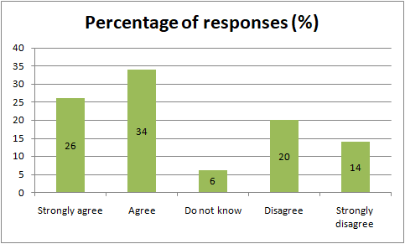
Q2. Moodle is well developed with all resources as per the needs of the students
Options | Total number of respondents | Frequency | Percentage of responses (%)
Strongly agree | 15 | 4 | 26
Agree | 15 | 6 | 40
Do not know | 15 | 2 | 14
Disagree | 15 | 2 | 14
Strongly disagree | 15 | 1 | 6

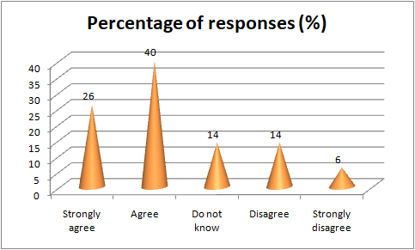
Q3. Moodle is supportive to make regular interaction and communication between the students and teachers
Options | Total number of respondents | Frequency | Percentage of responses (%)
Strongly agree | 15 | 5 | 34
Agree | 15 | 4 | 26
Do not know | 15 | 2 | 14
Disagree | 15 | 3 | 20
Strongly disagree | 15 | 1 | 6

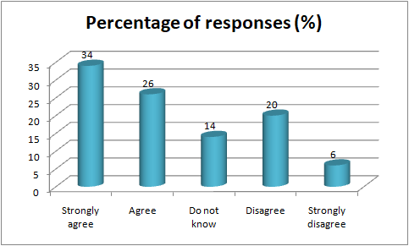
Q4. All information that is necessary for the students is available in the Moodle
Options | Total number of respondents | Frequency | Percentage of responses (%)
Strongly agree | 15 | 6 | 40
Agree | 15 | 5 | 34
Do not know | 15 | 1 | 6
Disagree | 15 | 2 | 14
Strongly disagree | 15 | 1 | 6

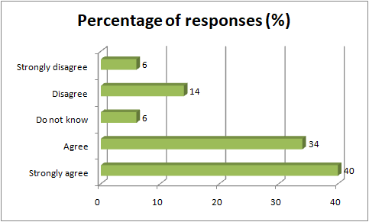
Q5. The interface of Moodle is student friendly

Options | Total number of respondents | Frequency | Percentage of responses (%)
Strongly agree | 15 | 4 | 27
Agree | 15 | 7 | 47
Do not know | 15 | 1 | 6
Disagree | 15 | 2 | 14
Strongly disagree | 15 | 1 | 6

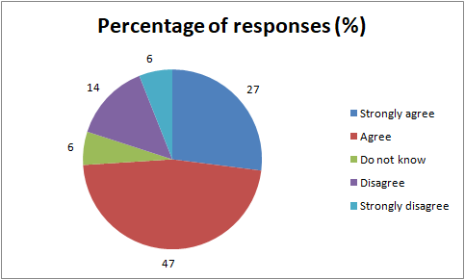

Q6. Flexible learning goals can be created in the Moodle to enhance knowledge
Options | Total number of respondents | Frequency | Percentage of responses (%)
Strongly agree | 15 | 4 | 27
Agree | 15 | 3 | 20
Do not know | 15 | 1 | 6
Disagree | 15 | 5 | 34
Strongly disagree | 15 | 2 | 13



