Module code: LCHS4004

Module Name: Introduction to Public Health
Assessment Component 2 - Major Health Issue
Lecturers: Dr Aishat Bakre (Module Lead)
Prof Robert Ashford
Kennedy Obohwemu
Gillian Weaver
Hamdi Hussain
Hajra Mustasim

Student Name: Abdul Salam

Student ID:2133509
Table of Contents
Introduction 3
Main Body 3
Public Health measures for preventing the disease 3
The principal reasons for the disease 4
Short-term consequences of the disease 5
Long-term consequences of the disease 7
Influencing elements on the health of individuals in the disease 8
Conclusion 8
References 10

Introduction
COVID-19 is an infectious disease caused by the Sars-COv-2 virus, which started to show its impact in the last quarter of the year 2019. The virus started showing first in the Wuhan province of China and then started to spread worldwide. The first wave of the disease reached the UK in the early months of the year 2020. It was mostly stated by the travellers who came from Europe, then gradually infected more people. At last, the first wave was identified in the month of the March of the same year. It was a massive outbreak at that time in the UK as it caused billions of cases and millions of deaths. Except for London, 1.3% of all the infected people got quickly death and close to 4% of people needed immediate care in medical facilities and nursing homes (Van Elsland, 2020). A total of 2, 20,982 people were dead during the whole tenure of the outbreak in the UK (GOV.UK, 2022).

Main Body

Public Health measures for preventing the disease
COVID-19 is a highly infectious disease which can cause a severe impact on public health by showing small symptoms and then gradually increasing. That is why any person should consult a medical professional if he or she comes into contact with this disease. One of the crucial ways by which people can ensure their safety primarily is by making a guarantee of the fact that they are maintaining a minimum safe distance from each other. As the virus of the disease is contaminated by the closer distance among the people, that is why it is most crucial for them to keep a minimum distance of 1 metre from each other. Social distancing will not allow the virus to attack easily and spread itself inside the body (Aslam, 2020). In addition to that, the usage of masks is also necessary to ensure that anyone is not exposed to the virus easily (Tso and Cowling, 2020). As the virus of the disease mainly attacks and enters the human body through the nose and mouth, that is why wearing proper masks will cover those sensitive areas and make sure that the virus would not enter through anywhere.
Then comes the most sensitive case of preventive measure, which is treating own self or any family members or close ones affected by the disease at home. As the pandemic had a massive outbreak globally, every hospital, nursing home and the medical facility did not have the facility of providing the required healthcare and attention to every single patient. In addition to that, the patient’s condition will become worse in many cases that is why medical professionals provided the solution of self-isolation (Weinstein and Nguyen., 2020). In this process, any person, who is affected by the disease should lock himself in his home for at least 2 weeks and for that tenure, he should keep his daily activities as, sleeping, studying, having lunch, dinner or breakfast, and almost everything in that room except the obvious use of the washroom. At that point in time, every single member of the family should keep the utmost distance from the infected person. The infected person also should take the responsibility of keeping himself and the rest of the family member’s safe by maintaining a safe distance and taking necessary precautions.

The principal reasons for the disease
The most important cause of the disease is the virus named Sars-Cov-2, which comes from a particular group of viruses. Those viruses are known for mostly causing respiratory problems in the human body. All those viruses are called by the name of “Corona” for their spike-like structure, which looks like a crown from above or any surface when looking closely. It is not that the Sars virus is the first kind of virus which has created a massive outbreak. Earlier also the other family members of the group have created illness for mankind. MERS or Middle East Respiratory Syndrome, SARS or severe acute respiratory syndrome and the virus responsible for the common cold, all are relatives of the same. Of all the deaths caused by COVID-19 globally, close to 6 million deaths are caused by respiratory diseases (Cleveland Clinic, 2022). A certain kind of virus, which is responsible for Coronavirus, is mainly found in bats, cats and some other animals. Although that virus is already there inside those animals’ bodies, they do not affect the animals. By the time of transfer, that virus is automatically mutated into another one. At the end of the day, the virus can be transferred from those animals’ bodies to the human body and then they can attack all of a sudden. In the case of the COVID-19 pandemic too, the first outbreak happened at an animal market in Woohan.
The virus gets into the body through the mouth, nose and even the eyes. After that, the virus travels to the end of the nasal passages and the mucus membrane situated there in the tissues of those membranes in the back of the throat. After it is successfully inferred to the mucus tissues of the throat and noise, it makes its place there permanently (Cleveland Clinic, 2022). Thereafter it attaches itself to the cells present at that spot and starts multiplying at a rapid rate. It not only stops there, instead but also moves to the tissues situated in the lungs.

Short-term consequences of the disease
Plenty of times people, who are infected by the virus that causes the disease, do not show one single symptom of the same. Most of the time they do not even know that they are affected by the Sars-Cov-2 virus. However, many times they show some symptoms too, which are not obvious signs of being affected by the virus only. Some of those short-term symptoms which are identified as mild effects of the disease include breathing problems, mild or heavy fever, cough, fatigue and aches in the body. In more severe cases, failure in breathing, confusion things and also other psychological problems, and damage in the kidney or heart due to less flow of oxygen to those organs (Health Desk, 2020). It also caused kidney failures in several cases, as of all the 30000 patients who visited the clinics in London for kidney dialysis, 17% tested positive and 8% were admitted to hospitals for COVID-19 (UCL, 2021). Sometimes lack of oxygen and blood flow may even result in blood clots which may create a huge long-term problem if they are not treated with well treatment procedures. The more major the symptoms are, the more chance of major organs of the body getting seriously damaged increases with time. The disease may also impact the organ systems of the body in direct or any kind of indirect ways. As an example, damage in the lungs is serious damage caused by the disease as a short-term effect. Those patients, who are diagnosed with several kinds of lung problems like Asthma, chronic obstructive respiratory problems and other types of lung problems are at high risk of getting affected on a short-term basis by the virus which may also move to long-term fatality.
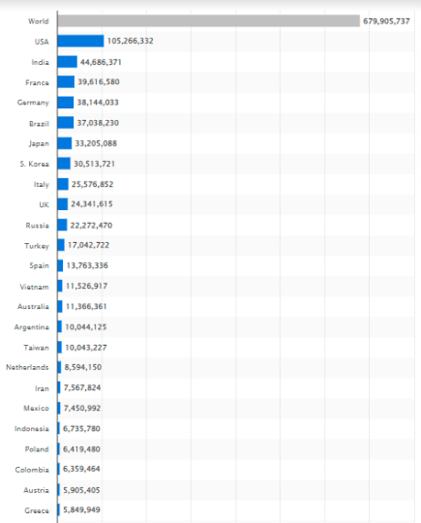
Figure 1: Number of coronavirus (COVID-19) cases worldwide as of February 28, 2023, by country or territory
(Source: Elflein, 2023)
Another crucial problem which also raises sometimes as the short-term effect of the disease is related to the heart. According to German research, 78% of people who had recovered from the disease had any kind of heart-related problems, mild or severe (Health Desk, 2020). However, they survived as they maintained proper care of themselves and also, they were affected by the short-term effects of the disease.

Long-term consequences of the disease
The COVID-19 pandemic caused a profound influence on worldwide public health. Aside from the immediate health repercussions, such as respiratory distress and death, the disease has had significant long-term public health consequences. These repercussions have been especially obvious in health and social care settings, where vulnerable groups are more likely to get the disease and experience severe consequences.
One of the most serious long-term effects of COVID-19 is an increased chance of mental health problems (Gudiol et al., 2020). The epidemic has raised stress, worry, and depression in the overall population. However, the impact has shown better relevance among healthcare workers and people infected with the disease. As reported by the Office for National Statistics, roughly one in every five adults (19.2%) in the United Kingdom experienced some kind of depression in June 2021, with greater rates among women, teenagers, and those with a pre-existing long-term health condition (Office for National Statistics, 2020). Fatigue is one of the most commonly observed long-term effects of COVID-19. Many people who have recovered from the condition continue to feel extremely weary and depleted of energy for several months afterwards. This can have a substantial influence on their capacity to work and do daily tasks, and in extreme situations, may necessitate continuing medical care and support. Another long-term consequence of COVID-19 is the deterioration of the lungs (Gudiol et al., 2020). The condition can induce lung inflammation, which can lead to scarring and decreased lung function. This might cause breathing problems and necessitate continuing medical care and monitoring.
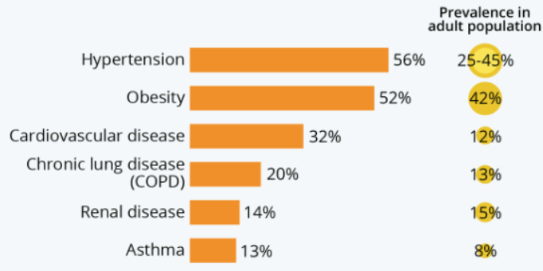
Figure 2: Underlying conditions of COVID-19 patients
(Source: Buchholz, 2020)
Cardiovascular disease is also a burning example of one of the crucial long-term effects of COVID-19. The cardiovascular system is gravely affected by the disease in various forms. There are microvascular injuries, dysfunction in the endothelial, and even diseases like thrombosis which are resulted from viral infections. They also cause sensitive systemic inflammatory diseases and immune responses. The survivors of the disease were also linked with risks of several cerebral diseases, such as stroke along with problems which are linked to arrhythmia (Gudiol et al., 2020). In addition to that, inflammatory heart problems such as myocarditis, ischemic cardiomyopathy, heart failures, thromboembolic disorders etc, are many common effects of the same. Moreover, the chance of affecting again by them also gets increased by the disease.

Influencing elements on the health of individuals in the disease
The COVID-19 epidemic has had a profound influence on people's health and well-being all across the world. Many factors have determined the extent to which people have been affected by the condition, as well as the constraints and penalties that come with it. Socioeconomic position is one of the most important determinants determining health and well-being throughout the epidemic. Individuals with lower incomes are more likely to contract and die from COVID-19 due to variables such as inadequate access to healthcare and increased exposure to the virus at work or in their living settings. Furthermore, the pandemic has had a huge influence on the global economy, resulting in job losses and financial uncertainty for many people, which can have a detrimental impact on their mental health and well-being. Access to healthcare is another element influencing health and well-being throughout the epidemic. Many non-COVID-related medical visits and treatments have been postponed or cancelled as a result of the pandemic. A report by Cancer Research UK found that the number of urgent cancer referrals in the UK fell by 76% during the first wave of the COVID-19 pandemic, compared to the same period in 2019 (UK, 2021). This suggests that many people may have delayed seeking medical help due to concerns about contracting COVID-19 in healthcare settings. This can have a negative impact on the health outcomes of people who have pre-existing medical conditions or new medical concerns.

Conclusion
The covid-19 pandemic has left quite a mark all over the world with its severe impact on the physical and mental health of mankind. It has made billions of deaths and millions of injured to several organs of the body. Although people have found short-term solutions for the problems and made a bit of progress too, still, it has impacted them by making long-term effects on them. There is no guarantee that the virus responsible for the outbreak will not come back in a form of any other disease. That is why people should follow proper preventive measures and also follow the necessary guidelines and take the advice of the experts to counter this disease or any kind of outbreak like this in future.

References
Aslam, F., 2020. COVID-19 and importance of social distancing.
Buchholz, K.B., 2020. Infographic: Which Underlying Conditions Do COVID-19 Patients Have? [online] Statista Infographics. Available at: https://www.statista.com/chart/21514/underlying-conditions-us-adult-hospitalized-covid-19-patients/ [Accessed 27 Mar. 2023].
Cleveland Clinic, 2022. Coronavirus Disease (COVID-19): What Is It, Symptoms, Causes & Prevention. [online] Cleveland Clinic. Available at: <https://my.clevelandclinic.org/health/diseases/21214-coronavirus-covid-19#:~:text=COVID%2D19%20is%20caused%20by> [Accessed 27 Mar. 2023].
Elflein, J., 2023. Novel coronavirus (COVID-19) cases by country worldwide 2023. [online] Statista. Available at: <https://www.statista.com/statistics/1043366/novel-coronavirus-2019ncov-cases-worldwide-by-country/> [Accessed 27 Mar. 2023].
GOV.UK, 2022. Coronavirus (COVID-19) in the UK. [online] coronavirus.data.gov.uk. Available at: <https://coronavirus.data.gov.uk/details/deaths> [Accessed 27 Mar. 2023].
Health Desk, 2020. What short and long-term effects does COVID-19 have on other body parts, including lungs, brain, heart and kidneys? [online] health-desk.org. Available at: <https://health-desk.org/articles/what-short-and-long-term-effects-does-covid-19-have-on-other-body-parts-including-lungs-brain-heart-and-kidneys> [Accessed 27 Mar. 2023].
Office for National Statistics. 2020. Coronavirus and depression in adults, Great Britain - Office for National Statistics. [online] www.ons.gov.uk. Available at: https://www.ons.gov.uk/peoplepopulationandcommunity/wellbeing/articles/coronavirusanddepressioninadultsgreatbritain/june2020 [Accessed 27 Mar. 2023].
Tso, R.V. and Cowling, B.J., 2020. Importance of face masks for COVID-19: A call for effective public education. Clinical Infectious Diseases, 71(16), pp.2195-2198.
UCL, 2021. Kidney failure patients among worst affected during COVID-19. [online] UCL News. Available at: <https://www.ucl.ac.uk/news/2021/jun/kidney-failure-patients-among-worst-affected-during-covid-19> [Accessed 27 March 2023].
UK, C.R. 2021. 2,000 fewer people in England began cancer treatment in January. [online] Cancer Research UK - Cancer News. Available at: https://news.cancerresearchuk.org/2021/03/11/2000-fewer-people-in-england-began-cancer-treatment-in-january/ [Accessed 27 Mar. 2023].
Van Elsland, S.L., 2020. COVID-19 in England - analysis of the first two waves | Imperial News | Imperial College London. [online] Imperial News. Available at: https://www.imperial.ac.uk/news/211673/covid-19-england-analysis-first-waves/ [Accessed 27 Mar. 2023].
Weinstein, N. and Nguyen, T.V., 2020. Motivation and preference in isolation: a test of their different influences on responses to self-isolation during the COVID-19 outbreak. Royal Society Open Science, 7(5), p.200458.
Yelin, D., Wirtheim, E., Vetter, P., Kalil, A.C., Bruchfeld, J., Runold, M., Guaraldi, G., Mussini, C., Gudiol, C., Pujol, M. and Bandera, A., 2020. Long-term consequences of COVID-19: research needs. The Lancet Infectious Diseases, 20(10), pp.1115-1117.

