Name: Chi Zhang
Student Number: 2208113
Course Title: Research in Practice (ADAD5004/C)
Tutor Name: Delyth Lloyd
Word Count: 2475

Animation and Motion
Introduction
This writing is going to focus on three key words. The key words I chose reflect the direction of my interest in my past learning and practice. The question I posed was how action scenes help animation to express its ideas. I will be researching in color contract, perspective and motion blur in animation. This writing is going to focus on how to use dynamic composition and exaggerated perspective skills to make the whole animation more loved by the audience while telling the story in animation production. In recent years, various modes of animation have been greatly developed, which is an art form that transforms text stories into visual expression, which interests me very much. Therefore, I will investigate and analyze some famous or successful animation works, and discuss and summarize some dynamic skills in them, which is the field that I am passionate about in my practice.
Animation has emerged as one of the most influential creative forms of the twenty-first century. (Sayfo, O. 2021, P4) With the development of animation software, the advantages compared with traditional films have gradually emerged. Today's animation technology has been able to produce action scenes beyond reality, and animation artists can freely design complex actions and special effects according to the creativity of the scene, breaking the physical restrictions in traditional film shooting, and creating fantastic works in different styles.
As an important part of animation works, excellent action scenes have many benefits. The one of the most important thing is that action scenes can bring exciting sensory experience to audiences. In addition, an advantage of animation is that it can realize the creativity and imagination of directors and artists to a greater extent, and action scenes are the perfect embodiment of this, and this free expression is one of the key characteristics of animation that is different from other media. For the story itself told by the animation, the action scenes can help shape the character's personality, and reveal the character's personality characteristics and emotional state through the details of a specific scene. From another perspective, it can also promote the development of the story. Through the action interaction between the characters, audiences can understand how the story progresses and how the conflict escalates. These scenes are often the turning points of the plot and determine the direction of the story. In the field of animation art, movement is a key element in conveying stories and emotions. In order to achieve high-quality dynamic performance in animation works, artists and directors usually use some skills in it.

Color contrast plays a crucial role in action animation, which can effectively enhance the visual impact of the entire segment and create a specific atmosphere and mood. Through bright colors, animation artists can make certain actions or objects stand out in the picture, so as to attract the audience's attention and guide the audience's line of sight. In this way, the audience's attention is focused on specific elements and highlighted the characteristics of the subject. Using strong color contrast in action scenes can also highlight key actions, help audiences capture action details, or distinguish between different characters in a fight. Artists can also convey specific atmospheres in action colors, such as tension, excitement. The direct psychological effect of color comes from the direct influence of physical light stimulation on human physiology. As we all know, color is divided into cool colors and warm colors, and cold and warm colors are a feeling of stimulation of light on the human eye, and it brings different psychological effects. For example, cool colors can make people feel cold in the heart, and warm colors can make people feel warm in the heart. The cold and warm tones are not the real temperature in physics, but the reflection of light in people's vision and mind. People today have an increasing requirement for the color of animation works, and color design has become one of the symbols that affect the quality of an animation.
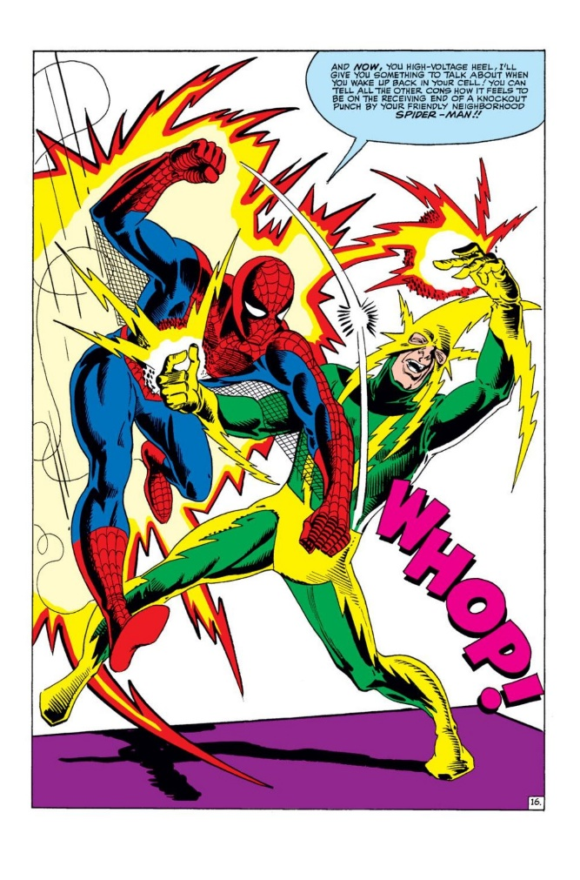
Many comics and animated works created by American artists often have strong colors. One of the most representative is Steve Ditko's 1962 Spider-Man comic and subsequent anime works, which have a very clear representation of color. It has since become a series of works popular with audiences around the world. In the original cartoon works, the most prominent color contrast exists between the two characters in a fight (Figure1). The huge color gap between the characters' costumes reflects the disharmony between the two, laying a visual foundation for the conflict between the characters. At the same time, the visual effects of highlight and lightning are added to the position of the hand and limb collision of the character to enhance the sense of power of the blow and express the creativity of the artist.
Figure 1 Steve Ditko (1962) Spider man
When a specific manga sells particularly well or otherwise shows narrative promise, publishers profit again by animating the story for television or for the movie theater. (Thomas, B. 2012, P3) In 2018, Marvel produced an animated film with Spider-Man as its main theme, which achieved great success. The cool action scenes of the characters in the screen and the excellent plot performance attracted a lot of audiences. As a famous artist, Zac Retz put too much effort in this movie, the color contrast between the characters themselves and the background is also an important technique to show the actions of the characters. Putting the characters with dark colors into the bright background environment can help the audience find the position of the characters more clearly in the fast-moving picture and clearly show the main part of the picture. In such complex animated scenes, this strong color contrast can immediately draw the audience's attention and direct them to specific actions, and make the motion trajectory more obvious, strengthen the visual effect, helping to emphasize key moments or characters in the story.
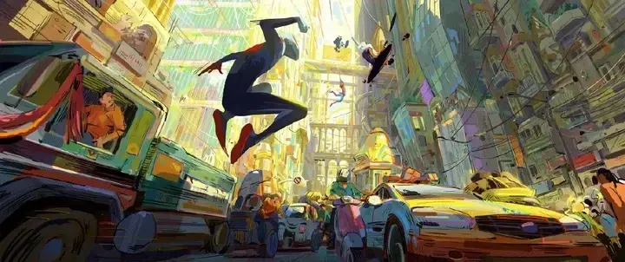
Figure 2 Zac Retz (2018) Spider-Man: Into the Spider-Verse
The same color will have different emotional characteristics in different situations. For example, some inherent colors such as red, which has a warm, lively, assertive meaning, but if you use red under a gray sky, then it is a warning of danger. Compared with the expression of sound, text and color in the expression of emotion, the visual expression of color is more intuitive, it can play a direct role in inspiring people, and its meaningful emotional characteristics will play a multiplier effect in the film.

Another technique that is often used is visual perspective. In all art forms based on flat media, perspective is a topic worth exploring. Visual perspective can help artists create a sense of three-dimensional space in flat media, allowing the audience to perceive the depth of the scene. As the object moves through the frame, perspective can simulate the change in relative position between the object and the background, making the movement look better.
Actions in animated worlds are not bound to the physical laws of our world in the way that events in live-action film tend to be, and animation therefore offers us an escape from that reality. (Pierson, R, 2020, P3)
Visual perspective can also provide artists with more creative space. By breaking the normal rules of perspective, animation artists can create unique visual effects that make the work more creative and interesting. If a world is a structure of relations that make movements sensible and possible, by what measure might we say that a world is the same one or a new one when its structure seems to have been altered? (Pierson, R, 2020, P102) This kind of creative display can bring more possibilities to animation art. This is also the biggest difference between animated works and conventionally shot films. In some scenes, in order to express the unique dynamic characteristics of the character, the artist will change the perspective ratio of the character, for example, drawing the head or fist of the character very large, or making a certain part of the body extremely exaggerated. Such perspective treatment can give the character a unique appearance and characteristics.
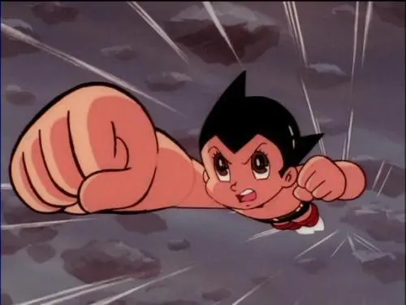
Figure 3 Osamu Tezuka (1963) Astro Boy
In Osamu Tezuka's 1963 Astro Boy comic and subsequent animated works, the use of perspective is often used to convey the sense of movement of the characters. In the rise of manga and anime studies, much emphasis has been placed on Tezuka Osamu as the pioneer and "God of Manga." (Clinton.G 2013). When the character is flying in the air or moving at high speed, the perspective changes make these actions look more realistic, and even create a visual effect that is about to rush off the screen. Moreover, in a specific scene, by narrowing the lens or adjusting the perspective, the audience can pay more attention to the actions and expressions of the characters, so as to enhance the sense of urgency in the narrative and effectively express some specific emotions of the characters.
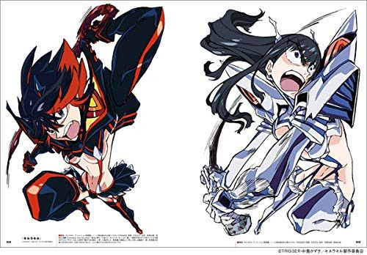
Figure 4 Hiroyuki Imaishi (2013) Kill la Kill
As one of the founders of TRIGGER Studio, Hiroyuki Imaishi is an excellent animation artist and animation director. The creativity of perspective relations is a major feature of his works. In many animated works he participated in, such as Gurren Lagann, Promare and Kill la Kill, they all changed the perspective relationship of the main characters in specific action scenes and broke the conventional composition. Each film reflects the unique vision and skills of a single artist, in concept and form, in style and substance. (Furniss, M,2012, P10) By changing the rules of perspective, the character's movements feel more powerful than normal angles. Through his unique artistic style, which includes a creative understanding of the rules of perspective, he produces novel visual scenes that bring a great experience to the audience.
In the continuous rapid complex action is good to use action blur, this technique can make the continuous action better excessive, so that the picture looks better. The mainly point in the dynamic simulation and motion blur of each frame to give animation a smoother and more infectious action performance. When action blur is not used, each frame of the action will be a completed picture, but it may make the overall clip look a little unnatural. Adding blur effect on fast-moving objects can better simulate the feeling of telling movement, which can make the audience feel the speed of the object more intuitively and enhance the dynamic expression. Especially in character animation, action blurring helps to emphasize the actions of the character. In true full animation, every drawing in a production is used only once, and because images tend to be highly metamorphic the drawing process is relatively complex. (Furniss, M, 2017, P133) When the character runs or jumps, action blurring can highlight the fluency and power of the action, making the character more lifelike.
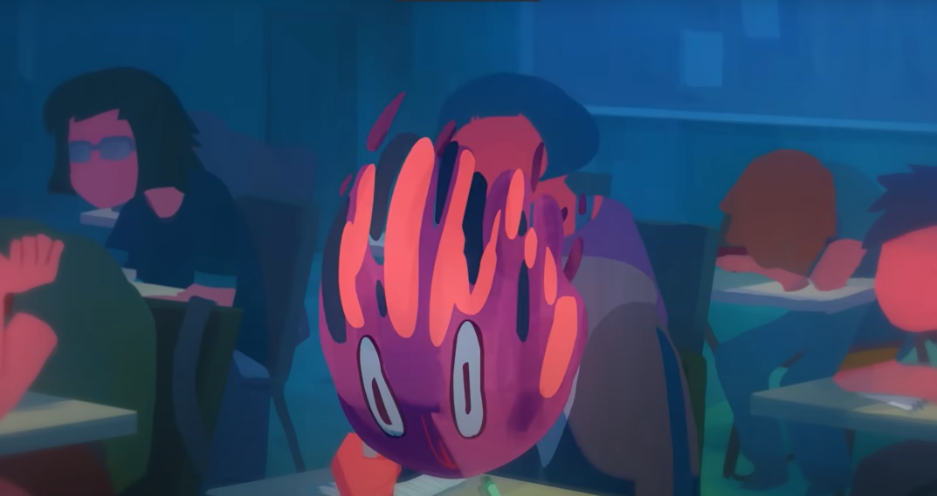
Figure 5 Seoro Oh (2015) Afternoon Class
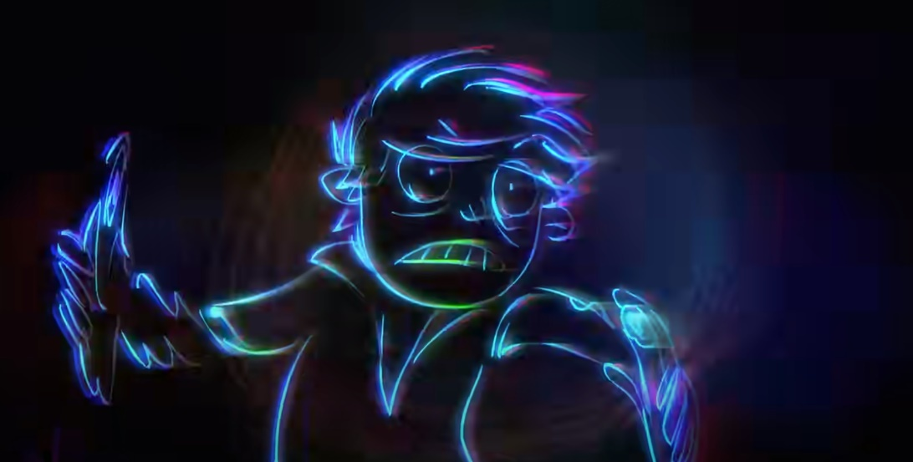
Figure 6 Seoro Oh (2015) Afternoon Class
Afternoon class, an animated short film produced by Seoro Oh in 2015, motion blur was used several times in rapid movement. This is a scene in this short animation video (Figure 5), which virtualizes the actions of the characters and makes the short film vividly complete the displacement and deformation, which is very creative. In just a few frames, the head of the character turns into a bowling ball in the rapid movement, expressing the exhaustion of the students in the afternoon, and the whole segment is vivid and coherent, bringing a good feeling to the audience. In this short film, Seoro used motion blur several times, but the amplitude was different (Figure6). This is to show different ranges of motion. Generally speaking, when the object or character moves at a fast speed, the effect of blurring is more obvious (Figure5), so as to simulate the visual perception in the scene of rapid movement in human eyes. On the contrary, when the moving speed of the object is not so fast, the amplitude of blurring will be weak, and some details of the object will be preserved (Figure6). This speed control makes the application of motion blur in animation more realistic.
In the post-production stage, the effect of action blur often needs to be carefully adjusted and improved, such as color correction, light and shadow effect enhancement, to ensure that the action blur effect is coordinated with the overall style.

Figure 7 Miyazaki Hayao 2001 Spirited Away
In Spirited Away, another very classic animation, Miyazaki Hayao also uses the way of motion blur to express the speed of action (Figure7). But unlike the previous example, this is done by blurring the background. By blurring the background, the audience can not only focus on the theme characters, but also reflect the rapid movement in progress through the side expression of relative movement to enhance the tension of the picture. Make the events and actions in the animation more noticeable. At the same time, there are also examples of imaginary scenes in other segments of this animation, creating a dreamlike atmosphere in the fantasy world, and using imaginary scenes as a creative expression to bring dreamlike visual experience to audiences.
So, what could be the future of animated film? Animation is already present everywhere: on billboards, the little screens of our cell phones when we turn them on, not to mention the animated gifs populating websites. (Bruckner, F,2019,P8)
In conclusion, color contract, perspective and motion blur are all effective means to express motion scenes in animation art. This article provides a detailed analysis of how they work and how they work in specific cases. These techniques can show the artist's ability and creativity from all aspects, and bring a good visual experience to the audience. As an art form that arose in the last century, animation art still has a lot of room for development. With the development of science and technology and society, the software and tools used for animating will become more fantastic, but at the same time, the development of AI will also bring certain challenges to this industry. With the development of science and technology and society, the software and tools for animation production will become more perfect, but at the same time, the development of AI will also bring certain challenges to this industry. As an emerging art form with digital as its main media, animation art needs to face this situation in particular. But I think technology is only one aspect, and the most important thing for any art form is the artist's unique understanding and creativity. AI art may surpass humans in detail, technology, and efficiency in the future, but there is no substitute for human creativity. As a result, while learning the excellent works left by previous artists, we should also try more creative forms of expression as much as possible to find more possibilities.

Reference list
Pierson, R. (2020). Figure and force in animation aesthetics. Oxford University Press.
Available at: https://academic-oup-com.ezproxy.uwtsd.ac.uk/book/35073
Bruckner, F. (Ed.). (2019). Global animation theory : international perspectives at Animafest Zagreb. Bloomsbury Academic.
Available at: https://www.bloomsburycollections.com/monograph?docid=b-9781501337161
Sayfo, O. (2021). Arab animation : images of identity. Edinburgh University Press.
Available at: Arab Animation: Images of Identity on JSTOR (uwtsd.ac.uk)
Furniss, M. (Ed.). (2012). Animation : art & industry. JL.
Available at: Animation: Art and Industry on JSTOR (uwtsd.ac.uk)
G. Clinton Godart. (2013). Tezuka Osamu’s Circle of Life: Vitalism, Evolution, and Buddhism. Mechademia, 8, 34–47.
Available at: Texuka Osamu's Circle of Life: Vitalism, Evolution, and Buddhism.: EBSCOhost (uwtsd.ac.uk)
Furniss, M. (2017). Art in Motion, Revised Edition: Animation Aesthetics (2nd ed.). John Libbey Publishing.
Available at: 7 Full and limited animation from Art in Motion, Revised Edition: Animation Aesthetics on JSTOR (uwtsd.ac.uk)
Thomas, J. B. (2012). Drawing on Tradition: Manga, Anime, and Religion in Contemporary Japan (1st ed.). University of Hawaii Press.
Available at: Drawing on Tradition: Manga, Anime, and Religion in Contemporary Japan on JSTOR (uwtsd.ac.uk)

Bibliography
Hodge, J. J. (2019). Sensations of History: Animation and New Media Art (1st ed., Vol. 57). University of Minnesota Press.
Chipp, H. B., Selz, P., & Taylor, J. C. (2020). Theories of Modern Art (Reprint 2020). University of California Press.
Manning, E. (2019). A Manga Perfeita. punctum books.
Gravett, Paul. (2004). Manga: sixty years of Japanese comics. Laurence King.

