Article 1: Pop Art and Popular Cultural Life

Name: Xuanjing Zhu
Email: 1915468@student.uwtsd.ac.uk
Course Title: ADAD7017 Professional Discourses
Three articles

Table of Contents
Abstract 3
Chapter 1: Introduction 4
Chapter 2:Pop Art Co-operative Development 5
Chapter 3:Pop Art and Modern Trends Collaboration Design 11
Chapter 4:Conclusion 13
Bibliography 14
Words:2268

Abstract
Ge Pengren (2000) said, "Pop artists each other in the creation of works of different styles, themes, and contexts, but in the concept of art and the means of operation have a period of common essential features." Pop art design is a distinctive visual style with unique creative concepts to reflect the resistance to traditional culture, constantly stimulate the imagination and creativity of designers, subvert the aesthetic view of traditional art, and get rid of the previous single form so that the picture is a more distinctive image of the design style.

This paper discusses pop art in a social and cultural context, the elements of popular culture, and how they are incorporated daily into the art works, resulting in a different state of the painting style. This paper discusses how pop art integrates with new technology and culture and makes pop art the wind vane of the new era.

Key words:Pop Art, Popular Culture, Popular Art

Chapter 1: Introduction
The rise of pop art reflects the social and cultural values of the young generation that grew up after the war, striving for self-expression and pursuing the psychology of novelty. However, this trend of artistic development also faces some novel outlets. Some people believe that pop art belongs to the new star of popular art. Pop artists are in the process of designing directly borrowed and reproduced elements of popular culture and commercial art, using repetition and mass production techniques to create works and imitating the characteristics of industrial production and consumer goods, in which the design of the products produces fresh and eye-catching visual effects and the social and cultural connotations conveyed in the works are easy to understand. The products are visually appealing, fresh, and easy to understand in terms of their social and cultural connotations.

On the one hand, they pursued novelty and eccentricity, adopted strong color treatments, and boldly used gaudy colors, presenting the world with an image of an upper-class and consumer society; on the other hand, pop works show a display of the unique personality of the individual artist, which is entirely personal, subjective, and spiritual, and it emphasizes the purity of art, becoming an art of aristocratic spirit. This spirit is placed in improvisation, and it is entirely based on one's own feelings and one's own ideas that are displayed. With the help of popular mass media, artists use oil painting, installation, collage, screen printing, and other methods to create and integrate people's daily lives into their art. Andy Warhol, on the other hand, was an iconic figure in the pop art genre. In 1952, at the age of 24, Warhol had his first success in New York with commercial advertising paintings and gradually became a famous commercial designer. He founded the famous art studio "Factory," which is also a gathering of artists, musicians, writers, and filmmakers in the art center. They rejected classical art and were determined to engage in the concept of subversion of traditional creation. In this studio, he collaborated with many artists and assistants to complete his works, and this innovative mode of cooperation also broke the boundaries of individualism in traditional art creation. His most famous production program, such as screen-printing, was produced through teamwork.

This paper will analyze in depth the series of works by Andy Warhol, a representative figure of pop art, and analyze the impact of his artworks on the development of pop art so as to better understand the impact of art on society. At the same time, better grasp this cultural phenomenon and the possible future direction of development.

Chapter 2:Pop Art Co-operative Development
"Pop" means "popular art" or "pop art." Although the spirit of pop art belongs to a vain, playful, and unrestrained creative attitude, the essence of pop art is an art movement that explores the connection between popular culture and pop art. Pop art transformed the most common symbols and images of popular culture into elements of artistic creation, which was closely related to the development of culture, technological progress, and the new situation of consumerism at that time. The wave of "counter-culture" movements in the United States played an important role in making pop art one of the most powerful, widespread, and influential art forms in the postmodernism of the 20th century. Pop art not only reflects the social and cultural phenomenon of the mid-20th century but also issues its own criticism and reflection on various problems of modern society. Pop art has become an important part of the history of modern art, with its own unique and distinctive visual style and profound social connotation. And pop artists represented by Andy Warhol used pop culture and daily life as the theme, boldly exposing, satirizing, and criticizing the development of this society.

Andreas Huyssen, a postmodern critic, states (1986), "If pop art has drawn our attention to the imagery of daily life, demanding that the separation of high and low art be eliminated, then today it is the task of the artist to break out of art’s ivory tower and contribute to a change of everyday life.”
Andy Warhol, regarded as one of the most famous figures in 20th-century art, was both a proponent of pop art and the artist who most influenced it. His works were produced using screen-printing techniques, and the "mass reproduction" of the faces of famous contemporary figures was another artistic style that led to the rise of pop art. In his "factory," Warhol, together with a number of artists and assistants, completed a large number of works, such as his series of portraits of celebrities, of which Marilyn Monroe is one of the outstanding works in this series. This series of works was completed by the "Factory" team through screen-printing techniques, which not only enhanced the productivity of the designs but also enriched the expression of the works. In this work, Warhol took the head of this unfortunate Hollywood sexy movie star as the basic element of the picture, arranged in rows and rows of repetitions, drawing on the superimposition effect of printing, and consciously adjusting and differentiating the colors of each repetitive head. Warhol used bright colors to make this monotonous and stagnant visual effect of the work come to life, and such a strong visual flushing effect shows and transmits the seriousness of the commercialization of the work to the general public. This strong visual wash effect shows and conveys to the public the seriousness of commercialization and expresses the repetitive reality that people are only indifferent, empty, boring, and confused. In this kind of art design, Andy Warhol blurred the boundaries between art and commerce through the mass reproduction of screen-printing technology, challenging the concept of traditional art and treating Monroe's image as a symbol through mass reproduction, suggesting to the public how celebrity images are commercialized and sold and satirizing how the media constantly reproduce and consume celebrities' images. Warhol's combination of personal tragedy and universal social phenomenon through color, screen-printing techniques, and visual impact estimation—a tragedy of no one's life against a colorful and vibrant backdrop—and his design made the Marilyn Monroe piece the most far-reaching as well as the most comprehensible classic of pop art.
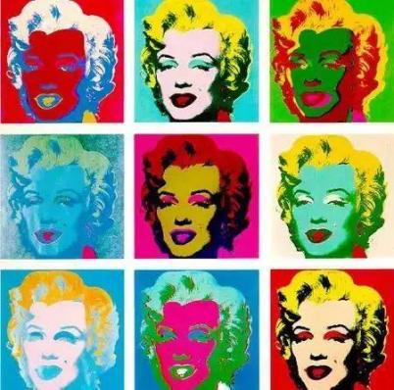
Fig 1:Marilyn Monroe
Richard Hamilton once defined pop art as（2022） "universal (designed for the masses), short (short-term), unforgettable, cheap, mass-produced, young, flashy, sexy, deceptive, charming, and big enterprise.”Indeed, Andy Warhol's Campbell's Soup Cans series is also one of the masterpieces of pop art, through which Warhol explored consumer culture, mechanical reproduction, and the relationship between art and commerce.

Andy Warhol is widely known to the general public for transforming cans of gumbo into works of art in this series. In this series, which consists of 32 paintings, each painting depicts a different-flavored can of Campbell's soup. These cans were the most common elements of everyday life in the mid-twentieth century, and by using such elements of life as artistic subjects, Warhol blurred the boundaries between high art and popular culture, elevating the artistic status of common elements of life and thus moving towards the emerging development of popular art. Warhol used everyday consumer goods as the basis for his designs as artworks, and in doing so, he not only praised the aesthetics of consumer culture but also criticized it; his works demonstrated people's dependence on and adoration of commodities in a consumer society and at the same time reflected the impact of materialism on individual life and social values. Warhol used the same visual element and related elements a large number of times in a single picture while making images of the same shape and equal space, repeatedly arranged and repeatedly composed, breaking the uniqueness that art should have. He has interpreted a new style of art and brought it to a new climax, so that it has had a profound impact on the people of recent and modern society. His works are reproduced over and over again, constantly changing the colors of the images and using different colors to compose the works to show the fascination of art. In this series, Warhol directly borrowed the visual language and images of commercial advertisements, transforming commercial images into artworks, a practice that blurred the boundaries between art and commerce, explored the relationship between the two, and advocated the close integration of art with commerce and daily life and the development of the public's vision. From a commercial point of view, it can be closely linked with the art industry, effectively enhance commercial value as well as brand awareness, and be for the commercial development of the footsteps of a step forward, the development trend of the hundred advantages and no harm. Campbell's Soup cans are not just a commodity brand but a cultural symbol, and Warhol explores the cultural significance of the brand in modern society by recreating the symbol of the brand. In this series of works, Warhol succeeded in closely integrating art and popular culture, challenging the boundaries of traditional artistic uniqueness, creating an art form with far-reaching impact, and taking an important step forward in the development of popular art.
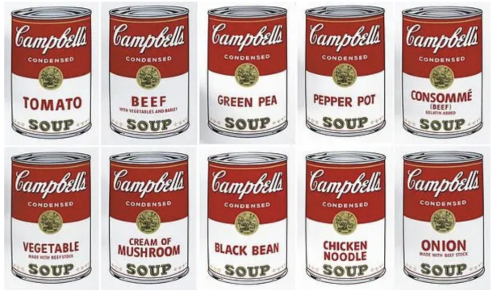
Fig 2: Campbell’s Soup Cans
Overall, pop art allows designers to break the rules, think outside the box, and design whimsical works along with new trends in a teamwork mode. It greatly enhances the imagination and creativity of the artists and incorporates popular culture into their works. The intention of pop art works covers many aspects, such as consumer culture, celebrity worship, the art of daily life, etc. Through these intentions, pop culture, with its distinctive visual style and profound social connotation, has become an important part of the history of modern art, and at the same time, it is also the beginning of the development of popular art.

Chapter 3:Pop Art and Modern Trends Collaboration Design
Pop art creates a dialogue between art and life that breaks through "art for art's sake" and is compatible with modern commercial illustration in terms of lifestyle, expressive content, pop culture, consumer culture, and formal aesthetics.

Modern commercial illustration is a kind of art that is used to meet the aesthetic and spiritual needs of art connoisseurs. It has a wide range of popularity and dissemination, and its commercial nature is stronger. The birth and development of wave spectrum art have injected new blood into modern commercial illustration art. The AIGA(2011), the professional association for graphic designers in the United States, defines graphic design as "a creative process that combines art and technology to communicate ideas" .

Pop art not only sees its work as a work of art, an ideology, but also as a form of production, a consumer product(2023). In the present era, pop art also influences the direction of modern trends. In mid-2022, Tiffany & Co. is designing a cross-border co-branding collaboration with Andy Warhol, inspired by the holiday cards that Andy Warhol created for the brand in the 1950s and 1960s. This is a crossover initiative combining an elegant jewelry brand with the classic works of the Pop Art masters and, at the same time, fulfilling Andy Warhol's vision of combining noble art with popular culture. This collaboration not only demonstrates the perfect fusion of the two fields but also brings about an abyssal cultural and commercial impact.
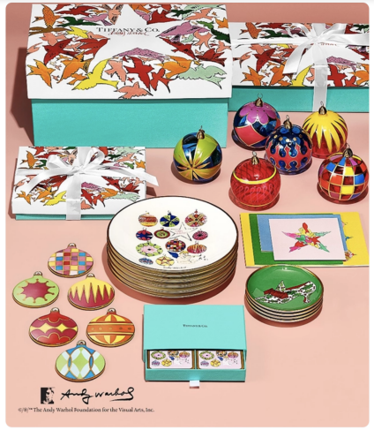
Fig 3:Tiffany & Co and Andy Warhol
Tiffany & Co. has created a series of limited-edition jewelry, accessories, and holiday gifts. These products combine Warhol's signature art style with Tiffany & Co.'s exquisite craftsmanship, and this cross-branding collaboration will attract a great deal of attention for the brand, especially among young consumers and art lovers. Through this collaboration, pop art will also be more widely spread and recognized, and more people will be able to come into contact with and appreciate Warhol's artistic charms.

In this collaboration Tiffany & Co. not only enhances the brand's modernity and market appeal but also promotes the popularity and commercialization of pop art. This kind of cooperation demonstrates the great potential of combining art and business and also brings new creativity and market opportunities for both brands, as well as providing consumers with richer and more varied choices and, at the same time, promoting the popular culture of pop art. Such a cross-border co-branding partnership can not only be commercially successful but also have a far-reaching impact on culture and art.

Chapter 4: Conclusion
To sum up, this paper believes that pop art is a new star in popular art. As one of the most influential art forms in the 20th century, pop art itself carries a unique and charming cultural image, and nowadays pop art has gradually become an indispensable part of people's consumer culture and spiritual field. Nowadays, pop art is becoming an indispensable part of people's consumer culture and spiritual realm. Art is always on the road of innovation; it comes from life but is higher than life; it will always be higher than the earthly world but can never be separated from the earthly world. Like the inner struggle of pop artists, art is born in contradiction. Pop thought is a bright pearl on the road of art thought. He not only advocated that art also needs teamwork but also said that art needs to be close to popular culture so as to provide more rich and diversified choices for artists. It is a clear response to modern human emancipation, greatly promoting the development of graphic design. In the future, art and design Pop art will also play its lustre and become a continuous source of contemporary young artists of the spirit of the source.

Bibliography
- Ge Pengren, Western Modern Art-Postmodern Art, Jilin Fine Arts Publishing House, 2000-10
- Andreas Huyssen, After the Great Divide: Modernism, Mass Culture, Post-Modern- ism, Bloomington: Indiana University Press, 1986,PP157-58
- Huang, Y. R. Research on the media function of pop art. East China Normal University,2022
- Poggenpohl, Sharon H, Graphic Design: A Career Guide and Education Directory. New York: AIGA, 1993.
- Jingya Yue, Study on the Relationship between Pop Art and Modern Commercial Illustration Art, Art and Design (Theory) 05, 2011
- Lin Xue, Xu Wen. Analysing the Influence of Pop Art on Commercial Illustration[J]. Fine Arts, 2013 (9): 101-101.

Article 2:Analysis of the importance of teamwork in the field of design

Table of Contents
Abstract 17
Chapter 1: introduction 18
Chapter 2:Team Positioning 20
Chapter 3:Personal experience 21
Chapter 4:Team dynamics analysis 25
Chapter 5:Conclusion 27
Bibliography 28
Words:2283

Abstract

In the current society, purely individual competition is inefficient, and teamwork is an important strategy. To some extent, good cooperation needs to be coordinated by building management and requires deeper understanding and experience. By analyzing the contents of teamwork, we can deepen our understanding, promote teamwork, and strengthen team building.

Instead, this paper will analyze the process of "collaborative dialogue," in which students are organized into groups of 4-6 in order to develop interdisciplinary and transdisciplinary cooperation between individuals. Students will be expected to share their ideas, contribute their experiences and skills, methods, and processes, negotiate, and work collectively to develop and design a project. This paper analyzes teamwork, analyzes the roles in teamwork, and discusses and analyzes their contribution to the project from their own perspective.

In this paper, we will analyze our positioning within the group from our own point of view, as well as study and analyze our own work in depth, dissect our contribution to the output of the project, analyze the production process based on what was going on at the time, and point out the problems to be corrected.

Keywords: Teamwork, Collaborative Innovation, Research Direction
Chapter1: Introduction
This paper looks back on a teamwork project with five fellow students in 2023 during graduate school, "collaboratively dialogues," which itself was designed to develop cross-disciplinary artistic collaborations between individuals, to share and exchange ideas and practices, to integrate the ideas and practices of each group member, and to deepen the group's understanding of the benefits of collective collaboration. The project itself was designed to develop cross-disciplinary artistic collaboration between individuals, to integrate the ideas and practices of each group member through sharing and communicating with each other, and to give the group a deeper understanding of the benefits of collective collaboration.

The group's production project is centered around feminist and environmentalist research and design, while the main drawing design project is around the surrealist game of exquisite corpse, whereby players take turns to add to a drawing passed between members. The project began on the 16th of December and ended on the 19th of January. This paper will analyze the trajectory of each person's activities during the design period of the group with the research data provided by the members of the group, as well as analyze the shortcomings of their designs and attempt to provide ways to improve them. How each person's contribution to the group will be judged is through the depth of research and participation in the project by the group at the end of the project. The contribution of each person to the group was determined by the depth of research and the amount of participation in the project at the end of the group.
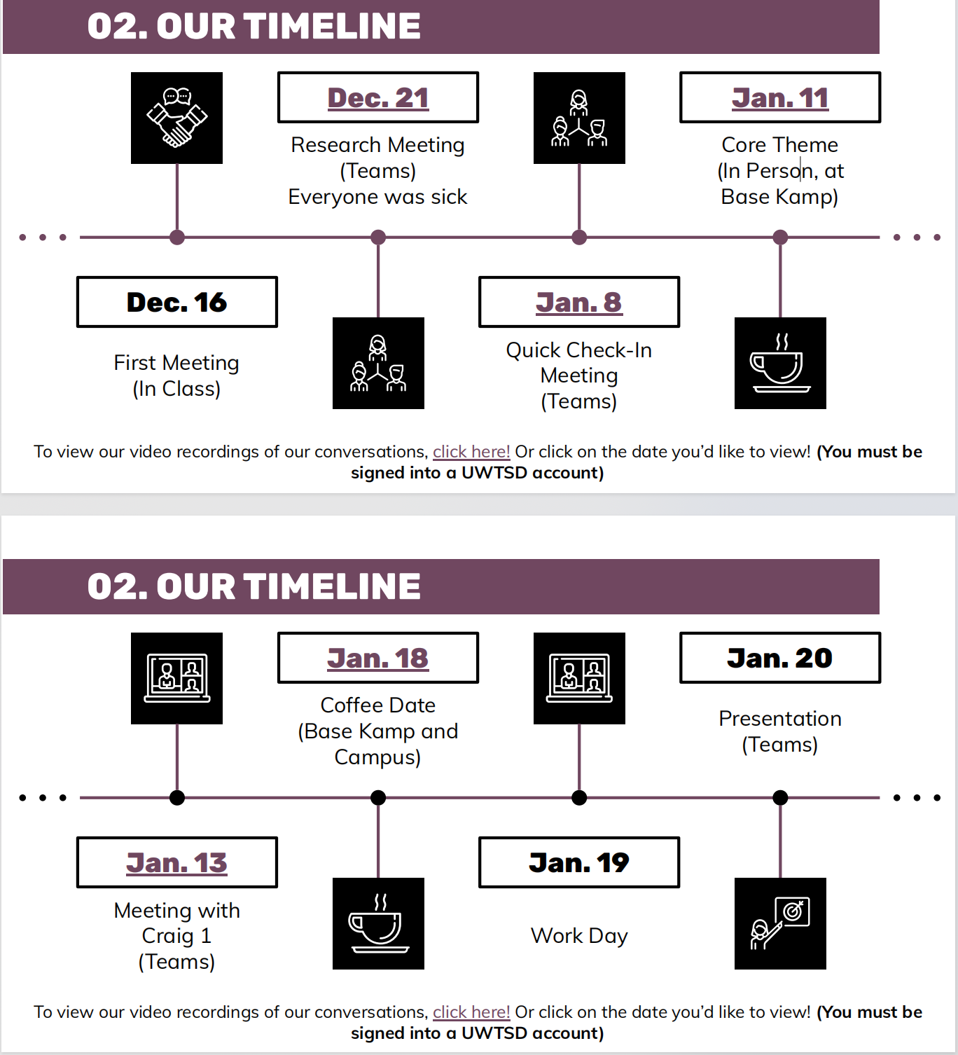
Fig.1 Team timeline
The aim of this project is for the group to demonstrate their ability to work more efficiently and effectively to achieve creative collective goals through deeper communication, and to demonstrate the height and potential of the results of the group's collaborative work.

At the beginning of the project my research direction was love, which can be divided into many different levels. What impressed me most was deformed love and the effect it could have later. Therefore, I chose domestic violence and women's rights as the two parts to be reflected in the following paintings.

This paper analyzes teamwork, analyzes the advantages and disadvantages of teamwork, and finds out what kind of convenience teamwork can bring to us.

Chapter 2: Team Positioning
In a society where information on the Internet spreads very quickly, the sharing of information on the Internet provides convenience to students in the new era. Collaborative innovation can facilitate the exchange of information among student groups. Collaborative innovation does not mean creating something new, but allowing innovation to communicate effectively, obtaining effective information to be assisted by resources from all sides, and promoting the team's innovative ability and scientific research efficiency.

In Meredith R. Belbi's book "Management Teams: Why They Succeed or Fail" (2017), the "Belbin Theory of Team Roles" states that “your team needs these nine roles: the wise man, the deliberator, the facilitator, the executor, finisher, diplomat, spur, cohesionist, and professional.” Our group is called a soup group, and we have six members: Becky, Dorothy, Fiona, Jenova, Lin, and Oliver Fiona, who are the thinkers, coordinators, and coordinators of our team, while the rest of us are the doers and finishers.

Fiona is the leader of the team; she is the coordinator who coordinates and communicates with each member's ideas and productions, and she is the cohesive leader who holds each member together. Because of the special production plan, each of us is the executor and finisher of the project, and each of us has made different degrees of changes and designs for the completion of this project.

We worked together as a team because everyone is good at drawing in different ways and everyone wants to contribute to the project, so our team leader chose to do a roller ball-style surrealist drawing to be passed among the members, and in this way, the roller ball-style drawing, to carry out our creative project.

We each carried out some research to kick-start the project and then used the results of that research to contribute to each round of paintings we made, including feminism and environmentalism. In the initial work carried out on the project, discussions amongst our internal members did not allow us to identify a theme that we could all work on together, so we carried out research and studies on the aspects that we were each interested in and then discussed them collectively to confirm them.

Chapter 3: Personal experience
Erich Fromm says "Is Love an Art?" (2018): Love can be found in many places, age, gender, family, etc., but it is right that we should look at it rationally, feel it inside, and resonate with it. And in the midst of this project, we examined the topic of feminism. In terms of women's social status, in many cases, women are labeled in a not very friendly way, but this is not what they want. Women need the world to see them in a different light. Women can also ignore these labels and once again face the world with the power of resistance, showing that women are not just for labeling but can contribute to the running of the world just as much as men.

Based on our different research directions and painting styles, our team leader developed the production method and the theme of the project, which was to paint the themes of feminism and environmentalism in the form of a ball painting relay. Everyone in our group was a performer and a finisher, and each of us contributed equally to the success of our project.

In this team, each one of us is a performer and a finisher, so I am equally a performer and a finisher. I did complete research and analysis of the project, I did simple brainstorming, and I thought that I could use the brilliant and bold colors of pop art to match and use dark color styles and shades to show the difference in my theme.

And in the first painting project, I was in the fifth relay for this painting. When I received this painting, the first thing I saw when I looked at it was an image of feminine power. In it, the woman is naked and opens her heart to the world. Her body is bare and shiny, but her body is empty, which represents that the woman is only trying to cater to society to make herself into what society wants her to be, but her heart is still empty and confused, and the plant patterns grow all over the woman's body, which means that the woman is united with nature. Susan Griffin, an American author says (2007), "Women know they are created by nature. We are nature." Therefore, in this picture, I think of the butterfly as a creature, and there is a Chinese idiom called "breaking the cocoon into a butterfly," which means that when people arrive at the trough, they are unwilling to give up and fight against destiny, and through unremitting efforts and struggles, they can regain their lives and get out of the difficult situation. The meaning is that when people reach a low point, they do not want to give up fighting with fate, and through unremitting efforts and struggles, they regain their lives and get out of the predicament. Women are often bound by their social and family environments, which make them gradually lose themselves, cater for the labels they are labeled with, and integrate into the bound environment. I want them to have the will to get out of this predicament, so I want to use this design to let them face their hearts bravely, start a new life again, and tear off the labels that the social environment has put on them. In my design, I added a pair of dark blue wings to the painting; the meaning of dark blue is to represent the future, and the broken scar with bright red blood represents the trials and tribulations that women need to go through to get out of their current predicament. Dark blue and bright red are complementary colors, which attracts people's attention, and at the same time, it also signifies that women need to pay the price for the bruises if they want to get the future that they aspire to, but they will be born with their wings spread out and fly free anyway.
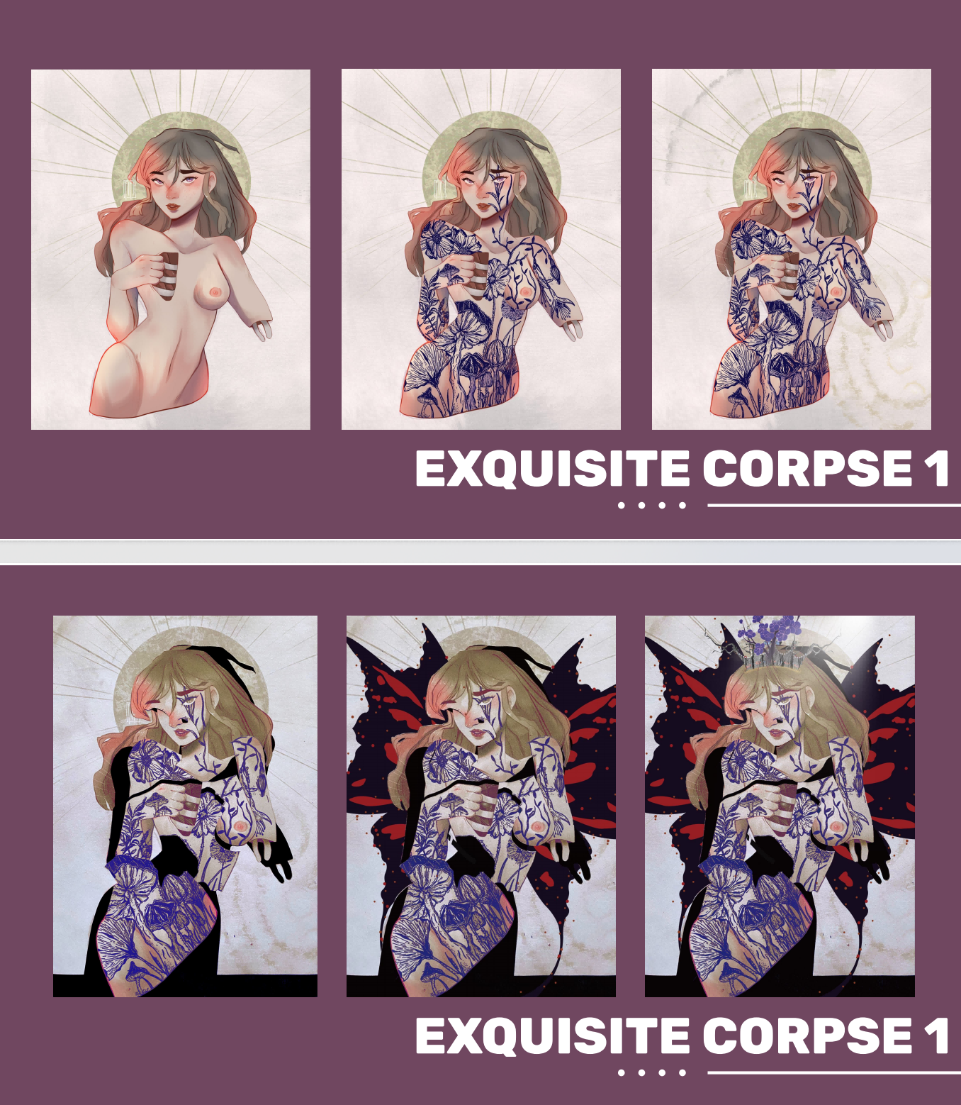
Fig 2: Production process 1
Plumwood (2019) says “Eco-feminism is the twin concept of both 'ecology' and 'feminism'”. During the production of the second painting, I was the third to work on the design of the relay painting. The painting I received was quite simple, with just a few stickers and a large tree with a flock of birds, symbolizing the peaceful coexistence of nature and mankind, and I think that nature and feminism go hand in hand as well. So I designed an eye and a woman escaping from the eye, and in the eye, a white planet. I believe that nature and women are the same; both have been destroyed and are now being called for protection, so I set the woman escaping from the eye with a ball that has not yet been contaminated; the pink dress represents that there is still hope; and the white planet behind her represents the damage and contamination that the girl has been subjected to. The main character of my design escapes from the controlled and polluted world with her body and her hope through her strong will and broken body. This is the symbolism of my painting. In this second painting, I want to express that the eyes are not only the window to the soul but also a place of hope.
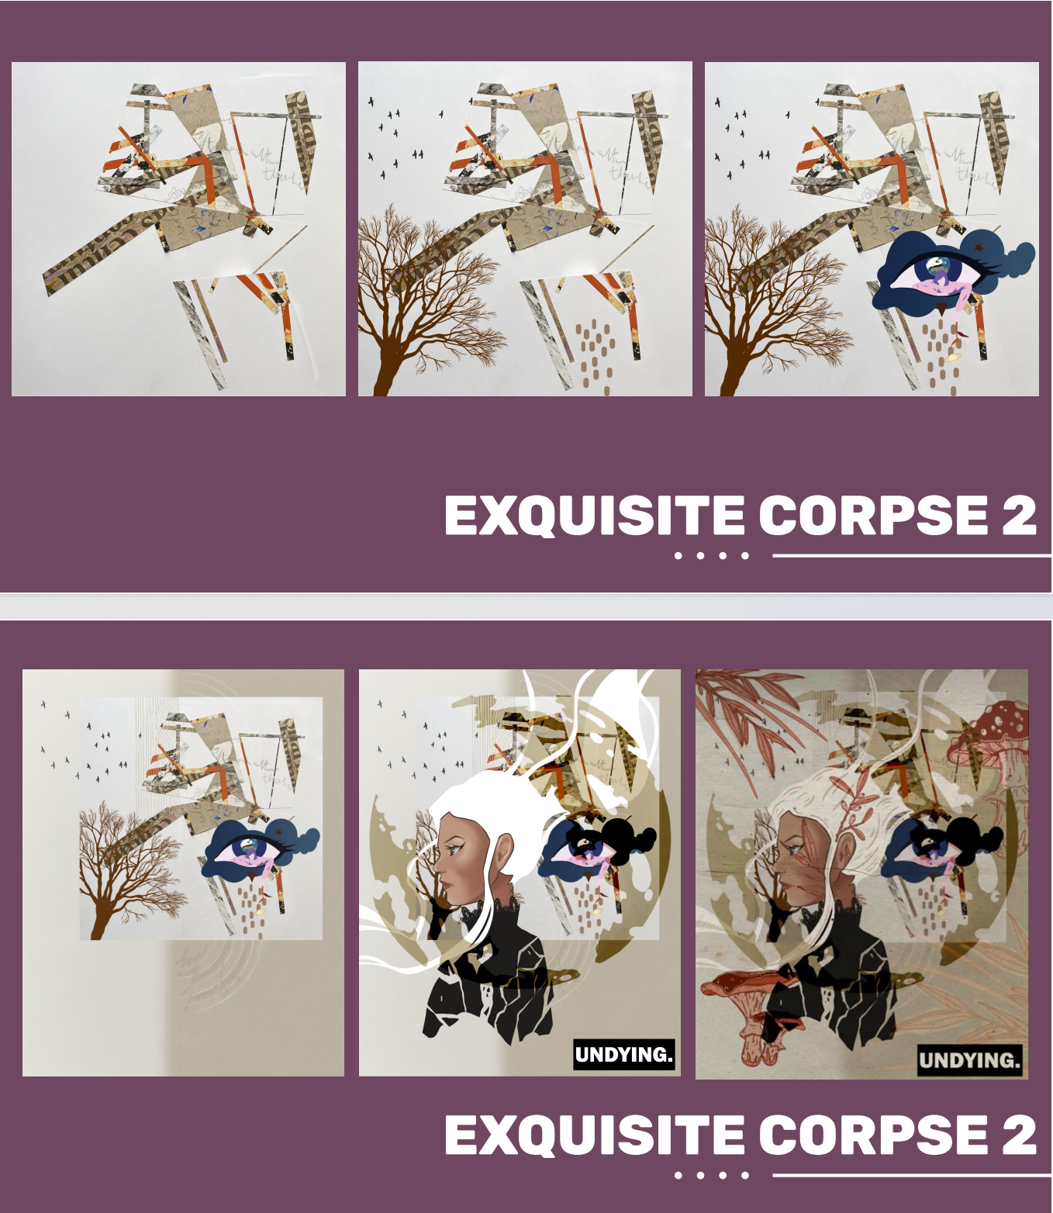
Fig 3: Production process 2
Once my part of the painting was produced, I continued to pass the painting on to the next member of the group and continued to complete the whole painting.
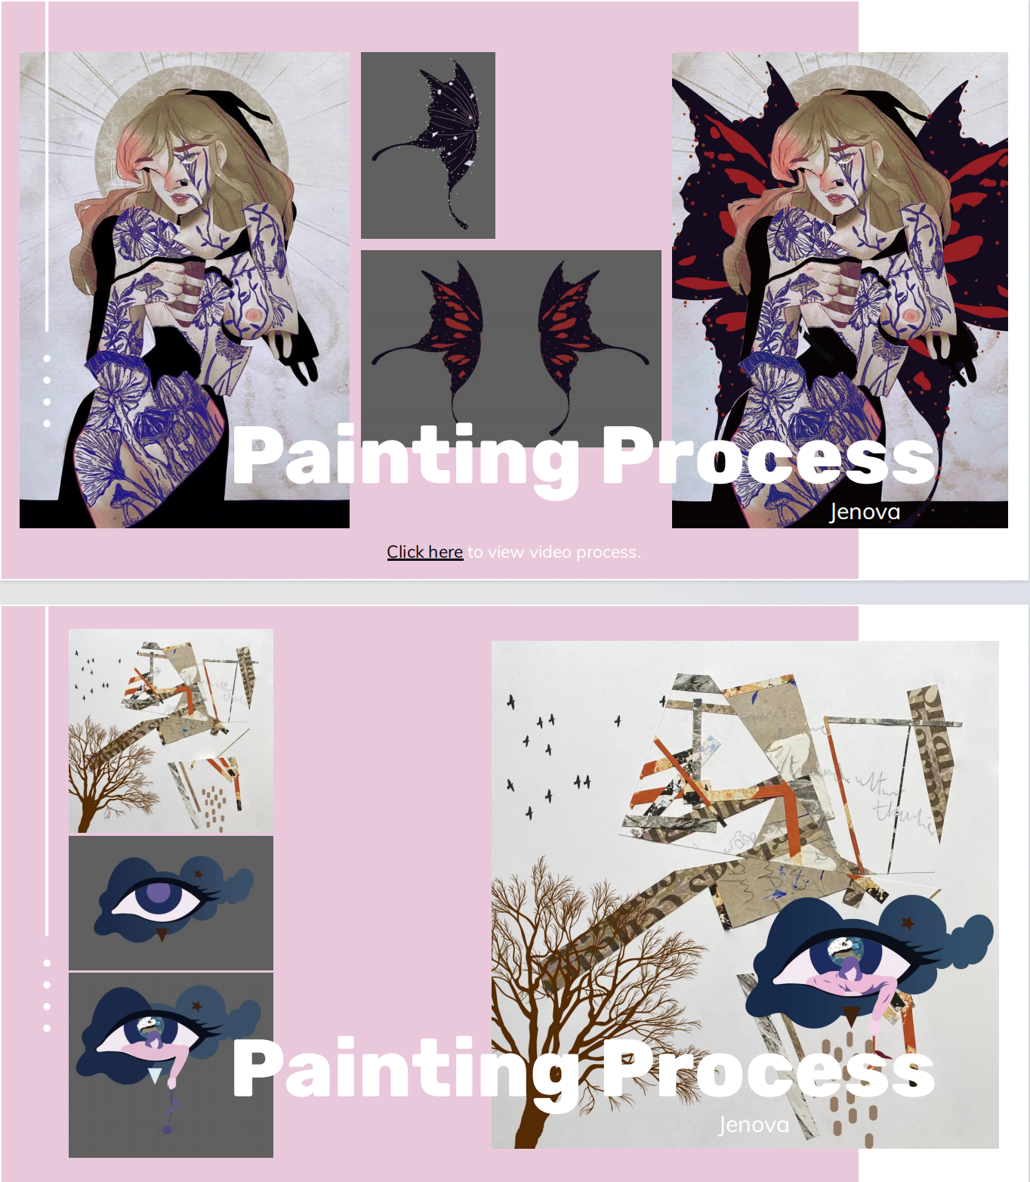
Fig 4: Author's production process

Chapter 4: Team dynamics analysis
“Team creativity has been described as a collective phenomenon where members behaviorally, cognitively, and emotionally attempt new things, take novel approaches to their work, or generate products or processes. ”(Gilson, Shalley, 2004). A good team leader needs to guide and pave the way for the group members in the preliminary work. Our leader, Fiona, had her team members think outside the box to collect data, then assign work to each member of the team and bring out the best in each person to create a complete piece of artwork. Because we were creating snowball paintings in a short period of time, we were working on two paintings at the same time. There was a lack of direct communication between our team members, and we could only communicate indirectly through the paintings we received. We imagined the thoughts and feelings of the previous team member's painting and then added our own ideas to sublimate the theme.

During the creation of the project, not all members of our team were present each time, and Fiona had to adjust the order of the paintings according to the actual situation and communicate with those who were not able to attend the meeting in a timely manner. “It's important for the leader to include himself or herself in collaborative team processes as a participant, not just as a leader. ”(Alexanian, Janet A,et al,2015 )This way, members know that their leader has invested as much time, effort, and energy into the project as they have, and it is only through direct involvement that the leader can connect with the team.

Bertie Freedholm has found that in the history of the Nobel Prize, "it is rare for a scientist to win alone. The Nobel Prize is usually awarded not to one scientist but to two or three scientists, or a team." It can be seen that whether a good team can make good results depends not only on the collaboration between the team but also on the leader's decision and direction. In the course of the project, Fiona organized six meetings before the PowerPoint presentation, in which Fiona recorded our discussion process in detail and made decisions and directions for our progress. But in the course of the project, our team members lacked actual discussion and communication and could not implement the ideas of other team members, which is something that Fiona as a This is something that Fiona, as a leader, did not take into account, so if our project can be taken further and better paintings can be created, our team needs to have more group discussions and express their own contributions and hopes for this piece of artwork so that the team can complete the project better.

Chapter 5: Conclusion
In an innovation project, a team with the spirit of cooperation is the core, and the synergistic enhancement of teamwork for students' research and innovation ability is quite big. And as a member of the team, you need to communicate more with the group members and also communicate more with the team leader, which is the best teamwork.
The most influential factor in the team is the team leader. From the perspective of team leadership, the team leader needs to formulate the overall direction of the team and the team's project goals, as well as establish a good team communication and collaboration mechanism and fully mobilize the positive initiative of each member of the team, which is the most important thing for a team, so I think that regular exchanges between the team can promote the synergistic growth of students' scientific research and innovation ability and also exercise the students' organizational leadership ability. It can also exercise students' organizational leadership abilities.

Bibliography

- Meredith R. Belbi, translated by Yuan Zheng, Li Heqing, Lin Hongyun, Management Teams: Why They Succeed or Fail，China machine press,2017
- Erich Fromm,translated by Liu Futang,The Art Of Loving, People's Literature Publishing House, 2018
- Susan Griffin,translated by Mao Yuyuan, Women and Nature,Chongqing Publishing Group,2007-4
- Plumwood V .Feminism and the Mastery of Nature[J]. 2019. (pp. 97–112).
- Gilson L L, Shalley C.E, A little creativity goes a long way: an examination of team’s engagement in creative processes. Journal of Management, 2004,30:453-470.
[12] Alexanian, Janet A, et al.Beyond the Team: Understanding Interprofessional Work in Two North American ICUs[J].Critical Care Medicine, 2015, 43.

Article 3: An innovative bionic design process from nature

Table of Contents
Abstract 31
Chapter 1: Introduction 32
Chapter 2: Current status of bionic design research 33
2.1 Morphological bionic design 34
2.2 Structural biomimetic design 35
Chapter 3: Research hot spots and development trends in bionic design 37
Chapter 4: Design ideas and sources 39
Chapter 5: Conclusion 43
Bibliography 44
Words:2379

Abstract
The purpose of this research paper is to start with nature, using the creatures in nature as the research object, which can inspire the general public through the visual design and discovery of inspiration and in-depth research and discussion. This paper documents and discusses the practical problems and design records that emerged during the stages of inspiration, the design process, the actual design drawings, and the final renderings of the new curved roof, as well as the solutions to the problems that emerged.
In the field of architecture, successful examples of biomimetic design abound. From the "Bird's Nest" in Beijing in the building structure of the form of biomimicry to Le Corbusier's " The La Chapelle de Ronchamp," similar to the "auditory organs" of the meaning of the symbols, biomimetic design has brought a new interpretation of architectural design.
I have conducted a descriptive study of butterflies as creatures of nature and selected them from a large number of studies to be the subject of my research. In this paper, by observing its biological structure and the basic forms such as dots, lines, and surfaces that it possesses, as well as the multiple modeling elements on the butterfly's wings, I conduct research and discussion and integrate the design with bionic architecture to introduce the conceptual design of natural bionic into the architectural design.
Key words: Biomimetic design, Structure, Butterfly, Building

Chapter 1: Introduction
From ancient times to the present, nature has always been the object of people's aspiration and expression, providing rich materials for literature and art, etc. Especially in today's extremely advanced science, human beings still have an inseparable relationship with nature. During the Spring and Autumn Periods, Lu Ban relied on the shape characteristics of toothed grass to design and invent the sawtooth, becoming one of the earliest bionic designers in China. Leonardo da Vinci made a series of flight drafts and models in 1500 A.D., following the example of the bionic flight of a bird's wing. Larkins suggested in his design guidelines, "Learn from nature, draw from nature, not blindly copy old patterns." Bionics, as the basis for bionic design of product shapes, allows us to find the source of design in nature, not simply imitate it, but to keep exploring and pursuing more advanced ways.

The colourful shapes of living creatures in nature provide a constant source of inspiration for art and design. The Japanese architect Koji Hirata found new architectural situations in butterflies, ants and raindrops, and he fused the characteristics of nature's organisms into architecture, which often took on irregular forms.

The research in this paper starts from nature and takes the butterfly wings in nature as the research object, and the butterfly wing structure is thoroughly subdivided and deeply researched and discussed. This paper documents and discusses the practical problems and design records that emerged during the stages of inspiration for the design of the new curved roof, the design process, the actual design drawings and the final rendering, and solves the problems that arose.

Chapter 2: Current status of bionic design research
The word bionics was formed in 1960 by Steele in the United States based on the Latin word "bio (meaning way of life) and the end of the word nic (with the nature of ....)". Bionic design, which is an emerging discipline based on bionics and design, can cover many fields.

Like bionic architecture is to take the functional organisation and image composition law of certain organisms in the biological world as the research object, to explore the scientific and reasonable construction law in the natural world, and through the application of these research results to enrich and perfect the architectural treatment method, to promote the efficient design and reasonable formation of the architectural form and structure and the architectural function layout.
2.1 Morphological bionic design
"Take from nature, use in life". Bionic design, an important tool in product design, is also a kind of design thinking. It seems simple, but it is necessary to achieve the unity of man and nature. One of the deepest meanings of the Confucian concept of "unity of heaven and man" is the affirmation of the meaning of life in nature, and the affirmation of nature has its own intrinsic value(2014).The "nature" referred to by Laozi (2018) is closely linked to "all things" and "people." "Taking from nature, higher than nature," it is necessary to consider both the natural properties of the imitation object and the social properties of the product. The bionic design method can provide the most intuitive and detailed design for cultural products because the types of bionic design include biomimetic form, structure, function, and other comprehensive and intuitive design. The new direction of bionic design is to solve design problems by analogizing biological systems, extracting biological forms, proposing creative design concepts, and then carrying out concrete or abstract design (2012).

The La Chapelle de Ronchamp is one of Corbusier's most outstanding works and an important example of architecture. Adopting a sculptural and peculiar design scheme, the church is intentionally metaphorical as an "acoustic device," linking the distance between believers and God by means of sound and reaching a channel of communication. The design of the church is skillfully integrated into its natural surroundings, with the curve of the roof echoing the contours of the hill as if it were part of the natural terrain, demonstrating the concept of harmonious co-existence between architecture and nature.
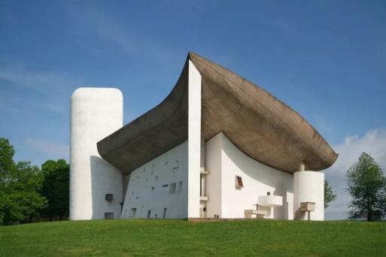
Fig. 1 “The La Chapelle de Ronchamp
2.2 Structural biomimetic design
Structural biomimetic design is a design methodology that applies the structure and function of living organisms in nature to the design of engineering structures by observing and studying them. Santiago Calatrava is one of the few generalist architects of the 20th century.(2007) He perfectly combined the rationality of an engineer with the romance of an artist to form a unique architectural language with movement, force, and bionic architectural forms as the main creative concepts. He used natural bionics in his architecture, not directly imitating the style of living organisms but analyzing the structural principles with a rational geometrical vision to develop new forms of architectural structures.
The National Stadium, also known as the "Bird's Nest," was built in 2008 as the main stadium for the Beijing Olympic Games. The components of the stadium's structure are interconnected to form a lattice-like framework that looks like a bird's nest made of tree branches, with a gray mineral-like steel mesh covered by a transparent membrane material (2013).

The design concept of the bird's nest comes from the imitation of a bird's nest. Birds build nests of various shapes and structures in order to reproduce and live. These nests are highly adaptable and flexible, and they can be changed and adjusted according to different environmental conditions. The Beijing Bird's Nest Stadium meets all the functional and technical requirements of an Olympic stadium, while at the same time the design is more innovative and simple, creating a unique landmark for the Olympic Games.
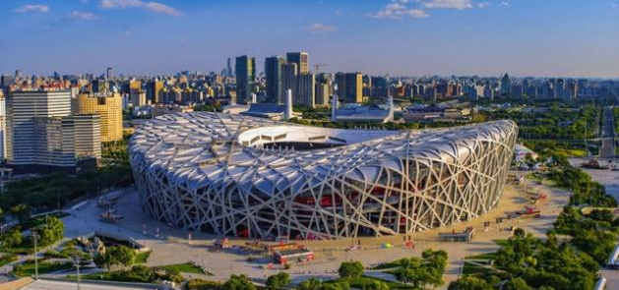
Fig.2: The National Stadium- Bird's Nest

Chapter 3:Research hot spots and development trends in bionic design
In recent years, people have paid more and more attention to man and nature, seeing bionic design as one of the important sources of inspiration for the innovative design of product shapes, how to better combine biological shapes with products, and how the fusion of the place can better show its characteristics, which will become the trend of people's research on the bionic innovative design of product shapes(2018).
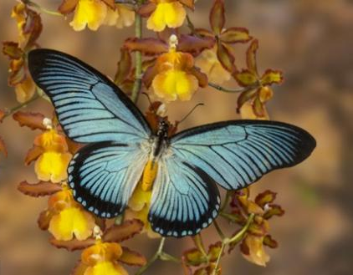
Fig 3: Butterfly
This study analysed around butterflies. Butterflies, people call them "the Xishi of the insect world." Scientists, scientists through the study of butterflies for the military, aerospace, life, building, and so on—have brought great gains. During World War II, people referred to the pattern and composition on the wings of butterflies and dyed the pattern on the aircraft to make anti-aircraft camouflage. In the aerospace field, researchers have developed a new concept called the "butterfly effect," which draws on the structure and movement of butterfly wings. Tiny concave and convex structures are formed on the surface of the aircraft to reduce air resistance and improve flight performance. By modeling butterflies, engineering designers can create more advanced vehicles and achieve more efficient and environmentally friendly flight patterns.

Bionic design can also appear in the field of architecture. The main reason for the rise of architectural design is that architecture has been required to protect humans from nature since ancient times, while the city of the future hopes to eventually integrate humans with natural ecosystems through its emerging methods(2006). Architecture can be metabolized(2017), Facades become intelligently renewable, and rooftops become the new world of green cities. Bionic architecture is the future to ensure harmony between buildings and the natural environment, maintain ecological balance, and realize the sustainable development of buildings(1998). Important means, designers get inspiration from plants and animals and always adjust the shape according to the function. The development of bionic architecture should follow the laws of nature, which can be derived from the mechanical properties of natural attributes(2011), structural relationships and material properties and apply them to the structural or shape design of buildings, aiming to improve the efficiency of building resources.

Chapter 4: Design ideas and sources
There are many different types of butterflies, most of which have a symmetrical shape and are colorful and brightly colored. They are elegant in flight and come in all sizes. The appearance of butterflies is based on the basic forms of dots, lines, and surfaces, and the butterflies themselves have a wide variety of colors and patterns, either in dots or in lines. The patterns on their wings, in particular, contain a great variety of modeling elements.
Because any phenomenon has two sides, i.e, externality and internality, art works are usually analyzed according to the basic constituent elements of the form of the content, starting from the "point". Kandinsky pointed out in On Points, Lines and Surfaces(2013): "Points, lines and surfaces are the most basic language and units of plastic arts, which have symbols and graphic features that can express different characters and rich connotations." All natural things grow according to a certain law, starting from the initial cell and spreading from the inside out, the point of painting is static and the point of nature is movement. This paper explores the laws of art design and nature through the study of butterflies. The intrinsic nature of dots, lines and surfaces is connected; the butterfly is not only the ancient metaphor of the cocoon into a butterfly; its microstructure allows us to see another world and the principle of opposites and parallelism will be the link between the two independently existing laws.
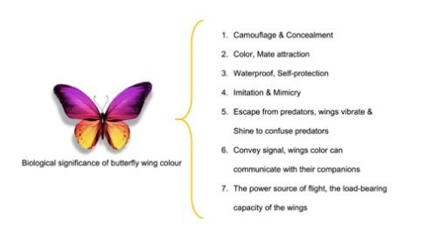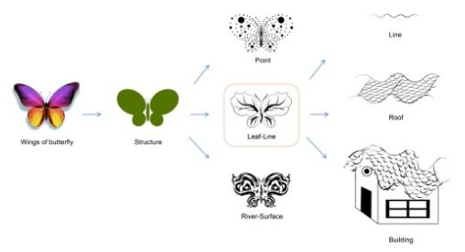
Fig 4: Sketch design
After determining the research objectives of the project, I did a lot of reading of data as well as literature references. I have analyzed several elements of butterflies that can become the design.
- First of all, the butterfly's wings have brilliant patterns and colors, which are made up of the butterfly's special wing structure, a double-sided structure with special reflective cells, which makes a unique pattern. However, this pattern has a variety of roles. The butterfly can camouflage and hide through this pattern, imitate and mimic various creatures in nature, and escape from its own predators through this role. The butterfly can also communicate with its companions through the vibration of the wings and confuse its predators through the reflective sheen of the wings.
2.Secondly, the butterfly's wings can withstand weights up to 40 times higher than its own, and the surface of the wings is covered with scales. According to the force and reaction, aerodynamics is generated to propel the butterfly to fly forward. The wings move with the help of updrafts.
3.Finally, the butterfly's wings are also waterproof, which allows it to fly in the rain and protect itself. The microstructures on the surface of the butterfly's wings not only repel water but also allow high-speed water droplets that hit them to quickly break up and disperse, thus providing protection in the rain.
Based on my previous research, I made a graphic extraction of the butterfly, starting from the simplest planar composition, where the principle of dots, lines, and surfaces corresponds exactly to the pattern of the butterfly's wings. I start from a point, using points of different sizes to converge into a butterfly shape, and then the points slowly coalesce into a line, giving the public the feeling of a natural birth that slowly extends. It is as if a dot is like a drop of rain that slowly converges from different branches into a river and finally flows into the sea. This is how the butterfly's wings carry the roots of nature. The most distinctive feature is the butterfly's linear structure. I got inspiration from the lines, and the wavy lines can be well combined with the roof of the house. Under a microscope, the scales on a butterfly's wings are as orderly and neatly arranged as the tiles on a roof. The uneven surface of the butterfly scales forms a certain regular texture. When the light shines on the scales, it naturally produces light images such as reflection and refraction, which makes the scales show different colors!
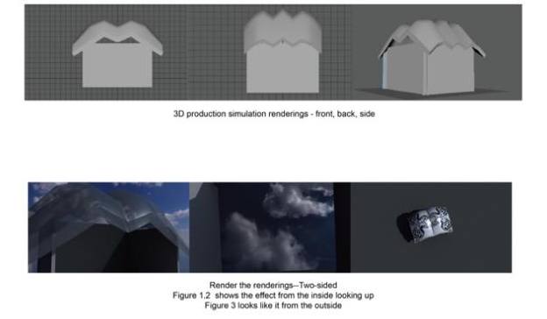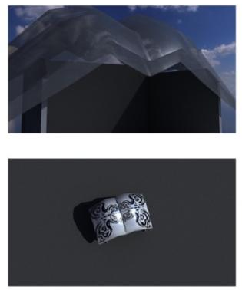
Fig 5: 3D Animation
Relying on the previous design, I finally designed a roof based on the bionic theory of butterfly wings. This design, which I named Butterfly Dance, has the versatility of a butterfly's wing, which includes double-sidedness, good load-bearing capacity, waterproofing, and extensibility, while its final output form is a curved roof. The bionic technology used in the roof is derived from the double-sidedness of butterfly wings. Standing in the house and looking up, there is a sense of transparency; you can see the weather conditions outside, but outside is the pattern of the butterfly. This type of roof has a strong waterproof and bending-bearing capacity. In rainy or windy weather, this roof can keep the water out well and won't let the people standing under the roof get wet. If the weather is sunny, the roof will absorb the sunlight for reflection and absorption and can be raised automatically for ventilation. Moreover, the appearance of the roof will change color according to the temperature; the higher the temperature, the brighter the color, and vice versa.

Chapter 5: Conclusion
Nature has always been a source of inspiration for scientists and researchers in various fields. The study of the evolutionary processes of many species and organisms has led to unique discoveries in science and technology. Butterflies play an important role in scientific research. With the continuous development of science and technology, the bionic principles of butterflies will continue to play an important role in various fields, creating more opportunities and breakthroughs for mankind. In this work, inspired by the magnificent structure of the butterfly's wings, I propose a bionic design that may have the potential to be used to increase the viewing capacity of scenic spots as well as to replace them in the field of general architecture to achieve more energy and resource conservation; it can be used as a scenic spot for a 360-degree view of the dynamics of nature without any dead ends as well as blending in with nature without disturbing the indigenous people; and secondly, it can be used in the field of general construction to create more opportunities and breakthroughs for mankind. It can be used as a scenic spot for better 360-degree viewing of nature's dynamics and integration into nature without disturbing the aborigines in nature; and secondly, in the field of general construction, the design has a better weighing and has fewer resources to build.

Bibliography

[13] Xu Chun. Modern Transformation of Confucian "Unity of Heaven and Man" Nature Ethics [D]. , 2014.
[14] Wang, Zhongjiang. Tao and the Nature of Things: An Examination of the Practical Meaning of Laozi's "Taoism and the Law of Nature"[J]. Philosophical Studies, 2010, 8: 37-47.
[15] GOEL A K, VATTAM S, WILTGEN B, et al. Cognitive, collaborative, conceptual and creative-four characteristics of the next generation of knowledge-based CAD systems: a study in biologically inspired design[J]. Computer-Aided Design, 2012, 44(10): 879–900.
[16] HU Qiaoling, LI Xiaodong, SHEN Jiacon. Progress of research on biomimetic structural materials[J]. Journal of Materials Research, 2003, 17(4): 337-344.
[17] Zhuangwei, Liu Songfu. The Power of Technology: An Interpretation of Santiago Calatrava's Architectural Form[J]. Central China Architecture, 2007, 25(1): 189-194.
[18] "Bird's Nest" out of the cocoon of the National Stadium officially started construction. Nanfang.com, 2013-07-19.
[19] Luo Shijian, Zhang Yufei, Bian Ze, et al. Research status and progress of bionic design of product shape[J]. Journal of Mechanical Engineering, 2018, 54(21): 138-155.
[20] Liu Rensheng.Marx's Ecological Discourse on the Harmonious Development of Man and Nature[J]. Teaching and Research, 2006 (6): 62].
[21] Li Yunyuan. A Review of Japanese Modern Historical and Cultural Thoughts and Their Influence on Japanese Modern Garden Design [J]. Landscape Gardening, 2017, 24(8): 118-125.]
[22] Zhuang Weimin.Sustainable development of architecture and pseudo-sustainable architecture[J]. Journal of Architecture, 1998 (11): 54-56.
[23] Yao Heng. The Laying of Classical Mechanics: The Unification of Mathematics and Mechanics[J]. Science Education Monthly, 2011 (340): 11-21.
[24] Dai Xiufang. Grasp the essence of the design, feel the soul of the design - talk about the design of graphic advertising "soul"[J]. Journal of Yunnan Administrative College, 2013.

