

Module Name: International Marketing: Principles and Practices
Module code: LCMB7026
Assignment Title: International Marketing: Principles and Practices
Student Name: Gabriela Szkutnik
Student ID: 2130794
Abstract
The report below has conducted a detailed analysis of the PESTEL framework for the business of Coca-Cola, where the socio-cultural aspects of the company have been discussed for the operations in both Denmark and Romania. This comparison included a discussion and comparison of their business in both countries. A range of STP strategies is embraced from the instance of Coca-Cola, which differs from region. Here, the report has taken Denmark and Romania to highlight differences in segmentation, targeting, positioning, marketing communications, cultural considerations and pricing strategies. While in Denmark the focus has been placed on sustainability, health and premium positioning, in Romania, affordability, family-oriented messaging, and traditional values are central. Comparison of the marketing mix has been considered here while discussing effective analysis in the business context. A Brief analysis based on Denmark and Romania has also been conducted in order to compare and contrast in the business context. Incorporation of this analysis has been critical in leveraging strengths, weaknesses and market threats for developing betterment strategies. The following analysis has put significant efforts towards the successful evaluation of the successful and tailored marketing approaches of Coca-Cola in Denmark and Romania. Identification of all the key ethical concerns regarding health and sustainability helps in providing lots of strategic recommendations.
Table of Contents
Introduction 5
Brand overview 6
Performing a comparative analysis of the socio-cultural context of Denmark and Romania for Coca-Cola using PESTEL analysis 7
Political Factors 7
Economic Factors 7
Social Factors 9
Technological Factors 9
Legal Factors 10
Environmental Factors 11
Comparison of Brand’s STP strategies in Denmark and Romania 12
Segmentation Strategies 12
Targeting Strategies 12
Positioning Strategies 13
Marketing Communications 14
Cultural Considerations 14
Price Strategy 15
Comparison of Marketing Mix Strategies between Denmark and Romania 17
Comparison of the Marketing Mix 17
Strengths, Weaknesses, Opportunities in Each Market 20
Providing a detailed evaluation of the effectiveness and success of the above marketing strategies in both Romania and Denmark 22
Understanding the reason behind the presence of ethical issues related to the Coca-Cola’s marketing mix of in one or both countries of Romania and Denmark 26
Showcasing some most appropriate recommendations for uplifting the future international marketing strategies of Coca-Cola in both Denmark and Romania 29
References 30
Appendix 34

Introduction
International marketing is referred to as the planning, promotion, pricing, as well as distribution of services or products in more than one country (Kihn, 2024). It also requires a change of approach to the cultural, legal, economic as well and social context in which it is operating to communicate and satisfy the foreign international consumers while meeting company goals. Therefore, in the following report, a company will be selected and the two countries where this company is present will be identified. In this case, the business of Coca-Cola has been chosen, and the two countries where it is present are chosen to be Denmark and Romania. Next, the overview of the company has been provided, where the financial information of the company has been shared along with its founder's name and the founding date. After that, the socio-cultural factors for the company in both countries have been discussed thoroughly using a PESTEL framework. After that, the STP analysis for the company has been conducted and compared for both places, following which a marketing mix analysis has been performed in the same manner. With these findings, the performance of the marketing strategies of the company has been evaluated, and then, the marketing ethics practices have been thoroughly evaluated. Finally, the recommendations for the business have been provided here in order to improve its marketing practices globally.

Brand overview
The business of Coca-Cola was developed by Dr John Stith Pemberton on 8th of May in the 1886, in Atlanta, Georgia, USA, is one of the world's best-recognised beverage companies (Coca-Cola , 2025 ). At first, the firm started to sell its beverages and drinks at Jacobs' Pharmacy, and through its gradual expansion into the global market, Coca-Cola have become a leader in the sector of refreshment and innovation. It operates in more than 200 countries and sells over 500 brands, like Coca-Cola, Fanta, Sprite, Diet Coke and many others. In 2023, this company reported its global net operating revenues were approximately £37.6 billion, involving a net income of approximately £8.8 billion, and more than 2.2 billion servings of its products were consumed per day across the globe (Ridder, 2025 ). Coca-Cola has been established in Denmark since 1934, and it has captured a strong position in the market within the country by emphasising sustainable packaging initiatives as well as an emphasis on locally made products. The Danish entity puts considerable focus on minimising and recycling its carbon footprint on the basis of the strict environmental guidelines governing Denmark. On the other hand, Romania is one of the smaller countries that Coca-Cola focuses on, where Coca-Cola HBC is considered to be the largest beverage business in Romania, with a beverage manufacturing facility situated in Ploiești. Coca-Cola HBC is an important part of its economy due to the number of people it employs, the number of Romanian suppliers it works with and the marketing campaigns it develops particularly for Romanian consumers.

Performing a comparative analysis of the socio-cultural context of Denmark and Romania for Coca-Cola using PESTEL analysis

Political Factors
Country A: Denmark
Denmark is a country with a high-income rate, which is politically stable and has an effective governance structure as well as low corruption. The government of Denmark ranks in the top 10 countries for very low corruption in Transparency International’s 2023 Corruption Perceptions Index (Transparency International , 2025 ). This type of political stability helps the company to operate and plan for the long term and invest sustainably. Food and beverage regulations are stringent in Denmark, specifically in the area of sugar taxes, labelling and packaging. Denmark has also initiated a number of public health campaigns as well as supported policy measures to reduce the intake of sugar in their population, which influences the product manufacturing for the firm and marketing approaches to products. For example, the company has introduced more sugar-free as well as low-calorie options in Denmark to better align its products with the public national health agenda.
Country B: Romania
Contrastingly, the political environment of Romania is more disrupted and rapidly affected by the influences of frequent changes in policy (Realinstitutoelcano, 2025). Despite being a member of the European Union since 2007, the country still operates with a degree of corruption and bureaucratic delays, which may adversely impact business. For Coca-Cola, it requires them to have flexible methods of responding to ongoing shifts in policy, like adjustments in excise duties, as well as the advertising policy. Nonetheless, the government has become more supportive of foreign investment, which has enabled firms like Coca-Cola HBC, one of the largest production units located in Ploiești, to receive a large tax incentive.

Economic Factors
Country A: Denmark
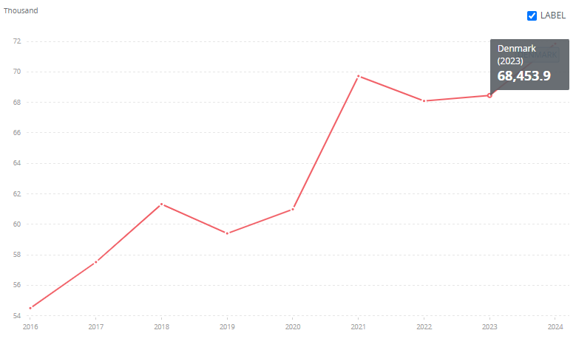
Figure: The per capita GDP of Denmark
Source: (World bank , 2025 )
Denmark has been ranked among the richest economies in Europe with a GDP per capita of just under £55,000 in 2023 (World bank , 2025 ). The country has a low unemployment rate of 4.3% and stable inflation rates around 2.5%. This robust economic environment delivers Coca-Cola with a stable and higher-value consumer base with high power for purchasing power. Moreover, the beverage industry in Denmark is extremely mature, and consumers are willing to pay more for premium, sustainable, as well as healthier choices. The focus of the company on the low-sugar products fits well within this high-value segment of the market. On the other hand, the high operating costs involve the costs of labour and environmental compliance costs increase the price structure for the entire firm.
Country B: Romania
Romania has been an upper-middle-income economy, having a GDP per capita of around £15,800 in 2023, which is noticeably lower than that of Denmark. This country experiences higher inflation, with an average of 7.8%, and an unemployment rate of approximately 5.6%. The purchasing power of the firm is still lower than in Denmark, yet Romania represents an emerging consumer market with enhanced disposable incomes and a youthful population. It can benefit from cheaper production as well as the costs of labour in Romania and runs one of its most efficient plants in Europe. Consumption of soft drinks per capita is also steadily increasing, signifying a rise in the demand for branded products.

Social Factors
Country A: Denmark
The consumers of Denmark are very concerned about their health and are also concerned about the environment. There is a strong cultural significance associated with healthy living as well as sustainability, which influences the behaviour of consumers (Bestle et al., 2024). The Danish population tracks its sugar consumption, and it has introduced very sugar-intensive products, and sugar-free as well as low-sugar drinks are very popular. Coca-Cola responded to this cultural perspective by introducing Coca-Cola Zero Sugar and providing smaller packaging options, promoting moderation of consumption. Social attitudes mainly encourage the firms to accept responsibility for their actions, both socially as well as environmentally, and this has a significant impact on brand image.
Country B: Romania
The social setting of Romania consists of a rising middle class, higher urbanisation levels as well as youthfulness. Drinks usually include aspects of socialising, festivals, as well as youth culture and thus, soft drinks remain a popular choice for the younger segment of consumers. It has a strong brand image, is involved with Western modernity as well as lifestyle aspirations. Recognition of health, while increasingly significant, is not to the same degree of symbolisation as in Denmark, which allows the firm to massively boost its sales of traditional sugary drinks across its newer health drinks.

Technological Factors
Country A: Denmark
Denmark is recognised for its leadership across the world in technological innovation as well as digitalisation. More than 98% of the population utilises the internet, and there is widespread acceptance of mobile payments as well (Bank, 2025 ). The chosen organisation plays into these trends by employing data-based marketing, digital advertising, as well as interactive vending machines as a way of enhancing engagement with its customers and the products. The advances of Denmark in recycling technology have been valuable for the sustainability efforts of Coca-Cola, involving the use of 100% recycled PET bottles in various deliverables.
Country B: Romania
Romania has enhanced the integration of technology, boasting its internet penetration of more than 90% as well as an emerging e-commerce sector. The company also leverages digital campaigns and social media as part of the overall instinct to attract a younger segment of the population. On the other hand, technological infrastructure has been increasingly developing, while logistics and recycling technology lag behind its capabilities. Coca-Cola is beginning to modernise its production lines in Ploiești and is working collaboratively with local partners to improve recycling and systems of waste management.

Legal Factors
Country A: Denmark
Denmark has a stringent legal system in place for food and beverage marketing, labelling, as well as environmental impact. There are strict regulations involving the advertising to children, and taxes on sugar product pricing. Coca-Cola should try to comply with EU as well as Danish laws over packaging and labelling products with nutritional information. Labour laws have also been very strong, confirming high standards of employee well-being and compliance with operations.
Country B: Romania
Romania has complied with the regulations of the European Union, yet its enforcement can vary at times. The legal framework is developing around advertising, the safety of food, and environmental protection. Labour law is more flexible in this country, which enables the firm to effectively manage costs. The legal environment is not as predictable, yet it helps the company with some negotiation as well as flexibility.

Environmental Factors
Country A: Denmark
Environmental sustainability is considered to be a key national priority, and two goals of it are to become carbon neutral by the end of 2040, and companies are expected to play an active role in achieving that goal. Coca-Cola has undertaken the steps to adjust the way it operates in Denmark by offering beverages produced locally, employing recycled packaging as well and relying on renewable energy in its operations. Many people in this company have displayed some significant support for environmental sustainability initiatives, demonstrating that the influence of environmental performance strategies directly affects the reputation of the brand and its sales.
Country B: Romania
The region of Romania is on board with the environmental policy of the EU, yet it is still in the stages of implementing it. Coca-Cola is leading the recycling efforts of Romanisa and operates as one of the most developed bottling plants in Central and Eastern Europe. Environmental awareness is enhancing, yet it is not instilled as deeply in consumer behaviour as it is in Denmark. The educational campaigns of Coca-Cola and partnerships with local non-government organisations aim to create a culture of recycling and an overall environmental responsibility.

Comparison of Brand’s STP strategies in Denmark and Romania

Segmentation Strategies
Denmark | Romania
The market of Denmark has been divided by Coca-Cola using demographic, behavioural and psychographic variables. It primarily targets youths and young professionals, who are health-conscious and technologically aware. From the habitual perception, consumers are increasingly demanding low-sugar and sugar-free varieties. Coca-Cola reacts to these demands by offering low-calorie versions of the Coca-Cola brand, such as Coca-Cola Zero (the guardian, 2025). Environmental sustainability is its psychograph and the Danish customers focus on environmentally friendly and sustainable products. | Coca-Cola also considers dividing the market in Romania, the same way Denmark has been. However, the focus varies, which is highly influenced by the socio-economic situation. Its target market consists of the middle and lower-income population, which constitutes the majority of the consumer population. Families represent a major target group behaviourally as families with a lot of members are typical. From a psychographic perspective, Coca-Cola appeals to individuals who appreciate socialising, tradition and experiences (King, 2025).

Targeting Strategies
Denmark | Romania
Key focus in the Danish market for Coca-Cola is urban and young adults who are health-conscious. The keen interest of this group in convenient and modern lifestyles implies their tendency towards healthier drink alternatives. Coca-Cola encourages the consumption of low-calorie products, including Coca-Cola Zero and Diet Coke, which resonates with the needs of the audience. Digital marketing platforms, including social media and influencers, are highly utilised to meet customer needs. Also, middle- to upper-middle-income consumers are targeted by Coca-Cola alongside green consumers, for their consistency with the sustainable brands (Pec, 2022). | A wider audience awaits Coca-Cola in Romania for targeting the middle-income families and young adults, particularly in urban areas. The brand also focuses to aims at the rural population and provides numerous offers on products in higher packaging volumes. Positioning itself as a necessary investment in social events, which emphasises family gatherings, has enabled Coca-Cola to target Romanian ideals of tradition and family (the guardian, 2025). Also, in the region, it has mostly been associated with celebrations and socialisation.

Positioning Strategies
Denmark | Romania
In Denmark, Coca-Cola is a high-quality product which is linked to innovation, sustainability and quality. Concerning environmental responsibility, the brand embraces the use of recyclable products and efficient energy production. Marketing itself as a healthier product in the form of Coca-Cola Zero, which aligns with the needs of Danish consumers. High-end status is reinforced by the campaigns, accentuating the contemporary responsible lifestyle of the target group (The Coca-Cola Company , 2025). It has made its presence desirable to the health and environmentally conscious consumers. | Coca-Cola is a keen observer of tradition, which consists of fun and social relationships and in Romania, it is well-embraced. Advertising itself as a drink which could improve social events and family get-togethers, the brand has spent a fortune on its ad. Aiming at developing a happy and relatable brand image and the campaigns are based on the collective experience. With its low price and huge packaging quantities, Coca-Cola reinforce itself as an everyday drink consumed by a wide audience (Medium, 2020).

Marketing Communications
Denmark | Romania
Digital-oriented marketing communications are applied by Coca-Cola in Denmark, which provides access to the use of social media, collaboration with influencers and online campaigns. Focus on health and sustainability of the brand, it targets a younger demographic (Pec, 2022). Digital content supports and emphasises its low-calorie products and environmental initiatives. Coca-Cola also takes part in sponsoring events such as music festivals and health-related activities to reach its green customers. Here, online platforms play a major role in targeting this generation of techno-savvy, modern generation, responding online. | Coca-Cola tends to use more traditional marketing messages while branding in Romania through TV advertisements, billboards and sponsorships. Relying on locally based celebrities and cultural icons helped in reaching the Romanian customer (BBC, 2024). Advertisements that required expenditure from Coca-Cola are more targeted at family values, social events and happy moments, embraced by Romanian culture. The brand also sponsors social events like festivals and sports events, which require outdoor advertising and direct contact with the masses for advertising.

Cultural Considerations
Denmark | Romania
Cultural values are based on sustainability, minimalism and health in Denmark. Hence, Coca-Cola is consistent with these values and advertises its products with eco-friendly actions and healthy product lines. Aiming at decreased plastic waste, recyclable options and low sugar alternatives, it has introduced products like Coca-Cola Zero. The product can solely attract the healthier and more sustainable choices of the Danish market. It emerges as a culturally oriented strategy that enhances the premium status of Coca-Cola in Denmark (Barrett, 2025). | In Romanian culture, family, custom and social events are valued, which has been reflected in every part of Coca-Cola's marketing strategy. The brand messages with a focus on family events, feasts and gatherings. However, the issue of environmental concerns has gained relevance in Romania. Still oriented at providing products at affordable and convenient rates, has positioned Coca-Cola as a necessity in family gatherings. Its large size packaging attracts family-oriented consumers and this theme helps to be more appealing to Romanian culture (King, 2025).

Price Strategy
Denmark | Romania
Premium positioning is one of the widely utilised pricing strategies Coca-Cola has used in Denmark (Barrett, 2025). The brand sells a higher proportion of its line of products that are health-conscious and eco-friendly, like Coca-Cola Zero. Justifying the premium pricing implies the readiness of Danish consumers to spend more on the products which correspond to their environmental and health values. It includes higher prices on sustainable production techniques, like recyclable packaging, in the pricing strategy. | Based on the needs of Romania, Coca-Cola has embraced a competitive pricing strategy. Its diverse products sold at different prices imply the aim to cater for a wider range of income brackets. Smaller packs with reduced prices have allowed Coca-Cola to be affordable to low-income consumers (Kakas, 2024). Larger family-sized packs are more economical. The pricing system has certainly outlined Coca-Cola as affordable to the majority of the population, along with rural communities. Accessibility is further promoted by using special promotions and discounts.

Comparison of Marketing Mix Strategies between Denmark and Romania

Comparison of the Marketing Mix
Elements | Denmark | Romania
Product | Strong emphasis on health and sustainability, while considering their product ranges like Zero Sugar, has been significant in these regions. Coca-Cola’s approach to integrating the tagline ‘better for you’ has mattered more in Denmark (Simoes-Coelho et al., 2023). Their product innovation has been tied to components like flavours, and limited editions are more likely to be quickly adopted in this region. | A broad portfolio of beverages, while expanding beyond the core of Coca-Cola, including local flavours and non-carbonated drinks, is more likely to gain fame in this region. Through these initiatives, Coca-Cola has been able to dominate with a 65.9% market value. Although some critical movements encompassing low-sugar versions are less developed than in Denmark (Huse et al., 2022).
Price | Higher absolute price levels are mainly experienced in Denmark due to the increased labour, packaging regulations and taxes. Danish consumers have accepted Premium pricing more effectively while considering their Green products to be marketed effectively (Greve, 2023). However, inflation and the existence of cheap alternatives are more likely to create competition for the brand. | Romanian consumers are more likely to be price sensitive with a lower disposable income, which can lead to challenges in segmenting their customers. Their organic net sales revenue has expanded to approximately 7.2% through tailoring their pricing towards each market response (Nikonova and Nikonov, A., 2022). Pricing and affordability are becoming big constraints in Romania, creating the need for better pricing in the business context.
Place | An excellent modern retail penetration approach has been considered by the company in Denmark with supermarkets, convenience stores and high-quality outlets. Their strong e-commerce and online retail presence has increased their presence in public spaces. High expectations of availability are more likely to be the core approach of Coca-Cola while operating in Denmark (Beswick-Parsons et al., 2023). | Mixed channels, including modern retail and traditional trade, have been significant in leveraging effectiveness. In Romania, the organisation has been significantly able to leverage its business in towns and rural areas. Place promotions for this region have encompassed in-store, point-of-sale, as well as the effectiveness of resilience through the given infrastructure.
Promotion | Potential usage of digital media influencers in marketing has been considered by Coca-Cola. In Denmark, Coca-Cola’s awareness has risen from the percentage of 9.3% to 18.4% in the year 2025 (Janberg, 2025). Their campaigns have showcased their value tied with the environment, local culture and social responsibility while going beyond just showing product features. | Aggressive promotional strategies have been followed by the company while working efficiently in the context of showcasing their products and services. The use of community and sustainability activities has been integrated by the company while trying to attract Romanian consumers. Marketing resources by Coca-Cola are more likely to be based on retention of volume and preventing decline.
People | The core people of Coca-Cola’s brand mix encompass their staff. Sales force, customer service executive and individuals who significantly align their initiatives to achieve brand values. Individuals who invest in being brand ambassadors and influencers are more likely to be the local staff, fostering a positive work culture. Denmark’s people value sustainability and other internal ethics, which have been taken in their workforce (Borah and Bonetti, 2022). | People in Romania are more likely to value local bottling, local operations, as well as the utilisation of Romanian suppliers. Potential economic legitimacy has been expected by the individuals in this region. Employee relations, community engagement initiatives and other relationship approaches are more likely to be followed by the organisation in the context of building trust with their core people (Lubis, 2024).
Process | Efficient, streamlined processes are needed in regions of Denmark. HGH regulatory compliance, sustainability in packaging and quality control are more likely to be approached by Coca-Cola. They have invested in enhancing the processes to include advanced digital ordering, a better supply chain system and seamless online and offline service delivery. Coca-Cola’s process in Denmark also encompasses customer feedback, complaints and regulatory demand management. | Process for Romania encompasses Coca-Cola’s approach in using local bottling, distribution across diverse terrain, as well as its approach in dealing with infrastructure challenges. Implementation of environmental processes and deposit return schemes is significant for them to strengthen their brand awarness. Their approach encompasses management for cost inflation, supply chain bottlenecks, regulatory compliance and more variation across regions.
Physical Evidence | Packaging has been the key physical evidence in Denmark for Coca-Cola, where the brand identity has been kept consistent through its potential Red brand design. Their physical environment, including hop displays, events and POS, is significantly standard. Utilisation of recyclable packaging has also been under their physical evidence and branding approaches (Borah and Bonetti, 2022). | In the context of Romania, similar packaging and branding are central in the process. Making visible physical cues mainly helps build credibility while point–of–sale displays created Coca-Cola’s brand presence for evidence. The brand of beverages encompasses a Corporate infrastructure which are visible for its effective communication and trust.

Strengths, Weaknesses, Opportunities in Each Market
Market for Coca-Cola | Strengths for 7Ps | Weaknesses for 7Ps | Opportunities and strategic actions
Denmark | Strengths of marketing mix for Coca-Cola encompass their approach in having high customer expectationdriving high quality in product, people and process and public evidence, creating a differentiator. In Denmark, the company has been able to develop a strong infrastructure with premium pricing, which has enhanced its profitability (Huse et al., 2022). | However, the maintenance of high cost led to difficulty while trying to manage regulatory compliance at the same time. Risk of negative sentiment remains critical, while the overpromoting nature of the environment can lead to greenwashing (Huse et al., 2022). | Critical emphasis on physical evidence is needed to be created while considering an effective approach in showing people and process while trying to build authenticity. Staff training, customer service have been significant in enhancing the people element.
Romania | Romania have Coca-Cola as one of its leading beverage companies, thriving competitively in the modern market environment. Their promotions and strong POS have helped their business to increase brand value and presence. Flexibility in their processes creates the ability for the business to adapt to new required infrastructure variations (Aguda, 2023). | Process variability is a common lack encountered in this region by the company, as their logistics, quality control, as well as distribution are lacking and causing a degradation in consistency. People may be more uneven, especially in smaller stores or in rural areas. Cost pressure can compromise quality in this region while causing a lag in physical evidence on demonstrating challenges (Aguda, 2023). | Coca-Cola had a large increase in its ad awareness in the year 2025, while promoting better sustainability-driven marketing campaigns in the context of educating staff can lead to betterment. Investment for process improvement through consistency, cold chain, bottling and quality assurance can lead to significant improvements.

Providing a detailed evaluation of the effectiveness and success of the above marketing strategies in both Romania and Denmark
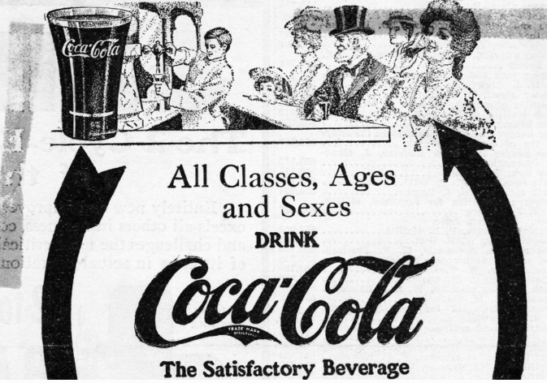
Figure: The Bitter Aftertaste Of Coca-Cola’s ‘Neutral’ Marketing Strategy
Source: (Oakenfull, 2023)
The global presence of Coca Cola is often regarded as undeniable and all its success factors of promotional strategies vary on the highly localised marketing strategies (Oakenfull, 2023). Conducting a very detailed evaluation of the current performance in Denmark and Romania plays a major role in disclosing different levels of success factors. The former country of Denmark basically demonstrates a highly emerging and growth-oriented market. On the other hand, Romania is considered a very emerging and growth-oriented market that has ended up revealing a highly tailored approach. All these are closely related to different levels of success factors.
Underscoring the level of success in Denmark by including the case of brand reinforcement
The presence of a very saturated and highly competitive market in Denmark demands the action of measuring success not only by volume growth alone (Investindk, 2025). It also equally prioritises the value of the brand relevance and high rate of adaptation. The strategy of the organisation in this case seriously focuses on the aspects of digital engagement, sustainability and portfolio diversification. All these elements play a pivotal role in getting strong alignment with all the Danish values.
Market share and sales
Despite all the annual sales for Denmark remaining consolidated, Coca-Cola is well known for holding a very dominant share of the soft drink market. An estimation of shares over 50% is made and it basically demonstrates the per capita consumption of sugary drinks (Carlsberggroup, 2025).
Strategy and adaptation
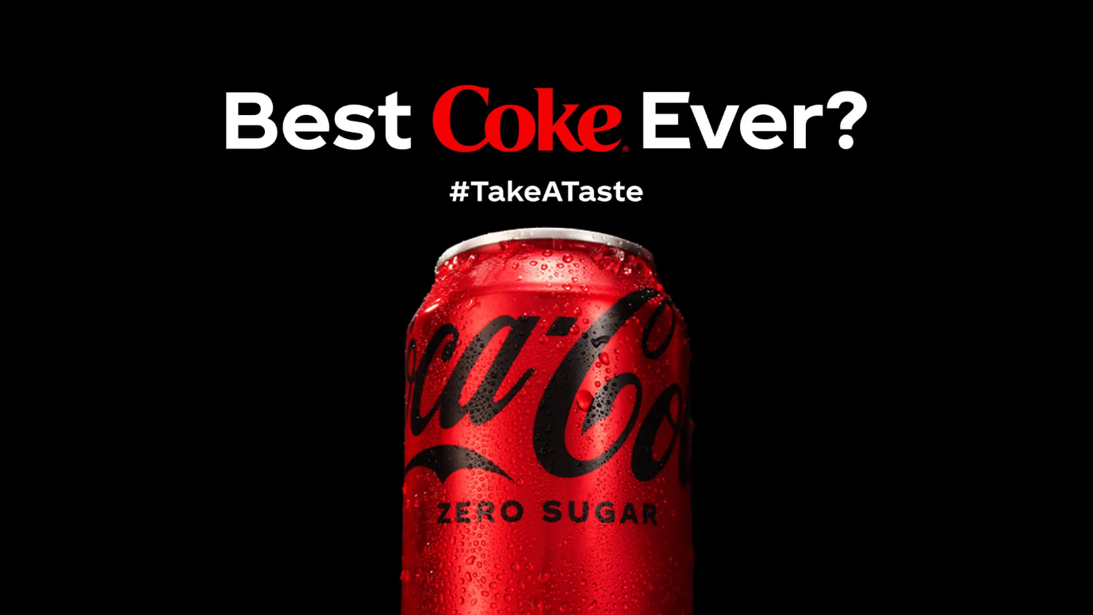
Figure: Coke Zero Sugar: Genuine Legacy Empowered By Modern Marketing Tech
Source: (Futuremarketinsights, 2025)
The company has been successful in introducing and marketing low or next to no-sugar alternatives such as Coca-Cola Zero Sugar (Futuremarketinsights, 2025). Along with this, many Stevia-sweetened options are also available and all the marketing campaigns of the company remain majorly digital centric. Furthermore, leveraging the use of social media platforms involving Instagram, TikTok and more play a pivotal role in engaging the minimalist and authentic Danish aesthetics.
Emphasising the social media engagement
All the social media channels of Coca-Cola Denmark primarily showcase a very strong engagement among the highly online population. The presence of different campaigns is known for often getting tied into local events and sustainability pledges (Coca-cola, 2025). These aspects offer major contributions becoming well resonated with the targeted audience.
Strong brand awareness
Majority of the cases denote all the challenges and success factors to lie in keeping the brand perceived as modern and responsible. Coco-Cola has successfully managed to build its brand awareness in the Danish market according to that basis rather than as a legacy sugary drink brand. The overall marketing strategy of the brand can be considered successful and it fulfills its primary goal of maintaining a strong market leadership. Strong evolution of the brand's identity while trying to stay relevant in a challenging environment also becomes very significant.
Stating the case of developing success in the soft drink industry of Romania through highlighting the case of volume growth and penetration
Romania represents a very rapidly growing market for Coca-Cola and the strategy concerns comparatively less regarding the aspects of reinvention. The majority of the focus is kept on further deepening the level of market penetration. At the same time, the goal of driving purchase frequency and leveraging the process of traditional mass-marketing also gets fulfilled.
Market share and sales
Coca-Cola is regarded as the undisputed leader in the Romanian soft drink market. It holds an astronomical market share of approximately and the company is known for investing a substantial amount in managing all its Romanian operations (King, 2025). All these positive aspects showcase a positive growth and simultaneously signal the development of a long-term commitment.
Shedding light on the strategy and adaptation
The goal of marketing remains heavily anchored in the development and continuation of all the universal and feel-good campaigns of Coca-Cola that are translated into Romanian. A very strong focus regarding the widespread availability and affordability is also put. It results in the creation of a significant presence in both modern retail and traditional small stores.
Social media engagement
All the contents of the company have turned out to be less niche than in Denmark even though customer engagement is pretty high. Due to this, the company is put forward towards featuring many major national campaigns, celebrity endorsements and other promotional activities that drive immediate sales.
Brand Awareness
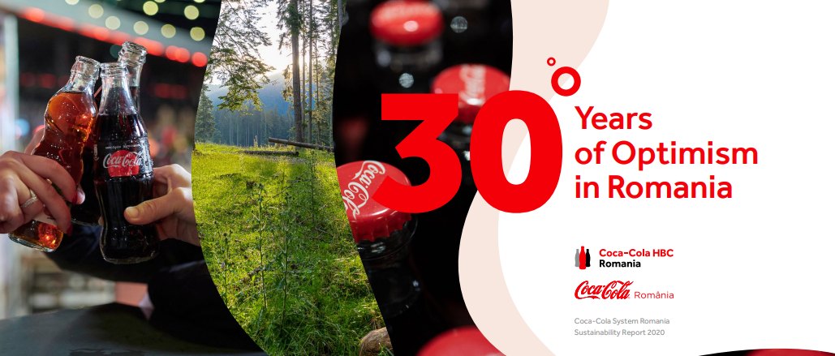
Figure: 30 Years of Optimism in Romania
Source: (Ro.coca-colahellenic, 2021)
Virtually universal and Coca-Cola is very synonymous with soft drinks in the industry of Romania (Ro.coca-colahellenic, 2021). The marketing strategy adopted by the company to tap into the Romanian market is highly successful. It has attained its goals of driving volume and solidifying its dominant market position. Keeping widespread availability and resonating mass-appeal advertising have been also successful in attaining a profitable sales outcome.

Understanding the reason behind the presence of ethical issues related to the Coca-Cola’s marketing mix of in one or both countries of Romania and Denmark
The global marketing mix of Coca-Cola has faced a very ethical scrutiny worldwide. Multiple distinct issues that are well-evident in both Denmark and Romania are identified and detonated below.
Stating all the critical ethical issues and challenges faced by Coca-Cola in Denmark
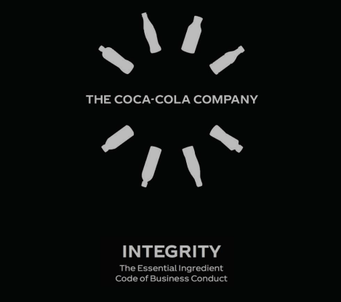
Figure: BE AWARE
Source: (Coca-colacompany, 2025)
The primary ethical concerns in Denmark that are experienced by Coca-Cola mainly revolve around the crucial aspects of health and greenwashing.
Product
Despite offering lots of low-sugar options, the core product portfolio of Coca-Cola still remains very high in the quantity of sugar. Marketing sugary beverages in a country with a high public health consciousness often provides regulatory challenges and raises ethical concerns. It is noticed especially among the younger demographic. Serious ethical based questions have been asked for contributing to lifestyle diseases. Another point of debate generally revolves around the application of artificial sweeteners in various zero-sugar products.
Promotion
A very high risk related to the aspect of perceived health-washing is often noticed by the company while promoting its products in the Danish beverage market. Putting over-emphasis on the elements of choice and light options during marketing potentially misleads the consumers regarding the overall healthiness of the brand's portfolio.
Highlighting all the critical ethical issues and challenges faced by Coca-Cola in Romania
The ethical landscape in Romania is significantly different from that of Denmark since it puts more focus on targeting vulnerable populations and environmental impacts.
Place
One of the key ethical strengths and weaknesses of the marketing of Coca-Cola involves its incredible distribution network (Barrera Borrega, 2025). Apart from ensuring adequate availability, it also means the products are present everywhere in several areas. All these have very limited access to the healthy alternatives. Inclusion of schools and low-income communities have also played a pivotal role further diversifying the portfolio of the company.
Promotion
Most of the marketing campaigns of Coca-Cola in Romania have been historically critiqued for potentially targeting the children and adolescents. Joyful and family-oriented advertisements are taken into account and this raises some ethical concerns. The brand is accused of fostering unhealthy dietary habits from a young age in a market that showcases growing obesity rates.
Price
Choosing the aspects of aggressive pricing and large has forced Coca-Cola to choose the economy-size packaging. Requirement of a comparatively higher consumption volume has also given rise to several public health implications.
Showcasing a common global ethical challenge involving the Water Stewardship
Both the countries of Denmark and Romania are greatly affected by Coca-Cola's global environmental footprint. Being one of the largest plastic polluters globally, the company has made investments for running various recycling initiatives in both nations. Many critics argue that all these are still insufficient to successfully offset the environmental damages.

Showcasing some most appropriate recommendations for uplifting the future international marketing strategies of Coca-Cola in both Denmark and Romania
Leading the market with the value of authentic sustainability along with marketing
The company moves beyond the action of messaging to concrete action in all its marketing operations. Especially, in various mature markets like Denmark and globally, the company must focus on investing heavily in circular economy models. Furthermore, making public commitments and achieving 100% recycled PET in all bottles can be also fulfilled. All these actions should be carried out within a very defined and short-term timeline.
Prioritising the use of various refillable systems
Pioneering and scaling up all the refillable packaging systems particularly in many dense urban areas like Romania can become very successful for Coca-Cola (Espinoza-Orias and Lundquist, 2025). It will enable the company to significantly reduce all its single-use plastic waste from the source. Suitable implementation of a region-specific Health-Positive Portfolio Shift should be also taken into great valuation by the company and it can also let the company to aggressively re-balance its marketing spends.

References
Aguda, L.C., (2023). Enhancing Coca Cola brand capacity building and its sustainability in Turkish market environment.
Bank, D. N., (2025). Payment habits in Denmark. [Online] Available at: https://www.nationalbanken.dk/en/what-we-do/safe-and-efficient-payments/payment-habits-in-denmark [Accessed 12 October 2025].
Barrera Borrega, D., (2025). Marketing in the Era of Artificial Intelligence.
Barrett, M., (2025). Jolly Cola is a nostalgic Danish product, but seems to be enjoying a resurgence. [Online] Available at: https://www.thelocal.dk/20250405/inside-denmark-jolly-times-for-danish-cola-and-tuborgs-unusual-promotion [Accessed 13 October 2025].
BBC, (2024). Romania media guide. [Online] Available at: https://www.bbc.com/news/world-europe-17776565 [Accessed 13 October 2025].
Bestle, S.M.S., Lassen, A.D., Biltoft-Jensen, A.P., Matthiessen, J., Gibbons, S.J., Christensen, B.J., Ersbøll, B.K. and Trolle, E., (2024) ‘Reduction in intake of discretionary foods and drinks among Danish schoolchildren: dietary results from the real-life cluster-randomised controlled trial ‘Are You Too Sweet?’.’ Public Health Nutrition, 27(1), p.e111.
Beswick-Parsons, R., Jackson, P. and Evans, D.M., (2023). Understanding national variations in reusable packaging: Commercial drivers, regulatory factors, and provisioning systems. Geoforum, 145, p.103844.
Borah, A. and Bonetti, F., (2022), May. Does Lego “Build” Reputation for Denmark? Consequences of Brand Performance on Country Brand Reputation: An Abstract. In Academy of Marketing Science Annual Conference (pp. 33-34). Cham: Springer Nature Switzerland.
Carlsberggroup, (2025). Carlsberg Danmark. [Online] Available at: https://www.carlsberggroup.com/who-we-are/about-the-carlsberg-group/global-presence/denmark/ [Accessed 12 October 2025].
Coca-Cola, (2025). OUR COMPANY. [Online] Available at: https://www.coca-colacompany.com/about-us [Accessed 12 October 2025].
Coca-cola, (2025). Our planet, people and communities are important to us. [Online] Available at: https://www.coca-cola.com/dk/da/sustainability [Accessed 12 October 2025].
Coca-colacompany, (2025). BE AWARE. [Online] Available at: https://www.coca-colacompany.com/content/dam/company/us/en/policies/pdf/corporate-governance/code-of-business-conduct/coca-cola-coc-external.pdf [Accessed 12 October 2025].
Espinoza-Orias, N. and Lundquist, L., (2025). Life cycle assessment of reusable food and beverage packaging systems: A proposal of good practice. Journal of Cleaner Production, p.145207.
Futuremarketinsights, (2025). Zero Sugar Beverages Market. [Online] Available at: https://www.futuremarketinsights.com/reports/zero-sugar-beverages-market [Accessed 12 October 2025].
Greve, M., (2023). Copenhagen, Denmark. MAERSK’S ROLE IN ECONOMIC DEVELOPMENT: A STUDY OF SHIPPING AND LOGISTICS FOREIGN DIRECT INVESTMENT IN GLOBAL TRADE, p.267.
Huse, O., Reeve, E., Bell, C., Sacks, G., Baker, P., Wood, B. and Backholer, K., (2022). Strategies used by the soft drink industry to grow and sustain sales: a case-study of The Coca-Cola Company in East Asia. BMJ global health, 7(12), p.e010386.
Investindk, (2025). Best for business in the EU - Denmark tops the charts on global competitiveness. [Online] Available at: https://investindk.com/insights/best-for-business-in-the-eu-denmark-tops-the-charts-on-global-competitiveness [Accessed 12 October 2025].
Janberg, W., (2025). Coca-Cola’s 2025 Forecast: A Fizzy Future or Flat Outlook?. [Online] Available at: https://www.reportlinker.com/article/10294 [Accessed 8 October 2025].
Kakas, A., (2024). How to Use Competitive Pricing to Drive Profitable Growth. [Online] Available at: https://arminkakas.medium.com/how-to-use-competitive-pricing-to-drive-profitable-growth-67e393eadc16 [Accessed 13 October 2025].
Kihn, (2024). What's Going On? The State Of Global Marketing. [Online] Available at: https://www.forbes.com/councils/forbescommunicationscouncil/2024/06/11/whats-going-on-the-state-of-global-marketing/ [Accessed 12 October 2025].
King, C., (2025). Coca-Cola HBC & Romania’s Largest Circular Economy Project. [Online] Available at: https://sustainabilitymag.com/articles/coca-cola-hbc-romanias-largest-circular-economy-project [Accessed 13 October 2025].
King, C., (2025). Coca-Cola HBC & Romania’s Largest Circular Economy Project. [Online] Available at: https://sustainabilitymag.com/articles/coca-cola-hbc-romanias-largest-circular-economy-project [Accessed 12 October 2025].
Lubis, M., (2024). The role of communication and employee engagement in promoting inclusion in the workplace: A case study in the creative industry. Feedback International Journal of Communication, 1(1), pp.1-15.
Medium, (2020). The Coca-Cola Company’s Competitive Strategies. [Online] Available at: https://medium.com/@shwethagowri/coca-cola-competitive-strategies-6af18bb70d6f [Accessed 13 October 2025].
Oakenfull, G., (2023). The Bitter Aftertaste Of Coca-Cola’s ‘Neutral’ Marketing Strategy. [Online] Available at: https://www.forbes.com/sites/gillianoakenfull/2023/09/12/the-bitter-aftertaste-of-coca-colas-neutral-marketing-strategy/ [Accessed 12 October 2025].
Pec, T., (2022). Why Businesses And Brands Need To Be Taking Advantage Of Social Media. [Online] Available at: https://www.forbes.com/councils/forbesagencycouncil/2022/09/06/why-businesses-and-brands-need-to-be-taking-advantage-of-social-media/ [Accessed 13 October 2025].
Realinstitutoelcano, (2025). Fault lines in the East: Romania’s political transformation and Europe’s future. [Online] Available at: https://www.realinstitutoelcano.org/en/analyses/fault-lines-in-the-east-romania-political-transformation-and-europe-future/ [Accessed 12 October 2025].
Ridder, (2025). The Coca-Cola Company's revenue from 2007 to 2024. [Online] Available at: https://www.statista.com/statistics/233371/net-operating-revenues-of-the-coca-cola-company-worldwide/?srsltid=AfmBOopgskm262m2eKJ-9o13kHiTTT90vrG9wT3SUjXStiZKqInJdXOZ [Accessed 12 October 2025].
Ro.coca-colahellenic, (2021). raport 2020 Coca-Cola. [Online] Available at: https://ro.coca-colahellenic.com/content/dam/cch/ro/documents/a-more-sustainable-future/our-progress/raport%202020%20Coca-Cola%20EN.pdf.downloadasset.pdf [Accessed 12 October 2025].
Simoes-Coelho, M., Figueira, A.R. and Russo, E., (2023). Balancing global corporate sustainability engagement in asymmetric markets: The Coca-Cola Co. case. Sustainable Production and Consumption, 40, pp.89-100.
The Coca-Cola Company, (2025). SUSTAINABILITY. [Online] Available at: https://www.coca-colacompany.com/about-us/sustainability [Accessed 13 October 2025].
the guardian, (2025). Coca-Cola recalls drinks in Europe over ‘higher levels’ of chemical chlorate. [Online] Available at: https://www.theguardian.com/business/2025/jan/27/coca-cola-recalls-drinks-in-europe-over-higher-levels-of-chemical-chlorate [Accessed 13 October 2025].
Transparency International, (2025). Corruption Perceptions Index. [Online] Available at: https://www.transparency.org/en/cpi/2023 [Accessed 12 October 2025].
Trofin, A.E., Ungureanu, E., Trincă, L.C., Eperjessy, D.B. and Sandu, T., (2022). Assessment of quality parameters for marketed soft drinks.
World bank, (2025). GDP per capita (current US$) - Denmark. [Online] Available at: https://data.worldbank.org/indicator/NY.GDP.PCAP.CD?locations=DK [Accessed 12 October 2025].

Appendix

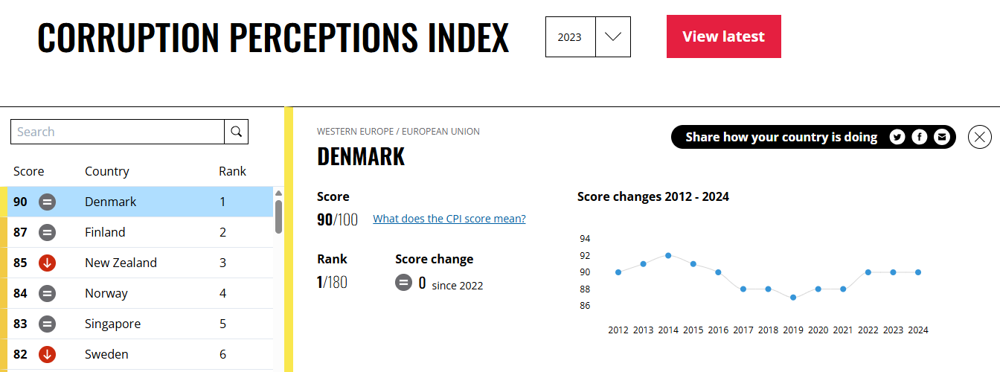
Figure: Rank of Denmark as per Corruption Perception Index

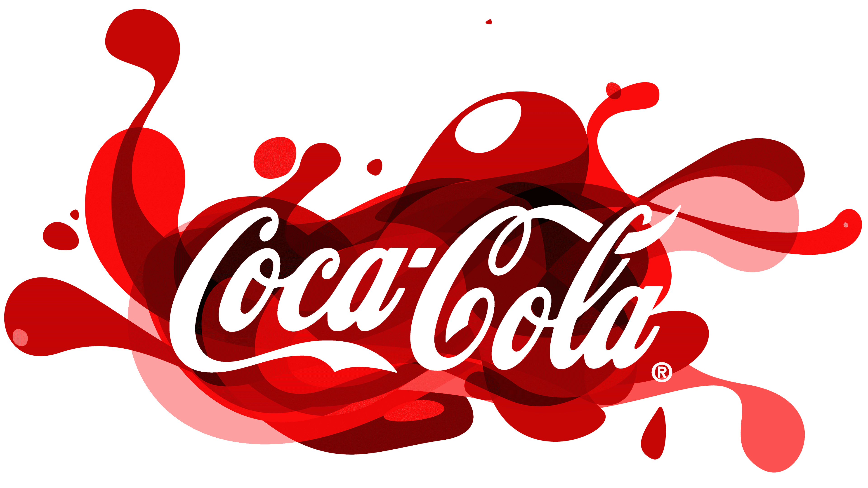
Figure: The logo of Coca Cola
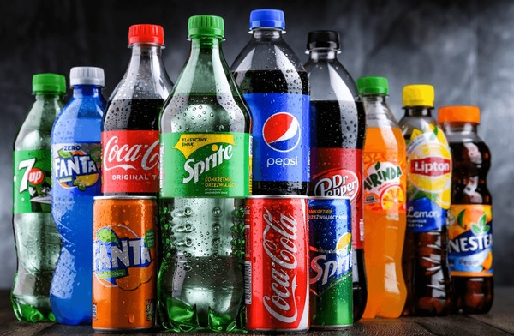
Figure: The range of products Coca-Cola

Figure: Coke Zero Sugar: Genuine Legacy Empowered By Modern Marketing Tech

Figure: 30 Years of Optimism in Romania

Figure: BE AWARE

