

Importance of Succession Planning within a
Medical Device Manufacturer

Rebecca Louise Howells

Student Number: 1705175

Master of Arts: Strategic People Management

University of Wales Trinity Saint David School of Business

Submission Date: May 2024

Table of Contents
List of Figures 3
List of Tables 3
Declarations 4
Acknowledgements 5
Chapter 1: Introduction 6
1.1 Background to the study 6
1.2 Company Introduction 7
1.3 Relevance of the Research 10
1.4 Research Aim 10
1.5 Research Objectives 11
1.6 Research Questions 11
1.7 Dissertation Structure 11
Chapter 2: Literature Review 13
2.1 Foundation of the Study 13
2.2 Succession Planning 13
2.2.1 Identifying Business Critical Positions within the Organisation 15
2.2.2 Understanding and Defining the competencies each role will require in the future 16
2.2.3 Assessing the potential employees for those roles 16
2.2.4 Providing the employees identified as potential successors with a clear development plan 19
2.2.5 Contemporary Approaches to Succession Planning 20
2.3 Talent Management 21
2.3.1 Training and Development 23
2.3.2 Benefits of combining learning with succession planning 24
2.4 Chapter Summary of Literature Review 24
2.4.1 Literature Review Findings 25
Chapter 3: Research Methodology 27
3.1 Introduction 27
3.2 Research Design 28
3.2.1 Data Collection 29
3.3 Research Philosophy 30
3.4 Research Approach 31
3.5 Research Strategies 33
3.5.1 Action Research 33
3.5.2 Grounded Theory 34
3.6 Research Methodology Comparisons 34
3.7 Chosen Research Methodology 35
3.8 Participation Selection 37
3.9 Ethical Considerations and Safeguarding Collected Data 38
3.10 Reliability and Validity of Research 39
3.11 Chapter Summary of Research Methodology 40
Chapter 4: Results and Analysis 42
4.1 Interview Findings 42
4.1.1 Theme One: Existence of Succession Planning Practices within The Magstim Company 42
4.1.2 Theme Two: Methods and Tools of Leadership Development conducted with direct reports 43
4.1.3 Theme Three: Identifying the importance of completing performance reviews and its links with succession planning 45
Chapter 5: Discussion 47
Chapter 6: Conclusion and Recommendations 54
6.1 Conclusion 54
6.2 Recommendations 54
Chapter 7: References 57
Appendix 1: Interview Schedule 63
Appendix 2: Performance Development Reviews 64

List of Figures
Figure 1: The Welcony Group 8
Figure 2: The Welcony Group Values 9
Figure 3: 9-Box Matrix (McKinsey, 2008) 18
Figure 4: Odiorne's typology (Odiorne, 1984) 18
Figure 5: The elements of talent management (Armstrong, 2012) 22
Figure 6: Research design (Saunders, et al., 2015) 28
Figure 7 Induction and Deduction (Ragab & Arisha, 2018) 32
Figure 8: Inductive and Deductive Approaches (Anderson, 2009) 32

List of Tables
Table 1: Qualitative and quantitative approaches to research (Neuman, 2008); (Jankowicz, 2005) 29
Table 2: Consideration of alternative research methods (Anderson, 2013) 35
Table 3: Participant demographics 38

Declarations

This declaration is the work of Rebecca Louise Howells. All other contributors are acknowledged in the text and listed in the referencing section.
DECLARATION
This work has not previously been accepted in substance for any degree and is not being concurrently submitted in candidature for any degree.
Signed....... ................... (candidate)
Date.............1st May 2024....................................................................

STATEMENT 1
This work is the result of my own investigations, except where otherwise stated. Where correction services have been used the extent and nature of the correction is clearly marked in a footnote(s).
Signed....... ..........(candidate)
Date................1st May 2024.....................................

STATEMENT 2
I hereby give my consent for my work, if accepted, to be available for photocopying and for inter-library loan, and for the title and summary to be made available to outside organisations.
Signed...... ..........................................................(candidate)
Date.........1st May 2024.................

Acknowledgements

I want to express my deepest gratitude and thanks to my advisor, Dr Emma Roberts. Her guidance and support have been incremental to this research project.

Lastly, I dedicate this dissertation to my husband Martin. For his support, patience, and belief in me.

Chapter 1: Introduction

1.1 Background to the study
The Magstim Company forms one part of The Welcony Group, as shown in Figure 1, which is comprised of four neurotechnology brands, Magstim, Neurosign, Technomed and EGI. The Welcony Group has over 300 employees located in the UK, USA, The Netherlands, and Indonesia.

The Magstim Company itself comprises of an innovative team of over 100 engineers, manufacturing operatives and supporting functions at its headquarters in Whitland, West Wales and its US office in Minnesota, USA. The Management Team within The Magstim Company comprises of Corporate Directors, who have responsibility across the group, and Departmental Managers and Supervisors who are responsible for the day-to-day operations. Each of the office locations within The Welcony Group has its own HR representative who ensures compliance with local employment regulations. Further details are referred to in section 1.2. I have worked for The Magstim Company for over ten years with my HR experience and knowledge gained during the last seven years as HR Manager. My academic background includes CIPD qualifications and a Postgraduate Diploma in Human Resource Management. Due to the size of The Magstim Company my area of responsibility covers all aspects of HR activities.

According to a study conducted in 2022 conducted by MedTech Europe, there are more than 34,000 medical technology companies in Europe. The majority of which are in Germany and closely followed by the UK. This industry directly employs more than 800,000 people (MedTech Europe, 2022); (MedTech Europe, 2021).

Consequently, in such a competitive market it is a challenge for organisations such as The Magstim Company to retain current employees and to find replacements in such a competitive market. The Magstim Company is a medical device manufacturing company which designs and manufactures an effective, non-invasive therapy used in the treatment of depression.

The competitive market has resulted in succession planning, primarily focusing on identifying and developing talent to fill future leadership and business-critical positions (CIPD, 2022a). The CIPD goes on to explain that succession planning has gained popularity with organisations during skills shortages and is now being completed within large and smaller organisations (CIPD, 2022a).

Succession planning is not a new management concept and encompasses several internal activities which aim that at any point organisations have a sufficient number of employees with the ability, knowledge, personal attributes, and experience required to step into senior roles when they become available (Taylor, 2010).

Succession planning when conducted correctly will ensure a smooth transition and avoid the need for temporary promotions, thus avoiding uncertainty and less disruption. Within human resource management, new terms for succession planning are becoming more popular such as talent management and talent planning (Taylor, 2010).

1.2 Company Introduction
The Magstim Company is a leading medical device manufacturing company which designs and manufactures Transcranial Magnetic Stimulators (TMS) an effective, non-invasive therapy used in the treatment of depression. The vision and purpose of The Magstim Company is to become the market leader within the medical device industry whilst driving innovation and creating a community of employees who are engaged, motivated and eager to make an impact (The Magstim Company, 2020).

Located with the Pembrokeshire and Carmarthenshire border in West Wales, The Magstim Company forms one part of The Welcony Group, as shown in Figure 1, which is comprised of four neurotechnology brands, Magstim, Neurosign, Technomed and EGI, which have a shared vision to transform lives by delivering minimally invasive neurotechnology to researchers and healthcare providers (The Welcony Group, 2022).

Globally The Welcony Group employs over 300 employees across its sites in the UK, USA, The Netherlands, and Indonesia, with a revenue of $32 million with double-digit growth expected year on year.

Figure 1: The Welcony Group

The Welcony Group is a venture capitalist owned by US-based Telegraph Hills Partners. They are dedicated to helping and supporting life science, medical device, and healthcare companies to achieve their growth objectives (Telegraph Hill Partners, 2022).

The Magstim Company has an innovative team of over 100 engineers, manufacturing operatives and supporting functions at its headquarters in Whitland, West Wales and its US office in Minnesota, USA.

The Group’s mission is to “Bring to market the best non and minimally invasive neurotechnology for researchers, clinicians and patients” (The Magstim Company, 2020).

Building on The Welcony Group values, as shown below in Figure 2, the organisation has a clear focus on employee collaboration and leadership.

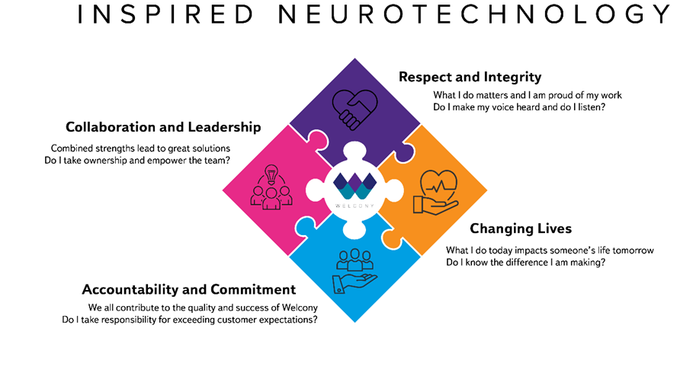
Figure 2: The Welcony Group Values
The Magstim Company is a Unitarist organisation with its managers and employees working together for a common interest and values (Bennet, et al., 2020); (Dunlop, 1958).
Following several restructures over the last five years The Magstim Company has moved from a hierarchical structure of an organisation to a matrix model one. A matrix organisational structure allows for several departments to work both independently and closely together which allows for communication and the decision-making process to be more effective. However, there are occasions when decision-making is arduous due to the decision-making authority being diffused (Kew & Stredwick, 2016).

1.3 Relevance of the Research
Within The Magstim Company having a knowledgeable and experienced workforce is not sufficient in a competitive labour market and beneficial succession planning practices should accompany these qualities and skills. Succession planning is best understood as a series of several individual stages which will formalise the overall process. These stages can be outlined as identifying those positions critical to the organisation; defining the capabilities required for each critical position; identifying and assessing potential candidates for these roles; providing those individuals with a personalised development plan and finally reviewing the progress of those identified successors against the implemented development plan (Bechet, 2008); (Taylor, 2010).
It is therefore imperative to establish whether there is importance portrayed on succession planning within The Magstim Company. In 2022 a nine-box grid, as shown in Figure 3, was introduced to aid and support the identification of each employee's future potential. This grid allowed managers to rate each employee within their team as having either high, moderate, or limited future management potential. Although this task was completed there was clear animosity towards the task and whether there was any benefit of the process.

1.4 Research Aim
The rationale for this research project is following negativity and animosity shown towards the introduction of the nine-box grid this research study aims to establish whether the Management team within The Magstim Company values the importance of managing succession planning.

1.5 Research Objectives
- To understand the factors that affect Magstim’s Succession Planning
- Discuss any improvements and offer recommendations on how to implement a succession plan within Magstim

1.6 Research Questions
- What level of awareness does the Management Team within The Magstim Company have regarding succession planning?
- What levels of commitment and buy-in do the Management team have within The Magstim Company surrounding Succession Planning?

1.7 Dissertation Structure

The first chapter “Introduction” provides a background to the study, an introduction to the organisation, the relevance of the research, and the research aims and objectives. The second chapter “Literature Review” will present relevant literature and theoretical frameworks.

The third chapter “Research Methodology” will guide the overall research project. This chapter will introduce the research design, research philosophy, research approach, research strategies, methodology comparisons, the chosen methodology, participation selection, key ethical considerations and the reliability and validity of the data.

The fourth chapter “Results and Analysis” will set out the key findings of the data gathered from the relevant stakeholders by setting out the identified themes regarding the levels of awareness the Management Team within The Magstim Company have on succession planning, and their levels of commitment and buy-in.

The fifth chapter “Discussion” will provide the reader with a summary of the findings following the completion of both the literature review and the findings chapter.

The final chapter “Conclusion and Recommendations” will conclude the overall discussion and will propose recommendations for practical implementation.

Chapter 2: Literature Review
The Literature Review chapter will review relevant literature and theoretical frameworks of succession planning within organisations.

2.1 Foundation of the Study
This study will focus on both leadership and motivational theories as the theoretical foundation to enhance the literature review. These theories will be focussed on as succession planning is linked to developing leaders at all levels within organisations and motivating those while managing retention. Leadership has been defined as a means of inspiring people to do their best to achieve the desired result. It also involves developing and communicating a clear vision for the future, motivating the workforce and ensuring their engagement (Armstrong, 2012); (Dixon, 1994, p. 214).

Management in comparison can be defined as establishing what to do and then by any means getting it done through effective use of available resources. A traditional model of what managers do is a logical and systematic process of clear planning, organising, motivating, and controlling (Armstrong, 2012).

2.2 Succession Planning
Succession planning, which is often referred to as talent management, encourages organisations to focus on identifying and growing talent to fill both leadership and business-critical roles in the future. It can cover a wide range of activities which are designed to attract, recruit develop and retain talented employees (CIPD, 2022a).

Succession planning is a tool which can assist in identifying an organisation's future demand and the supply of people. Succession planning when used correctly has the primary objective of thoughtful planning and efficient transition of employees into pivotal roles (Taylor, 2019). Succession planning differs considerably from traditional HR planning tools whereby the organisation must estimate the percentage of those employees who will remain for several years to one which has to estimate the probability of employees remaining with the company for a certain amount of time (Jackson & Schuler, 1990).

A prominent researcher in succession planning defined succession planning as an organisational, systematic and deliberate effort to ensure leadership continuity, retain and develop knowledge and encourage people’s development (Rothwell, 2016); (Ghazali, et al., 2022).

The process of succession planning incorporates several groups of activities which aim to ensure that organisations have adequate employees with the ability, knowledge, personal attributes, and relevant experience to step into senior roles when they become vacant.

In a similar nature to human resource planning, it requires organisations to focus clearly on the future and developing the next generation of future leaders. Managerial buy-in is required during this process as it requires them to look at the long-term investment and the development of those employees, that they have identified as best placed to take the organisation forward (Taylor, 2019). Investment in talent management has been identified as the differential between organisations with talent management initiatives and their industry peers who do not have similar initiatives. These organisations were also less likely to face difficulties in retaining and attracting key skilled employees (Ringo, et al., 2008); (Narayanan, et al., 2019).

The longer-term aspect of succession planning activities has considerable implications for an organisation’s culture, its ability to recruit and retain talent, and most importantly to maintain the performance levels of the employees lower down in the organisation's management hierarchy (Bechet, 2008).

Succession planning can be best appreciated through a series of distinct stages and activities:
- Identifying business-critical positions within the organisation
- Understand and define the competencies each role will require in the future
- Assessing the potential employees for those roles
- Provide the employees identified as potential successors with a clear development plan that will prepare them for these roles
- Conduct regular reviews to understand the progress of the identified successors. This can be done through the organisation’s annual performance development reviews and regular one-to-one meetings (Bechet, 2008, pp. 247-248); (Taylor, 2022).

2.2.1 Identifying Business Critical Positions within the Organisation
Literature states that most research conducted on succession planning heavily focuses on the most senior roles or those which are critical within organisations. Whereas, in smaller organisations, particularly those which are owner-managers are restricted to only focusing on family members. However, public sector organisations in comparison tend not to undertake formal succession planning and prefer to advertise all roles and allow for open competition between both internal and external candidates allowing for full transparency (Taylor, 2022); (Nyberg, et al., 2017).

All organisations must have processes in place for succession planning for all roles or posts within the organisation. However, for many, it can be a costly process and in turn, could potentially become an overly elaborate process (Taylor, 2022).

2.2.2 Understanding and Defining the competencies each role will require in the future
There are several publications which have stressed the importance of identifying and considering the attributes which will be required to ensure success in a future senior role, thus avoiding like-for-like replacements. Priorities and requirements of an organisation will change over time along with changes and developments in the business environment (Taylor, 2022).

Succession planners within organisations must consider the attributes and competencies they are looking to identify within their workforce and that they are the characteristics they require for the future. The management of the organisation must consider if they can select or identify a successor who is right and has the relevant competencies. Only then are they likely to succeed (Bowick, 1996, p. 180). Several writers have also advocated for a contingency-based approach to succession planning, which involves the planning for possible responses to a variety of potential environmental developments (Taylor, 2019, p. 119).

As the business environment remains uncertain many argue that organisations need to plan for several possible scenarios and ensure that they have a workforce with distinct talents which are suitable or that can be developed (Bechet, 2008, Cascio, et al., 2017, Taylor, 2022). Organisations must consider their future needs and requirements concisely. It is also important that when an organisation has a succession planning or talent management system in place, which identifies talented employees, the process measures the correct aspects and does not extinguish the appropriate talent from the organisation (Blass, 2009, p. 290).

2.2.3 Assessing the potential employees for those roles

Many organisations which deem succession planning as an integral part of their wider talent management processes, choose not to identify particular groups of employees, instead, they take a much more democratic viewpoint and label all their employees as “talented” and develop them all at the same time (Taylor, 2022). Although it may be beneficial to label all employees as equal it can be said that this is not an effective strategy for developing future leaders, nor will it be beneficial to the organisation to drive individual performance in such a competitive business environment (McLaughlin, et al., 2020, p. 186); (Taylor, 2022). It has been argued that treating all employees the same may be an effective strategy in reducing employee relation issues, however, it may not be an effective strategy for talent development, nor can it be a method of driving organisational and individual performance when dealing with a challenging business environment (McLaughlin, et al., 2020, p. 186).

When assessing an employee's performance there are two dimensions which need to be considered: the employee's current contribution to the organisation and their future potential.
One of the most used models for assessing an employee's performance is the 9-box matrix as shown in Figure 3 which was originally developed by David Clutterbuck. Whereas his model used terminology such as solid performer, core contributor and rising star, contemporary models represent such as that devised by McKinsey maps employees against current performance and future potential (Gupta, 2022); (Clutterbuck, 2012).

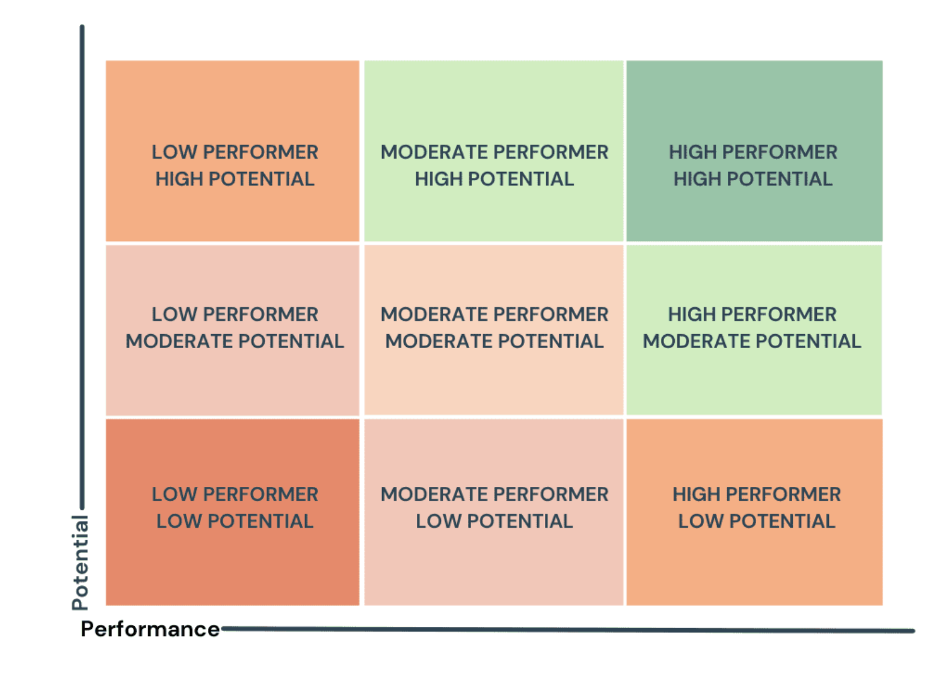
Figure 3: 9-Box Matrix (McKinsey, 2008)
It must be recognised that those employees identified with high potential and who are included in the succession plan have relatively frequent reviews through appraisals and using this model. This is to ensure an employee’s performance or potential does not change especially those who move job roles, and for those who have been promoted upwards in the organisation's hierarchy. In contrast, those employees who may not have initially been identified as high performers with high potential can improve their status if they are given new opportunities or a new reporting structure (Taylor, 2022); (Taylor, 2019).

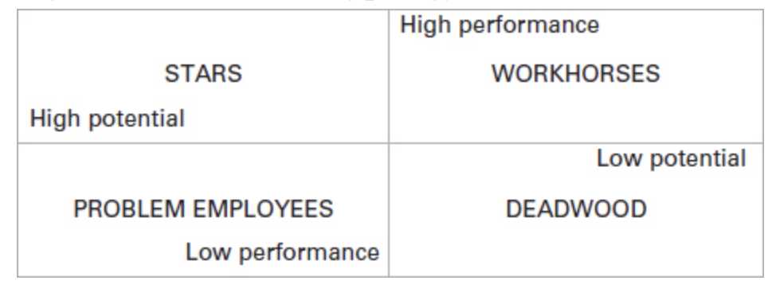
Figure 4: Odiorne's typology (Odiorne, 1984)

Odiorne in comparison developed a more helpful four-box model, as shown in Figure 4, which states that those who have been identified within the “stars” category should be included in an organisation’s success plan (Taylor, 2022).

2.2.4 Providing the employees identified as potential successors with a clear development plan
It is important to note that the developmental needs of those employees identified as potential successors will vary. The current annual performance development review process within The Magstim Company is designed to assist both Managers and Supervisors in supporting employees with their professional development by enhancing employees’ knowledge, skills, and experience (The Magstim Company Limited, 2021).

Performance development is best defined as a process which contributes to the effective management of individuals and teams to achieve high levels of organisational performance. Performance management is not a single activity but can be described as several practices that should be approached holistically. When effective, performance management will focus on two-way discussions with regular feedback between the manager and employee. This process should record clear objectives and improvement plans for those who are underperforming within the organisation (Rees & French, 2016); (Armstrong & Baron, 2005); (CIPD, 2022b).

Organisations such as The Magstim Company need to consider that the learning needs of an employee who is relatively new in their career will differ from an employee who has several years of experience. When devising a development plan to aid a company's succession plan managers and supervisors should ensure that it expands on the employees' interest in the company whilst also seeking to improve on their weaker areas. It is also encouraged that employees identified as future leaders are exposed to several functions within the organisation thus broadening their experience in unfamiliar functions of the organisation. These activities combined with structured coaching and mentoring sessions will aid and increase an employee's knowledge base (Taylor, 2022); (Taylor, 2019).

Once an employee has been identified and a clear development plan has been put into place their progress must be reviewed regularly. The Magstim Company's annual performance development reviews, as shown in Appendix 2, encourage Managers not only to complete the form on an annual basis but are encouraged to have regular review meetings so that progress on objectives can be discussed and reviewed. If it is clear that the employee would benefit from additional training this can be recorded and implemented.

2.2.5 Contemporary Approaches to Succession Planning
So far this research project has focussed on the more traditional approaches to succession planning there is still a need within organisations to develop their managers of the future. It has also been identified that there is a link between the presence of a formal succession plan with superior business performance (Kispal-Vitai & Wood, 2009, p. 183).

Having a formal succession plan can improve an organisation's retention, talent management, organisation development and an enhanced employer brand. Whereas traditional approaches to succession planning within organisations may have been shrouded in secrecy contemporary approaches have become more ethically minded and are becoming in tune with a more fluid labour market and have closer links to a wider talent management programme (Clutterbuck, 2012, Cascio, et al., 2017, Hirsh, 2000).

2.3 Talent Management
Talent Management is the process which an organisation uses to ensure that it has the talented employees it requires to achieve its strategic business goals. Talent management can also be described as several interlinked processes as shown in Figure 5. For organisations to conduct this activity they must incorporate processes which attract, develop, and engage valuable employees and is a process and opportunity to help management provide for individuals in the organisation as individuals with talent (Armstrong, 2012, CIPD, 2023, Blass, 2007, p. 1).

A key aspect of talent management is the consideration towards expectancy theory which focuses on individuals’ motivation and how motivation impacts an employee’s performance (Vroom, 1964). The expectancy theory although focuses primarily on the motivation of an individual, leadership behaviour and the practices of the organisation also have a greater impact on individual motivation and career development (Connolly, 1976); (Armstrong, 2012).

In an era where automation and AI practices are increasing, and some roles are replaced the need to upskill or reskill employees should become the primary focus of organisations. An organisation-wide talent management strategy will not only provide a clear focus on people investment but can contribute to several strategic objectives such as developing a high-performance workplace, encouraging continuous learning, and strengthening the employee value proposition (CIPD, 2023).
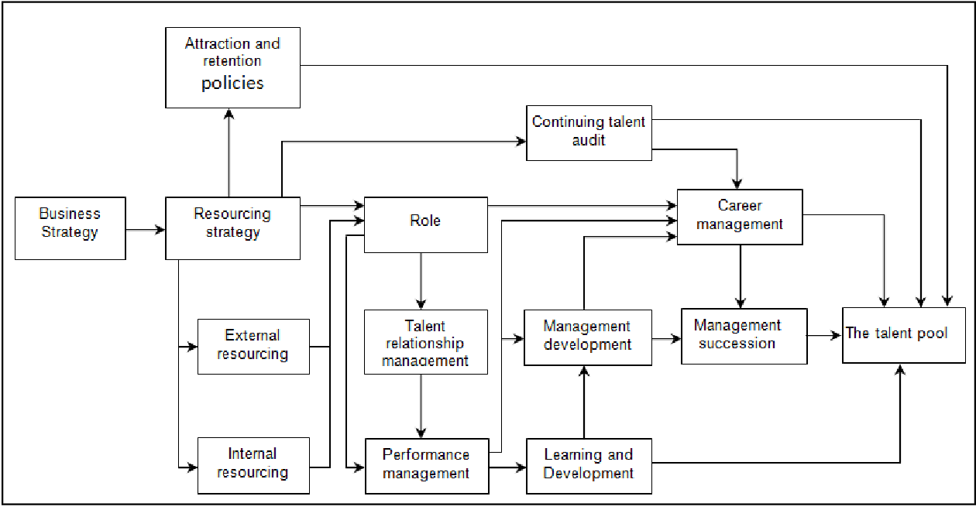
Figure 5: The elements of talent management (Armstrong, 2012)

In terms of developing and implementing a talent management strategy, it is imperative that it aligns with the organisation’s overall strategy and determines the future workforce needs of the organisation. Workforce planning looks at and identifies the supply and demand of the workforce for the future as well as labour market trends. The purpose of a workforce plan is to assist in the prioritisation of talent management activities within an organisation and can include the following activities:
- recruitment
- development of talent pools
- learning and development
- succession planning
- leadership development
- career management (CIPD, 2023)

A key ingredient of workforce planning is to identify the most business-critical roles which tend to be leadership and specialist roles. This is where succession planning, when used correctly, aids organisations in preparing potential leaders to fill business-critical positions from within (CIPD, 2023); (Armstrong, 2012). Having a robust performance management process in place is one of the first methods for identifying future talent early. Performance management focuses on a two-way discussion with regular, open, and supportive feedback on progress towards objectives. When carried out effectively performance management is a means of increasing engagement and motivation (CIPD, 2022b); (Armstrong, 2012).

2.3.1 Training and Development
Training and development are key for an organisation’s short- and long-term health. Training and development primarily can focus on equipping and improving employees’ skill sets and ultimately will have far-reaching benefits such as improving employee satisfaction and enhancing employee retention and employee engagement (Deshmukh, 2022).

Having a clear, systematic, and consistent identification of learning and development needs which relate to performance gaps, such as leadership development, is key to ensuring effective learning and progression throughout the organisation. Training and development sit hand in hand with an organisation’s workforce and succession planning programme. Such analysis allows for clear identification of training requirements for individuals, teams and on an organisational level (CIPD, 2023c).

A key tool for analysing training requirements is a learning needs analysis (LNA). It is intrinsic to succession planning as it focuses on the current check on the skills, talent and capabilities of the organisation and is carried out with multiple stakeholders. An LNA fundamentally gathers and analyses data regarding an employee's capability, the organisation's overall demands for skills, and the implications of both new and changing roles.

It has always been assumed that it was an employer’s responsibility for an employee’s training and development. However, training and development when organised by the employer is beneficial to the organisation and employees in comparison expect their employers to provide training opportunities as part of the psychological contract. Many organisations follow this model and see the key role of learning, training and development as to provide the knowledge, skills and behaviours required for sustainable success (Rees & French, 2016, p. 206); (CIPD, 2015, p. 7).

2.3.2 Benefits of combining learning with succession planning
When integrated within a training and development program, succession planning can significantly impact the bottom line of the organisation. When combining the two processes it allows the organisation to pre-plan for key role successors.
It also has multiple benefits such as:
- Saving money and resources as internal promotions cost significantly less than the use of external recruiters
- The process develops a sense of stability
- Retains top talent as employees who trust their organisation’s ability to invest in its employees and promote personal career development (Deshmukh, 2022).

2.4 Chapter Summary of Literature Review

The Literature Review chapter reviewed relevant literature and theoretical frameworks of succession planning within organisations.

This study focused on both leadership and motivational theories as the theoretical foundation to enhance the literature review. These theories will focus on succession planning and its link to developing leaders at all levels within organisations and motivating those while managing retention.

The research questions for the research project are:

- What level of awareness does the Management Team within The Magstim Company have regarding succession planning?
- What levels of commitment and buy-in do the Management team have within The Magstim Company surrounding Succession Planning?

2.4.1 Literature Review Findings

In summary, the key findings from the literature review as defined by (CIPD, 2022a) is that succession planning encourages organisations to focus on identifying and growing talent to fill both leadership and business-critical roles in the future.

Succession planning differs from regular HR planning whereby the focus is on estimating which employees will remain with the organisation for several years, to one which needs to estimate the probability that those employees will remain with the organisation for a certain amount of time (Jackson & Schuler, 1990). Succession planning has similarities to HR planning as it requires management within an organisation to focus on the future and develop those employees who have been identified as future leaders (Taylor, 2019).

The long-term aspect of succession planning has considerable implications for an organisation’s culture, its ability to recruit and retain talent, and most importantly the performance levels of those employees lower down within an organisation’s management hierarchy, who have been identified as those future leaders (Bechet, 2008).

It is imperative that when organisations undertake a Succession planning programme, they consider each distinct stage:
- Identification of those critical roles within the organisation
- Understand the competencies each role requires
- Assess potential internal employees for those roles identified as business-critical
- Provide those identified employees with clear development plans so that they are prepared for those roles
- Continuously review the progress of those employees (Bechet, 2008); (Taylor, 2022).

To have a successful Succession Planning Programme organisations must ensure that they have talented employees to achieve their strategic business objectives. Organisations can do this through a process identified as talent management. Organisations can successfully do this through the incorporation of several processes which will attract, develop, and engage valuable employees (Armstrong, 2012, CIPD, 2023, Blass, 2007, p. 1).

Ensuring an organisation has a clear organisation-wide talent management strategy doesn’t just provide a clear focus on investing in people but will also contribute to several strategic objectives and can develop a high-performing workplace, encourage a culture of continuous learning, and strengthen employee value (CIPD, 2023)

Chapter 3: Research Methodology
When conducting a research project, it is important to note that it involves systematic enquiry into an issue to increase knowledge and underpin effective decision-making (Anderson, 2013, p. 6).

This research project aims to analyse and understand the importance of Succession Planning within a medical device manufacturer. The proposed results can enhance the Succession Planning practices within the organisation by broadening their knowledge of effective performance management tools such as performance development reviews and talent reviews using tools such as the nine-box grid.

The methodological decisions made in this chapter will guide the overall research project. This chapter will provide a brief introduction to revise the research aims and objectives, followed by the research design, research philosophy, research approach, the chosen methodology and key ethical considerations.

3.1 Introduction

A study in 2022 which was conducted by MedTech Europe stated that there were more than 34,000 medical technology companies in Europe. The majority of which are in Germany and closely followed by the UK. This industry directly employs more than 800,000 people (MedTech Europe, 2022); (MedTech Europe, 2021).

Consequently, in such a competitive market it is a challenge for organisations such as The Magstim Company to retain current employees and to find replacements in such a competitive market. The competitive market has made succession planning, which focuses on identifying and developing talent to fill future leadership and business-critical positions in the future.

The CIPD states that succession planning has gained popularity during skills shortages and is now being carried out in large and smaller organisations (CIPD, 2022a).

3.2 Research Design
It has been suggested that when developing a research project its design relates not only to the writing but the composure of the research project itself (Yin, 2013). The topic chosen for this research project is to understand and to establish whether the management team within The Magstim Company values the importance of managing succession planning.

Research design by definition is the proposed manner in which the research question will be answered and when based on the Saunders model of research design it can have several identifiable layers which have been described and noted as a research onion as shown in Figure 6. The research onion has several inner and outer layers which provide an in-depth understanding of how the research should be conducted by covering aspects such as philosophy, approach, and data collection. The research design will contain clear objectives, specify the sources of data collection, and data analysis and discuss ethical considerations and constraints (Saunders, et al., 2015).
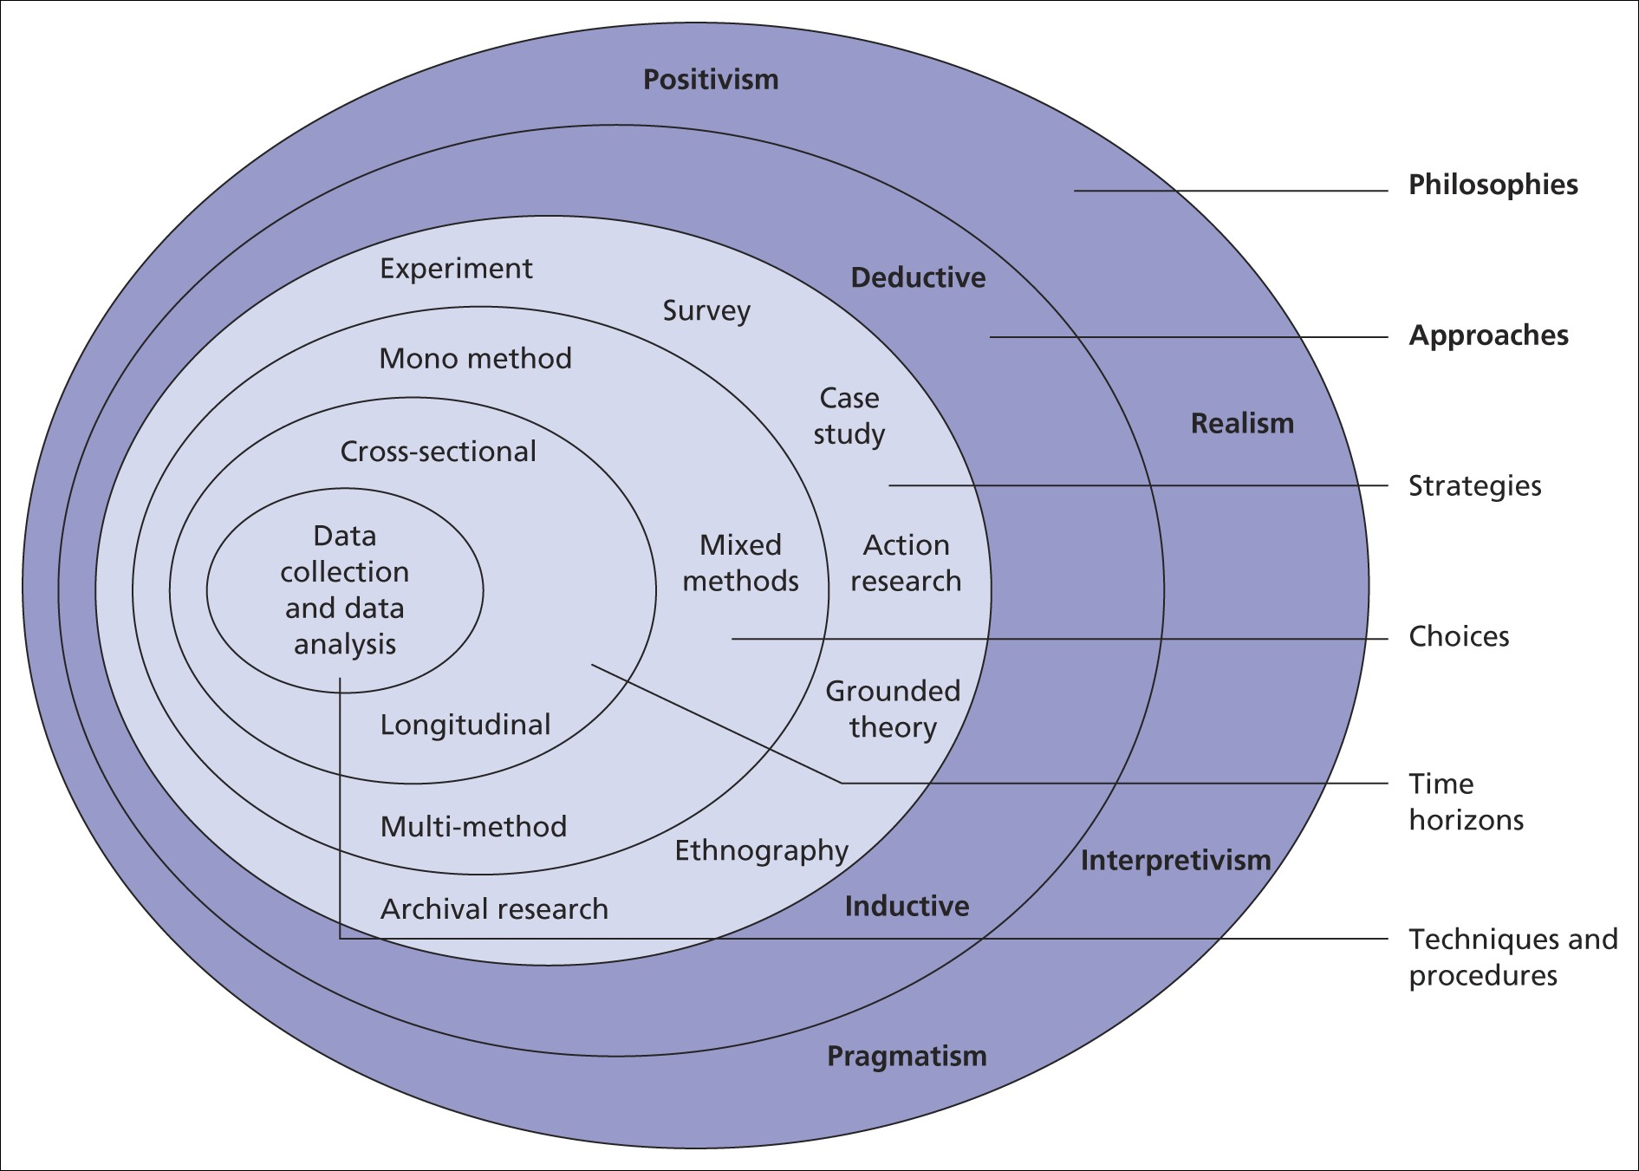
Figure 6: Research design (Saunders, et al., 2015)

3.2.1 Data Collection

Quantitative and qualitative are the most common methods for data collection. To differentiate quantitative research from qualitative research the research must distinguish between numerical (numbers) and non-numerical data (words or images). The quantitative method of data collection is the most used technique such as questionnaires and for the use of data analytical tools such as graphs or statistics. On the opposite side of the spectrum is the qualitative research method which uses data collection techniques such as interviews and analyses results by categorising data using a thematic analysis (Saunders, et al., 2015).

Table 1: Qualitative and quantitative approaches to research (Neuman, 2008); (Jankowicz, 2005)
Quantitative data | Qualitative data
Based on familiarisation of current research rather than specific situations | Based on a familiarisation with a real-life context or situation
Analyses a limited number of variables | Analyses significant themes that are suggested from a range of sources
Seeks to achieve abstraction from repeated observations | Seeks to find out how people understand a situation and how their understanding influences their actions

Qualitative data is categorised as encompassing information in the form of words and language through observation and participation, one-to-one interviews, focus groups and individual accounts or diaries (Anderson, 2009, p. 206). As qualitative data is generated by activity which takes the form of words, it can be difficult to quantify. Analysis of qualitative data involves working with a smaller sample size and as a result, the information gathered can be highly detailed, rich, and extensive (Anderson, 2009).

3.3 Research Philosophy
Research philosophy is a term which has been referred to as a system of beliefs and assumptions regarding the development of knowledge. During each stage of a research project, researchers will make several types of assumptions (Burrell & Morgan, 2016); (Saunders, et al., 2019). An imperative starting point of a research process is to determine the philosophical stance by using a research paradigm. A research paradigm is a set of linked assumptions and provides the researcher with a conceptual framework. A research paradigm is imperative during all research processes as it shapes the researcher's methodological approach in investigating the research question (Ragab & Arisha, 2018); (Kuhn, 1962).

There are two fundamental thoughts which influence research paradigms: scientific and humanistic. Each thought provides opposite ontological and epistemological views. An ontological assumption looks at human knowledge and the extent to which personal values interfere with the research process. These assumptions can shape research questions, methods selected and interpretation of findings (Crotty, 1998, Saunders, et al., 2016, Saunders, et al., 2019).

An ontological assumption focuses on the reality and the essence of its existence. There are two main perspectives of the ontological assumption: objective and subjective. Objectivism views reality as a concrete structure which exists externally to humans and will continue to exist as a tangible entity regardless of people's actions (Holden & Lynch, 2004, Burrell & Morgan, 1979, Ragab & Arisha, 2018).

Whilst objectivists believe in a single reality, subjectivists in comparison believe that multiple realities could potentially co-exist according to the different views and opinions of the world. In the subjectivist viewpoint, social phenomena are regarded as the outcome of actions and perceptions and are in a continual process of revision (Smircich, 1983).

An epistemological approach involves the study of how knowledge is acquired and can be presented as a debate between positivism and interpretivism, which can also be referred to as phenomenology (Becker & Niehaves, 2007). A positivist approach underlays a scientific approach and aims to develop generalised findings from experimentation and structured views of reality. Such as a researcher must objectively obtain data whilst remaining external and impartial to the research process (Hussey & Hussey, 1997); (Remenyi, et al., 1998).

Interpretivists will argue that, unlike natural or human phenomena, the element of social phenomena is unique as it is created by individuals within certain contexts and is too complex to be reduced to a generalised ruling or formula. Interpretive research focuses on the role of obtaining knowledge through research subjects to understand the phenomena which are being studied in a subjective and empathetic manner (Holden & Lynch, 2004, Crotty, 1998, Rowlands, 2005).

3.4 Research Approach
There are two contrasting approaches, as shown in Figure 7, which can be used during the development of a research project: deduction and induction.

Figure 7 Induction and Deduction (Ragab & Arisha, 2018)

A deductive approach involves the refinement and reconsideration of theories through the process of testing out propositions in a variety of contexts or situations. This is also referred to as a top-down approach. The deduction approach follows a highly structured methodology and will investigate the relationship between several variables and generate findings (Anderson, 2009, Trochim & Donnelly, 2008, Ragab & Arisha, 2018).
While deductive reasoning focuses on the refining and reconsideration of theories, inductive reasoning focuses on the level of practice. During the process of gathering data, the researcher will develop general propositions and will begin theory building. On several occasions, an inductive approach will be further developed into a deductive manner (Anderson, 2009).

Figure 8: Inductive and Deductive Approaches (Anderson, 2009)

As shown in Figure 8 the induction approach, builds theory through the identification and evaluation of patterns of data, involves observing and investigating the relationship between several variables within complex situations and is less concerned with generalisation although further avenues of exploration may be identified. The deduction process in comparison looks at theory building through the testing of various propositions and involves clear formulation of propositions or theories which need to be tested. Data gathering through a deduction approach can also identify weaknesses within the theory and may identify ways in which the theory could be modified (Anderson, 2009).

3.5 Research Strategies
The third layer of the research design, as shown in Figure 6, illustrates the foundation of the study and must be implemented within a research strategy to achieve the overall research goal.

A research strategy can also be identified as the methodical link between the research philosophy and the subsequent choice of methods selected to collect and analyse the data (Denzin & Lincoln, 2011); (Saunders, et al., 2016).

There are several research strategies which were considered for this research project including action research and grounded theory

3.5.1 Action Research
Action research is a term used to describe professionals studying their own practice to improve it. It can also be a flexible approach which allows for action such as change or improvement and research understanding and knowledge to be achieved in the same way (Dick, 2002); (General Teaching Council for Wales, 2002); (Costello, 2011).

Action research which is also known as Participatory Action Research is an approach which is commonly used for improving practices and conditions It is maintained that the strength of action research lies in the focus on generating solutions to practical problems (Lingard, 2008); (Whitehead, 2003); (Meyer, 2000).

3.5.2 Grounded Theory
Grounded theory is regarded as a methodological approach to data collection and analytic procedures and can be used within research projects to develop theoretical explanations of social interactions and processes in a wide range of contexts which can include business and management (Saunders, et al., 2016).

A grounded theory strategy needs to have a clear strategy, a plan of action, and a clear process which underlines the choice and the use of particular methods (Crotty, 2015); (Tarozzi, 2020).

Grounded theory allows for a systematic approach to the collection and analysis of qualitative data. Whereas, in quantitative data collection grounded theory can be used to collect a complete set of data and then analyse (Saunders, et al., 2016)

3.6 Research Methodology Comparisons
During the commencement of this research project, it was important to review several methods of data collection to gather the appropriate data. These methodologies, as shown in Table 2, considered the timescale available for this research project to be conducted and the availability of the participants. Consideration was also given during the comparisons of the research methodologies of the additional information which could be gathered from research forms such as focus groups and interviews.

Table 2: Consideration of alternative research methods (Anderson, 2013)
 | Advantages | Disadvantages
Focus Groups | Interaction between the researcher and participants allows for clarification and follow up questions | Large quantities of data which are gathered by the researcher may be difficult to analyse and critique
Focus Groups | The process can be less time consuming than individual interviews | Participants may be influenced by other focus group participants
Interviews | High response rate | Potential interviewer bias
Interviews | Additional information can be gathered | Time intensive
Observations | Can observe participants behaviours and actions within the workplace | A researcher’s presence may influence a participant’s behaviour one way or another
Questionnaires | Not time consuming to complete | No opportunity to ask follow up questions or expand on answers
Questionnaires | Can be completed from a workstation and does not require time away from work

3.7 Chosen Research Methodology
After considering both quantitative and qualitative data-gathering methods the chosen research methodology for this research project is interviews. Interviews can either be structured, semi-structured or unstructured. The process of interviews can be subtle and allows for conversations to take place which can lead to further collection of useful data (Quinlan, 2011). For this research project, semi-structured interviews have been chosen as its research methodology.

Semi-structured interviews allow for a flexible structure which will allow for interviewees to be prompted and encouraged to provide additional data for analysis. This form of methodology will also allow the interviewer to probe the interviewee to elaborate on responses or follow a new line of questioning based on the responses of the interviewee (Cohen & Crabtree, 2006). A semi-structured interview is one in which the interviewer has several questions in mind and does not follow any specific sequence of asking the questions. This will enable the respondent to respond freely and in the manner in which they feel comfortable (Bryman & Bell, 2011). This method of data capture will allow the researcher to introduce new points and can take advantage of and ask new relevant questions as well.

Qualitative research methods are a valued hypothesis of enquiry and the complexity which surrounds qualitative research requires methodical methods to create useful results. When gathering qualitative data, a suitable analysis tool must be used (Nowells, et al., 2017, p. 1).

By utilising semi-structured interviews as the research methodology thematic analysis will be utilised as it is an important research analysis tool. It is used when analysing large qualitative data sets as it is a method for identifying, analysing, organising, describing, and reporting themes found within a gathered data set (Braun & Clarke, 2006).

As the data captured within semi-structured interviews takes the form of words it is not quantifiable. Qualitative data tends to be generated through a process which can be less structured and whereby questions are not standardised. Therefore, presumed preconceptions are suspended (Anderson, 2013).

Semi-structured interviews in which the expressions and responses of the interviewees are recorded and analysed in their own words generate qualitative data. Qualitative data assists the researcher in explaining and understanding issues within their organisational context and provides a real-time picture of the processes which are taking place (Anderson, 2013).

Alternative methods of research gathering were considered as part of this methodology investigation. Although surveys/questionnaires can achieve a broad coverage for data collection and comparison this method of data capture also allows the research to repeat the study. It should also be noted that using surveys/questions as the method of data capture has several disadvantages which can include poor data quality capture due to questionnaire design and respondents may not submit their questionnaire therefore their thoughts will not be captured (Neuman, 2008); (Bryman & Bell, 2007).

For many of the participants in this research project, this will be the first time that they have been questioned or interviewed on this subject matter. It will be important to consider their nerves and their concerns about confidentiality.

3.8 Participation Selection
The Magstim Company currently has 85 employees based in their UK Head Office in West Wales. Fifteen of those employees hold Supervisory, Managerial or Director roles within the organisation. Within my role as HR Manager, I have the authority to conduct this research which will a better understanding of the level of awareness the Management Team within The Magstim Company have regarding succession planning and identify the levels of their commitment and buy-in.

Seven of the Supervisors, Managers and Corporate Directors were selected as participants in this research study to understand what succession planning practices exist within the organisation, whether the planning activity encourages career development through its annual performance development review procedures and whether performance goal orientation is linked to employee retention. A breakdown of the participant demographics is referenced in Table 3. This data, as shown in Table 3, was provided by The Magstim Company’s Time and Management System.

The duration of each interview was approximately 30 to 45 minutes. The interview schedule is referred to in Appendix 1.

Table 3: Participant demographics
 |  | Count | Percentage
Gender | Male | 4 | 57%
Gender | Female | 3 | 43%
Gender | Prefer not to say | 0 | 0%
Age | 18 or below | 0 | 0%
Age | 19 - 25 | 0 | 0%
Age | 26 - 35 | 2 | 29%
Age | 36 or above | 5 | 71%
Management Status | Corporate Director | 2 | 29%
Management Status | Senior Manager | 2 | 29%
Management Status | Middle Management | 2 | 29%
Management Status | Supervisor | 1 | 14%

The results of the qualitative information have been organised into different themes after a rigorous process of synthesising and categorisation.

3.9 Ethical Considerations and Safeguarding Collected Data
For the chosen research design careful consideration was made around ethical issues and safeguarding data. A code of behaviour must be adhered to during research projects concerning the rights of those individuals who become the subject of a research project or who participate in one (Wells, 1994, p. 284); (Anderson, 2013). The term ethics is a philosophy which addresses the issues of human conduct with doing what is right and what is wrong (Remenyi, et al., 2011, p. 1).

The CIPD code of conduct and ethics reiterates that HR professionals should safeguard all restricted, confidential, commercially sensitive, and personal data. This data should not be used for personal advantage or to the benefit or detriment of third parties (CIPD, 2023b). An ethical principle which was carefully considered for this research project was that the interest of the participants would be always protected along with the secure storage of the gathered data (Anderson, 2009).

Once the participants were selected for this research project interviews were scheduled giving each participant a minimum of a week’s notice so that it was not short notice. All participants were informed of the purpose of the research project in advance of their scheduled interview and that this exercise was purely to support a succession planning programme within The Magstim Company. Each participant was spoken to beforehand and informed that all information that they provided would be anonymised and that no details of the interviews would be shared. Consideration was also given to the possibility that participants would provide responses they felt the researcher was looking for. During the interview process, the purpose of the research project was reiterated and how this would aid The Magstim Company, and its succession planning processes in the future.

All interview transcripts relating to this research project are stored on a password-protected computer and uploaded onto the Microsoft Cloud which is also password-protected. The design of the interviews considered what data was required to achieve the research project objective and informed the question choices.

3.10 Reliability and Validity of Research
Reliability and validity are the most important and are fundamental in the measurement of methodology for data collection. Validity focuses on the instrument that measures, whereas reliability concerns the truthfulness of the obtained data (Ahmed & Ishtiaq, 2021).

Research projects will lack credibility if the researcher is unable to ensure that the data captured is relevant and trustworthy. In understandable terms, valid research will use research strategies and data capture processes that are appropriate to the research question and are implemented correctly. Validity of research means that the research conducted is appropriately robust to all confidence in the conclusion drawn. Reliable research is research, which is accepted as fair, trustworthy, and objectively undertaken (Biggam, 2011); (Anderson, 2013).

It is important when conducting a research project to assess the reliability of the questions. For example, it is important to question whether similar observations would be reached by different observers and would the methods used generate the same results. It is possible that not all research will produce generalisable conclusions (Hart, 2010); (Easterby-Smith, et al., 2003); (Robson, 2011).

When assessing and considering the validity of the research questions it is important to note and consider what difference the context of the investigation would make to the data captured and ensure intervening variables have not interfered with the data gathered. When using a qualitative research approach the following issues must be considered:
- credibility – accurate data capturing
- transferability- have you captured a true picture which draws on a range of perspectives
- confirmability – reflect on the extent personal bias or that of the respondents has been acknowledged (Lincoln & Guba, 1985); (Anderson, 2013).

3.11 Chapter Summary of Research Methodology

This chapter discussed the methodological decisions undertaken which guided the overall research project. This chapter provided a brief introduction to the research aims and objectives, followed by the research design, research philosophy, research approach, the chosen methodology and key ethical considerations.

For this research project, semi-structured interviews were the selected methodology due to its use of open-ended questions. Semi-structured interviews allow for a flexible structure allowing interviewees to be prompted and encouraged to provide additional data for analysis. This method of data capture allows for the introduction of new points and can take advantage of and ask new relevant questions. Qualitative research methods are a valued hypothesis of enquiry and the complexity which surrounds qualitative research requires methodical methods to create useful results. When gathering qualitative data, a suitable analysis tool must be used (Nowells, et al., 2017, p. 1).

By utilising semi-structured interviews as the research methodology thematic analysis will be utilised as it is an important research analysis tool. It is used when analysing large qualitative data sets as it is a method for identifying, analysing, organising, describing, and reporting themes found within a gathered data set (Braun & Clarke, 2006). This research project will use an inductive research strategy to evaluate its theory by identifying and evaluating themes. This theory is less concerned with generalisation although further avenues of exploration may be identified.

The Magstim Company has 85 employees based in their UK Head Office. Fifteen of those employees hold Supervisory, Managerial or Director roles. To achieve the research, aim of understanding whether the Management team values the importance of succession planning seven of the Supervisors, Managers and Corporate Directors were selected as interview participants to understand what succession planning practices exist within the organisation, whether the planning activity encourages career development through its annual performance development review procedures and whether performance goal orientation is linked to employee retention. A breakdown of the participant demographics is referenced in Table 3.

Chapter 4: Results and Analysis
This chapter sets out the findings of the data gathered from the interviews, as set out in Appendix 1, from the relevant stakeholders. The interview questions related to the management teams’ awareness of what succession planning process is currently used within The Magstim Company, their understanding of the current leadership development process in particular the performance development reviews and nine box matrix, and finally their awareness and understanding of how these activities intrinsically link to succession planning.

The findings are presented in three sections covering each identified theme.

Interview Findings

4.1.1 Theme One: Existence of Succession Planning Practices within The Magstim Company

One of the most common themes that emerged from the analysis is the need to enhance the organisation’s succession planning practices in retaining employees for identified business-critical roles. All the participants have stated that there is no clear succession planning process, and that the organisation only considers succession planning when an employee within a key role resigns. One participant (R2) stated that “it was very difficult to see how the leadership plans for succession”. A second participant (R3) stated that “last year a member of staff, who had a somewhat unique role, announced that they were retiring, and we took months to consider whether we would make a direct replacement or hire an alternative role. We were in this position as we could not identify a replacement internally. We then started to question whether it was an important role for our organisation going forward. The outcome was to recruit for a different role but did leave us with somewhat of a knowledge gap”.

It was also evident within this research project that although there are many positive aspects of having a management team located throughout Europe and the USA, there can be negative aspects as well, which were mentioned by one participant (R4) who stated that with “several of the Senior Management team located in Europe and USA it does make it difficult to align on certain roles as they don’t have a true understanding of what it is we need as each role can interlink with several other departments”.

It was clear when speaking to the participants that although they agree that there is no clear succession planning process, several of the Managers interviewed stated that they do however include development plans, outside of the annual performance development reviews, with their teams with R1 stating that they undertake this activity “in the hope that not only will they become high performers in their roles but one day they could be my replacement”. This Manager also stated that they “did not see succession planning within my team as a threat to my job but the company needs to have a plan b if I leave”.

A fellow Manager (R2) when questioned spoke about the struggles of recruiting specialist roles within the industry and have made a “conscious effort to recruit graduates within several specialities”. With this in mind, “we have already identified a potential graduate who has the skillset and the personality to one day become a team lead within their specialist area”.

4.1.2 Theme Two: Methods and Tools of Leadership Development conducted with direct reports

A second theme which arose from the semi-structured interviews was the variety of leadership development methods which have been carried out with direct reports. All the participants, some of whom were relatively new to management or supervisory roles, used a variety of leadership methods with their teams. One challenge two participants admitted to was that having remote workers or being the remote worker within the team presented challenges when developing their team members. One participant (R4) stated that as their team were “located throughout the UK it was challenging at times to allocate appropriate time to coaching or mentoring activities”.

One method that all the participants mentioned was that they conducted performance development reviews, also referred to as appraisals, every year with each member of their team. This allowed each Manager and Supervisor to sit down on a one-to-one basis with each report. The process of performance development reviews consisted of according to (R5) the ability to “sit down with them and review the previous year’s objectives, some of which was predominantly led by individual sales targets”. The performance development reviews also allowed “an opportunity to talk about their future aspirations for both the short and long term”. One participant (R5) of the research project admitted within their interview that they assumed that the short-term and future aspirations, section F of appendix 2, of the performance development review “would be a waste of time and nobody would be interested in completing the section”. However, they went on to state that “by going through the form and spending time discussing aspects of their lives, which we may not normally do, I came to understand that how many of my team want to go back to university or at least continue their education and complete degrees as one of my direct reports, in particular, would be the first in her family, and she feels that she has the support of our organisation”. What was also mentioned in this particular interview was that we do not “always recognise, especially as our organisation is so fast-paced, how deeply moved employees are when we promote them”.

The performance development review form, as shown in Appendix 2, itself has several positives as within the one document it captures several key forms of information. The first section of the form is to review the job description as on many occasions these have not been updated for several years.

A second method which the Management Team mentioned was the nine-box matrix, also referred to as the talent review. This tool was originally introduced in 2022 and was used throughout The Welcony Group in 2023. The participants explained that the nine-box matrix process was a little unnerving as it forced them “to discuss their teams and see where they fit within the nine-box matrix”. One negative point raised by (R5) was that the results may not be a true reflection on the individual and could be open to interpretation, with one manager stating “that at the time I felt one way but that could have been down to several factors or events. If we do conduct the review a few weeks later, I may feel differently and place individuals in different categories”. During one interview a manager (R2) explained that “at times there were disagreements and I had to reiterate my decision. Ultimately this was my opinion at the time as I am the one who works closely with them”.

4.1.3 Theme Three: Identifying the importance of completing performance reviews and its links with succession planning

It was evident throughout the interviews that the majority of the Management Team and was stated, by R1 that they “didn’t find any value in performance reviews” and only completed them because the Welcony HR team forced them to. There was an exception whereby one Manager (R2) stated that they are “normally the first to complete their teams’ development reviews within the given timescale as they see the benefits of performance reviews”. The time they spend with their direct reports allows the time and opportunity to sit down and talk through their progress and any training needs or concerns they may have. It was also important for them to show their team that “they were worthy of my time and the organisation wants to develop them for the future, which is not something I experienced with former employers and managers”.

A key aspect of an organisation’s succession planning process is to have clear development plans for those employees who have been identified as potential successors for business-critical roles. One tool to capture and monitor development reviews is the completion of the organisation’s performance development reviews. Sections E and G of the Performance Development Reviews, as shown in Appendix 2, provide both the Manager and Employee an opportunity to discuss and plan for training and development requirements for the coming year.

Initially, not all the participants saw the relevance of completing performance development reviews or the nine-box matrix (talent review) and its link to succession planning. However, by the end of the interview process, several of the participants could see the link between performance development reviews and the nine-box talent review and succession planning, with one participant (R7) going on to explain that they believed the “issue or concern I had especially with the talent review initially is that you are identifying your successor. I do not have any issues with the company conducting this activity, but it can be difficult to get to grips with the fact that the company is ultimately planning for your departure. As a Manager I 100% understand the need but if I put my employee hat on it is difficult to accept”.

Chapter 5: Discussion

The rationale of this research project is following negativity and animosity shown towards the introduction of the nine-box grid, which was introduced to identify employees with future potential, was to establish the levels of awareness of the Management team within The Magstim Company and whether they value the importance of managing succession planning.

For The Magstim Company to achieve its strategic goals it needs to have a knowledgeable and experienced workforce; however, it is not the only factor when operating within a competitive labour market. Having clear organisational succession planning practices should accompany these qualities and skills. The literature review found that succession planning can be best understood as a series of several individual stages which when used correctly will formalise the process for all organisations. These stages can be outlined as identifying those critical roles to the organisation; defining the capabilities required for each identified critical position; identifying and assessing potential candidates for these roles; providing those identified individuals with a personalised development plan and finally reviewing the progress of those identified successors against the implemented development plan (Bechet, 2008); (Taylor, 2010).

It is therefore important to establish whether there is an importance portrayed on succession planning within The Magstim Company. To support the organisation’s succession planning, in 2022 a nine-box grid, as shown in Figure 3, was introduced to aid and support the identification of each employee's future potential. This nine-box grid allowed managers to recognise and rate each employee within their team as being a high performer with high potential to being low performer with low potential. Although this task was completed there was clear animosity towards the task and whether there was any benefit of the process. To understand the levels of awareness within the Management Team within The Magstim Company, and whether they value the importance of managing succession planning, interviews with seven members of the Management Team within The Magstim Company were conducted to further understand their animosity towards the process of the nine-box matrix and to establish whether they value the importance of succession planning and whether they identify the link between conducting and completing performance development reviews, the nine-box grid and succession planning.

One of the most common themes that emerged from the primary research was the need to enhance or formalise The Magstim Company’s succession planning practices. This is primarily to aid in the retention of employees who have been identified as future leaders and successors for business-critical roles. Although the literature stated that organisations such as The Magstim Company would require formalised succession planning all the participants interviewed as part of this research project stated that there was no clear succession planning process, or none had been shared with them, within The Magstim Company and reiterated that the organisation only considers succession planning when an employee within a business-critical role resigns.

One of the key findings from the literature review is that succession planning encourages organisations to focus on identifying and growing talent to fill both leadership and business-critical roles in the future (CIPD, 2022a). It was clear from the interview findings that the process of succession planning does not occur within The Magstim Company regularly and on the occasions that it does, this is only due to the resignation of an employee who holds a business-critical role. One participant (R3) stated that “last year a member of staff, who had a somewhat unique role, announced that they were retiring, and we took months to consider whether we would make a direct replacement or hire an alternative role. We were in this position as we could not identify a replacement internally. We then started to question whether it was an important role for our organisation going forward. The outcome was to recruit for a different role but did leave us with somewhat of a knowledge gap”.

A succession plan requires clear management provisions, and it requires the management team within an organisation to focus on the future and develop those employees who have been identified as future leaders or successors for business-critical roles (Taylor, 2019). The long-term aspect of succession planning has considerable implications for an organisation’s culture, its ability to recruit and retain talent, and most importantly the performance levels of those employees lower down within an organisation’s management hierarchy, who have been identified as those future leaders and successors (Bechet, 2008).

It is imperative that when organisations undertake a succession planning programme, they consider each distinct stage within the process:
- Identifying business-critical positions within the organisation
- Understand and define the competencies each role will require in the future
- Assessing the potential employees for those roles
- Provide the employees identified as potential successors with a clear development plan that will prepare them for these roles
- Conduct regular reviews to understand the progress of the identified successors. This can be done through the organisation’s annual performance development reviews and regular one-to-one meetings (Bechet, 2008); (Taylor, 2022)

To have a successful Succession Planning Programme organisations must ensure that they have the right talented employees in place to achieve their strategic business objectives. Organisations can do this by working through a process known as talent management. Organisations can successfully do this through the incorporation of several processes which will attract, develop, retain and engage valuable employees (Armstrong, 2012); (CIPD, 2023); (Blass, 2007, p. 1). An important aspect of talent management which needs to be considered and monitored is the expectancy theory which primarily focuses on an employee’s motivation and how motivation ultimately impacts their performance (Vroom, 1964). Expectancy theory ultimately focuses on the motivation of the employee, however, it also requires the leadership and organisation to behave in a certain manner as this too has a greater impact on their motivation and overall career development (Connolly, 1976); (Armstrong, 2012).

Ensuring an organisation has a clear organisation-wide talent management strategy doesn’t just provide a clear focus on investing in people but will contribute to several strategic business objectives and can support the development of a high-performing workplace, encourage a culture of continuous learning, and strengthen employee value (CIPD, 2023). The business environment can be a hostile place, especially at times when automation and AI practices are increasing within workplaces resulting in the replacement of some roles. With this in mind, the need for organisations to upskill or reskill employees should become their primary focus. An organisation-wide talent management strategy will not only provide a clear focus on people investment but can contribute to the achievement of several strategic objectives such as developing a high-performance workplace, encouraging continuous learning, and strengthening the employee value proposition (CIPD, 2023). Within The Magstim Company, the interview findings found that the interview participants agreed that there is no clear succession planning process, several of the Managers questioned stated that they do however include development plans, outside of the annual performance development reviews, with their teams. One participant (R1) stated that they undertake this activity “in the hope that not only will they become high performers in their roles but one day they could be my replacement”. This participant also stated that they “did not see succession planning within my team as a threat to my job but the company needs to have a plan b if I leave”.

In terms of developing a talent management strategy, it needs to align with the organisation’s overall strategy and determines the future workforce needs of the organisation. Workforce planning looks at and identifies the supply and demand of the workforce for the future as well as analysing labour market trends. The purpose of a workforce plan is to assist in the prioritisation of talent management activities within an organisation and can include, but is not limited to, activities such as:
- recruitment
- development of talent pools
- learning and development
- succession planning
- leadership development
- career management (CIPD, 2023)

A key ingredient of workforce planning is to identify the most business-critical roles within an organisation which tend to be leadership and specialist roles. This is where succession planning, when used correctly, aids organisations in preparing potential leaders to fill key positions from within (CIPD, 2023); (Armstrong, 2012). Implementing a robust performance management process is one of the first management tools for identifying future talent early.

Performance management focuses on having a two-way discussion with regular, open, and supportive feedback on progress towards objectives. When carried out effectively performance management is a means of increasing an employee’s engagement and motivation (CIPD, 2022b); (Armstrong, 2012). A theme which was identified from the semi-structured interviews was the leadership development tools the interviewed Managers have carried out with direct reports. All the participants, some of whom were relatively new to management or supervisory roles, used aspects of leadership and development methods with their teams. One development method that all the interview participants consistently mentioned was that they conducted performance development reviews, also referred to as appraisals, annually with each member of their team.
Performance development can be best defined as a process which contributes to the effective management of individuals and teams to achieve high levels of organisational performance. Performance management should not be seen as a single activity but should be several interlinked practices that should be approached holistically. When used effectively, performance management focuses on two-way discussions with regular feedback. This management process should record clear objectives and improvement plans for those who have been identified as underperforming within the organisation (Rees & French, 2016, Armstrong & Baron, 2005, CIPD, 2022b).

The research discovered that this process of performance development reviews allowed each of the participants interviewed to sit down on a one-to-one basis with each of their direct reports. The process of performance development reviews consisted of, according to both R1 and R5, allowing them to “sit down with each of their direct reports and review the previous year’s objectives”. The performance development reviews also allowed “an opportunity to talk about their future aspirations for both the short and long term”. One participant of the research project admitted within their interview that they assumed that the short-term and future aspirations of the performance development review “would be a waste of time and nobody would be interested in completing the section”. One challenge two participants of the interview process admitted to was that having remote workers or being the remote worker within the team presented challenges when developing their team members. One participant stated that as their team were “located throughout the UK it was challenging at times to allocate appropriate time to coaching or mentoring activities”.

This research project identified the importance of organisational succession plans and why they should be implemented within organisations. Through the interview processes with Managers and Supervisors from The Magstim Company, it was noted and recognised that although there is no formal succession planning process within the organisation there is an undertone of employee development through performance development reviews and individual development plans. The nine-box matrix, or talent review, when introduced was met with animosity, however, through this process of discussion with Managers and Supervisors they are now able to see the link between this tool and succession planning which is clear evidence of an action research strategy in practice.

One key aspect of the research project which has been discussed is that the literature states that organisations should have succession plans in place for several reasons and the process they should undertake. However, in a wider context, organisations should focus on several aspects for successful succession planning. These activities can include training and developing their current workforce or potential recruitment of external personnel for identified business-critical roles.

Chapter 6: Conclusion and Recommendations

6.1 Conclusion

The purpose of this qualitative study was to establish whether the Management Team within The Magstim Company valued the importance of Succession Planning, to understand their levels of succession planning awareness and to identify their levels of commitment and succession planning buy-in.

To fulfil the purpose of this research project, a total of seven respondents were selected from various management levels within the organisation, to participate in face-to-face interviews. The analysis conducted using semi-structured interviews resulted in identifying three main themes of the analysis.

The three themes that emerged from the analysis were:
- Acknowledgement of the non-existence of succession planning practices within The Magstim Company
- Methods and tools of leadership development conducted with direct reports
- Identifying the importance of completing performance reviews and its link to Succession Planning

6.2 Recommendations

According to the findings of this study, it has been explored that integrated succession planning practices in developing the employees would not only retain them but would also assist in adding leadership competencies which will further assist in delivering the desired strategic business results of the organisation.

The success of a succession planning process is reliant on the development and clear implementation of succession management practices. While this research project indicated that The Magstim Company had some informal succession management practices, formal implementation of a process was lacking. The following recommendations are offered for consideration:

- As suggested by (Bechet, 2008, pp. 247-248) and (Taylor, 2022) the management within The Magstim Company should first identify which roles are business critical and understand and redefine, where necessary, the competencies of each identified role. The research discovered that roles are only considered business-critical, within The Magstim Company once an employee resigns. There needs to be a proactiveness in identifying these roles. It is recommended that in a similar manner to the nine-box matrix, which identifies an employee’s high performance and high potential, a similar matrix should be devised that analyses each job role for its importance to the organisation.

- The research found that although there was initially animosity and negativity shown towards the nine-box talent matrix it did allow Managers and Supervisors the opportunity to look at their direct reports and identify those employees with future potential. It is recommended that this activity is carried out on an annual basis and is peer-reviewed, amongst the management team, as this will identify potential candidates for the identified business-critical roles.

- It was noted from the research that several Managers have introduced individual development plans with their team members. It is a recommendation that once an employee is identified as a potential successor for a business-critical role a personalised development plan is created outside of the performance development review. This for example would include any requirements for both internal and external training. This will allow and support an employee’s expansion of personal growth and opportunity.

- It is recommended and advised that those employees identified as potential successors have regular reviews outside of the annual performance development review process. This will allow both the employee and Manager to discuss concerns or issues and is an opportunity to address any additional training needs which may be required. Senior Management should be at the forefront of providing the necessary support to its employees.

Chapter 7: References

Ahmed, I. & Ishtiaq, S., 2021. Reliability and validity: Importance in Medical Research. Journal of the Pakistan Medical Association, 71(10), pp. 2401-2406.

Anderson, V., 2009. Research Methods in Human Resource Management: Investigating a Business Issue. Third ed. London: CIPD.

Anderson, V., 2013. Research Methods in Human Resource Management: Investigating a Business Issue. 3rd ed. London: CIPD.

Armstrong, M., 2012. Armstrong's Handbook of Human Resource Management Practice. 12th ed. London: Kogan Page.

Armstrong, M. & Baron, A., 2005. Managing Performance: Performance Management in action. London: CIPD.

Bechet, T., 2008. Strategic staffing: a comprehensive system for effective workforce planning. 2nd ed. New York: AMACOM.

Bechet, T., 2008. Strategic Staffing: A comprehensive system for effective workforce planning. Second Edition ed. New York: AMACOM.

Bechet, T., 2008. Strategic Staffing: A comprehensive system for effective workforce planning. Second ed. New York: Amacom.

Becker, J. & Niehaves, B., 2007. Epistemological perspectives on IS research: a framework for analysing and systemizing epistemological assumptions. Information Systems Journal, 17(2), pp. 197-214.

Bennet, T., Saundry, R. & Fisher, V., 2020. Managine Employment Relations. 7th ed. London: Kogan Page.

Biggam, M., 2011. Succeeding with your master's dissertation. 1st ed. Maidenhead: Open University Press.

Blass, E., 2007. Talent Management: Maximising talent for Business Performance, s.l.: Chartered Management Institute / Ashridge Consulting.

Blass, E., 2009. Talent management: cases and commentary. Baskingstoke: Palgrave Macmillan.

Bowick, C., 1996. Eight ays to assess succession plans. In: Human resource management: perspectives, context, functions and outcomes. Englewood Cliffs(NJ): Prentice Hall.

Braun, V. & Clarke, V., 2006. Using thematic analysis in psychology. Qualitative Research in Psychology, Volume 3, pp. 77-101.

Bryman, A. & Bell, E., 2007. Business research methods. Oxford: Oxford University Press.

Bryman, A. & Bell, E., 2011. Business Research Methods. Third ed. New York: Oxford University Press Inc.

Burrell, G. & Morgan, G., 1979. Sociological Paradigms and Organisational Analysis. London: Heinemann.

Burrell, G. & Morgan, G., 2016. Sociological Paradigms and Organisational Analysis. Routledge: Abingdon.

Cascio, W., Boudreau, J. & Church, A., 2017. Usind a risk-optimisation lens: maximising talent readiness for an uncertain future. In: A research agenda for human resource management. Cheltenham: Edward Elgar.

CIPD, 2015. HR Outlook: Winter 2014-2015. Survey Report, London: CIPD.

CIPD, 2022a. Succession Planning. [Online]
Available at: https://www.cipd.org/uk/knowledge/factsheets/succession-planning-factsheet/
[Accessed 25 November 2023].

CIPD, 2022b. Performance management: an introduction. [Online]
Available at: https://www.cipd.org/uk/knowledge/factsheets/performance-factsheet/#one
[Accessed 2 December 2023].

CIPD, 2022c. Resource and talent planning report 2022, London: Chartered Institute of Personnel and Development.
CIPD, 2023b. Code of Conduct and Ethics, London: CIPD.

CIPD, 2023c. Learning needs analysis. [Online]
Available at: https://www.cipd.org/uk/knowledge/factsheets/learning-needs-factsheet/
[Accessed 9 February 2024].

CIPD, 2023. Talent Management. [Online]
Available at: https://www.cipd.org/uk/knowledge/factsheets/talent-factsheet/?_gl=1*6tvjg0*_ga*MjY2MjE0Nzc4LjE3MDA5MTcwNDg.*_ga_D9HN5GYHYY*MTcwMjQwNjU2My42LjEuMTcwMjQwNzEyMy42MC4wLjA.#Whatis
[Accessed 12 December 2023].

Clutterbuck, D., 2012. The talent wave: Why succession planning fails and what to do about it. London: Kogan Page.

Cohen, D. & Crabtree, B., 2006. Qualitative Research Guidelines Project. [Online]
Available at: http://www.qualres.org/HomeSemi-3629.html
[Accessed 19 December 2023].

Connolly, T., 1976. Some contested and methodoligical issues in expectancy models of work performance motivation. Academy of Management Review, 1(4), pp. 32-47.

Costello, P., 2011. Effective Action Research: Developing Reflective Thinking and Practice. Second ed. London: Continuum.

Crotty, M., 1998. The foundations of social research. London: Sage.

Crotty, M., 2015. The Foundations of Social Research: Meaning and Perspective in the Research Process. London: Sage.

Denzin, N. & Lincoln, Y. S., 2011. Introduction: The discipline and practice of qualitative research. In: The Sage Handbook of Qualititative Research. London: Sage, pp. 1-19.
Deshmukh, P., 2022. alent Development and Succession Planning: How It Works. [Online]
Available at: https://blog.imocha.io/talent-development-and-succession-planning-how-does-it-work
[Accessed 10 February 2024].

Dick, B., 2002. Action Research: action and research. [Online]
Available at: http://www.scu.edu.au/schools/gcm/ar/arp/aandr.html
[Accessed 17 February 2024].

Dixon, N. F., 1994. On the Psychology of Military Incompetence. London: s.n.

Dunlop, J., 1958. Industrial Relations Systems. New York: Holt.

Easterby-Smith, M., Thorpe, R. & Lowe, A., 2003. Management research: an introduction. London: Sage.

General Teaching Council for Wales, 2002. Professional Development Pilot Projects: Information Booklet, Cardiff: GTCW.

Ghazali, M., Ghani, M. A. & Rahman, S. A., 2022. Measuring the success metric for effective succession planning: The conceptual perspective. Institute Journal of Human Resource Studies, 12(1), pp. 42- 55.

Gupta, D., 2022. The 9-Box Grid: Benefits & Limitations in 2023. [Online]
Available at: https://whatfix.com/blog/9-box-grid/
[Accessed 2 December 2023].

Hart, C., 2010. Doing your master's dissertation. London: Sage.

Hirsh, W., 2000. Succession planning demystified. IES Report, Brighton: Institute for Employment Studies.

Holden, M. & Lynch, P., 2004. Choosing the appropriate methodology: understanding research philosophy. The Marketing Review, 4(4), pp. 397-409.

Hussey, J. & Hussey, R., 1997. Business Research: A practical guide for Undergraduate and Postgraduate Students. Baskingstoke: Macmillan Press Ltd.

Jackson, S. & Schuler, R. S., 1990. Human Resource Planning: Challenges for industrial/organisational psychologists. American Psychologist, p. 171.

Jankowicz, A., 2005. Business research projects for students. London: Thomson Learning.
Kew, J. & Stredwick, J., 2016. Human Resource Management in Context. Third ed. London: CIPD.

Kispal-Vitai, Z. & Wood, G., 2009. HR Planning. In: Human resource management: a critical approach. London: Routledge.

Kuhn, T., 1962. The structure of scientific revolutions. Chicago: University of Chicago Press.

Lincoln, Y. & Guba, E., 1985. Naturalistic enquiry. Beverley Hills: Sage.

Lingard, L. A. M. a. L. W., 2008. Qualitative Research. Grounded Theory, Mixed Methods, and Action Research.. BMJ, pp. 337-567.

McKinsey, 2008. The GE-McKinsey nine-box framework. McKinsey Quarterly, Issue 4.

McLaughlin, L., Vicere, A. & Ziskin, I., 2020. Leadership development: the shift from "ready now" to "ready able". In: The Sage hanbook of human resource management. London: Sage.

McLaughlin, L., Vicere, A. & Ziskin, I., 2020. Leadership development: the shift from "ready now" to "ready able". In: A. Wilkinson, N. Bacon, S. Snell & D. Lepak, eds. The Sage Handbook of human resource management. London: Sage.

MedTech Europe, 2021. National Association Survey, s.l.: MedTech Europe.

MedTech Europe, 2022. The European Medical Technology Industry in Figures 2022, s.l.: MedTech Europe.

Meyer, J., 2000. sing qualitative methods in health related action research. British Medical Journal, Volume 320, pp. 178-181.

Narayanan, A., Rajithakumar, S. & Menon, M., 2019. Talent Management and Employee Retention: An intergrative research framework. Human Resource Development Review, 18(2), pp. 228-247.

Neuman, W., 2008. Basics of social research: qualitative and quantitative approaches. Harlow: Pearson Education.

Nowells, L., Norris, J. M., White, D. E. & Moules, N. J., 2017. Thematic Analysis: Striving to Meet the Trustworthiness Criteria. International Journal of Qualitative Methods, Volume 16, pp. 1-15.

Nyberg, A., Schepker, D., Cragun, O. & Wright, P., 2017. Succession planning: talent management's forgotten, but critical tool. In: D. Collings, K. Mellahi & W. Casco, eds. The Oxford Handbook of talent management. Oxford: Oxford University Press.

Odiorne, G., 1984. Strategic management of human resources. San Francisco: Jossey Bass.

Quinlan, C., 2011. Business Research Methods. Hampshire: Cengage Learning EMEA.

Ragab, M. & Arisha, A., 2018. Research Methodology in Business: A Starter's Guide. Management and Organisational Studies, 5(1), pp. 1-23.

Rees, G. & French, R., 2016. Leading, Managing and Developing People. 5th ed. London: CIPD.

Remenyi, D., Swan, N. & Van Den Assem, B., 2011. Ethics Protocols and research ethics committee. Reading: Academic Publishing International Ltd.

Remenyi, D., Williams, B., Money, A. & Swartz, E., 1998. Doing Research in Business and Management - An introduction to Process and Method. London: Sage Publications.

Ringo, T. et al., 2008. Integrated Talent Management, Part 1 - Understanding the opportunities for success. First ed. New York: IBM Institute for Business Value.

Robson, C., 2011. Real world research: a resource for social scientists and practitioner-researchers. Oxford: Wiley.

Rothwell, W., 2016. Effective succession planning: ensure leadership continuity and building talent from within. 5th ed. s.l.:American Management Association.

Rowlands, B., 2005. Grounded in Practice: Using interpretive research to build theory. The Electronic Journal of Business Research Methodology, 3(1), pp. 81-92.

Saunders, M., Lewis, P. & Thornhill, A., 2015. Research Methods for Business Students. Seventh ed. Harlow: Pearson Education.

Saunders, M., Lewis, P. & Thornhill, A., 2016. Research Methods for Business Students. 7th ed. Harlow: Pearson Education Limited.

Saunders, M., Lewis, P. & Thornhill, A., 2019. Reseach Methods for Business Students. Eighth ed. Harlow: Pearson.

Smircich, L., 1983. Concepts of culture and organisational analysis. Administrative science quarterly, pp. 339-358.

Tarozzi, M., 2020. What is Grounded Theory?. First ed. London: Bloomsbury Academic.

Taylor, S., 2010. Resourcing and Talent Management. 5th ed. London: CIPD.

Taylor, S., 2019. Resourcing and Talent Management. London: Kogan Page.

Taylor, S., 2022. Resourcing and talent management the theory and practice of recruiting and developing a workforce. 8th ed. London: Kogan Page.

Telegraph Hill Partners, 2022. Helping Life Science & Healthcare Companies Achieve Growth Objectives. [Online]
Available at: https://thpartners.net
[Accessed 5 February 2022].

The Magstim Company Limited, 2021. Performance Development Review Policy and Procedure. s.l.:s.n.

The Magstim Company, 2020. Strategic Overview 2020, s.l.: s.n.
The Welcony Group, 2022. Welcony. [Online]
Available at: https://www.welcony.com
[Accessed 5 February 2022].

Trochim, W. & Donnelly, J. P., 2008. Research methods knowledge base. Third ed. Mason: Atomic Dog/Cengage Learning.

Vroom, V., 1964. Work and Motivation. New York: Wiley.

Wells, P., 1994. Ethics in business and management research. In: Principles and practice in business and management research. Aldershot: s.n.

Whitehead, D. T. A. &. S. P., 2003. Action research in health promotion. Health Education Journal, 62(1), pp. 5-22.

Yin, R., 2013. Validity and generalization in future case study evaluations. Evaluation, 19(3), pp. 321-332.

Appendix 1: Interview Schedule

- If you consider some of the positions within our company that may become vacant in the next few years, how would you describe the succession plans?

- Tell me about the forms of leadership development activities you have participated in throughout your career.
  - Why did you participate in these activities?
  - Which of these did you feel were most effective, and why?

- Tell me about what methods of leadership development you have done with your direct
reports?
- Which did you find most helpful, and why
(Link to current PDR process, does the management team understand the link)

- How would you describe our company’s overall leadership development processes?
For example, I would like to understand your thoughts on:
  - Our annual appraisal programmes
  - the talent review (9-box matrix) we undertake

- Do you believe undertaking these activities is linked with the organisation’s succession planning practices?

- How would you say The Magstim Company’s characteristics or culture influences the way it approaches succession planning?
  - Do you think succession planning is openly discussed or held in private?
    - Why do you feel like that?

- Would you like Magstim’s succession planning to change, and why?

Appendix 2: Performance Development Reviews

The Welcony Group
Performance Development Review (PDR)

NAME: | POSITION:
LINE MANAGER: | DATE OF PDR:

The Performance Development Review offers employees, supervisors/line managers the opportunity to assess individual progress and plan for training and development activities. It also provides the opportunity to reflect on performance levels and gain feedback on areas for improvement and development.

- JOB DESCRIPTION
Review of current job description.
Have any significant changes taken place in the job since the last appraisal review?

Andrea moved to Canada

B. REVIEW OF PREVIOUS OBJECTIVES
Review all personal objectives that were agreed upon for the previous appraisal period.

 | Objectives from previous year |  | Complete during annual appraisal
 | Individual objective & measure of success | Date for completion | Performance against set objective | Achieved? (Y/N)
1
2
3
4
5

- Identify performance strengths and successful objective achievements for the review period.

- Identify any objectives that need to be carried over to the next review period, along with any areas requiring development or improvement in the upcoming review period.

- What support is required to achieve the objectives?

- OBJECTIVES FOR NEW APPRAISAL YEAR
At the start of the appraisal year, set out no more than 5 objectives and timescales. Check that each Objective is “SMART”. Is it Specific i.e., unambiguous, and detailed? Is it Measurable i.e., how will you know it is completed? Is it Achievable i.e., is it realistic? Is it Relevant i.e., is it the person’s responsibility? Is it Timebound i.e., is there an end date for completion?

 | Objectives for new appraisal year | Agreed date for completion
1.
2.
3.
4.
5.

- EVALUATION OF CORE VALUES AND BEHAVIOURS
Our core values and behaviours provide the framework for how we treat our customers, how we treat one another at work, and how we increase the effectiveness of our organisation. At the end of the appraisal period, the Manager will need to consider scoring each attribute on a scale of 1-10, exploring why you have scored as you have.
Core Value & Behaviour Statements  Discuss each Core Value and Behaviour and assess how they have been demonstrated over the course of the year, providing examples wherever possible. |  | Rarely Exhibits  (1-3) | Sometimes Exhibits  (4-7) | Consistently Exhibits  (8-10)
1 | RESPECT AND INTEGRITY  What I do matters, and I am proud of my work  Do I make my voice heard and do I listen?  Be honest and sincere in every interaction.  Have the courage to admit mistakes  Treat all colleagues with respect regardless of position.
2 | CHANGING LIVES  What I do today impacts someone’s life tomorrow  Do I know the difference I am making?  Solve customer challenges with passion and persistence.  Continually striving for quality and excellence in my role
3 | ACCOUNTABILITY & COMMITMENT  We all contribute to the quality and success of Welcony  Do I take responsibility for exceeding customer expectations?  Contributes to the achievement of own, team and organisational objectives  Meets commitments, works independently, and accepts accountability
4 | COLLABORATION AND LEADERSHIP  Combined strengths lead to great solutions  Do I take ownership and empower the team?  Empower others to achieve shared goals.  Open to new ideas and proposals  Taking responsibility and ownership of your work
From the list above, select 2 behaviours and agree key actions to support development in those areas in the year ahead.
 | Selected Behaviour | Development Actions/Activities

1

2

Progress against selected behaviours at the end of the review period

- PERFORMANCE DEVELOPMENT PLAN
Identify training requirements in both skills and behaviours to enable you to be safe and effective in your job for the coming year.

Training or development required | Reason for training e.g., objectives, job related skills etc. | What will you be able to do as a result? | Date Required

Progress against training or development plan at the end of the review period

- MANAGING FUTURE EXPECTATIONS
Your Personal Development Plan also includes an opportunity to consider development actions to progress any future career aspirations (if applicable).
Employee’s aspirations (short term) | Employee’s aspirations (5-7 years)

- SUMMARY OF PERFORMANCE
Employee Comments

Manager Overall Review

- OVERALL PERFORMANCE RATING: (Please circle)
At the end of the appraisal year, based on the above assessment, please tick the box below that best reflects the employee’s overall performance rating against work expectations (Objectives & behaviours/values).
1 | 2 | 3 | 4 | 5
Does not meet expectations | Meets expectations mostly or New to role. | Meets expectations completely | Exceeds expectations | Exceeds expectations extraordinarily
EMPLOYEE SIGNATURE: |  | DATE:
LINE MANAGER SIGNATURE: |  | DATE:
DEPARTMENTAL LEADERSHIP TEAM MEMBER SIGNATURE: |  | DATE:

Please return the completed form to the HR Department, retaining a copy for your records.

