

MODULE CODE: Digital Skills for Personal Development and Business Growth BMSW4008

ASSESSMENT COMPONENT: PORTFOLIO

STUDENT NAME: Ieuan Robson

STUDENT NUMBER: 2519945

LECTURER: Philippa Fitzgerald

DATE:12.12.2025
Contents
Task 1 3
Assessment of Digital Skills 3
References 3
Task 2 4
LinkedIn Learning Certificates for Office365 4
Task 3 5
Essay on Relevance of Excel in professional and personal life. 5
References 5
Task 4 6
7 Minute Reflective Presentation 6
References 6

Assessment of Digital Skills
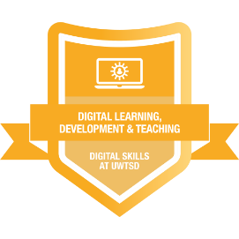
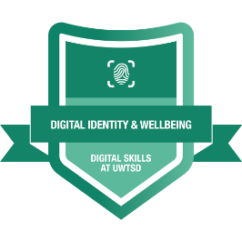
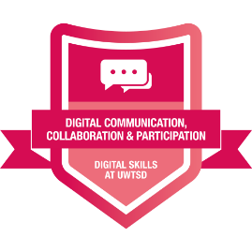
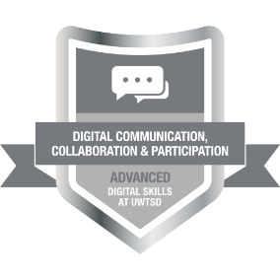
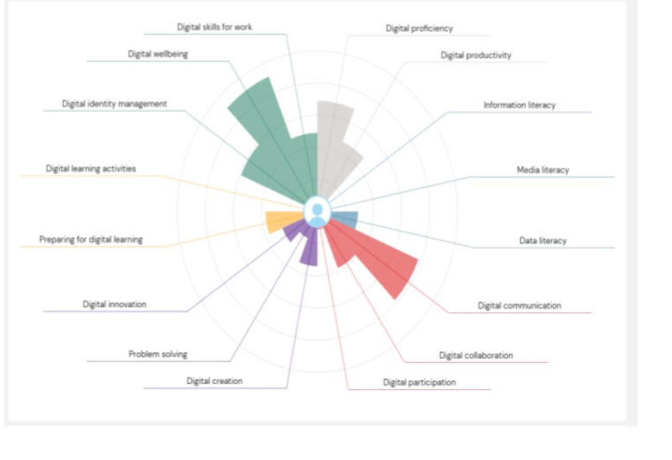

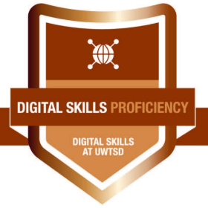
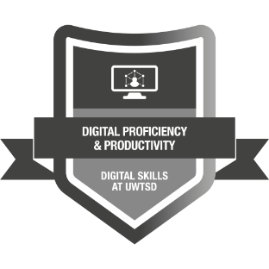
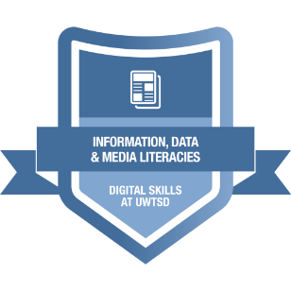
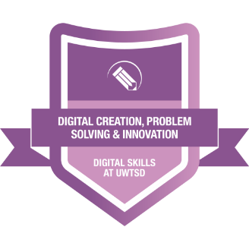

In today’s digital society, developing strong digital skills is essential for academic success, professional readiness, and personal wellbeing. Throughout my studies, I have actively engaged with the University of Wales Trinity Saint David (UWTSD) Digital Skills framework, completing a range of digital badges that collectively demonstrate my growth in confidence, competence, and responsible digital practice. These badges reflect not only technical ability but also critical thinking, creativity, digital identity management, and lifelong learning skills. One of the foundational badges I completed was Digital Skills Proficiency, which provided a strong baseline for my overall digital competence. This badge helped me develop confidence in using core digital tools such as Microsoft Office applications, cloud storage, email etiquette, and collaborative platforms like Microsoft Teams. Through this badge, I improved my ability to manage files efficiently, format academic documents correctly, and communicate professionally in digital environments. These skills have been essential in supporting my academic work and have prepared me for professional digital expectations. Closely related to this was the Digital Proficiency and Productivity (ICT Proficiency) badge. This badge enhanced my ability to use technology productively and efficiently, particularly in managing time, organising tasks, and working collaboratively online. I learned how to use digital calendars, task management tools, and shared documents to support group work and independent study. As a result, my productivity increased, and I became more confident in meeting deadlines and contributing effectively to collaborative projects. Another key area of development was achieved through the Information, Data and Media Literacies badge. This badge significantly improved my ability to locate, evaluate, and use digital information responsibly. I learned how to assess the credibility of online sources, recognise bias and misinformation, and reference digital content correctly. These skills are vital in an era where information is abundant but not always reliable. This badge has strengthened my academic writing and research skills and has encouraged me to be a more critical and ethical consumer of digital media. Creativity and problem-solving were developed through the Digital Creation, Problem Solving and Innovation badge. This badge encouraged me to move beyond basic digital use and engage in creative digital production. I gained experience in creating digital content, experimenting with new tools, and approaching problems with innovative digital solutions. This badge helped me develop transferable skills such as adaptability, creativity, and confidence in learning new technologies—qualities that are highly valued in both academic and professional contexts. I also completed the Digital Learning, Development and Teaching badge at an advanced level. This badge allowed me to reflect on how digital tools can enhance learning and teaching experiences. I explored online learning platforms, accessibility considerations, and inclusive digital practices. This has helped me become a more independent learner and has given me insight into how digital technologies can support others’ learning, particularly in collaborative or educational settings. Equally important was the Digital Identity and Wellbeing badge, which focused on responsible and ethical digital engagement. Through this badge, I developed a greater awareness of online safety, data protection, digital footprints, and personal wellbeing in digital spaces. I learned strategies for maintaining a healthy balance between online and offline life and for protecting my personal and professional identity online. This badge has been particularly valuable in helping me navigate social media and online platforms responsibly. Overall, completing these digital skills badges has allowed me to develop a well-rounded digital skill set. Each badge contributed to different aspects of my digital capability, from technical proficiency and productivity to critical thinking, creativity, and wellbeing. Together, they demonstrate my commitment to continuous digital development and readiness for the digital demands of higher education and future employment. I now feel more confident, capable, and responsible in my use of digital technologies, and I recognise the importance of continuing to develop these skills as technology continues to evolve.

References
Kayyali, M. (2024). Digital literacy in higher education. International Journal of Information Science and Computing.
Audrin, B. (2024). Digital skills at work. Technology in Society.
Georgopoulou, M.S. (2025). Digital literacy in higher education. Computers.
Zakir, S. (2025). Digital literacy and academic performance. Frontiers in Education.
Ndibalema, P. (2025). Digital literacy gaps in higher education. Education and Information Technologies.

LinkedIn Learning Certificates for Office365
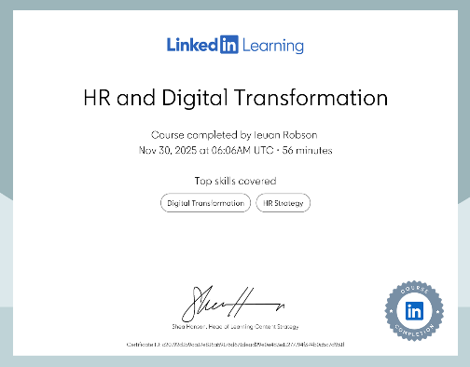
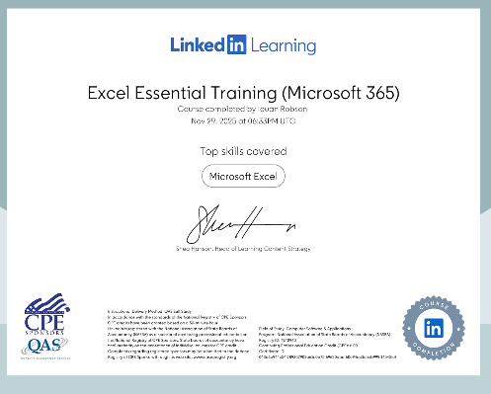
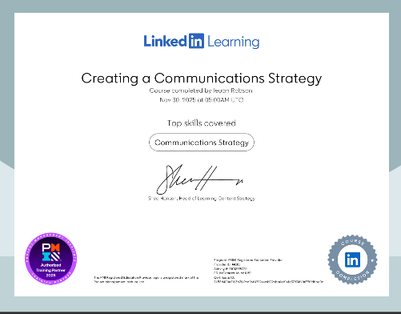

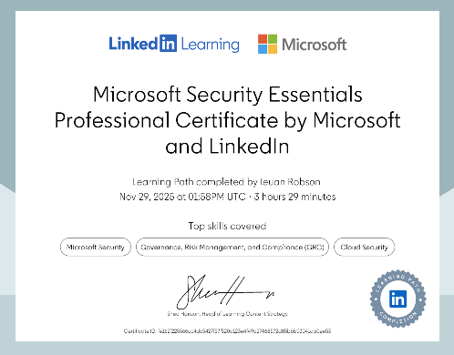
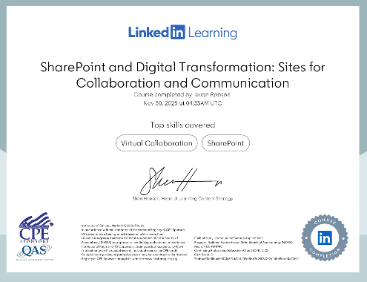
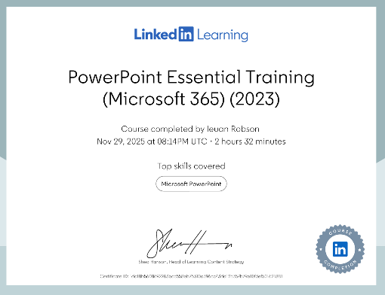

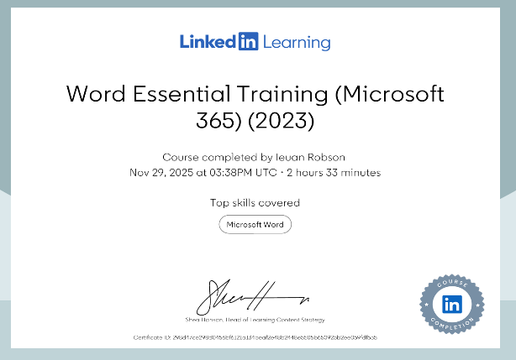
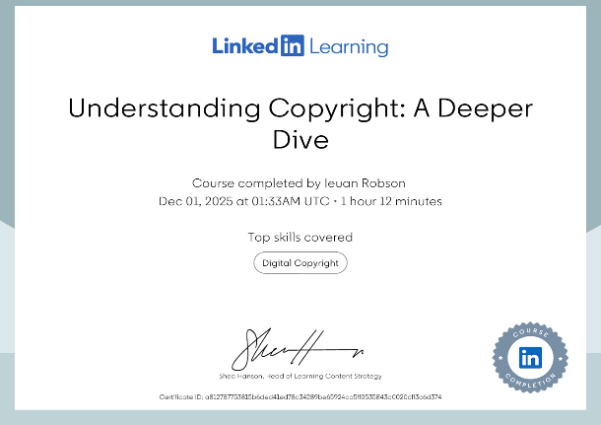

LinkedIn Learning has played an important role in developing my digital skills. The certificates I have gained demonstrate my commitment to continuous learning and professional development, particularly in Office 365 and digital transformation. Through these courses, I have improved my confidence and efficiency in using tools such as Word, Excel, PowerPoint and SharePoint, while also gaining a better understanding of communication, security and digital collaboration. These certifications have strengthened my digital literacy and better prepared me for modern workplace environments.

Essay on Relevance of Excel in professional and personal life.
Excel remains one of the most practical and widely used digital tools in both everyday life and the professional workplace. Its lasting relevance comes from how adaptable it is. Excel can be used for simple tasks like listing expenses, but it also offers advanced features for analysis, forecasting, and reporting. As Excel has continued to develop, it has become easier to use while also becoming more powerful, making it suitable for both beginners and experienced users. Whether managing personal finances or supporting business decisions, Excel helps people organise information and make sense of numbers. In personal life, Excel is particularly useful for budgeting and managing finances. Many people find it difficult to keep track of spending, especially when payments are mostly digital. Excel helps by turning everyday spending into something visible and structured. By recording income and expenses in a spreadsheet, users can clearly see where their money is going and how much they have left. Categories such as bills, food, travel, and leisure make spending easier to understand. Microsoft highlights that using structured expense tracking helps people stay consistent and feel more in control of their finances. Excel’s budgeting templates also make it accessible to those who may not feel confident creating their own spreadsheets. Excel also plays an important role in financial planning. It allows users to set savings goals and monitor progress over time, whether they are saving for emergencies, holidays, or large purchases. By comparing income against fixed and variable costs, Excel helps users make realistic decisions about what they can afford. Visual tools such as charts and graphs make progress easy to understand at a glance, while conditional formatting can highlight areas where spending is getting out of control. Microsoft’s household budgeting guidance explains how comparing planned spending with actual results helps people adjust their habits before problems develop. Over time, this builds confidence and encourages better money management. Beyond finance, Excel is useful in many areas of everyday life. People use it to plan events, organise study timetables, track fitness goals, manage household tasks, and compare prices when making important decisions. Excel is especially helpful for exploring “what-if” scenarios, such as how a change in rent or bills might affect monthly finances. Keeping information stored over time also allows patterns to appear, such as rising costs or seasonal spending, which can be difficult to notice without organised records. In the professional workplace, Excel is equally valuable and is used across a wide range of industries. Many organisations rely on Excel to manage data, track performance, plan budgets, and support decision-making. One of Excel’s greatest strengths is that it is widely understood, making it easy for teams to share and collaborate. Employees use Excel to create schedules, manage projects, track stock, forecast finances, and store key information. Its ability to combine calculations, organisation, and visual presentation in one tool makes it extremely efficient. Excel’s advanced features make it especially useful for business tasks such as projections and forecasting. By using formulas and structured tables, businesses can estimate future income, expenses, and growth based on existing data. These projections help managers plan ahead, assess risks, and make informed decisions. Graphs and charts allow this information to be presented clearly, making trends and comparisons easier to understand for both technical and non-technical audiences. Another key reason Excel remains so relevant is its ability to handle and prepare data. Workplace data often comes from different systems and is not always organised. Power Query allows users to import, clean, and combine data efficiently. Microsoft explains that Power Query helps automate these processes, making reports more reliable and reducing the need for repetitive manual work. Best practice guidance also highlights how this improves accuracy and saves time, especially when data needs to be updated regularly. Excel is also a powerful tool for analysis. Features such as formulas, PivotTables, and charts help users summarise large amounts of information and identify patterns. Managers can use Excel to review performance, finance teams can use it for forecasting, and project teams can track deadlines and progress. Even in workplaces that use more advanced data systems, Excel is often used for quick analysis and validation because it is flexible and familiar. Excel has continued to advance by introducing features that make spreadsheets easier to use and understand. Improvements such as dynamic formulas, better text functions, and automation tools have reduced the need for complex workarounds. These developments make spreadsheets clearer, easier to maintain, and more accessible to a wider range of users. More recently, Excel has introduced AI-assisted tools that help users work more efficiently. Microsoft explains that these features can assist with tasks such as explaining formulas, summarising data, and supporting analysis. While users still need basic spreadsheet knowledge, these tools reduce the learning curve and help users focus more on understanding the data rather than struggling with technical details. Finally, Excel is not just about numbers; it is also a communication tool. Clear tables, graphs, and summaries help people explain information and support decisions. In personal life, this might involve sharing a household budget. In professional settings, it could mean presenting business projections or performance reports. Excel helps turn complex data into clear insights that others can easily understand. In conclusion, Excel remains highly relevant because it supports both personal and professional needs. It helps individuals manage budgets, plan finances, and organise everyday life, while also supporting business forecasting, data analysis, and communication in the workplace. As Excel continues to develop and improve, it remains a practical, reliable, and valuable tool in an increasingly data-driven world.

References
Kaplan (2023) Is Microsoft Excel still relevant? Kaplan Professional, available at: https://kaplan.co.uk/blog/features/is-microsoft-excel-still-relevant (Accessed: 12 December 2025).
LearnSignal (2024) The importance of Microsoft Excel in finance, LearnSignal, available at: https://www.learnsignal.com/blog/microsoft-excel-in-finance/ (Accessed: 12 December 2025).
School of Coding UK (2023) Importance of Microsoft Excel in business, School of Coding UK, available at: https://schoolofcodinguk.com/blog/importance-of-microsoft-excel-in-business/ (Accessed: 12 December 2025).
ICAEW (2025) How to supercharge your Excel analytics, Institute of Chartered Accountants in England and Wales, available at: https://www.icaew.com/insights/viewpoints-on-the-news (Accessed: 12 December 2025).
Microsoft (2024a) Track expenses with Excel spreadsheets, Microsoft Support, available at: https://support.microsoft.com (Accessed: 12 December 2025).
Microsoft (2024b) Manage your household budget in Excel, Microsoft Support, available at: https://support.microsoft.com (Accessed: 12 December 2025).
Procogia (2025) Why Excel remains a powerful analytical tool, Procogia Analytics, available at: https://procogia.com (Accessed: 12 December 2025).
Wall Street Prep (2023) Excel for financial analysis and modelling, Wall Street Prep, available at: https://www.wallstreetprep.com/knowledge/excel-definition-for-finance/ (Accessed: 12 December 2025).

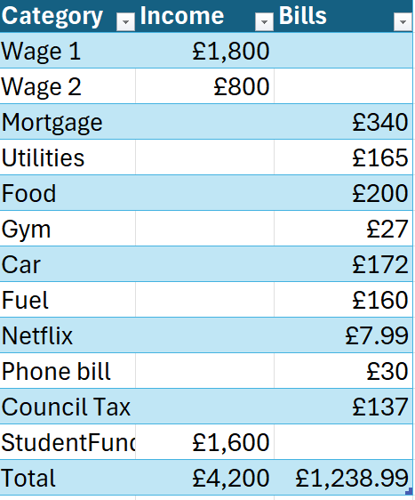

Embed your excel here

7 Minute Reflective Presentation

Embed PowerPoint here


