
ASSESSMENT 2
COMMUNITY ENGAGEMENT

STUDENT NAME: Diana Sharbanova
LECTURER NAME: AKINSEYE ALUKO
STUDENT ID: 2131741

Executive Summary
The current paper has provided an extensive understanding on the ways through which effective community engagement and community service delivery. In this paper, the knowledges on commonwealth games held in Birmingham and Olympic Games held in London have been used in a detailed and appropriate manner.

Table of Contents
1.0 Introduction 4
2.0 Main Discussion 4
2.1 Description of the differences between both projects 4
2.2 Comparison, analysis, and evaluation of best community engagement practices of both projects 5
2.3 Impact of active consultation, participation, and inclusion of stakeholders and communication 6
2.4 Community mapping and social engagement through the platforms of social media 7
2.5 Impact analysis, evaluation, and justification of best practices 9
2.6 Reflection (Reflect on what could have been done differently and why?) 10
3.0 Conclusion 12
Reference list 13

1.0 Introduction
Community engagement is one of the most vital aspects of world sports events. Communities participating in recreation and sports establish strong social bonds. The people living within a community of world sports are basically happier and healthier compared to places that do not take community engagement as a priority. In this following reflective report, I will reflect on the lessons gained from the entire study based on Olympics 2012 and Birmingham Commonwealth Games.

2.0 Main Discussion

2.1 Description of the differences between both projects
Both the Birmingham Commonwealth Games and the 2012 London Olympics were sports events of great success. That being said, there are a wide number of differences observed between these two sports events. This is pretty obvious considering how different their scales and mottos are, to begin with. The most important difference which sets the Olympic games and the Commonwealth Games apart from each other is the scale of their participants. According to Bauman et al. (2021), in the case of the Olympic 2012 sports projects, several countries across the world can participate to compete in it. On the other hand, however, the commonwealth game of Birmingham only allows for the participation of the countries that once were part of the British Commonwealth (Valencia-Forrester, 2020). This means only the countries that were once colonised by the British Empire can compete in the commonwealth games. Another very interesting difference observed between the Olympic games and the Commonwealth games are their para-sports events (Thurecht and Pelly, 2020). In the commonwealth games, the para-sports events are held along the able-bodied sports events unlike in the case of the Olympics and Paralympic events. This enables the athletes to socialise among themselves in a much more diverse environment. This is a major factor that branches out from the sports event scheduling of both these events.

2.2 Comparison, analysis, and evaluation of best community engagement practices of both projects
Both the projects selected in this paper have provided significant community engagement frameworks, as both the projects are sports event where, significant involvement of people from all around the world have been observed. In such respect, the community engagement practices that these projects have provided are immense and diverse.
As for Birmingham Commonwealth Games, the community engagement is definitely of a smaller scale because there are often fewer countries competing in it (de Ruyter et al. 2021). Therefore, the community is also much smaller when compared to that of the Olympic game 2012. Moreover, the engagement of community people, in delivering better services, particularly in terms of water supply, food items as well as cleaning the areas, dumping the garbage’s to the allocated places and a range of others have been there (birmingham2022, 2022).
Conversely, the community engagement process in the case of the Olympic game 2012 is far off in comparison to their scales (Aquilino et al. 2021). This massive arrangement requires to have an extensive preparation and planning in appropriate service delivery. Hence, about 250,000 people have signed up for volunteering the community services, which officially named as “Games Makers” out of whom 70,000 people have been selected to serve the people (Olympics, 2012). They have engaged with being “event stewards, drivers and welcome staff to supporting athletes and checking tickets. Others provided assistance with costumes, equipment and accreditation, or performed at the event ceremonies” (theconversation, 2022)
However, the differences become much more visible when taking the detailed analytics of community engagement into account.
As for the community engagement practices, both of these events make use of the contemporary social presence of the sports and engage the viewers through it. However, in the case of the Commonwealth game of Birmingham community engagement is observed to be done through television primarily (Valencia-Forrester, 2020). However, it is extremely different for the contemporary Olympic community engagement. This is because the observed way in which the Olympic game 2012 used to engage the community is not limited to a particular media (Naraine et al. 2019). This is mostly because of the difference in scale in both of these games. That is why the Olympics employ a far more widespread community engagement practice to ensure a proper endorsement of the events.
Both of these sports events as mentioned previously are extremely large-scale and are considered intercontinental (birmingham2022, 2022). This makes it obvious that their analytics will vary. However, the differences are far more when observed. As in the case of the Commonwealth Games of Birmingham, community engagement is far more sophisticated due to the royal family being a part of the entire community (Hamidu, 2021). On the other hand, the Olympic games do not bear such complexities and follow very standard procedures of community engagement at a much larger scale (Uittenbroek et al. 2019).

2.3 Impact of active consultation, participation, and inclusion of stakeholders and communication
As such massive sports events, the stakeholders and their management are extremely important factors. Both of the events share some differences in how they deal with the inclusion and management of their stakeholders. However, before getting into that it is advised to understand the types of stakeholders these sports events share. There is little to no difference in the types of stakeholders these events engage. Being divided into the Audience, athletes, sponsors, the members of the Olympic council, the government of the host country, and the staff (Lu and Lin, 2020). All of these stakeholders are engaged in various parts of both of these sports events.
Consultation: As for the process of consultation and inclusion of the stakeholders both of these events share very different views. As observed from the process Birmingham Commonwealth engages a much lesser number of overall stakeholders due to the scale of the event (Vest et al. 2022). However, they ensure the inclusion of athletes of all origins and allow seamless interaction and communication between them. This creates a higher level of stakeholder engagement and management at the same time while creating a much richer culture. The Olympic game 2012, on the other hand, focus on dividing their sports events due to the focus on them. As such the overall interaction and communication between the stakeholders were much lesser in Olympics 2012 compared to the commonwealth games (South et al. 2020).
Participation: As mentioned previously the proper participation of these stakeholders are extremely important to ensure the proper broadcasting of these events on a global scale. This means the stakeholders also hold a considerable influence over the financial aspects of these sports events. The active participants of the community service providers have specifically helped in addressing the event cleanly and without any issues.

2.4 Community mapping and social engagement through the platforms of social media
According to the study by Kyne and Aldrich (2020), community mapping is the development of strong social bonds with the communities in which an event is organised. Community mapping provides the opportunity for many people in a community to participate in sports events. Community mapping in Birmingham Commonwealth ensures a healthy and safe environment for the teams by complying with the Heal and Safety policy of the government (Chirgwin et al. 2021).
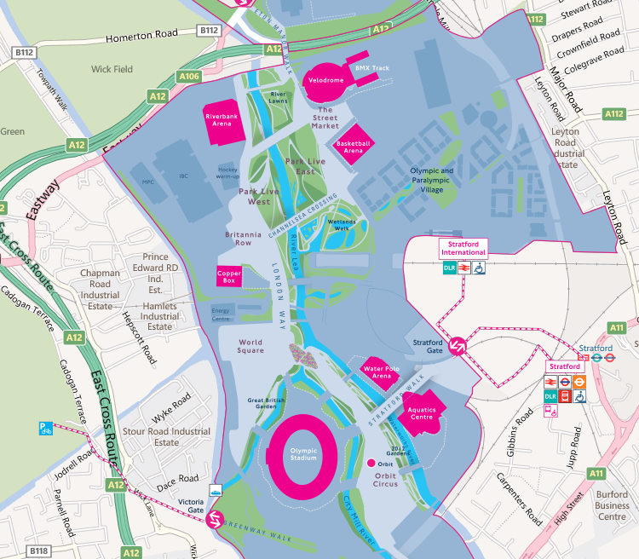
Figure 1: Community Mapping during Olympic Games, 2012
(Source: mappinglondon, 2012)
On the other hand, Olympics 2012 used some individuals and news media to map the data in the forum of a map (Usher, 2020). Birmingham Commonwealth commonly uses the means of television to promote sports events. However, the event was also promoted with the help of any website along with social media accounts related to cultural programs (McLoughlin et al. 2020). On the other hand, Olympic Games 2012 used a vast network of social media platforms for the promotion of the event. This was the first time that the organisers were betting big on social media platforms including Facebook. Facebook was the most popular social media promotion platform in Olympics 2012 (Sheldon et al. 2020).
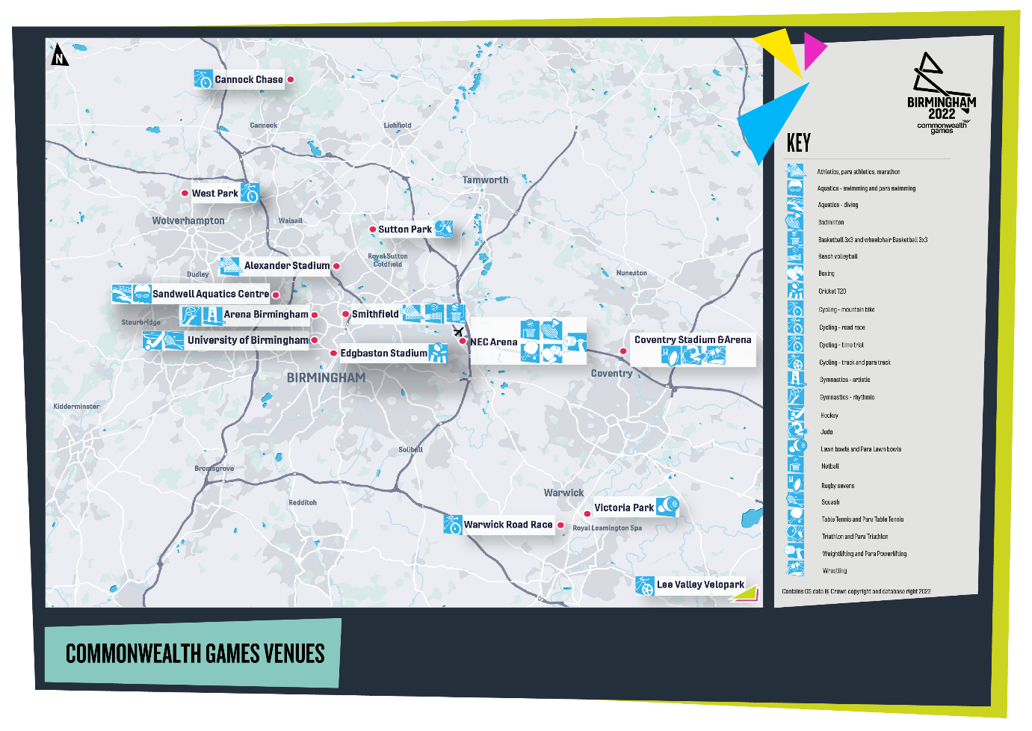
Figure : Community Mapping of Commonwealth Games
(Source: Commonwealth games, 2022)

2.5 Impact analysis, evaluation, and justification of best practices
Both the projects associated with sports events have provided extensive frameworks that strategically contributed to the success of the events. During the Olympic games, 2012, the Volunteers remained the lifeboat of the games and provided the wonderful arrangements in each section that help deliver spectacular games ever. Using easy to spot dresses that draws both the British Heritages with Regal purple and poppy red. Hence, according to the CEO of London Olympic 2012, Paul Deighton, “Delivering the Games is hard work and so the uniform needs to be functional, however, we also want our teams to wear it with pride”. This not only works towards addressing the changing requirements and helps the games to become grand successes. On other hand, the commonwealth games, 2022 also required to have the extensive engagement of volunteers, how helped worked delivering swift sports events and other arrangements. Particularly as drivers, first aiders, meet and greeters, venue preppers, kit careers and courtside assistants. Each of these components remained must crucial for the projects and worked towards providing a golden opportunity to transform the midlands and placing the spotlights on the UK. This observation has led to various conclusions depending on the perspective and results of the evaluation as a whole to be precise. On an entirely different note, there are that these events can adopt to achieve a higher level of performance for their desired processes as discussed earlier. As for Birmingham Commonwealth Games, they must reach out to a larger audience to improve their popularity across the globe (England, 2020). The event must understand that various sports enthusiasts do not belong to the commonwealth community. It is up to the event to reach out to such individuals for a higher degree of community engagement. As for the Olympics 2012, merging the Paralympic events with the main event can help in promoting better communication among the stakeholders as well as some better relationships (Kim and Manoli, 2022).

2.6 Reflection (Reflect on what could have been done differently and why?)
In the above discussion, it becomes clearer that the appropriate engagement with community services is very much effective in terms of enhancing professional career developmental opportunities. It not only helps strengthen the confidence level but also promotes motivation to its highest level which ultimately leads to effective career growth possibilities. Both the sports mega-events have provided extensive developmental opportunities for the volunteer service providers and the individuals who are willing to invest their time in volunteer services to deliver the best possible games events (Theconversation, 2022). In such respect, despite having significant success in both events, these have faced different challenges altogether. It also associates itself with a range of other events which are smothered to deliver and engage. The Olympic games, on the one hand, could have improved their volunteer recruitment procedure to a swifter manner. This could help the organisers to invest more times to improve the service delivery. I have also observed that the delivery of different community services where I have engaged including the first aid delivery people have also provided more robust and effective manner. It is understood that the Olympic games held in London, have provided extensive possibilities for people like us to understand and gain experiences for future professional career development opportunities (Mappinglondon, 2022). In such respect, I have developed different skills and expertise and knowledge, from my engagement in community services. The Olympic Games could also have developed strategies for providing appropriate training to different community engagement volunteers. These could be enhanced and might help the games to be more remarkable altogether.
In terms of Commonwealth games, the social media engagement remained most effective and critical for the delivery of crucial information regarding the volunteering activities in London. This also provided extensive strategies that associate with effective training and service management frameworks which also require proper training. community engagement is very much effective in terms of bringing more positive measurable changes to the community as well as the personal career developmental framework in a more robust and effective manner. Both the games organisations could have developed strategic frameworks on which diversified ways of information delivery. Particularly in terms of giving training to the first timers in community involvements.

3.0 Conclusion
The entire study has provided me with vital pieces of information regarding community engagement in the aspect of Olympic 2012 and the Birmingham Commonwealth games. I have learned that stakeholder engagement is one of the most crucial aspects of such world sports events. I have also gained lessons regarding the importance of social media platforms in engaging stakeholders and promoting the values of the games. The key difference between the two games is that Birmingham Commonwealth Game operates on a limited scale. On the other hand, Olympics 2012 consisted of a vast scale of operation. The lessons gained from the study would be beneficial for me and have provided me with certain career growth opportunities including communication and motivation.

Reference list
Aquilino, L., Harris, J. and Wise, N., (2021). A sense of rurality: Events, placemaking and community participation in a small Welsh town. Journal of Rural Studies, 83, pp.138-145.
Bauman, A.E., Kamada, M., Reis, R.S., Troiano, R.P., Ding, D., Milton, K., Murphy, N. and Hallal, P.C., (2021). An evidence-based assessment of the impact of the Olympic Games on population levels of physical activity. The Lancet, 398(10298), pp.456-464.
birmingham2022, (2022). Commonwealth Games. Available at https://www.birmingham2022.com/venues [Accessed on 16-11-2022]
Chirgwin, H., Cairncross, S., Zehra, D. and Sharma Waddington, H., (2021). Interventions promoting uptake of water, sanitation and hygiene (WASH) technologies in low‐and middle‐income countries: An evidence and gap map of effectiveness studies. Campbell Systematic Reviews, 17(4), p.e1194.
de Ruyter, A., Hearne, D., Beer, J. and Zaman, Y., (2021). Brexit, Birmingham and the 2022 Commonwealth Games: an opportunity for regeneration and rejuvenation?. Managing Sport and Leisure, 26(5), pp.413-428.
England, S., 2020). Active lives. Sport England. Available at: https://www. sportengland. org/know-your-audience/data/active-lives Accessed on, 14(5), p.20.
Hamidu, H.K., (2021). Community participation in managing public secondary schools: a case study of ward-based schools in the Morogoro region, Tanzania (Doctoral dissertation, University of Birmingham).
Kim, S. and Manoli, A.E., (2022). Does relationship quality matter in policy-making? The impact of government-public relationships and residents’ perceptions on their support towards a mega-sport event. International Journal of Sport Policy and Politics, 14(2), pp.207-224.
Kyne, D. and Aldrich, D.P., (2020). Capturing bonding, bridging, and linking social capital through publicly available data. Risk, Hazards & Crisis in Public Policy, 11(1), pp.61-86.
Lu, H.F. and Lin, H.W., (2020). Does the legacy governance of major sporting events affect urban development? The stakeholder's perspectives on the Taipei 2017 Universiade. International Journal of Sports Marketing and Sponsorship.
Mappinglondon, (2022). Mapping London Olympic Games. Available at https://mappinglondon.co.uk/2012/new-olympic-park-map/ [Accessed on 16-11-2022]
McLoughlin, L., Ward, S. and Lomas, D.W., (2020). ‘Hello, world’: GCHQ, Twitter and social media engagement. Intelligence and National Security, 35(2), pp.233-251.
Naraine, M.L., Wear, H.T. and Whitburn, D.J., (2019). User engagement from within the Twitter community of professional sport organizations. Managing Sport and Leisure, 24(5), pp.275-293.
Olympics, (2012). Volunteers: Helping to make the Games happen. Available at https://olympics.com/ioc/news/volunteers-helping-to-make-the-games-happen [Accessed on 16-11-2022]
Sheldon, P., Herzfeldt, E. and Rauschnabel, P.A., (2020). Culture and social media: the relationship between cultural values and hashtagging styles. Behaviour & Information Technology, 39(7), pp.758-770.
South, J., Woodall, J., Southby, K., Jones, R., Yates, G., Kinsella, K. and May, E., (2020). Volunteerism, social context and health impacts: a qualitative study of Glasgow Commonwealth Games event volunteers. Cities & Health, pp.1-13.
Theconversation, (2022). Why the London 2012 Olympics had limited impact on volunteering across the UK. Available at https://theconversation.com/why-the-london-2012-olympics-had-limited-impact-on-volunteering-across-the-uk-187305#:~:text=When%20London%20was%20preparing%20to,d%20done%20anything%20like%20this. [Accessed on 16-11-2022]
Thurecht, R. and Pelly, F., (2020). Key factors influencing the food choices of athletes at two distinct major international competitions. Nutrients, 12(4), p.924.
Uittenbroek, C.J., Mees, H.L., Hegger, D.L. and Driessen, P.P., (2019). The design of public participation: who participates, when and how? Insights in climate adaptation planning from the Netherlands. Journal of Environmental Planning and Management, 62(14), pp.2529-2547.
Usher, N., (2020). News cartography and epistemic authority in the era of big data: Journalists as map-makers, map-users, and map-subjects. New Media & Society, 22(2), pp.247-263.
Valencia-Forrester, F., (2020). The commonwealth games (2018) and event WIL: Inclusive action for journalism education. Asia Pacific Media Educator, 30(1), pp.92-107.
Vest, N., Hennessy, E., Castedo de Martell, S. and Smith, R., (2022). A Socio-Ecological model for collegiate recovery programs. Addiction Research & Theory, pp.1-8.

