

Student name: Ionut Claudiu Ungureanu
Student number: 2323114
Module: Creativity and Innovation (BMSW5031)
Assignment title: Critically detailing and discussing an innovative/creative solution to an operational problem
Lecturer: Chris Wilkin
Word count: 4000
Submission deadline: 31st March 2026 at 23:59

Executive Summary
Creativity and innovation are crucial in businesses to develop the overall business. Seren Coffi focused on generating innovative solutions in the business to deal with low resources and leadership threats in the business. Different frameworks, such as blue ocean application, become helpful for organisational climate development. From the second part, the key detail was gathered about the use of AI in generating the solution associated with the business problem. It had also provided the details about the contribution made by AI in the context of innovation and creativity. Furthermore, this study had also provided the solution generated by AI for the identified issue in the case study of Sereno Coffee.

Table of Contents
Part 1: 5
Introduction 5
Organisational overview 5
Issue in the organisation 5
Creativity and innovation concepts 5
Theories 5
Issues of creativity 6
Innovation issues 7
Creativity process and the context situation (Business model canvas) 10
Lewin’s Force Field analysis and value chain 12
Organisational climate 15
Conclusion 15
Part 2 17
Introduction 17
Use of AI in getting a solution to the Business problem 17
Contribution of AI in sustaining Creativity and Innovation 17
Issue 1: Creativity Issue 17
Copilot Solution 17
Reason for the arising of this issue. 18
The company's obligation to solve this issue. 18
The issues the company will face in implementing the solution 18
Mitigation strategy to solve the implementation issue 19
Justification 19
Issue 2: Innovation Issues 19
Copilot Solution 19
Reason for the arising of this issue. 20
The company's obligation to solve this issue. 20
Issues will be faced by the company in implementing the solution. 20
Mitigation strategy to solve the implementation issue. 20
Justification 21
Conclusion 21
References 22
Appendices 28
Appendix 1 28

Part 1:

Introduction
The study aimed to evaluate the creativity and innovation in the business process with a discussion about the key issues in it. The study is going to evaluate the case study of Seren Coffin and focus on its innovation and creativity in the business while focusing on its current business situation.

Organisational overview
Seren Coffi is an innovative coffee shop, and as per the case study, it has not been an ordinary coffee shop. It has focused on the innovation in business, as the chalkboard which has been by the door lists their origins, and cooperatives have been involved in the process. Students are able to enter the shop with laptops, and retired persons are able to read newspapers. The company has decided to start poetry readings and an informal language exchange. Hiring extra staff has been followed by the company, and fairness and community engagement have also been decided to be followed by the company.

Issue in the organisation
The company has been a startup, and a lack of budget has remained a serious issue for the company to complete its innovative aspects. Technical issues are presented in the company as the technicians have warned that servicing is needed in the espresso machine. Climate pressures have also created serious threats for the company, and that affected its innovation process. Fear of failures have been present in the business, and consistent maintenance has not been easy for the new startup in the market. Decision-making issues are also presented in the business, and that affects growth and innovation (Games et al. 2024).

Creativity and innovation concepts
Creativity
Creativity refers to the generation of new and original ideas in the business, and it leads to a competitive advantage. Long-term sustainability of the organisations is developed through this process. Creativity is the process of thinking outside the box in business, and new products and good quality of service have been resulted through creativity (Trott, 2016). Cognitive and emotional creativity are presented in the business, and companies are also focused on spontaneous creativity. New idea adoption and the development of the business process are also part of business creativity. Financial literacy and training are useful for creative performance in business (Rahmawati et al. 2023).
Innovation
Innovation refers to the practical implementation of creative ideas in the business. Value has been created in the business, and the business gets effective solutions for the problem solving in business through innovation. Innovation has been all about change, and that has helped in the development of business performance. Value has been created from the ideas in the business through following the innovation process (Tidd, 2018). Logistics and supply chain innovation are useful for business growth and development. Disruptive technologies have been used in the business by companies as that increased business innovation (Manners-Bell and Lyon, 2022).

Theories
De Bono’s six thinking hats of creativity
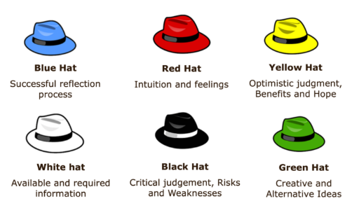
Figure 1: Six thinking hats
(Source: learning materials)
This theory is a creativity development theory that helps people to become more creative and productive in business. Blue hat refers to successful reflection, red hat refers to intuition and feelings, and yellow hat is the optimistic judgment. White hat supported available information, black hat focused on the critical judgements and green hat focused on the creative ideas. Organisations though following this theory are able to generate creative business ideas (Vedawala et al. 2024). This model is criticised due to its artificial and time-consuming nature. Multiple thinking at one time has not been possible, and that becomes a serious issue (Majed, 2022).
Rogers’ theory of innovation
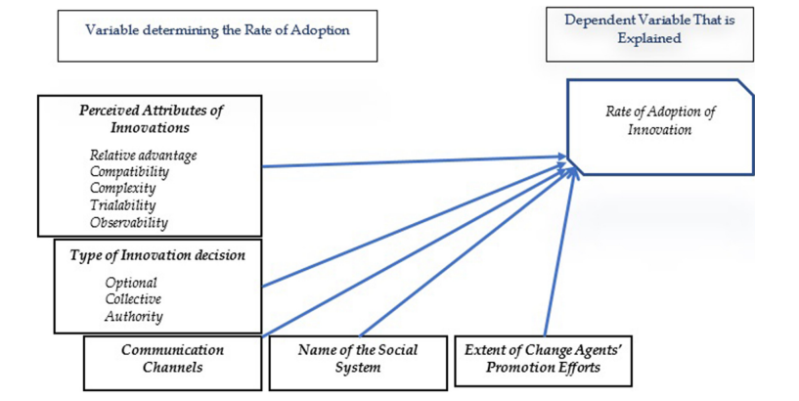
Figure 2: Rogers’ innovation theory
(Source: Menzli et al. 2022)
Rogers' theory application mainly focused on the generation of new ideas in the business. Companies through focusing on this theory, could be able to develop communication channels and social systems. Through this theory, individuals become able to participate in business innovation, and that helped in business development (Menzli et al. 2022). This theory is criticised due to the presence of pro-innovation bias. Application in different business contexts has not been easier, and that has become a serious issue (Van Houtven et al. 2023).

Issues of creativity
Fear of failure
Fear of failure has become a serious threat that affected the business creativity. Seren Coffi is the new coffee shop in the market and faces threats from its competitors. It increases the threat of failure among the company representatives, and the business gets affected. Risks are presented in the new business, and that affects the business performance and innovative management of risks is necessary (Pomaza-Ponomarenko et al. 2023).
Lack of effective leaders
In Seren Coffi, there have not been experienced leaders and managers presented. It affected the creativity processes as the employees were not properly guided through the innovative process in the business. Leadership feedback has been missing in the company that affected the entire creativity of the business process. Successful leaders generated creativity, and that has been missing in the company (Vukadinović, 2022).
Shortage of talent
Talent shortage is also a serious issue in the company that affects the creativity process. The company has not been able to hire the right candidates for the coffee shop, and that has created serious difficulty. Customer service has not been possible, and the sense of creativity has been missing in some contexts of the existing staff (Balková et al. 2022).

Innovation issues
Lack of adaptability
Seren Coffin lacks adaptability as new and innovative technological options have not been adopted properly in the business. Customers have not gotten proper care as per their requirements, as the company has not focused on this matter. Goodwill maintenance has been followed by the company, while it has not followed the update of the business process, which created innovation difficulty (Anshari and Almunawar, 2022).
Technical issues
The company suffered from a technological issue as technicals have warned the company about this. Technological failure remained a serious threat in the innovation process, and that created difficulty for the business. Fewer people have been added for the technological upgradation, and that has created difficulty in the business. Technological innovation and environmental sustainability have to be balanced in the business process (Chauhan et al. 2024).
Resource and financial constraints
As a startup, the Seren Coffin lacks resources such as financial resources, which affected the business process. Due to a shortage of workers and government support, the company faced difficulty in the innovation process. Business operations get affected due to a lack of financial sources and financial management is needed (Egorov, 2022).
4P of Innovation
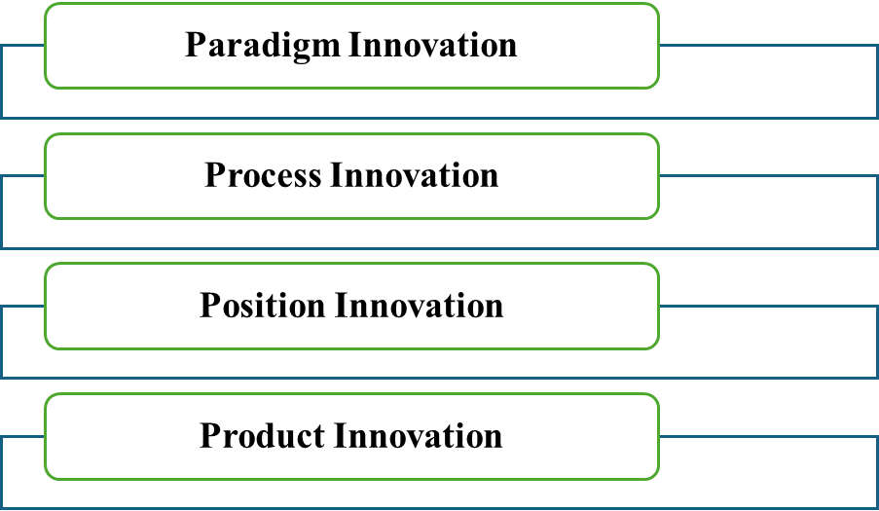
Figure 3: 4Ps of innovation
(Source: Self-created)
The 4Ps of innovation is the strategy framework that helped in leveraging innovation and driving the success of the company. Innovation strategies following this model are able to develop the quality of the product or service, and creativity enhancement have become easier (Lucidity, 2025).
Paradigm Innovation
Sereno Coffee is the Coffee shop that focuses on the new way of thinking application in the business. A subscription model is decided to be used, and a coffee studio will be followed in which students will come with laptops, and the retired persons will come and read the newspaper. Automation and technology focusing have been followed by the company and that innovation led the company to develop its business performance. Poetry culture has been decided to start by the company, and supplying coffee for civic events has also been followed by the company (Bager et al. 2022).
Process Innovation
Changes in the traditional coffee shop development have been followed by the new startup. Digitalisation would be preferred more in business, and that could be helpful for the development of business performance. Automation has been directing new outlets going to focus on the development of the business, and disruptions should be avoided in the business. “Just to steady things” has been followed in the business, and that could be effective for the business performance. Mobile coffee shop operation has become an effective process that helps in the fast delivery of the products to the customers (Hidayat, 2025).
Position Innovation
Seren Coffi decided to open the shop in Cardiff, and the shop will occupy the narrow unit near the old docs, and the vape store will be opened. Travel well feature has also been focused to attract the consumers to the business, and customers have appreciated the transparency that the company has followed in the market. Creative solutions have been followed in the business and governance, and suppliers have not been changed by the company (Rahmania, 2024).
Product Innovation
Innovations such as better quality of the beans used for coffee production. This product has been different from other coffee shops, and the stock pastries have also been focused on in the business. Reclaimed chapel pews have been included in the product, and the tables of the shops have been built by a local carpenter. Product innovation helped in the attractiveness development of the products, and that enhanced business performance (Salma et al. 2023).

Creativity process and the context situation (Business model canvas)
Business model canvas (BMC) is a useful framework that deals with new startup launching and its creativity and innovation management. This framework helped companies to reconfigure how organisations created and delivered value in the business (Fakieh et al. 2022).
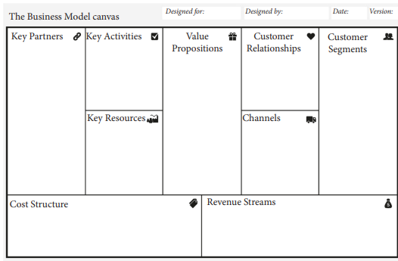
Figure 4: BMC
(Source: Fakieh et al. 2022)
Key partners
In the company, there are not that many partners of Seren Coffi as it has been a startup. Seren Coffi, focused on partnership with the small companies in Cardiff to develop business innovation and understand local culture (Turner, 2020).
Key activities
Innovative business activities are followed by the company, and good coffee products have been introduced. Cultural activities such as poetry readings and exchange of informal languages become effective business activities (Trott, 2016).
Key resources
Resources such as financial resources of almost £2000 are available and that are going to be used for the business. Extended opening hours and better quality of coffee beans have become effective resources of the company (Foss, 2015).
Value proposition
Good quality of coffee product and innovation generation have followed in the business to develop the business. Options such as cultural support and a relaxing atmosphere in the shop have become effective for the creation of value (Turner, 2020).
Customers segments
Different age groups of consumers are targeted by the company, and that becomes useful for the development of business success. The company focused on targeting students with laptops, while older persons also got chances for better conversations and felt like validation (Trott, 2016).
Customer relationship
Consumer relationships would be developed, and the company has decided to allow students with laptops and retirees with newspapers. Customers have noticed that the praised care and the community development have been followed in the business (Chesbrough, 2014).
Channels
Online channels such as Facebook and Instagram will be effective in targeting the consumers. Offline channels, such as the use of leaflets and magazine promotion, would attract consumers to the business (Trott, 2016).
Cost structure
Prices are raised in the business, and a cost breakdown has been followed by the company. £2000 has been presented in terms of cash in the business, and that helped the company to generate creative solutions in the business.
Revenue streams
The savings and some support from the investors are becoming key streams for the business revenue. Advertising fees have also been presented that helped in the development of the business.

Lewin’s Force Field analysis and value chain
Lewin’s Force Field
Lewin’s form fielded changes focused on the driving forces and restraining forces that helped in the change management. Changes, obstacles and opportunities have been identified easily through this process (Change Management Coach, 2025).
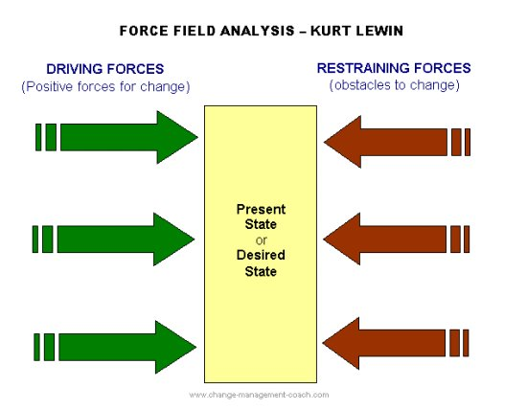
Figure 5: Lewin Forces
(Source: Change Management Coach, 2025)
Driving forces
Innovation and creativity are the most effective driving forces that lead towards the changes in business. Seren Coffi, through innovation, made changes in the business, and good quality of beans have been included in the products. The company, on the other hand, focused on the development of a good atmosphere in the business. Open innovation has become effective in the business as it has helped in business promotion (Chesbrough, 2014).
Restraining forces
Low cost of the company has become a serious threat for the company to affect the business. In the business, lack of better investors also became a serious threat that affected the driving of the change in business. The coffee shop in future would suffer from the high competition in the business, and that could affect the overall business performance of the company. Lack of talent management and an employee experience shortage have created threats in the business of the company (Fakieh et al. 2022).
Value chain
Porter’s value chain analysis becomes useful for the understanding of the competitive advantage of the company by focusing on different inbound and outbound logistics. Management perspective formation has become easier through this process, and that helped in the business development (Eisenreich et al. 2022).
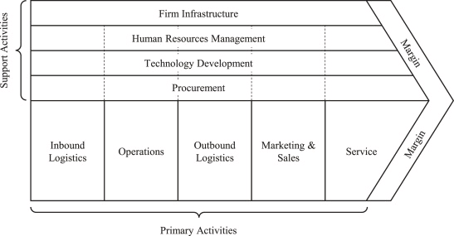
Figure 6: Value chain
(Source: Eisenreich et al. 2022)
Firm Infrastructure | The quality management system application has been effective for the development of the company’s business.
Human resources | Incentives are provided to the employees and focused on hiring good team members in the business.
Technology development | Automation focusing and giving consumers a better quality of service through a good quality technological system (Maulana, 2023).
Procurement | Coffee machines, the development and production of cups and furniture.
Inbound logistics | Operations | Outbound logistics | Marketing and sales
Beans sourcing and management of the relationship with the suppliers in business (Foss, 2015). | Focused on innovation and creativity, such as interior operational development. | Coffee serving to all age groups and management of the inventory in the business process. | Online marketing challenges are used, such as Facebook and Instagram marketing processes in the business (Deveau et al. 2023).
Table 1: Value chain

Organisational climate
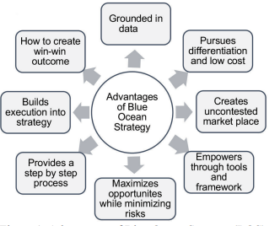
Figure 7: Blue ocean
(Source: Awladthani et al. 2023)
Blue ocean strategy application in the evaluation of the organisational climate analysis. New market space creation has become easier through the application of this strategy in the business. Unknown market space analysis could become easier through this strategy application in the business. Sustainable growth of Seren Coffi could become easier through this model application in the business. Sustainability generation in the business has become easier through applying this theory. Seren Coffi, through the application of this strategy, could become able to understand the creation of win-to-win situations (Awladthani et al. 2023). This theory is criticised due to a lack of a proper implementation protocol in the business. Practical applicability has also been lacking in the business, and that becomes its key criticism. The company through focusing on this theory, could be able to improve the sustainable outcome in the business. Reduction of carbon emission could become easier, and the sustainable growth could be enhanced (Nasereddin, 2023).

Conclusion
It has been concluded that innovation is useful for business development. Creativity helped in the generation of new ideas in the business, and that helped in the business performance. Seren Coffi, through focusing on innovation and creativity, would be able to generate better business success in the future.

Part 2

Introduction
The key detail will be provided about the use of AI in generating the solution associated with the business problem. It will also reflect the information related to the contribution made by AI in the context of innovation and creativity. Furthermore, this study will also provide the solution generated by AI for the identified issue in the case study of Sereno Coffee. It will also generate the reason associated with the issue within the case study.

Use of AI in getting a solution to the Business problem
The AI can play an effective role in generating solutions related to the business problem. The solution can be generated from this tool as it helps in unlocking the groundbreaking efficiency of the business. It also helps in providing deep insight along with the growth opportunities. It has also been found that through the use of this tool, they can get the solution that enhances the competitive landscape (Downie and Finio, 2025).

Contribution of AI in sustaining Creativity and Innovation
The AI plays a significant role in sustaining creativity as it provides the opportunity to enhance the mindset of people. It also provides support in adopting creative learning, which helps in solving the identified issue effectively (Henriksen et al. 2024). Furthermore, the use of AI also leads to supporting innovation through leveraging the intelligence, along with promoting higher education. It also contributes towards bridging the accessibility gap and promoting innovation as well (Allam et al. 2025).

Issue 1: Creativity Issue
From the given case study, the company Sereno Coffee faced a creativity issue, which comprised the fear of failure, a lack of effective leaders, and a shortage of talent.

Copilot Solution
The solution for the issue of fear of failure, being provided by AI (MS Copilot), is to introduce the “Safe-to-Fail” experiment. This solution deals with providing support to the creative ideas that reinforce the learning culture. Furthermore, the solution associated with the issue of a lack of effective leaders being provided by AI is to adopt a shared leadership model. It helps in deciding the captain every week. Moving to the next solution related to the issue of shortage of talent includes adopting the strategy of a community talent pool by Sereno Coffee. It helped in promoting the skilled exchange system within the company [Appendix 1].

Reason for the arising of this issue.
From the AI (MS Copilot), the reason behind the occurrence of the issue is identified. It has been found that the high emotional investment and the financial fragility led to the issue of fear of failure in Sereno Coffee. Furthermore, with the influence of fatigue and avoidance of hierarchy, the issue of a lack of effective leaders is being addressed. Through the repeated debate, which drained the energy of leaders in the Sereno Coffee. Furthermore, the reason for the shortage in talent arises due to the high volunteer dependency [Appendix 1].

The company's obligation to solve this issue.
By considering the result of AI (MS Copilot), it was found that Sereno Coffee holds the obligation of creating a safe environment for employees to avoid the issue of fear of failure. Furthermore, the company also leads to promoting decision-making strategy and resilience to avoid the issue of a lack of effective leadership. The company needs to develop a clear set of leadership to ensure accountability within the operation. Finally, the company also needs to attract talent from the community by offering growth opportunities. This is the obligation that Sereno Coffee needs to consider avoiding such issues from occurring [Appendix 1].

The issues the company will face in implementing the solution
Undertaking the results of AI (MS Copilot), it was found that Sereno Coffee will face several issues in implementing the strategy provided by AI. It found that it can face resistance to change issues from the existing employees. To mitigate the second issue, the company can deal with the issue of delayed decisions and confusion through clearer accountability. Towards implementing the solution for talent shortage, the company can deal with the issue of the mismatch of skills. Due to the lack of professional skills, the company is unable to implement the solution obtained from AI [Appendix 1].

Mitigation strategy to solve the implementation issue
From the AI, different mitigation strategies are being obtained that can help in avoiding the implementation issue. It comprises considering the peer reinforcement along with normalising the setback. Furthermore, the mitigation strategy also comprises adopting the conflict management strategy, along with supporting the structured volunteer program. This can help in implementing the obtained solution effectively [Appendix 1].

Justification
From the external analysis, it was found that the solution provided by the AI is appropriate, as the use of creative ideas can avoid the issue of fear of failure within the organization. This issue can be avoided with the adoption of the latest technology to keep the relevant notes (Wallis, 2025). Furthermore, it has also been identified that with the promotion of the shared leadership model, the business enables the opportunity of enhancing its performance by integrating the different knowledge and experience of the leaders (Groh, 2025). From the external research, it has also been obtained that the community talent contributes towards the growth of the business as the local staff holds a high ability to meet the business needs. These community staff have prior knowledge of meeting the customers (Ardi et al. 2024).

Issue 2: Innovation Issues
From the given case study, the company Sereno Coffee faced an innovative issue, which comprised a lack of adaptability, technical issues, and resources & financial constraints.

Copilot Solution
The solution related to the lack of adaptability provided by the AL (MS Copilot) comprises adopting the strategy of agile experimentation. It helps Sereno Coffee in making quick adjustments without incurring high costs. Furthermore, the solution associated with the technical issue obtained from AI is to provide the community with technical support. It enables the company to get maintenance services in exchange for coffee credits. Finally, the solution associated with the resources & financial constraints comprises adopting a micro-investment environment [Appendix 2].

Reason for the arising of this issue.
The AI also provided a reason behind the occurrence of the issue, which comprises the right process of making the decision. It contributed to raising the issue of the lack of adaptability. Furthermore, the reason behind the technical issue faced by Sereno Coffee includes using aging and outdated equipment with limited technical expertise. Then the reason associated to the issue of resources and financial constraints also comprises an inappropriate funding strategy and the competitive pressure [Appendix 2].

The company's obligation to solve this issue.
AI (MS Copilot) leads to provide an obligation that Sereno Coffee holds towards meeting the issue if there is a lack of adaptability, including remaining responsive to the community's needs. It also needs to build flexibility in its operation. Furthermore, the company's obligation towards solving the technical issue comprises maintaining functional tools and other infrastructure. Then the obligation related to the issue of financial constraints is that Sereno Coffee needs to balance financial sustainability [Appendix 2].

Issues will be faced by the company in implementing the solution.
AI (MS Copilot) highlighted the issues that Sereno Coffee can face at the time of implementing the solution, including cultural resistance and decision fatigue. The implementation issue associated with the solution of the technical difficulty faced by Sereno Coffee includes limited expertise and the delay of the supply chain. Due to the ethical sourcing, along with the part shortage, it creates difficulty in solving the technical issues. Finally, the implementation issue for the solution of financial constraints comprises facing volunteer inconsistency [Appendix 2].

Mitigation strategy to solve the implementation issue.
With the influence of AI, the mitigation strategy that Sereno Coffee can use to avoid implementation issues includes structured experimentation. It also ensures clear communication to make a rational decision. Furthermore, the mitigation strategy associated with the next implementation issue will include supporting the community repair partnership. Finally, adopting the strategy of phase spending and the community contribution scheme will help Sereno Coffee in avoiding the implementation issue for the solution of financial constraints [Appendix 2].

Justification
Conducting the external research, it was found that the solution provided by the AL is appropriate. It has been found that this solution can provide the opportunity to bring rapid changes by adapting to market conditions and changes in consumer demand (Alchemy Solutions, 2025). Furthermore, the external research also reveals that the other solution provided by the AI is effective, as getting community technical support enables the company to promote networking. It will help in getting the growth opportunity to the business as well (Timmes, 2023). Finally, the solution of adopting a micro-investment environment is accurate to resolve the issue of resource and financial constraints. It also helps in eliminating the scenario of financial credit issues (Ayalu et al. 2023).

Conclusion
The information was gathered about the use of AI by the business in generating an appropriate solution for their issues. It had also provided the contribution of AI towards sustaining innovation and creativity. It had shown the solution from the AI, which was MS Copilot, about the creativity and innovation issue faced by Sereno Coffee. It also deals with justifying the AI solution with the external research.

References
Part 1
Anshari, M. and Almunawar, M.N., (2022). Adopting open innovation for SMEs and industrial revolution 4.0. Journal of Science and Technology Policy Management, 13(2), pp.405-427. Link: https://www.emerald.com/jstpm/article-pdf/13/2/405/1683765/jstpm-03-2020-0061.pdf
Awladthani, F.S., Porkodi, S., Saranya, R. and Pandurengan, V.A.I.D.E.H.I., (2023). A systematic literature review of the adoption of a blue ocean strategy by small and medium enterprises for sustainable growth. Journal of Sustainability Science and Management, 18(2), pp.197-230. Link: https://jssm.umt.edu.my/wp-content/uploads/sites/51/2023/06/14-JSSM-Volume-18-Number-2-February-2023-FINAL.pdf
Bager, S.L., Düdder, B., Henglein, F., Hébert, J.M. and Wu, H., (2022). Event-based supply chain network modeling: Blockchain for good coffee. Frontiers in Blockchain, 5, p.846783. Link: https://www.frontiersin.org/journals/blockchain/articles/10.3389/fbloc.2022.846783/pdf
Balková, M., Lejsková, P. and Ližbetinová, L., (2022). The values supporting the creativity of employees. Frontiers in Psychology, 12, p.805153. Link: https://www.frontiersin.org/journals/psychology/articles/10.3389/fpsyg.2021.805153/pdf
Change Management Coach (2025) Lewin’s force field analysis explained, Change Management Coach. Available at: https://www.change-management-coach.com/force-field-analysis.html (Accessed: 17 March 2026).
Chauhan, D., Mewada, H., Gondalia, V., Almalki, F.A., Patel, S., Modi, H., Kavaiya, S., Trivedi, Y. and Mujlid, H.M., (2024). Balancing technological innovation and environmental sustainability: a lifecycle analysis of 6G wireless communication technology. Sustainability, 16(15), p.6533. Link: https://www.mdpi.com/2071-1050/16/15/6533
Chesbrough (2014) New Frontiers in Open Innovation. Oxford: Oxford University Press.
Deveau, R., Griffin, S.J. and Reis, S., 2023. AI-powered marketing and sales reach new heights with generative AI. McKinsey & Company. Link: https://183degrees.com/wp-content/uploads/ai-powered-marketing-and-sales-reach-new-heights-with-generative-ai.pdf
Egorov, A., (2022). Financial innovation and financial risks. Procedia Computer Science, 214, pp.441-447. Link: https://www.sciencedirect.com/science/article/pii/S187705092201907X/pdf?md5=424d4eebe52ed72cb93c5091ff580a8d&pid=1-s2.0-S187705092201907X-main.pdf
Eisenreich, A., Füller, J., Stuchtey, M. and Gimenez-Jimenez, D., (2022). Toward a circular value chain: Impact of the circular economy on a company's value chain processes. Journal of Cleaner Production, 378, p.134375. Link: https://www.sciencedirect.com/science/article/pii/S0959652622039476
Fakieh, B., AL-Malaise AL-Ghamdi, A.S. and Ragab, M., (2022). The effect of utilizing business model canvas on the satisfaction of operating electronic business. Complexity, 2022(1), p.1649160. Link: https://onlinelibrary.wiley.com/doi/pdf/10.1155/2022/1649160
Foss, N. J. (2015) Business Model Innovation: the organisation dimension, 1st edn. Oxford: Oxford University Press.
Games, D., Sari, D.K., Khairiyyah, N. and Shaikh, H.A., (2024). Entrepreneurial fear of failure and well-being of incubated and non-incubated startups during crises. Journal of Science and Technology Policy Management, 15(5), pp.948-962. Link: https://www.emerald.com/jstpm/article-pdf/15/5/948/9458285/jstpm-03-2022-0052.pdf
Hidayat, S., (2025). An Exploration of Product and Process Innovation Practices in Mobile Coffee Shop Operations in Banda Aceh City: A Compliance Perspective on Sharia Law and Its Implications for Customer Satisfaction. Al-Mubin: Islamic Scientific Journal, 8(1), pp.227-240. Link: https://jurnal.iuqibogor.ac.id/index.php/almubin/article/download/2222/1159
Lucidity (2025) 4Ps of innovation strategy: A Framework for Effective Innovation, Lucidity. Available at: https://getlucidity.com/strategy-resources/fries-with-ketchup-the-4ps-of-innovation-strategy/ (Accessed: 17 March 2026).
Majed, S.S., (2022). The effectiveness of the six thinking hats strategy in testing the cognitive achievement of handball basic skills. SPORT TK-Revista EuroAmericana de Ciencias del Deporte, 11, p.20. Link: https://digitum.um.es/bitstreams/a0b08c28-50f3-4631-b90b-d32d32774b2e/downloadbv
Manners-Bell, J. and Lyon, K. (2022). Logistics and Supply Chain Innovation: A practical guide to disruptive technologies and new business models. 2nd edn. London: Kogan Page.
Maulana, W., (2023). Development and analysis of a unified mobile app for Coffee Shop operations and ordering experience: a proposal review. International Journal of Information Technology and Computer Science Applications, 1(3), pp.161-173. Link: https://pdfs.semanticscholar.org/d800/44776fe0fe5080c4a2864c7a9bb084350d58.pdf
Menzli, L.J., Smirani, L.K., Boulahia, J.A. and Hadjouni, M., (2022). Investigation of open educational resources adoption in higher education using Rogers’ diffusion of innovation theory. Heliyon, 8(7). Link: https://www.cell.com/heliyon/pdf/S2405-8440(22)01173-2.pdf
Nasereddin, A.Y., (2023). Impact of the blue ocean strategy dimensions in achieving competitive advantage from the perspective of faculty members. Information Sciences Letters, 12(6), pp.2685-2698. Link: https://www.naturalspublishing.com/download.asp?ArtcID=25954
Pomaza-Ponomarenko, A., Kryvova, S., Hordieiev, A., Hanzyuk, A. and Halunko, O., (2023). Innovative risk management: identification, assessment and management of risks in the context of innovative project management. Economic Affairs (New Delhi), 68(4), pp.2263-2275. Link: https://www.researchgate.net/profile/Alina-Pomaza-Ponomarenko-2/publication/377278762_Innovative_Risk_Management_Identification_Assessment_and_Management_of_Risks_in_the_Context_of_Innovative_Project_Management/links/65d5a6dfe7670d36abcacf43/Innovative-Risk-Management-Identification-Assessment-and-Management-of-Risks-in-the-Context-of-Innovative-Project-Management.pdf
Rahmania, M.D., (2024). The Effect of Market Orientation, Innovation, and Entrepreneurial Orientation to the Competitive Advantage of the Independent Coffee Shops in Indonesia. Technoarete Journal on Advances in E-Commerce and E-Business,(4), pp.1-11. Link: https://technoaretepublication.org/ecommerce-and-ebusiness/article/effect-of-market-orientation.pdf
Rahmawati, A., Wahyuningsih, S.H. and Garad, A., (2023). The effect of financial literacy, training and locus of control on creative economic business performance. Social Sciences & Humanities Open, 8(1), p.100721. Link: https://www.sciencedirect.com/science/article/pii/S2590291123003261
Salma, A.S., Hamdani, N.A. and Nugraha, S., (2023). The Influence of Product Innovation and Organizational Innovation On Culinary Business Performance Of Small And Medium Enterprises. Business Innovation and Entrepreneurship Journal, 5(4), pp.275-283. Link: https://ejournals.fkwu.uniga.ac.id/index.php/BIEJ/article/download/695/277
Tidd, J. (2018) Managing Innovation: integrating technological, market and organizational change. 6 th edn.Hoboken: Wiley
Trott, P. (2016) Innovative management and new product development. 6 th edn. Harlow: Pearson.
Turner, E. (2020) Be Less Zombie: How great companies create dynamic innovation, fearless leadership and passionate people. Chichester: Wiley
Van Houtven, C.H., Drake, C., Malo, T.L., Decosimo, K., Tucker, M., Sullivan, C., D’Adolf, J., Hughes, J.M., Christensen, L., Grubber, J.M. and Coffman, C.J., (2023). Ready, set, go! The role of organizational readiness to predict adoption of a family caregiver training program using the Rogers’ diffusion of innovation theory. Implementation science communications, 4(1), p.69. Link: https://link.springer.com/content/pdf/10.1186/s43058-023-00447-x.pdf
Vedawala, N.P., Thakrar, S.J., Thakrar, J.V., Patel, P.G. and Patel, Y.G., (2024). Six Thinking Hats model of learning—Creative teaching method in physiotherapy—A pilot study. Journal of Education and Health Promotion, 13(1), p.24. Link: https://journals.lww.com/jehp/_layouts/15/oaks.journals/downloadpdf.aspx?an=01679914-202402070-00024
Vukadinović, M., (2022). Creativity and leadership. International Journal of Economic Practice and Policy, 19(1), pp.63-75. Link: https://aseestant.ceon.rs/index.php/skolbiz/article/download/41391/24516/
Part 2
Alchemy Solutions (2025) Why agility is important to building an adaptive business , Alchemy Solutions. Available at: https://alchemysolutions.com.au/learn/why-agility-is-important-to-building-an-adaptive-business/ (Accessed: 17 March 2026).
Allam, H.M., Gyamfi, B. and AlOmar, B., (2025). Sustainable innovation: Harnessing AI and living intelligence to transform higher education. Education Sciences, 15(4), p.398. Link: https://www.mdpi.com/2227-7102/15/4/398
Ardi, A., Cahyadi, H., Meilani, Y.F.C.P. and Pramono, R., (2024). Talent attraction through flexible work anytime from anywhere. Journal of Infrastructure, Policy and Development, 8(3), p.2998. Link: https://d1wqtxts1xzle7.cloudfront.net/111376972/Article_JIPD_Q2-libre.pdf?1707693392=&response-content-disposition=inline%3B+filename%3DTalent_attraction_through_flexible_work.pdf&Expires=1773750239&Signature=dlJ-vpEL0DRtjG6E-9b1tsz3rBEAJMyp0xa-QYZingIvjsla4Yr5AAlu0XcdRxntP3PaX9XyDkmnidmEB8xWe4~~jEMSM0am~H6SesoYfVR0WX0IEPO4Kr7aWeul~Grm1ewgW8jaqx8E2DzGKIFEHzNXKXrFxaNF~JS9dmDjmTsjajdUAaELGaIvpd5lpyAzEMQMaVepgEYOQ2uBAnnoMO4Z7DmvhLcliX5xfjeprISm9kOvkg9mYSu2MPLwh4~Q3Ljw-yO2ehCga3-XM-O72lPGYsgqgm4LtL1fZM0J~aStKBy0LE6gps2Pz-7JaUUPnBVa7VPCKQiy3VE-u9Oz3g__&Key-Pair-Id=APKAJLOHF5GGSLRBV4ZA
Ayalu, G., Abbay, A.G. and Azadi, H., (2023). The role of micro-and small-scale enterprises in enhancing sustainable community livelihood: Tigray, Ethiopia: G. Ayalu et al. Environment, Development and Sustainability, 25(8), pp.7561-7584. Link: https://link.springer.com/article/10.1007/s10668-022-02359-7
Downie, A. and Finio, M. (2025) The benefits of AI for Business, IBM. Available at: https://www.ibm.com/think/insights/ai-for-business-benefits (Accessed: 17 March 2026).
Groh, K. (2025) Shared leadership: Characteristics, benefits, challenges [tips], Valamis. Available at: https://www.valamis.com/hub/shared-leadership (Accessed: 17 March 2026).
Henriksen, D., Mishra, P. and Stern, R., (2024). Creative learning for sustainability in a world of AI: Action, mindset, values. Sustainability, 16(11), p.4451. Link: https://www.mdpi.com/2071-1050/16/11/4451
Timmes, M. (2023) Council Post: Why community involvement supports business success. Available at: https://www.forbes.com/councils/forbescoachescouncil/2023/07/11/why-community-involvement-supports-business-success/ (Accessed: 17 March 2026).
Wallis, K. (2025) How to overcome the fear of failure when starting a business, Enterprise Nation. Available at: https://www.enterprisenation.com/learn-something/overcoming-the-fear-of-failure-when-starting-a-business/ (Accessed: 17 March 2026).

Appendices

Appendix 1
Issue 1
Copilot Solution
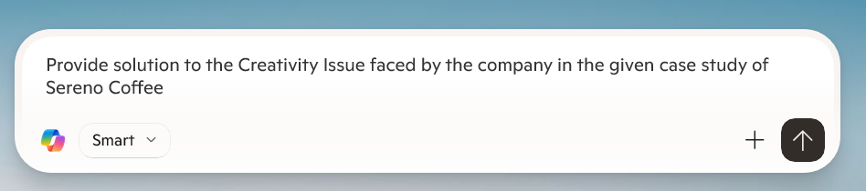
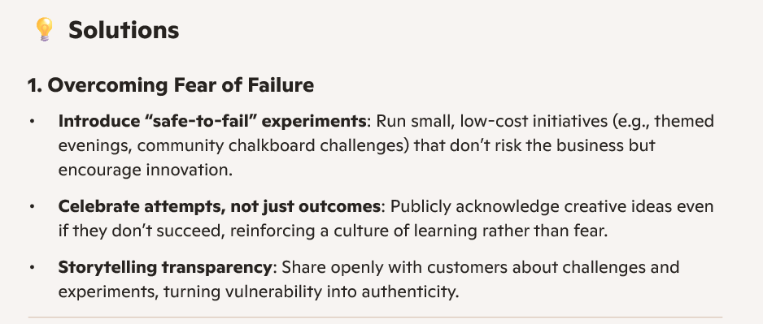
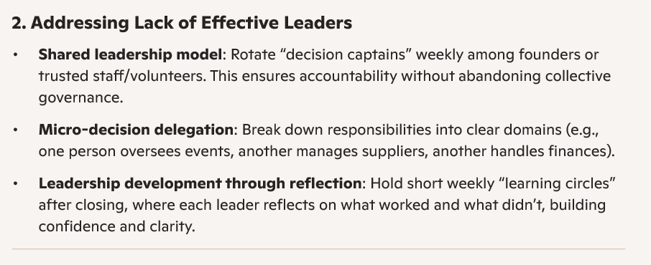
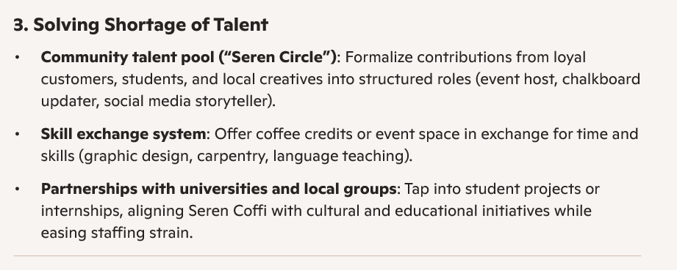
Reason for this Issue

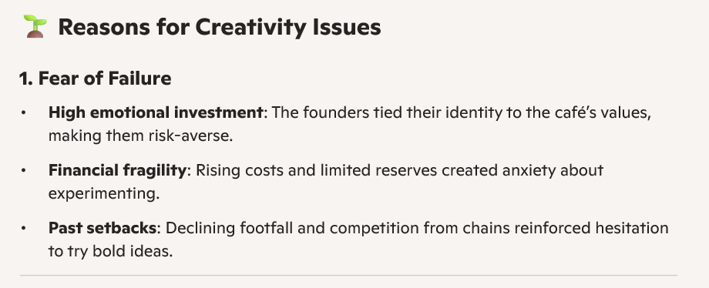
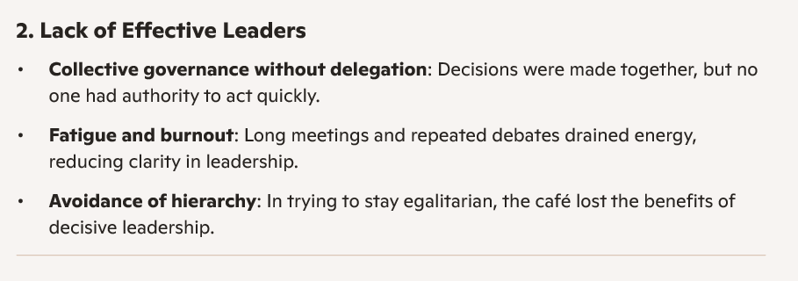
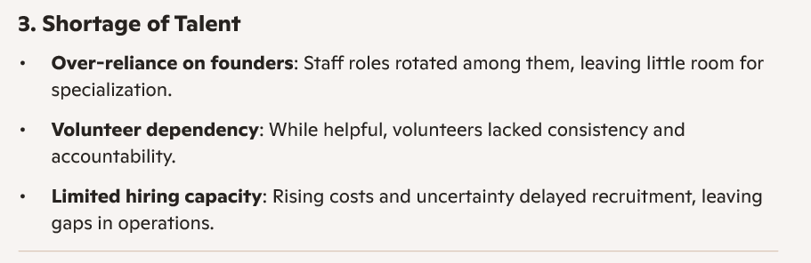
The company's obligation to solve this issue
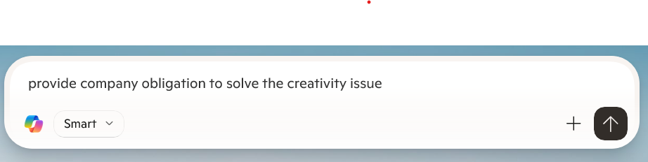
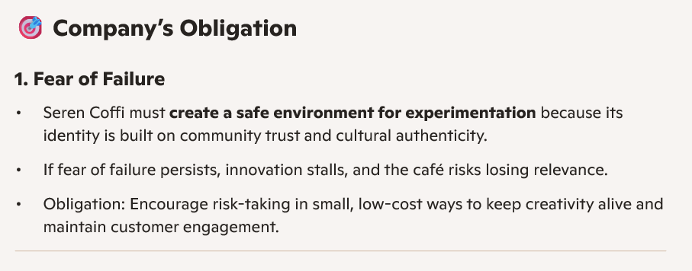
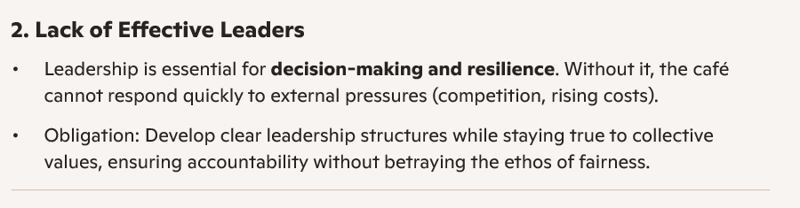
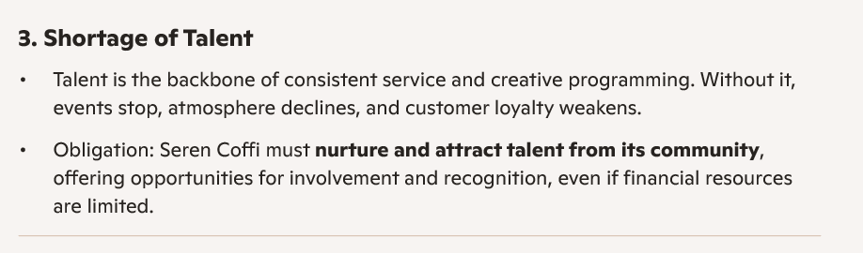
The issues the company will face in implementing the solution
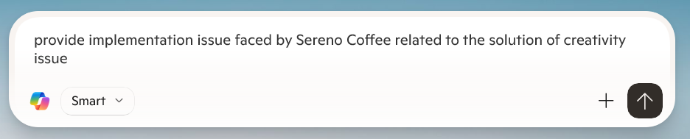
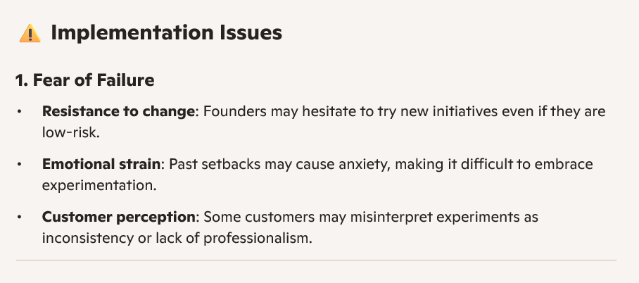
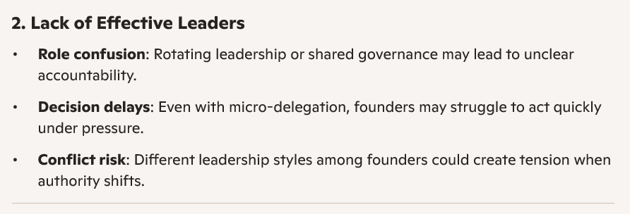
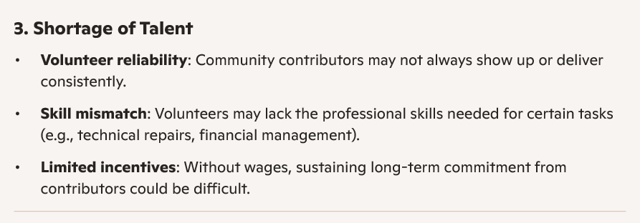
Mitigation strategy to solve the implementation issue
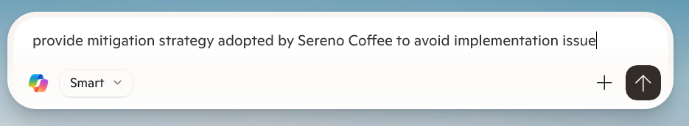
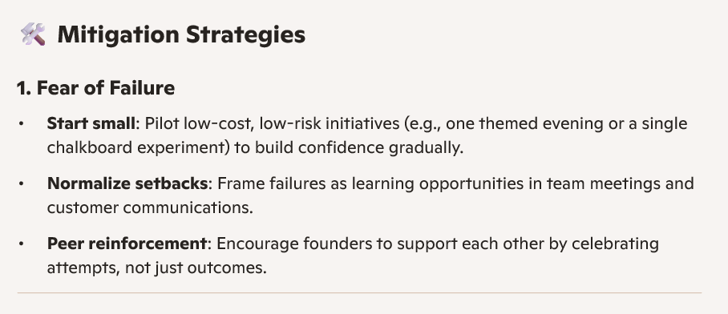
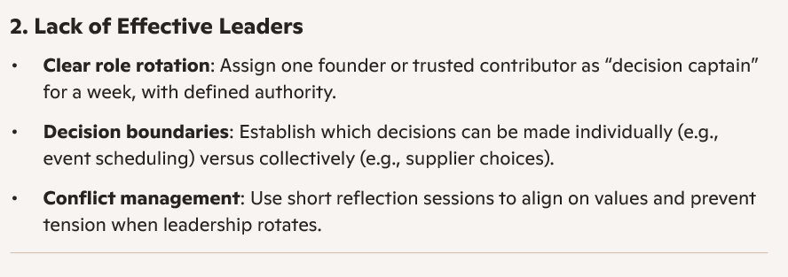
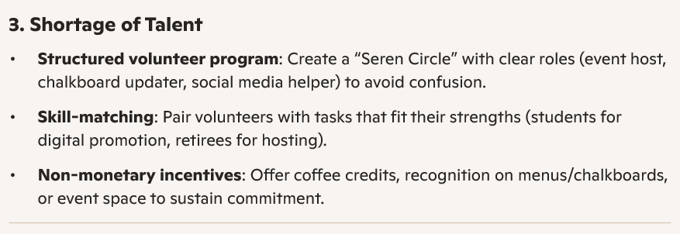

Appendix 2
Issue 2
Copilot Solution
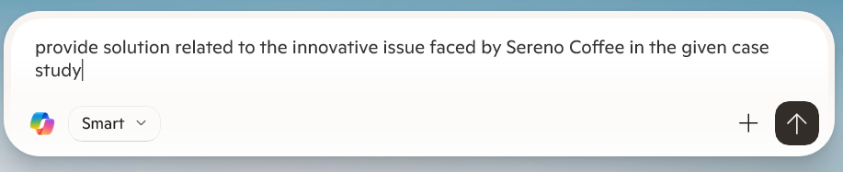
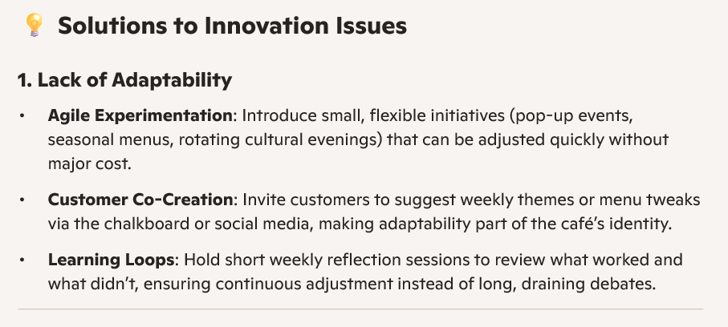
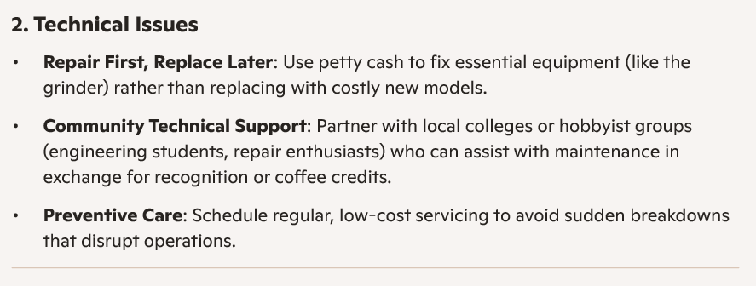
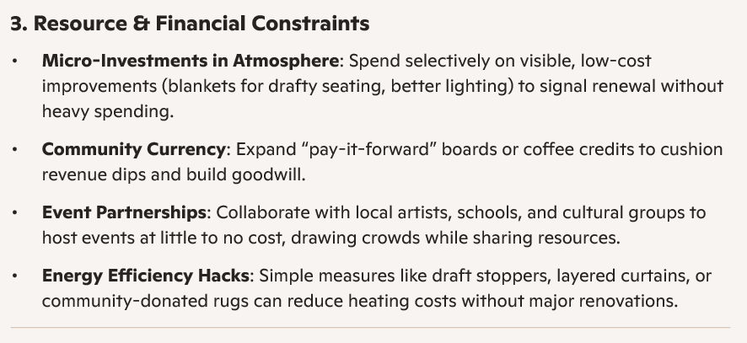
Reason for this Issue

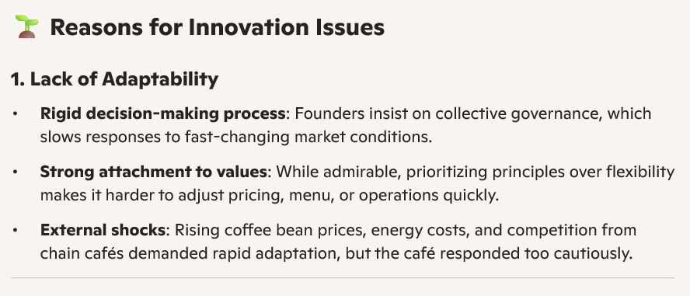
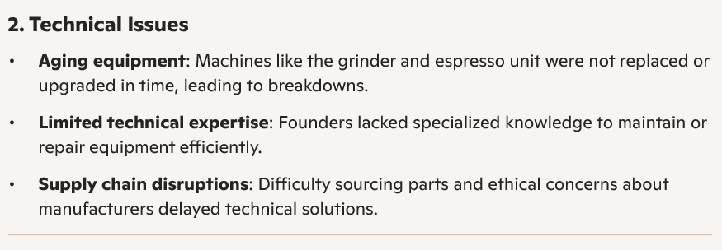
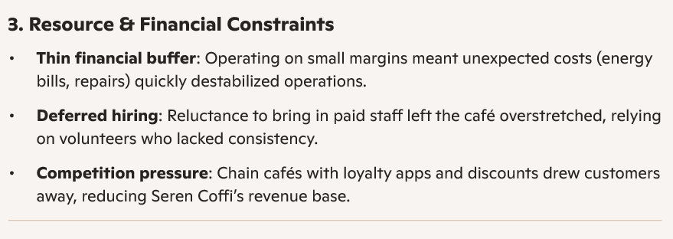
The company's obligation to solve this issue

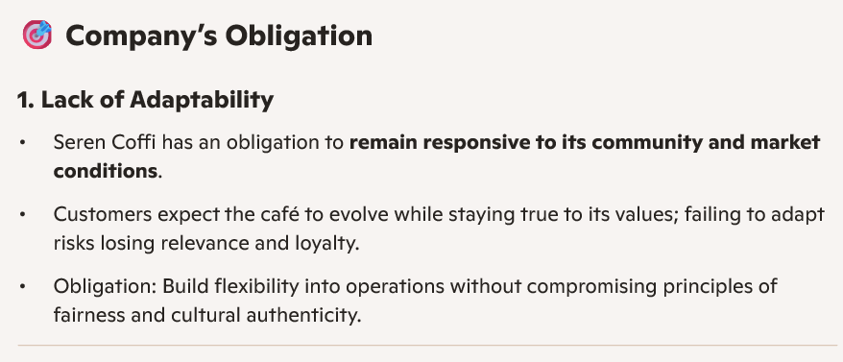
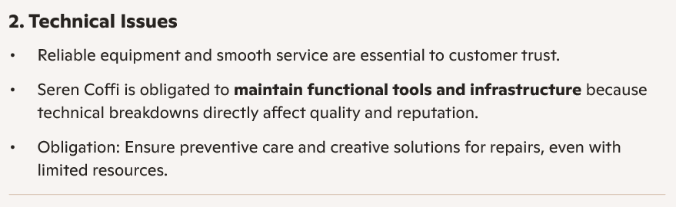
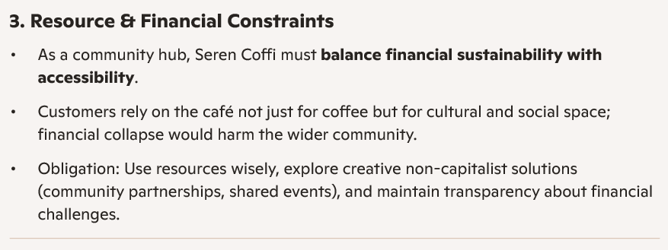
The issues the company will face in implementing the solution
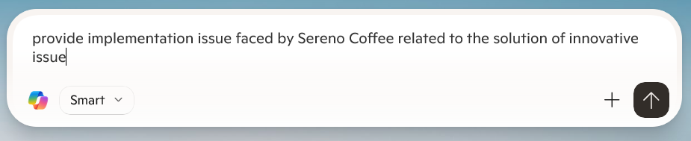
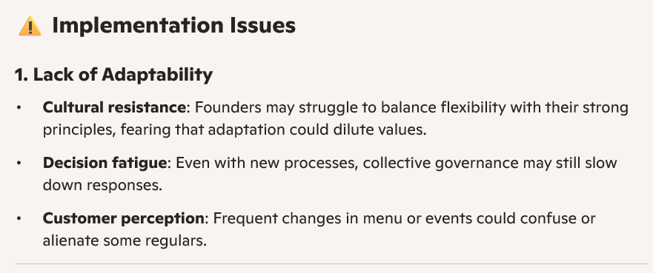
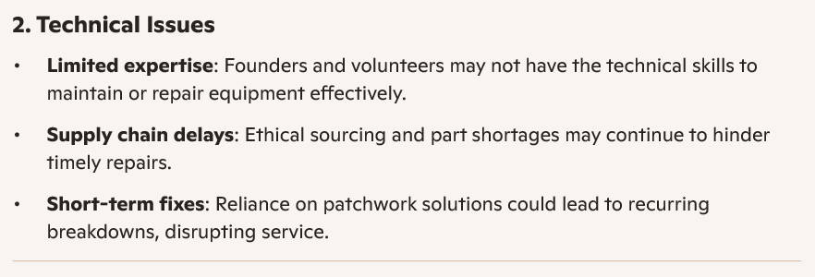
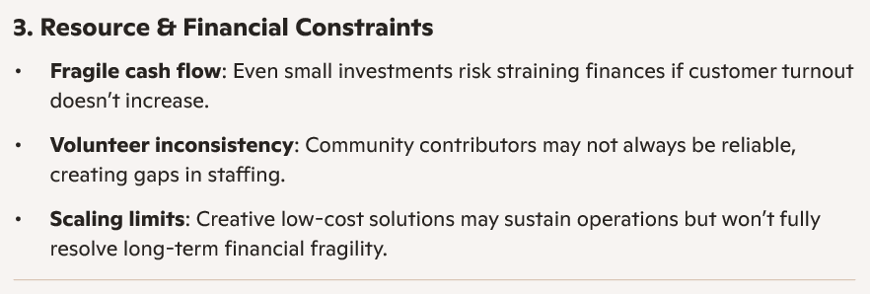
Mitigation strategy to solve the implementation issue


