Machine Learning
Author: Dylan Thomas 2014801
AI and Machine Learning (ACCA6011)
School of Applied Computing
Wales Institute of Science and Art
10/02/24 Date of Submission

Contents
1. Introduction 3
2. Related Literature 3
3. Data Set 4
3.1 Dataset Background 4
3.2 Data Set Evaluation 5
3.3 MNIST Fashion Image Previous Experiments 5
4. Solution Evaluation 6
4.1 Supervised Learning Options 6
4.1.1 K Nearest Neighbour (Knn) 6
4.1.2 Decision Tree 6
4.1.3 Naïve Bayes 7
4.1.4 Artificial Neural Networks 7
4.1.5 Support Vectors 7
4.2 K Nearest Neighbour 7
4.3 Decision Tree 9
4.4 Confusion Matrix 11
4.5 Python Script Enhancements 11
5. Conclusion 12
6. Reference List 13
7. Appendix 14

1. Introduction
Machine Learning is a broad topic, but it is one that is redefining how computers make decisions and learn. A lot of the theoretical groundwork and fundamental concepts date to the early 20th century, however the area of machine learning is growing just as rapidly as computers are advancing. This report explores the topic of ML, related literature, and the implementation of two practical classified machine learning algorithms to categorise the MNIST Fashion dataset [1] following the recognised steps and evaluating the outputs of the experiment.

2. Related Literature

According to Andrew Ng, Machine Learning is defined as “The Science of getting computers to learn, without being explicitly programmed” [2]. Machine Learning is a form of Artificial Intelligence that empowers a system to learn from previous experience with the use of training and test datasets without additional programming. The systems can identify patterns within large datasets to then allow informed decision-making. Machine Learning is used in a variety of sectors, but regardless of what it’s use the systems all rely on the decision-making from identifying trends and/or patterns in the dataset it is working with.
Machine Learning has been of increasing interest recently; however, it can be traced back to the early 20th century where individuals like Samuel were laying the foundations for the thriving subject of today. Samuel however was constrained by the technology of his time, the lack of computational power, data availability hampered the progress until the late 20th century where the development of foundational algorithms and neural networks progressed significantly. Without the theoretical concepts of Samuel, including the work during his time at IBM developing the game of checkers on the IBM 701 machine [3] the rapid rise of Machine Learning in line with advancing technology wouldn’t be possible.
When developing a Machine Learning Algorithm there is a guideline of steps to be followed, once the problem has been defined,
- Collect Data – Data required for training, validation, and testing.
- Prepare Data – Data cleansing, normalising of the data and removing outliers or missing values.
- Model Selection – Selecting a model most appropriate to the problem and data characteristics.
- Model Training – Pattern identification and parameter adjustment using the training dataset.
- Model Evaluation – Assessment of the performance and results using the test dataset.
- Adjust the Model
- Prediction and Repeat – Repetition of the above steps until optimal performance/output is achieved.
This process is championed by Géron [4] who defines a similar cyclical process when getting hands on with Machine Learning. He also includes a monitor and maintain step following the Model’s adjustment to ensure performance is maintained and monitored for any drop in performance.
There are three main types of Machine Learning, Supervised, Unsupervised and Reinforced.
Supervised Learning relies on labelled datasets with clearly defined variables, input, and output values (x + y). The model learns to make predictions when given unseen data based on its learning. Example tasks for this model include regression problems and image recognition. Supervised Learning can be differentiated by the inclusion of perception provided on expected inputs and output, according to Russel and Norvig. [5]
Unsupervised Learning relies on training models using unlabelled data, and it’s tasked to identify patterns or relationships within the dataset. Commonly used is clustering, where datapoints of similar values are grouped. Examples of uses for this model are heavily involved in data exploration as advocated by Bishop [6].
Reinforced Learning focuses on decision-making within a changing environment, differing to the previous examples the model learns via trial and error, getting rewards or penalties in the form of feedback. This learning is adaptable, allowing models to learn strategies for complex and changeable conditions, unsurprisingly this algorithm is heavily utilised for gaming as it is perfect for changing in-game needs. Sutton [7] provides a comprehensive guide that covers the fundamentals of the reinforced learning concepts.
While the technology grows, so does the ethical complexities of Artificial Intelligence. Ethical complexities include bias, privacy, security, and accountability.
Bias often is a result of bias contained within the datasets, this can pose an ethical challenge depending on the nature of the experiment, society/demographic experiments for example.
Privacy issues will always be a concern given the vast amounts of data handled, especially when it involves personal data. This raises further questions around consent, ownership, and correct use of the data as per GDPR regulations as investigated by Wulf. [8]
ML models can be vulnerable to adversarial attacks, which could pose a threat to the applications linked to the models depending on which sector this could lead to a significant data leak. This then poses the question of accountability, given ML models lack a human conscience, are errors and their consequences a human responsibility?
As the ethical landscape evolves with the technology, ongoing efforts focus on developing frameworks and guidelines to mitigate the ethical complexities mentioned. With the aim of responsible deployment of ML technologies, striking a balance between innovation and ethical considerations. The Council of Europe [9] has already drafted frameworks aimed at the responsible use of AI. Given the recent emergence of generative AI like ChatGPT and other options of the same ilk, the responsibilities and ethics of the subject will continue to be under the spotlight.

3. Data Set

3.1 Dataset Background
The Fashion-MNIST dataset was created by Zalando Research (2017) as an alternative to the traditional MNIST dataset, which had become widely used as a benchmark for testing machine learning models, particularly in the early days of deep learning. The original MNIST dataset consists of 28x28 grayscale images of handwritten digits (0 to 9) and served as a simple and accessible dataset for researchers and practitioners to experiment with image classification algorithms.
However, as machine learning models and techniques advanced the original MNIST dataset has become less challenging, a more complex and realistic dataset was required. This is where the Fashion-MNIST dataset was introduced to provide the complex and challenging dataset for the more sophisticated models, especially deep convolutional neural networks, to achieve accurate classification. The Fashion-MNIST dataset has a similar structure with greyscale images, 60,000 training images, 10,000 test images, but of 10 different fashion items rather than the handwritten digits. The dataset has become known as the benchmarking and testing dataset of choice for emerging image classification models.

Figure – MNIST Dataset Comparison [10]

3.2 Data Set Evaluation

As mentioned above, the dataset consists of greyscale 28x28 pixels images, 70,000 images split into training and test datasets consisting of 10 different fashion items. Although the dataset is relatively small compared to other image specific datasets, the complexity of this dataset lies in the small image size, grey scaling, and the slight differences between the clothing items.
The dataset is seen as the benchmark dataset in the context of image classification algorithms, with high accuracy indicating a model’s ability to handle complex images, as is achieved with highly sophisticated models. A known challenge of the dataset is the imagery causing overfitting; however, the ununiformed nature of the images requires a model with sophisticated feature extraction. Although the images aren’t complete duplications, the representation of clothing items won’t completely compare to the complexity of real-world fashion images by only being limited to the 10 classes, there are many different types of footwear for example.
Overall, the Fashion MNIST Dataset is a balanced dataset, meaning it contains similar numbers of examples per class. Given the dataset has been designed to have similar values per each class, it exposes models to similar numbers from each class to train it effectively by negating potential bias to a particular class. Another positive of having balanced values for each class allows the model to be examined on its performance for each class, it can assist in identifying a specific class suffering with strong bias or preference to certain categories.

3.3 MNIST Fashion Image Previous Experiments

The Fashion image dataset is seen as a benchmarking dataset for algorithms, image recognition specifically, and as such there are other examples of experiments conducted using a variety of supervised learning options.
During their research, Xiao et al [11] conducted an experiment using the Fashion MNIST dataset, however they deployed a variety of Supervised and Unsupervised Learning model solutions including Decision Tree, KNN, Logistical Regression and Perceptrons. They were able to get an equal comparison of results for each solution not only against the more advanced Fashion dataset but the original hand drawn figures dataset too. Unsurprisingly all models achieved higher accuracy on the original dataset, finding KNN as one of the higher scoring models with 85% accuracy, decision tree with 80% scoring higher than some unsupervised learning options.
There are many instances of the Fashion Dataset being tested by a Convolutional neural network (CNN) solution. Henrique et al [12] tested the dataset using four different CNN models using python, keras and TensorFlow, finding effective accuracy scores of over 90% and declaring CNN’s are a more effective model especially for minimising model bias. Nocientini et al [13] also experimented with a CNN model against the Fashion dataset, they found that implementing a multiple CNN utilising 15 layers yielded an accuracy of 94% but testing it against further variations of the fashion product and household datasets yielded less impressive accuracy scoring.
Edwards et al [14] conducted an experiment of the Fashion dataset using KNN, Decision Tree and CNN models, finding the CNN model achieving the highest score of 92% accuracy. Like other experiments the KNN model achieves a higher accuracy score than Decision Tree, and BPNN within this experiment. By creating visual clustering outputs they were able to interrogate the findings further.

4. Solution Evaluation

4.1 Supervised Learning Options

4.1.1 K Nearest Neighbour (Knn)
KNN is a simple supervised classification algorithm that classifies data points based on the majority class of the nearest neighbour. This option makes no assumptions, however it does utilise the pre-labelled dataset provided. Balabanova [15] explores the use of AI, KNN approach for image recognition.
KNN is a simpler option when it comes to implementation, it’s easier to understand and is effective with smaller datasets. Given that it doesn’t make assumptions, the model learns from the data provided during the predictive phase. It can be an expensive solution for larger datasets, and sensitive to redundant features. There are few negatives to implementing this solution for the MNIST Fashion experiment.

4.1.2 Decision Tree
Decision Tree is an algorithm with many different types, all with the same purpose of breaking down a dataset based on certain features to make decisions. Tying back to the tree notion, internal nodes are represented by features, decision rules or outcomes of a test by branches, and class labels as a leaf. Yang et al [16] conducted a study into image recognition using both decision tree and regression methods like logistical regression, finding Decision Tree was the higher performing.
Decision Trees require minimal data preprocessing, with an ability to handle both categorical and numerical data to provide simple visuals and interpretations. Decision Tree can also capture feature importance by the hierarchy split within the tree. This option is however prone to overfitting when the trees get deeper, also being prone to bias towards dominant classes. When overfitting does occur, pruning is a technique that can be utilised to address the issue.

4.1.3 Naïve Bayes
Naïve Bayes (NB) is an algorithm based on Bayes theorem of probabilities. It is a supervised algorithm used primarily for classifications. It assumes that features are conditionally independent.
Naïve Bayes requires a small amount of training data, is undeterred by irrelevant features and is comfortable working with high-dimensional data. The assumption of independent features isn’t always the case, along with it being sensitive to outliers.

4.1.4 Artificial Neural Networks
According to AWS, Neural Networks are “a method in artificial intelligence that teaches computers to process data in a way that is inspired by the human brain”. [17]
The neurons (interconnected nodes) mimic that of a biological neural network. Artificial Neural Networks can adapt to a variety of problems, identifying complex relationships within the data, especially image, speech, and sequential data. ANN’s require significant amounts of training data, along with advanced hardware requirements and being susceptible to overfitting with smaller datasets. These negatives of ANN’s played a significant role during the solution selection process, and ultimately lead to the selection of Decision Tree and kNN.

4.1.5 Support Vectors
Support Vectors aim to identify points that are closest to the hyperplane. Taking the hyperplane it then separates the data into classes by the margin between each class.

4.2 K Nearest Neighbour

For the KNN method there are 4 scores allocated to each clothing class (0-9). The Training dataset is the largest of the 3 datasets, it has 54,000 images in total, given it’s a balanced dataset there should be roughly 5,400 occurrences of each class. The scores measured are precision, recall, f1 score and support.
K Nearest Neighbours Prediction – the ratio of true positive predictions to the total number of predicted positives.
Recall – True positive predictions ratio to the total actual number of positives.
F1 Score – This is the mean of recall and precision.
Support – The number of actual occurrences of the class within the dataset
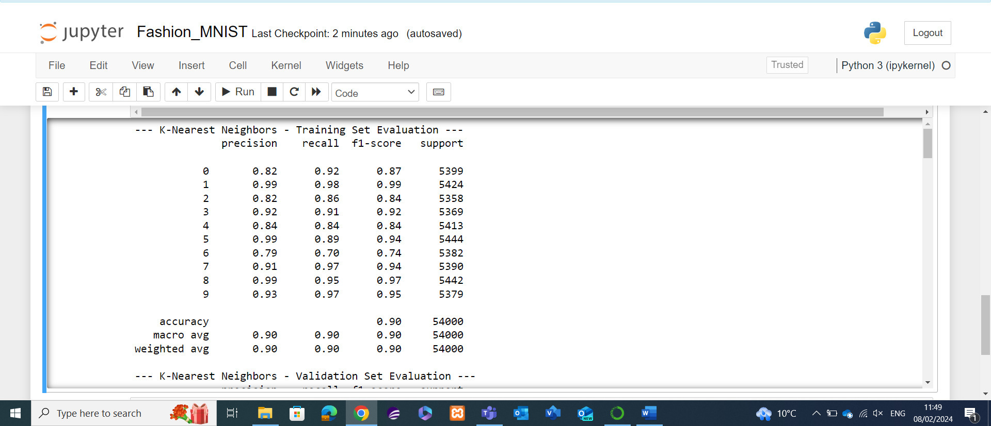
Figure KNN Training Dataset Results
The training dataset has an average accuracy of 90% which is a very strong score. The scores make for interesting reading, with Class 6 proving to be the only one with which the model struggles with, with the lowest KNN precision and recall scores, being the only class with a score below .8 in the F1 scoring. Class 1 and 8 record near perfect scoring, it’ll be interesting to see if the model continues to identify these classes with ease as we move on to the unseen data of the Validation and Test datasets.
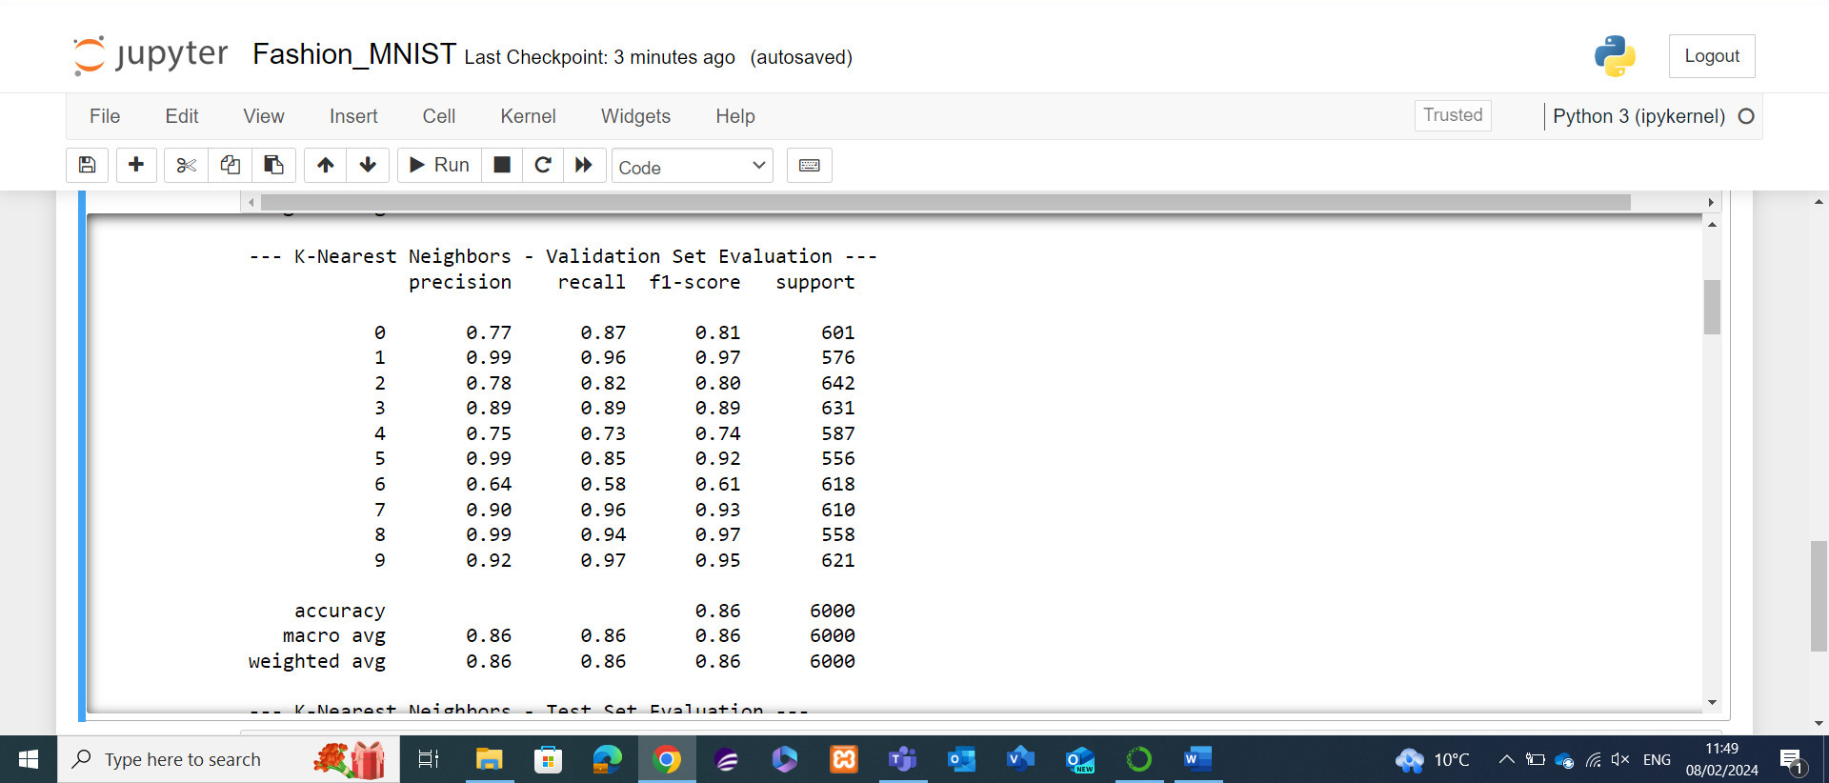
Figure KNN Validation Dataset Results
Validation Dataresults show a slight dip in accuracy average to 86%. The Validation Dataset is only 6,000 occurances large, but proved more difficult than the Training dataset. A similar trend is seen in this dataset with Class 6 being the lowest performing of the classes, an F1 score of .61 a drop of .09 being far worse than the others and the largest drop in performance of all the classes. There is a similar trend with Class 1 being near perfect scoring, along with Class 8. Noticably Class 9’s F1 score didn’t change from the previous set evaluation.
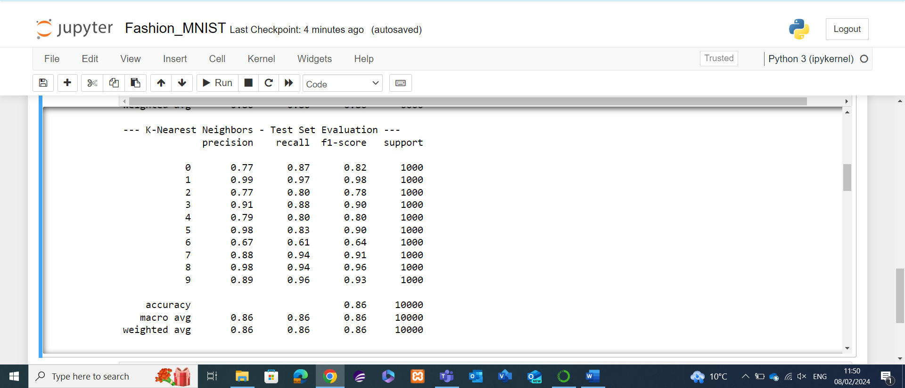
Figure KNN Test Dataset Results
Finally, the Test Dataset results, the average of 86% Is a similar score to the previous validation set, even with an increase of 4,000 total instances to a 10,000-instance dataset. There is little change in the scoring trends identified in the Validation set, Class 1 and 8 being high performing, Class 6 improving slightly but still the worst performing prediction. Given that the overall performance of the model remains at 86% for the Validation and Test sets, and 90% for the training dataset it would lead me to believe that there’s a case of overfitting affecting the model, whereby it performs worse with the unseen test and validation sets. Overall, it’s only a drop by 4% in performance, it’s still an effective score for the KNN model.

4.3 Decision Tree
Like the KNN method there are 4 scores allocated to the Decision Tree model for each clothing class (0-9). The Training dataset is the largest of the 3 datasets, it has 54,000 images in total, 6,000 within the Validation set and 10,000 within the training dataset. Again, the scores measured are precision, recall, f1 score and support.
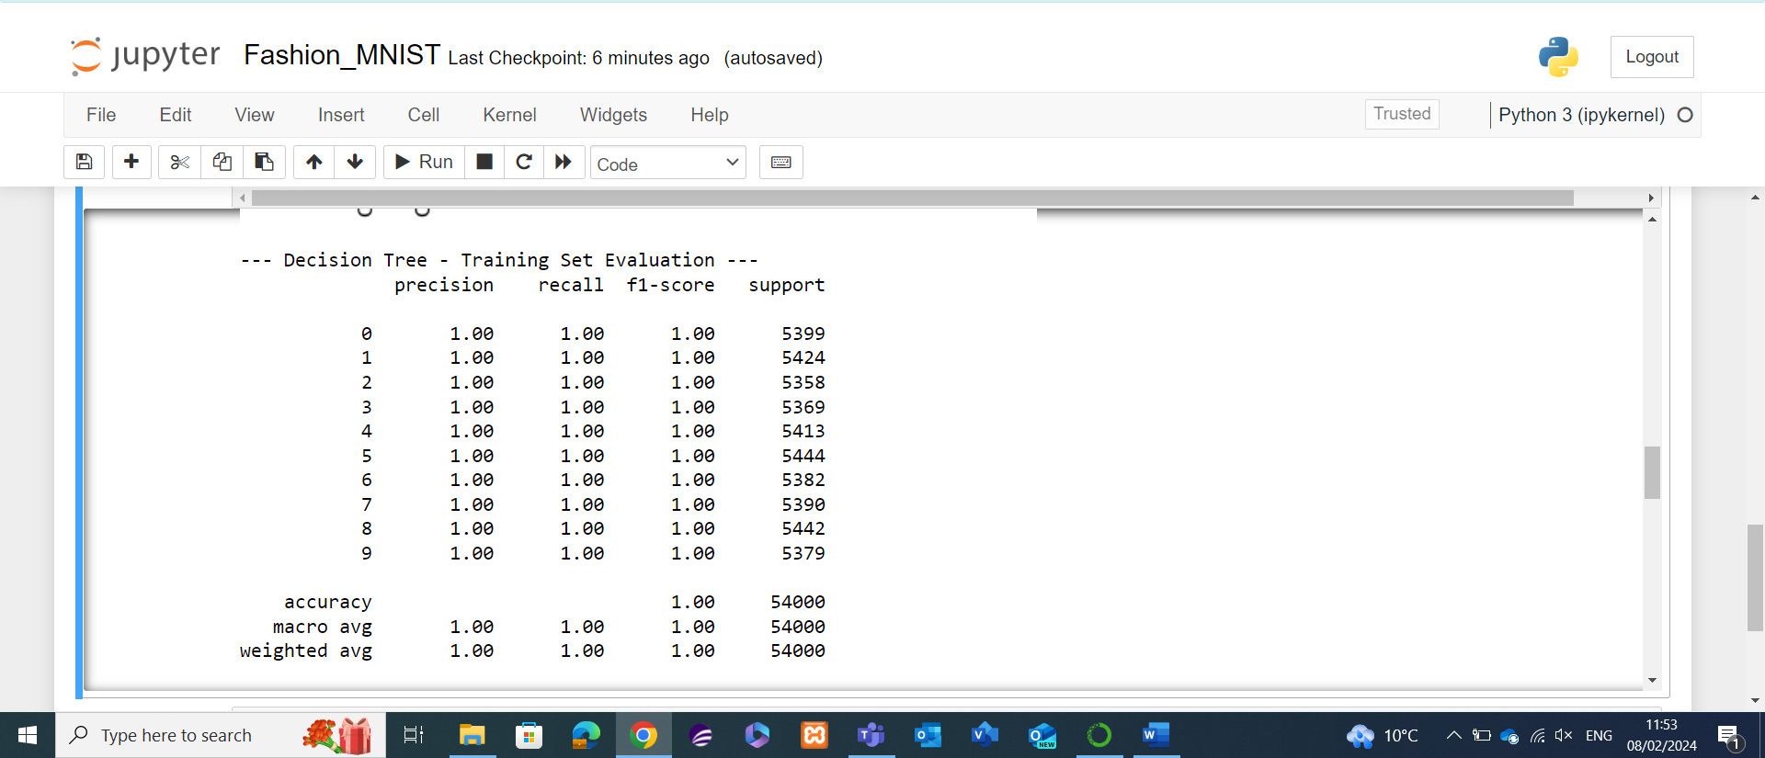
Figure Decision Tree Training Dataset Results
The scoring for the Decision tree models is rather staggering, it has scored 100% accuracy across all the classes and all the scoring metrics we’re measuring against for the 54,000 occurrences.
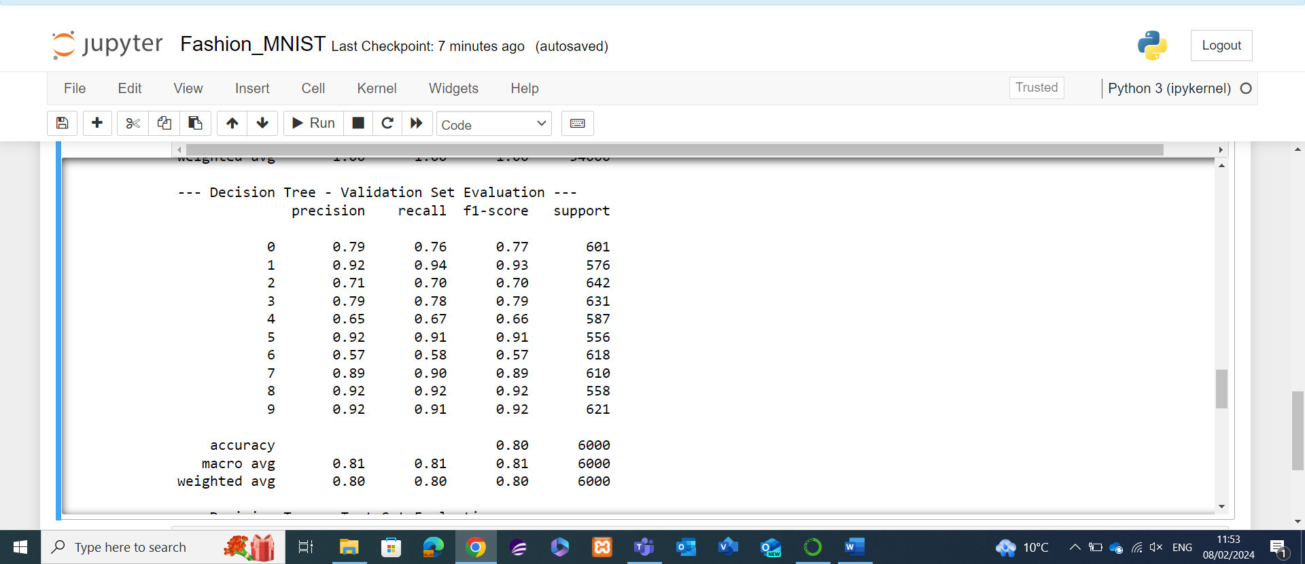
Figure Decision Tree Validation Dataset Results
Unfortunately, the model was unable to maintain the 100% scoring achieved within the training dataset, with the average dropping drastically to 81%. There is a similar pattern to the KNN results whereby Class 1 and 8 being of the highest scoring, Class 6 again being the lowest performing with a rating of .57, being incorrect on the assumptions almost half the time. The score of .57 f1 score for class 6 is the lowest score achieved thus far from all the testing for both models. Class 2 is another low performing prediction in comparison to the others.
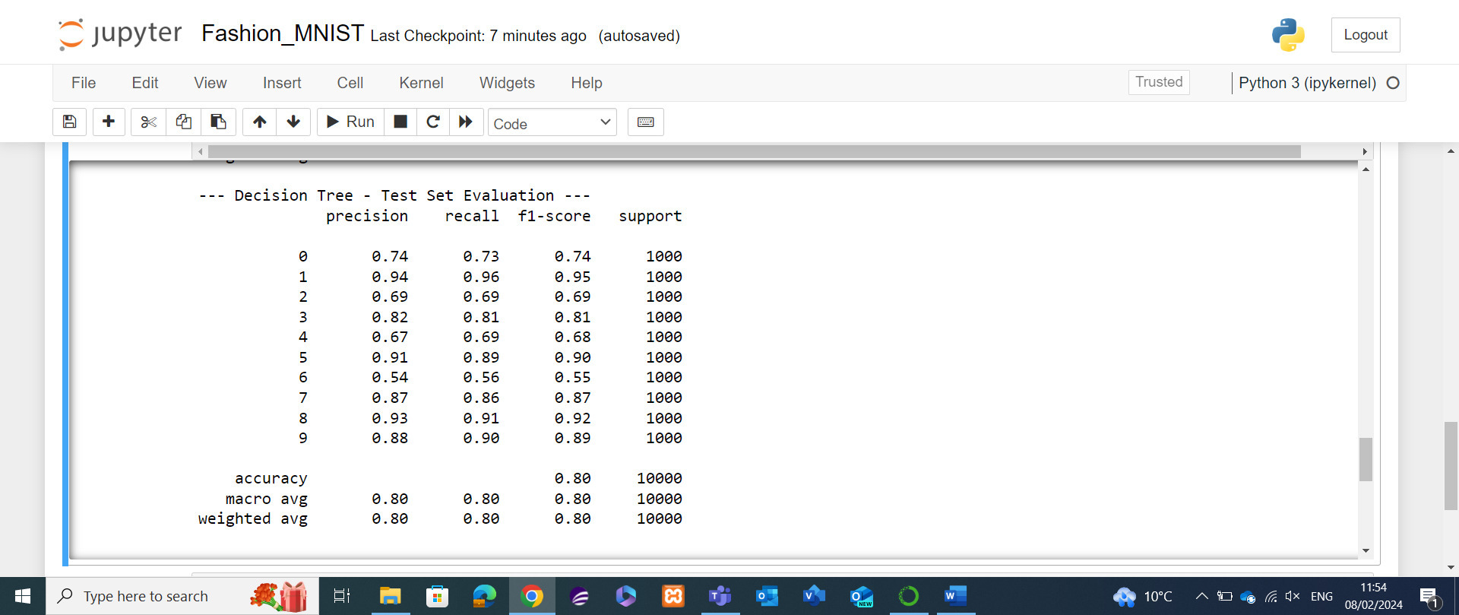
Figure Decision Tree Test Dataset Results
Finally, the Test dataset of 10,000 occurrences produces a similar outcome to the Validation set with the overall average dropping slightly to 80%. The trends identified within the Validation set are similar to those found here, with Class 6 being the lowest scoring by far with an f1 score of .55, Class 1 and 8 remaining as higher performing with the only scoring along with Class 5 of 90 and above for the F1 score.
Given the dramatic drop in performance from the Training dataset to the validation and test datasets it’s likely this model has also been affected by overfitting.

4.4 Confusion Matrix
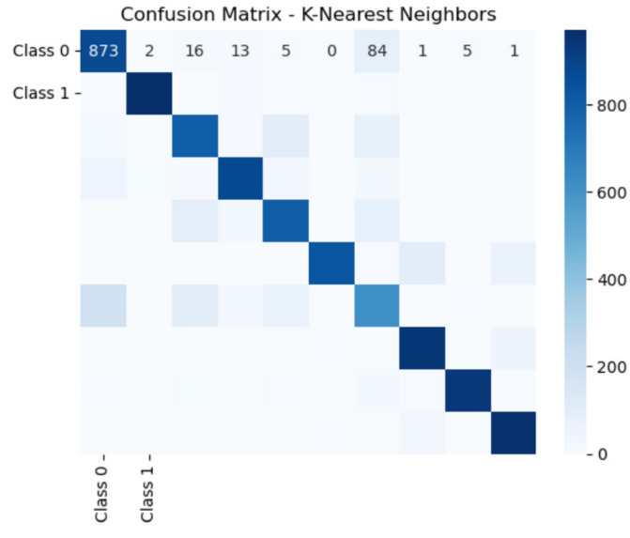
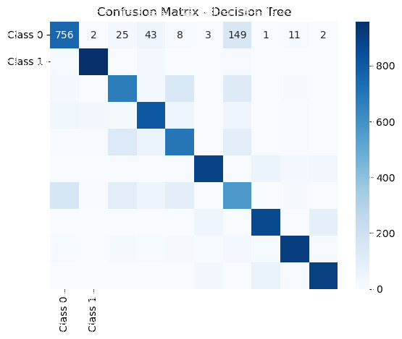

Figure Confusion Matrix Comparison
According to Towards Data Science, a Confusion Matrix is “a performance measurement for machine learning classification problem where output can be two or more classes.” [18]
Essentially the confusion matrix is used to evaluate algorithm performance, it uses four values of True Positive, True Negative, False Positive and False Negatives. By utilising these four values it assesses the model’s accuracy among other performance metrics.
By using the confusion matrix, it allows the assessor to pinpoint where models are making errors, this performance evaluation can be done per classifier to drill down on errors. The intensity of the colour indicates counts, dark blue indicating high counts and the lightest of shades indicating lower counts. This is exampled by Class 0 counts for both models.
Comparing the Confusion Matrix of KNN and Decision tree models, the KNN is the better performing of the two models, which supports the accuracy findings found in the dataset testing of the two models. The KNN model outperformed the Decision Tree model 86% to 80% during dataset testing and has again outperformed decision tree in the Confusion Matrix comparison.

4.5 Python Script Enhancements
The script function can always be improved, and this is no different. The current script currently uses a single validation set; however cross validation could be considered to provide a cross validation score for improved accuracy.
For the KNN script, currently it has a set hyperparameters value of 5, this could be improved by using a random search, or a grid search to find the optimal value as “n_neighbors=5” isn’t certain to be the optimal score.
The Decision tree script could also be improved by implementing a pruning process, which involves removing part of the tree that isn’t of significant power when making predictions. Given that the model implemented along with other decision trees are prone to overfitting, pruning is a solution to prevent the model from over capturing patterns that wouldn’t generalise to never seen data.

5. Conclusion

To conclude, the main finding of this report is of the two models implemented, the KNN model performed with higher accuracy than the Decision Tree model. This result was affected largely by the factor of overfitting, which the Decision Tree model was less effective of mitigating. To mitigate the effect of overfitting the pruning technique could be deployed in future experiments. Similar to previous experiments undertaken using the MNIST dataset, a performance comparison by deploying the models on the original hand drawn figures dataset could’ve added further evidence of the performance of the models.

6. Reference List

[1] Han Xiao, Kashif Rasul, and Roland Vollgraf, “Fashion-mnist: a novel image dataset for benchmarking machine learning algorithms.” arXiv preprint arXiv:1708.07747, pp. 1–6, 2017.
[2] Ng. A, “What is Machine Learning?”, 2023. [Online]. Available: http://mlclass.stanford.edu/#:~:text=Machine%20learning%20is%20the%20science,act%20without%20being%20explicitly%20programmed [Accessed: 08-Feb-2024]
[3] A. L. Samuel, "Some Studies in Machine Learning Using the Game of Checkers in IBM Journal of Research and Development”1967. [Online]. Available: https://ieeexplore.ieee.org/abstract/document/5391906 [Accessed: 08-Feb-2024]
[4] A. Géron, “Hands-on machine learning with Scikit-learn, Keras, and TensorFlow : concepts, tools, and techniques to build intelligent systems”, 2nd ed. Sebastopol: O’Reilly, 2019. [Online]. Available: https://ebookcentral.proquest.com/lib/trinity/detail.action?docID=5892320&pq-origsite=primo [Accessed: 05-Feb-2024]
[5] S. Russell and P. Norvig, Artificial Intelligence A Modern Approach, Upper Saddle River, New Jersey: Pearson Education, 1995.
[6] C. M. Bishop, Pattern recognition and machine learning. New York: Springer, 2006. [Accessed: 05-Feb-2023]
[7] R. S. Sutton and A. G. Barto, “Reinforcement learning an introduction”. Cambridge, Mass: MIT Press, 1998. [Online]. Available: https://muse.jhu.edu/book/60836 [Accessed: 05-Feb-2024]
[8] A. J. Wulf and O. Seizov, “‘Please understand we cannot provide further information’: evaluating content and transparency of GDPR-mandated AI disclosures,” AI & society, 2022. [Online]. Available: https://librarysearch.uwtsd.ac.uk/discovery/fulldisplay?docid=cdi_openaire_primary_doi_833cbdff759e7adea771a36b61d002df&context=PC&vid=44WHELF_UWTSD:44WHELF_UWTSD_VU1&lang=en&search_scope=MyInst_and_CI&adaptor=Primo%20Central&tab=Everything&query=any,contains,AI%20GDPR&offset=0 [Accessed: 05-Feb-2024]
[9] Anonymous, “Artificial Intelligence, Ethical Frameworks”, 2024. [Online]. Available: https://www.coe.int/en/web/artificial-intelligence/ethical-frameworks [Accessed: 05-Feb-2024]
[10] S.Kadam, “CNN Model for Image Classification on MNIST and Fashion MNIST Dataset”, 2020. [Online]. Available: https://www.bhu.ac.in/research_pub/jsr/Volumes/JSR_64_02_2020/51.pdf [Accessed: 05-Feb-2024]
[11] H. Xiao and K. V. R. Rasul, “Fashion-MNIST: A novel Image Dataset for Benchmarking Machine,” 25th August 2017. [Online]. Available: https://arxiv.org/abs/1708.07747. [Accessed: 05-Feb-2024].
[12] A. Henrique et al, “Classifying Garments from Fashion MNIST Dataset through CNN’s”, 2021. [Online]. Available: https://comum.rcaap.pt/bitstream/10400.26/37237/1/ASTESJ_0601109.pdf [Accessed: 08-Feb-2024]
[13] O.Nocentini et al, “Image Classification Using Multiple Convolutional Neural Networks on the Fashion-MNIST Dataset”, 2022. [Online]. Available: https://www.mdpi.com/1424-8220/22/23/9544 [Accessed: 08-Feb-2024]
[14] C.Edwards, “Introduction to Pattern Recognition Fashion MNIST”, 2021. [Online]. Available: https://cnedwards.com/files/Edwards_Yen_Final_Project.pdf [Accessed: 08-Feb-2024]
[15] I. S. Balabanova and G. I. Georgiev, “Image recognition by FFT, artificial intelligence and k-nearest neighbours approach,” Journal of physics. Conference series, 2022. [Online]. Available: https://librarysearch.uwtsd.ac.uk/discovery/fulldisplay?docid=cdi_crossref_primary_10_1088_1742_6596_2339_1_012008&context=PC&vid=44WHELF_UWTSD:44WHELF_UWTSD_VU1&lang=en&search_scope=MyInst_and_CI&adaptor=Primo%20Central&tab=Everything&query=any,contains,k%20Nearest%20neighbour%20image%20recognition&offset=0 [Accessed: 05-Feb-2024]
[16] C.-C. Yang et al., “Application of decision tree technology for image classification using remote sensing data,” vol. 76, 2003. [Online]. Available: https://www.sciencedirect.com/science/article/pii/S0308521X02000513 [Accessed: 05-Feb-2024]
[17] Anonymous, “What is a Neural Network?”, AWS, 2024. [Online]. Available: https://aws.amazon.com/what-is/neural-network/#:~:text=A%20neural%20network%20is%20a,that%20resembles%20the%20human%20brain [Accessed: 09-Feb-2024]
[18] S.Narkhede, “Understanding Confusion Matrix”, Towards Data Science, 2018. [Online]. Available: https://towardsdatascience.com/understanding-confusion-matrix-a9ad42dcfd62 [Accessed: 09-Feb-2024]

7. Appendix

Experimental Setup
Python Libraries Used

Fashion MNIST Files
File | Description | Examples
t10k-images-idx3-ubyte.gz | Test dataset images | 10,000
t10k-labels-idx3-ubyte.gz | Test dataset labels | 10,000
train-images-idx3-ubyte.gz | Training dataset images | 60,000
train-labels-idx3-ubyte.gz | Training dataset labels | 60,000

Dataset Investigation
from tensorflow.keras.datasets import fashion_mnist
# Loading Fashion MNIST dataset
(x_train, y_train), (x_test, y_test) = fashion_mnist.load_data()
print("Training data shape:", x_train.shape)
print("Training labels shape",y_train.shape)
print("Testing data shape:", x_test.shape)
print("Testing labels shape:", y_test.shape)
#Use the mnist.load_data() function from the tensorflow.keras.datasets to load the dataset. Assigns training and testing data to variables x_train y_train and x_test and y_test
#Display the shapes of the training, testing data and labels using shape before outputting the data
(x_train, y_train), (x_test, y_test) = fashion_mnist.load_data()
import matplotlib.pyplot as plt
for i in range(10):
plt.imshow(x_train[i],cmap='gray')
plt.title(f"Label:{y_train[i]}")
plt.show()

import matplotlib.pyplot as plt
print("Fashion MNIST Dataset Description:")
print(f"Number of training samples:{len(x_train)}")
print(f"Number of testing samples:{len(x_test)}")
print(f"Shape of it image:{x_train[0].shape}")
print(f"Number of Classes:{len(set(y_train))}")

#Print some sample Data
print("\nSample Images")
sample_images = x_train[:5]
sample_labels = y_train[:5]
for i,image in enumerate(sample_images):
plt.subplot(1,5, i+1)
plt.imshow(image, cmap='gray')
plt.title(f"Label:{sample_labels[i]}")
plt.axis('off')
plt.tight_layout()
plt.show()

#Print 20 rows of image
num_rows = 20
num_cols = 10
fig, axes = plt.subplots(num_rows,num_cols, figsize=(num_cols, num_rows))
for row in range(num_rows):
for col in range(num_cols):
axes[row, col].imshow(x_train[row*num_cols + col],cmap='pink')
axes[row, col].axis('off')
plt.tight_layout()
plt.show()

Algorithm Script
import pandas as pd
from sklearn.model_selection import train_test_split
from sklearn.preprocessing import StandardScaler
from sklearn.neighbors import KNeighborsClassifier
from sklearn.tree import DecisionTreeClassifier
from sklearn.metrics import classification_report, confusion_matrix
import seaborn as sns
import matplotlib.pyplot as plt

# Loads the training dataset
train_data = pd.read_csv(r'fashion-mnist_train.csv')
# Loads the test dataset
test_data = pd.read_csv(r'fashion-mnist_test.csv')

# Spliting the training data into labels and features
X_train_full = train_data.drop('label', axis=1)
y_train_full = train_data['label']
# Split the test data into labels and features
X_test = test_data.drop('label', axis=1)
y_test = test_data['label']
# Spliting the training data into a training and validation set (10% of training data for validation)
X_train, X_val, y_train, y_val = train_test_split(X_train_full, y_train_full, test_size=0.1, random_state=42)

# Standardize features
scaler = StandardScaler()
X_train_scaled = scaler.fit_transform(X_train)
X_val_scaled = scaler.transform(X_val)
X_test_scaled = scaler.transform(X_test)

# Function to print classification reports and evaluate for a classifier
def evaluate_classifier(classifier, X_train, y_train, X_val, y_val, X_test, y_test, classifier_name):
classifier.fit(X_train, y_train)

# Evaluating the training set
y_train_pred = classifier.predict(X_train)
print(f"--- {classifier_name} - Training Set Evaluation ---")
print(classification_report(y_train, y_train_pred))
# Evaluating the validation set
y_val_pred = classifier.predict(X_val)
print(f"--- {classifier_name} - Validation Set Evaluation ---")
print(classification_report(y_val, y_val_pred))
# Evaluating the test set
y_test_pred = classifier.predict(X_test)
print(f"--- {classifier_name} - Test Set Evaluation ---")
print(classification_report(y_test, y_test_pred))

# Plotting of confusion matrix for test set
conf_matrix = confusion_matrix(y_test, y_test_pred)
sns.heatmap(conf_matrix, annot=True, fmt='d', cmap='Blues', xticklabels=['Class 0', 'Class 1'], yticklabels=['Class 0', 'Class 1'])
plt.title(f"Confusion Matrix - {classifier_name}")
plt.show()

# Implement and evaluate K-Nearest Neighbors Classifier
knn_classifier = KNeighborsClassifier(n_neighbors=5)
evaluate_classifier(knn_classifier, X_train_scaled, y_train, X_val_scaled, y_val, X_test_scaled, y_test, "K-Nearest Neighbors")

# Implement and evaluate Decision Tree Classifier
tree_classifier = DecisionTreeClassifier(random_state=42)
evaluate_classifier(tree_classifier, X_train_scaled, y_train, X_val_scaled, y_val, X_test_scaled, y_test, "Decision Tree")

