Evidence of Learning (E-Portfolio)

Module Title: Digital Skills for Personal Development and Business Growth
Module Code: BMSW4008
Lecturer: Philippa Fitzgerald

Student name: Ana Ivona Misu
Student ID: 2008695

Table of Contents

Task 1 3
Task 2 5
Task 3 6
Analysis of the responses 6
Task 4 11
1. Analysing questionnaire data 11
2. Website design 14
3. Marketing materials 16
References 19
Appendix 24

Task 1
Introduction
This essay aims to present a clear definition of storytelling in the context of developing a corporate brand entity. A brief overview of what storytelling is will be provided. Also, the use of storytelling in developing a brand identity will be discussed. A real-world example of the storytelling of a brand in engaging the target audience and fostering a strong connection between the brand and its target audience will be presented in this essay. With this discussion, the readers will be provided an understanding of the significance of storytelling in setting up and advancing a new brand.
Main Body
‘Storytelling’ is defined as the set of ideas, beliefs, personal experiences, and lesions that are depicted through stories or narratives so that powerful emotions and insights can be evoked (Serrat, 2008). Through the systematic construction of emotion and selected words, a new experience is produced. With the help of storytelling, listeners are helped to understand the relevance of complex ideas and concepts in meaningful and personal ways (Lugmayr et al. 2017). Storytelling is not a typical advertising or marketing method rather storytelling is about producing a cohesive and compelling narrative that resonates with the target audience, and perceptions, and fosters emotional connections. At its core, brand storytelling is seen as a way of crafting a narrative with which the brand's features are communicated. Also, ‘brand storytelling' considers the reasons why the brand needs to be presented in an authentic, relatable, and engaging way (Suzuki et al. 2018). Also, storytelling is regarded as a useful method to enhance the communication skills of oneself (Mokhtar et al. 2011). An individual with good communication skills presents the storytelling to make the listeners feel attracted towards the topic, influencing their mental perceptions. Recruiters look for employees with good storytelling skills to convince their clients in a specific way and present their goods and services to the clients to achieve greater success.
Through several mechanisms, the storytelling of a brand manages to engage the audience effectively and forge a strong connection between the audience and the brand. Emotional resonance is one key mechanism of storytelling to evoke the emotions of the customers and create a sense of connection with the brand. Narratives resonating with the values, experiences, and aspirations of the demographic factors of the target audience, a strong emotional connection is created by the brand with the target customers (Adobe, 2024). Customers emotionally connected to the brand will raise brand loyalty and advocate for the brand as well. Also, with storytelling, the brand is made more relatable to the audience as experiences, challenges and aspirations are shared. Customers feel valued when they find themselves in the stories of the brand. This way the brand is humanised so that customers can be approached in an easier way. Also, authenticity is a crucial factor too. The narratives of the brand should be authentic and independent so that the values of the brand are reflected through that storytelling. This is important for building trust and credibility with the customers, leading to a stronger relationship between the customers and the brand (LinkedIn, 2024). Consistency and empowerment are other two factors that make storytelling effective when setting up a strong connection between the audience and the brand (Herskovitz and Crystal, 2010). Consistent communication of the brand with its target audience reinforces the brand identity, therefore, customers become familiar with the brand. Empowering storytelling inspires customers to resonate the same feeling and connection towards the brand, hence, driven towards deeper engagement and loyalty (Dhote and Kumar, 2019).
One of the real-world examples of brand storytelling includes the Journey of Coca-Cola. Coca-Cola is one of the largest soft drinks and beverage brands in the world. There have been more than 500 brands of the company across 200 countries for Coca-Cola. For storytelling, the company also made use of the Augmented Reality (AR) techniques. In 2012, the company declared its corporate website as a ‘highly visual, sharable digital magazine’. Using the website, the company integrated stories with its brand. The company considered feedback from the customers to publish valuable and relevant content regularly. ‘Unbottled’ is one of the most popular and featured blog posts by the company. Under ‘the empowering Women’ category, users were allowed to read stories of the role played by Coca-Cola in empowering women in society. Consumers were also allowed to share their happy moments on the website of Coca-Cola and other Social media platforms (Du Plessis, 2015).
In recent times, the innovative augmented reality (AR) campaign of Coca-Cola promoted the storytelling marketing of the company. By pointing their phone’s camera at the can of Coca-Cola, customers can see one of the 12 stories come to life. Here, animated characters were engaged in the lighthearted exchange, and then a positive outcome revolving around the sharing of a Coke will be found. One of the animated features is about two football fans playing in a friendly game where the football is coming out of a Coke can. Another one is regarding a couple of kids whose beach ball is deflated by a beach umbrella. According to the Creative Director Kevin Lau, the objective of this storytelling campaign was to encourage the customers in a fun and experimental way to purchase the Coca-Cola brand products. It was seen as a perfect opportunity for exploring new mediums and testing storytelling skills in emerging markets, as stated by the director (O’Brien, 2019).
Conclusion
It can be concluded that storytelling is not a specific marketing tactic rather it is a fundamental aspect of setting up and advancing a brand identity. The example of Coca-Cola’s storytelling provides an overview of how storytelling is useful in raising brand loyalty and identity in the practical world. Apart from Coca-Cola, there are other popular brands which make use of storytelling to promote their brands and raise the values of the brand as well. Effective storytelling not only captivates and inspires the customers but also, drives meaningful changes and makes a lasting impact on both the customers and the society.

Task 2
For Task 2, the video advertisement will be accessed through the link down below:
https://youtu.be/SDqTTOREDVo?si=AqjeGKNz3OPO2Ky0

Task 3
The questionnaire has been prepared on Microsoft Forms (Microsoft Forms, 2024).

Analysis of the responses
9 responses have been recorded from the survey conducted. The analysis of the responses regarding the cafe business named ‘Goalpost Grind Cafe’ has been conducted below –
Question 1:
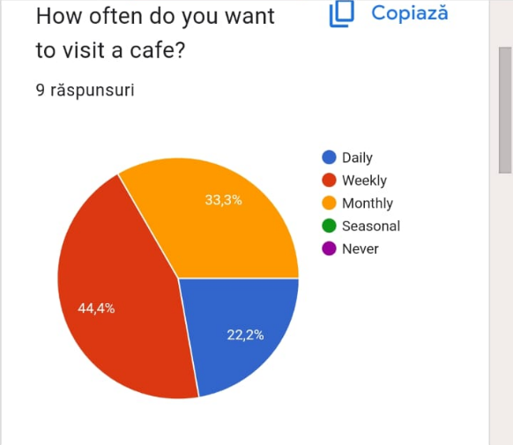
Cafes are delineated as the serving aspects of social hubs that provide effective space for all the people to connect, work, and engage with all the customers (Nielsen, 2024). Here in this scenario, the survey conducted by Goalpost Grind Cafe where 9 people took part fostered the fact that 44.4% visit a cafe on a weekly basis. On the other hand, 22.2% visit a cafe daily and monthly visitors of a café is 33.3%.
Question 2:
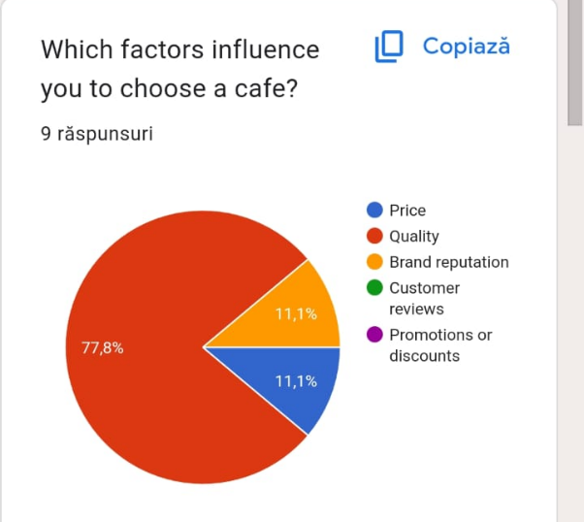
Rendering an effective consumer perception becomes an inevitable object for a cafe to get an effective competitive advantage fruitfully (Barlow, 2023). The survey of 77.8% of people fostered the fact that the majority of them want proper quality coffee. On the contrary, it could be evaluated from the survey that 11.1% of the 9 people stated that they would look into the price of the coffee and another 11.1% people fostered their views about the reputation of the brand.

Question 3:
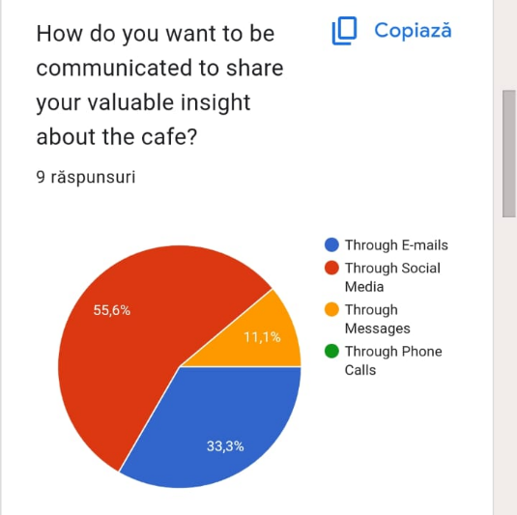
Effective communication can be very useful for a cafe to enrich the level of satisfaction of all the customers (Petty, 2024). The survey that was conducted among 9 people optimised the fact that the majority of the people i.e. 55.6% wanted to be communicated through social media. 33.3% of people wanted to communicate through emails and 11.1% of people stated that communication through messages would be a proper communication medium.
Question 4:
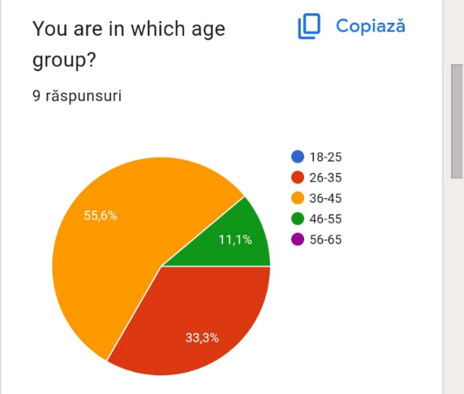
The attributes of the generation and the tech-savvy perspective of the characteristic traits in the age influence enrich the operational sphere of a cafe (Restaurant, 2024). The majority of the 9 people who participated in the survey were 36-45 years which is 55.6%; 11.1% people were 46 to 55 years years of age and 33.3% were 26-35 years.

Question 5:
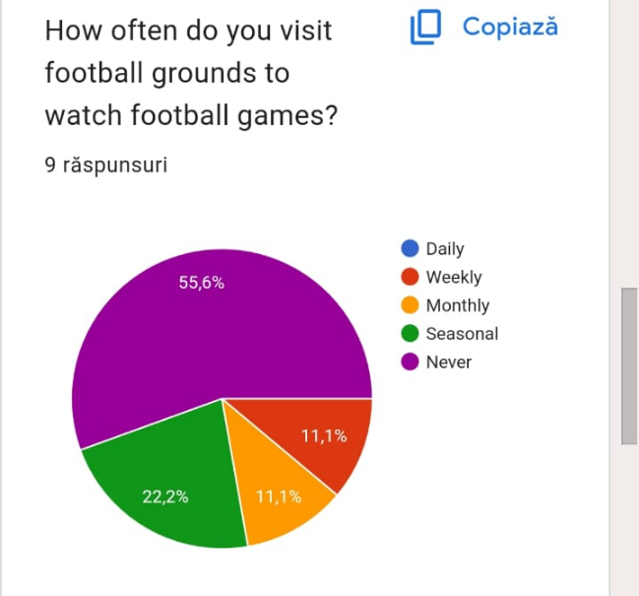
With the help of the survey, Goalpost Grind Cafe could optimise that a suave juxtaposition of football visitors and the environment cafe could be generalised. Around 11.1% people of the 9 respondents stated that they visited football grounds to watch football matches on a weekly basis. Another 11.1% of people visited on a monthly basis. Among the 9 people, it could also be rendered that 22.2% of people visit a football on seasonal times and 55.6% never visit.
Question 6:
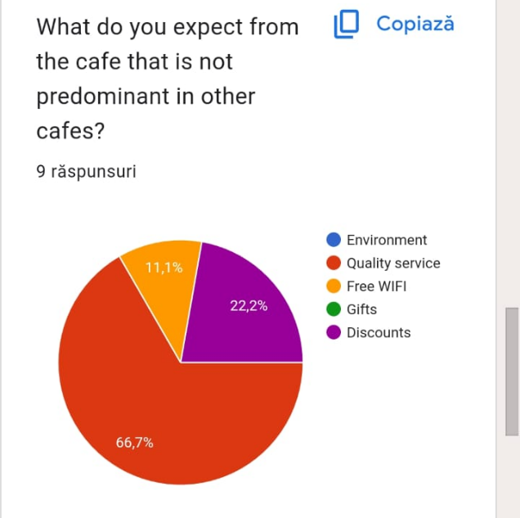
An effective approach of exception in any business helps it to grow at a rapid speed. It helps to carry effective information to serve the needs of all the customers (Mukhtar, 2022). The survey showed that 66.7% of them believed in quality studies and the exceptional features of Free Wi-Fi and Discount rates were put forward by 11.1% respectively along with 22.2% for discounts.

Question 7:
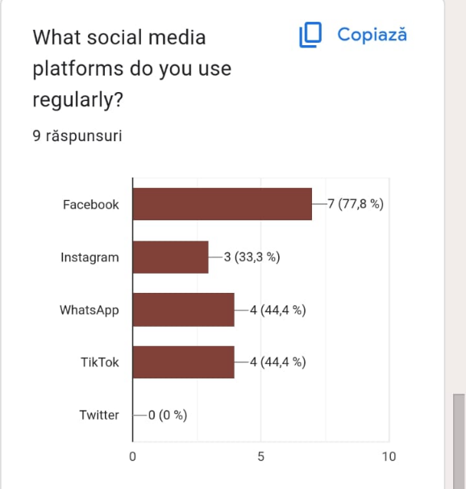
Social media platforms play a pivotal role in summing up the satisfaction level of the customers in a cafe. It helps to get proper views and feedback from all the consumers (Czuczman, 2024). With the help of the survey, it could be optimised that 7 people out of 9 used Facebook and the number of daily Instagram users was also 3. 4 people used TikTok daily and 4 people used WhatsApp on a daily basis.
Question 8:
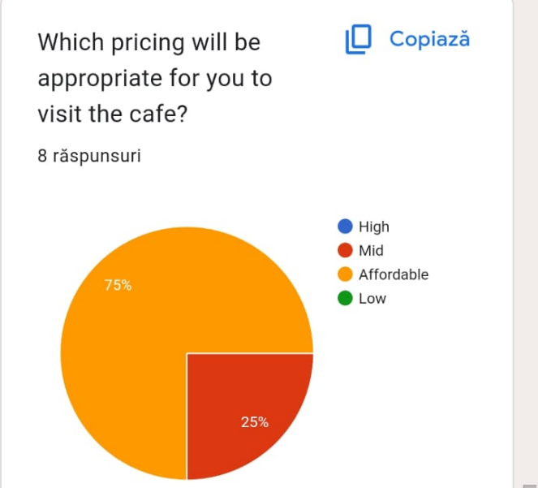
A proper pricing strategy helps a cafe business attract customers by covering the operational cost and enriching the level of profit (Linkedin, 2023). The survey showed that 75% of people fostered affordable pricing, people delineated medium and low pricing, and medium pricing is appropriate for 25%.

Question 9:
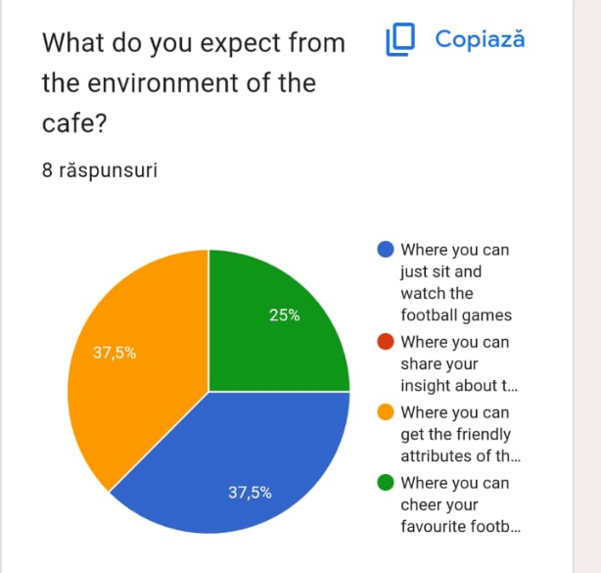
The conduction of the survey of 8 people described that 25% of the people wanted to cheer their favourite football team by quenching their thirst with beverages. 37.5% of people wanted to get the friendly attributes of all the employees, and another 37.5% of them wanted to just sit and watch the football games.
Question 10:
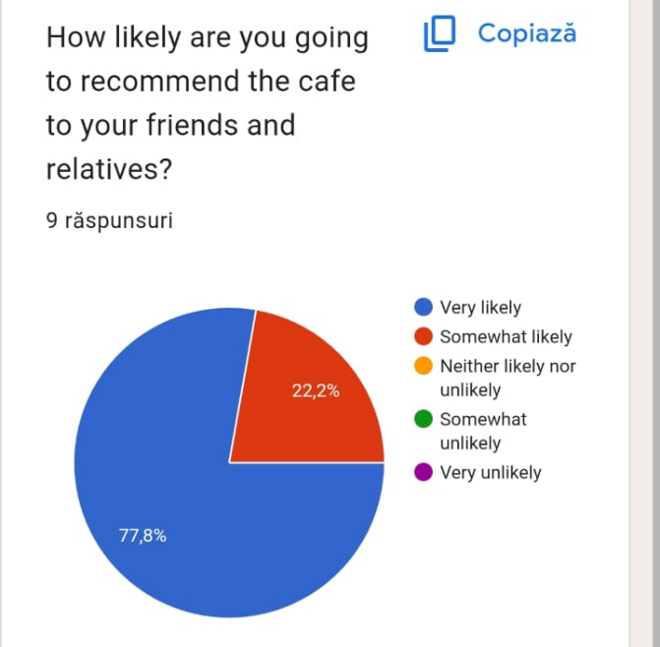
It became utterly satisfactory from the survey of Goalpost Grind Cafe that 77.8% of people were very likely to recommend the effectiveness of the cafe to their families and friends. On the other hand, 22.2% of the people were somewhat likely to recommend the cafe to their friends and families.

Use of findings from the analysis to shape and enhance the cafe business of ‘Goalpost Grind Cafe’
The findings can be fostered by the company Goalpost Grind Cafe to enrich the fundamentalism of its business scenario. It can be able to get proper insight about the market credentials and the consumer views. For that reason, with the help of the feedback from the survey the company can be able to delineate an effective marketing strategy for enhancing its operational sphere. It will also help the company to formulate proper business ideas for uplifting the competitive advantages in the entire market by ensuring a sufficient level of profit.

Task 4

1. Analysing questionnaire data
The questionnaire has been developed so that the target market, their needs, wants and demands can be known. The target population, what influences them to choose a cafe, their age group, social media platforms they use and much more information has been gathered. Based on the results gathered from the survey, the marketing materials and website have been made. There are several demographic questions in the questionnaire. It is mandatory for businesses to analyse a market to start their business (TheHartford, 2024). When marketing the business, the marketing team needs to know the current demand and situation of the market (Kantar, 2023). Thus, for Goalpost Grind Cafe, market research was also very much necessary for the business to establish and run successfully. There are many aspects of the market and research like strategic partners, market segmentation, potential population, costs, income, distribution channels etc. (Byrd, 2021). Therefore, these need to be included when developing a business first so that a company can understand how they can modify their services or products.
Segmentation: Segmentation is known as the process in marketing that is used for dividing the market based on some criteria into smaller groups. There are four kinds of segmentations which are behavioural, demographic, psychographic and geographic (TechTarget, 2024). From the first question it has been known that most of the people who will visit the cafe will be between 18 to 45 years. They mostly visit the cafes weekly and it can be stated that their target will be the people who are frequently visiting cafes. Demographic, geographic and psychographic segmentation will be done by the cafe owner (Mailchimp, 2023). In the case of demographic segmentation, they will consider the age and target people from 18 to 45 years of age. In the geographic segmentation, they will target people who live near the cafe and will be established in urban areas. Moreover, in psychographic segmentation, they will target based on lifestyle, attitudes and interests. When considering the needs of the business and its services, the people who like to visit cafes will be targeted as this is a part of their lifestyle. People who have the attitude to express themselves and convey their opinions and feelings will be targeted. Lastly, the ones who have a core interest in football will be targeted (Yieldify, 2022).
Through this, the website has been created with a calm and tender colour palette where people can visit the page with ease. They can understand the theme of the cafe and what extra benefits and features they can get in the cafe. The website shows in its description that people can enjoy coffee and also, they can talk about football. There are also many options for them to browse around so that they can know the menu of the cafe. In terms of the marketing materials, the first one is an Instagram post which can also be used on Facebook. Other than that, two more marketing materials have been prepared which clearly show the menu and the other one is a flyer which can be necessary to attract some customers. The colour palette chosen for the marketing materials is like the website which will be helpful to have customer satisfaction.
SEO or Search Engine Optimisation: SEO is used for promoting brand awareness, developing product or service reputation and enhancing the sales volume (Dean, 2024). Through the help of SEO, a business can increase the success of its online operations (Pinto and Guarda, 2020). Therefore, to get sustainable digital growth, companies can use SEO to get more exposure. The questionnaire includes some questions which were added to know which social channels can be used by the company to communicate with the target population. The result shows that social media is the primary channel chosen for the company to communicate with customers. Moreover, how often they go to football games has been known to understand their interest. The expectations of people from cafes and the most used social media platforms have been known. Gifts are one of the main reasons to go to the cafes and they mostly use Facebook, Instagram and TikTok. A question related to pricing has also been included as price is one of the most necessary components of marketing and market research. People have also stated that they are very much interested in cheering and sharing opinions on their favourite football teams while enjoying coffee, snacks and other beverages. They will also be interested in recommending the cafe as they will be able to visit the cafe with their friends and family to chat about football.
Goalpost Grind Cafe will have a website that shows coffee, football and chatting altogether. The homepage has a logo which shows the brand name along with the other three components. Other than that, the timing of the cafe, its tagline and the subscription process have been provided here. This helps in knowing the brand in a better way and what they offer in the cafe. The social media links are also provided through which interaction with the customers will happen. Facebook helps in knowing the value of individual users, and Instagram and other social media channels are used for improving brand awareness (Burgess et al. 2028). The website includes all the elements which will help it to become more visible in the search engines. The marketing materials include the name of the cafe, menu, open hours etc. which will be beneficial to get many people towards the cafe.

2. Website design
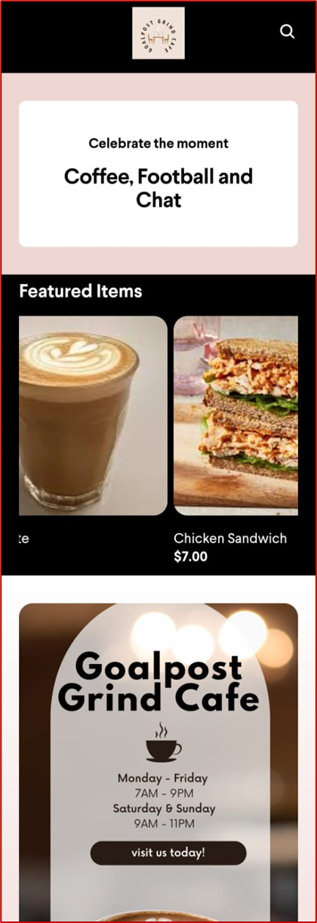

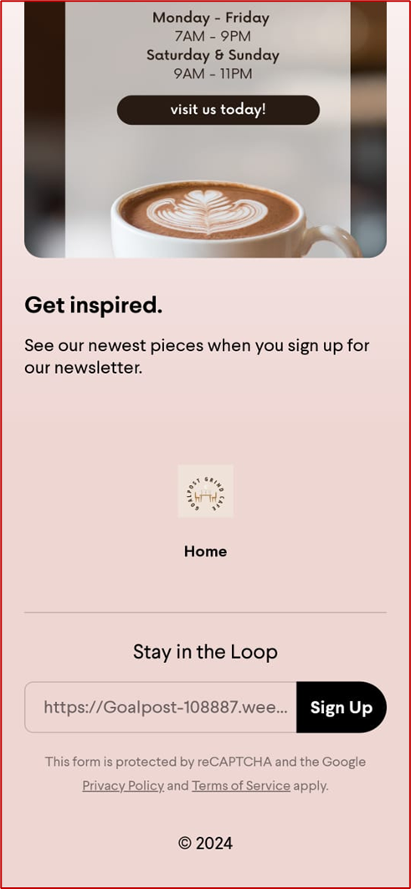

3. Marketing materials
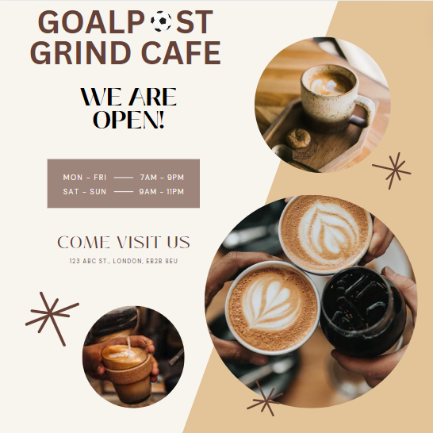
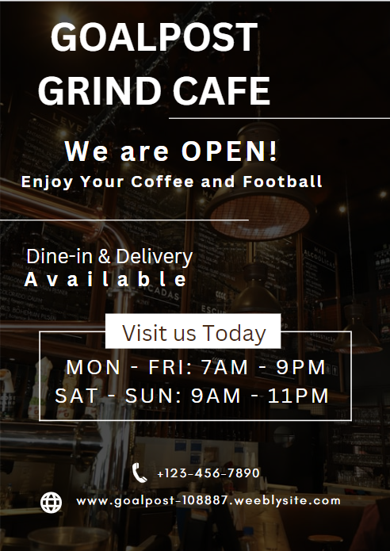
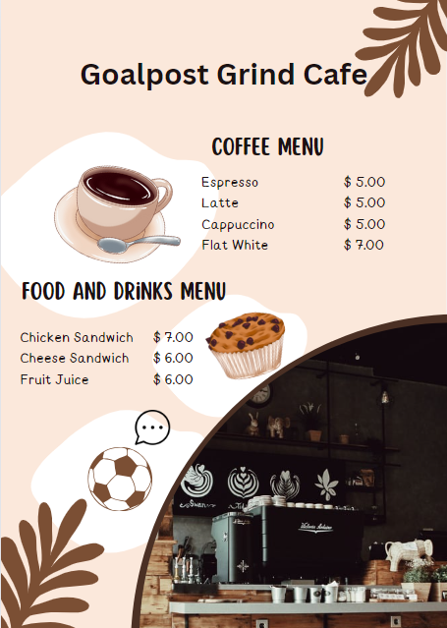

References
Adobe. (2024). Brand Storytelling: How to Connect with Your Customers. [online] www.adobe.com. Available at: https://www.adobe.com/express/learn/blog/brand-storytelling#:~:text=Connect%20with%20your%20audience%20over%20a%20good%20story [Accessed 4 Jun. 2024].
Aziz, A. (2020). Global Study Reveals Consumers Are Four To Six Times More Likely To Purchase, Protect And Champion Purpose-Driven Companies. [online] Forbes. Available at: https://www.forbes.com/sites/afdhelaziz/2020/06/17/global-study-reveals-consumers-are-four-to-six-times-more-likely-to-purchase-protect-and-champion-purpose-driven-companies/ [Accessed 4 Jun. 2024].
Barclays. (2024). Consumer spending grew just 4.3 per cent in April, yet summer holiday planning and Eurovision ticket sales boosted travel and entertainment | Barclays. [online] Available at: https://home.barclays/news/press-releases/2023/05/consumer-spending-grew-just-4-3-per-cent-in-april--yet-summer-ho/ [Accessed 4 Jun. 2024].
Barlow, T. (2023) How to attract customers to a coffee shop: Proven Strategies For Success, Majesty Coffee. Available at: https://majestycoffee.com/blogs/posts/how-to-attract-customers-to-a-coffee-shop-proven-strategies-for-success (Accessed: 05 June 2024).
Burgess, J., Marwick, A. and Poell, T. eds., (2018). The SAGE handbook of social media. Sage.
Byrd, L.S., (2021). Future Forward: Assessing the Potential of Post-Pandemic Expansion of Experiential Learning and Assessment Trends. In Cultivating Entrepreneurial Changemakers Through Digital Media Education (pp. 223-236). IGI Global.
Czuczman, R. (2024) 7 reasons why social media is important for your food business, Nutritics. Available at: https://www.nutritics.com/en/blog/7-reasons-why-social-media-is-important-for-your-food-business/ (Accessed: 05 June 2024).
Dashthis, (2024) Top 5 advertising & paid media kpis to track. DashThis. Available at: https://dashthis.com/blog/top-5-advertising-and-paid-kpis/#:~:text=to%20dive%20in%3F-,What%20are%20advertising%20and%20paid%20media%20KPIs%3F,can%20plan%20your%20next%20moves. (Accessed: 05 June 2024).
Dean, B. (2024) What Is SEO?, Backlinko. Available at: https://backlinko.com/hub/seo/what-is-seo (Accessed: 06 June 2024).
Dhote, T. and Kumar, V., (2019). Long-duration storytelling: Study of factors influencing retention ability of brands. Journal of Creative Communications, 14(1), pp.31-53. https://journals.sagepub.com/doi/pdf/10.1177/0973258618822871.
Du Plessis, C. (2015). Brand storytelling: the case of Coca-Cola's journey corporate website. https://scholar.ufs.ac.za/bitstream/handle/11660/3780/comm_v20_n1_a6.pdf?sequence=3&isAllowed=y.
Herskovitz, S. and Crystal, M., (2010). The essential brand persona: storytelling and branding. Journal of business strategy, 31(3), pp.21-28. http://www.guillaumenicaise.com/wp-content/uploads/2013/10/herskovitz_essential_brand_persona.pdf.
Kantar, (2023) 5 reasons why marketing research is important to your business, Kantar. Available at: https://www.kantar.com/inspiration/research-services/why-marketing-research-is-important-pf#:~:text=research%20with%20Kantar-,Marketing%20research%20is%20a%20critical%20tool%20that%20businesses%20and%20organisations,manage%20risk%2C%20and%20measure%20success./ (Accessed: 05 June 2024).
Linkedin, (2023) What are the most effective ways to price menu items for a cafe?, How to Price Menu Items for a Cafe Effectively. Available at: https://www.linkedin.com/advice/0/what-most-effective-ways-price-menu-items-ybrkc#:~:text=Pricing%20your%20menu%20items%20is,proposition%2C%20and%20your%20target%20market. (Accessed: 05 June 2024).
LinkedIn. (2024). Brand Storytelling: Connecting Emotionally with Your Audience. [online] Available at: https://www.linkedin.com/pulse/brand-storytelling-connecting-emotionally [Accessed 4 Jun. 2024].
Lugmayr, A., Sutinen, E., Suhonen, J., Sedano, C.I., Hlavacs, H. and Montero, C.S., (2017). Serious storytelling–a first definition and review. Multimedia tools and applications, 76, pp.15707-15733. https://www.researchgate.net/profile/Artur-Lugmayr/publication/307606121_Serious_storytelling_-_a_first_definition_and_review/links/5a2ee90eaca2726d0bd69fde/Serious-storytelling-a-first-definition-and-review.pdf.
Mailchimp (2023) 4 marketing segmentation variables & how they work, Mailchimp. Available at: https://mailchimp.com/resources/what-are-segmentation-variables/#:~:text=The%204%20main%20types%20of%20market%20segmentation%20include%20demographic%2C%20geographic,depth%20in%20the%20next%20section. (Accessed: 06 June 2024).
Mailchimp, (2024) What are 5 types of advertising campaigns? Mailchimp. Available at: https://mailchimp.com/resources/advertising-campaigns/ (Accessed: 05 June 2024).
Mailchimp. (2024). Using Survey Results To Improve Your Business. [online] Available at: https://mailchimp.com/resources/survey-results/ [Accessed 4 Jun. 2024].
Microsoft Forms. (2024). Microsoft Forms - Free tool to create online surveys, forms, polls, and quizzes. [online] Available at: https://forms.office.com/Pages/DesignPageV2.aspx?prevorigin=Marketing&origin=NeoPortalPage&subpage=design&id=mDD8tPZPsE-RqrODrDxpANql1nAUsbdAphY1nrAKUhlUQU4xS1hHUDBZSEFJSlJJQkNCSEw5MEhPRi4u&tab=0&analysis=false [Accessed 4 Jun. 2024].
Mokhtar, N.H., Halim, M.F.A. and Kamarulzaman, S.Z.S., (2011). The effectiveness of storytelling in enhancing communicative skills. Procedia-Social and Behavioral Sciences, 18, pp.163-169. https://www.sciencedirect.com/science/article/pii/S1877042811011372/pdf?md5=52f67cc48d16adcd5d5ecd07b9e294dc&pid=1-s2.0-S1877042811011372-main.pdf.
Mukhtar, E.A. (2022) Important of exception, Medium. Available at: https://medium.com/@abuoop123/important-of-exception-96a26b16cdd2 (Accessed: 05 June 2024).
Nielsen, N. (2024) Why Coffee Shop is a good business choice. Limepack Why Coffee Shop is a Good Business Choice Comments. Available at: https://www.limepack.eu/blog/coffee-shop/why-coffee-shop-is-a-good-business-choice#:~:text=Coffee%20shops%20serve%20as%20social,shout%2Dout%20to%20other%20businesses. (Accessed: 05 June 2024).
O’Brien, K. (2019). Coca-Cola embraces augmented reality with interactive experience. [online] The Drum. Available at: https://www.thedrum.com/news/2019/09/10/coca-cola-embraces-augmented-reality-with-interactive-experience [Accessed 4 Jun. 2024].
Petty, L. (2024) What is the importance of effective communication in the hospitality industry?, The Hub | High Speed Training. Available at: https://www.highspeedtraining.co.uk/hub/communication-in-the-hospitality-industry/#:~:text=Effective%20communication%20is%20important%20in,with%20according%20to%20their%20needs. (Accessed: 05 June 2024).
Pinto, F. M., and Guarda, T. (Eds.). (2020). Digital Marketing Strategies and Models for Competitive Business. IGI Global.
Program-ace, (2024) Augmented reality advertising: An ultimate guide - program-ACE Program. Available at: https://program-ace.com/blog/augmented-reality-advertising/#:~:text=Augmented%20reality%20empowers%20marketers%20to,are%20memorable%20and%20easily%20shareable. (Accessed: 05 June 2024).
Restaurant, (2024) Restaurant expectations vary with different age groups NRA. Available at: https://restaurant.org/education-and-resources/resource-library/restaurant-expectations-vary-widely-with-different-age-groups/ (Accessed: 05 June 2024).
Serrat, O. (2008). Storytelling. https://ecommons.cornell.edu/bitstream/handle/1813/87742/Storytelling.pdf?sequence=1&isAllow.
Statista (2023). Share of outbound vacationers by age UK 2021. [online] Statista. Available at: https://www.statista.com/statistics/1087669/share-of-individuals-taking-overseas-holidays-uk-by-age-group/ [Accessed 4 Jun. 2024].
Statista (2023). UK: most active social networks 2022. [online] Statista. Available at: https://www.statista.com/statistics/284506/united-kingdom-social-network-penetration/ [Accessed 4 Jun. 2024].
Suzuki, W.A., Feliú-Mójer, M.I., Hasson, U., Yehuda, R. and Zarate, J.M., (2018). Dialogues: The science and power of storytelling. Journal of Neuroscience, 38(44), pp.9468-9470. https://www.jneurosci.org/content/jneuro/38/44/9468.full.pdf.
TechTarget (2024) market segmentation, Tech Target. Available at: https://www.techtarget.com/searchcustomerexperience/definition/market-segmentation. (Accessed: 06 June 2024).
TheHartford (2024) Why Do Market Research?, The Hartford. Available at: https://www.thehartford.com/business-insurance/strategy/market-research/business-market-research#:~:text=Why%20Do%20Market%20Research%3F,clients%20you%20want%20to%20reach. (Accessed: 06 June 2024).
Times Higher Education. (2020). 10 things international students should know about studying in the UK. [online] Available at: https://www.timeshighereducation.com/student/advice/10-things-international-students-should-know-about-studying-uk [Accessed 4 Jun. 2024].
Yieldify (2022) 4 Types of Market Segmentation: Real-World Examples & Benefits, Yieldify. Available at: https://www.yieldify.com/blog/types-of-market-segmentation/. (Accessed: 06 June 2024).

Appendix
Questionnaire-
The questionnaire
1. How often do you want to visit a cafe?
- Daily
- Weekly
- Monthly
- Seasonal
- Never
2. Which factors influence you to choose a cafe?
- Price
- Quality
- Brand reputation
- Customer reviews
- Promotions or discounts
3. How do you want to be communicated to share your valuable insight about the cafe?
- Through E-mails
- Through Social Media
- Through Messages
- Through Phone Calls
4. You are in which age group?
- 18-25
- 26-35
- 36-45
- 46-55
- 56-65
5. How often do you visit football grounds to watch football games?
- Daily
- Weekly
- Monthly
- Seasonal
- Never
6. What do you expect from the cafe that is not predominant in other cafes?
- Environment
- Quality service
- Free Wifi
- Gifts
- Discounts
7. What social media platforms do you use regularly?
- Facebook
- Instagram
- WhatsApp
- TikTok
- Twitter
8. Which pricing will be appropriate for you to visit the cafe?
- High
- Mid
- Affordable
- Low
9. What do you expect from the environment of the cafe?
- Where you can just sit and watch the football game on live match screens
- Where you can share your insight about the football game
- Where you can get a friendly attribute from all the employees to be involved in the game
- Where you can cheer your favourite football team in an enthusiastic manner by sharing a beverage
10. How likely are you going to recommend the cafe to your friends and relatives?
- Very likely
- Somewhat likely
- Neither likely nor unlikely
- Somewhat unlikely
- Very unlikely

