LECTURER | MAGDALENA WRONSKA
HIGH STAFF TURNOVER IN DOMICILARY CARE SECTOR
PROBLRM SOLVING AND DECISION MAKING (BMSW4004)
Omolara Lawal-akintola (1906883)
2020

Table of Contents
INTRODUCTION 2
SCOPE AND IMPACT 2
FISHBONE ANALYSIS 4
PROPOSAL OF ALTERNATIVE SOLUTIONS 4
IMPLEMENTATION OF THE SOLUTION PLAN 8
COMMUNICATION TO STAKEHOLDERS 10
MONITORING AND REVIEW 11
CONCLUSION 11
REFERENCES 12

INTRODUCTION

One of the essential elements of effective management is good Decision Making. Decision Making is how an organisation comes to an agreement as to how it solves its problems, allocates its resources and achieves its objectives (Lindberg, 2017). A problem is a gap between what you have and what want, while problem solving is a series of steps used to overcome obstacles and achieve goals (Roy, 2015). This is an academic report on the identification of a complex problem facing the provision of Domiciliary Care at the workplace, which is High Staff Turnover. The report will include some literature review, related to the technical terms in Decision Making and Problem Solving. The report will focus on the scope and impact of the problem and analyse the problem, using the Fishbone Analysis Technique to find the root cause of the problem. Some solutions will be prospered using the Brainstorming technique include some of the major stakeholders of the company. To decide which solution is appropriate for the complex problem at hand the PMI (Plus, Minus Interesting) will be used to root out the most appropriate solution. The report will also map out a plan using the PERT (Program Evaluation & Review Technique) to implement the appropriate solution. The report will also indicate how the solution to the problem will be communicated to the Stakeholders. Furthermore, it will recommend a constant monitoring system that will be put in place to enable the organisation to monitor the implementation plan as well as a feedback system to ensure that the desired result is being met.

SCOPE AND IMPACT
High Staff Turnover in the provision of Domiciliary Care affects both the Service User as well as the Service Provider. Staff turnover can be defined as the frequent disengagement or movement of working employees in and out of an organisation within a specified period of time (Alkinson, et al., 2016). There are several reasons why an employee might disengage, and not all of them a controllable, some could receive offers that they cannot refuse, transition into a new career path, it could also be due to employees leaving voluntary due to dissatisfaction, retirement or termination of contract. Domiciliary care is the provision of a variety of support services to an individual in their own residence (Health, 2019). This is due to the fact that the service to be provided depends on human capital that is, in skills, abilities and knowledge of employees, thus productive levels depend on them or even for the organisation to survive. Human capital is not easily transferred, it takes time and finance to train another person (MorBarak, et al., 2001). High turnover puts an organisation in a disadvantaged position as continuity as continuity is key. The cost of hiring and training people to replace those that have left can be highly time consuming and a financial burden to the organisation (MorBarak, et al., 2001). Thus, instead of the organisation to use its resources on improving and providing the best quality care, its wasting time rehiring employees. The domiciliary care section is characterised with the low pay compared to other sectors on the same grade level such as the retail sector and also 57% of the Domiciliary care workforce are on zero hour contract, while the turnover rate of Care Workers increased to 31.8% (Cater, 2019).
Staff turnover impacts gravely on the provision of service. When an employee leaves the service of the organisation, he/she takes their expertise with them. This creates a knowledge gap which could be exploited by the organisation’s competitor.
Intermittent continuous loss of experience staff could have an effect on remaining staff this could damage the morale and confidence within the organisation. There will be a decrease in the quality of the provision of service, lack of retention of clients, increase in direct and indirect costs for recruiting new staff, decrease in productivity and increased stress, existing staff will have to cover the duties of the staff that left. There will be a reduction in revenue and profitability.

FISHBONE ANALYSIS
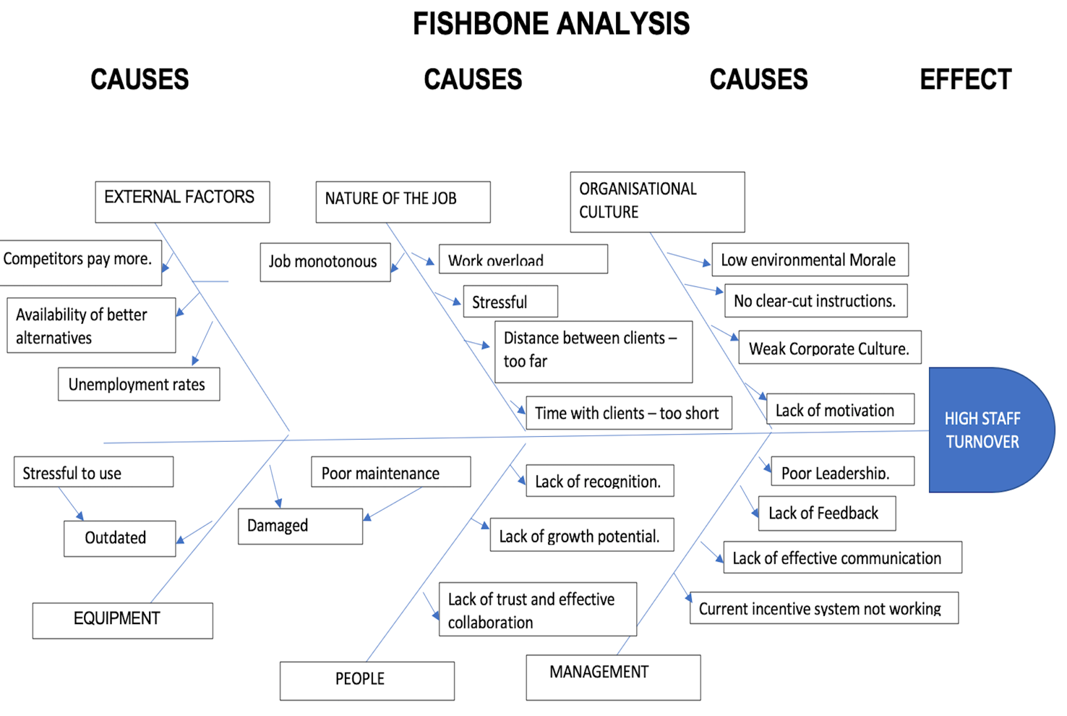

PROPOSAL OF ALTERNATIVE SOLUTIONS
A brainstorming session was held, which is where individuals gather ideas associated with a topic or task, with no restrictions on the quality of ideas (SimplyInfo, 2017). Some of the stakeholders such as a Director, Top Management, some Managers and experienced Employees were in attendance. Below are some of the solutions presented during the brainstorming session.

- Hire the right people, using unfaltering hiring practices. Employ personnel that have strong skills, are competent and can easily fit for the positions available as well as be able to fit into the organisational culture.
- Engage a Hiring Consultant to use expertise to recruit to avoid any mistake that could arise from internal processes.
- Offer competitive pay and benefits. Offer salaries and benefits that will put the organisation at competitive advantage or at least be within the minimum level that prevails within the organisation’s sector.
- Create career opportunities for development and growth. Providing opportunities for advancement has a huge impact on employees and retention. It is an indication that the organisation values them and are actively interested in their success (Simpson, 2017).
- Provide training that will drive Communication and promote Transparency. Having clear cut information to do one’s job reduces confusion and frustration. Transparency builds trust which are equally important in retaining valuable employees (Horsager, 2020).
- Offer Flexibility. Offering flexible work hours is the current trend in organisations today. Employees desire for a flexible work-life balance, it enables the to attend to their private lives.
- Build Autonomy and Empowerment. Create opportunities that enable employees to make decisions concerning their work, it makes them feel recognised as a member of the team. Management should allow staff to take initiative or command influence within their role and not maintain full control at all times.
- Appreciation of Employees. Giving incentives and appreciating work done, creates a sense of belonging and recognition. Sometimes a mere “Thank you” can do the job, do something that the employee can relate to and refocus back to the task for which appreciation is being shown, it goes a long way (Claire, 2015).
- Staff recognition. Acknowledging employees’ actions, efforts, behaviours or performance by reinforcing these performances, e.g. extraordinary accomplishment which contributes to the success of organisational objectives (Lindberg, 2018).
- Establish an operative incentive system.

SOLUTION: HIRING THE RIGHT STAFF
PLUS | MINUS | INTERESTING
- Right attitudes and behaviour. (7)  - Easy to fit into the system. (7)  - Competent personnel (7) | - Difficult to find.  (-10)  - Cost implications – Recruitment, Selection and other hiring expenses.  (-10)  3. Time consuming (-10) | - The work will be done. (5)  - There will be continuity in the flow of work. (5)
TOTAL = +21 | TOTAL = - 30 | TOTAL = +10
TOTAL = +21+10-30=1
ENGAGE A HIRING CONSULTANT
PLUS | MINUS | INTERESTING
- Standard hiring processes. (+7) | - Cost implications.  (-10) | 1. Objective selection.  (+7)
TOTAL = +7 | TOTAL -10 | TOTAL +7
TOTAL = +7+7-10=4
CREATING CAREER OPPORTUNITIES
PLUS | MINUS | INTERESTING
- Staff are motivated (+10)  - Improve competency level of workforce (+10) | - Cost implications  (-10)  - Staff could still disengage (-10) | - Continuity of flow of organisational activities (+10)  - Work overload in employment gap created (-10)
TOTAL = +20 | TOTAL = -20 | TOTAL = 0
TOTAL = +20-20 +0 = 0

PROVIDE TRAINING TO DRIVE EFFECTIVE COMMUNICATION AND TRANSPARENCY
PLUS | MINUS | INTERESTING
- It will provide clarity and direction (+10)  - It will increase engagement and commitment (+10)  - It will Promote team building (+10)  - It will establish an open organisational culture. (+10) | - Long term gradual solution considering the urgency. (-5)  - People’s attitude to change. (-10) | - It will Improve provision of services. (+10)  - It will increase interpersonal interaction. (+10)  - It will establish a positive corporate image. (+10)
TOTAL = +40 | TOTAL = -15 | TOTAL = +30
TOTAL= +40-15+30 = +55

APPRECIATION OF EMPLOYEES

PLUS | MINUS | INTERESTING
- Employees feel acknowledged. (+8)  - They are self-motivated. (+10)  - They feel respected (+10)  - Little or no financial implications (+9) | - Difficult for egocentric persons to comply (-10) | - Employees feel elevated. (+8)  - Employees feel engaged and committed. (+10)  - Staff feel a sense of belonging. (+10)
TOTAL = +38 | TOTAL = -10 | TOTAL = +28
TOTAL = +38-10+28 = 56

OFFER COMPETITIVE PAY AND BENEFITS
PLUS | MINUS | INTERESTING
- Employees will be happy. (+10)  - High morale. (+10) | - High cost implementation. (+10) | - Retain staff. (+10)
TOTAL = +20 | TOTAL = -10 | TOTAL = +10
TOTAL= +20-10+10 = +20

ESTABLISH AN OPERATIVE INCENTIVE SYSTEM
PLUS | MINUS | INTERESTING

INTRODUCE FLEXIBILITY
PLUS | MINUS | INTERESTING
- It has a positive impact on employee’s work-life balance. (+10)  - Improves employees physical and mental well-being. (+8) | - Have to employ more staff to cover uncovered hours. (-8)  - Extra cost. (-10) | - It improves staff morale. (+10)
TOTAL = +18 | TOTAL = -18 | TOTAL = +10
TOTAL = +18-18+10 = +10

IMPLEMENTATION OF THE SOLUTION PLAN

The solution chosen is to retain existing employees as well as reduce high turnover rate. It will be from the PMI that to drive communication and promote transparency as well as appreciation for staff can be executed simultaneously as a singular solution since showing appreciation costs little next to nothing compared to the impact it can have on an individual.

ACTION | RESPONSIBILITY | PRIORITY  (1-5) | STATUS | START DATE | END DATE | NOTES
Arrange Motivational speeches in Appreciation and Emotional Intelligence | Human Resource Manger | Urgent (4) | In-progress | 1st Sept 2020 | 11th Jan, 2021 | Resources: Finance, Motivational Speaker – Internal or External  Risk: Costs  Adaptation: Management can start with words of affirmation
Source for Motivational Speaker | Assistant Human Resource Manager | Urgent (5) | In progress | 1st Sept, 2020 | 15th Sept, 2020 | Resources: Use Company Intranet, make internal poster.  Risk: Time consuming might not met the set target.  Adaption: Use internal staff tentatively.
Location: Internal or External | Assistant Programmes Manager | 4 | In-progress | 1st Sept, 2020 | 7th Sept, 2020 | Resources: Venue, Handyman if internal, tables and chairs, refreshments, visual aids.  Risks: Meeting or Conference room not available.  Adaptation: Source for another available venue.
Time: will be done in several sessions, 3 times a day, 8am – 9am, 12pm – 1pm and 3pm – 4pm. | Human Resource Manager | 3 | Nearly completed | 31st Aug, 2020 | 7th Sept, 2020 | Resources: Available Time.  Risk: Not all staff might fit in the required time provided.
Regular Team meetings, these meetings could be in the format of brainstorming or informative which will be an avenue to receive constructive feedback, networking and interpersonal interaction. | Manager | 5 | In progress | 1st sept, 2020 | Till further notice | Resources: Time staff room or clinical room.  Risk: cannot be understood at once, that the drive for effective communication and transparency.  Adaptation: will be done in piece meal sessions.
Delivery, | Motivational speaker or Internal trainee, For the Teams the Manager of the various sections will be responsible for their teams. | 5 |  | 16th Sept, 2020 | 11th Jan, 2020
Evaluation | Manager | 5 | Start after the first 2 weeks of receiving the lectures |  |  | Blind surveys will be used to access whether the is a behaviour change as well as close observation and direct supervision by the Manager.

COMMUNICATION TO STAKEHOLDERS

Stakeholders are essential to any organisation. A Stakeholder can be defined as any group or individual who can influence or is influenced by the success of the organisation’s goals (Matuleviciene & Strvinskiene, 2015). Stakeholder has also been defined as individuals and groups who considerable impact upon an organisation’s behaviour (Roome & Wijen, 2005). It is important that those who influence the organisational behaviour are duly kept informed.

COMMUNICATION PLAN TO STAKEHOLDERS
STAKEHOLDER | POWER/INTEREST | KEY INTERESTS & ISSUES | COMMUNICATION VEHICLE | FREQUENCY | COMMENTS
Directors | High power, High interest | Final goal achievement, Retention of staff, improvement in the quality of service, improved staff morale, improved corporate image. Provision of finance, availability of time. | Board meetings, Official E-mails, Conferences, Proposals, weekly Reports | Twice a month initially, may for the 1st quarter and then Monthly.
Managers | Medium power, High interest. | Interests: Achievement of sub-goals towards the ultimate goal. Establish a conducive workplace environment that will encourage staff to stay.  Issues: Being able communicate effectively and appreciate staff appropriately. | Official E-mails, Periodicals, Newsweek, Reports | Weekly
Employees | Low power, High interest. | Interests: Continued personal development, friendly encouraging environment | E-mails, memos posters | Initially twice a week, | Very close supervision is required at the initial stage as individuals are not easily susceptible to change.

MONITORING AND REVIEW

Adapting the organisational culture of Appreciation and drive communication as well as Transparency through motivational speech on Employee Appreciation, Emotional Intelligence and Team networking requires Behavioural and Clan control. Managers of the various departments will through observation and close supervision and evaluate whether the has been any behavioural change in the organisation system. Initially they will be weekly feedback which could be by visiting employees at the service user’s residence, face to face discussions with employees as well as applying Concurrent and feedback controls.

CONCLUSION

High staff turnover in the domiciliary care sector is impacting negatively on the sector today and the figures keep on rising. The are several factors that contribute to this phenomenon, which are both external and internal to the organisation. Organisations should look into this complex problem facing them and be able to root out the causes and effects of this problem to be able to survive the prevailing problem of High staff turnover.

REFERENCES
- Alkinson, C., Crozier, S. & Lewis, L., 2016. Factors that affect the Recruitment and Retention of Domciliary Care Workers and the Extent to which Factors Impact Upon the Quality of Domiciliary Care. [Online]
[Accessed 27 August 2020].
- Cater, C., 2019. Adult Care Staff Turnover Rises for the Sixth Consecutive Year, report finds. [Online]
Available at: https://www.communitycare.co.uk/2019/10/04/adult-care-staff-turnover-rises-sixth-consecutive-year-report-finds/#
[Accessed 29 August 2020].
- Claire, M., 2015. Missing the Obvious in Employee Recognition. [Online]
Available at: https://www.youtube.com/watch?v=JWlzc6x5u10
[Accessed 30 August 2020].
- Health, D. o., 2019. Domiciliary Care. [Online]
Available at: https://www.google.com/search?q=definition+of+domiciliary+care&oq=definition+of+domi&aqs=chrome.0.0l5j69i57j0l2.24294j1j7&sourceid=chrome&ie=UTF-8
[Accessed 27 August 2020].
- Horsager, D., 2020. Introduction: Trust for the workplace. [Online]
Available at: https://www.youtube.com/watch?v=lCEfNTG1XPM
[Accessed 30 August 2020].
- Lindberg, G., 2017. Decisions and Problems in Management. [Online]
Available at: https://www.youtube.com/watch?v=eBNVJUSKe9U
[Accessed 31 August 2020].
- Lindberg, G., 2018. HR Basics: Employee Recognition. [Online]
Available at: https://www.youtube.com/watch?v=bRM19CxIDek
[Accessed 31 August 2020].
- Matuleviciene, M. & Strvinskiene, J., 2015. The Important of Stakeholders for Corporate Reputation. Engineering Economics, 26(1), pp. 75-83.
- MorBarak, M. E., Nissly, J. A. & Levin, A., 2001. Antecedents to Retention and Turnover among Child Welfare, Social Work and Other Human Service Employees: What can we Learn from Past Researches? A Review and Metanlysis.. Social Service Review, 75(4), pp. 625-661.
- Roome, N. & Wijen, F., 2005. Stakeholder Power and Organisational Learning in Corporate Environmental Management. Organisational Management, 27(2), pp. 235-263.
- Roy, J., 2015. What is Problem Solving?. [Online]
Available at: https://www.youtube.com/watch?v=rxn407cm6MM
[Accessed 31 August 2020].
- SimplyInfo, 2017. What is Brainstorming| How to Brainstorm a Topic for Great Results. [Online]
Available at: https://www.youtube.com/watch?v=j8innLVXwtg&t=37s
[Accessed 26 August 2020].
- Simpson, R., 2017. 7 Reasons Why Your Best Employees Want to Leave. [Online]
Available at: https://www.youtube.com/watch?v=YEPKi0st6xw
[Accessed 30 August 2020].

