

To What Extent Is There Effective Mental Health Support for Police Officers Frequently Exposed to Trauma?

University: UWTSD Swansea
Degree: BSc (Hons) Professional Policing Practice
Name: Geraint Hall-Moore
Student Number: 2125218
Word Count: 8134

Acknowledgements
Firstly, I would like to express my deepest gratitude to my partner, Shannon, for her unwavering support throughout this journey. I truly couldn’t have done this without her by my side. I appreciate you so much and I’ll forever grateful.
To my parents and family, thank you for your endless belief in me. Your support and faith have been a constant source of strength throughout this process.
Finally, I am sincerely thankful to everyone who took the time to participate in my survey. Your contributions were invaluable, and without your input this dissertation would not have been possible.

Declaration
This work has not previously been accepted in substance for any degree and is not being concurrently submitted in candidature for any degree.
Signed: Geraint Hall-Moore
Date: 06/10/2024

STATEMENT 1
This dissertation is being submitted in partial fulfilment of the requirements for the degree of BSc.
Signed: Geraint Hall-Moore
Date: 06/10/2024

STATEMENT 2
This dissertation is the result of my own independent work/investigation, except where otherwise stated.
Other sources are acknowledged in the Reference Section.
Signed: Geraint Hall-Moore
Date: 06/10/2024
STATEMENT 3
I hereby give consent for my dissertation, if accepted, to be available for photocopying and for interlibrary loan, and for the title and summary to be made available to outside organisations.
Signed: Geraint Hall-Moore
Date: 06/10/2024

STATEMENT 4
I hereby give consent for my dissertation, if accepted, to be available on the university’s IT system to those who have consent to use the system.
Signed: Geraint Hall-Moore
Date: 06/10/2024

Abstract
This dissertation explores the impact of frequent trauma exposure on the mental health of police officers in the United Kingdom. Police officers frequently encounter high-stress situations that can lead to long-term psychological issues, yet the availability and effectiveness of mental health support within police forces remain insufficient. Through a mixed-method approach involving a survey, this research examines the mental health challenges officers face and evaluates the accessibility and adequacy of the support services currently in place.
The findings highlight the gaps in mental health support, particularly around stigma, access to services and the limitations of current support. The research reveals that while some support is offered, it is often reactive rather than proactive and many officers feel unsupported.
This dissertation makes several recommendations, including enhancing the accessibility of mental health services, reducing stigma, and involving regular mental health check ins for officers. These findings have the potential to influence policy changes and improve overall well-being of officers.

Table of Contents
Chapter One: Introduction 8
1.1 Introduction 8
1.2 Rationale 8
1.3 Background 9
1.4 Aim and Objectives 10
1.4.1 Aim 10
1.4.2 Objectives 10
1.5 Purpose of the Chapters 10
1.6 Conclusion 11
Chapter Two: Literature Review 12
2.1 Introduction 12
2.2 Exploring the effects of Trauma 12
2.2.1 Trauma 12
2.2.2 The Effects of Frequent Exposure to Trauma 13
2.3 Examining the Magnitude of the Current Mental Health Crisis 15
2.3.1 The Current Mental Health Crisis 15
2.3.2 Factors Contributing to the Crisis 16
2.4 Examining whether there is effective and appropriate support available. 18
2.4.1 The Support Available 18
2.4.2 The Effectiveness 20
2.5 Conclusion 20
Chapter Three: Methodology 22
3.1 Introduction 22
3.2 Research Questions 22
3.3 Research Strategy 22
3.4 Research Approach 23
3.5 Research Design 24
3.5 Sampling 24
3.5.1 Sample Size 24
3.6 Data Collection Procedure 25
3.7 Validity and Reliability 25
3.8 Ethical Considerations 26
3.8.1 Informed Consent 26
3.8.2 Confidentiality and Privacy 26
3.9 Limitations 27
3.10 Analysis of Data 27
3.11 Conclusion 27
Chapter Four: Analysis of Results 29
4.1 Introduction 29
4.2 Demographic Information 29
4.3 Questionnaire Results 31
4.3.1 Mental Health Support Available for Police Officers 31
4.3.2 The Magnitude of the Current Mental Health Crisis in the UK police force 32
4.3.2 Barriers to Seeking Mental Health Support 33
4.3.3 Effects of Trauma on Police Officers 34
4.3.4 Improving Mental Health Support in the Police Force 34
4.4 Conclusion 36
Chapter Five: Conclusion and Recommendations 37
5.1 Introduction 37
5.2 Main Findings 37
5.4 Contributions to Theory 40
5.4 Limitations 41
5.3 Recommendations 41
5.5 Further Research 43
5.6 Conclusion 43
Reference List 45
Appendices 58
7.1 Appendix 1 – Copy of Questionnaire 58
7.2 Appendix 3 – Questionnaire Results 62
7.3 Appendix 3 – Email sent to participants 75
7.4 Appendix 4 – Ethics Form 76

Chapter One: Introduction

Introduction
This chapter aims to explain the background and rationale for completing this study. While also outlining the aims and objectives of the research. This study aims to examine to what extent is there effective mental health support available for police officers that are frequently exposed to trauma. Police officers are regularly exposed to high-stress situations (Milliard, 2020), which can significantly impact their mental health and overall well-being (Marshall et al., 2021). The issue of trauma and mental illness among police forces in the United Kingdom (UK) has become increasingly prevalent. I have chosen this topic because police officers are often at the forefront of dealing with crises, violence, and other emotionally difficult situations, which I believe can lead to long term mental health issues. As I am a police officer myself, this has deepened my interest in understanding the link between mental health challenges and exposure to trauma for police officers.

Rationale
This research seeks to explore the impact of trauma exposure on police officers’ mental health and to evaluate the effectiveness of the support in place. The mental health of police officers has been largely understudied compared to other emergency services, yet officers routinely face traumatic incidents that can have a lasting impact. Through my research, I want to highlight the importance of proactive mental health support and the gaps in current systems, aiming to inform policies and future programs that can be put in place to help support officers.

Background
According to a report by *The Guardian*, the number of mental health-related requests within police forces in England and Wales rose dramatically between 2019 and 2021. For example, Northamptonshire Police saw a 90% increase, Norfolk a 260% rise, Suffolk recorded 360%, and Leicestershire reported a 54% growth (Syal, 2023). Many officers in the UK attribute their mental health struggles directly to the nature of their work. Alarmingly, 93% of officers surveyed acknowledged that they would continue to attend work while grappling with mental health challenges such as anxiety and depression (Police Care UK, 2023). This suggests that mental health struggles are often seen as a routine aspect of the job. Furthermore, one in five officers is estimated to have posttraumatic stress disorder (PTSD), and two-thirds of those affected by PTSD are unaware of their condition (Police Care UK, 2023). The mental health of police officers is profoundly impacted by repeated exposure to traumatic events, often leading to conditions such as PTSD, anxiety, and depression (Marmar et al., 2006; Soravia et al., 2021).
Peer interventions can promote resilience and well-being among police officers. Milliard (2020) investigated how police officers used and were affected by peer-support programs. But Marshall et al. (2021) found variables linked to police officers' underreporting of mental health symptoms, raising the possibility that not everyone in need of assistance is receiving it via the current systems. Despite the availability of mental health support initiatives such as peer support groups, screening programs, and counselling services, the effectiveness and accessibility of these resources remain insufficient. Current mental health support systems are not adequately meeting the unique needs of officers, especially those consistently exposed to trauma (Stogner, Miller and McLean, 2020). There is a pressing need to improve mental health programs to better align with the specific challenges faced by police officers. Furthermore, Velazquez and Hernandez (2019) emphasise the stigma attached to the mental health of police officers and the necessity of raising awareness and promoting de-stigmatisation within law enforcement. Addressing this issue requires the implementation of a comprehensive strategy that includes proactive interventions, ongoing support, and a concerted effort to de-stigmatise mental health issues within the police force (Stogner, Miller and McLean, 2020).

Aim and Objectives

Aim
This study aims to examine to what extent is there effective mental health support available for police officers that are frequently exposed to trauma.

Objectives
- Objective 1: Explore the effects of trauma on police officers in the UK.
- Objective 2: Examine the magnitude of the current mental health crisis within the UK police force.
- Objective 3: To examine whether there is appropriate and effective support in place to help police officers deal with trauma and mental health issues.

Purpose of the Chapters
The purpose of Chapter 2 which is the literature review is to examine existing research on mental health support for police officers, particularly focusing on the impact of trauma exposure and the effectiveness of current support systems. The purpose of chapter 3 being the methodology is to outline the mixed-method approach used in the research, including the design of the questionnaire, the rationale for using both open and closed questions, and how the data was collected. The purpose of chapter 4 being the analysis of the result is to present the findings from the survey, presenting both the quantitative data from closed questions and the qualitative responses from open-ended questions. The purpose of chapter 5 which is the conclusion and recommendations chapter is to discuss the key conclusions drawn from the analysis comparing to the literature and provides recommendations for improving mental health support for police officers based on the findings. The purpose of chapter 6 is the reference list which includes all of the academic sources referenced throughout the dissertation. Finally, the purpose of chapter 7 the appendices is to contain any supplementary material, such as the questionnaire used in the study and any additional data or information relevant including the ethics form.

1.6 Conclusion
Understanding these dynamics is essential for developing more effective, targeted interventions to address the mental health crisis within UK police forces. This research is particularly important because it highlights the gaps in current mental health measures and underscores the urgency of improving support systems to ensure they are both effective and accessible for all officers in need. The findings of this study have the potential to inform future initiatives designed to provide better care and resources for police officers facing mental health challenges, contributing to the overall well-being of the force and improving their ability to perform their duties safely and effectively.

Chapter Two: Literature Review

2.1 Introduction
The purpose of this chapter is to review the current literature available to assist with answering the research question and objectives. The literature review explores the mental health challenges faced by UK police officers due to their frequent exposure to trauma. It discusses how traumatic events, such as domestic violence and physical assaults can significantly affect mental well-being. The literature review highlights the prevalence of mental health issues such as PTSD, depression and anxiety among police officers and examines factors that contribute to the crisis, including police culture and stigma. The review further critiques available support services such as Trauma Risk Management (TRIM) and noting the need for improved mental health services.

2.2 Exploring the effects of Trauma

2.2.1 Trauma
Exposure to traumatic events is a prevalent issue affecting police officers globally and across the UK. Goodman et al. (1998) define traumatic events as extremely horrific or life-threatening incidents or a series of such events. According to Wagner et al. (2020), approximately 92% of police officers participate in the management of critical events or incidents during their first two years of work. In the UK, at least 90% of police officers report exposure to critical/traumatic events, with every one in five officers currently suffering from either Complex Post-Traumatic Stress Disorder (C-PTSD) or PTSD because of all the exposure to these incidents (Miller et al., 2022; Miller et al., 2020). Trauma has been established to impair cognitive function and negatively impact a person's performance and general well-being, including being detrimental to their essential skills, such as situational awareness. Although these figures are alarming, they lack granularity. For instance, overall statistics fail to account for variations in individual resilience and experiences among police officers. Moreover, dependence on self-reported data raises concerns regarding possible over-reporting or underreporting of traumatic exposures and their effects.
Police officers are exposed to various types of trauma, including child abuse cases, sudden deaths, fatal road traffic collisions, murders, and threats to life or injury to themselves or colleagues (Police Care UK, 2023; Elliott-Davies, 2023). Some police experience trauma during a shooting or a stabbing, which in some instances results in the death of innocent civilians during large-scale or grisly crimes (Gekoski et al., 2012). Police officers in more specific roles like detectives also frequently experience severe trauma since they are responsible for investigating serial killings, brutal crimes, and multiple murders in addition to the daily hassles and stresses of their occupation (Gekoski et al., 2012). While this information underscores the intensity and diversity of traumatic exposures, the literature lacks depth in studying the cumulative impact of these encounters over time. The focus on high-profile traumas could overshadow the chronic, daily stressors that affect the mental health of police officers significantly.

2.2.2 The Effects of Frequent Exposure to Trauma
Research consistently shows a substantial link between frequent exposure to trauma and poor mental health among police officers. Stevelink et al. (2020) found correlations between high blood pressure, PTSD, depression, and anxiety in frontline officers. Soravi et al. (2021) noted that many officers develop PTSD after joining the force. Foley and Massey (2021) discuss the "cost of caring," highlighting how prolonged exposure to trauma leads to burnout and PTSD. Their findings suggest that continuous exposure significantly increases the likelihood of mental health issues, stress, and anxiety.
Demou, Hale, and Hunt (2020) focused on Scottish police officers and their need for mental health support and research on how their well-being was currently. They found similar issues as the above mentioned from the frequent exposure to trauma. Bringing attention to compassion fatigue and the fact that police forces often fall short of the support networks following traumatic incidents is also supported by Grant et al. (2019) research. These studies underscore the urgent need for improved mental health support and policies designed to mitigate the negative effects of unavoidable trauma. However, these studies often fail to address the heterogeneity of responses to trauma. For instance, individual resilience, organizational support, and personal coping strategies are not sufficiently examined, leading to a potentially one-dimensional understanding of trauma's impact.
Police culture is often associated with a negative attitude towards seeking help for mental health, and many officers, as a result, suffer in isolation. According to Porter and Lee (2024), police culture can cause severe mental health disorders such as posttraumatic stress disorder (PTSD), anxiety, and depression. Police exposure to environments like domestic violence, motor vehicle accidents, crowd control, handling dead bodies, physical assaults, and dealing with armed and unpredictable dangerous criminals is linked to poor mental health. Besides, police officers encounter organizational pressure like inadequate resources, increasing public demand and lack of support. These organizational stressors expose police officers to depression, trauma, and other mental illnesses (Bikos, 2020; Bullock and Garland, 2018). The police culture is characterized by masculinity and emotional self-control. As a result, police officers are expected to suppress their emotions and appear tough. This leads to stigmatization and marginalization as anything deviating from this is considered a weakness and can affect their career (Bikos, 2020; Bullock and Garland, 2018). This causes Police to avoid seeking help regarding their mental health.

2.3 Examining the Magnitude of the Current Mental Health Crisis

2.3.1 The Current Mental Health Crisis
Police officers are frequently exposed to stressful work environments, dealing with child abuse cases, murders, serious assaults, armed criminals, and emergencies like natural disasters. This exposure places them among the most adversely impacted occupations in terms of mental health. The Police Firearms Officers Association (2017) reported a significant increase in officers' absences due to workplace stress. Additionally, the Police Federation's 2016 evaluation of 17,000 officers revealed that 39% needed help for mental health conditions, highlighting a stark contrast to the general population (Houdmont and Elliott-Davies, 2016). Furthermore, Mind (2019) found that 70.2% of officers had personal experiences with mental health issues, with 91% reporting poor mental health and frequent stress. Stevelink et al. (2020) noted that 40,299 UK law enforcement officers commonly exhibited symptoms of anxiety, depression, and PTSD. These statistics clearly indicate a mental health crisis among UK police officers despite growing efforts to address the issue and normalize seeking psychological assistance.
However, these studies predominantly rely on self-reported data, which may introduce biases and inaccuracies. Besides, they do not capture the complexity of individual experiences and the variation in the severity of mental health issues among officers.

2.3.2 Factors Contributing to the Crisis
Police Culture
The study shows that police culture greatly hinders officers from accessing mental health care and being open about their mental status. This culture was found to be masculine, emotionally contained, and dominant, diminishing displays of emotions (Foley and Massey, 2021). In their study, Kane et al. (2017) concluded that officers have ambivalent attitudes about this position, and knowledge of mental health records is considered dangerous, while support-seeking is seen as a violation of masculinity. This culture values endurance, and officers are constantly told things like ‘get over it,’ ‘it is just the job,’ or ‘grow some balls’ (Porter and Lee, 2023). It is required for police officers to walk away from the traumatic scenes they come across in the line of duty with a ‘tough it out’ mentality (Porter and Lee, 2023). This cultural barrier creates a significant obstacle to mental health support. The emphasis on toughness and self-reliance discourages officers from seeking help, exacerbating mental health issues.
Social Stigma
The social stigma surrounding mental health further isolates and discriminates against officers who seek psychological assistance (Kotera et al., 2018; Kotera and Ting, 2019). In turn, police officers who face stigma are likely to develop negative views concerning seeking psychological assistance throughout their careers (Soomro and Yanos, 2019). They are viewed as marginalized groups within their police service and can find themselves ostracized personally (Bell and Palmer-Conn, 2019; Lane, 2019). Thus, many police officers avoid seeking help as a result of fear of dimming their career progression as they can be perceived as not able to do the job, lack of confidentiality, and invincibility culture (Lane, 2019). Bullock and Garland (2017) argue that police peers and supervisors mostly doubt the genuineness and validity of their colleagues' ill mental health, making them hesitant to seek support. Turner and Jenkins (2018) posit that this stigma can be related to suppressing one's response since police officers experience uneasiness when evaluating an emotional experience that they feel might threaten their identity. Addressing this stigma requires cultural and organizational changes to promote acceptance and support for mental health issues.
Organisational Pressures
Lastly, UK police officers face organisational pressures, including increased public demand, inadequate resources, and lack of support in the work environment (Purba and Demou, 2019). Due to these stressors, most police officers are vulnerable to a wide range of mental illnesses, such as depression and anxiety (Purba and Demou, 2019; Santa Maria et al., 2018). Majority of the officers interviewed stated that most of them work under high stressful situations which are equivalent of working under conditions of occupational fatigue and burnout. According to Stogner et al. (2020), the authors of this study concluded that the COVID-19 pandemic significantly exacerbates the crisis. Importantly, the research focuses on how the pandemic augmented the precariously prioritized pressure on police officers and, in turn, worsened police officers’ mental health. Some of the reasons that may have contributed to the stress levels during this period included expanded work demands, health complaints, PR probe, pressure, and conflict. In the current study, there was a focus on the moderating effects of stress. The research highlighted that stress had significant negative effects on mental health, but that mental health support could improve resilience and hence lessen the negative impacts of stress (Chitra and Karunanidhi, 2021). Workplace pressures exacerbate the mental health problem due to the culture set in organisations that fosters high levels of stress and burnout. This is intensified by the lack of resources and welfare support, hence the need for system changes by improving the handling and support for these officers.

2.4 Examining whether there is effective and appropriate support available.

2.4.1 The Support Available
In the recent past, both the government as well as other related authorities that attend to police officers have been at the forefront of awareness campaigns about the mental health state of UK police officers. One of the above measures is TRiM (Trauma Risk Management) – this is a peer-support program that focuses on eliminating the manifestations of stigma regarding mental health among armed forces and police officers (Porter and Lee, 2023, as cited in Flaherty and O’Neil, 2022). It is crucial to apply the TRiM protocol after critical occurrences to prevent the formation of future psychological problems. According to other scientific research, the use of the TRiM programme provides the police officers with decreased stigma, lesser rates of the PTSD, and healthier help-seeking behaviours than the officers having the similarly no access to the similar kind of support. Nonetheless, burnout and mental conditions still prevail, thus emphasizing the existing inadequate resources (Millard, 2020). Also, there is are probability that some officers do not get the required support before their symptoms get to severe levels because of under-reporting due to the fear of receiving stigma or even losing their jobs due to their mental ill-health (Marshall et al., 2021).
The Police Federation of England and Wales (PFEW) has also been engaged in such causes and support mechanisms such as the ‘Hear’Man up,’ Think ‘Man down’ campaign that was set to address the controversies involving series of suicide cases involving the policemen. (Police Federation, 2018). Such campaigns as this one and others have the goal of disassociating mental illness from work stress in order to improve conditions in the workplace. They also posted a video during the coronavirus outbreak to inform officers on how to keep their state of mind healthy (PFEW, 2020).
Moreover, in the UK, the National Police Wellbeing Service (NPWS) provides a booking system through Oscar Kilo, which allows officers to schedule an appointment with the Wellbeing Van that provides financial, psychological, as well as physical checks and support (Oscar Kilo, 2019). A list of measures and activities has been developed within the framework of the NPWS program for policemen and is intended to enhance their mental health (NPWS, 2024). Another tool is the Blue Light Wellbeing Framework (BLWF) that looks to assess and benchmark the well-being support for police organisations and establish a template for the audit of shortcomings and best practice for emergency services (Oscar Kilo, 2024).
In the same way, several forces, including the Essex Police (2019), encourage police officers’ mental health action days via Hashtags like #WorldMentalHealthDay and #TimeToTalk to reduce the societal stigma of police officers consulting mental health support services since it is perceived as a sign of weakness. There have also been localized campaigns that have been embarked on to enhance the mental health of the police, and in this regard, there have been welfare vans donated to the Hampshire police to offer the law enforcers at the scene a likely solace (The Telegraph, 2019). Another duty that the local authorities offer is the well-being wagons that include physical and psychological checkups.

2.4.2 The Effectiveness
This literature review identifies a clear need to improve the support for police officer’s mental health as discussed in the literature review section. Operation and organizational pressures, especially in smaller organizations, continually put pressure on the mental health of employees, work-life disequilibrium, toxic masculinity, mental illness prejudice, and minimal support from the organization make up contemporary challenges on mental health at the workplace (Phythian et al., 2023; Knight et al., 2019; Ordon et al., 2019). Nonetheless, the efforts towards encouraging practice of mental health among the force have been stepped up, but the current available support can hardly sufficiently address that need of the officers. By extending support, there is a significant lack of early support of similar measure to curb the increasing suicide rates among officers (PFEW, 2020).
Research still goes on identifying the radicals of the policing occupation regarding the mental and physical health implications (Kamkar et al., 2020; McDaniel, 2019; Violanti et al., 2018). The cumulative effect of ends and stakes in carrying out their duties put the health (Marmar et al., 2006) of officers at risk of PTSD, anxiety, and depression. Although various forms of support have become more within reach, it is still difficult to guarantee that these measures are indeed arresting and can be provided for all officers. Preventing and effectively combating mental health problems calls for pre-emptive practice strategies, encouragement, and reduction of taboos regarding this area (Stogner et al., 2020).

2.5 Conclusion
Although the previous years have recorded some improvement regarding police officer’s mental health in the UK, there are significant gaps in the process. Yes, there are other positive changes that are not limited to gender-sensitive initiatives signalled by TRiM, PFEW campaigns, and NPWS initiatives, but the officers’ mental health remains threatened. It only goes to confirm that cultural and organizational factors and insufficient provision of treatment and prevention measures make it necessary to reinforce adequate mental health support services for officers before their case gets to the next level of severity. There is a need for future studies to determine the durability of these support systems, as well as examining other approaches valuable to police personnel’s mental health.

Chapter Three: Methodology

3.1 Introduction
This chapter outlines the methodology used to investigate the extent to which effective mental health support is available for police officers frequently exposed to trauma.

3.2 Research Questions
As mentioned, three key objectives have been identified to assist in answering the research question and obtaining reliable and valid responses. They are as follows:
- Explore the effects of trauma on police officers in the UK.
- Examine the magnitude of the current mental health crisis within the UK police force.
- To examine whether there is appropriate and effective support in place to help police officers deal with trauma and mental health issues.
Research questions are crucial to any study as they provide a clear aim and focus, especially within a broad topic. A well-defined research question ensures the information is more reliable (Igwenagu, 2016). Consequently, incorporating research questions/aims is essential for a successful research project (Burton, Brundrett and Jones. 2014). They enhance the reliability, relevance, and ease of analysis of the results, particularly in small-scale studies, while contributing valuable insights to the existing literature (Stokes and Wall, 2017).

3.3 Research Strategy
Questionnaires were chosen to address the research objectives. Typically used to gather information on specific subjects (Rea and Parker, 2014). They offer a cost-effective, quick, and efficient way to collect large amounts of data from a broad sample (Regmi et al., 2016). Since the researcher does not need to be present during completion, this method is beneficial for large samples where individual interviews would be impractical (Dewaele, 2018). However, a common issue with questionnaires is the potential for respondents to provide false information, which can affect data validity (Thomas, 2009).

3.4 Research Approach
For this research study a mixed-method approach was adopted, using a combination of quantitative and qualitative elements within a questionnaire. Mixed methods, as described by Leavy (2022), is particularly valuable when a single methodological approach is insufficient to address the complexities of a research question. Quantitative methods focus on gathering numerical data to generalise findings across groups or explain specific phenomena (Carminati, 2018; Tsang, 2014; Yilmaz, 2013). Conversely, qualitative methods provide deeper insights into research questions, exploring reasons and perceptions to aid theory development (Hennink, Hutter, and Bailey, 2020). By integrating diverse data types and analytical techniques, mixed-method research enhances the robustness and comprehensiveness of the findings, leading to a more holistic understanding of the subject under investigation. Quantitative data was crucial for identifying patterns within the research and quantifying the data, while qualitative responses provided the richness required to understand the subjective opinions of individuals and to help expand on the quantifiable data. The dual approach allowed for a better exploration of the research questions (Carminati, 2018). As this is a small-scale study, the results gathered needed to be as in depth as possible, given the time restraint a mixed method data approach within the questionnaire felt adequate to answer the research question at hand.

3.5 Research Design
The questionnaire used in this study was designed with both quantitative and qualitative components, such as yes/no and multiple-choice options to gather the quantitative data. These questions provided structured, easily analysed data to enable identifying patterns. In addition to structured questions free-text boxes were incorporated to allow participants to elaborate on their experiences and opinions. These qualitative responses added to the depth of the research by providing personal opinions that contextualised the quantitative findings.

3.5 Sampling
To be involved in this study, the following criteria were used for selecting participants.
a) must be a police officer,
b) be 18 years and above, and
c) be in a stable state of mind and health.
For this research project, non-probability sampling was employed due to convenience sampling, which involves selecting participants who are readily available and willing to participate (Rahman, 2023). While non-probability sampling often results in samples that are not fully representative of the entire population, it was the most feasible option for this study given police officers' tight schedules, the sensitive nature of the topic, the small scale of the study, and the lack of funding (Schreuder, 2001).

3.5.1 Sample Size
Fifty questionnaires were distributed to various police officers in Gwent Police. The goal was to achieve a 50% response rate or approximately twenty or more completed questionnaires from the email invites. The link for the questionnaire was also posted on “The Beat” internal website for Gwent and South Wales officers with the hope of obtaining more responses. All participants were aged between 25 and 50.

3.6 Data Collection Procedure
Questionnaires were created using an online platform named Microsoft Office Forms. The link was posted on a platform called “The Beat” where both Gwent and South Wales police officers had access too as well as an email sent internally to several officers asking to complete the survey to ensure I had responses and the post on “The Beat” was not missed (See Appendix 3). Participation was voluntary, and respondents were assured of their anonymity and the confidentiality of their responses.

3.7 Validity and Reliability
Reliability refers to the consistency of a measurement tool, specifically whether it produces the same results when used multiple times (Cook and Beckman, 2006; Kimberlin and Winterstein, 2008; Zohrabi, 2013). In other words, it indicates the extent to which repeated applications of the same method produce identical outcomes. Validity concerns the degree to which your findings accurately reflect the data you are measuring (MacKenzie et al., 2011; Kimberlin and Winterstein, 2008). Both validity and reliability are crucial for research; without validity, the research lacks value (Noble and Smith, 2015). For research and data to be valid, there must be a sound rationale behind the questions being asked (Brod, Tesler and Christensen, 2009) and within my questioning in the survey they were all chosen specifically to answer the research objectives.

3.8 Ethical Considerations
This study will involve police officers from the UK with specific reference to Gwent Police. This study adhered to the ethical guidelines set forth by the British Educational Research Association (BERA, 2018). Ethics in research involve maintaining values and morals during data collection and dissemination of findings (Bell and Waters, 2018). Key ethical considerations include ensuring the confidentiality of data and preserving participant anonymity (Bell and Waters, 2018). Bryman and Bell (2007) emphasise that research ethics hinge on the agreement between the researcher and participants. For this research project, the participants were provided with all the information they required at the beginning of the survey (See Appendix 1).

3.8.1 Informed Consent
Informed consent involves participants fully understanding and agreeing to their involvement in the research (BERA, 2018). Participants must be provided with detailed information about the research, including its purpose, their role, and their rights. At the beginning of the survey (see Appendix 1) it explains the involvement of completing the survey and that by completing this they are consenting to being involved in the study and the sample criteria.

3.8.2 Confidentiality and Privacy
To maintain confidentiality all the questionnaires were completed anonymously, and no identifiable information is shown on them, even to the researcher. Therefore, all the participants identities are completely anonymous and safe from being identified through any of this research.

3.9 Limitations
It is important to acknowledge the limitations of the study, which include potential response bias, the limitations of self-reported data, and the generalisability of the findings to other populations. Additionally, the qualitative findings are not generalisable but provide in-depth insights that complement the quantitative results. Furthermore, the open-ended nature of some questions within the questionnaire may have led to variability in the level of detail provided by participants. Some responses may be brief, or incomplete, while others more detailed. This makes consistency challenging across the qualitative data.

3.10 Analysis of Data
Initial analysis of the questionnaire revealed that many questions were overly simplistic and did not yield in-depth responses. Therefore, the decision was made to reduce the number of questions and provide more open text answers. A thematic analysis was conducted to identify recurring themes and align responses with specific research questions. Direct quotes from the free text box of the questionnaire that closely related to each research question were extracted to enrich the discussion and results chapters, ensuring clarity and relevance to the study's objectives.

3.11 Conclusion
In conclusion, the missed-methods approach, combining both quantitative and qualitative elements within the questionnaire, was appropriate to the aims of the research. By integrating both types of data, this approach provided a comprehensive view of what frequent exposure to trauma can do to police officers and whether the support in place is effective. As well as providing much needed recommendations for bettering the support available. The inclusion of free-text responses added depth to the study, offered valuable insights. While this approach had some limitations, as this is a small-scale study the possibilities were already limited, it ultimately provided a balanced view of the complex issue.

Chapter Four: Analysis of Results

4.1 Introduction
A survey was used to gather findings regarding what extent is there effective mental health support for police officers frequently exposed to trauma for this research paper. 46 responses were received to the survey. Throughout this chapter the themes will be discussed in relation to the questions asked.
The survey consisted of 16 questions in total, some were multiple choice and others had a free text box for participants to type their own answers (See Appendix 1). The survey was created using the Microsoft office forms platform. The link to this survey was posted on the Gwent Police web page named “The Beat” to get as many responses as possible as this is a platform all internal officers have access too.

4.2 Demographic Information
In this analysis, the demographic data collected was the age, rank in the police force, and years of experience. The total number of respondents for the study was 46. Out of the 50 participants, 16 were aged between 25 and 34 years, 11 were aged 35-44 years, and 13 were aged 45-54 years. About 67% of the participants were police constables, 15% were police sergeants, and 11% were inspectors. Most of the participants, 41%, had about 1 to 5 years of service in the police force, 17% had between 6 to 10 years of experience, 15% had between 11 to 20 years of experience, and 24% had more than 20 years of experience.
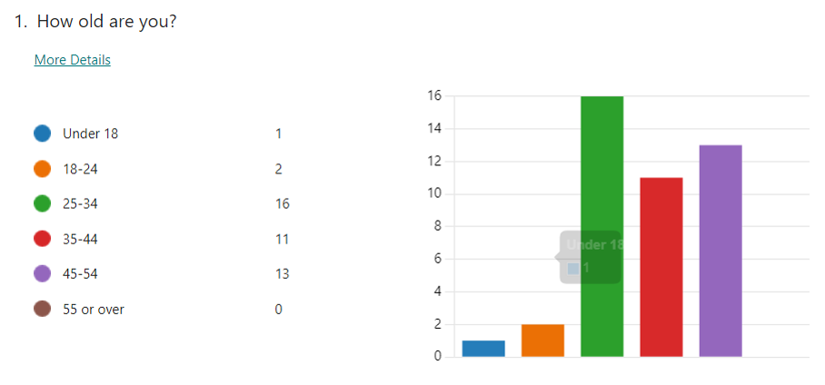
(Graph 1 – Responses to Question 1)
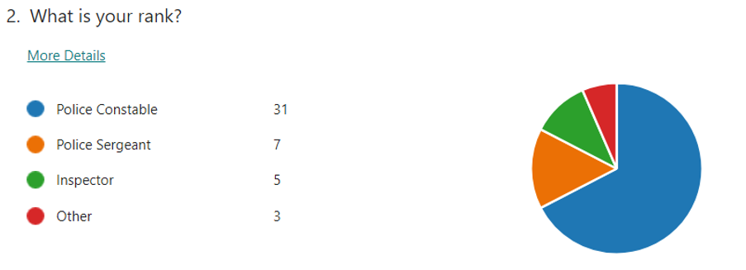
(Graph 2 – Responses to Question 2)
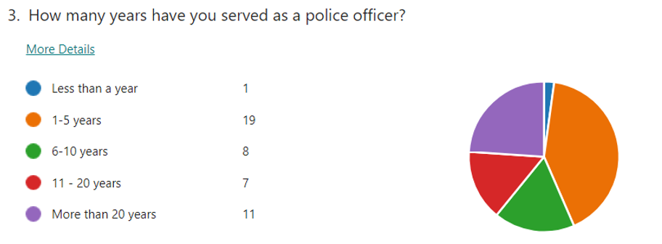
(Graph 3 – Responses to Question 3)

4.3 Questionnaire Results

4.3.1 Mental Health Support Available for Police Officers
When asked if they were aware of the mental health support services provided by the force this was the result: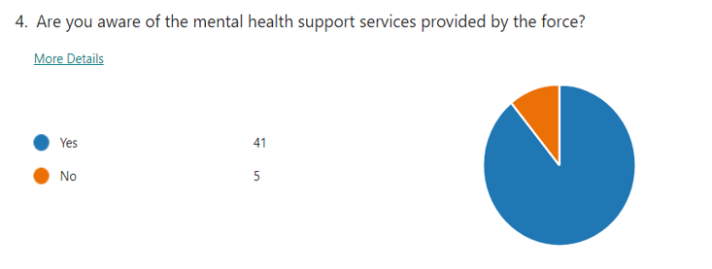
(Graph 4 – Responses to Question 4)
In trying to understand the mental health services available to police officers currently, various services were found to be available to the police officers based on the responses, with TRIM being the most mentioned.
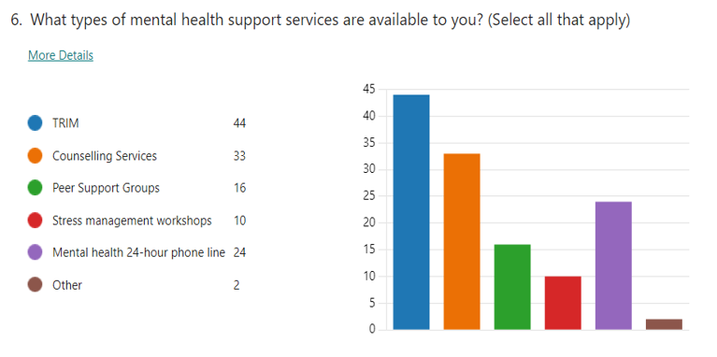
(Graph 5 – Responses to Question 6)

4.3.2 The Magnitude of the Current Mental Health Crisis in the UK police force
There are various reasons that police officers seek mental health services, which can reflect the impact of trauma is as follows:
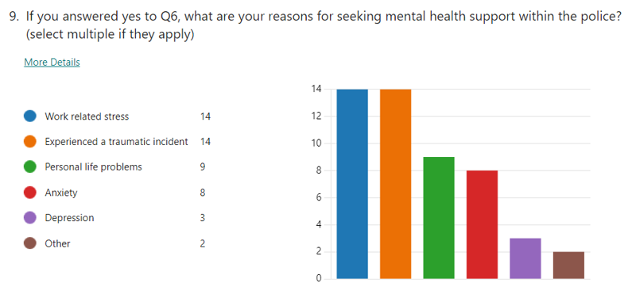
(Graph 6 – Responses to Question 9)
In the graph shown below, 50% of the police participants have used the mental health services available to them. The other 50% have never used the mental health services available to them.
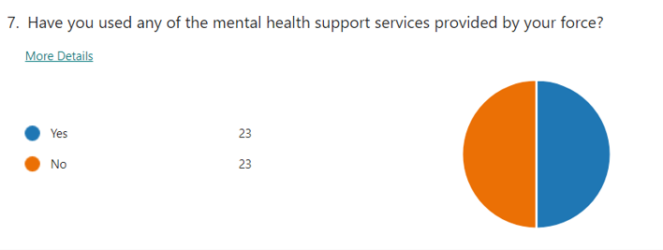
(Graph 7 – Responses to Question 7)
Question 8 was a follow on from question 7 if officers answered yes. 63% of the officers using the mental health services, use them only once or less per year. Less than 1%, 0.04% use the mental health services monthly.
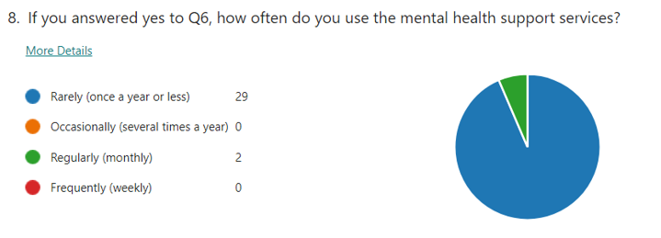
(Graph 8 – Responses to Question 8)

4.3.2 Barriers to Seeking Mental Health Support
One of the main barriers evident within this survey for police officers not seeking mental health services was stigma:
“The stigma around mental health is still prevalent, and I would fear that it might hinder future opportunities within my career using the services.” (Participant 1)
“More work to focus on removing stigma associated with mental health” (Participant 13)
“.. still feel that the stigma is so prevalent .. “ (Participant 46)
The theme of accessibility has been evident throughout the survey. In question 12 participants were asked what barriers they have faced in accessing mental health support:
“Accessing it” (Participant 4)
“Difficult to actually get counselling face to face” (Participant 20)
Another key theme that emerges is that many police officers do not see the need to use mental health services. Many participants stated that they do not feel the need for support, the service is not required as yet, and they do not see the necessity for the service.
Also, many participants expressed the barrier of the waiting times and the lack of response when requesting the support.
“Appointment” (Participant 8)
“length of time for referral” (Participant 10)
“I had a triage over the phone and was promised support- never heard anything since” (Participant 15)
"Long waiting time.." (Participant 18)

4.3.3 Effects of Trauma on Police Officers
Participants offered various insights into the effects of trauma on police officers.
"…repeated exposure to trauma means there is a significant risk to an individual's welfare. Often, it's recognized or accepted too late." (Participant 21)
“It [trauma] is naturally destructive and is said to almost guarantee a diagnosis of PTSD after a period of time.” (Participant 23)
"A healthy workforce provides a positive return, but you can't keep flogging individuals to breaking point." (Participant 5)

4.3.4 Improving Mental Health Support in the Police Force
When asked what improvements officers would suggest being made some participants noted that there is a need to engage in various aspects to improve the accessibility of mental health support to police officers. As mentioned previously accessibility has been brought up throughout the survey results, which was particularly evident in question 15 when participants were asked what improvements they would suggest:
“Make it accessible like a nurse office in a school” (Participant 5)
“More easily available for all” (Participant 8)
“Easier access and follow up on what is promised or offered” (Participant 20)
“Easier access to support services” (Participant 38).
Mandatory counselling, regular 1-1 counselling and face to face counselling were other suggestion many participants made to improve services.
“I think TRIM and regular counselling should be mandatory and regularly completed as many officers wont ask for help” (Participant 19)
“.. More face to face meetings” (Participant 25)
“More face to face counselling as better than via telephone” (Participant 27)
“Access to counselling prior to mental health crisis” (Participant 29)
"As above, there are so many [reasons which] make officers suffer in silence. Group counseling and person should be [made] regular and mandatory so that people can seek help without feeling that they are weak for asking.' – (Participant 11)
Another suggestion that was mentioned within this question was in relation to the waiting times for the services, these should be much shorter.
“Speed up process” (Participant 6)
“Be available sooner” (Participant 23)
“Waiting time to be shortened...” (Participant 25)

4.4 Conclusion
In conclusion, the data gathered from the questionnaire highlights several significant barriers to accessing mental health support for police officers frequently exposed to trauma. Stigma remains a dominant factor deterring many officers from seeking help, alongside lengthy wait times and inadequate follow ups. While a portion of the respondents do not currently feel the need to use the services, the effects of repeated trauma and the risks to officer welfare are evident.

Chapter Five: Conclusion and Recommendations

5.1 Introduction
This chapter synthesizes the findings from the investigation into the mental health challenges and support systems within the UK police force. It addresses the three core research objectives, which include investigating the psychological consequences of trauma among officers, analysing the scale of the mental health crisis within the force, and examining the sufficiency and effectiveness of the support mechanisms so far. The gathered information is intended to add a better insight into the impact that trauma causes among officers and the immediate requirement of solid frameworks with regard to mental health support. Similarly, while analysing responses from the survey conducted and comparing them with the existing literature, this chapter also explains the theoretical contributions of the study, discusses its limitations, and proposes avenues for further research to enhance support for police officers facing mental health challenges.

5.2 Main Findings
The findings show that 89% of the police officers were aware of the mental health services that are provided by the force. This number is higher than Padilla's (2023) findings of 34%. The findings suggest that the police force in the UK has a higher knowledge of the mental health services on offer. Additionally, 43% of the participants note that accessibility to mental health services is easy. This affirms Arjmand et al. (2024) findings that there is a need to increase the accessibility of mental services to officers. Malke et al. (2014) confirms the need to have a strong peer support network as an asset in mental health service delivery which was also prevalent in the survey. Based on the results, one of the critical issues to consider is increasing the awareness of the various mental health services on offer and one of the critical programs to consider is the trauma-focused peer support system.
One of the key issues that arises is the negative attitude of police officers towards mental health services. The findings show that there is a high stigma in the police force when it comes to seeking mental health services. This finding is consistent with other findings where, unlike teaching and nursing professionals, police officers have a negative attitude toward mental health issues (Salimi et al., 2021; Watson et al., 2014). This confirms Newell et al. (2021) findings that stigma, the concern surrounding confidentiality, and occupation are the significant barriers to police accessing mental health services. Richards et al. (2021) note that mental health support varies depending on location, especially regarding resources available to support the services. As such, various aspects of the matter need to be considered for improved effectiveness and interventions. To improve access to mental health services, there is a need to improve confidentiality, as it can assist in eliminating the stigma. Additionally, engaging in strategies such as electronic resources and improving knowledge of mental health services can be an appropriate approach to demystify mental health services. Moreover, education on the importance of the service can create insight into the need for the service and its necessity.
Traumatic events are a common occurrence in the line of policing. They have some adverse health outcomes on officers. Craddock and Telesco (2021) note that police officers suffer from nightmares, and they often seem to avoid seeking assistance due to being perceived as being too weak for the job. This is consistent with the research findings that trauma leads to a significant risk of loss of an individual's welfare, but officers are too scared to seek support for this due to the stigma. Some of the welfare aspects that officers suffer from include depression, substance abuse disorders, and suicidal ideations (Velazquez and Hernandez, 2019). The stigma that results from seeking mental health treatment can be associated with various law enforcement and environmental factors. Some of the organisational factors include occupational stress, which includes the day-to-day engagement in social and law enforcement cultural ideologies. The cultural ideologies include the need to be tough, again very evident in the survey results from this study, which does not work on trauma since it is naturally destructive and can cause post-traumatic stress disorder. Meaning, officers are suffering negative effects from constant trauma exposure and no support being provided due to this stigma. Miller (2000) notes that police officers have increased numbed responsiveness. As such, there is a negative implication on productivity, as noted in the findings. Individuals will deliver poorer services, which will affect community policing.
The findings also show that there is a need to improve police officer services. Some key strategies include encouraging police officers to seek confidential therapy, increasing peer counselling, making organisational modifications, adding diversity programs, and providing critical incident training to assist in reducing the risk of work stress and improving police officers' mental health.
The findings suggest the need to increase the accessibility to mental health services. This is appropriate as the workplace is a significant environment for promoting mental health and behavioural change (Santre, 2024). Various workplace interventions, such as stress management and skills enhancement programs, are significant for psychological health protection. The organisational level programs assist through concentration on workplace policies and conditions to assist employees in dealing with job difficulties. Additionally, mental health check-ins are an essential strategy to promote healthy psychological well-being among police officers.
The magnitude of the current mental health crisis in the UK police force is varied. Police officers have high depression and suicide ideation rates (Padilla, 2023). The findings suggest that police officers often seek mental health services, which can reflect the trauma impact. Many police officers seek mental health services because of work-related stress. Bland (2023) notes that during the COVID period, police officers reported higher sickness rates due to work-related stress. This indicates the impact of trauma on police officers and the need to deal with work-related stress and traumatic incidents. Some personal life problems include anxiety and depression. On the positive side, there was a high inclination of police officers to be comfortable talking about their health issues with their colleagues. Through peer-to-peer counselling, police officers can be engaged to deal with arising mental health issues. To this end, there is a need for an in-force counselling team that can assist in delivering the appropriate services to the team members, and to reduce the stigma of seeking this support it has been suggested throughout the findings that it is made compulsory to avoid this concern, thus officers receiving support that wouldn’t usually receive it due to the fear of the consequences of reaching out for help.

5.4 Contributions to Theory
This study contributes to the theoretical understanding of trauma's impact on police officers by reinforcing the pervasive role of cultural stigmas in impeding mental health support, as discussed in the literature review. Given the findings of high levels of awareness and very limited-service use, results indicate a disconnect between knowledge and action, one most likely to be exacerbated by police culture norms of valorising resilience and stigmatizing vulnerability. The study extends existing theories to suggest that even well-established support systems are insufficient if cultural barriers remain unaddressed, thus urging a theoretical shift towards holistic approaches that integrate cultural transformation with practical support mechanisms.

5.4 Limitations
The study's primary limitation is its reliance on the small sample size hindering generalization to a wider population of police officers in other areas. If the sample size had been larger, this would have needed to be refined to decrease biases that can take place with a specific set of samples. Additionally, the self-report methods carry response bias, underreporting of problems because of stigma or over-reporting due to perceived expectations. The absence of in-depth qualitative interviews limits the depth of understanding regarding the personal experiences and nuanced challenges that officers face, which could significantly enrich the findings.

5.3 Recommendations
From completing this small-scale study, mental health among police officers in the UK has various unique factors. According to Santre (2024), police officers have a high chance of experiencing mental health challenges as compared to the general population, which again seemed evident considering those stating they had these challenges. As such, there is a need to have access to an effective mental health program that can assist police officers in reducing the burden of their psychological problems. This research confirms that police officers lack effective mental health support when exposed to frequent trauma, consistent with current literature. Key barriers included accessibility, stigma, and the absence of consistent counselling services. There is a clear need to improve the services, again very evident in current literature and has been throughout literature for many years. It was clear that most officers are aware of the services available, and it’s more the need to increase the accessibility to mental health services that is the issue. While also tackling the stigma associated with seeking this support. Key barriers include accessibility, stigma, and the absence of consistent counselling services. To address these issues and improve support for officers, the following recommendations are proposed:
Enhancing Accessibility to Mental Health Services.
One significant barrier identified is the limited access to mental health services. To overcome this:
- Increase in-house support: Establish dedicated mental health units, staffed by professionals experienced in trauma care. Having these resources on-site makes access easier and more immediate.
- Regular mental health check-ins: Proactive, routine mental health assessments should be offered to all officers, as opposed to waiting for a particular incident to prompt an intervention or offer for help. This helps identify any mental health issues early on.
Addressing Stigma Around Seeking Support.
Stigma around mental health remains a major deterrent for officers seeking help. Changing this culture is crucial:
- Peer support networks: Establish peer support programs where officers can confidentially discuss their issues with trained colleagues, reducing the fear of judgement.
- Confidentiality: Strong confidentiality policies must be in place and clearly communicated. Officers need assurance that seeking help will not negatively affect their careers.
Routine Mental Health Support.
Mental health services should become a routine aspect of police work rather than a response to crises:
- Mandatory counselling after critical incidents: Following traumatic events, counselling should be required for all involved officers. This proactive approach can prevent long-term mental health problems and reduce the stigma associated with asking for help.
By improving accessibility, reducing stigma, institutionalising mental health care, and committing to long-term well-being initiatives, law enforcement agencies can create a supportive environment that prioritises the mental health of their officers. Implementing these recommendations will help address the gaps identified and lead to better mental health outcomes for police officers facing trauma.

5.5 Further Research
Future research should aim to incorporate broader demographics, such as police forces drawn from wider geographical and intercontinental settings, considering cultural and systemic differences in the effects on mental health and support mechanisms in place. Such an extension would afford the opportunity for comparison and underline best practices and areas of concern across the world. Longitudinal studies could also be conducted to explore changes longitudinally, providing insights into the long-term effects of interventions. Conducting in-depth interviews with a diverse group of officers could also yield deeper insights into individual experiences, further personalizing and refining support strategies.

5.6 Conclusion
This research has significantly contributed to understanding of the challenges faced by police officers in the UK, associated with trauma and mental health. This was done by first identifying that trauma forms an important factor that influences police personnel in ways that lead to long-term disabilities psychologically and affect their effective ability for the performance of duties. Secondly, the findings reveal a substantial mental health crisis within the force, with a high prevalence of stress, depression, and PTSD among officers. The effectiveness of these mental health supports is, however, curtailed in the existence of cultural stigmas and access barriers. It further cements the notion that there needs to be more comprehensive and culturally appropriate mental health support within the policing organization, not only to deal with the present crisis but to foster a supportive environment that can further help in achieving improved community policing and ensure the welfare of those who protect and serve.

Reference List
- Arjmand, H.A., O'Donnell, M.L., Sadler, N., Nursey, J., Peck, T. and Varker, T. (2024). Improving mental health service and practice for police: A qualitative assessment. Traumatology.
- Bell, S. and Palmer-Conn, S. (2018). Suspicious minds: Police attitudes to mental ill health. International Journal of Law and Public Administration, 1(2), pp.25-40.
- Bell, E. and Bryman, A. (2007). The ethics of management research: an exploratory content analysis. British journal of management, 18(1), pp.63-77.
- BERA. (2018). Ethical Guidance for Educational Research, fourth edition (2018). Available at: Ethical Guidelines for Educational Research, fourth edition (2018) | BERA (Accessed on: 09 June 2024)
- Bikos, L. J. (2020). ‘It’s all window dressing:’ Canadian police officers’ perceptions of mental health stigma in their workplace. Policing: An International Journal, 44(1), 6376..
- Bland, M. (2023). Excess Mortality, Sickness and Absence in the Police Workforce in England and Wales During the COVID-19 Pandemic. Policing: A Journal of Policy and Practice, 17, p.17.
- Brod, M., Tesler, L.E. and Christensen, T.L. (2009). Qualitative research and content validity: developing best practices based on science and experience. Quality of life research, 18, pp.1263-1278.
- Burton, N., Brundrett, M. and Jones, M. (2014). Doing your education research project. London: Sage.
- Bullock, K., and Garland, J. (2018). Police officers, mental (ill-) health, and spoiled identity. Criminology & Criminal Justice, 18(2), 173189.
- Carminati, L. (2018). Generalizability in qualitative research: A tale of two traditions. Qualitative health research, 28(13), pp.2094-2101.
- Chitra, T. and Karunanidhi, S. (2021). The impact of resilience training on Occupational stress, resilience, job satisfaction, and psychological well-being of female police officers. Journal of Police and Criminal Psychology, 36(1), pp.8-23.
- Cook, D.A. and Beckman, T.J. (2006). Current concepts in validity and reliability for psychometric instruments: theory and application. The American journal of medicine, 119(2), pp.166-e7.
- Craddock, T. B., Telesco, G (2022). Police Stress and Deleterious Outcomes: Efforts Towards Improving Police Mental Health. Journal of Police and Criminal Psychology, 37(1): 173–182.
- Demou, E., Hale, H. and Hunt, K. (2020). Understanding the mental health and wellbeing needs of police officers and staff in Scotland. Police Practice and research, 21(6), pp.702-716.
- Dewaele, J.M. (2018). Online questionnaires. The Palgrave handbook of applied linguistics research methodology, pp.269-286.
- DiCicco‐Bloom, B. and Crabtree, B.F. (2006). The qualitative research interview. Medical education, 40(4), pp.314-321.
- Edwards, A.M. and Kotera, Y. (2021). Mental health in the UK police force: a qualitative investigation into the stigma with mental illness. International Journal of Mental Health and Addiction, 19(4), pp.1116-1134.
- Elliott-Davies, M. (2023). COVID-19, distress and potential trauma exposure in the police service of England and Wales: A mixed method approach. The Police Journal, 96(4), pp.626-651.
- Essex Police, (2019). Essex Police marks World Mental Health Day. Chelmsford, UK. Essex Police. Available at: https://www.essex.pfcc.police.uk/news/pfcc-essex-police-mark-world-mental-healthday/#:~:text=Today%20is%20World%20Mental%20Health%20Day.%20Roger (Accessed on: 26th March 2024).
- Flaherty, M. and O’Neil, V.E. (2022). Psychological peer support for staff: implementing the trauma risk management model in a hospital setting. Nursing Management, 29(1).
- Foley, J. and Massey, K.L.D. (2021). The ‘cost’ of caring in policing: From burnout to PTSD in police officers in England and Wales. The police journal, 94(3), pp.298-315.
- Foley, J., Hassett, A. and Williams, E. (2022). ‘Getting on with the job’: a systematized literature review of secondary trauma and post-traumatic stress disorder (PTSD) in policing within the United Kingdom (UK). The Police Journal, 95(1), pp.224-252.
- Gekoski, A., Gray, J.M. and Adler, J.R. (2012). What makes a homicide newsworthy? UK national tabloid newspaper journalists tell all. British Journal of Criminology, 52(6), pp.1212-32.
- Goodman, L.A., Corcoran, C., Turner, K., Yuan, N. and Green, B.L. (1998). Assessing traumatic event exposure: General issues and preliminary findings for the Stressful Life Events Screening Questionnaire. Journal of Traumatic Stress: Official Publication of The International Society for Traumatic Stress Studies, 11(3), pp.521-542.
- Grant, H.B., Lavery, C.F. and Decarlo, J. (2019). An exploratory study of police officers: Low compassion satisfaction and compassion fatigue. Frontiers in psychology, p.2793.
- Hennink, M., Hutter, I. and Bailey, A. (2020). Qualitative research methods. London: Sage.
- Houdmont, J. and Elliot-Davies, M. (2016). Police Federation of England and Wales 2016 Officer demand, capacity, and welfare survey. Available at: https://www.polfed.org/media/14061/welfare-survey-2016-pfew-descriptive-results-reportv30.pdf#:~:text=In%20February%202016%20approximately%2017,000 (Accessed on: 26th March 2024).
- Igwenagu, C. (2016). Fundamentals of research methodology and data collection. LAP: Lambert Academic Publishing.
- Irvine, A. (2011). Duration, dominance and depth in telephone and face-to-face interviews: A comparative exploration. International Journal of Qualitative Methods, 10(3), pp.202-220.
- Jain, N. (2021). Survey versus interviews: Comparing data collection tools for exploratory research. The Qualitative Report, 26(2), pp.541-554.
- Jones, N., Burdett, H., Green, K. and Greenberg, N. (2017). Trauma risk Management (TRIM): promoting help-seeking for mental health problems among Combat-Exposed UK military personnel. Psychiatry, 80(3), pp.236-251.
- Jordan, L.M. (2022). Peer Counseling: Method, Metaphor, or Mindset?. Frontiers in Rehabilitation Sciences, 3, p.822484.
- Kamkar, K., Edwards, G., Hesketh, I., McFee, D., Papazoglou, K., Pedersen, P., Sanders, K., Stamatakis, T. and Thompson, J. (2020). Dialogue highlights from the LEPH2019 panel on police mental health and well-being: [LEPH2019]. Journal of Community Safety and Well Being, 5(1), pp.2-7.
- Kane, E., Evans, E. and Shokraneh, F. (2017). Effectiveness of current policing Related mental health interventions in England and Wales and Crisis Intervention Teams as a future potential model: a systematic review. Systematic Reviews, 6, pp.1-7.
- Kimberlin, C.L. and Winterstein, A.G. (2008). Validity and reliability of measurement instruments used in research. American journal of health-system pharmacy, 65(23), pp.2276-2284.
- Knight, L., Cahalin, K., Callender, M., Britton, I., Doran, B. and Lugli, V. (2019). Home Office Police Front Line Review 2018/2019: Key themes in qualitative research projects with police forces in England and Wales. Available at: http://nectar.northampton.ac.uk/12266/7/Knight_etal_HO_2019_Home_Office_Police_Front_Line_Review_2018_2019_Key_themes_in_qualitative_research_projects_with_police_forces_in_England_and_Wales.pdf/. (Accessed on: 1st of June 2024).
- Kotera, Y. and Ting, S.H. (2021). Positive psychology of Malaysian university students: Impacts of engagement, motivation, self-compassion, and well-being on mental health. International Journal of Mental Health and Addiction, 19(1), pp.227-239.
- Kotera, Y., Green, P. and Sheffield, D. (2019). Mental health attitudes, self-criticism, compassion and role identity among UK social work students. The British Journal of Social Work, 49(2), pp.351-370. Laufs, J. and Waseem, Z. (2020). Policing in pandemics: A systematic review and best practices for police response to COVID-19. International journal of disaster risk reduction, 51, p.101812.
- Lane, R. (2019). "I'm a police officer, not a social worker or mental health nurse": Online discourses of exclusion and resistance regarding mental health‐related police work. Journal of Community & Applied Social Psychology, 29(5), pp.429-442.
- Leavy, P. (2022). Research design: Quantitative, qualitative, mixed methods, arts-based, and community-based participatory research approaches. Guilford Publications.
- MacKenzie, S.B., Podsakoff, P.M. and Podsakoff, N.P. (2011). Construct measurement and validation procedures in MIS and behavioral research: Integrating new and existing techniques. MIS quarterly, pp.293-334.
- Mahlke, C., Kraemer, U. M., Becker, T., Bock, T. (2014). Peer support in mental health services. Current Opinion, 27(4).
- Marmar, C.R., McCaslin, S.E., Metzler, T.J., Best, S., Weiss, D.S., Fagan, J., Liberman, A., Pole, N., Otte, C., Yehuda, R. and Mohr, D. (2006). Predictors of posttraumatic stress in police and other first responders. Annals of the New York Academy of Sciences, 1071(1), pp.1-18.
- Marshall, R.E., Milligan-Saville, J., Petrie, K., Bryant, R.A., Mitchell, P.B. and Harvey, S.B., (2021). Mental health screening amongst police officers: factors associated with under-reporting of symptoms. BMC psychiatry, 21, pp.1-8.
- McDaniel, J.L. (2019). Reconciling mental health, public policing, and police accountability. The Police Journal, 92(1), pp.72-94.
- Miller, L. (2000). Law enforcement traumatic stress: Clinical syndromes and intervention strategies. Trauma Response, 6(1), pp.15-20.
- Miller, J.K., Brewin, C.R., Soffia, M., Elliott-Davies, M., Burchell, B.J. and Peart, A. (2022). The development of a UK police traumatic events checklist. The Police Journal, 95(1), pp.207-223.
- Miller, J.K., Peart, A. and Soffia, M. (2020). Can Police be trained in trauma processing to minimize PTSD symptoms? Feasibility and proof of concept with a newly recruited UK police population. The Police Journal, 93(4), pp.310-331.
- Milliard, B., (2020). Utilization and impact of peer-support programs on police officers' mental health. Frontiers in Psychology, p.1686.
- Mind, (2019) Mental Health in the Emergency Services. Available at: https://www.mind.org.uk/media-a/4849/2019-survey-police-service-summary.pdf (Accessed on 28th March 2024).
- Nardi, P.M. (2018). Doing survey research: A guide to quantitative methods. London: Routledge.
- Newell, C.J., Ricciardelli, R., Czarnuch, S.M. and Martin, K. (2022). Police staff and mental health: barriers and recommendations for improving help-seeking. Police practice and research, 23(1), pp.111-124.
- Noble, H. and Smith, J. (2015). Issues of validity and reliability in qualitative research. Evidence-based nursing, 18(2), pp.34-35.
- Olson, K. and Bilgen, I. (2011). The role of interviewer experience on acquiescence. Public opinion quarterly, 75(1), pp.99-114.
- Ordon, G., Dewar, L. and Cameron, A. (2019). Leadership, wellbeing, professional development and innovation for the Police front line: an evidence review. Transforming Police for the 21st Century. Available at: https://assets.publishing.service.gov.uk/media/5d25bb79ed915d69031d7c8b/FLR_literature_esearch_report.pdf (Accessed on: 01 June 2024).
- Oscar Kilo, (2019) The Wellbeing Vans. Available at: https://www.oscarkilo.org.uk/services/wellbeing-vans (Accessed on: 24th of March 2024)
- Oscar Kilo, (2024). Blue Light Wellbeing Framework (BLWF). Available at: https://www.oscarkilo.org.uk/blue-light-wellbeing-framework-blwf (Accessed on: 24th of March 2024).
- Padilla, K.E. (2023). A descriptive study of police officer access to mental health services. Journal of Police and Criminal Psychology, 38(3), pp.607-613.
- Phakiti, A. (2015). Quantitative research and analysis. Research methods in applied linguistics: A practical resource, pp.27-48.
- Phythian, R., Birdsall, N., Kirby, S., Cooper, E., Posner, Z. and Boulton, L. (2023). Organizational and individual perspectives of police wellbeing in England and Wales. The Police Journal, 96(1), pp.128-152.
- Police Care UK., (2023). Police trauma checklist. Available at: https://www.policecare.org.uk/research/police-traumatic-events-checklist/ (Accessed on: 26th of March 2024).
- Police Federation of England and Wales, (2020). Police officers' mental health focus of the new campaign. Leatherhead, UK: POLFED. Available at: https://www.polfed.org/news/latest-news/2020/police-officers-mental-health-focus-of-new-campaign/ (Accessed on: 26th March 2024).
- Police Federation, (2018). Hear ‘Man Up’, Think ‘Man Down’. Available at: https://www.polfed.org/wasc/about-us/campaigns/hear-man-up-think-man-down/ (Accessed on: 21st March 2024).
- Porter, C.N. and Lee, R. (2023). The policing culture: an exploration into the mental health of former British police officers. Current Psychology, pp.1-15.
- Purba, A. and Demou, E. (2019). The relationship between organizational stressors and mental wellbeing within police officers: a systematic review. BMC Public Health, 19, pp.121.
- Rahman, M.M. (2023). Sample size determination for survey research and non-probability sampling techniques: A review and set of recommendations. Journal of Entrepreneurship, Business and Economics, 11(1), pp.42-62.
- Regehr, C., Carey, M.G., Wagner, S., Alden, L.E., Buys, N., Corneil, W., Fyfe, T., Matthews, L., Randall, C., White, M. and Fraess-Phillips, A. (2021). A systematic review of mental health symptoms in police officers following extreme traumatic exposures. Police practice and research, 22(1), pp.225-239.
- Regmi, P.R., Waithaka, E., Paudyal, A., Simkhada, P. and Van Teijlingen, E. (2016). Guide to the design and application of online questionnaire surveys. Nepal journal of epidemiology, 6(4), p.640.
- Rea, L.M. and Parker, R.A. (2014). Designing and conducting survey research: A comprehensive guide. New York: John Wiley & Sons.
- Richards, N.K., Suarez, E.B. and Arocha, J.F. (2021). Law enforcement officers’ barriers to seeking mental health services: a scoping review. Journal of police and criminal psychology, 36(3), pp.351-359.
- Rosenthal, M. (2016). Qualitative research methods: Why, when, and how to conduct interviews and focus groups in pharmacy research. Currents in pharmacy teaching and learning, 8(4), pp.509-516.
- Santre, S. (2024). Mental Disorders and Mental Health Promotion in Police Officers. Health Psychology Research, 12.
- Salimi, N., Gere, B. and Shafaie, S. (2021). POLICE OFFICERS'KNOWLEDGE OF, AND ATTITUDES TOWARDS, MENTAL ILLNESS AND THE MENTALLY ILL INDIVIDUALS. Psychological Applications and Trends, p.287.
- Schreuder, H.T., Gregoire, T.G. and Weyer, J.P. (2001). For what applications can probability and non-probability sampling be used?. Environmental Monitoring and Assessment, 66, pp.281-291.
- Stokes, P. and Wall, T. (2017). Research methods. London: Bloomsbury Publishing.
- Thomas, G (2009). How to do your Research Project. London: SAGE.
- Soomro, S. and Yanos, P.T. (2019). Predictors of mental health stigma among police officers:
- The role of trauma and PTSD. Journal of Police and Criminal Psychology, 34, pp.175-183.
- Soravia, L.M., Schwab, S., Walther, S. and Müller, T. (2021). Rescuers at risk: posttraumatic stress symptoms among police officers, fire fighters, ambulance personnel, and emergency and psychiatric nurses. Frontiers in psychiatry, 11, p.602064.
- Stevelink, S.A., Opie, E., Pernet, D., Gao, H., Elliott, P., Wessely, S., Fear, N.T., Hotopf, M. and Greenberg, N. (2020). Probable PTSD, depression and anxiety in 40,299 UK police officers and staff: Prevalence, risk factors and associations with blood pressure. PLoS One, 15(11), p.e0240902.
- Stogner, J., Miller, B.L. and McLean, K. (2020). Police stress, mental health, and resiliency during the COVID-19 pandemic. American Journal of Criminal Justice, 45, pp.718-730.
- Syal, R. (2023). Police in England and Wales dealing with more mental health crises than ever.
- Talavera-Velasco, B., Luceño-Moreno, L., Martín-García, J. and García-Albuerne, Y. (2018). Psychosocial risk factors, burnout, and hardy personality as variables associated with mental health in police officers. Frontiers in Psychology, 9, p.1478.
- Tsang, E.W. (2014). Generalizing from research findings: The merits of case studies. International Journal of Management Reviews, 16(4), pp.369-383.
- The National Police Wellbeing Service, (2024). More about the National Police Wellbeing Service. Available at: https://www.oscarkilo.org.uk/about-us/more-about-the-service. (Accessed on: 28th March 2024)
- The Guardian (2023). Police in England and Wales dealing with more mental health crises than ever. Available at: https://www.theguardian.com/uk-news/2023/feb/21/mental-health-crises-police-england-and-wales (Accessed on 16th February 2024).
- The Telegraph (2019). Police force sends out 'Welfare Vans' to crime scenes so officers can take a break on long jobs. Available at: https://www.telegraph.co.uk/news/2019/11/22/policeforce-send-welfare-van-crime-scenes-officers-can-take/ (Accessed on: 24th of March 2024).
- Trauma Resilience in UK Policing Project (2019). Cambridge, UK: Cambridge University.
- Turner, T. and Jenkins, M. (2019). 'Together in work, but alone at heart': Insider perspectives on the mental health of British police officers. Policing: A Journal of Policy and Practice, 13(2), pp.147-156.
- Velazquez, E. and Hernandez, M. (2019). Effects of police officer exposure to traumatic experiences and recognising the stigma associated with police officer mental health: A state-of-the-art review. Policing: An International Journal, 42(4), pp.711-724.
- Violanti, J.M., Owens, S.L., McCanlies, E., Fekedulegn, D. and Andrew, M.E. (2018). Law enforcement suicide: a review. Policing: An International Journal, 42(2), pp.141-164.
- Wagner, S., White, N., Matthews, L.R., Randall, C., Regehr, C., White, M., Alden, L.E., Buys, N., Carey, M.G., Corneil, W. and Fyfe, T. (2020). Depression and anxiety in policework: a systematic review. Policing: An International Journal, 43(3), pp.417-434.
- Watson, L. and Andrews, L. (2018). The effect of a Trauma Risk Management (TRiM) program on stigma and barriers to help-seeking in the Police. International journal of stress management, 25(4), p.348.
- Watson, A.C., Swartz, J., Bohrman, C., Kriegel, L.S. and Draine, J. (2014). Understanding how police officers think about mental/emotional disturbance calls. International journal of law and psychiatry, 37(4), pp.351-358.
- Yardley, L. and Bishop, F.L. (2017). Mixing qualitative and quantitative methods: A pragmatic approach. The Sage handbook of qualitative research in psychology, pp.398-413.
- Yilmaz, K. (2013). Comparison of quantitative and qualitative research traditions: Epistemological, theoretical, and methodological differences. European journal of education, 48(2), pp.311-325.
- Zohrabi, M. (2013). Mixed method research: Instruments, validity, reliability and reporting findings. Theory and practice in language studies, 3(2), p.254.

Appendices

7.1 Appendix 1 – Copy of Questionnaire
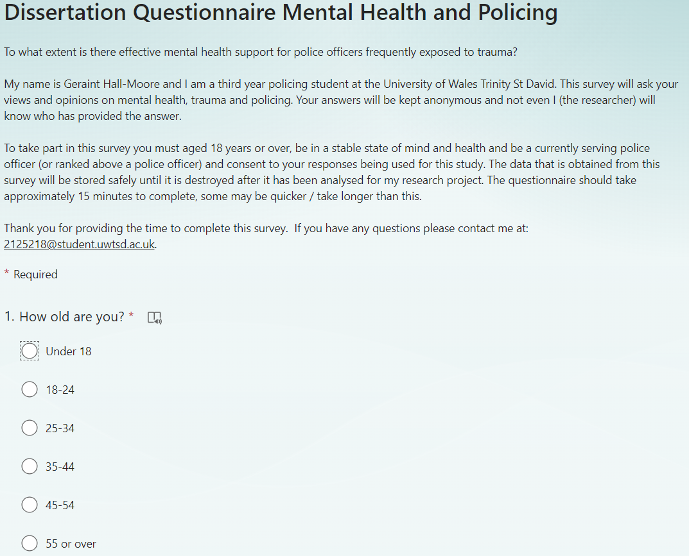
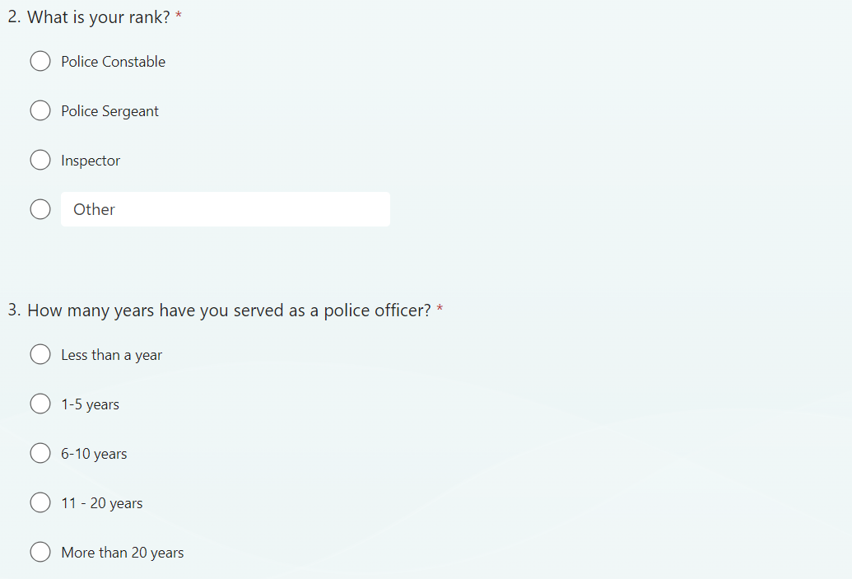
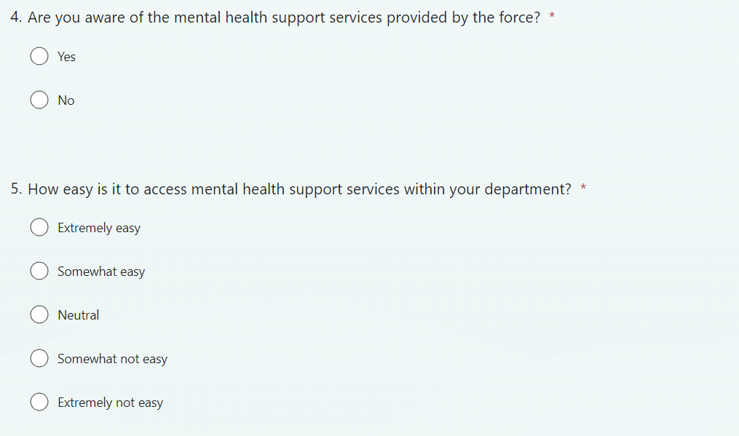

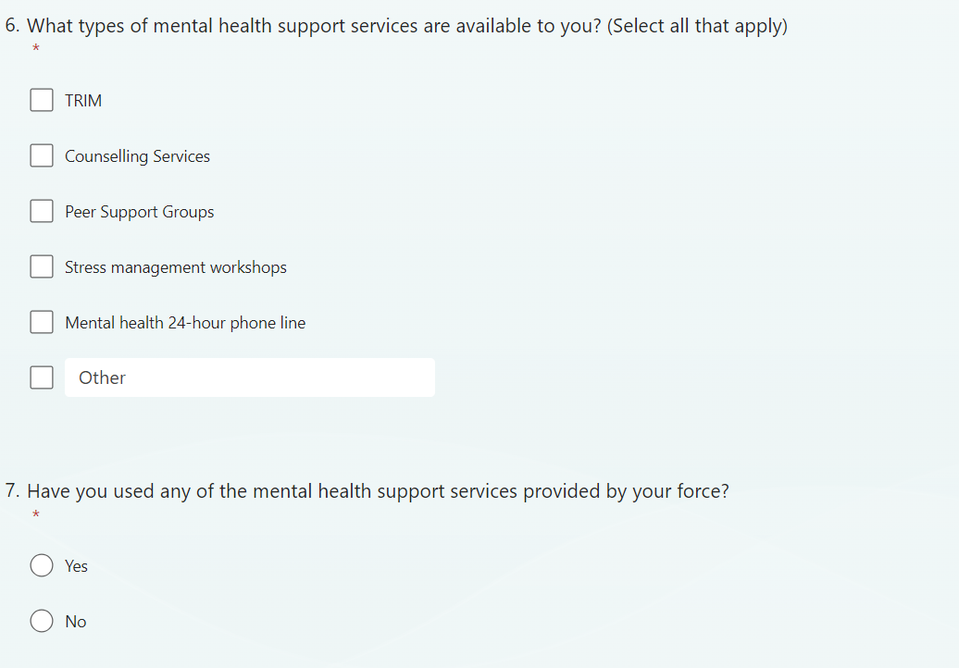

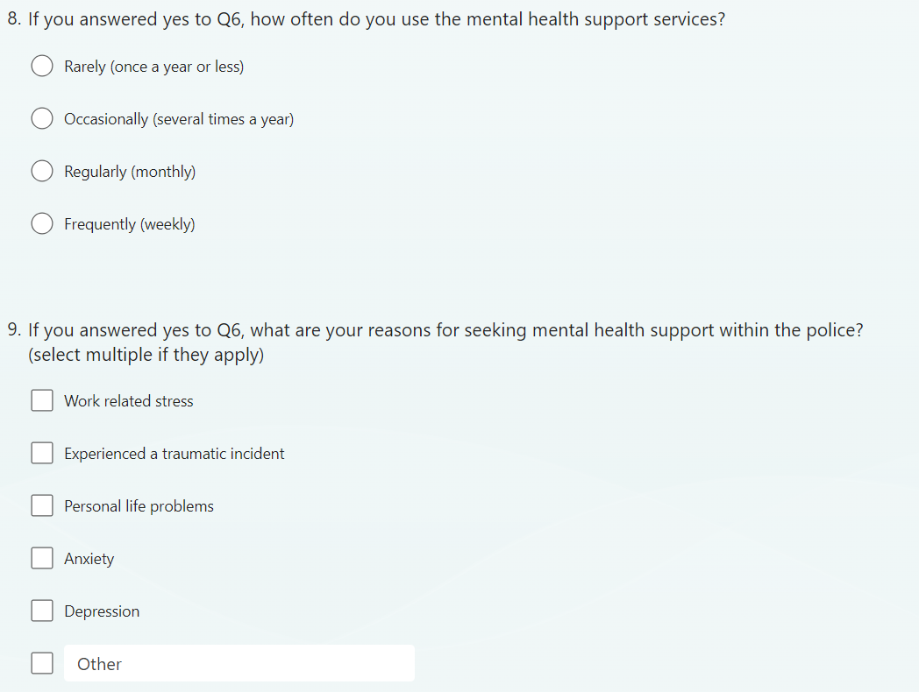

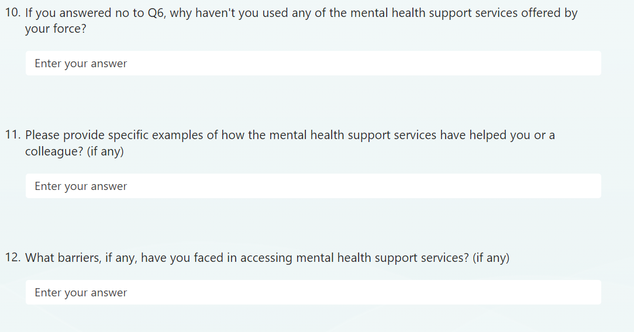

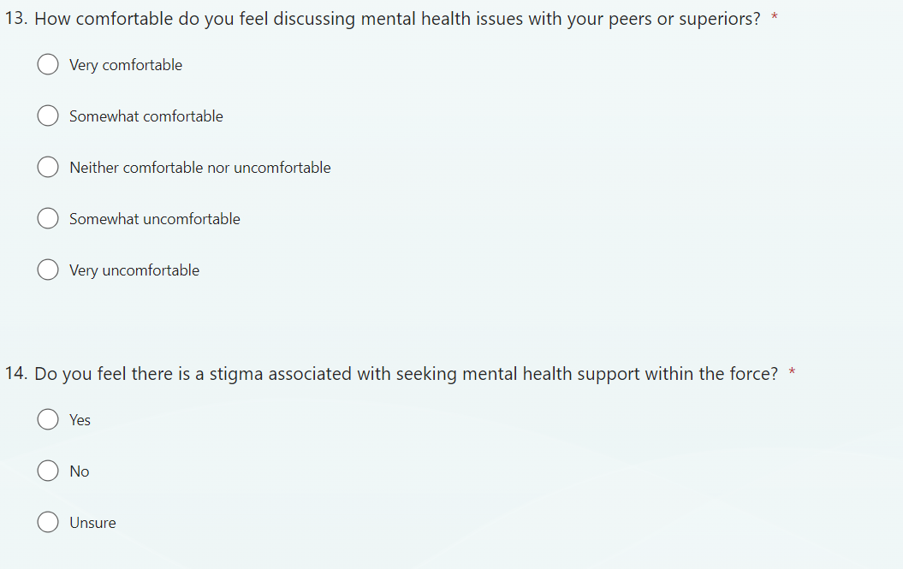

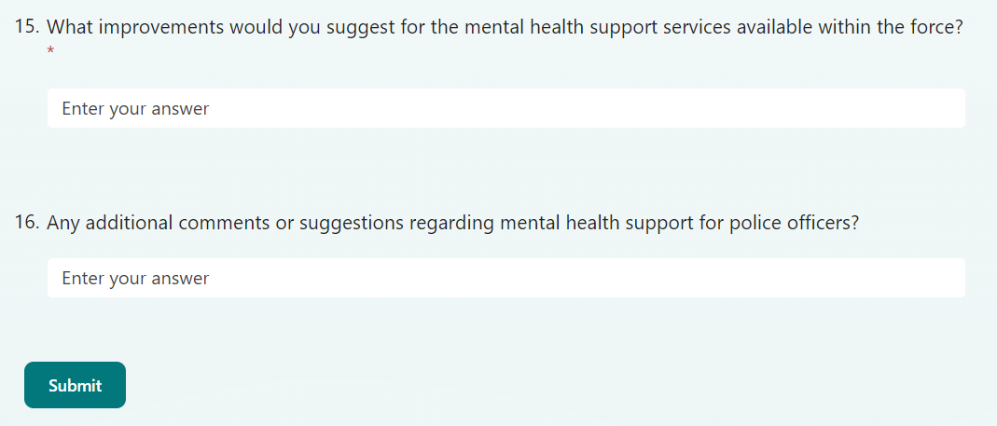

7.2 Appendix 3 – Questionnaire Results

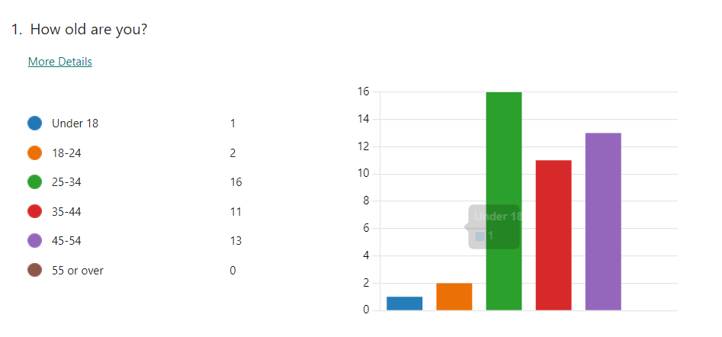
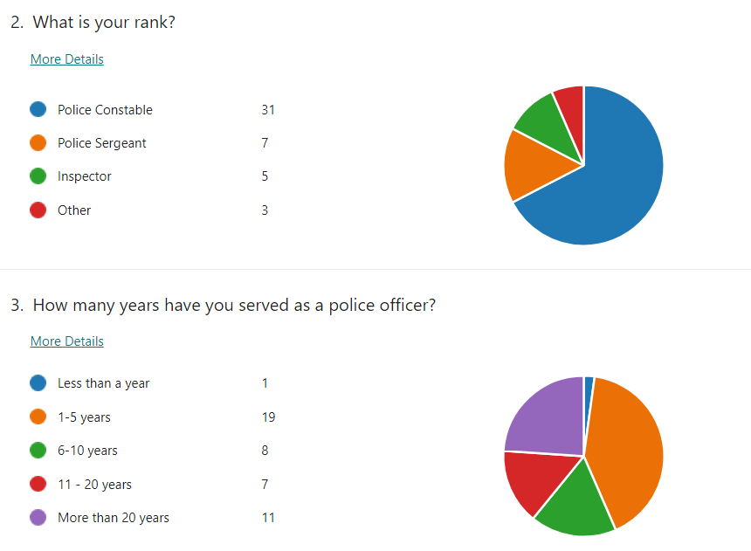

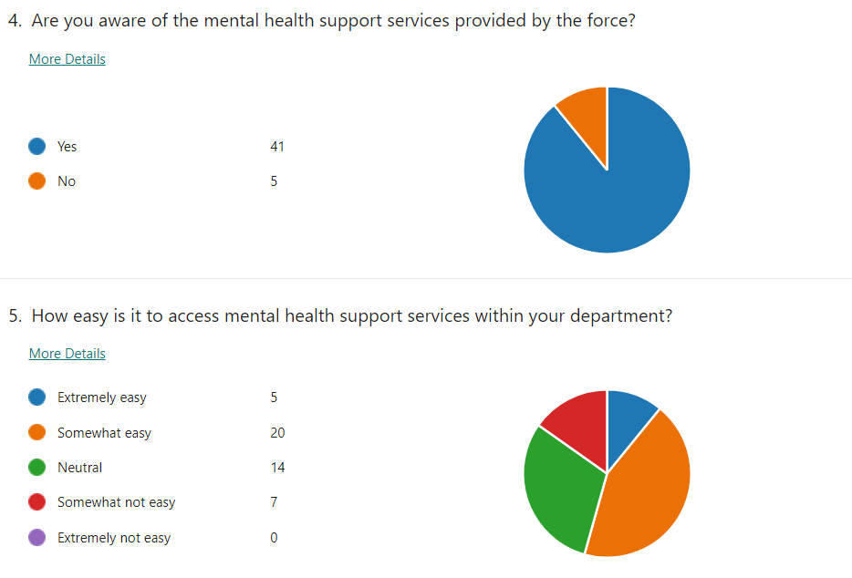
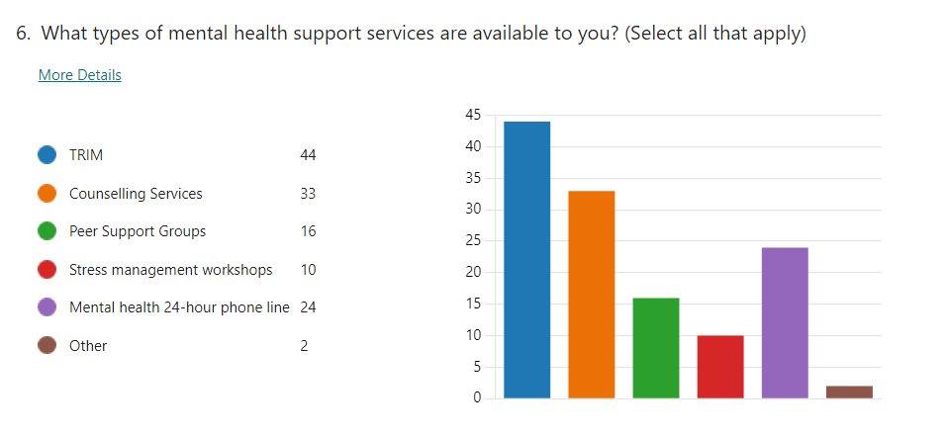
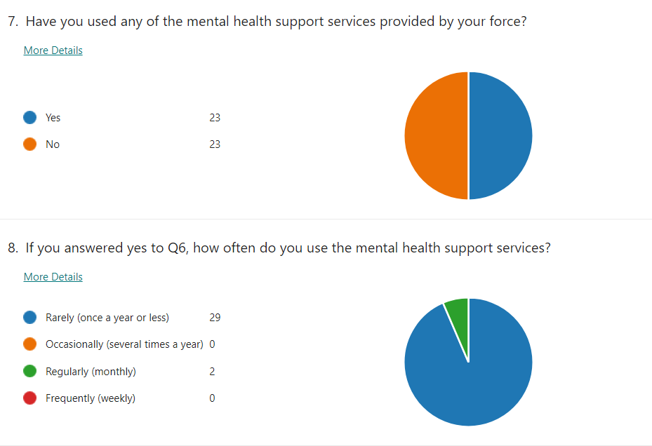

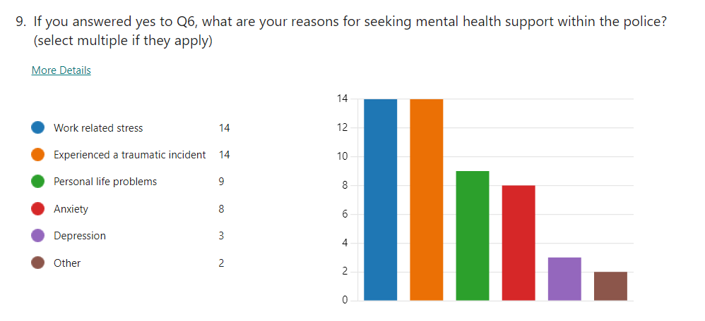

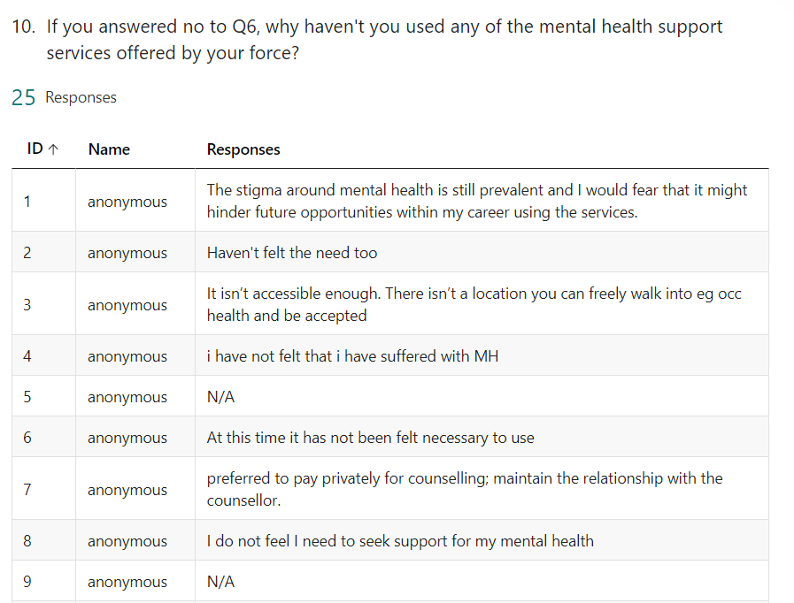
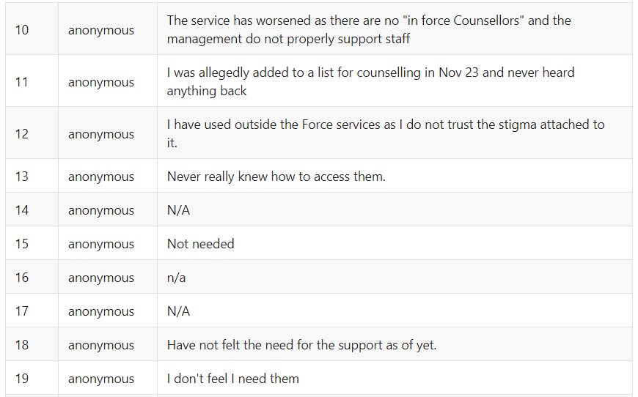
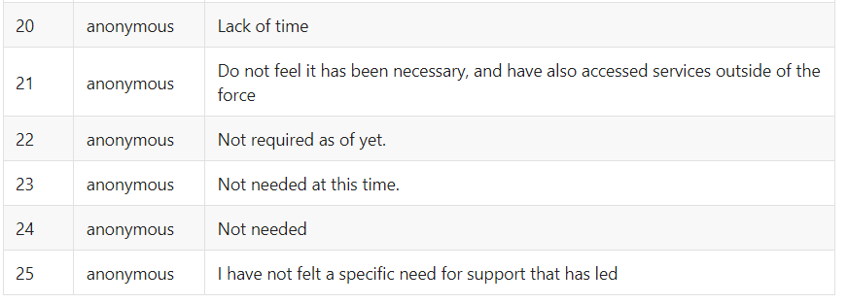

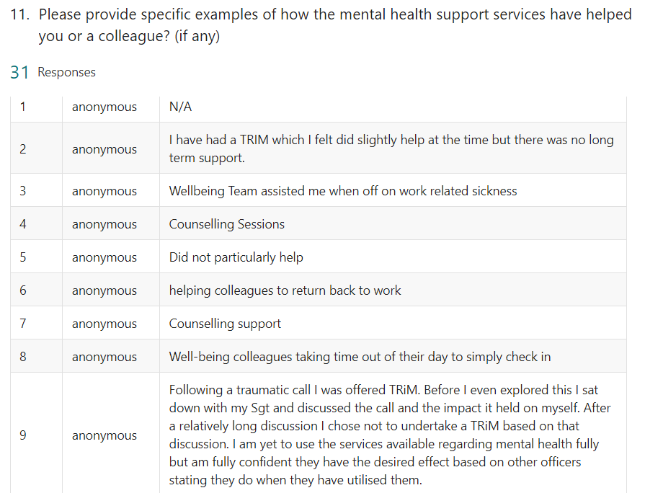
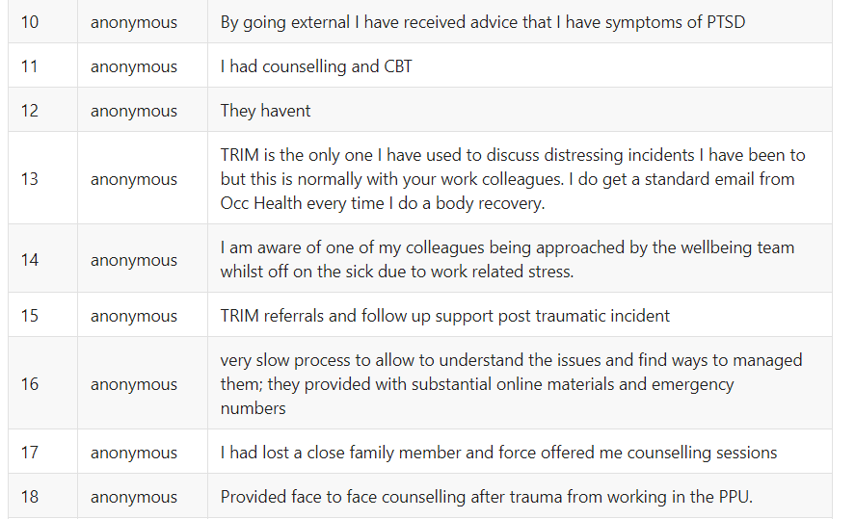
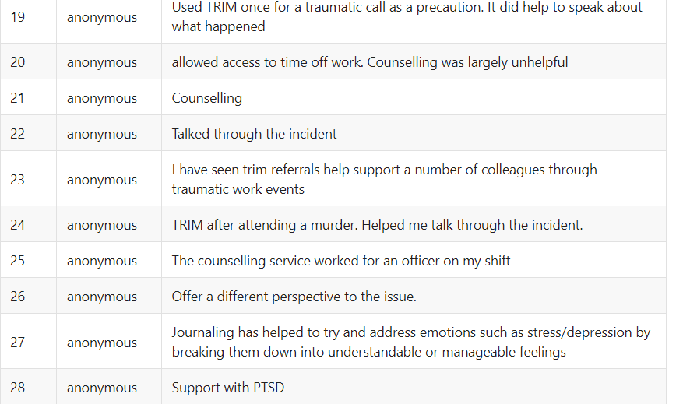
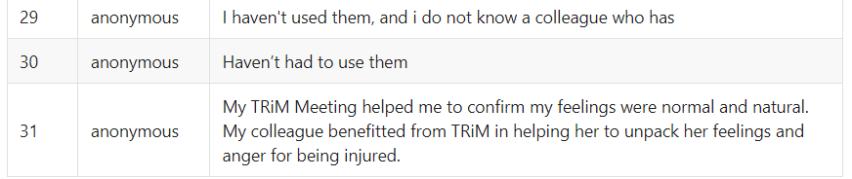

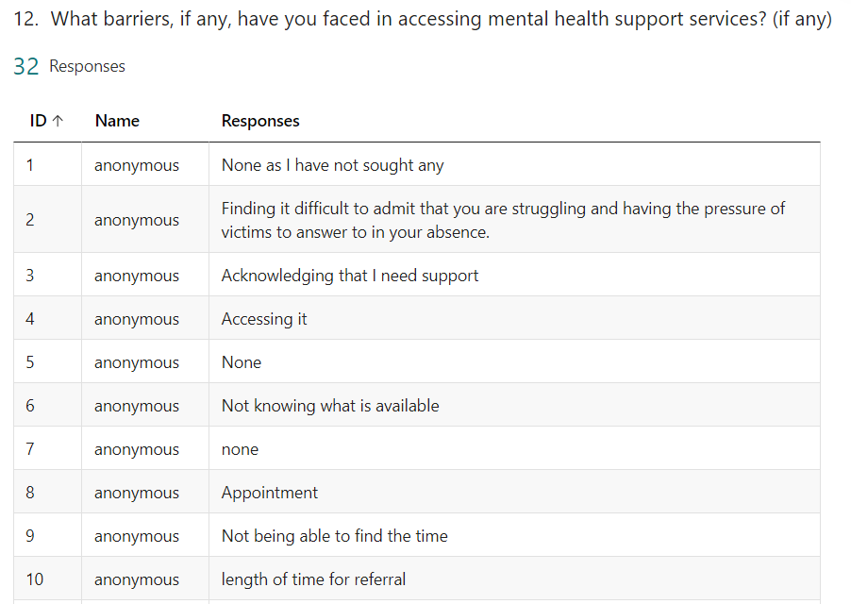
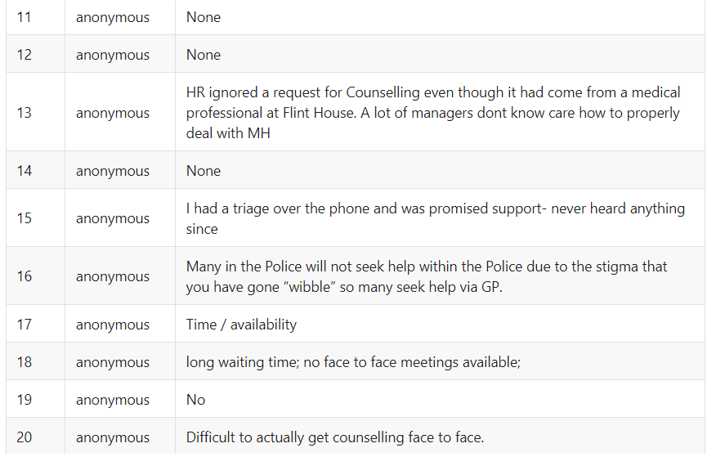
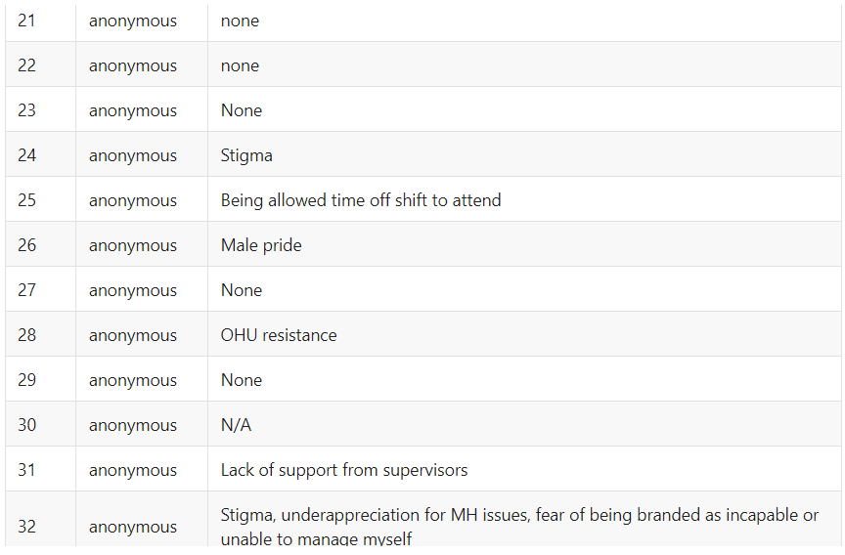

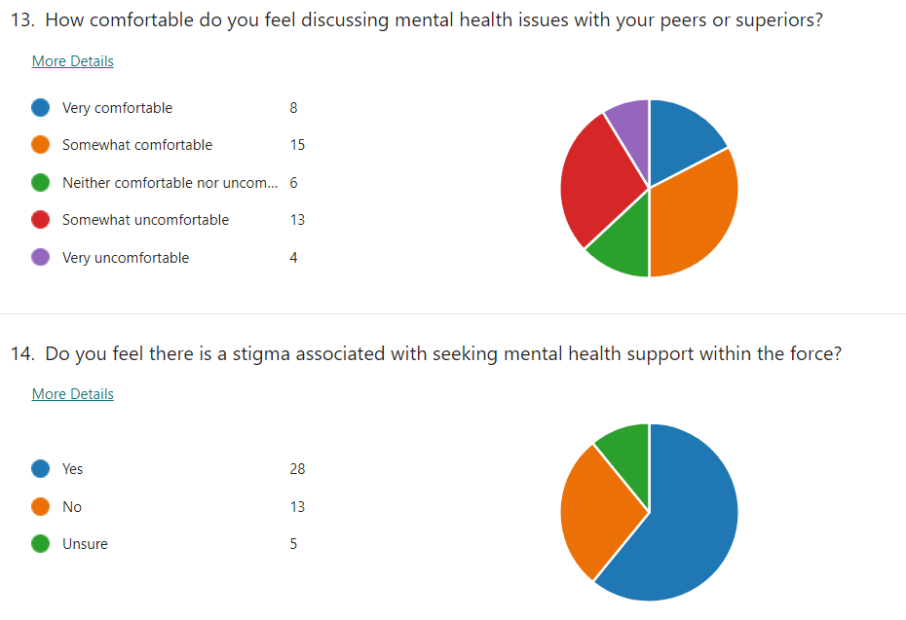

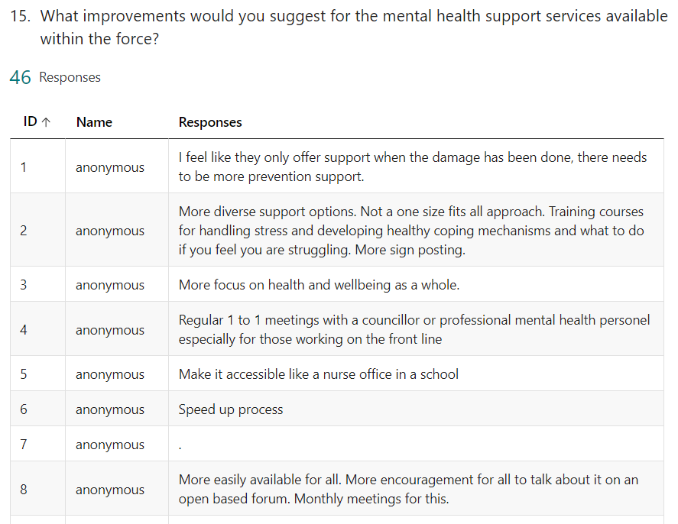
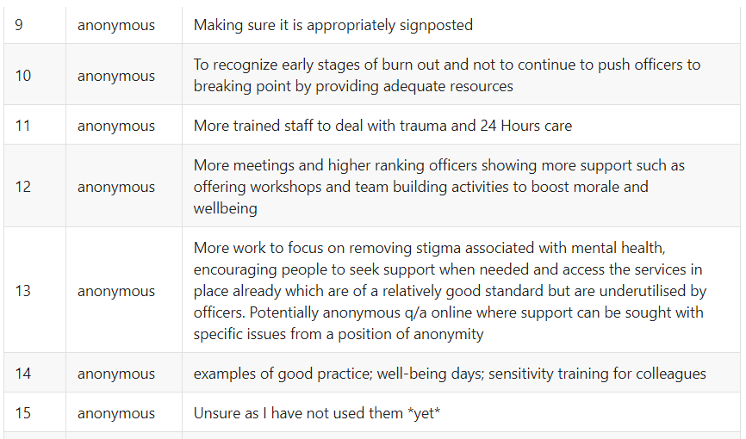
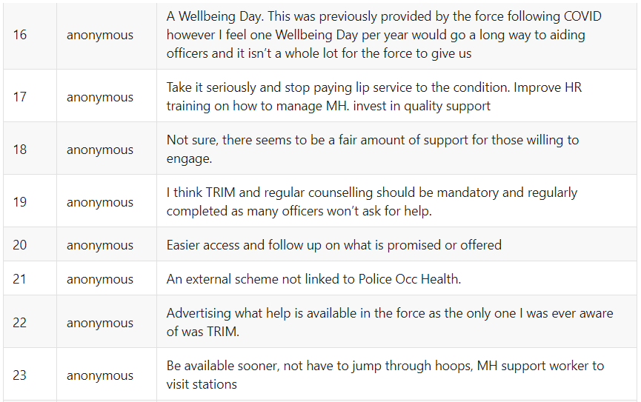
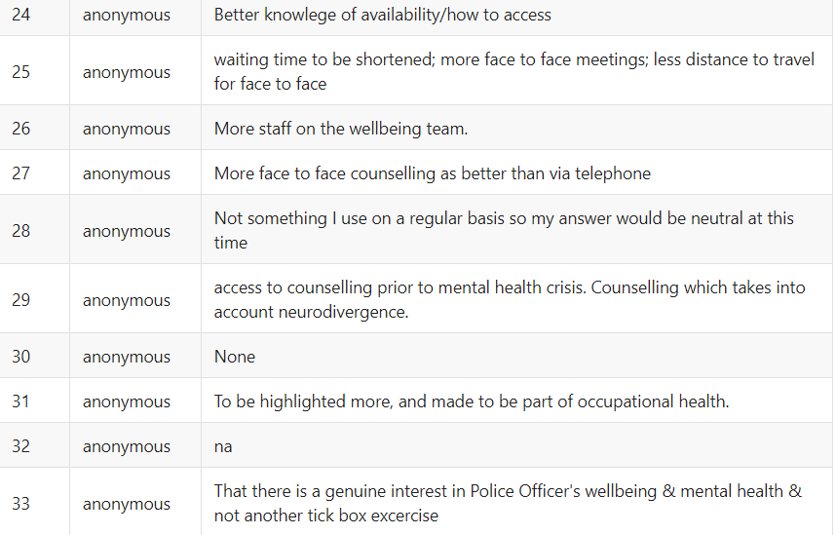
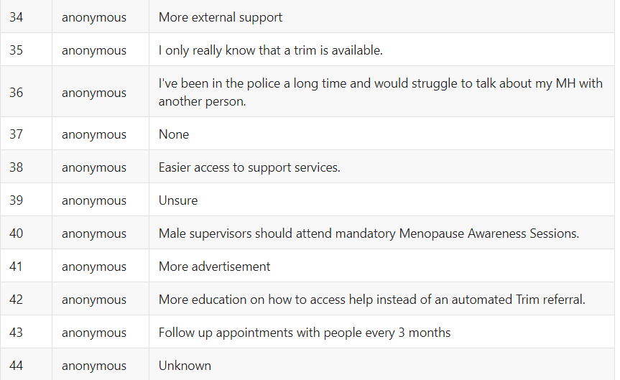
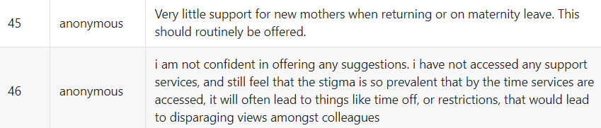

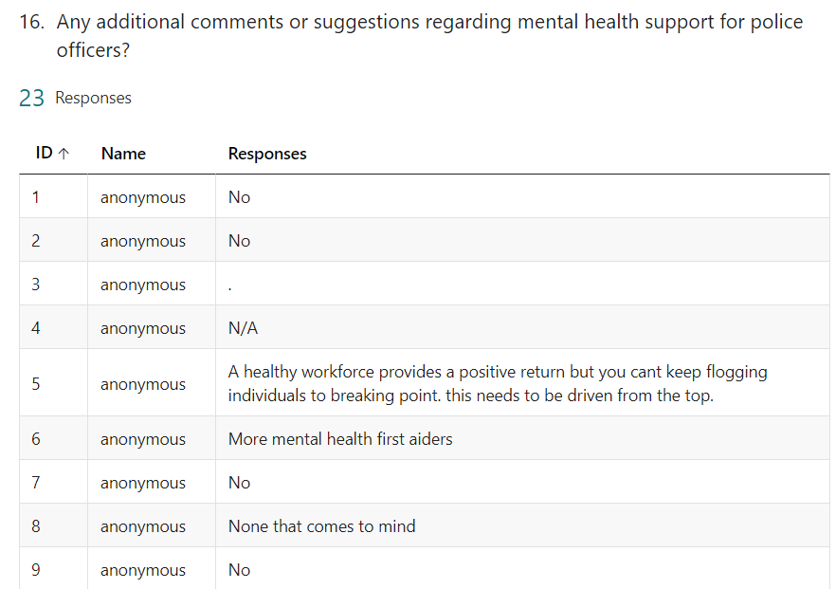
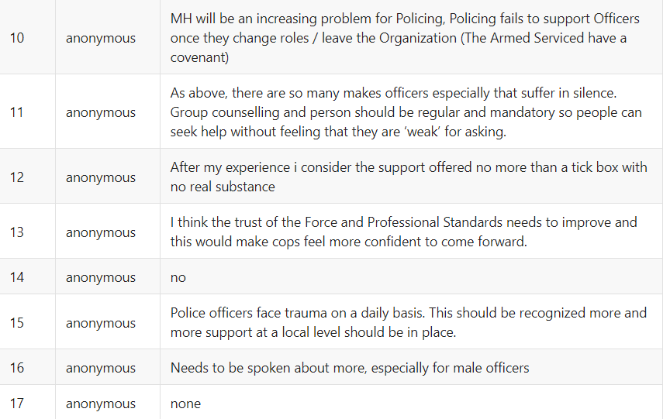
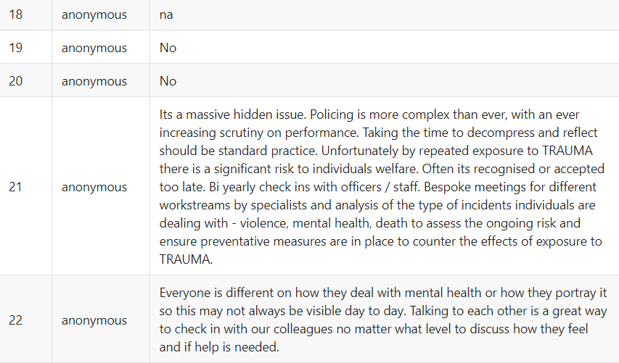
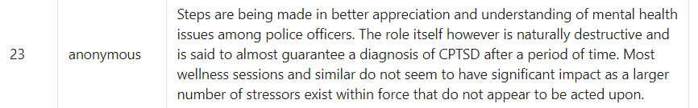

7.3 Appendix 3 – Email sent to participants

Good morning/afternoon/evening
My name is Geraint Hall-Moore and I am currently conducting a research project examining to what extent is there effective mental health support for Police Officers frequently exposed to trauma. To gain data for my research project I need several officers to complete a survey. I am writing to you to request for you to complete the following survey at your earliest convenience:
https://forms.office.com/e/5f8qvUpDa4
It will take approximately 15 minutes for you to complete. Taking part is completing voluntary and you do not have to complete the survey. Your responses will be kept strictly confidential as you will be completing it anonymously, any report of this research that is made available to the public will not include your name or any other identifiable information. Not even I (the researcher) will know who has submitted which answer.
I’d like to thank you in advance for your time. Should you have any questions please do not hesitate to contact me.

Geraint Hall-Moore.

7.4 Appendix 4 – Ethics Form

APPLICATION FOR ETHICAL APPROVAL

RESEARCH STUDENTS
This form is to be completed by the student within SIX months for full-time students and TWELVE months for part time students, after the commencement of the research degree or following progression to Part Two of your course.

Once complete, submit this form via the MyTSD Doctoral College Portal at (https://mytsd.uwtsd.ac.uk).

This document is also available in Welsh.

RESEARCH STAFF ONLY
All communications relating to this application during its processing must be in writing and emailed to pgresearch@uwtsd.ac.uk , with the title ‘Ethical Approval’ followed by your name.

STUDENTS ON UNDERGRADUATE OR TAUGHT MASTERS PROGRAMMES should submit this form (and receive the outcome) via systems explained to you by the supervisor/module leader.

In order for research to result in benefit and minimise risk of harm, it must be conducted ethically. A researcher may not be covered by the University’s insurance if ethical approval has not been obtained prior to commencement.

The University follows the OECD Frascati manual definition of research activity: “creative work undertaken on a systematic basis in order to increase the stock of knowledge, including knowledge of man, culture and society, and the use of this stock of knowledge to devise new applications”. As such this covers activities undertaken by members of staff, postgraduate research students, and both taught postgraduate and undergraduate students working on dissertations/projects.

The individual undertaking the research activity is known as the “principal researcher”.

Ethical approval is not required for routine audits, performance reviews, quality assurance studies, testing within normal educational requirements, and literary or artistic criticism.

Please read the notes for guidance before completing ALL sections of the form.

This form must be completed and approved prior to undertaking any research activity. Please see Checklist for details of process for different categories of application.

SECTION A: About You (Principal Researcher)
1 | Full Name: |  | Geraint Hall-Moore
2 | Tick all boxes that apply: |  | Member of staff: | ☐ | Honorary research fellow: | ☐
 | Undergraduate Student | ☒ | Taught Postgraduate Student | ☐ | Postgraduate Research Student | ☐

3 | Institute/Academic Discipline/Centre: | IMH
4 | Campus: | Swansea
5 | E-mail address: | 2125218@student.uwtsd.ac.uk
6 | Contact Telephone Number: | N/A
 | For students:
7 | Student Number: | 2125218
8 | Programme of Study: | BSc (Hons) Professional Policing Practice
9 | Director of Studies/Supervisor: | Jane Thomas

SECTION B: Approval for Research Activity
1 | Has the research activity received approval in principle?  (please check the Guidance Notes as to the appropriate approval process for different levels of research by different categories of individual) |  | YES | ☒ | NO | ☐
 |  |  |  |  | Date
2 | If Yes, please indicate source of approval (and date where known): Approval in principle must be obtained from the relevant source prior to seeking ethical approval | Research Degrees Committee |  | ☐
2 |  | Institute Research Committee |  | ☐
2 |  | Other (write in) |  | ☒ | Jane Thomas

SECTION C: Internal and External Ethical Guidance Materials
 | Please list the core ethical guidance documents that have been referred to during the completion of this form (including any discipline-specific codes of research ethics, location-specific codes of research ethics, and also any specific ethical guidance relating to the proposed methodology). Please tick to confirm that your research proposal adheres to these codes and guidelines. You may add rows to this table if needed.
1 | UWTSD Research Ethics & Integrity Code of Practice | ☒
2 | UWTSD Research Data Management Policy | ☒
3 | [List any other relevant documents here] | ☐

SECTION D: External Collaborative Research Activity
If there are external collaborators then you should gain consent from the contact persons to share their personal data with the university. If there are no external collaborators then leave this section blank and continue to section E.
1 | Institution
2 | Contact person name
3 | Contact person e-mail address
4 | Is your research externally funded? |  | YES | ☐ | NO |  | ☐
5 | Are you in receipt of a KESS scholarship? |  | YES | ☐ | NO |  | ☐
6 | Are you specifically employed to undertake this research in either a paid or voluntary capacity? | Voluntary | YES | ☐ | NO | ☐
7 |  | Employed | YES | ☐ | NO | ☐
8 | Is the research being undertaken within an existing UWTSD Athrofa Professional Learning Partnership (APLP)? | If YES then the permission question below does not need to be answered. | YES | ☐ | NO |  | ☐
9 | Has permission to undertake the research has been provided by the partner organisation? | (If YES attach copy)  If NO the application cannot continue | YES | ☐ | NO |  | ☐

Where research activity is carried out in collaboration with an external organisation
10 | Does this organisation have its own ethics approval system? | YES | ☐ | NO | ☐
 | If Yes, please attach a copy of any final approval (or interim approval) from the organisation (this may be a copy of an email if appropriate).

SECTION E: Details of Research Activity
1 | Indicative title: | What are the effects of frequent exposure to trauma on police officers and is the mental health support available for them effective?
2 | Proposed start date: | 01/01/2024 | Proposed end date: | 07/10/2024
Introduction to the Research (maximum 300 words per section)
Ensure that you write for a Non-Specialist Audience when outlining your response to the points below:
- Purpose of Research Activity
- Proposed Research Question
- Aims of Research Activity
- Objectives of Research Activity
Demonstrate, briefly, how Existing Research has informed the proposed activity and explain
- What the research activity will add to the body of knowledge
- How it addresses an area of importance.
3 | Purpose of Research Activity  Police officers' mental health is affected greatly by repeated trauma exposure. This often results in disorders including posttraumatic stress disorder (PTSD), depression, and anxiety. Even though there are varied mental health support systems in place, such as screening programs, peer support groups, counselling to name a few, challenges remain, especially when it comes to ensuring they are both efficient and available to all officers when required. Mental health programs should be reformed to ensure they meet the specific needs and demands of officers, especially those dealing with trauma and mental health disorders. To effectively address the mental health needs of police officers in the UK, a comprehensive strategy that includes proactive intervention techniques, continuous support, and de-stigmatisation of mental health issues is needed. This study is critical in the sense that understanding the effects of exposure to trauma on police officers and the mental health support currently available will aid in developing future targeted interventions that may help the victims and to support the understanding that the current measures in place are still not affective enough to help tackle the current mental health crisis within the police force.  (this box should expand as you type)
4 | Research Question  What are the effects of frequent exposure to trauma on police officers and is the mental health support available for them effective?  (this box should expand as you type)
5 | Aims of Research Activity  Through my research within this dissertation, I will aim to answer these research questions through current literature and facts and figures that are available through them and other sources, along with conducting questionnaires and interviews with officers who are currently serving in Gwent Police.  (this box should expand as you type)
6 | Objectives of Research Activity  1. Explore the effects of trauma on police officers in the UK with specific reference to Gwent Police  2. Examine the magnitude of the current mental health crisis within the police force with specific reference to Gwent Police  3. To examine whether there is appropriate and effective support in place to help police officers deal with trauma and mental health issues with specific reference to Gwent Police  (this box should expand as you type)
Proposed methods (maximum 600 words)
Provide a brief summary of all the methods that may be used in the research activity, making it clear what specific techniques may be used. If methods other than those listed in this section are deemed appropriate later, additional ethical approval for those methods will be needed. You do not need to justify the methods here, but should instead describe how you intend to collect the data necessary for you to complete your project.
7 | I will be using questionnaires using a website called Survey Monkey to facilitate this, which will be sent to police officers in the United Kingdom to gain a general understanding of the issue I am researching, aiming to obtain around 50 responses for a good amount of data to be analysed. I will then be conducting semi-structured interviews with a selected sample of 4 police officers from Gwent Police to gain a more in depth understanding of the issues I am researching for this project. I will be typing up my interview plan and then interviewing the officers and typing up their responses which will be attached to my dissertation appendices.  (this box should expand as you type)
Location of research activity
Identify all locations where research activity will take place.
8 | Cardiff, Caerphilly and Cwmbran  (this box should expand as you type)
Research activity outside of the UK
If research activity will take place overseas, you are responsible for ensuring that local ethical considerations are complied with and that the relevant permissions are sought. Specify any local guidelines (e.g. from local professional associations/learned societies/universities) that exist and whether these involve any ethical stipulations beyond those usual in the UK (provide details of any licenses or permissions required). Also specify whether there are any specific ethical issues raised by the local context in which the research activity is taking place, for example, particular cultural and/or legal sensitivities or vulnerabilities of participants. If you live in the country where you will do the research then please state this.
9 | N/A  (this box should expand as you type)

10 | Use of documentation not in the public domain: Are any documents NOT publicly available? | NO | ☒
10 |  | YES | ☐
11 | If Yes, please provide details here of how you will gain access to specific documentation that is not in the public domain and that this is in accordance with the current data protection law of the country in question and that of England and Wales.  (this box should expand as you type)

 | Does your research relate to one or more of the seven aims of the Well-being of Future Generations (Wales) Act 2015? | YES | NO
12 | A prosperous Wales | ☐ | ☒
13 | A resilient Wales | ☐ | ☒
14 | A healthier Wales | ☐ | ☒
15 | A more equal Wales | ☐ | ☒
16 | A Wales of cohesive communities | ☐ | ☒
17 | A Wales of vibrant culture and thriving Welsh language | ☐ | ☒
18 | A globally responsible Wales | ☐ | ☒
19 | If YES to any of the above, please give details:
 | (this box should expand as you type)

SECTION F: Scope of Research Activity
 | Will the research activity include: | YES | NO
1 | Use of a questionnaire or similar research instrument? | ☒ | ☐
2 | Use of interviews? | ☒ | ☐
3 | Use of focus groups? | ☐ | ☒
4 | Use of participant diaries? | ☐ | ☒
5 | Use of video or audio recording? | ☐ | ☒
6 | Use of computer-generated log files? | ☐ | ☒
7 | Participant observation with their knowledge? | ☐ | ☒
8 | Participant observation without their knowledge? | ☐ | ☒
9 | Access to personal or confidential information without the participants’ specific consent? | ☐ | ☒
10 | Administration of any questions, test stimuli, presentation that may be experienced as physically, mentally or emotionally harmful / offensive? | ☐ | ☒
11 | Performance of any acts which may cause embarrassment or affect self-esteem? | ☐ | ☒
12 | Investigation of participants involved in illegal activities? | ☐ | ☒
13 | Use of procedures that involve deception? | ☐ | ☒
14 | Administration of any substance, agent or placebo? | ☐ | ☒
15 | Working with live vertebrate animals? | ☐ | ☒
16 | Procedures that may have a negative impact on the environment? | ☐ | ☒
17 | Other primary data collection methods. Please indicate the type of data collection method(s) below. | ☐ | ☒
 | Details of any other primary data collection method:  N/A  (this box should expand as you type) | ☐ | ☒
If NO to every question, then the research activity is (ethically) low risk and may be exempt from some of the following sections (please refer to Guidance Notes).

If YES to any question, then no research activity should be undertaken until full ethical approval has been obtained.

SECTION G: Intended Participants
If there are no participants then do not complete this section, but go directly to section H.

 | Who are the intended participants: | YES | NO
1 | Students or staff at the University? | ☒ | ☐
2 | Adults (over the age of 18 and competent to give consent)? | ☒ | ☐
3 | Vulnerable adults? | ☐ | ☒
4 | Children and Young People under the age of 18? (Consent from Parent, Carer or Guardian will be required) | ☐ | ☒
5 | Prisoners? | ☐ | ☒
6 | Young offenders? | ☐ | ☒
7 | Those who could be considered to have a particularly dependent relationship with the investigator or a gatekeeper? | ☐ | ☒
8 | People engaged in illegal activities? | ☐ | ☒
9 | Others. Please indicate the participants below, and specifically any group who may be unable to give consent. | ☐ | ☒
 | Details of any other participant groups:  N/A  (this box should expand as you type) | ☐ | ☒

Participant numbers and source
Provide an estimate of the expected number of participants. How will you identify participants and how will they be recruited?
10 | How many participants are expected? | Approx 50 officers for the questionnaire responses.  4 officers to be interviewed.  (this box should expand as you type)
11 | Who will the participants be? | Police officers over the age of 18  (this box should expand as you type)
12 | How will you identify the participants? | Through work (i.e colleagues) and through social media to help gain a bigger audience for my questionnaire.  (this box should expand as you type)

 | Information for participants: | YES | NO | N/A
13 | Will you describe the main research procedures to participants in advance, so that they are informed about what to expect? | ☒ | ☐ | ☐
14 | Will you tell participants that their participation is voluntary? | ☒ | ☐ | ☐
15 | Will you obtain written consent for participation? | ☒ | ☐ | ☐
16 | Will you explain to participants that refusal to participate in the research will not affect their treatment or education (if relevant)? | ☒ | ☐ | ☐
17 | If the research is observational, will you ask participants for their consent to being observed? | ☐ | ☐ | ☒
18 | Will you tell participants that they may withdraw from the research at any time and for any reason? | ☒ | ☐ | ☐
19 | With questionnaires, will you give participants the option of omitting questions they do not want to answer? | ☒ | ☐ | ☐
20 | Will you tell participants that their data will be treated with full confidentiality and that, if published, it will not be identifiable as theirs? | ☒ | ☐ | ☐
21 | Will you debrief participants at the end of their participation, in a way appropriate to the type of research undertaken? | ☒ | ☐ | ☐
22 | If NO to any of above questions, please give an explanation
 | (this box should expand as you type)

 | Information for participants: | YES | NO | N/A
24 | Will participants be paid? | ☐ | ☐ | ☒
25 | Is specialist electrical or other equipment to be used with participants? | ☐ | ☐ | ☒
26 | Are there any financial or other interests to the investigator or University arising from this study? | ☐ | ☐ | ☒
27 | Will the research activity involve deliberately misleading participants in any way, or the partial or full concealment of the specific study aims? | ☐ | ☐ | ☒
28 | If YES to any question, please provide full details
 | (this box should expand as you type)

SECTION H: Anticipated Risks

Outline any anticipated risks that may adversely affect any of the participants, the researchers and/or the University, and the steps that will be taken to address them.

If you have completed a full risk assessment (for example as required by a laboratory, or external research collaborator) you may append that to this form.
1 | Full risk assessment completed and appended? |  | Yes | ☐
1 |  |  | No | ☒
2 | Risks to participants  For example: sector-specific health & safety, emotional distress, financial disclosure, physical harm, transfer of personal data, sensitive organisational information
 | Risk to participants:  Emotional distress could be a risk as the topic we are discussing is trauma and mental health related.  (this box should expand as you type) | How you will mitigate the risk to participants:  I will ensure that I monitor responses by the officers when conducting interviews, If I feel they are getting too distressed a break will be offered and I will reiterate that their involvements is voluntary, and they are free to stop or leave the interview at any time without any consequence.  (this box should expand as you type)
3 | If research activity may include sensitive, embarrassing or upsetting topics (e.g. sexual activity, drug use) or issues likely to disclose information requiring further action (e.g. criminal activity), give details of the procedures to deal with these issues, including any support/advice (e.g. helpline numbers) to be offered to participants. Note that where applicable, consent procedures should make it clear that if something potentially or actually illegal is discovered in the course of a project, it may need to be disclosed to the proper authorities
N/A

(this box should expand as you type)
4 | Risks to the investigator  For example: personal health & safety, physical harm, emotional distress, risk of accusation of harm/impropriety, conflict of interest
 | Risk to the investigator:  As I am a police officer myself some of their responses could trigger emotional distress for me and potentially, I could relate to their experiences given some may be my colleagues.  (this box should expand as you type) | How you will mitigate the risk to the investigator:  I will ensure that my own well-being is also a priority while conducting the research, and If I feel I get distressed I will have a break and continue when I feel appropriate.  (this box should expand as you type)
5 | University/institutional risks  For example: adverse publicity, financial loss, data protection
 | Risk to the University:  N/A  (this box should expand as you type) | How you will mitigate the risk to the University:  (this box should expand as you type)
6 | Environmental risks  For example: accidental spillage of pollutants, damage to local ecosystems
 | Risk to the environment:  N/A  (this box should expand as you type) | How you will mitigate the risk to environment:  (this box should expand as you type)

 | Disclosure and Barring Service
 | If the research activity involves children or vulnerable adults, a Disclosure and Barring Service (DBS) certificate must be obtained before any contact with such participants. | YES | NO | N/A
7 | Does your research require you to hold a current DBS Certificate? | ☐ | ☐ | ☒
8 | If YES, please give the certificate number. If the certificate number is not available please write “Pending”; in this case any ethical approval will be subject to providing the appropriate certificate number.

SECTION I: Feedback, Consent and Confidentiality

1 | Feedback  What de-briefing and feedback will be provided to participants, how will this be done and when?
I will make them aware of what happens to their research from then on, and if they would like a copy of my research once it is complete I will send one to them once its available.

(this box should expand as you type)
2 | Informed consent  Describe the arrangements to inform potential participants, before providing consent, of what is involved in participating. Describe the arrangements for participants to provide full consent before data collection begins. If gaining consent in this way is inappropriate, explain how consent will be obtained and recorded in accordance with prevailing data protection legislation.
I will be writing a letter that I will be providing a copy to each participant to explain what the research is about, why it is being conducted, what their involvement will be, their rights during the interview and that it is voluntary. I will ensure this will be signed by them before they take part in any research and that they can keep a copy for their own records, and I will also keep one to protect myself.

(this box should expand as you type)
3 | Confidentiality / Anonymity  Set out how anonymity of participants and confidentiality will be ensured in any outputs. If anonymity is not being offered, explain why this is the case.
I will be using random numbers to identify each participant. For example, Participant 1, Participant 2 and so on. No personal identifiable information will be used.

(this box should expand as you type)

SECTION J: Data Protection and Storage

 | Does the research activity involve personal data (as defined by the General Data Protection Regulation 2016 “GDPR” and the Data Protection Act 2018 “DPA”)? | YES | NO
1 | “Personal data” means any information relating to an identified or identifiable natural person (‘data subject’). An identifiable natural person is one who can be identified, directly or indirectly, in particular by reference to an identifier such as a name, an identification number, location data, an online identifier or to one or more factors specific to the physical, physiological, genetic, mental, economic, cultural or social identity of that natural person. Any video or audio recordings of participants is considered to be personal data. | ☐ | X
 | If YES, provide a description of the data and explain why this data needs to be collected:
2 | N/A  (this box should expand as you type)
 | Does it involve special category data (as defined by the GDPR)? | YES | NO
3 | “Special category data” means sensitive personal data consisting of information as to the data subjects’ –  (a) racial or ethnic origin,  (b) political opinions,  (c ) religious beliefs or other beliefs of a similar nature,  (d) membership of a trade union (within the meaning of the Trade Union and Labour Relations (Consolidation) Act 1992),  (e) physical or mental health or condition,  (f) sexual life,  (g) genetics,  (h) biometric data (as used for ID purposes), | ☐ | X
 | If YES, provide a description of the special category data and explain why this data needs to be collected:
4 | N/A  (this box should expand as you type)

 | Will data from the research activity (collected data, drafts of the thesis, or materials for publication) be stored in any of the following ways? | YES | NO
5 | Manual files (i.e. in paper form)? | ☐ | ☒
6 | University computers? | ☐ | ☒
7 | Private company computers? | ☐ | ☒
8 | Home or other personal computers? | ☒ | ☐
9 | Laptop computers/ CDs/ Portable disk-drives/ memory sticks? | ☐ | ☒
10 | “Cloud” storage or websites? | ☐ | ☒
11 | Other – specify: | ☐ | ☒
12 | For all stored data, explain the measures in place to ensure the security of the data collected, data confidentiality, including details of backup procedures, password protection, encryption, anonymisation and pseudonymisation:
This study will involve police officers from the UK with specific reference to England and Wales. The participants are likely to give out personal information, especially concerning their health and well-being. The information provided must remain private and confidential. Breaching such crucial information may have far-reaching implications for the well-being of participants. To ensure the privacy and confidentiality of the personal details of the participants, random numbers will be used as identifiers as opposed to using names or personal details, such as Participant 1, Participant 2 and for the interviews and then the questionnaires will be random numbers. To enhance data integrity and privacy, I will encrypt the information and only store the information on my personal work laptop, once the research is complete, I will delete all the additional documents that I have saved and only keep the final research project. There will be no personal identifiable information stored about the individuals throughout.

(this box should expand as you type)

 | Data Protection
 | Will the research activity involve any of the following activities: | YES | NO
13 | Electronic transfer of data in any form? | ☐ | ☒
14 | Sharing of data with others at the University outside of the immediate research team? | ☐ | ☒
15 | Sharing of data with other organisations? | ☐ | ☒
16 | Export of data outside the UK or importing of data from outside the UK? | ☐ | ☒
17 | Use of personal addresses, postcodes, faxes, emails or telephone numbers? | ☐ | ☒
18 | Publication of data that might allow identification of individuals? | ☐ | ☒
19 | Use of data management system? | ☐ | ☒
20 | Data archiving? | ☐ | ☒
21 | If YES to any question, please provide full details, explaining how this will be conducted in accordance with the GDPR and Data Protection Act (2018) (and any international equivalents, where appropriate):
 | (this box should expand as you type)
22 | List all who will have access to the data generated by the research activity:
 | (this box should expand as you type)
23 | List who will have control of, and act as custodian(s) for, data generated by the research activity:
 | (this box should expand as you type)
24 | Give details of data storage arrangements, including security measures in place to protect the data, where data will be stored, how long for, and in what form. Will data be archived – if so how and if not why not.
 | (this box should expand as you type)
25 | Please indicate if your data will be stored in the UWTSD Research Data Repository (see https://researchdata.uwtsd.ac.uk/ ). If so please explain. (Most relevant to academic staff)
 | (this box should expand as you type)
26 | Confirm that you have read the UWTSD guidance on data management (see https://www.uwtsd.ac.uk/library/research-data-management/) | YES | ☒
27 | Confirm that you are aware that you need to keep all data until after your research has completed or the end of your funding | YES | ☒

SECTION K: Declaration
The information which I have provided is correct and complete to the best of my knowledge. I have attempted to identify any risks and issues related to the research activity and acknowledge my obligations and the rights of the participants.

In submitting this application I hereby confirm that I undertake to ensure that the above named research activity will meet the University’s Research Ethics and Integrity Code of Practice which is published on the website: https://www.uwtsd.ac.uk/research/research-ethics/
1 | Signature of applicant: | GERAINT HALL-MOORE | Date:  25/02/2024

For STUDENT Submissions:
2 | Director of Studies/Supervisor: |  | Date:
3 | Signature: |  | Date:

For STAFF Submissions:
4 | Academic Director/ Assistant Dean: |  | Date:
5 | Signature: |  | Date:

Checklist: Please complete the checklist below to ensure that you have completed the form according to the guidelines and attached any required documentation:
☐ | I have read the guidance notes supplied before completing the form.
☐ | I have completed ALL RELEVANT sections of the form in full.
☐ | I confirm that the research activity has received approval in principle
☐ | I have attached a copy of final/interim approval from external organisation (where appropriate)
☐ | I have attached a full risk assessment (where appropriate) ONLY TICK IF YOU HAVE ATTACHED A FULL RISK ASSESSMENT
☐ | I understand that it is my responsibility to ensure that the above named research activity will meet the University’s Research Ethics and Integrity Code of Practice.
☐ | I understand that before commencing data collection all documents aimed at respondents (including information sheets, consent forms, questionnaires, interview schedules etc.) must be confirmed by the DoS/Supervisor, module tutor or Academic Director.

RESEARCH STUDENTS ONLY
Once complete, submit this form via the MyTSD Doctoral College Portal at (https://mytsd.uwtsd.ac.uk).

RESEARCH STAFF ONLY
All communications relating to this application during its processing must be in writing and emailed to pgresearch@uwtsd.ac.uk , with the title ‘Ethical Approval’ followed by your name.

STUDENTS ON UNDERGRADUATE OR TAUGHT MASTERS PROGRAMMES should submit this form (and receive the outcome) via systems explained to you by the supervisor/module leader.

