
COMPONENT 1
Report : Critical Evaluation of Digital Innovation (Oxevision) in Health and Social Care
Name | Sofia Jabeen | ID Number | 2309199
Programme | BSc Health and Social Care
Module | Digital Transformation in the Health and Care Professions
Module code | BMHP6026
Tutor’s Name | Zakiyyah Ahmed
Word Count | 2193 Words

Table of Contents
Introduction ---------------------------------------------------------------------------4
Background----------------------------------------------------------------------------4
Critically Evaluated Considerations-------------------------------------------6
- workforce ----------------------------------------------------------------------6
- Service Delivery--------------------------------------------------------------9
Critical Discussion----------------------------------------------------------------11
Recommendations ----------------------------------------------------------------11
Conclusion --------------------------------------------------------------------------12
References --------------------------------------------------------------------------13

List of Figures
Figure#1----------------------------------------------------------------------------------4
Figure#2 ---------------------------------------------------------------------------------4
Figure#3 ---------------------------------------------------------------------------------5

Introduction
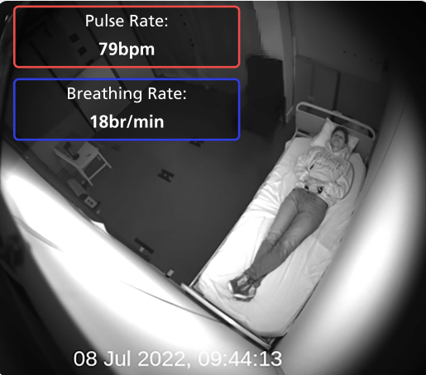
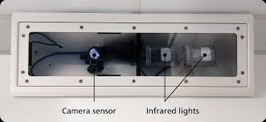
Healthcare digitalization is becoming a modernized service delivery which is driven by the increasing demands for enhanced service user safety, quality of care, workforce sustainability and efficiency. Oxevision introduced by Oxehealth in MHS is a contactless patient monitoring system which uses infrared sensitive cameras and advanced algorithms to observe patient’s mobility and vitals.
Figure 1: OMS (Hutchinson and Woodward, 2025).

Figure 2: Monitoring vitals and movement patterns (North Staffordshire Combined HCT, 2024).

This system helps the providers in treating patients who are experiencing severe mental illness and acute psychological distress by avoiding traditional observation practices, alongside resolve the workforce deficit issue (Ndebele et al., 2023).Oxevision is efficiently executed in mental health setting, by providing continuous surveillance and generate alerts when potential or physiological risks are generated but later on within the past decade it has been successfully adapted by the NHS mental health trusts (Buckley et al., 2024).It is a real-world validated invention and has supported over 4 million hours of care in healthcare(NSUN website, 2024).
This report critically appraises the implementation of Oxevision in UK health and social care settings, with a specific focus on inpatient mental health services. The discussion looks at the impact of the technology on workforce roles and competencies, service delivery and patients; whilst also identifying persistent challenges associated with its deployment.
Background
Oxevision is used in psychiatric wards and psychiatric intensive care units to monitor the mental health suffering patients. Unlike a traditional system of providing live video to the staff instead it gives analysis video clips to the clinical staff when necessary, regarding patient mobility which is associated with the poor mental health concerns delayed recovery , vital signs, generates alerts when potential risks are detected so this feature has been promoted as an important advantage of the technological innovation. Its implementation in NHS integrates two technologies together such as computer vision technology and AI algorithms to detect physiological and behavioral indicators in the inpatient wards gives real time vigilance to the professional staff when abnormal behavior patterns and safety concerns identified (Buckley et al., 2024).
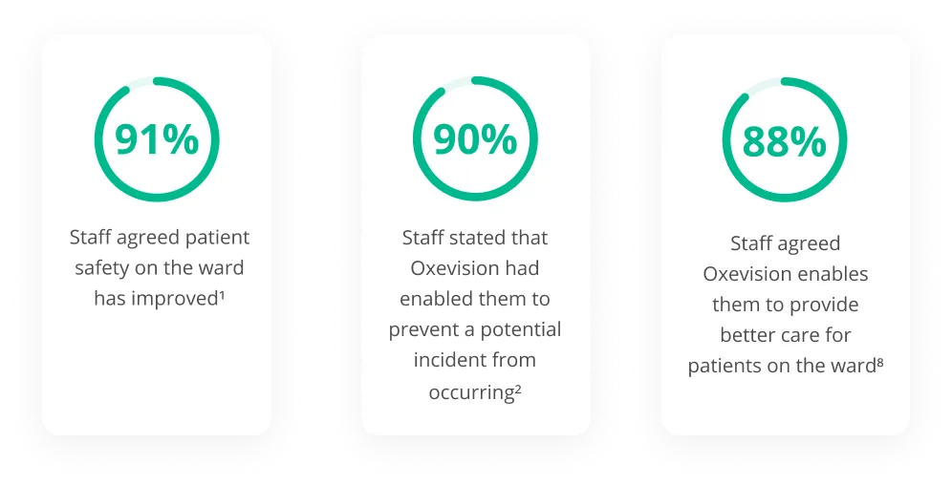
According to the Oxehealth report, 100 healthcare sites are using this technology internationally and approximately 50% deploying in the English MHT over the last decade.Research indicates that its implementation is reflecting boost confidence in its potential usage to enhance the operational efficiency and patient safety resulting reductions in harmful incidents (Impact Report (OUI), 2024).Additionally, economic evaluations advocate that Oxevision causes cost savings through reduced physical observations and improved allocation of clinical resources (Malcolm et al., 2022).
Figure 3: Staff acceptance survey %age of Oxevision in NHS(UCL Partners, 2023).

However, the worldwide recognition of Oxevision has not occurred without controversy. One of the most intense condemnations is its ethical implications of inpatient surveillance by breaching their privacy without informed consent particularity in mental health settings where people may confine with the mental health legislation and diminished capacity of decision making. Although Oxehealth stresses that oxevision is not the same as conventional monitoring systems, some patients and advocacy groups see the transforming technology as intrusive and against the principles of autonomy and privacy (NSUN website, 2024).There have been questions raised as to whether patients understand the digital technology and whether they are able to refuse participation in truth.
Secondly, implementation of oxevision in system highlighted the complex balance between person-centered care approaches and technological innovations. This debate explains that it is either useful in workforce efficiency or patient safety but potentially it is reducing meaningful therapeutic healthcare relationships. Whether mental healthcare has conventionally stressed on the therapy engagement reflecting empathy and positive human interaction which is an essential component of recovery- oriented practices (Sántha, 2018).
According to the legislative standpoint, the launch of oxevision aligns with the NHS ambitions to build digitally connected health systems that can improve efficiency, quality and safety. However, technical efficacy alone is not enough for successful deployment. Healthcare companies need to tackle issues such as ethical responsibility, data security, patient participation, employee skills and management that are still very pertinent to contemporary health and social care practice (Health Research Authority, 2020).
Critically Evaluated Considerations
a. Workforce
Positive Outcomes | Negative Outcomes
Improved Staff Safety  - In mental health setting, violence and aggression are the substantial risk for the working staff in PICU and PW, restrictive interventions following the execution of oxevision.  - It has improved awareness regarding patient behavior before escalating violent situations interventions can be adopted. This contribution of technology provides a safer working environment for the staff by reducing their stress and burnout (Ndebele et al., 2023). | Switching Job  - Due to the incorporation of technology in workspace like in mental health setting, merger of oxevision overlooked the patient’s psychological aspects and some critics argue about it that without physical interaction many aspects of treatment are over pass because this technology reducing the therapeutic engagement and face to face healthcare relationship due to remote monitoring(Sántha, 2018).
Enhanced Clinical Monitoring  - One of the primary workforce benefits associated with Oxevision is improved patient monitoring. Traditional observation practices often require nursing staff to Prime workforce advantage is the non-physical monitoring of the patients specifically during nighttime, demands more labor- intensive and may divert the on duty staff attention from other clinical accountabilities.  - Invention of oxevision enables the NHS staff to remotely monitor the sufferers by identifying the risks more rapidly before escalation and reduction in adverse incidents and events.  - From a staff outlook, oxevision assists in clinical decision-making by providing additional data related to patient behavior and physiological vitals. Staff gain access to information that may not be observable during periodic intervals, potentially enhancing risks assessment accuracy(Buckley et al., 2024). | Loss of Expertise  - Oxevision is also contributed to professional deskilling as digital monitoring reduces conventional assessment skills because healthcare expertise largely depended on technology rather than relying on clinical observations and judgement, resulting in weakening the critical thinking abilities(Buckley et al., 2024).
Augmented Efficiency  - In NHS, mental health nursing shortage is a significant challenge, due to the introduction of oxevision, cost savings and work efficacy is improved by lessens the repeated manual patient monitoring during nighttime suggested by the economic evaluations.  - Enhanced efficiencies enable the workforce to concentrate eon therapeutic engagement and care planning(Buckley et al., 2024). | Skill Requirements  - An implementation of the oxevision in mental health system requires staff to be more educated and competent to understand the system functionality, algorithms, interpretation of the risks, legislative requirements and escalation procedures to deal the adverse events.  - Digital literacy is essential for the staff, unexperienced may face implementation challenges such as safety risks, alert interpretations, over reliance on technology. Hence, training and workshops create financial burden on trust to educate the workforce(Sántha, 2018).

Explicative Clinical Scenario
In an acute mental health ward a patient named, James Wicks has severe mental depression with suicidal thoughts, and he needs to be monitoring with the interval of 15 minutes.
In a traditional observation method, a nighttime nurse is required to monitor James to confirm that his vitals are fine. Approximately, 48 physical observations are compulsory during a 12-hour shift which makes the patient disturb for frequent opening of door and lights by increasing his anxiety and frustration. Concurrently, the nurse had not enough time to check other patients because of substantial proportion of observational visits.
After Oxevision execution in the system, James’s vitals can be checked by remote monitoring through infrared sensors. By the usage of oxevision nurse monitored through digital dashboard from the nursing station helps in detecting the prolonged immobility followed by the increase in the respiratory rate. This helps in early intervention prevented from the serious injury and assisted multidisciplinary team to review the James care plan.
Oxevision has changed the monitoring methods and helps in the interpreting digital information by using professional judgement when direct intervention is required. This technology supports the nurses in prior identification of clinical deterioration while delivering the therapeutic care and also changes the workforce competencies. Oxevision implementation provides objective physiological and activity data which enhances the multidisciplinary team working.

b. Service Delivery
Positives Changes | Negative Changes
Service Users Safety  - According to the Impact Report of Oxford University Innovation (2024), 44 % bedroom self-harm incidents and 48% nighttime falls are reduced due to the successful implementation of oxevision in mental health setting.  - Continuous and rigorous monitoring allows staff to identify risks beforehand because of the incorporation of the alert generators to prevent adverse events happening. | Technology Addiction  - Over reliant on oxevision technology leading the overlooking of mental health crises due to physiological monitoring, hence it involves the emotional, psychological and social factors which cannot be measured through remote monitoring.  - Moreover, technological errors such as software errors, equipment failures and false alerts enable the staff to detect clinical indictors on time(Impact Report (OUI), 2024).
Nighttime Monitoring Care  Oxevision assists professionals in monitoring patients remotely without entering their rooms during night hours which may disrupt their sleep causing delayed recovery of mental health patients. It helps patients with improved sleep quality and staff in delivery services for overnight care(Freeman et al., 2017). | Ethical Dilemma  - Debate regarding patient privacy and autonomy during monitoring of the bedroom has questioned the oxevision invention because individuals are experiencing paranoia or trauma-related conditions. They perceive it as intrusive, dehumanizing or coercive(NSUN website, 2024).  - Hence, NHS must ensure compliance with the following legislation to cater for the integration of technology in the system:  - GDPR  - Data Protection Act 2018  - Human Rights Act 1998  - Mental Health Act Principles
Management of Resources  - There is a lot of financial strain on mental health care to make the professionals educated regarding technology which increasing the work safety.  - Economic modelling indicates significant savings linked to fewer unfavourable occurrences and less surveillance needs.  - Services may be able to reallocate staff resources toward patient-centred activities, interdisciplinary cooperation, and therapeutic interventions if there is less need for ongoing physical observations(Buckley et al., 2024). | Deployment Expenses  - Technological integration requires substantial investment for software licensing, hardware installation, infrastructure upgrades, maintenance and staff training.  - Financial resources are required to implement these kinds of systems effectively, but not all organizations cannot afford this expense causing differing levels of digital maturity(Buckley et al., 2024).

Illustrative Example
NHS acute mental health ward, where a recently admitted patient named Mr Charles Roy having an acute psychotic episode. During the first week of admission, appointed nurse staff observed him and reported that he feels well during daytime interactions but monitoring report shows that he has less sleep hours and restless movement. According to observational model, nurse was unable to recognise, seems patient is fine at the regular interval recorded information but due to continuous monitoring provided authentic information with evidence of nocturnal agitation and persistence sleep disturbance which are identified as early indicators of psychosis relapses(Freeman et al., 2017).
Assessment of meeting represents that the psychiatrist adjusted Mr Roy antipsychotic medication, while the psychologist introduced sleep-focused CBT and calming strategies. Appointed nurse also transformed the Mr Roy’s evening routine by lessen environmental stimulation before bedtime and increasing therapeutic care engagement in the evening. By following this intervention over the next week, gradual improvement in nocturnal agitations and sleep durations indicated that the revised intervention person centred care plan was highly effective.
This instance explains that how oxevision invention change service delivery from a reactive model, in which clinical professionals respond quickly to a proactive model that recognised elusive behavioural changes prior a significant clinical deterioration occurs. This invention supports technology supports clinical judgement by providing continuous objective data that enhance multidisciplinary collaboration and enable more personalised care planning approaches(NHS England, 2019).
Critical Discussion
Digital transformation in mental health and social care exhibits Oxevision implementation opportunities and challenges.
From a staffing standpoint, this technology helps in improving work efficiency, patient safety and access to clinical resources and information but existing dilemma is deskilling and over relying on technology remains the biggest concern which required time and finances to fix this problem.
As well as its impact on service delivery are same as discussed above but lapses are coming in balancing successful technological integration in the system and person centered care approaches because healthcare relationships are affected due to this, which are essential for mental health patients’ faster recovery.
In terms of patient’s experiences, oxevision improved safety and reduced sleep disturbance, but intrusive technology is highly distressing. These differing experiences highlight the significance of informed consent procedures, person-centered care strategies and public concerns regarding monitoring are important barriers to acceptance of oxevision.
Recommendations
Hence, several measuring strategies should be prioritized in future for its successful implementation to avoid all the barriers are as follows:
- Informed Consent Procedures
- Prioritise Patient and Stakeholders Decision
- Ethical Considerations
- Clear and Legal Governance Frameworks
- Robust Staff Training
- Technology Evaluation
- Independent Research
- Managing Finances

Conclusion
Oxevision implementation in mental healthcare over the las decade representing it substantial benefits such as enhanced work efficiency, patient safety, remote surveillance, early detection of vitals and generated risks exhibiting its providing quality of care. But its biggest dilemma is intruding the privacy of the patients and lack of therapeutic engagement between patients and carers.
After critical analysis, it has been identified that oxevision is a supportive clinical tool to cure mental health patients but cannot be replaced with human care. Its effective execution requires certain considerations with community, patients, service delivery and workforce perspectives specifically balancing between technological capability and person-centered care approaches.

References
- Buckley, C., Malcolm, R. and Hanlon, J. (2024). Economic impact of a vision-based patient monitoring system across five NHS mental health trusts. PLOS Digital Health, 3(9), p.e0000559. doi:https://doi.org/10.1371/journal.pdig.0000559.
- Day, A. and Goswami, L. (2020). Driving change with evidence and knowledge: Transforming knowledge services for the NHS across England. Business Information Review, 37(1), pp.10–18. doi:https://doi.org/10.1177/0266382120909240.
- Dewa, L.H., Broyd, J., Hira, R., Dudley, A., Hafferty, J.D., Bates, R.H. and Aylin, P. (2023). A service evaluation of passive remote monitoring technology for patients in a high-secure forensic psychiatric hospital: a qualitative study. BMC Psychiatry, 23(1). doi:https://doi.org/10.1186/s12888-023-05437-w.
- Freeman, D., Sheaves, B., Goodwin, G.M., Yu, L.-M., Nickless, A., Hinds, C., Blagrove, M., Haddock, G., John, B., Coulson, M., Fowler, D., Pugh, K., Cape, J., Moseley, P., Brown, G., Hughes, C., Obonsawin, M., Coker, S., Watkins, E. and Schwannauer, M. (2017). The effects of improving sleep on mental health (OASIS): a randomised controlled trial with mediation analysis. The Lancet Psychiatry, [online] 4(10), pp.749–758. doi:https://doi.org/10.1016/s2215-0366(17)30328-0.
- Health Research Authority. (2020). Our response to concerns raised about the Inpatient Safety in Mental Health study. [online] Available at: https://www.hra.nhs.uk/about-us/news-updates/our-response-concerns-raised-about-inpatient-safety-mental-health-study/.
- Hutchinson, S. and Woodward, S. (2025). Lampard Inquiry: ‘Grave concerns’ about Oxevision monitoring system. BBC News. [online] 14 Oct. Available at: https://www.bbc.co.uk/news/articles/cvgk399m70lo.
- Impact Report 2024. (2024). Oxford University Innovation - Impact Report 2024. [online] Available at: https://impactreport2024.innovation.ox.ac.uk/.
- Malcolm, R., Shore, J. and Stainthorpe, A. (2022). Economic evaluation of a vision-based patient monitoring and management system in addition to standard care for adults admitted to psychiatric intensive care units in England. Journal of Medical Economics, 25(1), pp.1101–1109. doi:https://doi.org/10.1080/13696998.2022.2120719.
- Ndebele, F., Wright, K., Gandhi, V.C. and Bayley, D. (2023). Non-contact monitoring to support care in acute inpatient mental health. Journal of Mental Health, pp.1–6. doi:https://doi.org/10.1080/09638237.2023.2245882.
- NHS England (2019). NHS England» NHS Long Term Plan to tackle major killer conditions and save up to half a million lives. [online] England.nhs.uk. Available at: https://www.england.nhs.uk/2019/01/long-term-plan/.
- North Staffordshire Combined Healthcare Trust. (2024). Combined Healthcare launches Oxevision on wards - North Staffordshire Combined Healthcare NHS Trust. [online] Available at: https://www.combined.nhs.uk/news/latest-updates/combined-healthcare-launches-oxevision-on-wards/.
- NSUN website. (2024). The Shape of Safety (2024). [online] Available at: https://www.nsun.org.uk/resource/the-shape-of-safety-2024/.
- Sántha, Á. (2018). Deborah Lupton: Digital Health. Critical and Cross-Disciplinary Perspectives. Acta Universitatis Sapientiae, Social Analysis, 8(1), pp.109–112. doi:https://doi.org/10.2478/aussoc-2018-0007.
- UCLPartners. (2023). Enhancing patient safety with innovative technology - UCLPartners. [online] Available at: https://uclpartners.com/impact-story/enabling-safety-and-trust-on-mental-health-wards-through-innovation/ [Accessed 18 Jun. 2026].

