
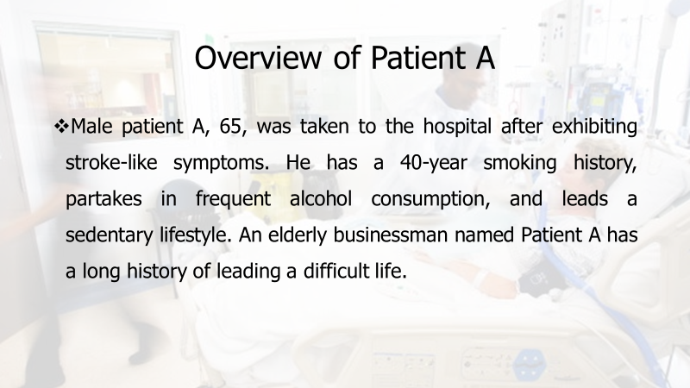
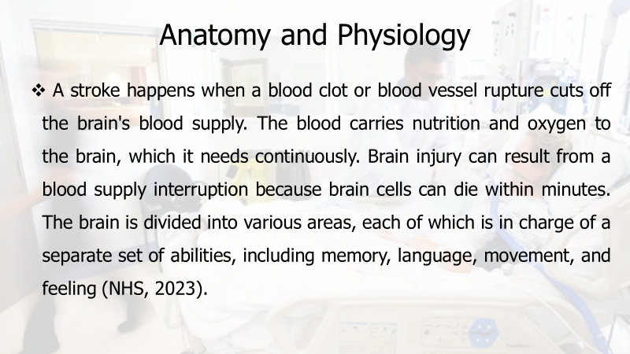
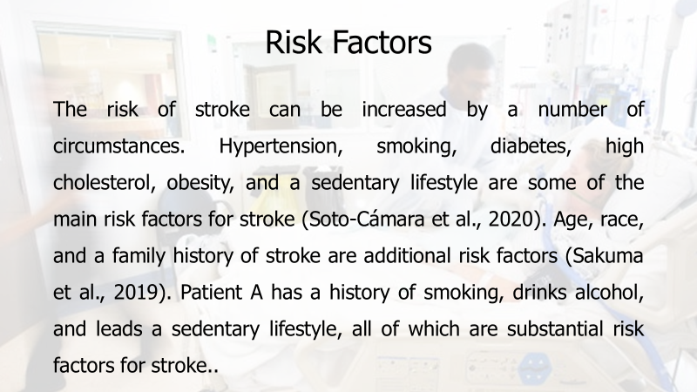

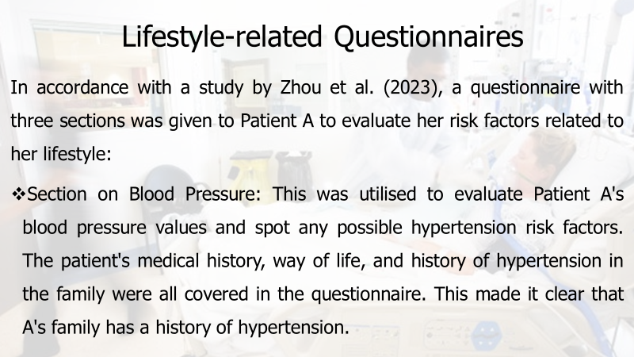
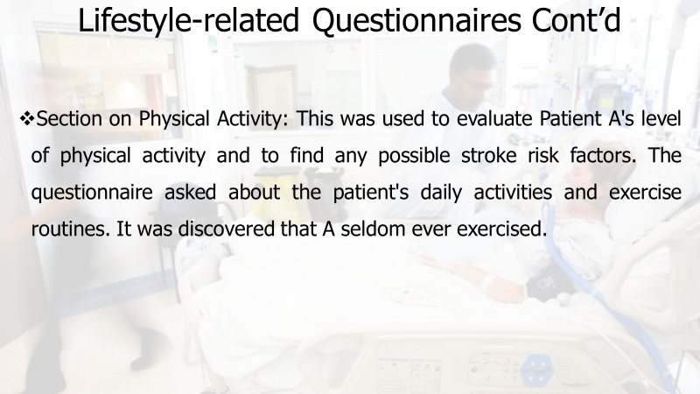

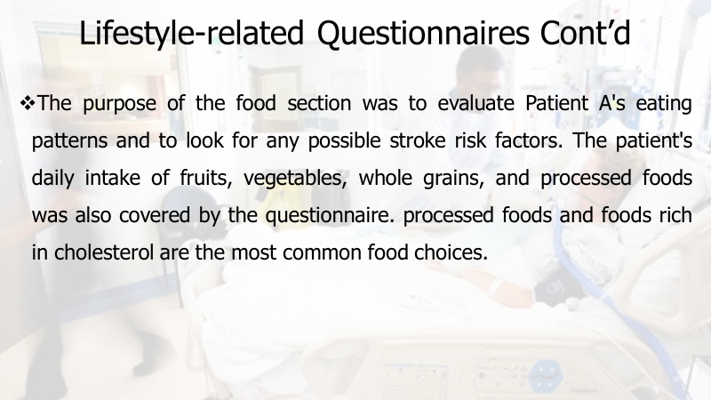
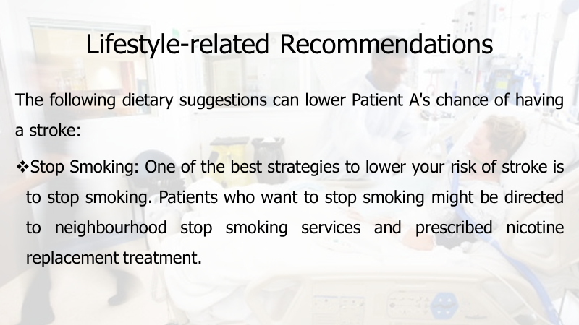

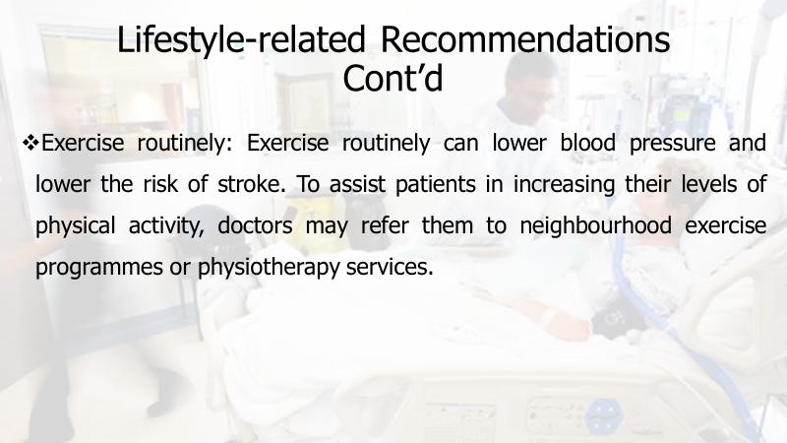
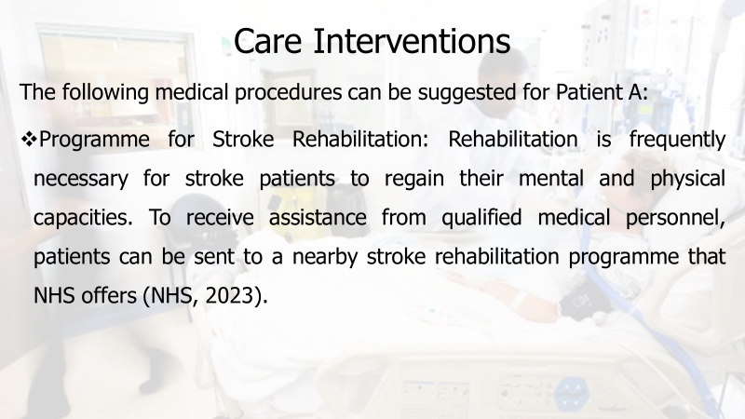

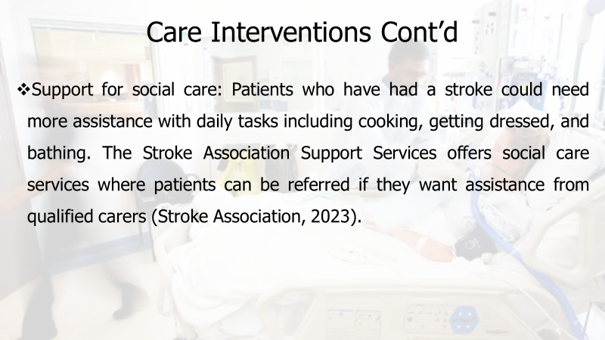
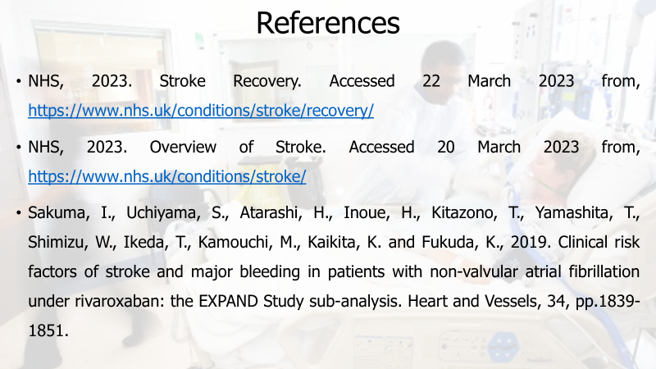
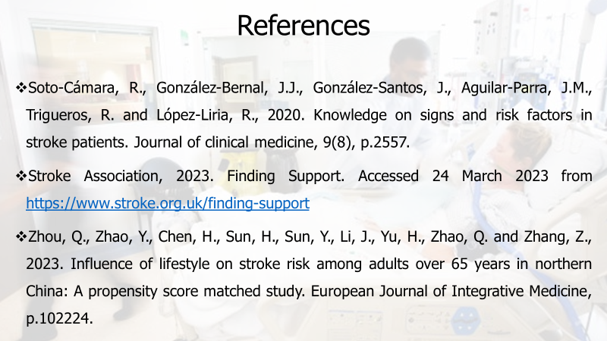


INTRODUCTION TO PHYSIOLOGY
Diabetes Mellitus


Barts Health NHS Trust

Lecturer: Olusegun Awolaran

Contents
Introduction 2
Anatomy and Physiology 2
Health and Lifestyle Routine Measures 3
Health and Social Care Practice 4
Recommendations 5
Conclusion 6
References 7

Introduction
The health and social care systems are well-established in the United Kingdom (UK). This system aspires to improve the health and well-being of its residents while offering everyone access to high-quality healthcare services. The UK, like many other nations, is faced with a number of health issues, such as an ageing population, rising healthcare expenses, and a rise in the prevalence of chronic diseases. This essay will concentrate on diabetes, a chronic illness that affects millions of people worldwide and is one of the biggest problems to the UK's public health. In the UK, an estimated 3.9 million people have received a diabetes diagnosis, while a further 1 million cases go undiagnosed, according to Diabetes UK (2022). This essay will discuss diabetes' anatomy and physiology, common health and lifestyle checks to learn more about how the body works, social and health care procedures, and suggestions for people with diabetes in the UK. This essay's main goal is to shed light on the difficulties experienced by diabetics in the UK and the methods that can be employed to effectively avoid and control the illness.
Recent academic studies have demonstrated that a mix of medical care, lifestyle modifications, and self-management training is necessary for efficient diabetes management. For instance, Bhatti et al.'s study from the year 2021 discovered that those with type 2 diabetes who got comprehensive lifestyle treatments, such as diet and exercise recommendations, had a lower risk of cardiovascular disease and other problems. The value of diabetes self-management education in enhancing diabetes control and lowering the risk of complications was noted in another study by Jaser et al. (2020). In order to effectively manage the condition, people with diabetes must understand the anatomy and physiology of the disease, the standard health and lifestyle measures for learning about how the body functions, the health and social care practises in the UK, and the recommendations for those individuals. This information can assist those working in healthcare, government officials, and people with diabetes to collaborate successfully to prevent and manage the condition and enhance the quality of life for those with diabetes in the UK.

Anatomy and Physiology
According to Chandra and Liddle (2019), the endocrine gland known as the pancreas is responsible for a significant portion of the body's ability to control glucose levels. (Marieb and Hoehn, 2019) The islets of Langerhans, which are found within the pancreas, contain beta cells, which are responsible for the production of insulin, and alpha cells, which are responsible for the production of glucagon. According to Alam et al. (2014), insulin is a hormone that makes it easier for cells to take up glucose, whereas glucagon is the hormone that causes blood glucose levels to rise by stimulating glycogenolysis and gluconeogenesis. Insulin is responsible for facilitating the uptake of glucose into cells.
According to the American Diabetes Association (2022) and Blair (2016), type 1 diabetes is an autoimmune disorder that is characterised by the death of pancreatic beta cells, leading to a shortage in insulin production. This condition affects around 1% of people in the United States. According to Pozzilli and Buzzetti (2018), it is believed that the condition is brought on by a confluence of genetic and environmental variables, such as viral infections and dietary components. (American Diabetes Association, 2022) In the absence of enough insulin, glucose is unable to enter cells and instead builds up in the bloodstream, which ultimately results in hyperglycemia. On the other hand, type 2 diabetes is brought on by a confluence of hereditary and environmental factors, such as being overweight, leading a sedentary lifestyle, and eating an unhealthy diet (American Diabetes Association, 2022). According to Chandra and Liddle's research from 2019, this disease causes the body to become resistant to the effects of insulin because it makes the body less sensitive to the action of insulin. At first, the pancreas responds to the increased demand for insulin by manufacturing more of it. However, after some time, the pancreas is unable to keep up with the demand, which results in hyperglycemia (Chandra and Liddle, 2019).
If the condition is not kept under control, diabetes of either type can, over time, result in a variety of serious problems, including cardiovascular disease, nerve damage, and renal failure (American Diabetes Association, 2022). Modifications to one's lifestyle, medicine, and consistent monitoring are all necessary components of effective diabetes management, which is necessary for the prevention of problems and the maintenance of good health.

Health and Lifestyle Routine Measures
Monitoring one's blood glucose levels on a consistent basis is an essential component of diabetes care. A glucometer is a device that may be used to test blood glucose levels at home. This device measures the quantity of glucose present in a very little drop of blood. According to the American Diabetes Association (2021), people who have diabetes should measure the amount of glucose in their blood at least four times a day, or more frequently if their healthcare professional instructs them to do so. In addition to keeping track of blood glucose levels, managing diabetes effectively also requires keeping a healthy diet and engaging in regular physical activity. According to research done by Colberg et al. (2016), people who have diabetes who engage in regular physical activity had better management of their blood glucose levels and a lower chance of developing cardiovascular disease. It is recommended that people who have diabetes participate in at least 150 minutes of aerobic exercise per week, of a moderate intensity, such as brisk walking or cycling, spread out over at least three days per week, with no more than two consecutive days without exercise (American Diabetes Association, 2021). In addition, it is recommended that people with diabetes consume a diet that is low in saturated fat and high in fibre (Rajput et al., 2022).
Managing diabetes effectively also requires maintaining a healthy diet. According to the American Diabetes Association (2021), consuming a diet that is well-rounded and contains a range of fruits, vegetables, whole grains, lean proteins, and healthy fats can help to control blood glucose levels and lower the risk of problems associated with diabetes. In addition, the American Diabetes Association recommends that people who have diabetes cut back on their consumption of processed foods, sugary beverages, and foods that are high in saturated and trans fats. This is because all of these things can contribute to poor control of blood glucose levels and an increased risk of cardiovascular disease (American Diabetes Association, 2021). Individuals who have diabetes should also have routine checkups with their healthcare provider, who may propose additional tests or modifications to the medication or insulin dosage as necessary (Diabetes UK, 2021). This is in addition to the actions that have been outlined above (Diabetes UK, 2021).

Health and Social Care Practice
It has been demonstrated that participation in the NHS Diabetes Prevention Programme can effectively lower one's likelihood of developing type 2 diabetes. According to the findings of a study that was carried out by Penn et al. (2018), those who took part in the programme had a noticeably decreased incidence of developing type 2 diabetes after a period of one year when compared to individuals who did not get the intervention. According to the findings of the study, the initiative had a potential return on investment of £2.84 for every £1 that was invested. In addition, the programme was shown to be cost-effective. Additionally, it has been demonstrated that the services and tools provided by Diabetes UK are useful in enhancing diabetes control and lowering the risk of complications. People who received education and support from Diabetes UK were found to have a lower risk of diabetes-related complications, as well as a higher likelihood of achieving their blood glucose and blood pressure targets, in a study that was carried out by Khunti et al. (2020). Those who did not receive the intervention were found to have a higher risk of diabetes-related complications. In addition, the government of the United Kingdom has established a number of programmes with the dual goals of lowering the diabetes prevalence rate and enhancing diabetes treatment. Guidelines for the management of diabetes are provided by the National Institute for Health and Care Excellence (NICE), which includes advice for blood glucose targets, medication, and lifestyle interventions (NICE, 2021). In addition, the government has mandated the imposition of a tax on sugary beverages in order to curb the intake of sugar and enhance the general state of public health (HM Revenue and Customs, 2021).
Simply put, these health and social care practises reflect a comprehensive and holistic approach to the management and prevention of diabetes in the United Kingdom. This strategy incorporates lifestyle interventions, educational and support programmes, as well as legislation enacted by the government.

Recommendations
In accordance with the most recent recommendations and recommended methods for managing diabetes (Rajput et al., 2022; Hellmund et al., 2018), the following advice is given to people with diabetes living in the UK:
- Regularly check blood glucose levels and modify treatment as necessary.
- Adhere to a healthy lifestyle that includes frequent exercise and a well-balanced diet.
- Go to routine check-ups with medical professionals, which should include cholesterol and blood pressure checks as well as eye and foot examinations.
- Take your medication as directed by your doctor.
- Take part in diabetes self-management education workshops to get knowledge about the disease and appropriate management strategies.
- Enlist the help of loved ones, close friends, and medical experts to handle the emotional effects of having diabetes.
It has been demonstrated that regular blood glucose monitoring, a healthy lifestyle, routine doctor visits, taking prescribed medication, and taking part in diabetes self-management education programmes can improve diabetes control and lower the risk of complications (American Diabetes Association, 2021; NHS, 2022). The psychological effects of having diabetes can also be managed by asking for emotional support from family, friends, and medical professionals (Diabetes UK, 2022). The potential complications of diabetes must be understood by those who have the disease, and preventive measures must be taken. By effectively managing blood glucose levels and other risk factors, diabetes consequences such cardiovascular disease, renal disease, and nerve damage can be avoided or postponed (American Diabetes Association, 2021). Regular medical examinations, including as eye, foot, cholesterol, and blood pressure tests, can aid in spotting and managing these concerns early on. Diabetes patients should also be aware of their rights and entitlements within the UK healthcare system in addition to these guidelines. All citizens of the UK are entitled to free healthcare from the NHS, which includes support and care for people with diabetes (NHS, 2022). In order to assist people with diabetes in navigating the healthcare system and obtaining the treatment and resources they require, Diabetes UK also offers advocacy and support services (Diabetes UK, 2022).
In general, people with diabetes can successfully manage their illness and lower their risk of complications by following these suggestions and getting access to the right assistance and resources, so improving their overall health and well-being.

Conclusion
In the UK, millions of people suffer with diabetes, a common chronic health disease. There are numerous common health and lifestyle changes that people may make to properly manage diabetes, despite the fact that the condition can have considerable negative effects on a person's health and well-being. These include routinely checking blood sugar levels, leading a healthy lifestyle, going to checkups with healthcare providers regularly, taking prescribed medications, taking part in diabetes self-management education programmes, and asking for help from loved ones, friends, and healthcare providers. The NHS Diabetes Prevention Programme and the tools and services offered by Diabetes UK are just a few examples of health and social care practises and policies in the UK that are geared at efficiently managing and preventing diabetes. To enhance diabetes treatment and stop problems from arising, additional research and actions are still required.
Generally, people, medical professionals, and the larger community must work together to successfully treat diabetes. We can improve the quality of life for those with diabetes in the UK and lessen the financial and personal toll that this chronic illness takes on both individuals and the healthcare system by cooperating and putting evidence-based measures into practise.

References
Alam, U., Asghar, O., Azmi, S. and Malik, R.A., 2014. General aspects of diabetes mellitus. Handbook of clinical neurology, 126, pp.211-222.
American Diabetes Association, 2022. Diagnosis and classification of diabetes mellitus. Diabetes Care, 45(Supplement 1), S14-S21.
American Diabetes Association, 2022. Type 2 Diabetes. Retrieved 14 April 2023 from, https://www.diabetes.org/diabetes/type-2
Bhatti, J. A., Nath, R., Kim, D. J., Siddiqui, F. J., Lee, J. H., and Yoon, S. J., 2021. Intensive lifestyle interventions reduced cardiovascular disease risk in patients with type 2 diabetes mellitus: A systematic review with meta-analysis of randomized controlled trials. Diabetes Research and Clinical Practice, 172, p.108640.
Blair, M., 2016. Diabetes mellitus review. Urologic nursing, 36(1).
Chandra, V., and Liddle, R. A., 2019. Insulin and glucagon physiology and their roles in diabetes mellitus. Endocrinology and Metabolism Clinics of North America, 48(1), pp.1-16.
Colberg, S. R., Sigal, R. J., Fernhall, B., Regensteiner, J. G., Blissmer, B. J., Rubin, R. R., ... and Braun, B., 2016. Exercise and type 2 diabetes: the American College of Sports Medicine and the American Diabetes Association: joint position statement. Diabetes care, 39(11), pp.2065-2079.
Diabetes UK, 2022. About diabetes. Retrieved 14 April 2023 from, https://www.diabetes.org.uk/about_us/news/campaigns/diabetes-week
Diabetes UK, 2022. Facts and Figures. Retrieved 17 April 2023 from, https://www.diabetes.org.uk/professionals/position-statements-reports/statistics
Diabetes UK, 2022. Facts and stats. Retrieved 17 April 2023 from, https://www.diabetes.org.uk/professionals/position-statements-reports/statistics
Hellmund, R., Weitgasser, R. and Blissett, D., 2018. Cost calculation for a flash glucose monitoring system for UK adults with type 1 diabetes mellitus receiving intensive insulin treatment. Diabetes Research and Clinical Practice, 138, pp.193-200.
HM Revenue and Customs, 2021. Sugar Tax. Retrieved 14 April 2023 from, https://www.gov.uk/guidance/soft-drinks-industry-levy
Jaser, S. S., White, L. E., and Simmons, J. H., 2020. Diabetes self-management education and support in adults with type 2 diabetes: A consensus report of the American Diabetes Association. Diabetes Care, 43(7), pp.1636-1649.
Khunti, K., Davies, M., Majeed, A., and Stone, M., 2020. Improving care for people with diabetes and COVID-19: Lessons from the pandemic. Diabetes and Primary Care, 22(3), 98-102.
Marieb, E. N., and Hoehn, K., 2019. Human Anatomy and Physiology (11th ed.). Pearson.
National Institute for Health and Care Excellence (NICE), 2021. Type 2 diabetes: prevention in people at high risk. Retrieved 14 April 2023 from, https://www.nice.org.uk/guidance/ph38
National Health Scheme (NHS), 2022. Exercise. Retrieved 14 April 2023 from, https://www.nhs.uk/live-well/exercise/
NHS, 2022. NHS Diabetes Prevention Programme. Retrieved 14 April 2023 from, https://www.england.nhs.uk/diabetes/diabetes-prevention/
Penn, L., Rodrigues, A., Haste, A., Marques, M. M., Budig, K., Sainsbury, K., ... and White, M., 2018. NHS Diabetes Prevention Programme in England: formative evaluation of the programme in early phase implementation. BMJ open, 8(2), p.e019467.
Pozzilli, P., and Buzzetti, R., 2018. A new sense of urgency: the need for early treatment of type 2 diabetes. Diabetes research and clinical practice, 137, pp.269-271.
Public Health England, 2021. National Cardiovascular Intelligence Network: Diabetes. Retrieved 14 March 2023 from, https://www.gov.uk/government/publications/national-cardiovascular-intelligence-network-diabetes-diabetes-in-england-2021
Rajput, S.A., Ashraff, S. and Siddiqui, M., 2022. Diet and Management of Type II Diabetes Mellitus in the United Kingdom: A Narrative Review. Diabetology, 3(1), pp.72-78.

