Design and Evaluation of Computer Networks
  - Liam Blunt (P149891)
Module Code: ACCA5004
Course: Wireless Networks and Simulation

Contents
Design and Evaluation of Computer Networks 1
I. Introduction 2
II. Research & Evaluation of Modulation Techniques 2
A. Research 2
B. Experimentation 3
Wireless Sensor Design & Evaluation 4
A. Conclusion 5
I. Figures 6
II. Acronyms 13
III. References 13

Introduction

In the topic of wireless networks, there are a lot of variables that greatly affect the operation of a network, be it interference, technique, technology, environment; all of them are variables for a wireless network. The aim of this report/assignment is to evaluate and experiment with a number of these variables, and see the results of what happens when such variables are changed, and then to compare and contrast the different variables with each other, to determine what variable, or technology, is best used within a certain environment, in this report’s case, as seen in part III, a smart factory and the technology choice will be the modulation techniques.

Research & Evaluation of Modulation Techniques

Research
In communication systems, “Modulation is the process of encoding information into a signal that can be transmitted (or recorded) over a channel of interest”[1]. Modulation allows for the sending of a signal over a certain frequency range, depending on the signal, therefore multiple signals can be send simultaneously over a single channel, allowing for a relatively more compact communication, or at least less likelihood of communication errors due to collision. Another function of modulation is that due to the use of modulation techniques, antennae’s in general can be smaller, for example; lower frequency signals tend to require larger antennae’s, but by using modulation to shift the wave upwards into a high frequency waves allows for the use of smaller antennae. This being said, modulation does have its problems, namely in the corruption of the sent data if using certain modulation techniques.[2]

Computer network simulation allow users to create and manage a virtualised computer network, of which can be used to test different techniques and configurations without the need for physical equipment and configuration. With simulation software, the user can create a perfect scenario, of which is both an advantage and disadvantage, for example in a perfect scenario there will be no noise
For the purpose of this task, this writer’s chosen modulation technique will be BPSK, or Binary Phase Shift Keying. BPSK works by converting the binary stream that is the sent data into a binary wave, with 1 being 1 and 0 being -1. The zero must be converted to -1 otherwise it would be an incorrect wave, not balanced around the axis such as a sin or cos wave. BPSK is a relatively very basic modulation technique used in several wireless communication standards such as WLAN 11a, Satellite and WiMAX.

The main advantages of BPSK come with its simplicity, for example due to the fact that it only has two constellation points, it can withstand sub-par channel conditions that would otherwise interfere in modulation techniques such as QPSK, therefore it has a higher noise tolerance than QPSK or QAM, and therefore has a higher degree of reliability, the constellation points of which can be seen in figure 1. Of course, this does come with the downside of a lower bandwidth, as it technically transmits one bit per symbol, whereas in the same scenario QPSK will transmit two bits per symbol, and QAM, depending on the type used can transmit from 3 to 8 bits per symbol, with 256QAM being the maximum in this case. Important to note is that as this bit-rate increase, so does the signals susceptibility to noise and other interference, should a symbol fail to send correctly, it will be resent; slowing down the total throughput. In terms of implementation, PSK is used widely in WLAN, RFID and Bluetooth, of course this covers BPSK and QPSK as they are simply sub-categories of Phase-Shift-Keying. QAM on the other hand is used often in 802.11 Wi-fi standards and optical fibre systems, of which allows for high bitrate usage due to the lack of noise and other interface in a fibre-optic system.[3]

When it comes to network design, there will always be the debate of simulation vs physical, such as mathematically proving and test beds.
While both have their merits, it is this writer’s belief that, for the most part, when building/testing a network, a simulation will suffice as long as the user is user software sufficient enough to create certain variables, such as noise or other interference in wireless channels and delay, no matter how insignificant on physical channels, these features of which are not present in some software packages, and therefore they can only provide a perfect scenario.[4]–[8]

Experimentation

The purpose of this experimentation will be to compare and contrast the aforementioned modulation techniques; BPSK, QPSK and QAM. The experiment will look at each modulations susceptibility to noise, at least in the case of this experiment, in discussion, noise can be substitutes for interference. It is this writer’s belief that the modulation techniques susceptibility will do as such; QAM>QPSK>BPSK, the former being the most susceptible to outside interference. This experiment looks only at the error-rate and is limited by a sample time of 10 seconds, enough for reasonable error rate sample. On the other hand, having a set time of 10 seconds and the way the ‘random integer generator’ works, the speed of transmission is not taken into account, but as the previous research shows, it is highly likely that in terms of transmission speed, it will follow as such; QAM>QPSK>BPSK, with again the former having the higher transmission speed.
In figures 1, 2 and 3 there are the Simulink models used to check for error rates and are BPSK, QPSK and QAM respectively. They are all very similar, but each model suffices to show error rate at different noise level. This experiment will look at the error rate at five levels; 50db, 0db, -10db, -25db and at what db. level errors appear in each modulation technique.
To begin, at 50db, all modulation techniques show no sort of errors at all, of which is to be expected at this level, and this simply acts as a baseline; making sure the models do work.
At 0db signal/noise ratio, things start to differ; BPSK has an error rate of 0%, QPSK has an error rate of 18.18%, and QAM has an error rate of 45.45%. As you can see each modulation technique has had varying levels of susceptibility to the newly introduced level of noise, with BPSK being the most resilient of the three.
At -10db the techniques worsen, which of course is to be expected, but a result nonetheless. BPSK has now cracked at an error rate of 18.18%, QPSK with a rate of 63.64%, and QAM with 81.82%. Although this writer expected BPSK to fair better than the other two, he did not expect such a severe degradation at such a level, that being said while 10db looks like a small jump in ordinary numbers, it would be a completely different amount on the logarithmic scale, of which the decibel meter is part of.
At -25db BPSK still stands with a relatively impressive rate of 27.27%, at least when compared to the other methods. QPSK has an error rate of 54.55%, losing just over half of its original eleven packets. QAM on the other hand has nearly completely broken down with an error rate of 90.91%, which this writer imagines would be pretty much incomprehensible.
Now moving onto the point of which errors appear for each technique; done by trial and error to narrow it down to one decimal place. BPSK’s errors start to appear in the -0.5-0db range, of which is to be expected due to the nature of a minus signal to noise ratio. QPSK errors seem to appear between 2.5-4db, with one or two outliners at 2db and 5db, of which can be disregarded due to the infrequency of them. QAM’s errors in this simulation appear between 6.5-7.5db, this couldn’t be narrowed down further due to the error rate changing back and forth between one and two packets lost in this range.
In conclusion, the assumed hypothesis did indeed happen, with BPSK being the most resilient to interference, and QAM being much less so. Although not a very interesting find, at the very least we can assume it is correct due to the fact that we have research to back it up. Well, backing up the results at the very least, it is possible that results were achieved that match the status quo but something wrong with the method.

Wireless Sensor Design & Evaluation

This task requires the design and creation of a Netsim-simulated smart factory. This smart factory must have; “a display on the warehouse manager’s PC, reception PC and health and safety officers’ smart device. Additionally, the WSN should be linked to the main backbone network to allow for remote monitoring by ‘Warehouse Secure’ a security contractor”, according to the spec. This writer’s factory design can be found in figure 4, with a floor plan in figure 5, although due to the application arrows, it is, suffice to say, difficult to read. In this designed factory there are three main rooms that consist of a reception area, factory floor and office area, while from the diagram they may looked too close together, bear in mind this is a logical topology of the network, and the physical design/implementation of such a network would likely vary greatly. For example, from the diagram the main router, server and sink node are just off to the side on the factory floor, but in a real scenario they would ideally be behind a secured door which is physically locked, as if it were smart locked, in the event of a sever failure, no one would be able to gain access to fix said issue.
Each room in the factory has a multitude of sensors, most namely; temperature, smoke alarm, light sensors, motion sensors and an RFID doorway. To start, the RFID doorways are present in any areas of which to limit the amount of people, for example only a select amount of workers in the factory would have access to the office, even less so the manager’s office, but in this case this writer would imagine the manager’s office would be locked physically. Although they have different icons, the three main factory doors would also run via RFID, either via work card or RFID tag-based device on the vehicle itself. This writer is unsure of the specific RFID technology used, but further research could provide sufficient results.
The light and motion sensors vary from room to room, the reception and office area both incorporate motion sensors, whereas light sensors are on the factory floor. This is due to the fact that although it is alright to turn off the lights in an office environment, no so much to do so on a factory environment where loss of sight/light, even for a few seconds can cause injuries and huge amounts of damage. For that reason, there is light sensors, where when the light level goes below a certain lux level, the lights would turn on, this writer would advise said threshold being ~350 lux, to make sure that it is always bright enough for workers and such. Of course there would be an external sensor to factor in that isn’t in the design, due to it being external. This is because if there were no external variable, the lights would stay on forever, the lights would turn off again once the light level is sufficient.
Moving onto the results of the simulation; The first results, as you may see in figure 6, are the result of a ‘No Path Loss’ multipoint to multipoint, of which is a best case scenario. As you may see, in terms of error rate, it is very low, with 1 error in 5757 packets, and 0% in control packets. Collision on the other hand is a different story, with ~16,000 combined packet collisions all from node 14, although there was a large amount of collisions, due to the low error rate, these packets were likely re-transmitted, in which case it was successful. This high rate of collision is likely due to link 14 acting as the final point from the sink node, aka the sensors are all sending their information to node 25, and it is then sent to the sink node, a ‘last port of call’ if you will.
The second simulation results, as seen in figure seven, are the result of an ‘INDOOR_FACTORY’, ‘Path loss only’ setup, of which is the closer to the real-life scenario that would be present on the factory floor. Although a small amount of interference is present, there are very few differences in the results, the error rate has jumped from 1 to 2, and again, a large amount of the collisions are coming from node-link 14.
To increase the interference present, the third results, in figure eight are that of a ‘Path loss and shadowing’, ‘indoor_factory’ and 5db of noise present. Strangely enough, although there is now additional interference, hardly any difference is seen in the results, actually literally no difference is seen in the results, the delay is not even budged by a microsecond. Because of this, this writer has tried rerunning the simulation three times on this pc, and another three times on another pc, none the less the same results show up, so this one has no way but to accept the results.
The last simulation is now that of ‘Path loss, fading and shadowing’, ‘Indoor_factory’ and 12db of interference, the results of which can be seen in figures 12 and 13. As you may see in these results the error rate relatively skyrockets, jumping from 1 error or such to 325, meaning that the introducing of shadowing and an additional 7db has had a much larger effect that originally suspected, although this writer should have suspected such a change due to the fact that 5db was within QPSK’s ‘safe-zone’, and as all of these simulations run on QPSK due to Netsim limitations, this change was not unwarranted. Although it is a bad result, it is definitely welcome, as having multiple results all the same, even though variables were changed is unnerving to say the least.
Looking at figures 15 to 17, we can see the results of each simulation in graph form, allowing for easier comparison, although the last simulation has the highest number of errors, it also had the highest amount of transmitted bytes and the lowest collisions. This is likely due to the fact that the resent bytes that were making up for the errors were therefore sent at a later time than most, even if it were only a few microseconds, these bytes therefore had a much lower rate of collision. Simply put the collisions were replaced with errors, and since technically in this simulation an error is re-sent straight away, it cannot collide.
Important note to make is that while the assignment specification asks for the contrast and comparison of the aforementioned modulation techniques by using each one in the design, due to software limitations Netsim can only use QPSK is this scenario, therefore we cannot properly answer the question. That being said, an estimation will have to suffice; this writer believes of the three modulation techniques BPSK would be the most suited to this task, while QPSK is sufficient for the task, one or two errors still show up, and the throughput of the network is nowhere near the maximum throughput that QPSK or even BPSK can handle. Therefore, this writer suggests using BPSK over QPSK to eliminate the errors that could appear if using QPSK. Another note is that the simulation software has a maximum of 12db interference, whereas in a factory, depending on the type, the decibel count is certain to reach over 50db, only warranting the use of BPSK further, to put it into frame the average factory reaches an average noise level of 80db, meaning both QPSK and QAM are out of the question in such an environment, as even BPSK would have trouble, the others would likely bring the network to a halt with the amount of errors.[9]
[10], [11]

Conclusion

In conclusion, while each modulation technique has its advantages and disadvantages, in the provided scenarios, BPSK would be the best choice due to its non-susceptibility to interference, and its adequate bandwidth. That being said this choice is only for these scenarios which mostly consist of small sensor networks with certain amounts of interference, this writer imagines that this choice would vary in other situations.

Figures
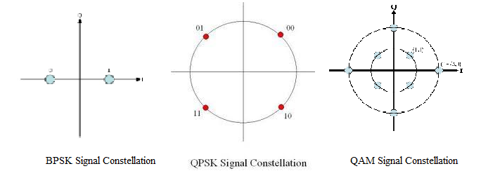
Figure 1- Modulation Diagram[12]–[14]
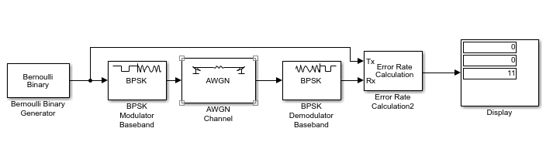
Figure 2 -BPSK Modulation Experiment

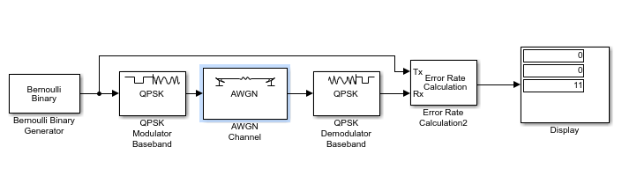
Figure 3-QPSK Modulation Experiment

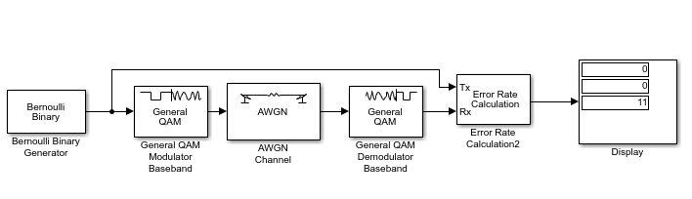
Figure 4 -QAM Modulation Experiment

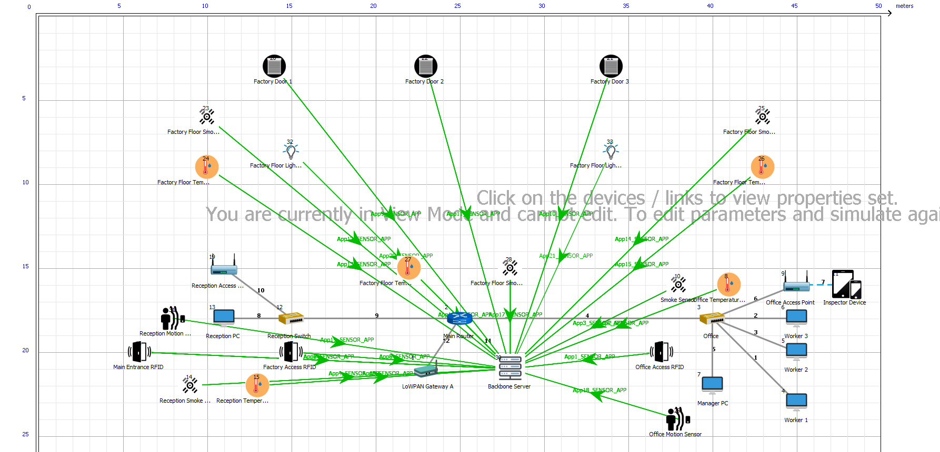
Figure 5- Smart Factory Design
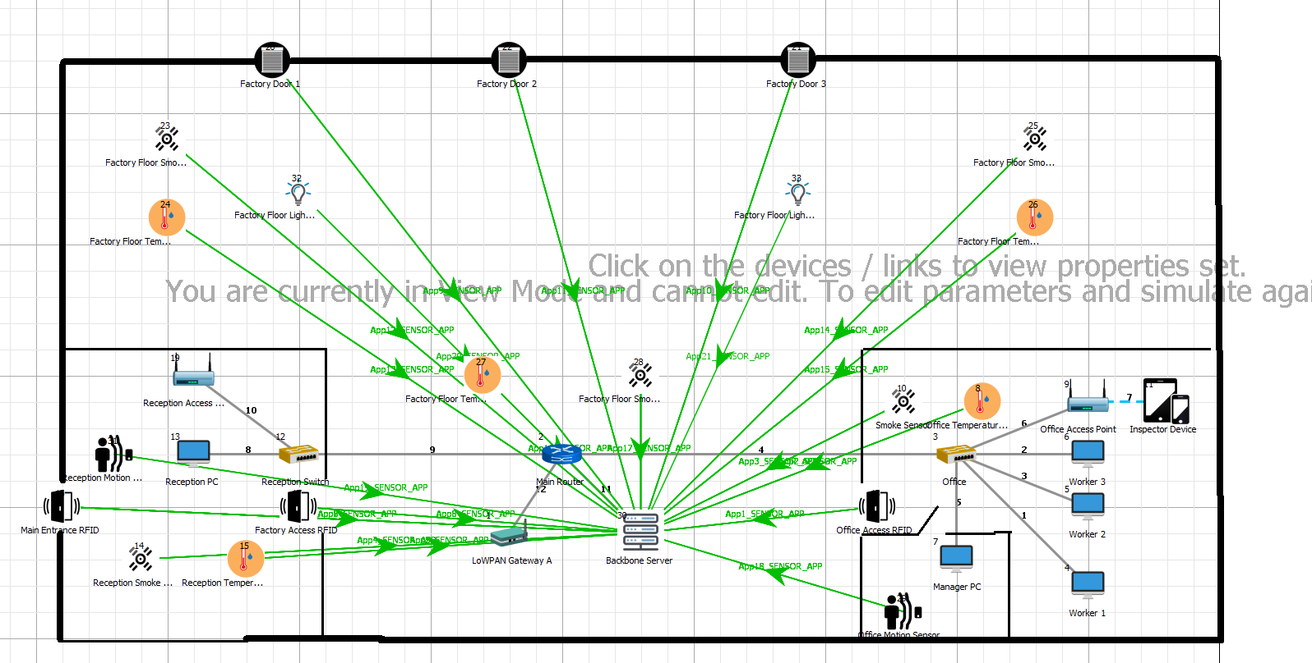
Figure 6- Design Edited to incorporate floor plan
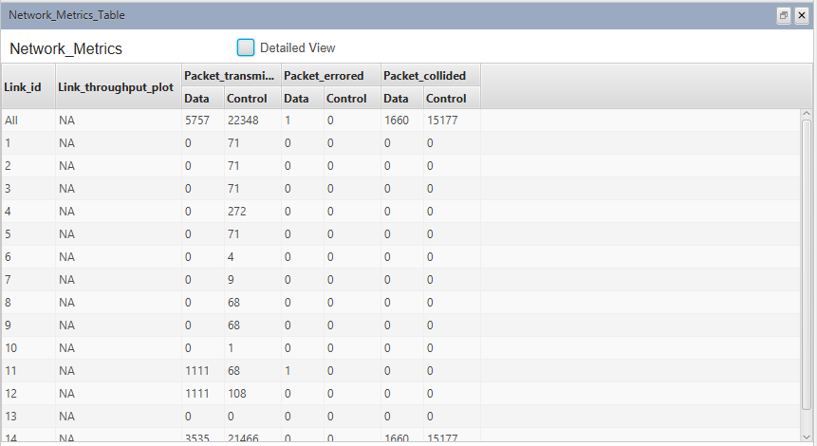
Figure 7- Initial Design Packet results
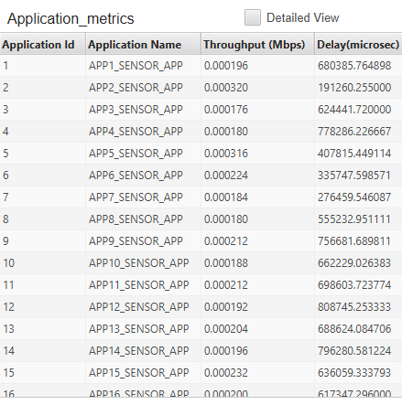
Figure 8- Initial Design application metrics
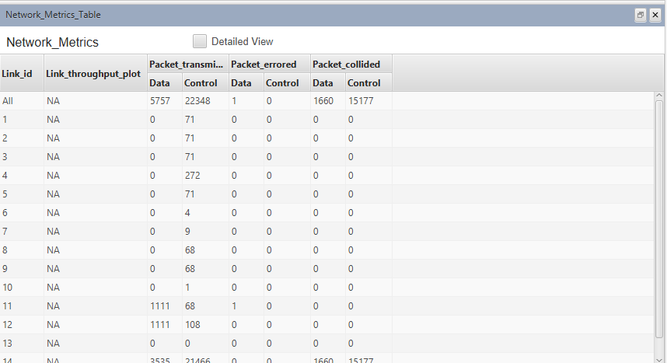
Figure 9- Path loss Indoor_factory results.
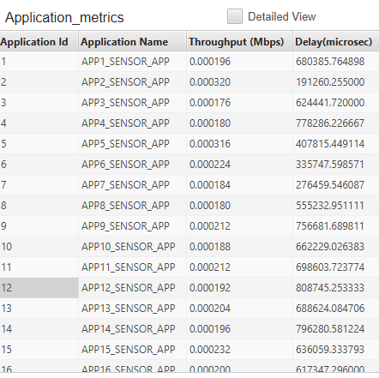
Figure 10- Path loss Indoor factory metrics
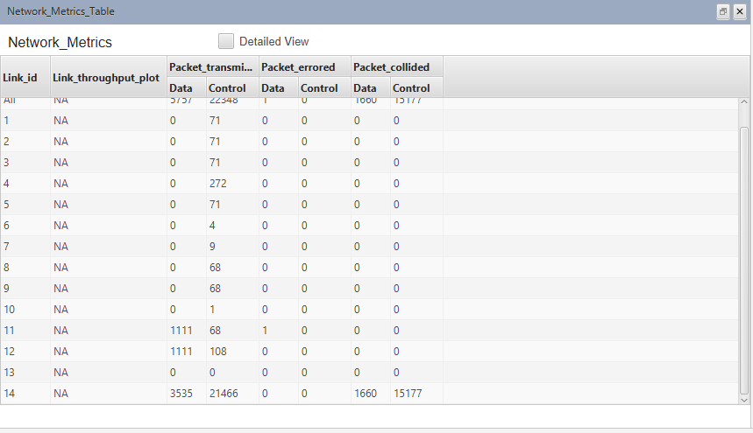
Figure 11- Indoor_factory Path loss, 5db results
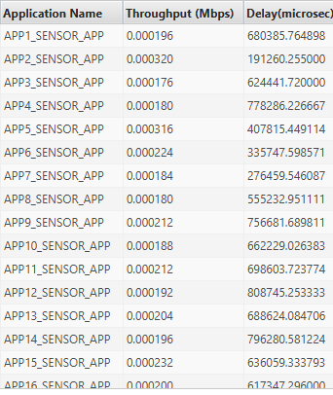
Figure 12- Indoor_factory Path loss 5db metrics
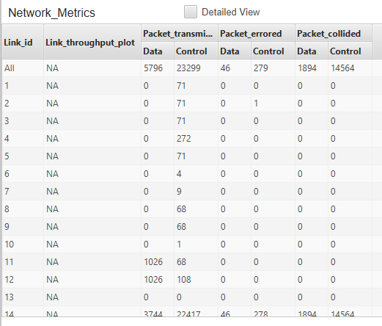
Figure 13- Indoor factory, Path loss, fading and shadowing and 12db results
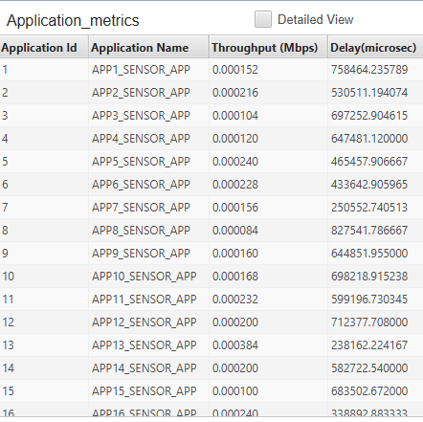
Figure 14- Indoor factory, Path loss, fading and shadowing and 12db metrics.
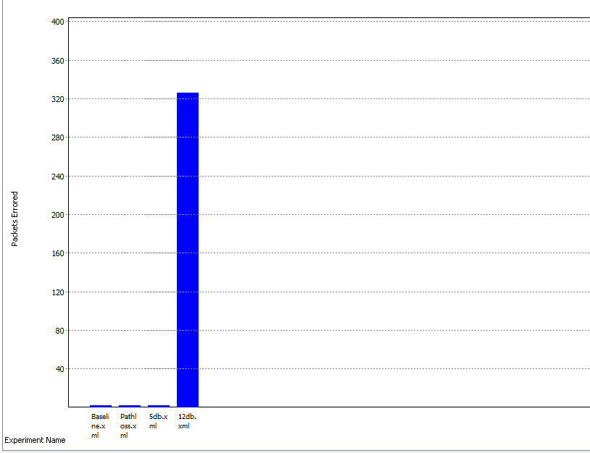
Figure 15- Graph detailing error rate comparison
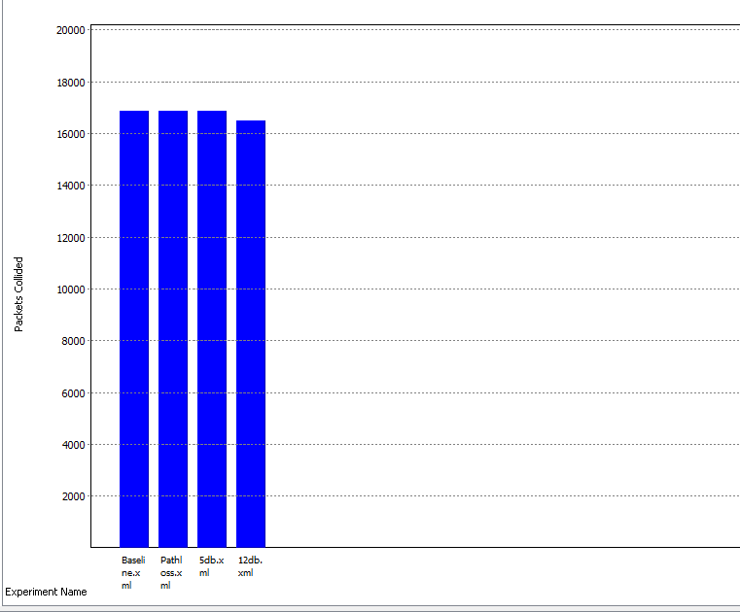
Figure 16- Graph detailing collision rate
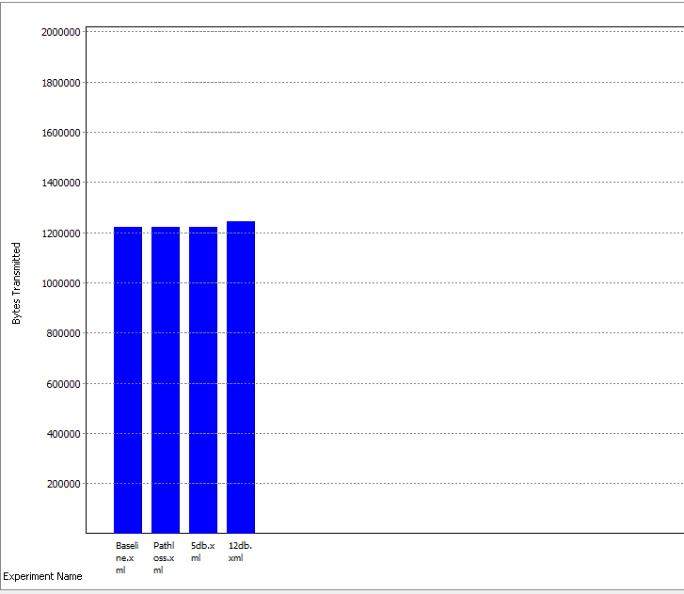
Figure 17- Graph showing bytes transmitted

Acronyms

BPSK- Binary Phase Key Shifting
QPSK- Quadrature Phase Shift Keying
QAM-quadrature amplitude modulation
RFID-radio frequency identification
WLAN- wireless local area network

References

[1] F. G. Stremler, “Introduction to communication systems,” p. 757, 2014.
[2] C. Langton, “All About Modulation - Part I Basic Concepts of modulation,” Www.Complextoreal.Com, pp. 1–38, 2002.
[3] A. K. M. Azad, “Teaching of digital modulation techniques using a simulation environment,” 2005.
[4] N. Vlajic, “Analog Transmission of Digital Data (PPT),” Comput. Syst. Eng., 2010.
[5] V. K. Garg and Y. C. Wang, “Modulation and Demodulation Technologies,” in The Electrical Engineering Handbook, 2005, pp. 971–981.
[6] T. Questions, “BPSK - BINARY PHASE SHIFT KEYING BPSK - BINARY PHASE SHIFT KEYING generation of BPSK,” vol. D, pp. 69–78.
[7] S. O. Tatu, Quadrature Phase Shift Keying (QPSK), no. c. 2005.
[8] A. Lapidoth, Quadrature Amplitude Modulation. .
[9] Y.-L. Hsu, P.-H. Chou, H.-C. Chang, S.-L. Lin, S.-C. Yang, H.-Y. Su, C.-C. Chang, Y.-S. Cheng, and Y.-C. Kuo, “Design and Implementation of a Smart Home System Using Multisensor Data Fusion Technology,” Sensors, vol. 17, no. 7, p. 1631, 2017.
[10] B. Chen, J. Wan, L. Shu, P. Li, M. Mukherjee, and B. Yin, “Smart Factory of Industry 4.0: Key Technologies, Application Case, and Challenges,” IEEE Access, vol. 6, pp. 6505–6519, 2017.
[11] P. L. Dordal, “An Introduction to Computer Networks Principle : Layering Layering,” 2018.
[12] “QPSK Diagram.” [Online]. Available: http://iitg.vlab.co.in/?sub=59&brch=163&sim=1065&cnt=1.
[13] W. U. ’Life of Riley’, “8QAM Diagram.” [Online]. Available: https://upload.wikimedia.org/wikipedia/commons/f/f4/Circular_8QAM.png.
[14] “BPSK Diagram.” [Online]. Available: https://www.slideshare.net/Tehnanali/digital-modulation-61719297.

marking criteria and Student FEEDBACK

This section details the assessment criteria. The extent to which these are demonstrated by you determines your mark. The marks available for each criterion are shown. Lecturers will use the space provided to comment on the achievement of the task(s), including those areas in which you have performed well and areas that would benefit from development/improvement.

Common Assessment Criteria Applied (Assignment 1) | Marks available | Marks  awarded
1. Research-informed Literature
Extent of research and/or own reading, selection of credible sources, application of appropriate referencing conventions.
Research informed literature demonstrated but more referencing could be utilised, see report for more feedback. Referencing convention used. (Grade mark: 66.67%) | 15 | 10
2. Knowledge and Understanding of Subject
Extent of knowledge and understanding of concepts and underlying principles associated with the discipline.
Exhibits understanding but could be strengthen more by utilising more referencing content. (Grade mark: 66.67%) | 15 | 10
3. Analysis
Analysis, evaluation and synthesis; logic, argument and judgement; analytical reflection; organisation of ideas and evidence
Your results were explained and discuss well but aspects lack justifications. The use of graphs and figures would allow for a better flow in the document to ensure that the reader does not have to search for the relevant information. See report for more feedback. Your conclusion need improvement. (Grade mark: 73.33%) | 30 | 22
4. Practical Application and Deployment
Deployment of methods, materials, tools and techniques; application of concepts; formulation of innovative and creative solutions to solve problems.
To improve the validity of the testing some traffic should be configured from the backbone server to the devices. (Grade mark: 62.86%) | 35 | 22
5. Skills for Professional Practice
Attributes in professional practice: individual and collaborative working; deployment of appropriate media; presentation and organisation.
Can communicate professionally and confident in a suitable format. Just remember to spell out all acronyms first time used, avoid contraction grammar and the use of 1st person writing. (Grade mark: 80.00%) | 5 | 4

Assignment Mark (Assessment marks are subject to ratification at the Exam Board. These comments and marks are to give feedback on module work and are for guidance only until they are confirmed. ) | Late Submission Penalties (tick if appropriate) |  | 68%
 | Up to four weeks late |  | 68%
 | First Attempt? |  | 68%

