Assignment 2
Menu Engineering
The objective of this assignment is to design a menu for a new restaurant concept of my choice being introduced to the Hotel Trinity Hotel Chain.
Student name: Fruzsina Valoczki
Student ID number: 2223630
Module title: Food & Beverage Operations
Module Code: BMIH4002
Lecturer: Jaliya de Silva
Word Count: 407
Date: 09/06/2023

Part 1: Restaurant Concept
I'm delighted to introduce my charming restaurant concept, 'Le Jardin,' specially designed for Hotel Trinity. Inspired by the rich heritage of French cuisine, my goal is to provide the esteemed guests with an unforgettable culinary experience. Le Jardin embodies an elegant French dining experience, where culinary expertise and sophistication come together. A flawless service, an elegant atmosphere, and innovative menu are my goals in transporting the guests to the enchanting world of French gastronomy.
Le Jardin appeals to discerning hotel guests and locals in the surrounding area who appreciate refined dining. Whether they are lovers of French gastronomy, fine dining gourmands, or simply food enthusiasts, this concept will captivate their senses. Everyone, from leisure or business travellers to locals seeking a sophisticated dining experience, can indulge in the refined culinary journey that awaits at Le Jardin.
The menu at Le Jardin is thoughtfully curated to showcase the very best of French cuisine. Drawing inspiration from renowned sources such as 'French Cuisine: A History of French Gastronomy' and 'The Art of Fine Dining’ (Henaut & Mitchell, 2018): Mastering the Art of French Cuisine' (Reardon, 2005), my menu celebrates the flavours, techniques, and traditions deeply rooted in French culinary heritage.
Guests can indulge in beloved French delicacies, such as the classic French Onion Soup (Thorn, 2018) and Escargots in Garlic Butter (Behr & Macguire, 2011). For those seeking bolder flavours, my menu offers the French culinary delight, Coq au Vin (Harrison, 2021), and the timeless French classic, Beef Bourguignon (Hendrix & Kolasa, 2022). Seafood enthusiasts can relish in the delicate flavours of Pan-Seared Sea Bass with Beurre Blanc Sauce (Yamaguchi & Harrison, 2013). To satisfy their sweet tooth, we present decadent French desserts (Peterson, 2012) like Crème Brûlée, Chocolate Soufflé, and Tarte Tatin. And, of course, no French dining experience would be complete without a guide to Fine French Cheeses (Kothi, 2020), adding a touch of indulgence to the culinary journey. Additionally, I have created a wide variety of beverages, including non-alcoholic mocktails and French wines and champagne for the menu.
The rationale behind my menu choices is to provide a comprehensive and authentic French dining experience (Traub, 2023). I meticulously select dishes that embody the essence of French gastronomy, incorporating traditional recipes and techniques while infusing modern twists to cater to the evolving tastes of our guests. Each dish reflects our commitment to utilizing high-quality ingredients, seasonal produce, and meticulous attention to detail, ensuring that every bite delivers a delightful experience.
In conclusion, Le Jardin at Hotel Trinity could present a sophisticated French dining experience that harmoniously combines elegance, culinary excellence, and a touch of modernity.

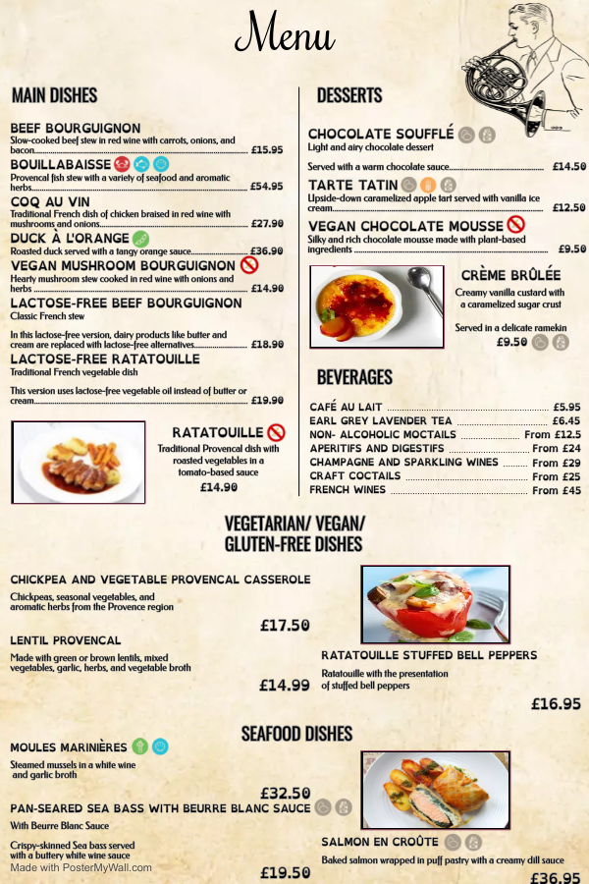

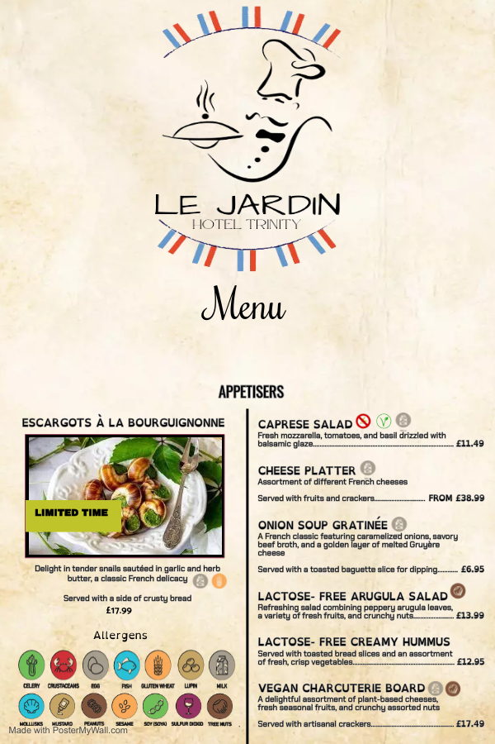

References

Behr, E and Macguire, J (2011) ‘ESCARGOTS À LA BOURGUIGNONNE: Snails in Garlic Butter’, in The Art of Eating Cookbook. 1st edn. University of California Press, p. 138–. Available at: https://doi.org/10.1525/j.ctt7zw44f.74.

Harrison, C. (2021) ‘The Mediterranean Diet’, Alternative medicine (Saint Paul, Minn.), (55), pp. 22–25.

Henaut, S. and Mitchell, J., 2018. A Bite-sized History of France: Gastronomic Tales of Revolution, War, and Enlightenment. The New Press.

Hendrix, K. and Kolasa, K.M., 2022. Popular herb throughout the ages, dill packs flavor.

Kothi, P. (2020). Craving for Some Mouth-Watering French cheese? [online] www.france.fr. Available at: https://www.france.fr/en/news/article/french-cheese-yes-please [Accessed 27 May 2023].

Peterson, J., 2012. Glorious French Food: A Fresh Approach to the Classics. Houghton Mifflin Harcourt.

Reardon, J., 2005. Mastering the Art of French Cooking: A Near Classic or a Near Miss. Gastronomica, 5(3), pp.62-72.

Thorn, B. (2018) ‘François Payard to head up reimagined Karvér’, Restaurant Hospitality [Preprint].

Traub, C. (2023). Decrypting French Restaurants: Brasseries, Bistros, Table d’Hôtes & More. [online] Paris Unlocked. Available at: https://www.parisunlocked.com/food/eating-out/different-types-french-restaurants-what-to-expect/ [Accessed 27 May 2023].

Yamaguchi, R. and Harrisson, J., 2013. Roy's Fish and Seafood: Recipes from the Pacific Rim [A Cookbook]. Ten Speed Press.

